Advanced Augmented Reality Activities for SHSM Programs
Focus on Merge VR

Please Note - It is the teachers responsibility to ensure that the technology and applications outlined in this resource are approved by their School Board.

Introduction: Augmented Reality (AR) applications allow for students to work with manipulatives that can be hard to find, expensive, fragile, or dangerous, without needing the ‘real’ thing!

Table of Contents:
- Materials Needed
- Merge Cube AR Experiences: Merge EDU
- Merge EDU Highlights: Science Simulations (Merge Explorer)
- Merge EDU Highlights: Teaching Aids (Merge Object Viewer)
- Merge EDU Highlights: STEM Projects
- Merge EDU Highlights: Uploading your own Content
- Merge EDU Highlights: Teacher Dashboard Functionality
- Recommendation: Should I invest in Merge EDU for my SHSM?

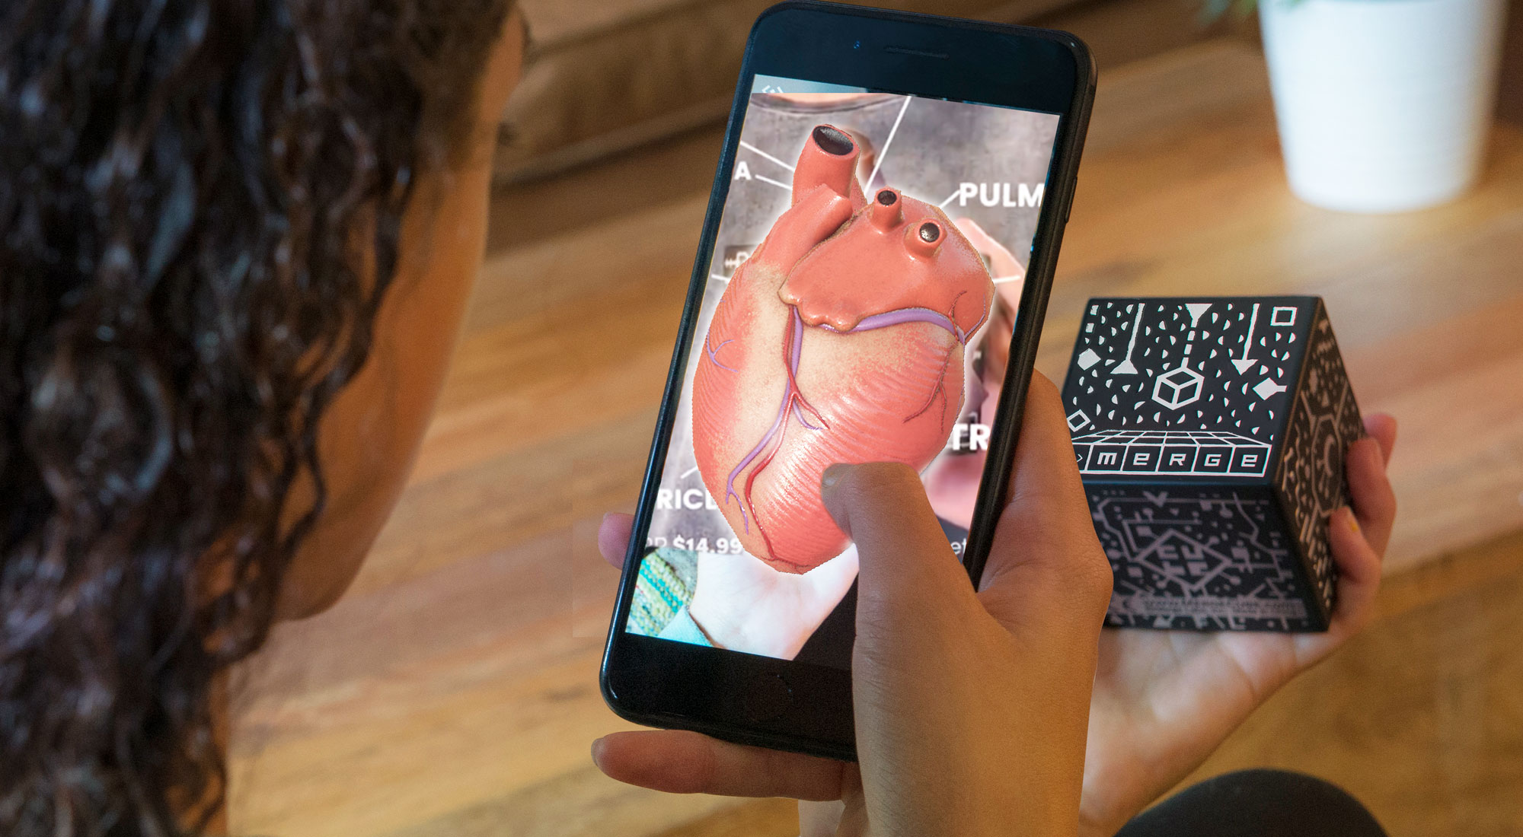
Materials Needed
For the activities that use Merge VR’s headset, you can either purchase a Merge Cube (made of a comfortable foam material) OR you can make a paper version. Although Merge makes a comfortable VR headset, the activities listed on this page do not require one.

You will also need to download: Merge Explorer and Merge Object Viewer from the iOS or Google Play store.

Merge VR also has a list of compatible mobile devices.

Health Warning: Educators and students using Merge Virtual Reality headsets along with the Merge Cube might find these experiences disorienting, nauseating, and/or may have headaches with extended use.

Merge Cube AR Experiences
Merge Labs publishes its own content that uses the cube. There are some other apps that use the cube, but the stable ones require a purchase (for example: Anatomy AR+ for Merge Cube).
You can pay for a single subscription for yourself (that is accessible for up to three devices) but you will need to subscribe to Merge Explorer and Merge Object Viewer separately. The cost is $10 for each app. The available activities for Merge Explorer include Merge’s Science Simulations. The Merge Object Viewer contains Digital Teaching Aids. These will be included in later sections of this overview.

It’s also important to note that the Merge Explorer app has text to speech functionality, along with an ability to edit the font in order for the content to be more accessible for students.

Merge Cube AR Experiences: Merge EDU
There is also the option to register for a Merge VR EDU Classroom license ($1480 for 30 simultaneous users for 1 year term) or for a Schoolwide License ($3710 for 1 year term: unlimited access for all students and teachers in a school) as opposed to one teacher registering. In addition to have Merge Explorer and Merge Object Viewer content accessible, Merge EDU license provides access to:
- All Activity Plans and STEM Projects
- Teacher Dashboards
- Integrations with Select SSO/Rostering Tools

Merge EDU Highlights: Science Simulations (Merge Explorer)

Here is a list of Science Simulations found in Merge EDU, and suggested SHSM Programs. These activities begin in the Merge Explorer app, and use content from a web browser to walk students through pre-made lessons and quizzes. These are accessible with a regular Merge subscription.

These Science Simulations are supported with Activity Plans (found on Merge EDU’s website). Although the grade levels are catered to Grades K - 2, 3 - 5, or 6 - 8, the SHSM Lead could modify or add to the questions while using Merge EDU’s existing content and assessments as part of an activity and not for an assessment. Activity plans can only be accessed with a Merge EDU subscription.
Recommended Science Simulations | Suggested SHSMs
Art Attack!! | Arts and Culture, Information and Communications Technology
Galactic Explorer | Aviation/Aerospace
Laws of Attraction | Aviation/Aerospace
Stars in the Sky | Aviation/Aerospace
Beyond our Solar System | Aviation/Aerospace
The Rotation of Earth | Aviation/Aerospace, Environment
Ticket to Mars! | Aviation/Aerospace, Environment
Water & Weather | Aviation/Aerospace, Environment
Use the Force | Construction, Transportation
Conservation and Transfer of Energy | Energy
Non Renewable Resources | Energy, Environment, Mining
Radiating Light | Energy, Environment
Renewable Resources | Energy, Environment
About Plants | Environment
Breeding Bugs | Environment
Carnivorous Plants! | Environment
Environmental Adaptation | Environment
Island Diversity | Environment
Terraforming Earth | Environment
The Food Web | Environment
The Great White Shark | Environment
A Frog’s Life | Environment, Health and Wellness
The Building Blocks of Life | Environment, Health and Wellness
Predicting Catastrophe | Environment, Justice Community Safety and Emergency Services
Rock History of Earth | Environment, Mining
Genetic Material | Health and Wellness, Justice Community Safety and Emergency Services
Human Anatomy | Health and Wellness, Justice Community Safety and Emergency Services
Mr Body | Health and Wellness, Justice Community Safety and Emergency Services
We’re Making Waves! | Information and Communications Technology
Diamonds are Forever | Manufacturing, Mining
Structure of Matter | Manufacturing

Merge EDU Highlights: Teaching Aids (Merge Object Viewer)
Here is a list of Teaching Aids found in Merge EDU, and suggested SHSM Programs. Teachers can find these Teaching Aids in the Merge EDU Dashboard or in the Merge Object Viewer App. The EDU Dashboard can generate a quick link for students to jump right into the Teaching Aids.

Each Teaching Aid has a collection of 3D objects along with a description. Students can add the object to their collection to quickly view at a later time instead of digging around in the app. These are accessible with a regular Merge subscription.

Recommended Teaching Aids | Suggested SHSMs
Seeds & Plant Reproduction | Agriculture, Environment
Honey Bees | Agriculture, Environment, Food Processing
Garden | Agriculture, Environment, Food Processing, Hospitality and Tourism
The Museum Collection | Arts and Culture
Edgar Allen Poe | Arts and Culture
World War 2 | Arts and Culture, Aviation/Aerospace, Hospitality and Tourism, Transportation
Architecture | Arts and Culture, Construction
Ancient Egypt | Arts and Culture, Hospitality and Tourism
Broward Library African Artifacts | Arts and Culture, Hospitality and Tourism
Famous Artworks in 3D | Arts and Culture, Hospitality and Tourism
Our Solar System | Aviation/Aerospace
Meteorology | Aviation/Aerospace, Environment
Space Science | Aviation/Aerospace, Information and Communications Technology
Simple Machines | Construction
City Builder | Construction, Landscaping, Justice Community Safety and Emergency Services
Mechanisms | Construction, Manufacturing, Transportation
Renewable Resources | Energy, Environment
Anatomy of the Brain | Health and Wellness, Justice Community Safety and Emergency Services
Anatomy of The Ear | Health and Wellness, Justice Community Safety and Emergency Services
Anatomy of the Eye | Health and Wellness, Justice Community Safety and Emergency Services
Animal Classification | Environment
Animal Teeth | Environment
Arthropods | Environment
Butterflies & Moths | Environment
Butterflies & Their Life-Cycle | Environment
Development of a Chicken | Environment
Eggs | Environment
Extinct Animals | Environment
Insects | Environment
Life Cycle of a Frog | Environment
Life Cycle of a Silk Moth | Environment
Reptiles | Environment
Sea Life | Environment
The Ocean Deep | Environment
Fungi | Environment, Food Processing, Hospitality and Tourism
Flowers & Their Structures | Environment, Horticulture and Landscaping
Fossils (there are five additional categories on Dinosaurs) | Environment, Hospitality and Tourism
Cells | Health and Wellness
Dental Health | Health and Wellness
Genetics | Health and Wellness
Human Development | Health and Wellness
Muscles | Health and Wellness
Neurons | Health and Wellness
Laboratory Equipment | Health and Wellness or any SHSM using science based experiments
Vocal Pedagogy | Health and Wellness, Arts and Culture
Circulatory System | Health and Wellness, Justice Community Safety and Emergency Services
Human Anatomy | Health and Wellness, Justice Community Safety and Emergency Services
Lung Health | Health and Wellness, Justice Community Safety and Emergency Services
Urinary System | Health and Wellness, Justice Community Safety and Emergency Services
Viruses | Health and Wellness, Justice Community Safety and Emergency Services
Computer Parts | Information and Communications Technology
Gemstones | Mining, Environment
Geology | Mining, Environment
Minerals | Mining, Environment
Rocks | Mining, Environment
Engines | Transportation

Merge EDU Highlights: STEM Projects
Here is a list of STEM Projects found in Merge EDU and suggested SHSM Programs. Each of these topics has a guiding resource (in the form of slides) that guides students through a design challenge related to that industry. Students use various resources and applications (non limited to Merge EDU) to complete the task. This can be a great resource to enhance ICE trainings, and these STEM Projects are cross-sector applicable. This is only accessible in Merge EDU.
Activity Name | Description | Suggested SHSMs
Future Builders | Students will be tasked to create a hotel. They must consider a design that is plastic free and must be environmentally friendly. They must justify their design choices and consider its impacts. | Construction, Environment, Hospitality and Tourism, Manufacturing
Future Chefs | Students will be tasked with making a menu using only locally sourced ingredients from within 100 miles of where they live as part of a “Farm to Table” Contest. | Agriculture, Hospitality and Tourism
Future Engineers | Students are tasked with designing a new bridge for a town in Cambodia. Lessons in Bridge design are included, and students will make a 3D design of the bridge. | Construction, Manufacturing
Future Inventors | Students will be guided through a project in which they will design a product that will hold a mobile device in meetings. Tinkercad is used in this project. | Business, Construction, Information and Communications Technology
Future Product Designers | Students are challenged to make a low-cost Reusable Connector Kit that turns everyday objects into building materials. Students will be guided through a research process, and will eventually build a prototype in 3D using Tinkercad. Eventually, their 3D model is refined to a point where they will print a 3D model of their prototype. | Construction, Environment, Information and Communications Technology

Merge EDU Highlights: Uploading your own Content

For teachers who are comfortable with coding or 3D modelling, teachers and students can upload Tinkercad or 3D printing files to Merge EDU Dashboard on the “My Stuff” page”. The class can then view these designs in Augmented Reality.
.
Upload an object:

- Accessing Object Uploader
  - Go to https://dashboard.mergeedu.com/ and sign into your Merge Account
  - Select “My Stuff” under Home from the left-side navigation menu
  - Click the “Upload” button on the top-right corner of the screen to open the Object Uploader
- Uploading your 3D Creation
  - Drag and drop your 3D file onto the upload window or click “Browse” to search for the 3D object you want to upload.
    - Note: Object Uploader supports FBX, OBJ, STL, and GLTF file types. You can also upload a ZIP archive containing your model (in a supported file type), along with materials and associated textures.
  - Select the 3D Object file you wish to upload, then click “Continue”
  - Allow the object to Process; when processing is complete click “Continue”
- You can choose to edit or share the 3D object with your class (click “Copy Link” or copy the Object Code”. The link will automatically open the Object Viewer app and download the object onto a mobile device OR you can use “Code Search” on the Object Viewer app.

Read this link for more information on how to upload creations to Merge EDU.
Upload an Image from Tinkercad: (directions taken from Merge EDU)

- Login or sign up at https://www.tinkercad.com/join.
- Hover over the 3D Object you want to Export and tap “Tinker this” to open the object
  - If you have not yet created your object, tap “Create new design”
  - If you are new to Tinkercad, check out the tutorials at https://www.tinkercad.com/learn to get started creating your object!
- With your object open, tap “Export”
  - Tap “OBJ” to begin your export
  - Wait for the object to download onto your device
- Now you can sign in to your Merge Account on the Dashboard and upload your 3D Object using the Object Uploader.
- Finally, you can use the Merge app, Object Viewer, to view your own 3D Object in the palm of your hand with the Merge Cube, or share your object with your class.

Read this link for more information on how to export files from Tinkercad to Merge EDU.

Merge EDU Highlights: Teacher Dashboard Functionality

If a classroom or school wide license is used, teachers can be added by their administrators onto Merge EDU via email (teachers will need to make an account with Merge EDU first, then they will activate their account.

Teachers can then create classes in their Merge EDU account (on the website). Then, teachers will give students a “join class” code. Once students have entered their code, their status will change on your Dashboard Roster from “Not Activated” to “Online” or “Offline”. You will also be able to share links or QR codes for Teaching Aids and Science Simulations (the link is created in the specific topic, but the sharing is done outside of Merge EDU)

The main highlight of having a class registered is the ability to track progress. When the teacher clicks on a Science Simulation, they’ll be able to see their classes’ quiz results from that activity.

Recommendation: Should I invest in Merge EDU for my SHSM?

First and foremost, sign up for a free trial to explore these resources on your own. IF your SHSM is well represented, I would at least subscribe to the Merge Object Viewer. This will allow you to have a device set up in the classroom to have a Merge Cube (or paper cube) station with up to three devices. Also, Merge has just recently added Chromebook support for their content, so this may allow you some flexibility in having students share the content in smaller groups.

The Merge Explorer questions may be too easy for your Grade 11 and 12 SHSM students, but at least it’s a place to start, and a SHSM Lead and their community partner can tweak the questions to make them more difficult. Having a guided experience instead of wondering what to do with the object viewer can help to create a more engaging learning experience.

The Merge EDU platform would be better if there were more appropriate grade level resources. It may not be a draw for SHSM leads, for example, to invest in the EDU platform for the quiz tracking (since it is Grading at a grade 8 level at most). The STEM challenges are well done, but there may not be enough of them to consider at a school level, but maybe a better option would be to have a school board invest in a Merge EDU “tech trailer” that goes from school to school to access these resources.

Ultimately, if your SHSM is well represented, having an individual license for SHSM leads is likely the better way to go.

4/5 Stars for Merge Object Viewer and Explorer App
3/5 Stars for Merge EDU Platform

