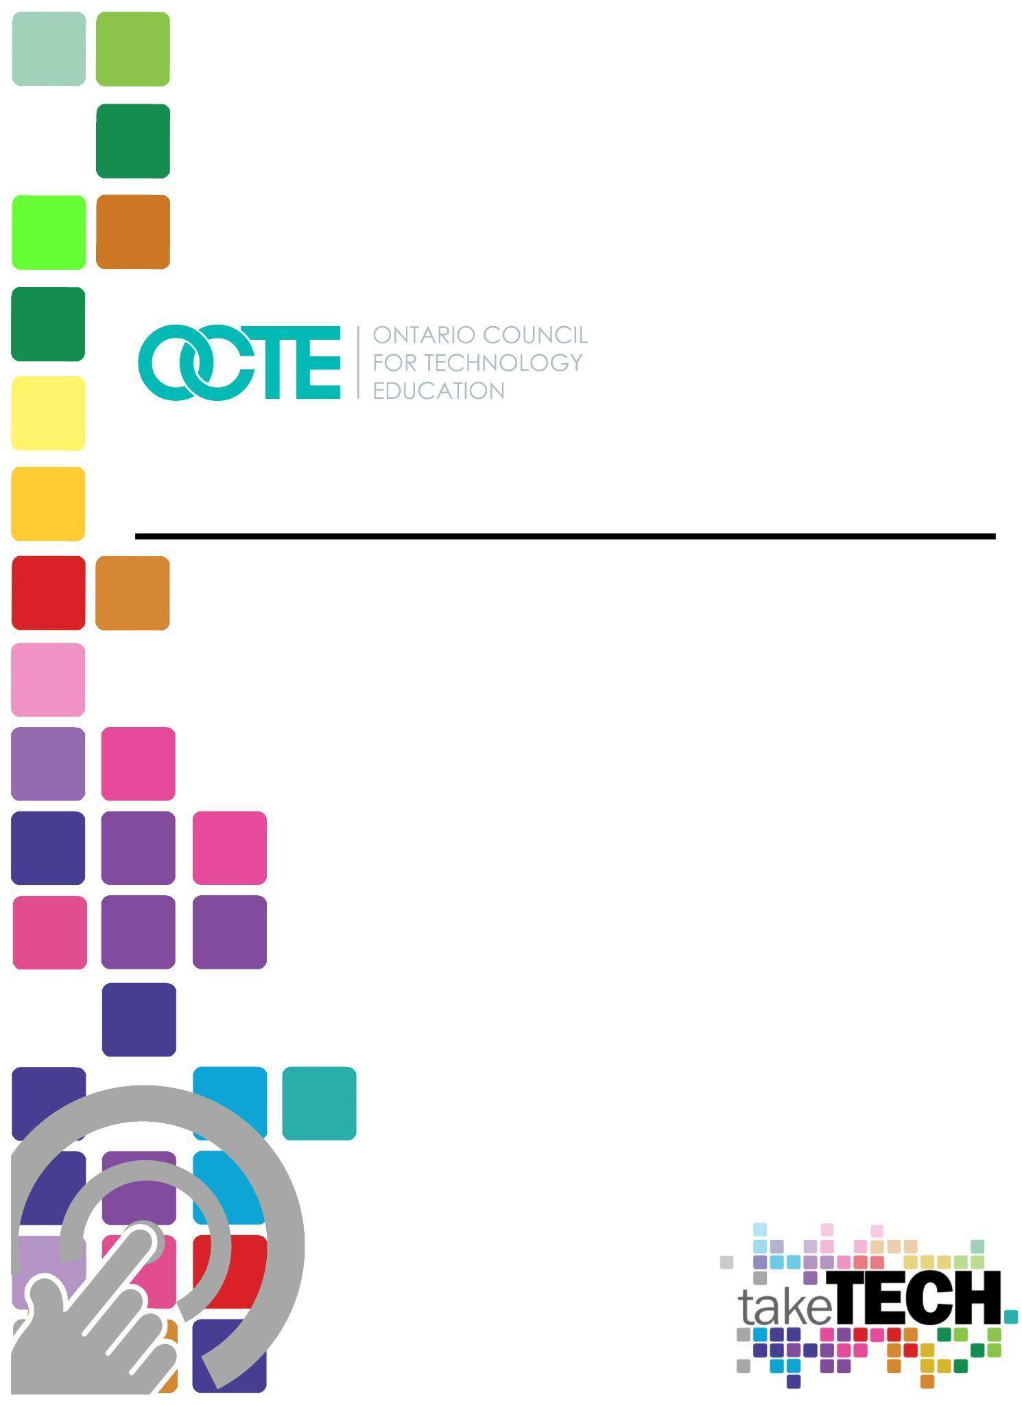

Becoming a Secondary Technological Educator,
Technology Education Teacher Outline
Becoming a Secondary Technological Educator / Pre-Service
Overview/Outline
Pre-service teacher applicants will provide broad-based technology competencies in the area that they are applying to teach. Proof will be a combination of both academic and work experiences in the broad-based subject area.
Please note that you will have to provide proof of documented wage earning experience to your teaching program. In accordance with the Ontario College of Teachers, all technology teachers are required to provide proof of wage earning experience. This experience is used to demonstrate skills and competencies in one’s broad-based technology subject area.
The purpose of this resource is to:
- provide information that will assist those individuals that are considering becoming a technological educator to make an informed decision.
- provide information that will assist guidance counselors to better understand the technological educator and be able to answer the question “How do I become a tech teacher?”
- provide information to assist the existing pre-service candidates as they complete their training and enter the education sector.

Schools that offer pre-service training
The following schools offer pre-service training in technological education:
University of Ottawa (please note; the UOttawa program is offered in French only) EduTek | Faculté d'éducation (uottawa.ca)
Queen’s University Faculty of Education | Queen's University (queensu.ca)
York University Welcome to the Faculty of Education | Reinventing Education (yorku.ca)
Brock University Faculty of Education (brocku.ca)
University of Windsor Faculty of Education (uwindsor.ca)
Lakehead University Diploma in Technological Education
For further details, refer to the document titled Schools Offering Technological Education in Ontario

Upon completion of a Teacher Education program, you will receive either a Bachelor or Certificate of Education. Teachers entering their Teacher Education program with a previously acquired degree will graduate with a Bachelor of Education. Those teachers that have a diploma or certificate will graduate from their Teachers Education program with a Certificate of Education.
Having a Degree may allow you to teach academic subjects outside of the technology area. You would need to have a minimum of 4-6 university credits in your degree in one specific subject area. You will need to also take that AQ to become eligible to teach that subject.
For example: Teacher candidate A has a university degree of Graphics with a Minor in Art. In their degree program they have completed 4 art studio courses. This teacher may be eligible to take the Art AQ and teach Visual Arts as well as Communication Technology.
If you have a college diploma or trade certificate, at this time, you are not eligible to teach academic subjects.
However, all technology teachers are allowed to take certain AQ qualifications that allow them to teach outside of their subject area. More about this in the AQ / ABQ section.

Broad Based Technology (BBT) Sectors/Areas
As potential technological educators traditionally come from industry, they may not know which sector to apply for. Usually, it is the sector that best fits their skill set. The following is a listing of those sectors including examples of skills/careers associated with each.
- Communication Technology (graphic design, photography, video production, advertising layout, broadcast journalism, new media, web design)
- Computer Technology (programmer, IT technician, network cabling, game/ simulation design, electronics, robotics)
- Construction Technology (carpentry, framing, millwork, plumbing, residential electrical, masonry, HVAC, building inspection, health and safety inspector)
- Green Industries (arborists, surveyor, landscape designer, forestry, floristry, horticulture)
- Hairstyling & Aesthetics (nail technician, makeup artist, hair stylist)
- Health Care (careers include, but are not limited to, child care worker, dental assistant/dentist, gerontologist, laboratory technician/technologist, doctor, nursing assistant/nurse, pharmacy assistant/pharmacist, and personal support worker)
- Hospitality and Tourism (event planner, chef, dietician, food service worker, tourism management, inventory management, restaurateur, baker, cook)
- Manufacturing Technology (design, process planer, machine operator, welder)
- Technological Design
- Transportation Technology (mechanic, small engine mechanic)
Related emphasis courses by Broad Based Technology Sector
If the potential educator is still unsure of where they fit, this link will provide a list of courses related to specific skills (emphasis courses), as designated by the Ontario

College of Teachers (OCT)
Course Codes for Emphasis courses in the Revised Curriculum: Technological Education, Grades 11 and 12 (2009)/Codes des cours de spécialisation : Éducation Technologique, 11e et 12e année, édition révisée (2009) (gov.on.ca)

Ontario College of Teachers (OCT)
Home | Ontario College of Teachers (oct.ca)
To teach in Ontario’s publicly funded schools, a teacher must be certified by the Ontario College of Teachers. Certified teachers pay an annual membership fee to maintain their membership and certification.
To be certified, teachers must:
- have successfully completed a four semester teacher education program
- apply to the College for certification and pay the annual membership and registration fees
- have successfully completed the sexual abuse prevention program.
Becoming a Technological Educator is different to becoming a traditional teacher (science, math, English), As it requires a combination of industry experience and education. If you are applying as a teacher of technological subjects, read Requirements for Becoming a Teacher of Technological Education in Ontario. (pages 9-16)

Education Act
Education Act, R.S.O. 1990, c. E.2 (ontario.ca) The Education Act (gov.on.ca)
Each educator regardless of discipline, should be familiar with the education act in general and specifically regulation 298 as it pertains to the assignment of teaching positions and the duties of the teacher and principal.
Regulation 298 Teacher Assignment in Ontario Schools Resource Guide Teacher Assignment in Ontario Schools: A Resource Guide (gov.on.ca)
Duties of Teachers and Principals Microsoft Word - Duties - Teachers Principals - Ed Act - 9 pages.doc (utoronto.ca)

Ministry of Education Curriculum
The Technological education curriculum is a guide to program delivery in the intermediate (grade 9-10) and senior (grades 11-12) levels. It provides direction on how to meet the expectations (of a sector/discipline) as defined by industry and the Ministry of Education. It is deliberately written in an “open” way so that it could be adapted to meet the needs of the community. The curriculum was written by technological educators for technological educators. It is recommended that prospective educators, pre-service candidates, guidance counselors, and anyone who has an interest, review the documents to gain an understanding of technological education programs and how they integrate all disciplines (academic and technical).
The following links will take you to the grade 11 and 12 document ( The Ontario Curriculum, Grades 11 and 12: Technological Education, 2009 (revised) (gov.on.ca) ), and the grade 9 and 10 document ( The Ontario Curriculum, Grades 9 and 10: Technological Education, 2009 (revised) (gov.on.ca) ).

New Teacher Induction Program (NTIP)
This is a program that every new teacher participates in regardless of subject area. The intent is to pair the new teacher with a single point of contact (mentor), who will provide guidance and answer questions as the new teacher navigates their first years. The nature of technological education requires some enhancements to the traditional NTIP, The following link will take you to a resource developed specifically for the technological educator NTIP for technological educators :: Octe

Qualifications Evaluation Council of Ontario (QECO) QECO/COEQ
This is an evaluation process that is used to determine initial placement on the pay grid and is evaluated every time a teacher successfully completes an upgrade course (e.g., ABQ) and applies. The evaluation is usually based upon your academic and work experience. The QECO evaluation process is recognized by all school boards in the province. New teachers should initially apply as soon as they are eligible as it is an essential component of employment. Interested parties are encouraged to visit the QECO website for further details.

Grid Placement
You can google each board's Collective Agreement and research their Grid Pay.
The Grids are all based on a 4 level group scale that goes by your education levels. The grid moves horizontally Group 1, Group 2, Group 3, Group 4 based on your education. You will need to apply to QECO for Grid placement.
The grid moves vertically by years of experience. The years of experience are based on a 10-12 year range (this depends on the board and what they negotiated during their collective agreement bargaining).
The benefit of being a technology teacher is that each board will give you years of service on the Pay Grid. Having said that, each board has their own list of years of experience to grid. Example: One board (Board 1) may give you a 1:1 ratio for years of experience in industry to teaching years, up until year 6. Another board (Board 2) may give you a 2:1 ratio up to 10 years on the grid. That would mean if you worked 16 years in industry you would come in as a 6 year teacher with Board 1 and 8 year teacher in Board 2 on the grid. To find this information out in further detail you would need to contact each board’s HR department.
Also, please be aware that you may have had some years of experience removed to enter into your Pre-Service program.
Here is an example of the TDSB Collective Agreement Grid Pay.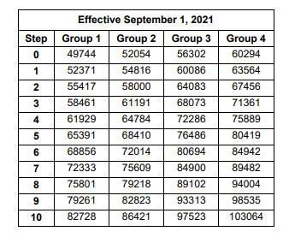

AQ / ABQ’s
AQ/ABQ stands for additional qualification/additional basic qualification.
You must be a registered member with the Ontario College of Teachers (OCT) in order to take an AQ/ABQ. You can not take an AQ/ABQ while you are in teachers college. You will need to complete your program and register with the OCT.
Differences between AQ / ABQ
This can be quite confusing for many. However, we will try to explain it here.
AQ - Additional Qualification - These courses are designed to provide training on professional learning in a subject or topic. (Examples of these courses are: Single Session Qualification, Part 1 Qualification, Part 2 Qualification, Specialist Qualification)
ABQ - Additional Basic Qualification - These courses expand your knowledge, skills, delivery, and assessments in a specific division. (Examples of these courses are: ABQ Primary, Junior, Intermediate, Senior)
Which one(s) should I get? It depends upon your career path and where you work, for example teachers working in a Catholic board will be required to take religious education part 1.
AQ’s are a necessary component to moving up the pay grid and a prerequisite to being able to take your Honours Technological Education Specialist.
Technology teachers without a degree can take AQ courses that will allow them to teach outside of their subject area. You can take any technology course that is offered to grade 9/10 (A course). However, you will not be able to take the 11/12 (B course) unless you have 12 months of related work experience and/or academic background in this field of technology as per regulatory requirements.
Teachers may be able to qualify to teach 2 B level courses (grades 11/12). If a teacher has industry or educational experience in two of the teachable subject fields, you can take your B qualifications in the other subject area once you are qualified to teach. Example: There are many construction teachers that can be qualified to teach A & B (9/10 & 11/12) Construction as well as Tech Design because of their CAD experiences through work / education.
The most common AQ’s that technology teachers take are Co-op Part 1, Special Education Part 1, and Guidance and Careers Part 1. All technology teachers can take these courses. You do not need a degree to qualify to take them.

Online Delivery
Overview of online delivery (including the new mandatory 2 credits)
The classroom is always evolving (the pandemic was proof of that). The Ministry (and the government), has made it mandatory to complete two courses on-line. There are several platforms, however each board will have their choice and process. It is essential that prospective candidates, pre-service educators, parents, etc., familiarize themselves with this trend, The following links will provide an overview of on-line learning and the most common platforms being used:
A parent's guide to online learning platforms | CTV News
Teacher Guide PDF
Student Guide PDF
Brightspace Learning Platform
Brightspace LMS for K-12 Ontario | D2L
Google Classroom, check out the steps here.
Comparison of Brightspace Online Classroom and Google Classroom

Virtual Learning Environment (VLE) training resource videos
Learn how the VLE can help you be more effective, engaging, and efficient
VLE Training | D2L
Resources for Parents
A guide to Brightspace and supporting learning at home
A Guide to Brightspace and Supporting Learning at Home | D2L

Zoom can be found here

FAQ’s (?)
What is NTIP?
NTIP stands for New Teacher Induction Program. It is a mandatory program for all new teachers, where the new teacher is paired up with a mentor who will help guide and direct the new teacher as they navigate their first years.
What is an LTO?
An LTO is a Long Term Occasional position. As a new teacher, you may have an opportunity to fill in for a permanent teacher while they are away from their position. Please note that an LTO teacher will not be part of the NTIP program. You will not have a mentor assigned to you. However, you should have a department head that you can seek clarifications with.
Decisions seem to take longer in education than industry, is this normal?
Yes! While in industry the goal is to complete the product/project with all expediency (time is money), education takes a more measured approach with the goal being the education of the learner in a safe and controlled manner.
What is a TPA?
TPA stands for Teacher Performance Appraisal. This is conducted by the school administration with the purpose of improving a teacher’s craft.
What is STEM/STEAM?
STEM/STEAM stands for Science Technology Engineering and Math/ Science Technology Engineering Arts and Math. It’s a philosophy of education that embraces teaching skills and subjects in a way that resembles real life. The following link will provide an overview What is STEM and STEAM? A guide for parents and educators (steampoweredfamily.com)
Am I expected to teach outside of my area of specialty? ex., electrician teaching plumbing.
As a technology teacher you are expected to be able to teach all aspects of your subject area. You are required to teach anything that falls within your course details based on the Ministry of Education curriculum document. However, many teachers design their courses around their strengths. You may have to teach outside of your comfort zone if you are hired into a school that has a speciality program in your BBT. You will be required to familiarize yourself with that curriculum.
And if so, what resources and programs are available to help me do that?
OCTE is a great resource for Safety Docs and assignments.
Your board may have a subject council built up of the same teaching subject members. This can be a great resource as teachers help to support other teachers.
You can take additional college level interest courses.
Google groups have subject council groups.
You can reach out to other technology teachers in your board. Your department head may be a liaison for you.
Why can't I take an ABQ/AQ prior to graduation, while I'm at the Faculty?
You must be a registered member with the Ontario College of Teachers (OCT) in order to take an AQ/ABQ. You can not take an AQ/ABQ while you are in teachers college. You will need to complete your program and register with the OCT. The OCT designation provides public recognition of their professional standing
What General Studies course(s) can I teach with an undergrad degree?
If you have a general undergraduate degree, then you need to examine if you have 4-6 similar courses such as Social Sciences or studio Visual Arts. If you do, then you can take an academic AQ course and be qualified to teach these courses. If you do not have a minimum of 4 of the same subject area courses in your undergrad then you are not eligible to teach an academic subject. Please feel free to reach out to the OCT if you have any specific questions in regards to pre-requisites for AQ Courses.
What Additional Qualifications as a TechEd teacher am I eligible to take?
Co-op Part 1, Special Education Part 1, and Guidance and Careers Part 1.
Are there special courses required to teach in a Catholic Board?
Religion Part 1.
Questions regarding Letter of Permission, Transitional Certificates, Emergency Supply List?
This is relatively new information in the world of teaching and each teacher’s pre-service faculty seems to have their own rules and regulations around this. Please contact them for more information.

