Table of Contents

SECTION 1: GENERAL 1
Safe Activity Foundation In Education (SAFEdoc): Health Care 1
Usage of the SAFEdoc 2
Delegating the Responsibility for Safety 4
Locking Out and Tagging Out Equipment 9
Safety Perspective Overview 11
Safety Topics in the Classroom 12
Communication 13
Safety Expectations 14
TPJ2O Health Care 14
TPJ3C/M Health Care 14
TPJ4C/M Health Care 14
TOJ4C Child Development and Gerontology 14
TPJ4E Health Care: Support Services 15
Internet Acceptable Use Agreement Form 15
Student Conduct Agreement 18

SECTION 2: SAFETY INFORMATION SHEETS 20
Autoclave 21
Biohazards and Infection Control 23
Chemical Handling 24
Electrical Hazards 25
Ergonomics 26
Facility Emergency Procedures 27
Fall Protection 28
Fire Extinguishers 29
First Aid 30
First Aid Kits 31
General Housekeeping 33
Hand Hygiene 34
Health Care Equipment 36
Hospital Beds 40
Mechanical/Electrical Patient Lift (Full and Sit-to-Stand) 41
Personal Hygiene 43
Personal Protective Equipment 44
Practice Labs 46
Sharp Instruments 47
Wheelchair 48
WHMIS 49
WHMIS 2015 Pictograms 54

SECTION 3: SAFETY ASSIGNMENTS AND TESTS 60
Assignment # 1 – Room Inventory and Safety Identification 61
Assignment # 2 – Safety Requirements 62
Assignment # 3 – Perform a Safety Audit 63
Assignment # 4 - WHMIS Quiz 64
Assignment # 5 - Safety Brochure 65
Assignment # 6 - Body Mechanics 66
Moving a Person Up in Bed Lab Checklist 67
Transferring a Person from a Bed to a Chair Lab Checklist/
One-Person Pivot Transfer 68
Raising the Person's Head and Shoulders Lab Checklist 70
Giving a Modified Simulated Bed Bath Lab 71
Using Mechanical/Electrical Patient Lift 73
Section 3 Culminating Activity: Equipment Safety Guidelines 75

SECTION 4: SAFETY PASSPORTS 77
Sample Student Safety Record 79
Form 2: Equipment/Procedure Passport 80
Form 3: Equipment/Procedure Passport 81
Disinfectant Passport - including Hand Hygiene and PPE 82
Ergonomics Passport - including Body Mechanics 83
Sample: Record of Safety Training 85
Safety Orientation Quiz 86

APPENDIX A: HEALTH AND SAFETY RESOURCES 87
Health and Safety Ontario (HSO)
Ontario School Boards Insurance Exchange (OSBIE)
North American Occupational Safety and Health (NAOSH) Public Health Ontario, Young Worker Links, Take Our Kids to Work – Teacher’s Guide; Workplace Guide
Ontario Service Safety Alliance

APPENDIX B: OCTE SAFETYNET BLANK TEMPLATE 92
Overview
Establishing Your Safety Binder
Starting Your Safety Net
Safety Net Lesson Plan
Materials, Physical Resources Planning Sheet

Disclaimer

This material was designed to assist teachers implement the Ontario Curriculum – Technological Education, (revised Grade 10 -12) but is fully adaptable to the Ontario Curriculum Grade 1 – 8 Science and Technology curriculum. This material was created by members of the Ontario Council for Technology Education (OCTE) subject association and is intended as a working guide for classroom, lab or shop activities. Permission is given to reproduce these materials for any purpose except profit. Teachers are encouraged to amend, revise, edit and adapt this material for educational purposes. Please acknowledge the source in all uses. Any references in this document to particular to commercial resources, materials or equipment reflect only the opinions of the writers of this material, and do not reflect any official endorsement by the Ontario Council for Technology Education, the Ontario Ministry of Education, or any other agency or government body.

All materials within these safety related documents are to be considered as suggestions and recommendations only. These are not legal documents and are not to be considered as legal requirements or as official policy. OCTE or the individual contributors makes no claim to the accuracy or the completeness of the enclosed documents and accepts no responsibility for any damages pertaining to their use. Users of this document should not assume all warnings and precautionary measures are contained herein, that additional information or measures are not required, or that local by-laws, regulations or Board policies are explicitly included.

© Ontario Council for Technology Education 2013, Revised September 2020, Revised August 2022

SECTION 1: GENERAL

Safe Activity Foundation In Education (SAFEdoc):
Health Care

This SAFEdoc was designed to provide safety data sheets, posters, safety passports, and safety resources for all technology educators. While originally developed as a resource for the Course Profiles, it is available for any grade level or any technology education environment.
In 2013 another resource called the safetyNET was created by OCTE with many subject-specific exemplars of exciting student projects that incorporate varying levels of safety risk. Please review exemplar TPJ safetyNET resource documents created ‘by teachers for teachers’ with experienced tips and customization options for your course projects.
The SAFEdoc has been created for eleven separate disciplines per Ontario Ministry Courses:
Communications, (COM) | Hospitality and Tourism (HOST)
Computer Engineering Technology (CET) | Manufacturing (MANU)
Construction, Custom Woodworking (CON) | Technological Design (DESIGN)
Green Industries (GREEN) | Transportation (TRANS)
Hairstyling and Aesthetics (H&A) | Exploring Technologies (EXPL)
Health Care (HC)

Please note that due to the cross-curricular nature of Technological Education, there may be a need to refer to other SAFEdocs for cross-discipline data sheets. For example, a Health Care teacher may need to utilize food production and handling equipment, therefore may need to refer to the HOST SAFEdoc Teachers are encouraged to download all SAFEdocs for reference.
Teachers are encouraged to add to this SAFEdoc with data sheets, tests or other materials on an ongoing basis. Additions or revisions to this document will be posted on the Ontario Council for Technology Education (OCTE) website (http://www.octe.ca/) periodically.
This document is a practical safety resource that compliments and elaborates on other recommended resources for technical teachers. See Appendix A for information such as industry associations dedicated to safe working practices.

It is imperative that all students are made aware of the issues of health and safety particular to your class, and that you have assessed and evaluated their understanding before they are permitted to work in a shop environment or on specific procedures or tools. The use of Safety Passports, Safety Agreements, Skill Safety and Safety Tests (provided in this document) are highly recommended.

NOTE: While it is important to give students initial safety training and testing at the beginning of the semester, it is also important to practice JIT Safety Training (Just In Time). Reinforce specific safety procedures and rules each day before initiating new procedures or using equipment. For example, before students use a bandsaw, review the setup and ask key questions of students before allowing its use.

USAGE OF THE SAFEdoc
Teachers are encouraged to use and modify this document as they see fit. Individual pages may be directly printed, or custom formatting may be applied for printing any part of the document. General Guidelines may be used in Board or school policy documents. Safety Guidelines may be used as student handouts, as a teacher reference for tests, or printed and mounted as posters around equipment.

The SAFEdoc also contains sample Safety Passports. These can be used as verification that students have been trained and understand the safety aspects of each equipment or procedure they need to use to accomplish their tasks. There are several formats that may be used. Teachers are encouraged to document and retain all student safety records.

See Appendix A for related safety resources, the Young Workers Awareness Program, the Ministry of Labour and other organizations dedicated to safe practices.

It is important that teachers are knowledgeable about their own individual school board and specific school policies regarding safety. Teachers should be familiar with local municipal policies, procedures, and regulations.

Responsibilities for Safety
[From the Ontario Ministry of Education The Ontario Curriculum (Revised) 2009, Technological Education, Grades 9 and 10 (page 28); Grade 11 and 12 (page 33)]

Health and safety is of paramount importance in technological education. In every course, students must be made aware that health and safety is everyone’s responsibility at home, at school, and in the workplace. Before using any piece of equipment or any tool, students must be able to demonstrate knowledge of how the equipment or tool works and of the procedures they must follow to ensure its safe use. Personal protective equipment must be worn as required.
Classroom practice and all aspects of the learning environment must comply with relevant municipal, provincial, or federal health and safety legislation, including the following:
- Ontario Workplace Safety and Insurance Act
- Workplace Hazardous Materials Information System (WHMIS)
- Food and Drugs Act
- Ontario Health Protection and Promotion Act
- Ontario Building Code
- Occupational Health and Safety Act
- local by-laws

Teachers should make use of all available and relevant resources to make students sufficiently aware of the importance of health and safety. These resources include:
- Parachute Canada- (https://parachute.ca/en/)
- Worker Awareness Training Program - https://www.ontario.ca/document/guide-occupational- health-and-safety-act-requirements-basic-awareness-training/worker
- Young Worker Awareness Program – http://ywap.ca/english/
http://ywap.ca/english/pdf/YWAP_ResourceBook.pdf
- Workplace Safety and Insurance Board (WSIB) – http://www.wsib.ca/ and related resources
- Workplace Safety and Prevention Services (WSPS) – https://www.wsps.ca/ and related resources
- Ministry of Labour, Immigration, Training and Skill Development http://www.labour.gov.on.ca/english/ and related resources
- Canadian Centre for Occupational Health and Safety (CCOHS) – (http://www.ccohs.ca/) and related resources
- Public Health Ontario – (https://www.publichealthontario.ca/)
- Public Services Health and Safety Association – (https://www.pshsa.ca/)
- Ontario Public Health Association – (https://opha.on.ca/Home.aspx)
- Ontario Hospital Association Health and Safety – (https://www.oha.com/labour-relations-and- human-resources/health-and-safety)
- Appropriate Safe Workplace Associations (SWAs) and clinics, such as:
  - Infrastructure Health and Safety Association of Ontario (IHSAO) – https://www.ihsa.ca/Homepage.aspx
  - Workers Health and Safety Centre (WHSC) – http://www.whsc.on.ca/
  - Occupational Health Clinics for Ontario Workers (OHCOW) – https://www.ohcow.on.ca/

Teachers should also be aware of the Occupational Health and Safety Act, Regulations 857, Amended to O. Reg. 352/91. The Occupational Health and Safety Act can be found at:
http://www.e-laws.gov.on.ca/html/regs/english/elaws_regs_900857_e.htmg

Delegating the Responsibilities for Safety
As well, there are key areas of responsibility that must be clearly delegated for all technological subject areas and they must be addressed for their individual board, school and facility.
These may include administration, subject based program leads, technology teachers, students, board facilities, custodian/maintenance and other local partners or board-defined roles.

* An original source of this delegation example has been adapted from the Toronto District School Board – Experiential Learning Department – Technological Education ‘Front Matter’ for the purposes of the SAFEdoc revision 2013. Please note that this section is not original to the SAFEdoc writers but is a result of collaboration between the TDSB and OCTE. This in no way refers any responsibility to the TDSB for this information and has been provided as a guideline reference only.

Administration
The responsibility rests with the Principal or their designate to ensure that each Technological Education Teacher has received the information and instruction on the safe use of equipment in the classroom.
In order to achieve safety goals, the School Board, Superintendents and Principals should:
- establish and maintain a written Board safety policy and program
- emphasize and enforce the safety policy and procedures
- ensure that each Teacher has been satisfactorily trained on the use of equipment within the classroom
- ensure in‐service education sessions are held for Teachers concerning the safety policy and procedures therein, such as machine guarding, lock‐out, fire prevention, first aid, personal protective equipment
- be aware of current legal issues about liability for classroom accidents; ensure that such is part of in‐service sessions for staff
- assist and encourage the teacher to correct and avoid situations that could result in liability to the Teacher and the school
- provide for proper safety equipment in all technology areas
- hold staff accountable for safety practices in their respective areas
- analyze accident records in order to determine the most frequent causes of accidents and the more severe types of accidents
- take corrective measures to change accident‐causing conditions
- ensure that staff health and safety training and information is current
- make safety literature, posters, and safety promotional material available to all persons associated with the technology program
- set up a program for the safety orientation for new staff
- ensure that all Occasional Teachers working in the Technology areas are informed about and understand the standard accident and emergency procedures
- not permit the overcrowding of classes, taking into account the physical size of a room, the arrangement of the equipment, furniture and facilities in the room, and the kind of activities that are being carried out in the room
- ensure that the use of space has not changed unless changes have been designed by a qualified architect or engineer
- at the beginning of the year/semester, make the Technological Education Teacher aware of any student medical condition that could result in a safety problem
- ensure that individuals are designated to be responsible for safety in the Technology Department
- limit after‐hours access to the Technological Education facilities and equipment to qualified personnel

Department Heads/Curriculum Chairs/Subject Based Program Leads
The Subject Based Program Lead (SBPL) is the intermediary between the individual Teacher and Administration. Each Subject Based Program Lead is accountable to their Principal to ensure input into the administrative process and enforcement of both the Occupational Health and Safety Act and Board policies.
The Subject Based Program Lead should:
- ensure that each Technology area has a floor plan posted in a strategic place to show the locations of items such as:
- fire extinguishers
- school Automated External Defibrillator
- posted emergency phone numbers, codes and instructions
- fire blankets
- emergency power stop buttons
- emergency kit
- eyewash station(s)
- emergency exits
- special shut‐off valves (gas, etc.)
- nearest fire pull station

- ensure that a first‐aid kit is available in each Technology area
- ensure there is Personal Protective Equipment (PPE) available for Technology staff and students
- ensure implementation and understanding of the safety policies and procedures. This includes developing specific departmental safety procedures or rules for specific areas.
- ensure a designated Teacher is responsible for specific areas of safety in his or her specific areas
- inform the Principal when the physical condition or other factors in the classroom may detrimentally affect safe instruction
- when a program is disbanded, ensure equipment is locked‐out and room is not accessible (rekeyed)
- inform the Principal, in writing, of any known or potential safety hazard
- encourage the use of safety posters, literature, multimedia, and audiovisual aids
- advise the Technological Education staff to ensure that all student projects are completed with safety guards in place. Keep safety guard and anti‐kickback devices in position, if possible. use approved alternate safety devices where appropriate.
- advise Teachers to ensure that safety guards are placed back immediately when process is finished
- where applicable, ensure that there is an appropriate spill kit and spill procedure present
- develop, implement, and post a standard accident emergency procedure in each Technology area
- ensure that current inventories of Safety Data Sheets (SDSs) are maintained
- ensure that no unapproved or unsafe equipment, materials, or procedures are used in the area. Equipment should be purchased through Board‐approved vendors.
- advise Technology staff that any equipment deemed not to be safe must be taken out of service immediately, tagged, locked out, and reported to the Principal
- advise the Technological Education staff to ensure that no practical shop work requiring the use of tools or equipment shall take place during their absence or when an unqualified Teacher in Technological Education is supervising the class
- advise any certified Occasional Technological Education Teacher working in a specific subject area not to engage in practical work until familiar with the shop environment
- encourage the Technology staff to receive first‐aid training
- ensure that all accidents and incidents are recorded and reported on the appropriate forms
- conduct, along with the Health and Safety representative where appropriate, a follow‐up analysis of all accidents and incidents
- notify the Chief Custodian, Facility Services of any special needs or deficiencies in the area
- review, at least annually, all procedures and rules

Technology Teacher
In order to provide a safe environment for students involved in any Technological Education course, the following procedures must be adhered to:

Teachers must be aware of their individual Board Safety Documents that outline safety procedures for machinery, tools, and equipment, by completing advised Board Training.
Use of Board Safety Documents is required as the minimum basis for safety instruction. Enhancements and additions to these documents are permitted to meet program needs.
Students must receive instructions on the safe and proper operating procedures for specific machinery and equipment by a qualified Technological Education Teacher before permission is given to use tools, machinery, and equipment. The following excerpt from the Ontario Curriculum document for Technological Education explains this point further:
Teachers are responsible for ensuring the safety of students during technology lab, shop, and classroom activities. Health and safety issues must also be addressed when learning involves cooperative education and other workplace experiences. Teachers need to encourage and motivate students to assume responsibility for their own safety and the safety of others, and they must help students develop the knowledge and skills needed for safe participation in all technology‐related activities. For these reasons, teachers must model safe practices at all times and communicate safety expectations to students in accordance with school board policies and procedures, Ministry of Education policies, and Ministry of Labour regulations.
To carry out their responsibilities with regard to safety, it is important not only that teachers have concern for their own safety and that of their students, but also that they have:
- the knowledge necessary to use the materials, tools, and procedures involved in science and technology safely
- the skills needed to perform tasks efficiently and safely
Note: Teachers supervising students using power equipment such as drills, sanders, and saws need to have specialized training in handling such tools. This specific training requirement applies to listed equipment in all areas of technology education specialization.
Teachers of Technological Education courses must carefully maintain records of student attendance and records of safety instruction given.
Teachers are expected to be able to provide documentation:
- that the student was present on the date each safety lesson was taught (dated lesson plans, attendance records clear and unambiguous)
- of the safety lesson that was delivered (e.g., PowerPoint, note taking, signed safety pledge, pre‐printed sheets, successful passing on an announced written test that is dated and stored by the teacher, correction of errors completed)
- that indicates student understanding of the safety lesson (e.g., completed evaluation tool, student notes)
- of how students are reminded of safe practice throughout the course (e.g., notation in teacher daybook, in learning management system)
- that the work and learning environments are kept safe, tidy, and in good condition (e.g., photos, focus on machines with guards in place, maintenance records, safety inspections, cleanup procedures, student safety stewards, modeling of best practices), and that the Head Caretaker is informed of any maintenance issues
- that students’ different learning styles and needs are taken into account, both during the delivery of the safety lessons and during any follow‐up evaluation (e.g., use of visuals, opportunities to demonstrate understanding orally)
- that safety procedures are explained using various strategies such as verbal explanation, demonstrations through modeling, and accompanied by both written and pictorial explanations that are posted throughout the work and learning environments
- those accommodations and, if necessary, modifications are made to the curriculum and included in the Individual Education Plan (IEP) in the event that the student cannot manage all curriculum expectations safely
- that each student has signed the annual acknowledgment form, stating that he/she has been informed of the safety procedures

LOCKING OUT AND TAGGING OUT EQUIPMENT
The process for Teachers for locking out and tagging out equipment is as follows:
- If the equipment can be locked out by way of a power switch located on the actual piece of equipment, by use of a padlock, then the Teacher can lock it out.
- If the power cannot be locked out at the equipment, then the Head Caretaker must be notified and the power should be locked out at the panel box.
- Lockout is always required when repairs/adjustments are being performed on any piece of equipment.
- Once the equipment is locked out, it must be “Tagged Out” by attaching an appropriate tag in a conspicuous location, showing the worker’s name and reason for lockout, along with the date and time.
- Notify the school Administration and the Head Caretaker once lockout and tag‐out have occurred.

Students

Students demonstrate that they have the knowledge, skills, and work habits required for safe participation in Science and Technology activities when they:
- maintain a well‐organized and uncluttered workspace
- follow established safety procedures
- identify possible safety concerns as they arise and bring them to the attention of the teacher
- suggest and implement appropriate safety procedures
- carefully follow the instructions and example of the Teacher
- consistently show care and concern for their own safety and that of others

Board Facilities

- Inspect the Technology areas on at least an annual basis with respect to maintenance items such as gas leaks, electrical outlets, safety indicators or signs, ventilation, and any other potential hazards.
- Report the results of the inspection to the Principal.
- If work is planned in a Technology area, ensure the Teachers are informed and check for special hazards which may be present.
- Before working in a shop or on any of the shop services, inform the Teacher what will be done, and when the work will be starting and finishing. The classroom Teacher is responsible for ensuring that work area within the room is free from physical and chemical hazards.
- In situations where the hazard cannot be totally removed, specific work procedures must be developed in conjunction with the Teacher and the Health and Safety Officer.

Safety Perspective Overview
Health and Safety Resources and Curriculum
These resources identify safety rules associated with hazards and processes. They are applicable to a wide range of occupations and situations.
e.g. Occupational Health and Safety Act,1990, Live Safe! Work Smart!
Based on the Ontario curriculum this resource contains safety lessons for technology subjects

Classroom Safety Resources
These resources identify safety policies and procedures that ensure the safety of people in schools.
e.g. WHMIS Training Sessions, Board Safety Policies, SAFEdocs- These resources provide a framework for developing safety procedures in school classrooms
It is highly recommended that all teachers complete an OCTE SafetyNET template for their individual experience / program / classroom / school / board. This is an excellent starting point for self-reflection and preparation for MOL/MOE inspection.

Safety Management
The teacher develops these resources. The daily classroom safety routines and policies are based on the above safety resources and applied to each individual facility/classroom. Protocols developed to teach safe behaviour directly should include managing safe work practices and behaviour through demonstration and reinforcement of safe working procedures, establishment of clear safety rules, safety passports, assignments, quizzes, and research.
Again, it is highly recommended that teachers complete a safetyNET template to review their unique projects and procedures and consider risks as advised by OSBIE, and other professional health and safety partners.

Equipment and Hazard-Specific Safety Rules

These resources are Just-in-Time (JIT) safety rules. They are applicable to specific equipment in the facility and may apply to specific hazards associated with a program emphasis.

These rules are developed at the classroom/school level to implement safe work practices. They may be adapted from a variety of sources including equipment manufacturer’s manuals. A summary is often posted near equipment.

Safety Topics In The Classroom

The following are suggested topics for teaching in the classroom. See Appendix A for available resources pertinent to general safety and particular safety rules and procedures for your subject area and specific resources or links that are associated with Health Care. See also your Board, school and relevant municipal policies for local safety rules and procedures. See Appendix B for a Safety Net template

Emergency Procedures procedures for handling fire, security threats, and other emergencies

Ergonomics safe posture and body mechanics when using equipment, avoiding
repetitive stress injuries

Fire Protection location and types of fire protection equipment, procedures to follow in the event of a fire or fire alarm

First Aid procedures for handling breathing difficulties, bleeding, burns, allergic reactions, epileptic seizures, etc.
Hand Hygiene Public Health Ontario procedures for hand hygiene requires hand washing and hand rub use to last fifteen (15) seconds.

Housekeeping and Storage procedures and rules regarding maintaining safe facilities and proper storage of materials and equipment
Material Handling procedures for safely handling heavy loads, chemicals, potentially hazardous materials
Personal Protective Equipment use of eye, ear, hand, foot, body, and respiratory protection

WHMIS 2015 Workplace Hazardous Materials Information System governs the identification and safe use of hazardous materials

Communication
It is important to the safety of all students and staff at a school that safety be taught and reinforced daily. Some basic methods of communication are:
- Safety Notice Board, containing posted minutes from the joint health and safety committee and the Occupational Health and Safety Act (must be posted by law);
- visible WHMIS binders, symbols and SDS sheets;
- readily available manuals for the operation of various types machinery, tools or equipment;
- safety posters around major equipment and work areas;
- clear and precise instructions, reinforced each time a procedure or equipment is used (for examples see sample checklists below);
- clearly marked areas that contain safety items such as fire extinguishers, eyewash stations, first aid kits, etc.

Safety Expectations
The following are safety related expectations from The Ontario Curriculum 2009 Revised) - Technological Education for:

TPJ2O Health Care
OVERALL EXPECTATIONS – TPJ2O
B1- demonstrate an understanding of and apply correct procedures for ensuring asepsis, good hygiene, and proper use of medical equipment;
C1- demonstrate an understanding of environmental issues related to health care and personal wellbeing;
D1- identify and apply health and safety legislation and safe working practices relating to the health care industry.

TPJ3C/M Health Care
OVERALL EXPECTATIONS – TPJ3C/M
B1- Use health care instruments, equipment and materials safely and correctly;
B3- demonstrate the ability to apply health care skills and techniques safely and to industry standards;
C1- describe the impact of health care industry activities on the environment and identify ways of minimizing their harmful consequences;
D1- demonstrate an understanding of and comply with safe working practices and the laws and regulations governing the health and safety of workers in the health care industry.

TPJ4C/M Health Care
OVERALL EXPECTATIONS – TPJ4C/4M
A4- demonstrate an understanding of the transmission of disease and methods of preventing it;
B1– demonstrate competence in using health care instruments and equipment and materials;
B3– demonstrate and understanding of and apply practice and procedures used in the health care field;
C1– assess the impact of the health care industry on the environment and identify legal requirements and guidelines for protecting the environment from harmful consequences;
D1- demonstrate an understanding of and comply with safe working practices and the laws and regulations governing the health and safety of workers in the health care industry.

TOJ4C Child Development and Gerontology
OVERALL EXPECTATIONS – TOJ4C
A2– identify common diseases and illnesses that affect children and older adults and explain how their occurrence or transmission can be prevented;
B4– demonstrate appropriate use of techniques and practices required to assess and meet the physical needs of children and older adults;
D1- demonstrate an understanding of and comply with laws, regulations and guidelines related to the health, safety and care of children and older adults.

TPJ4E Health Care: Support Services
OVERALL EXPECTATIONS – TPJ4E
A4- demonstrate and understanding of the chain of infection and the practices for preventing the transmission of infection;
B1- identify instruments, equipment and materials that are commonly used in the health care industry and use them correctly and safely;
B3- demonstrate the ability to apply health care skills and techniques safely and to industry standards;
C1- identify the impact of medical wastes on the environment, and describe ways of protecting
the environment from these hazards;
D1- demonstrate an understanding of laws and regulations governing the health and safety of workers in the health care industry.

INTERNET ACCEPTABLE USE AGREEMENT FORM

The form below is a sample agreement form that can be used with your board Internet use policy and guidelines. The teacher/instructor must follow the guidelines/policy as established by their school board.

Acceptable Use Agreement For Students Using Information and Communication Technologies (ICT)

Agreement

In order to create and maintain an effective and safe electronic learning environment for students, the Board requires that all students follow the sets of rules and netiquette stated in this Acceptable Use Agreement. Information and Communication Technologies include, but are not limited to, the use of computers, the Internet, our Intranet and e-mail.

The granting of a computer account and the access given to curricular resources on the Internet/Intranet is a privilege, not a right. It is the intention that every student will use school computers and network resources wisely and for educational purposes only as directed by your teacher. Parents and guardians, students and teachers are asked to read the contents of this Acceptable Use Agreement carefully. A parent/guardian signature is required on the attached Agreement and Consent Form before student access is granted for use of the ICT services provided by the Board

Netiquette and Ethical Behaviour
- You are expected to use appropriate language online and to be polite and respectful at all times. Obscene, vulgar, socially offensive, sexist, profane or other objectionable language is not to be used or transmitted on any of the networks.
- Bullying or harassment, via the Internet or any other communication device, is totally unacceptable. Never post, publish or display defamatory, abusive, embarrassing, sexually-oriented, racially offensive, harassing or threatening material.
- This Acceptable Use Agreement extends to cover use of the Internet from non-Board computers and networks where any inappropriate reference is made to Board staff, students, programs or properties.
- Do not access or transmit pornographic, sexually explicit, or other inappropriate materials including violence and gore. If such material is accessed by accident, the incident must be reported immediately to a teacher.
- Posting messages and attributing them to another user, or otherwise misrepresenting yourself online, is unacceptable.
- Do not broadcast a private message sent to you without permission of the sender.
- Non-academic use of Board computers (e.g., instant messaging, social networking, playing online games), except where directed by a teacher, will not be tolerated.

Plagiarism and Copyright

Do not plagiarize works found on the Internet/Intranet. It is unlawful to take the ideas, writings or images of others and present them as if they were yours.

Do not transmit or download information, media or software in violation of copyright laws.

Use information accessed on the Internet judiciously. The information may not be accurate, factual or without bias.

Safety
- Never reveal personal information online. This includes your name (first, last or nickname), address, phone number, age, e-mail address, school name and location, etc., as well as anyone else’s personal information.
- Do not share your password or account information with anyone.
- Never send a picture of yourself, another person or a group over the network without the proper permission.

Vandalism

The introduction of malicious programs, e.g., viruses, worms, Trojan horses, into a single computer, server or network is strictly prohibited.

Adding, deleting or modifying installed software is not permitted.

Any malicious attempt to modify, erase, harm or destroy the files of other users on the network will not be tolerated.

Do not cause damage to any computer hardware or peripherals including keyboards, monitors, mice, printers, etc

System and Security
- Logging into the system as another user is strictly prohibited.
- Do not attempt to access information for which you are not authorized. This includes the unauthorized access to Board files or servers.
- Adding, deleting or modifying installed software is not permitted.
- Keep the use of network services within reasonable limits in terms of time and volume of information transferred through the system. Sending mass mailings of large documents or transferring large files at times of peak system usage may disrupt the use of the network by other users.
- Do not transmit or place unlawful information on the system or carry out unlawful activities using the network (e.g., the illegal installation of software).
- Do not use the Board network to buy or sell anything

STUDENT CONDUCT AGREEMENT

An example of an agreement is given below.

STUDENT CONDUCT AGREEMENT FORM
I, agree to:

Ensure Personal Safety
1. Inform teacher if there is insufficient personal protective equipment (PPE) such as safety glasses/goggles/face shields, gowns/aprons/lab coats, masks, or non-latex gloves.
2. Inform teacher if PPE is not in good condition (e.g., safety-glass lenses are not scratched or deformed).
3. Inform teacher if materials or chemicals decanted into/stored in secondary containers are not clearly identified, as per WHMIS requirements.
4. Review safety posters or notices that remind students of the use of PPE, health and safety regulations, possible hazards, or safeguards and precautions are prominently displayed.
5. Inform teacher if good housekeeping practices are not evident e.g., the room is well-organized, there are no trip hazards, exits are clearly marked and clear of obstructions, the facility is clean and inviting, etc.
6. Inform teacher if sharps containers are not readily available or sharps are not disposed of properly.
7. Inform teacher if there are insufficient electrical outlets or if electrical outlets appear to be overloaded.
8. Inform teacher if electric or mechanical beds are not kept in their lowest position and unplugged when not in use.
9.Students are trained in proper lifting posture. Lifting aids are readily available and in good working condition. In the Province of Ontario, unassisted manual lifting is limited to 23 kg (51 pounds). Do not lift any load if it cannot be handled safely due to its size/shape.
10.Students practice hand hygiene before and after patient care procedures.

Ensure a safe workplace
- Inform teachers of all injuries, damaged equipment and potentially dangerous situations.
- Make sure I know all fire exits and power shutdown/emergency stop switches and how to use them during emergency situations.
- Not compromise the safety of others through horseplay or aggressive action.
- Only use equipment when properly trained, always with any necessary personal protective equipment, and when I fully understand all related safety issues
- Ask for assistance from the teacher when I am unsure of the proper procedures or health and safety issues

Prescribed and Non-prescribed Medications
- Report any use of prescription medications and inform teachers of any possible side effects of the medication [e.g. penicillin, phenobarbital]
- Report any use of non-prescription medication and any possible side effects of the medication [e.g. Reactine, Benadryl, cough syrups]
- Never enter a shop or lab carrying, or under the influence of illegal substances

Consequences for Improper Action
I understand that failure to comply with this agreement may result in injury to myself or others, and that failing to comply with safety procedures may result in my temporary removal from the class or shop.

I have read the above and understand the expectations and consequences.

Student signature: ________________________________________

Parents signature ________________________________________

Date: ________________________________________

SECTION 2: SAFETY INFORMATION SHEETS

This section contains Safety Information Sheets (listed in alphabetical order) that can be used as:

- Student handouts

- Safety posters (can be mounted in and around specific equipment or bulletin boards)

- Teacher notes in project binders, safety binders or assessment plans

- Information that can support a lesson(s)

Safety Information Sheets contain information specific to various common tools and procedures. Before using them, ensure they accurately describe your own particular facilities and equipment, and that they align with specific manufacturer’s safety instructions.

NOTE:

All materials within this document are to be considered as suggestions and recommendations only. These are not legal documents and are not to be considered as legal requirements or as official policy. OCTE or the individual contributors makes no claim to the accuracy or the completeness of the enclosed documents and accepts no responsibility for any damages pertaining to their use. Users of this document should not assume all warnings and precautionary measures are contained herein, that additional information or measures are not required, or that local by-laws, regulations or Board policies are explicitly included.

Please see specific equipment manuals for further safety information, as well as local, Board and school policies and regulations. Please review exemplar TPJ OCTElab safetyNET resource documents for experienced teacher tips and customization options for your course projects.

Autoclaves 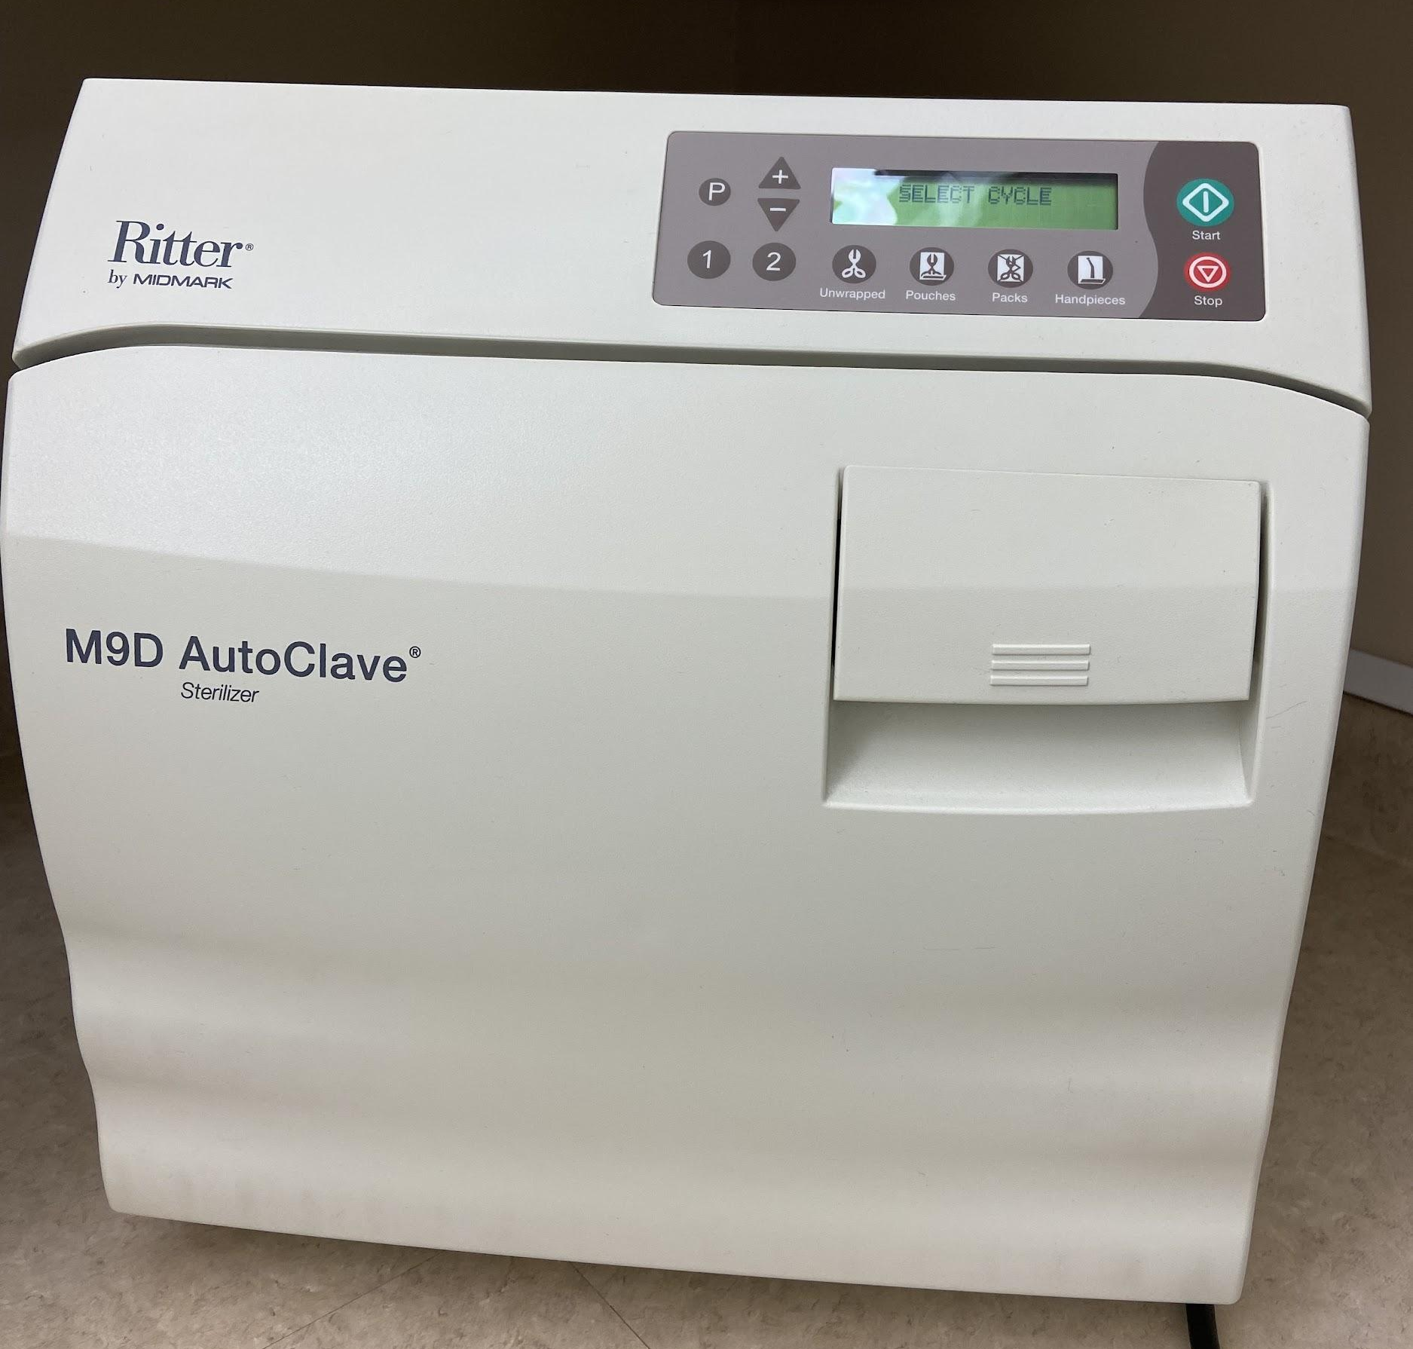
- Autoclaves are used for reprocessing or reusing health care equipment such as dental instruments. An autoclave sterilizes/kills all living organisms by using pressurized steam. There are quality assurance mechanisms used in health care settings to ensure that the autoclave is effective.

- All autoclaves must meet Canadian Standards Association (CSA) criteria for use in Health Care settings.

- Read the autoclave manufacturer’s manual in full before use and follow all directions to avoid injuries such as scalds or burns. Do not use the autoclave until you have received proper instructions.

- Ensure that the distilled water level is maintained (as the autoclave works on steam).

- Wear PPE when using the autoclave (safety glasses/goggles, lab coat, heat resistant gloves - see photos below)

- Check that items to be sterilized are compatible with autoclaving.

- Ensure that the door locks before the autoclave runs a cycle.

- Choose the cycle that is appropriate to that which you are sterilizing.

- Ensure that the autoclave reaches the temperature high enough to kill pathogens and spores.

- Ensure that the cycle is overpressure is zero, and the temperature has dropped before attempting to open the door.

- Set and follow a cleaning and maintenance schedule (office may assist with this).

- 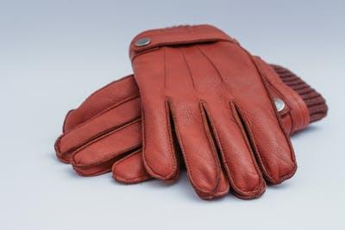

- See also https://www.publichealthontario.ca/en/health-topics/infection-prevention-control/reprocessing

AT ALL TIMES-IF IN DOUBT, STOP!, ASK YOUR INSTRUCTOR

Biohazards and Infection Control
Use Standard Precautions for all patient care activities. When working with people, always be aware of biohazards. Wearing of appropriate protective devices, keeping work areas clean and sanitized, and knowing proper infection control procedures can minimize or reduce risks associated with biological hazards.

- Wear proper Personal Protective Equipment (PPE) as directed at all times (e.g., safety glasses/goggles/face shield, mask, gloves, gown/apron/lab coat, etc.)

- Clean, disinfect or sterilize equipment after each use or prior to storage. If equipment is dropped ensure it is disinfected as required before use. Please note that Cardiopulmonary Resuscitation (CPR) mannequins/manikins are disinfected in phases, with specific chemicals, and for specific time periods.

- Handle sharp objects with extreme care and dispose of in appropriate methods.

- Store all equipment and materials in appropriate location.

- Dispose of biological material in approved containers ONLY.

- Clean any spills and remove any contaminated materials immediately.

- Call attention to any potential contamination or dangerous conditions to your instructor immediately.

AT ALL TIMES-IF IN DOUBT, STOP! ASK YOUR INSTRUCTOR

Chemical Handling
Procedures in health care may involve the use of disinfectants and other chemicals. Ensure you know how to handle these chemicals: their use, as well as storage and disposal procedures.

- Before handling any chemicals, ensure you understand the safe handling procedures as outlined on container labels, WHMIS SDS sheets, designated instructions or posted classroom procedures as appropriate. If you are unsure, see your instructor before proceeding.

- Place or decant any chemicals in approved, labeled containers ONLY.

- DO NOT mix chemicals without prior knowledge of the consequences.

- Discard any used chemicals in approved disposal containers ONLY. Inform your instructor of near-full containers. DO NOT dispose of chemicals down drains. Ask your instructor for proper disposal methods and procedures.

- Ensure that there is adequate ventilation when using chemical substances.

- Do not use any chemical for any other purpose other than what it is designed for.

- Use appropriate PPE (personal protective equipment) at all times when handling chemicals. PPE includes eye protection (safety glasses, goggles, or face shields), skin protection (e.g. gloves, gowns, aprons, lab coats), foot protection (firmly-soled shoes with closed toe and heel), and respiratory protection (e.g. mask or respirator) as required under safe operating procedures.

- Take note of expiry dates and storage requirements of chemicals. Do not use chemicals beyond their expiration.

AT ALL TIMES-IF IN DOUBT, STOP! ASK YOUR INSTRUCTOR

Electrical Hazards
Touching an exposed electrical wire or electrical equipment that has not been grounded properly causes shocks. Shock can vary from a slight tingle to a rocking jolt. A very severe shock can cause death. Do not touch equipment or electrical wires that have been exposed to fluids.

Protect yourself against shocks by following these rules:

- Check the condition of electrical cords on equipment. Report all problems to your instructor immediately. Replace worn or damaged cords.

- When disconnecting a cord, pull on the plug. Never pull on the cord. You may loosen the wires and get a shock.

- Never handle electrical equipment with wet hands or while standing in water.

- Wear rubber-soled shoes to prevent shocks. Rubber does not conduct electricity.

- Be sure an appliance is turned off before plugging it into an outlet.

- Make sure you use proper power supplies and cables designated for use with specific pieces of equipment.

- Store all electrical equipment in areas designated by your instructor.

- Never change or interfere with the operating environment set up by someone else without permission.

AT ALL TIMES-IF IN DOUBT, STOP!, ASK YOUR INSTRUCTOR

Ergonomics 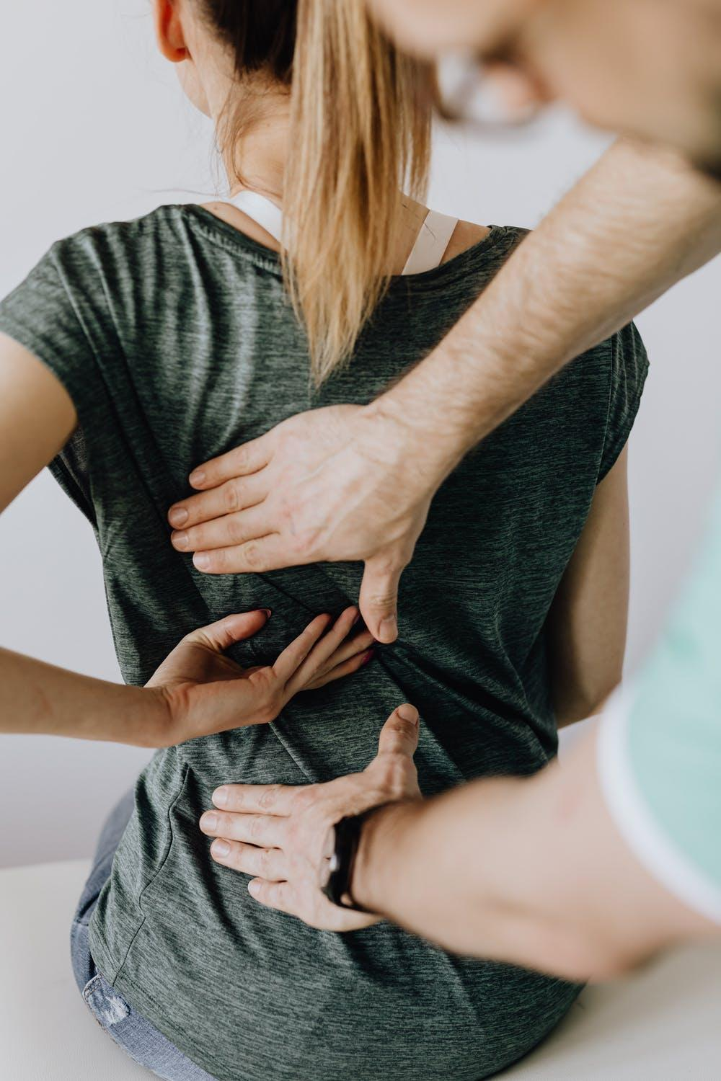
A strain is a feeling of stiffness or soreness from using muscles too long or the wrong way. Strains usually occur in the lower back, the weakest point of the spinal column. In the health care industry, lifting heavy loads (patients or equipment) incorrectly often causes strains. Once your back has been strained or weakened, it can easily be injured again. A good knowledge of safe body mechanics can help health care providers to avoid overuse injuries to the lower back and other susceptible areas of the body.

- In the Province of Ontario, unassisted manual lifting is limited to 23 kg (51 pounds). Do not lift any load if it cannot be handled safely due to its size/shape.

- You can prevent back strain by lifting with your strong arm and leg muscles. When you must lift a heavy object, squat with knees bent, feet hip width apart, and back straight. With your arms straight, get a firm grip on the load. Stand up keeping your back straight. Make your leg muscles do the work. Do not twist or bend. Set objects down by using the same method outlined above but in the reverse. Ask for help if the object is too heavy. Use a cart to carry heavy objects any distance.

- When doing "patient" care, work with a partner as much as possible.

- Ensure you have a good understanding of and practice the safe transfer of a "patient". Patients should be assessed regularly for their ability to participate in transfers. If a patient’s status changes and you are in doubt of their ability to transfer safely, use a mechanical/electrical patient care lift.

- When giving care using the bed, ensure that the bed is at waist height and the wheels are locked/brakes are on.

- Heavy articles should be stored on the bottom shelves. Do not lift anything above shoulder height.

AT ALL TIMES-IF IN DOUBT, STOP! ASK YOUR INSTRUCTOR

Facility Emergency Procedures

- Ensure you know the location of all nearby fire alarms and emergency exits.

- EMERGENCY PROCEDURES AND EVACUATION ROUTES must be clear at all times, and occupants must know and understand these procedures and routes.

Location of Emergency Exits and Fire Alarms:

Locations of Emergency Stops:

AT ALL TIMES-IF IN DOUBT, STOP! ASK YOUR INSTRUCTOR

Fall Protection

Studies of accidents in the service industry show that most injuries are caused by falls. Observing a few simple rules will help to avoid most accidents of this type.

The points below give guidelines for preventing falls.

- Walk in the classroom; do not run.

- Keep floor clean and dry. Ensure that hand washing practice at sinks does not leave water spills. Wipe up any spills immediately and warn others of slippery conditions. Even if you did not make the spill, clean it up. Advise instructor of spill.

- Use proper, supportive footwear while in the lab (firmly-soled with closed toe and heel).

- Keep work areas and high traffic areas clear. Electrical cords should not extend across traffic lanes. Maintain a clutter-free work area.

- Use a stepladder, never a chair or table, if you need to reach something on a high shelf.

AT ALL TIMES-IF IN DOUBT, STOP! ASK YOUR INSTRUCTOR

Fire Extinguishers 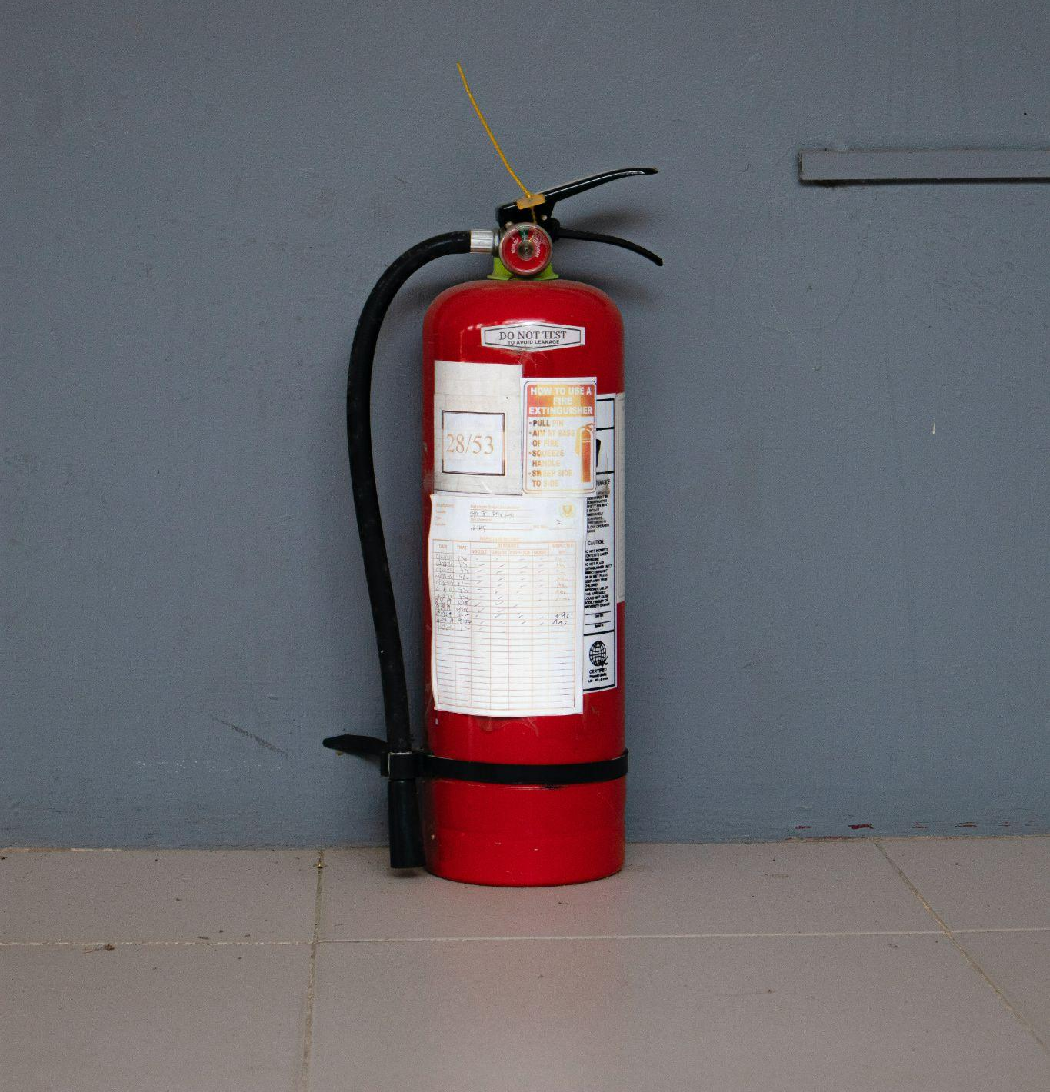

Know your Fire Safety Exit and Plan
If you see a fire, call for attention, get everyone out, pull fire alarm to activate emergency services.
Stay calm.
If using a fire extinguisher:
- PULL THE PIN, AIM LOW AT BASE OF FIRE
- SQUEEZE HANDLE, SWEEP SLOWLY AT BASE OF FIRE
- STAY LOW TO AVOID HEAT AND SMOKE
- Have the fire department check to make sure the fire is out.
- Ventilate room when fire is completely out.
Learn and know the types of fire extinguishers (see below):
CLASS A  water |  | Ordinary Combustibles: paper, cloth, wood, rubber, many plastics.
CLASS B  CO2 |  | Flammable Liquids:  oil, grease, gasoline, some paints, solvents etc.
CLASS C  dry chemical |  | Electrical:  wiring, fuse boxes, electrical equipment etc.
CLASS D  special liquid or powder |  | Combustible Metals: magnesium, sodium.

AT ALL TIMES-IF IN DOUBT, STOP! ASK YOUR INSTRUCTOR

First Aid 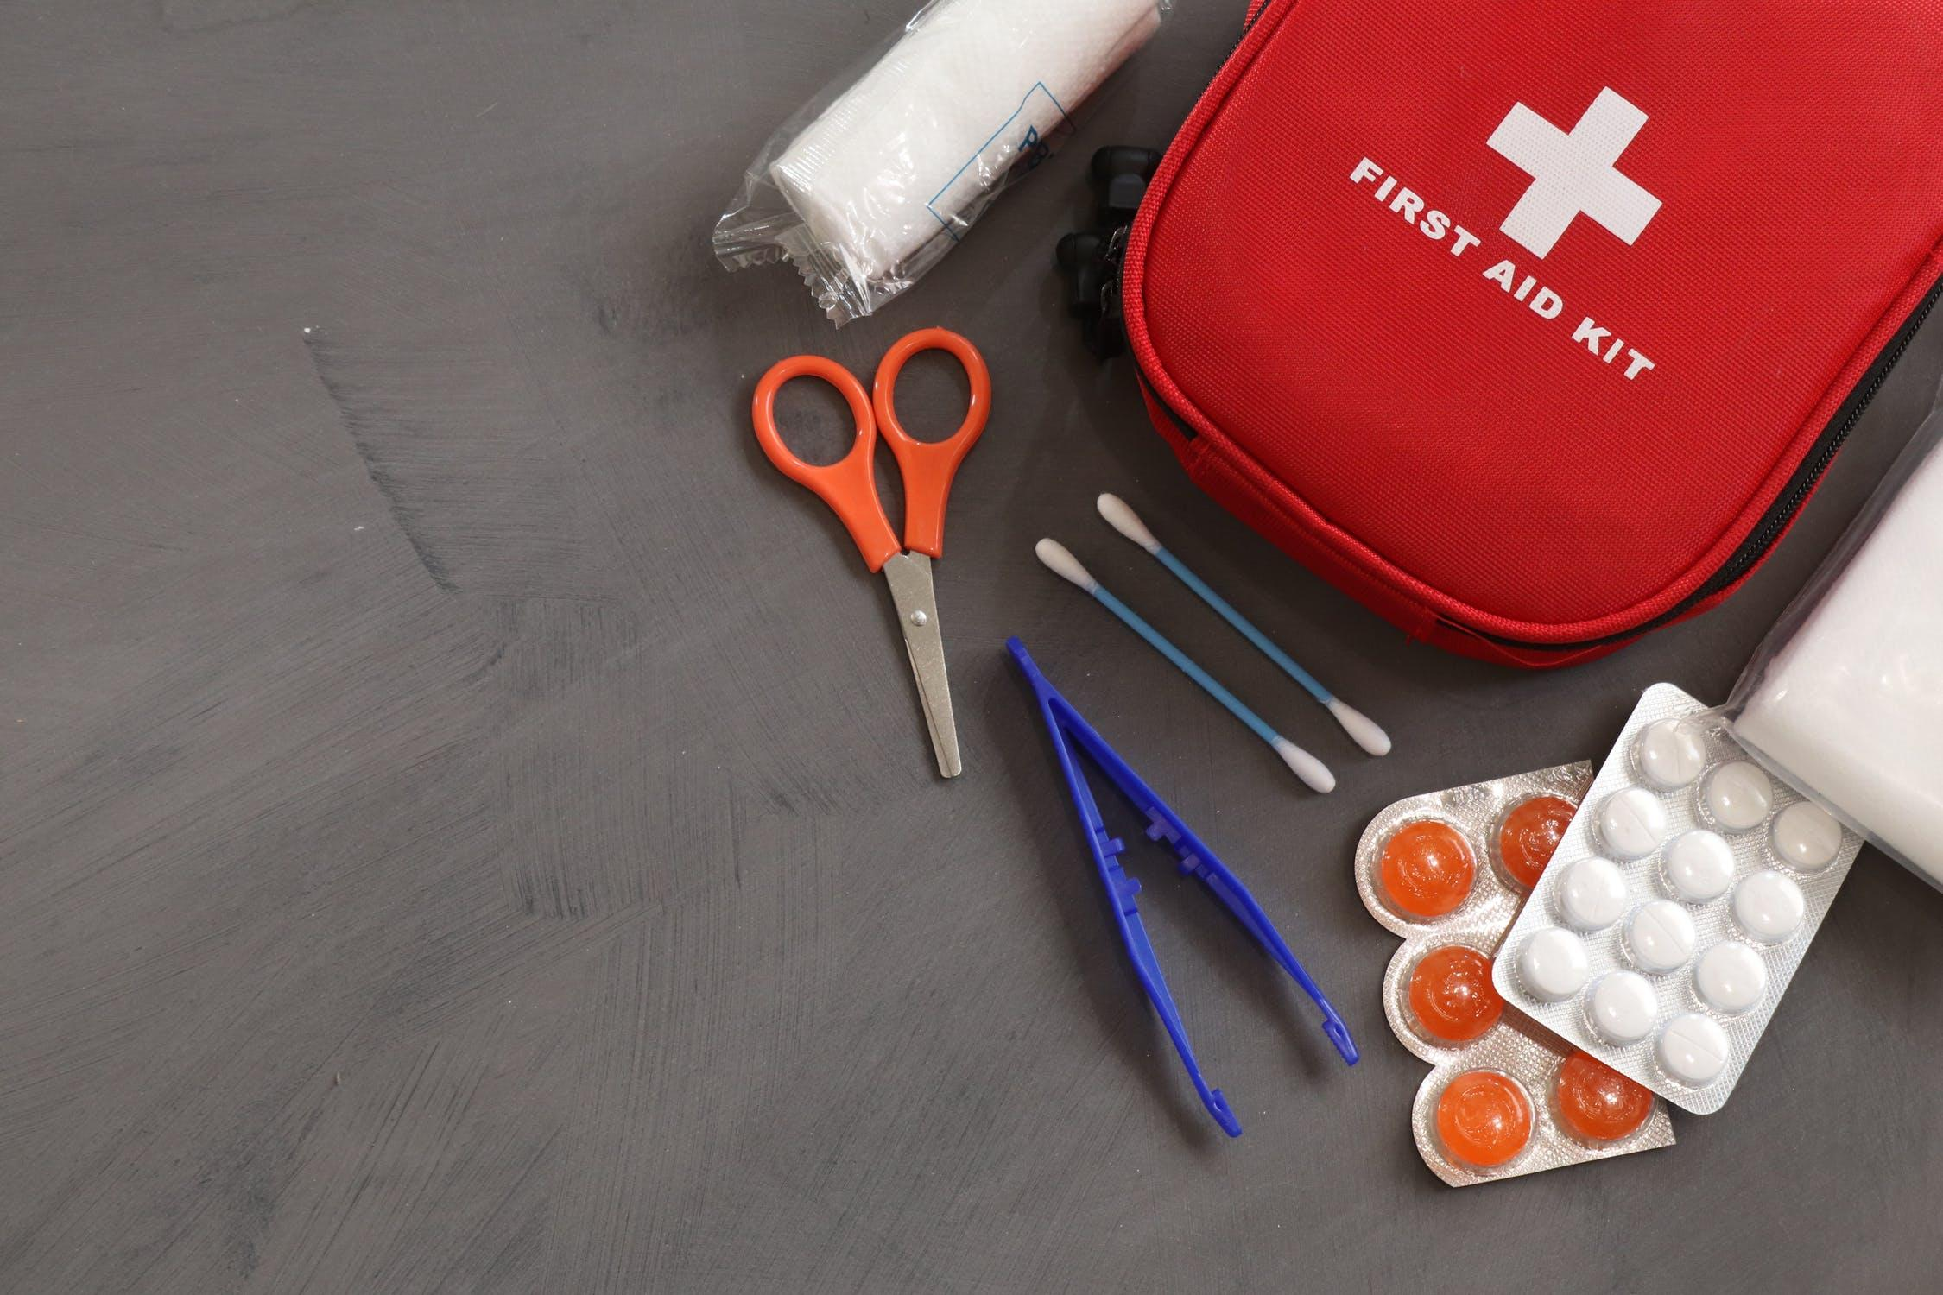
The immediate response to an emergency often involves First Aid. First Aid involves assisting an injured person until professional medical help can be provided. The general action tips in the list below should be followed in an emergency. They do not replace the need to be properly trained in first aid. Your teacher will provide you with instructions regarding what to do in cases of emergencies.

- Remain calm and assess the area for dangers, (e.g. electrical shock hazards, chemical spills, hot objects, fire). Call out for help. Do not touch or move the victim until instructed to by a certified medical professional or if the victim is in immediate danger such as electrical or fire emergency.

- Assist if asked by your teacher to keep the victim comfortable and calm.

- Call the office and/or 911 for medical help as directed by the teacher.

- If you are certified in First Aid, care for the victim by administering first aid or care for the victim according to your teacher’s or administrator's instructions until First Responders or trained and certified First Aid team members arrive.

- Help keep people who are not needed away from the victim.

- Reassure and keep the victim calm. Have the victim lay down in a secure area and keep warm with a blanket to treat for shock.

- Follow emergency procedures as outlined in your board's emergency manual.

- Must have a first aid team trained/certified CPR Level C with AED/Standard First Aid with renewal every 3 years.

AT ALL TIMES-IF IN DOUBT, STOP! ASK YOUR INSTRUCTOR

First Aid Kits 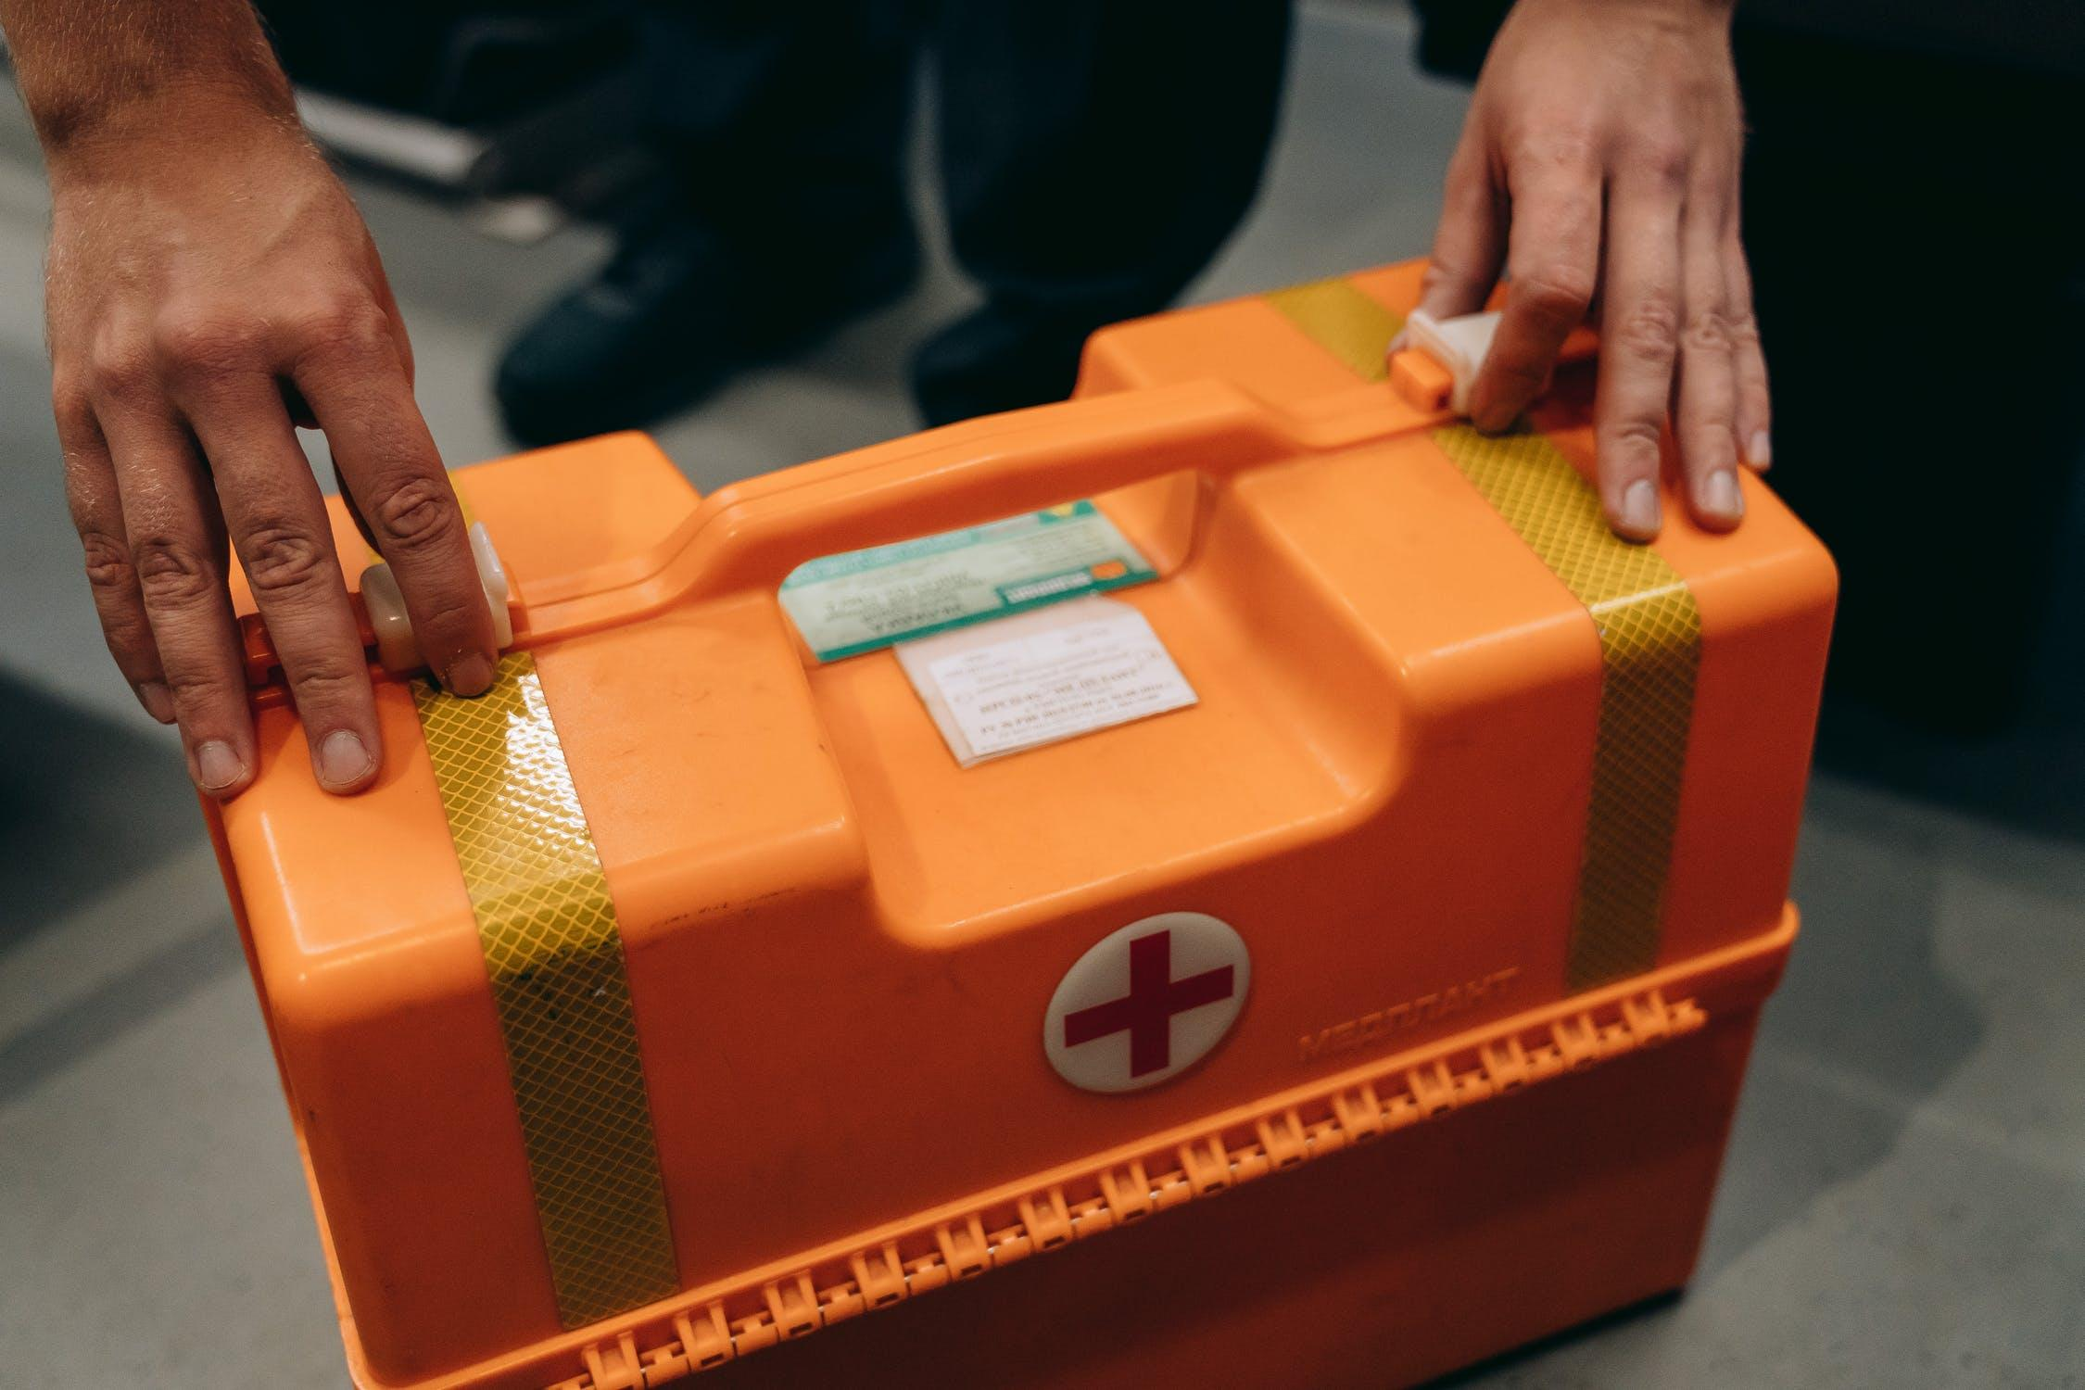
ALL INJURIES MUST BE REPORTED TO MAIN OFFICE
REPORT ANY USE OF FIRST AID KIT TO TEACHER TO ENSURE THAT ANY SUPPLIES THAT ARE USED ARE REPLACED

Suggested list (add items specific to your needs) See WSIB Regulation 1101, Required first aid kit items https://www.wsib.ca/sites/default/files/documents/2019-01/faeng.pdf

DATE CHECKED:

CHECKED BY:
ITEM | Number
First Aid Manual | 1
Mask | 12
Disposable non-latex gloves various sizes | 1 box
Pair of scissors | 1
3"x3" sterile gauze pads | 12
Adhesive dressing individually wrapped | 48
Assorted splints | 2 rolls
Splint padding | 2
Sterile pressure bandages individually | 4
Triangular bandages | 12
Preferred metal basin | 1
Safety Pins | 24
Sterile gauze bandages 2” | 8
Sterile gauze field dressing | 6
Sterile gauze 4” | 8
1 ½" width roll adhesive tape | 1
Antiseptic swabs | 24

AT ALL TIMES-IF IN DOUBT, STOP! ASK YOUR INSTRUCTOR

General Housekeeping
- The health care lab should be set up so that chalkboards/white boards, screens and all equipment are accessible by all individuals.

- Everything has a proper storage location. If you don’t know where it is, please ask. If you do know, put it back.

- If it is broken, report it. If it doesn’t work, report it. If it is broken or doesn’t work, don’t use it.

- Dirt, dust, debris are harmful to your safety and health. Even if you didn’t put it there, pick it up, clean it up, or move it aside.

- If you spill or drop any water or fluid on the floor, clean it, or use absorbent materials. If you find a spill, wipe it up. You are responsible for prevention of injuries.

- Never block fire exits, fire pull alarms, doorways, aisles, and electrical breakers of machine switches for any reason at any time.

- Chemicals all have proper storage containers. Chemicals are to be stored on metal lipped trays inside a locked cabinet. Never mix chemicals.

AT ALL TIMES-IF IN DOUBT, STOP! ASK YOUR INSTRUCTOR

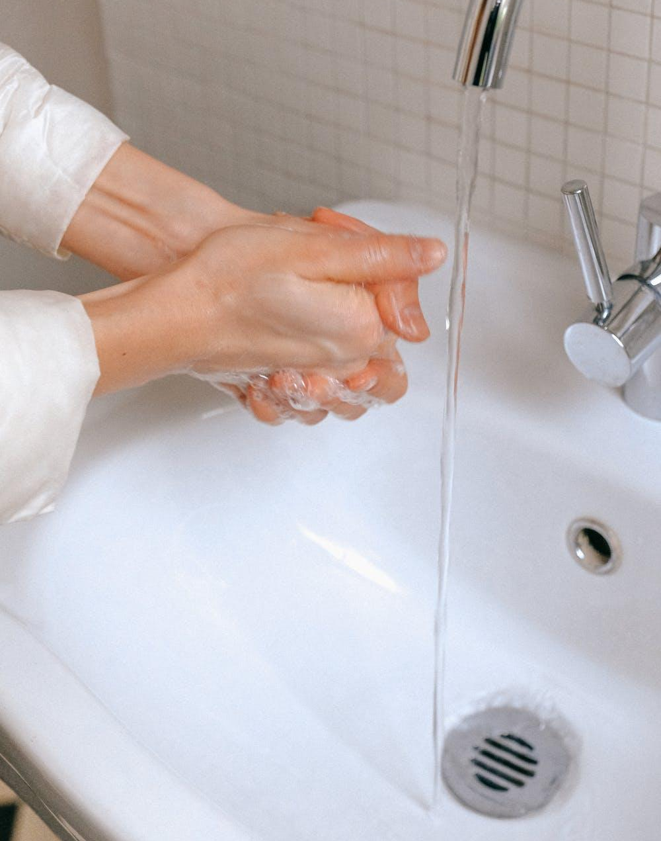 Hand Hygiene 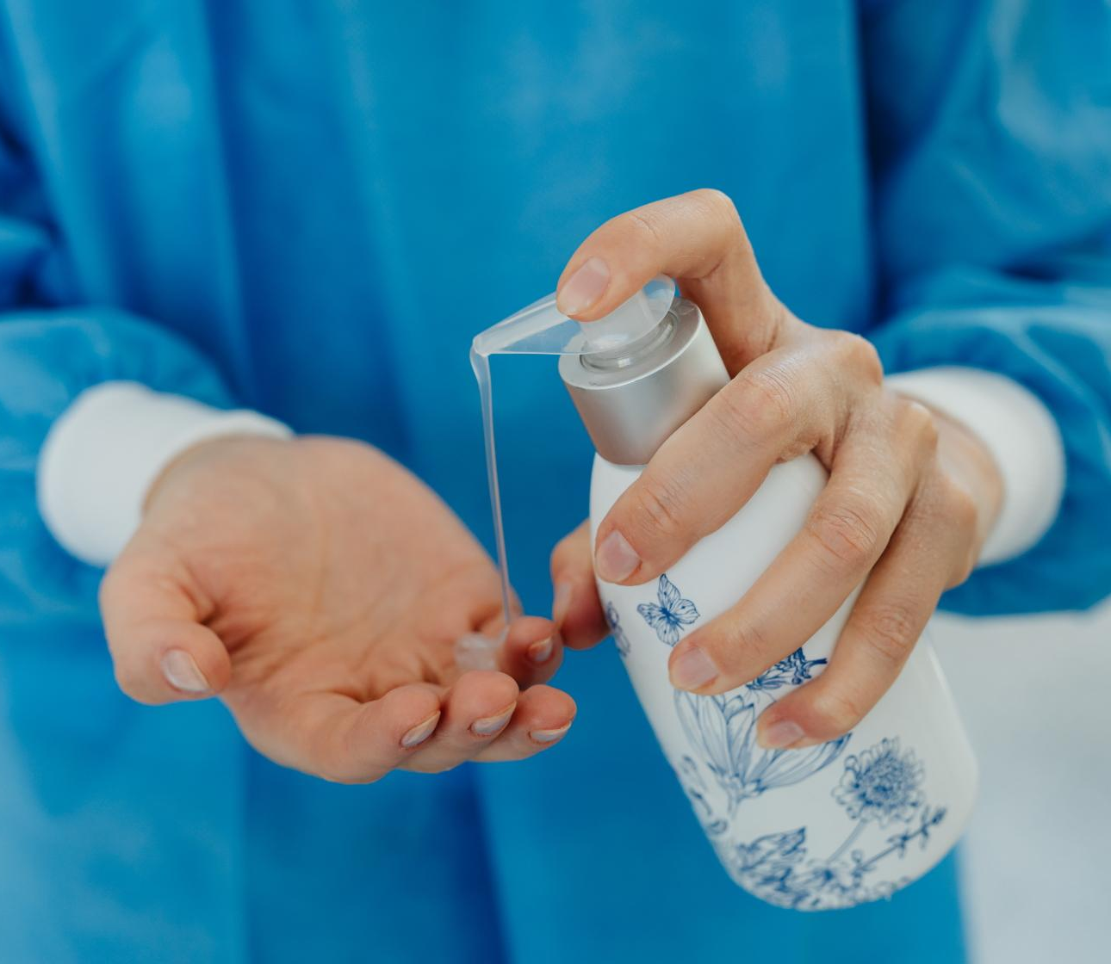

Effective hand hygiene is extremely important part of infection control. Hand hygiene prevents the transmission of dangerous microorganisms in both the health care and food service industries.

HAND WASHING
- Prepare garbage pail, paper towel and soap
- Stand away from sink
- Turn on and adjust water temperature
- Wet hands with hands pointed downwards
- Apply adequate amount of hand soap
- Rub palms together and interlace fingers
- Wash backs of hands
- Wash each thumb clasped in opposite palm
- Rub fingertips on of each hand on opposite palm
- Wash each wrist by clasping
- Rinse one hand at a time, hands pointed down
- Dry hands from fingertips to elbow
- Turn faucet off with paper towel
- Discard paper towel

HAND SANITIZER with at least 60% alcohol
- Apply 1 to 2 pumps of product to palms of dry hands.
- Rub hands together, palm to palm.
- Rub in between and around fingers
- Rub back of each hand with palm of other hand
- Rub fingertips of each hand in opposite palm
- Rub each thumb clasped in opposite palm
- Rub hands until product is dry

Always wash your hands:
- If they are visibly dirty or have a build-up of hand sanitizer.
- Before starting work.
- After any work breaks, including those to eat, smoke, drink or chew gum.
- Before and after handling raw foods such as meat, fish or poultry.
- After touching your face, hair or body.
- After sneezing, coughing or using a tissue.
- After using the restroom.
- After using any cleaning or sanitizing product.
- After taking out the garbage.
- After cleaning dirty dishes and tables.
- After touching anything else that could contaminate food, such as a phone, money, door handles or soiled tablecloths.

AT ALL TIMES-IF IN DOUBT, STOP! ASK YOUR INSTRUCTOR

Health Care Equipment
Health care equipment is used to assist or care for patients. It is important to understand the proper use and how to determine if the equipment is effectively assisting the patient. When working with equipment, students must recognize that equipment used for multiple patients is a source for cross-contamination of pathogens (health care acquired infections). It is important to follow the recommended manufacturer’s instructions prior to operating any equipment. The operation and the practice of using equipment enables students to improve practical skills and become aware of equipment use legislated by the Ministry of Health and Long-Term Care. Individual teachers are encouraged to add guidelines specific to their equipment in their classroom.

Health Care Equipment may include any of the following items (that do not have their own, individual SAFEdoc) such as:
pulse oximeter
thermometers (various types)
stethoscope
sphygmomanometer (BP cuff)
electronic blood pressure monitor
scale
automated external defibrillator
walkers
crutches
canes
transfer/gait belts
transfer/slider boards
patient care or CPR mannequins/
manikins

Protect yourself against injury by following these rules:

- Equipment should be assessed by the teacher daily to ensure proper maintenance (e.g., check brakes/casters on walkers, beds and wheelchairs, check wooden transfer/slider boards for smoothness, and not splinters).

- Ensure all electrical equipment is safely stored and charged for use. Electrical equipment requires a secure or locking charging dock to ensure battery recharging.

- Equipment must be cleaned as per industry standards with disinfecting cleansers after each “patient” use.

- Always practice hand hygiene prior to and after use of health care equipment.

- An in-class practical evaluation is required prior to the use of any equipment.

- Any sharps equipment must be disposed of in an industry standard biohazardous waste sharps container.

- Use proper footwear while in the lab. Shoes must provide support (closed back and toe) and be firmly-soled.

- Store equipment properly in cabinets at accessible heights to prevent falls.

- Ensure that tall equipment and manipulatives such as IV poles, scales and skeletons are stable and balanced.

- Ensure that all participants are aware of angular equipment such as scales and patient care mannequins/manikins joints so they are are not hazards.

- Ensure that latex-free equipment (e.g. blood pressure cuffs) are provided for patients who have latex allergies or sensitivities)

- Notify teacher and Occupational Health and Safety of injury resulting from the use of equipment.

- Notify appropriate department or supervisor of any malfunctioning equipment. Follow school lock-out tag-out protocol.

AT ALL TIMES-IF IN DOUBT, STOP! ASK YOUR INSTRUCTOR

Hospital Beds 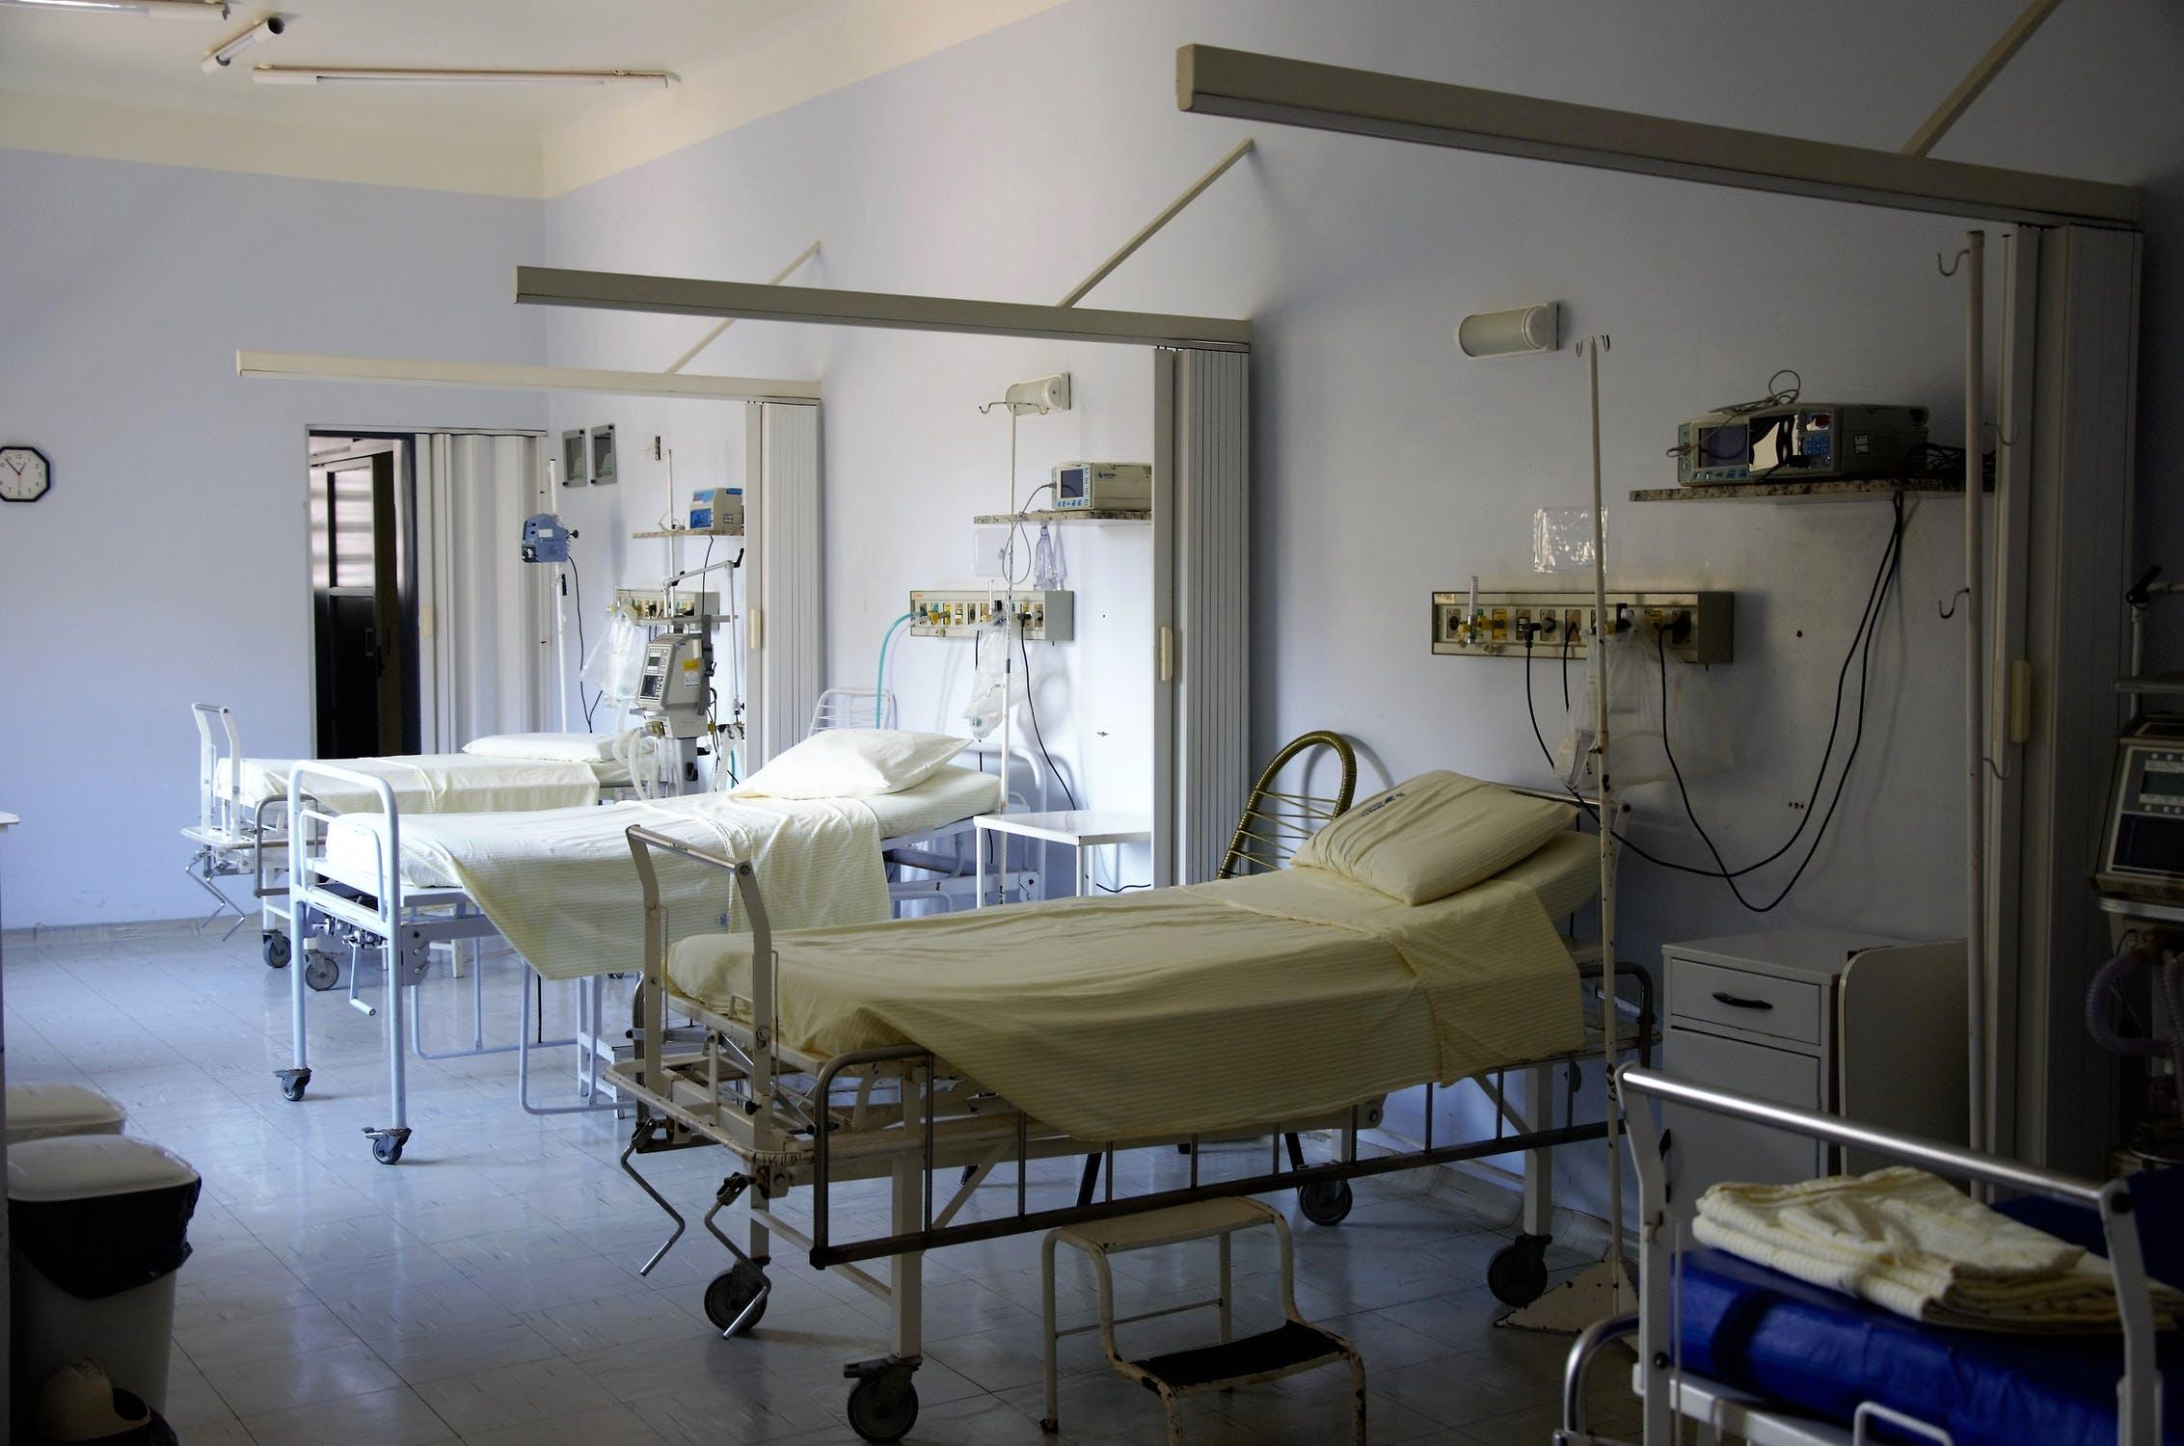
Using hospital beds in the classroom plays a vital role in practicing health care skills taught. The use of hospital beds and providing "patient" care requires care of the electrical component, if present, and safe body mechanics/ergonomics. Students should maintain care of themselves and their classmates when delivering "care" in the simulated classroom environment.

Protect yourself against injury by following these rules:

- FOR ELECTRICAL BEDS: Ensure that the bed is plugged in prior to use. Check the condition of electrical cords of the bed. Report any frayed or damaged cords to your instructor immediately. Unplug the bed when finished.

- Do not use the bed until you have received proper instructions.

- Ensure all long hair is secured away from the face with an elastic. This applies to both the "patient" and the "health care workers".

- The bed should always start/finish in the lowest horizontal position when the "patient" comes in and out of the bed. When performing care, the height of the bed should be at the health care providers' waist level to prevent back strain.

- When a "patient" is in the bed, the bedrails are to be up. Bed rails are meant to be protective so patients do not fall out of bed but note that that bed rails can also be a hazard in that patient body parts can become pinned between and below them.

- All personal items, such as shoes, purses, backpacks are to be placed away from the bed to reduce tripping hazards.

- If there are situations you are not comfortable practicing, please inform your instructor immediately.

- FOR MECHANICAL BEDS: Ensure that the crank handle is tucked back under the bed so it is not a tripping hazard.

AT ALL TIMES-IF IN DOUBT, STOP! ASK YOUR INSTRUCTOR

Mechanical/Electrical Patient Care Lift

(Full and Sit-to-Stand)

To avoid health care staff injury, mechanical or electrical lifts are used to lift patients who are unable to transfer themselves. If a patient is too weak to transfer, Students should maintain care of themselves and their classmates when delivering "care" in the simulated classroom environment.

Full Lift:
- device differs from a sit-to-stand mechanical/electrical patient lift
- device is a full lift for non-weight bearing patients and uses a sling similar to that of a ceiling lift
- 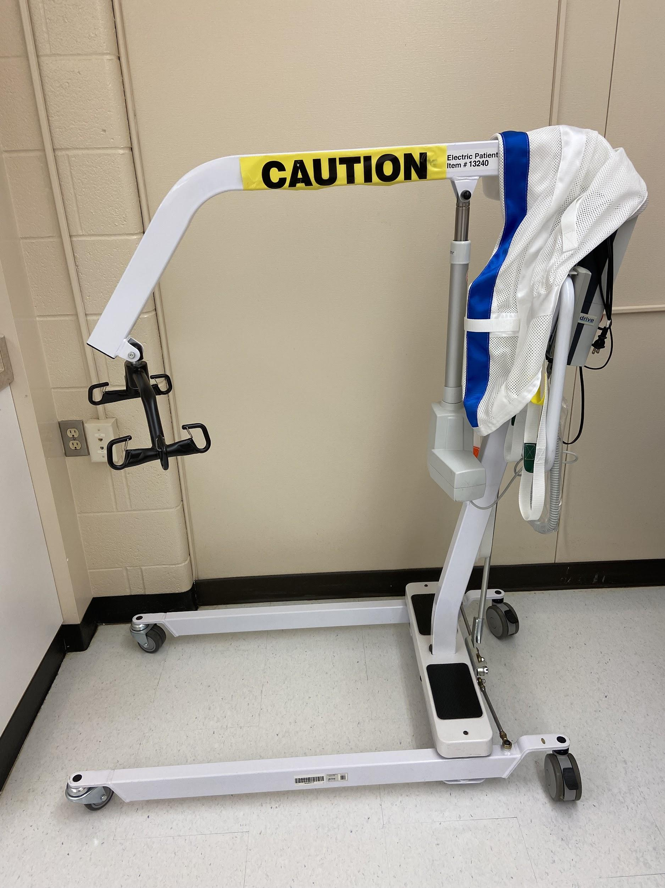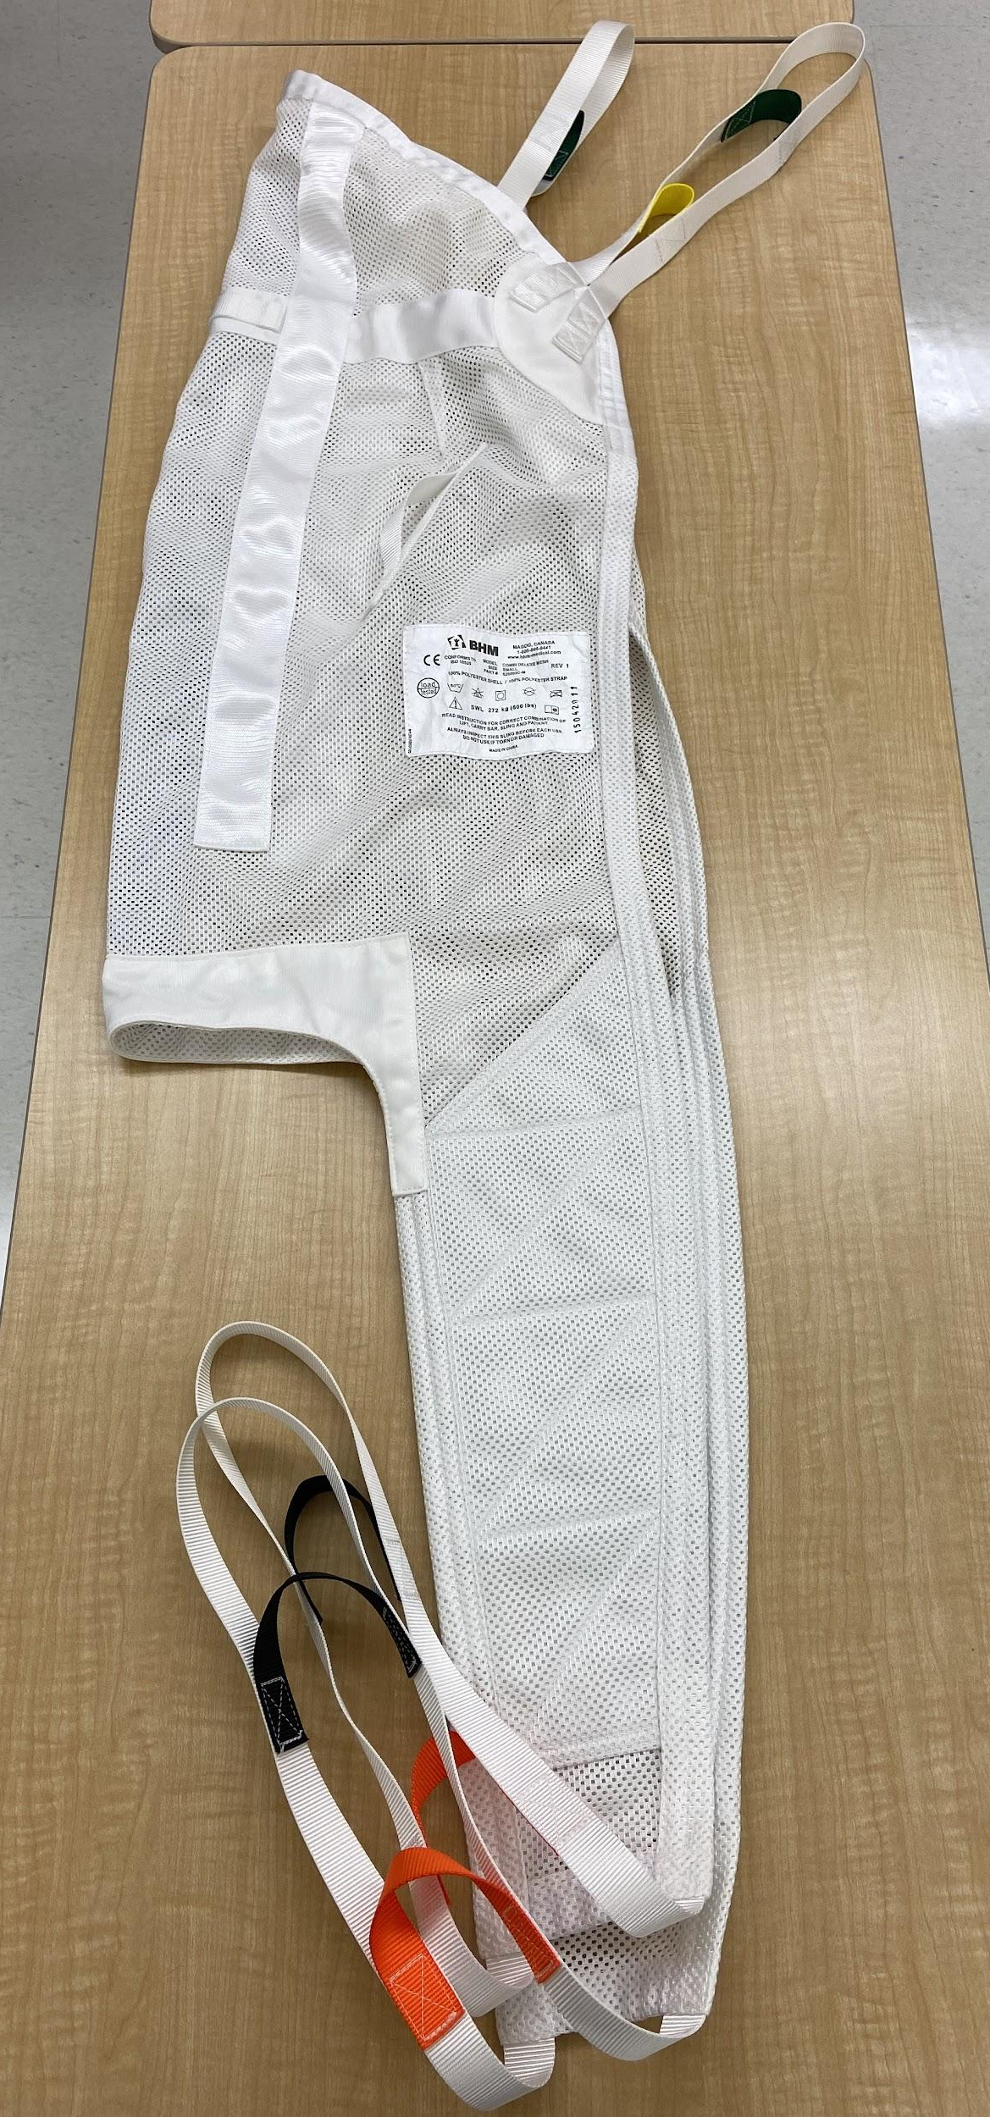

Sit-to-Stand Lift:
- device differs from a mechanical/electrical patient lift (full)
- device is for at least partial-weight bearing patients
- pulls patient from a sitting position to a standing position
- 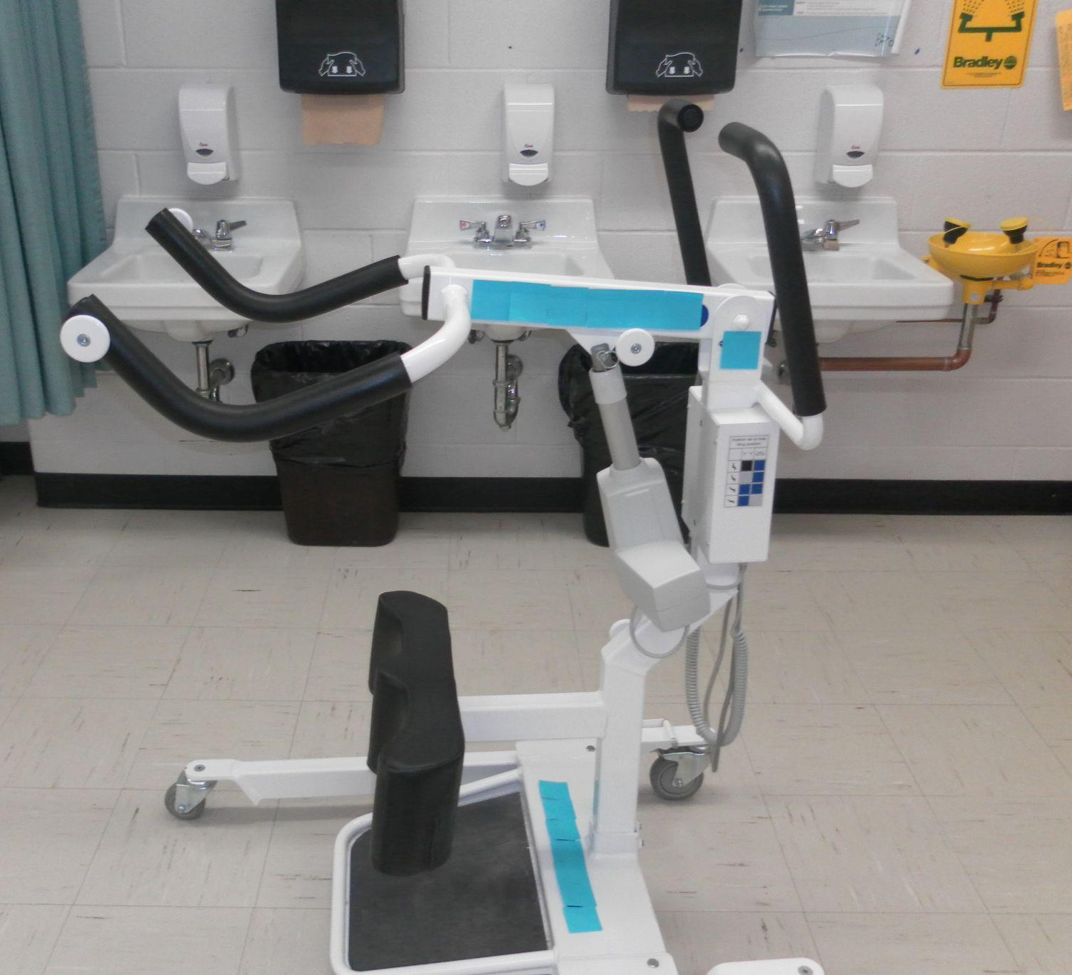

For Both Types of Lifts:

- Read the lift manufacturer’s manual in full before use and follow all directions to avoid injuries. Do not use the lift until you have received proper instructions.

- Ensure lifts are routinely maintained according to manufacturers’ specifications. Follow a maintenance schedule (the office may assist with this)]

- All users of the lift should be able to name and describe the function of all lift parts. This is to prevent injury (e.g., the full lift moving boom can hit and injure patients and health care staff)

- Follow the step-by-step use checklist included with the device. This includes when to use brakes/casters and when to separate lift base legs for maximum stability.

- Assess transfer slings prior to each use to ensure that they are safe to use (e.g. loops and buckles are intact, there is no fraying).

- Follow “patient” height and weight guidelines on lift and slings to avoid injury.

- The “patient” must remain stationary while in the lift.

- In the event that the battery should not work, the Emergency quick release feature should be used to lower the boom of the lift.

- Two people should operate the lift together at all times with one person using the controls and the other person acting at the patient spotter. The lift must be used in the presence of the instructor.

- If there are situations you are not comfortable practicing, please inform your instructor immediately.

See also:
https://www.fda.gov/files/medical%20devices/published/Patient-Lifts-Safety-Guide.pdf

AT ALL TIMES-IF IN DOUBT, STOP! ASK YOUR INSTRUCTOR

Personal Hygiene 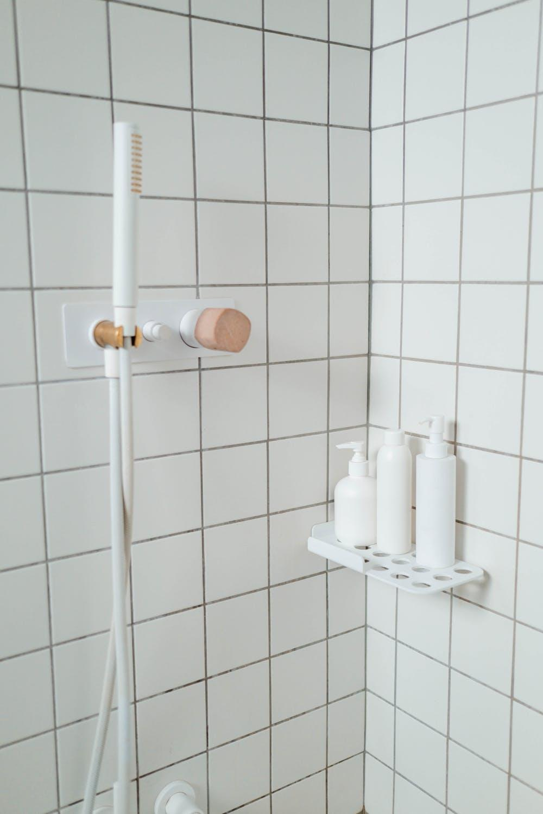
Health care workers have direct contact with patients and other health care providers and as a result are often the cause of contamination and the transmission of pathogens. The hand hygiene procedures listed above can assist greatly in stopping the spread of infection. These occurrences can also be reduced if the health care worker practices good grooming habits. Good grooming also helps put the “patient” at ease.

The following points outline some of the things the health care worker can do to maintain good hygiene.

- Bathe daily and wash hair regularly.
- Brush teeth and use breath fresheners as appropriate.
- Fingernails should be clean, trimmed neatly, and relatively short.
- Always wear clean clothes to work.
- Shoes should be appropriate to the workplace: closed toe and heel with firmly-soled non-slip soles.
- Always tie back long hair with an elastic.
- Always wear a clean uniform/gown/apron/lab coat.
- Always wear gloves when serving food items or when in contact or potential contact with bodily fluids.
- Never reuse gloves. This means caring for only one patient, then changing gloves. This also applies to not reusing gloves that have touched raw food.
- Never use soiled or ripped gloves.
- Do not work with food or serve meal trays if you are ill.
- Keep cuts completely covered.

AT ALL TIMES-IF IN DOUBT, STOP! ASK YOUR INSTRUCTOR

Personal Protective Equipment

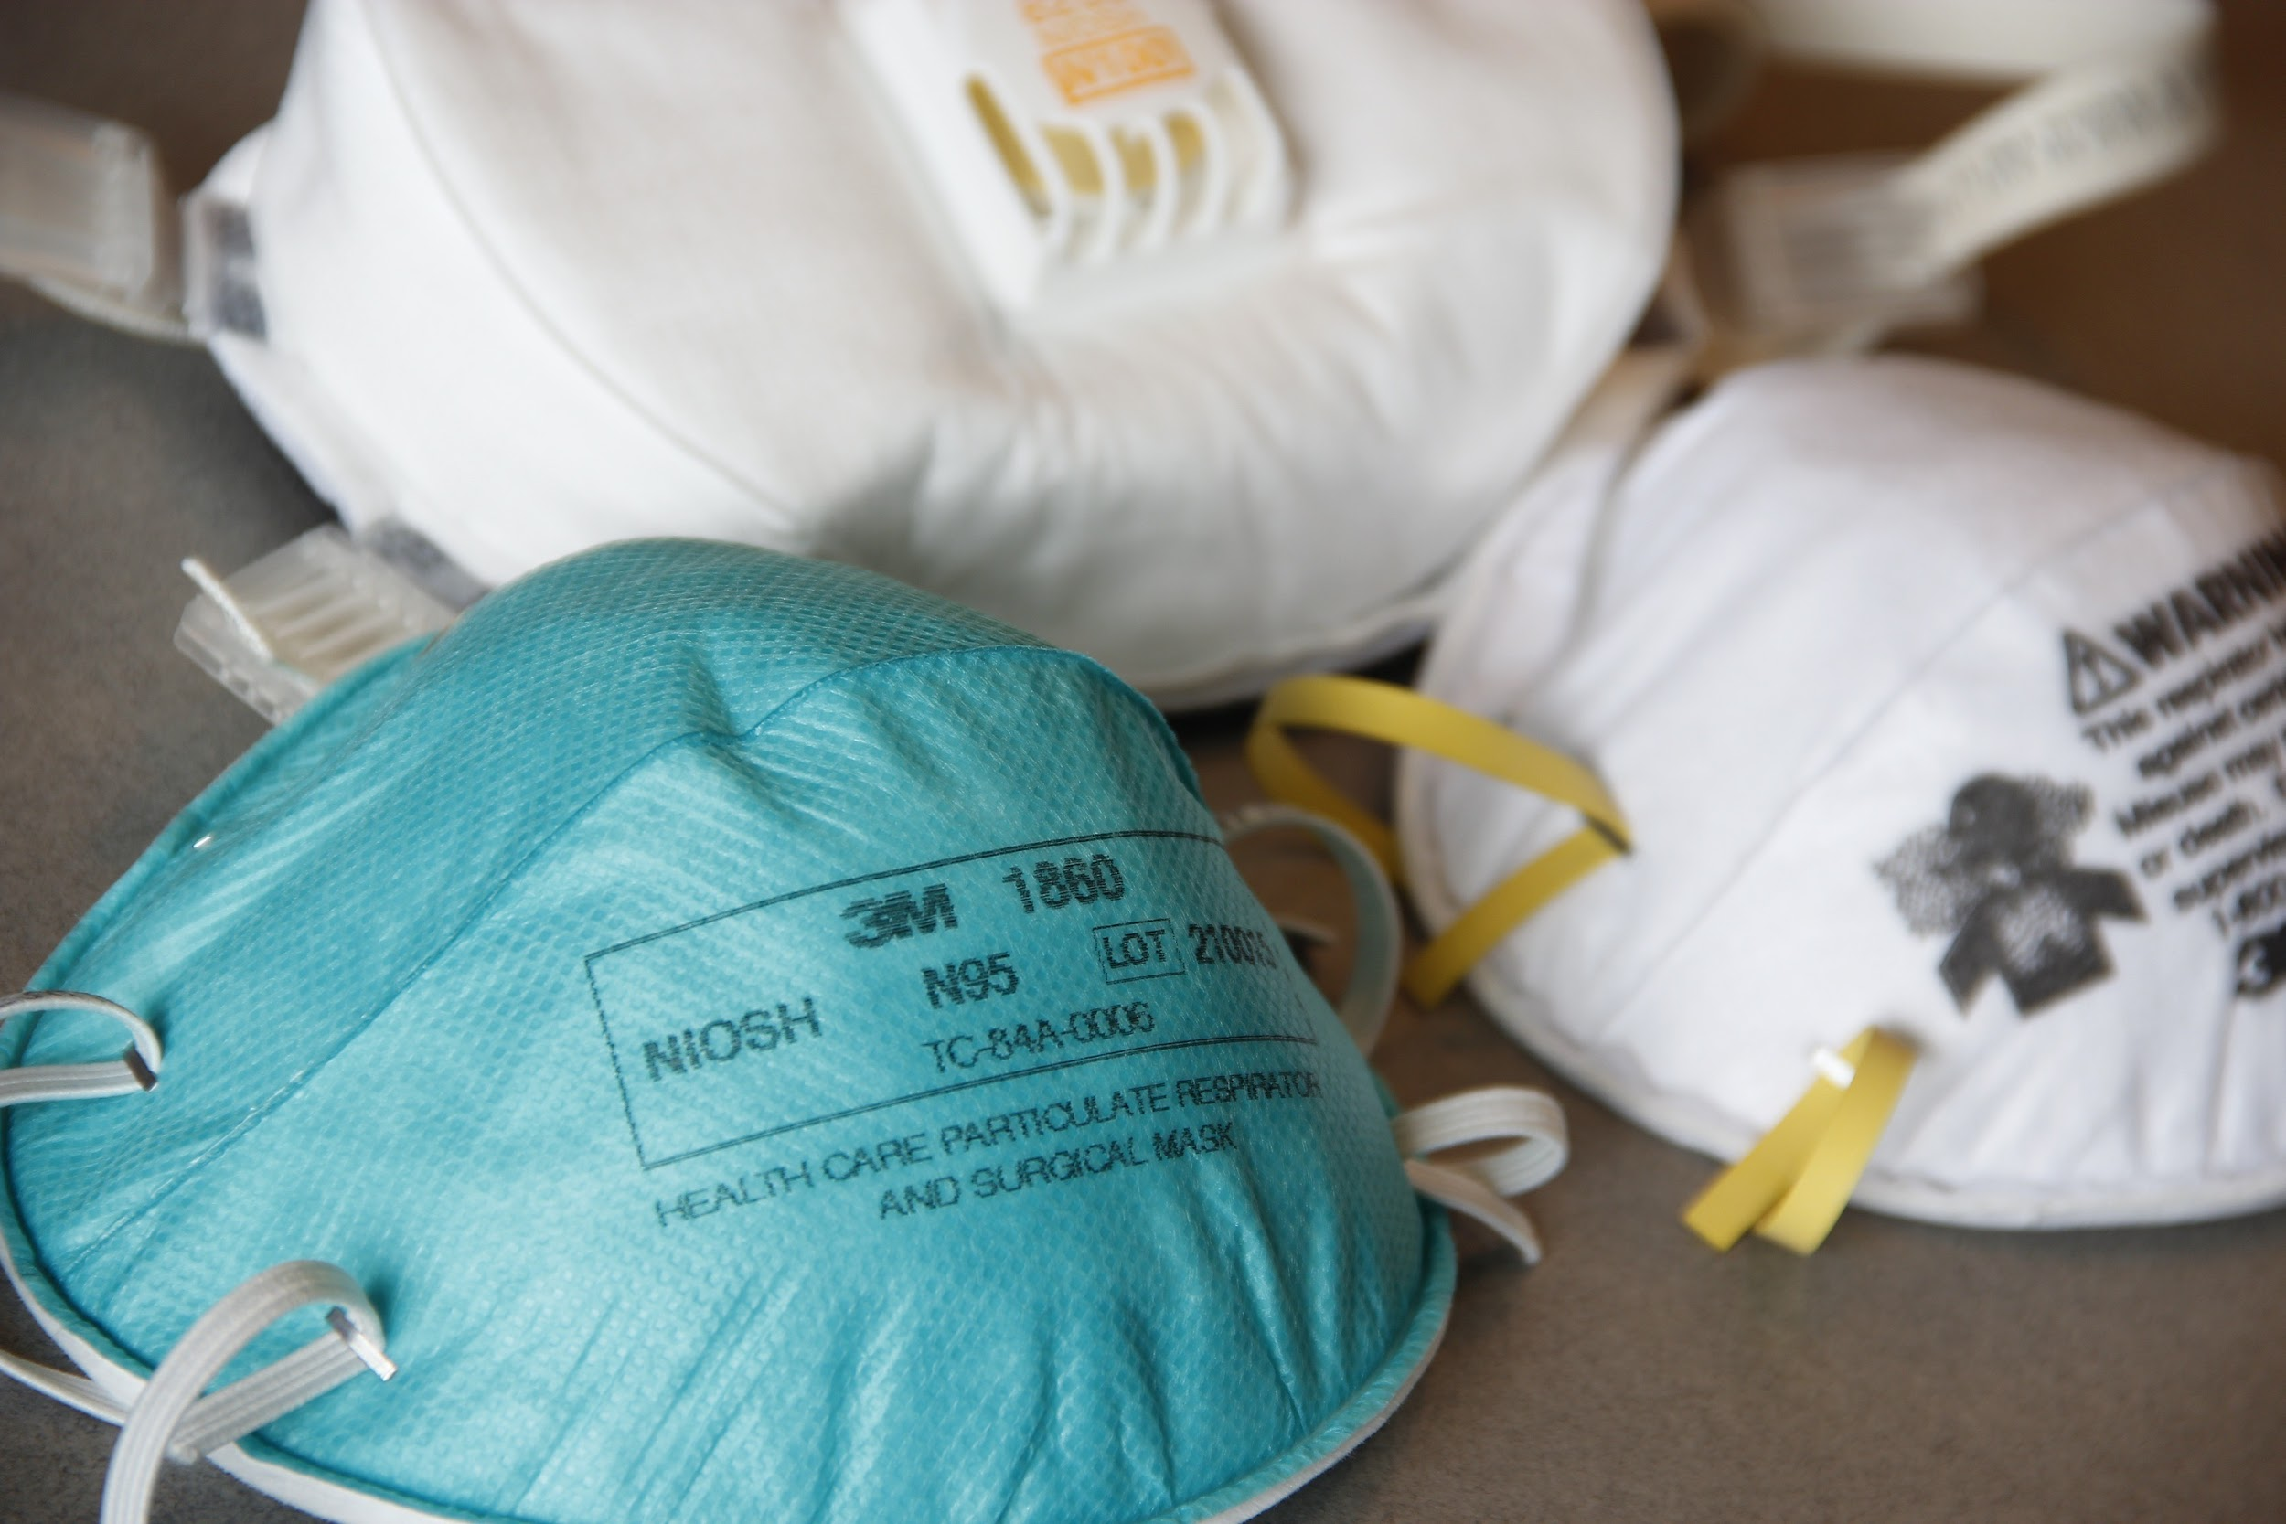
Personal Protective Equipment is a key part of Infection Control and Standard Precautions. In health care, there is always risk of contamination (e.g. with bodily fluids) and self-injury due to the working environment. Use of personal protective equipment (PPE) should become an integral part of day-to-day practice, and students should never hesitate to use them when practicing skills. All students must learn how to safely apply and remove PPE in order to adhere to the strict principles of practice in the industry. Protect yourself against injury and infection by following these rules:

- Ensure you are aware of where the PPE equipment is in the room and how it is stored. Determine the appropriate size of equipment, such as gloves, required. In health care settings, qualitative mask fit testing occurs every two years to ensure that N95 masks and respirators fit appropriately.

- Ensure that you have a thorough knowledge and understanding of the need for specific PPE in specific situations. (Contact, Droplet, or Airborne Precautions)

- Ensure proper procedures and order for applying/donning and removing/doffing PPE (non-latex gloves, gown, mask, and safety glasses/goggles or face shield) and the appropriate equipment required for the various health care situations.

- Practice hand hygiene and dry thoroughly prior to using, during and after removing personal protective equipment. Use skin moisturizers if needed to ensure intact skin on the hands.

- Dispose of PPE in the appropriate receptacles. If the gloves have biohazardous material on them (e.g. after dissection), dispose in appropriate garbage. If leaving the room, dispose of equipment, then reapply PPE if returning to practice skill.

- Wear firmly-soled shoes with closed toe and heel.

See also: https://www.publichealthontario.ca/-/media/documents/ncov/ipac/ppe-recommended-steps

AT ALL TIMES-IF IN DOUBT, STOP! ASK YOUR INSTRUCTOR

Practice Labs
The use of practical labs allows students to practice and apply theoretical skills in a controlled practical setting. An understanding of how to safely use, store and clean equipment is of vital importance in health care classrooms and settings. Students must have completed the in-class theory components and have a thorough understanding of equipment prior to entering the lab area. The student must follow the manufacturer’s instructions and understand the possible risks when using equipment. Individual teachers are encouraged to add guidelines specific to their classroom.

Protect yourself against injury by following these rules:

- Ensure proper Personal Protective Equipment is used as outlined in the manufacturer’s instructions.

- Use proper footwear while in the lab. Shoes should be non-slip with a firm rubber sole, provide good support, and have a closed heel and toe. NO open toed shoes or sandals allowed.

- Ensure long hair is tied back and secured by an elastic.

- Students will only practice lab skills and use health care equipment when the teacher is present.

- All equipment will be stored in designated areas by the teacher.

- All equipment must be cleaned as per teacher instructions after use.

- Students must complete related safety activities and have thorough knowledge and understanding prior to using any piece of equipment.

AT ALL TIMES-IF IN DOUBT, STOP! ASK YOUR INSTRUCTOR

Sharp Instruments 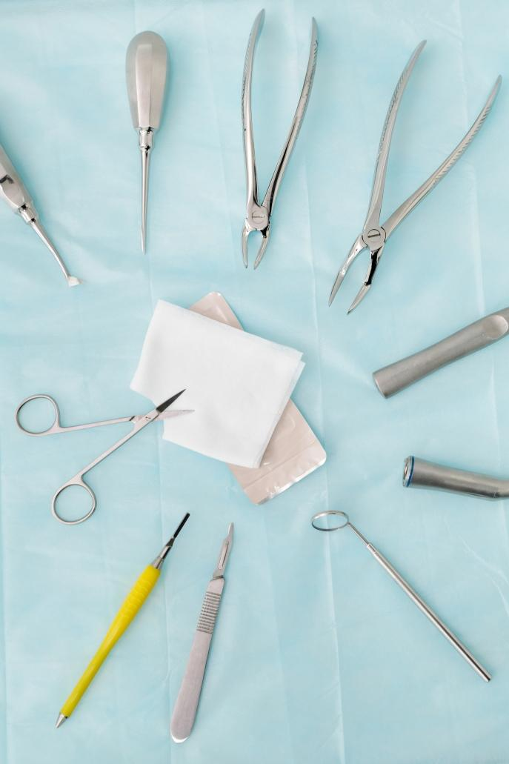
The safe handling of sharp instruments is a vital part of a variety of health care services. Some of these can include cleaning teeth, taking blood, starting an intravenous site and surgery. The handling of these instruments in the classroom can pose a risk to the student, instructor and other school staff if safety precautions are not followed. For example, if the sharp instrument is not disposed of safely, the custodian can be at risk when cleaning the room or emptying the garbage.

Protect yourself against injury from sharp instruments by following these rules:

- Wash your hands appropriately before handling any instrument.

- Ensure long hair is tied back, secured by an elastic, and kept clear of the working area.

- Remove all rings, watches and other jewelry prior to handling instruments.

- Remain in your seat when working with instruments.

- Maintain professional behaviour at all times.

- When a sharp instrument is not in use, place it on a safe surface or in a contained tray.

- Students are to never share or pass sharp instruments to each other. If sharing of instruments cannot be avoided, the student is to pass the instrument in a safe tray.

- If there is a situation or procedure the student is not comfortable performing, please inform the instructor prior to proceeding.

- All sharp instruments are to be disposed of in the biohazard or sharps container. This container is brought to the student’s desk so that the student does not move about the room with the instrument in their hands.

AT ALL TIMES-IF IN DOUBT, STOP!, ASK YOUR INSTRUCTOR

Wheelchairs
Using wheelchairs in the classroom allows students to practice skills taught and to prepare students for practical cooperative education placements. Wheelchairs used may be electric or standard manual. The use of electric wheelchairs requires students to understand how to safely store and use electrical chargers. The use of wheelchairs in health care requires an understanding of body mechanics, the safety and brake features as outlined in the manufacturer’s instructions and how to properly maintain and clean the chairs before and after care.

- Protect yourself against injury by following these rules:

- Ensure electric wheelchairs are stored in designated areas as outlined by the teacher.

- Students must demonstrate their knowledge of the use of a wheelchair prior to using wheelchairs in practical labs or in the clinical area.

- Use proper footwear while in the lab. Shoes must wear shoes with good support (closed back and toe) and have a rubber sole. No sandals permitted.

- Examine wheelchair for any malfunctioning parts. Observe areas of brakes, wheels, treads, electrical cords and charger (when applicable), handrails, spokes, seat and back support.

- Students must demonstrate prior knowledge of body mechanics and identify risks pertaining to body mechanics when using wheelchairs.

- Always prepare area prior to transferring a “patient” to or from a wheelchair.

- Must instruct “patient” regarding pushing off of chair arms, stretching, leaning and tipping.

- Be aware and demonstrate use of proper seated angle of 75-90 degrees for “patient”. Note: patients who have had hip replacements cannot bend their hip less than 90 degrees.

AT ALL TIMES-IF IN DOUBT, STOP! ASK YOUR INSTRUCTOR

WHMIS 2015 SDS SAFETY LABELS
GENERIC SAFETY DATA SHEETS FOR PERSONAL ENHANCEMENT PRODUCTS PROTECTED BY TRADE SECRET LAWS (SDS)

MATERIAL IDENTIFICATION

_____________________________________________________________________
TRADE NAME/MATERIAL NAME PRODUCT USE

______________________________________________________________________
OTHER NAMES:

______________________________________________________________________
MANUFACTURER'S/SUPPLIER'S NAME:

______________________________________________________________________
ADDRESS:

______________________________________________________________________
EMERGENCY TELEPHONE:

______________________________________________________________________
FIRST AID PROCEDURE

AT ALL TIMES – IF IN DOUBT, SEE YOUR INSTRUCTOR

WHMIS 2015 REGULATIONS

- The acronym WHMIS stands for Workplace Hazardous Materials Information System

- Canada aligned the Workplace Hazardous Materials Information System (WHMIS) from 1988 with the Globally Harmonized System of Classification and Labeling of Chemicals (GHS) in 2015.

- Suppliers and employers must use and follow the WHMIS 2015 requirements for labels and safety data sheets (SDSs) for hazardous products sold, distributed, or imported into Canada.

- SDS stands for Safety Data Sheets

- SDS is a printout on paper that identifies how to handle, store, use, health effects if exposed, emergency procedures, and protective measures

- Employers will be required to make sure that all hazardous products (as defined by the Hazardous Products Regulations have an up-to-date SDS when it enters the workplace.

- The SDSs must be readily available to the workers who are exposed to the hazardous product, and to the health and safety committee or representative.
- A label will be required to be updated when the supplier becomes aware of any "significant new data". According to the regulation, the definition of significant new data is:
- "New data regarding the hazard presented by a hazardous product that changes its classification in a category or subcategory of a hazard class, or result in its classification in another hazard class, or change the ways to protect against the hazard presented by the hazardous product." (Source: Canada Gazette, Part II, Hazardous Products Regulations, Section 5.12 (1))
- Labels will be required to be updated within 180 days of the supplier being aware of the new information. If you purchase a product within this 180-day time period, the supplier must inform you of the changes, and the date they became available, in writing.

AT ALL TIMES – IF IN DOUBT, SEE YOUR INSTRUCTOR

WHMIS LABELS

Supplier labels must be attached to the controlled product container which has detailed information about the product. Legislation states that 10 kg or more of a controlled product or hazardous material from a supplier must contain the following information:
- The hatched border that was required under WHMIS 1988 is not required under WHMIS 2015. However, it is also not forbidden to use the hatched border, so you may see it on a WHMIS 2015 label.
- Labels must be in English and French. They may be bilingual (as one label) or be presented as two labels (one each in English and French).
- The pictogram, signal word, and hazard statement are to be grouped together,
- To be clearly and prominently displayed on the container,
- To be easy to read (e.g., you can see it easily without using any item except corrective glasses), and
- To be in contrast with other information on the product or container.
- Labels will be required to be updated within 180 days of the supplier being aware of the new information. If you purchase a product within this 180-day time period, the supplier must inform you of the changes, and the date they became available, in writing.
- Product identifier – the brand name, chemical name, common name, generic name, or trade name of the hazardous product.
- Initial supplier identifier – the name, address, and telephone number of either the Canadian manufacturer or the Canadian importer*.
- Pictogram(s) – hazard symbol within a red "square set on one of its points".
- Signal word – a word used to alert the reader to a potential hazard and to indicate the severity of the hazard.
- Hazard statement(s) – standardized phrases which describe the nature of the hazard posed by a hazardous product.
- Precautionary statement(s) – standardized phrases that describe measures to be taken to minimize or prevent adverse effects resulting from exposure to a hazardous product or resulting from improper handling or storage of a hazardous product.
- Supplemental label information – some supplemental label information is required based on the classification of the product. For example, the label for a mixture containing ingredients with unknown toxicity in amounts higher than or equal to 1% must include a statement indicating the percent of the ingredient or ingredients with unknown toxicity. Labels may also include supplementary information about precautionary actions, hazards not yet included in the GHS, physical state, or route of exposure. This information must not contradict or detract from the standardized information.

In addition to this and if the container has more than 100 milliliters the following information must be on the label:
- Risk time factors
- Precautionary measures while using or being exposed to the product/chemical
- First aid measures to address immediate injuries and not progressive illnesses

Workplace labels must be identified on a container that is not from the supplier, and must contain the following information:
- Product name (matching the SDS product name).
- Safe handling precautions may include pictograms or other supplier label information.
- A reference to the SDS (if available).
- First aid measures

AT ALL TIMES – IF IN DOUBT, SEE YOUR INSTRUCTOR

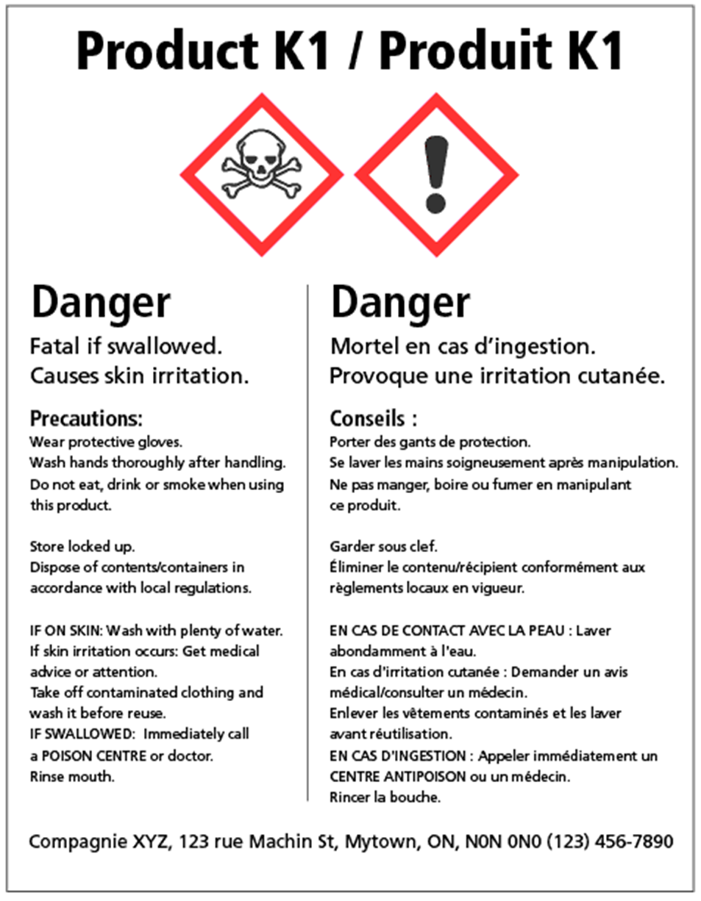

This is an example of an updated 2015 supplier label using the Globally Harmonized System.

More information can be found on the Government of Canada, Canadian Centre for Occupational Health and Safety Website. See the link below.

https://www.ccohs.ca/oshanswers/chemicals/whmis_ghs/pictograms.html

WHMIS 2015 Pictograms

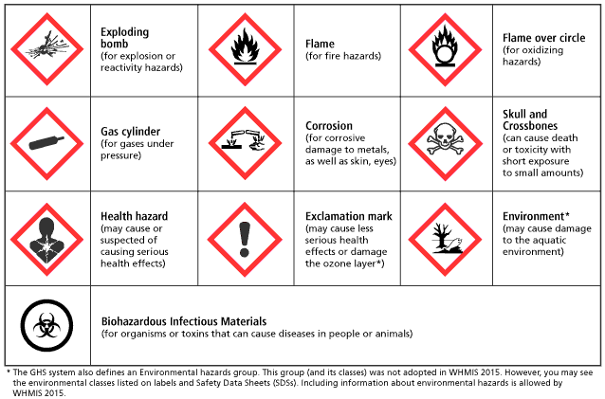

WHMIS 2015 Pictograms

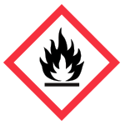

- The flame pictogram is used for the following classes and categories:
- Flammable gases (Category 1)
- Flammable aerosols (Category 1 and 2)
- Flammable liquids (Category 1, 2 and 3)
- Flammable solids (Category 1 and 2)
- Pyrophoric liquids (Category 1)
- Pyrophoric solids (Category 1)
- Pyrophoric gases (Category 1)
- Self-heating substances and mixtures (Category 1 and 2)
- Substances and mixtures which, in contact with water, emit flammable gases (Category 1, 2 and 3)
- Self-reactive substances and mixtures (Types B*, C, D, E and F)
- Organic peroxides (Types B*, C, D, E and F)
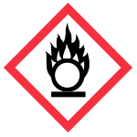
The flame over circle pictogram is used for the following classes and categories:
- Oxidizing gases (Category 1)
- Oxidizing liquids (Category 1, 2 and 3)
- Oxidizing solids (Category 1, 2 and 3)

The gas cylinder pictogram is used for the following classes and categories:
- Gases under pressure (Compressed gas, Liquefied gas, Refrigerated liquefied gas, and Dissolved gas)

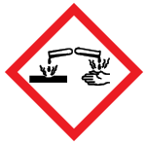
The corrosion pictogram is used for the following classes and categories:
- Corrosive to metals (Category 1)
- Skin corrosion/irritation – Skin corrosion (Category 1, 1A, 1B and 1C)
- Serious eye damage/eye irritation – Serious eye damage (Category 1)

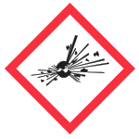
The exploding bomb pictogram is used for the following classes and categories:
- Self-reactive substances and mixtures (Types A and B*)
- Organic peroxides (Types A and B*)

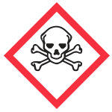
The skull and crossbones pictogram are used for the following classes and categories:
- Acute toxicity –
- Oral (Category 1, 2 and 3)
- Dermal (Category 1, 2 and 3)
- Inhalation (Category 1, 2 and 3)

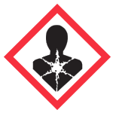
The health hazard pictogram is used for the following classes and categories:
- Respiratory or skin sensitization – Respiratory sensitizer (Category 1, 1A and 1B)
- Germ cell mutagenicity (Category 1, 1A, 1B and 2)
- Carcinogenicity (Category 1, 1A, 1B, and 2)
- Reproductive toxicity (Category 1, 1A, 1B and 2)
- Specific Target Organ Toxicity – Single exposure (Category 1 and 2)
- Specific Target Organ Toxicity – Repeated exposure (Category 1 and 2)
- Aspiration hazard (Category 1)

The exclamation mark pictogram is used for the following classes and categories:
- Acute toxicity – Oral, Dermal, Inhalation (Category 4)
- Skin corrosion/irritation – Skin irritation (Category 2)
- Serious eye damage/eye irritation – Eye irritation (Category 2 and 2A)
- Respiratory or skin sensitization – Skin sensitizer (Category 1, 1A and 1B)
- Specific target organ toxicity – Single exposure (Category 3)

The biohazardous infectious materials pictogram is used for the following classes and categories:
- Biohazardous Infectious Materials (Category 1)

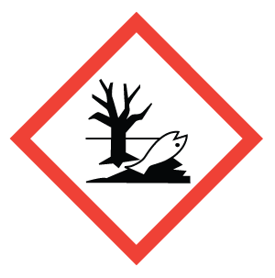
Environment. May cause damage to the aquatic environment.
The Global Harmonized System has defined an environmental hazard group. This group was not adopted in WHMIS 2015; However, you may see this symbol on labels and Safety Data Sheets, and WHMIS allows this, so we are including it in this document.

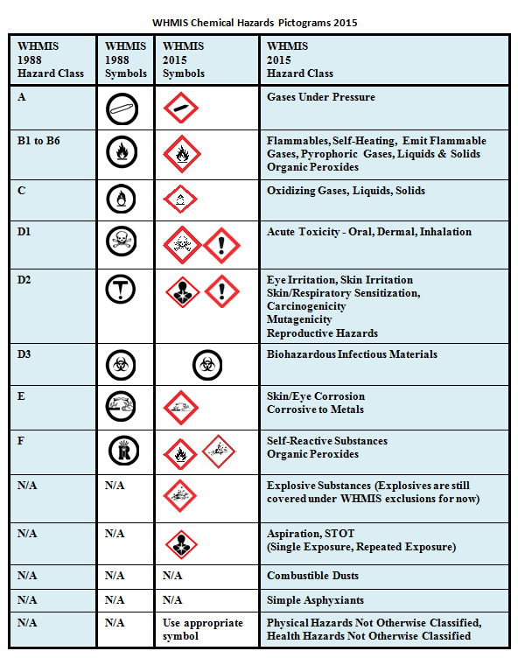

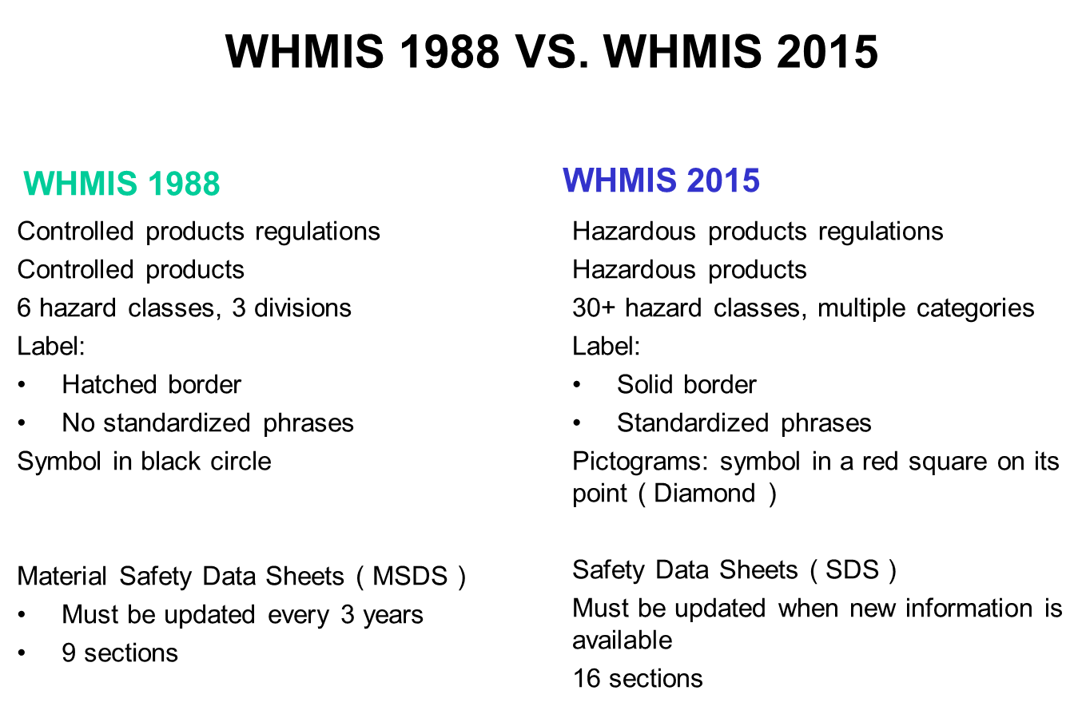

SECTION 3: SAFETY ASSIGNMENTS AND TESTS
SECTION OVERVIEW
This section contains sample tests and assignments related to safety. They are designed as samples that can be used as written or edited for your purposes. They can be used for evaluation of the safety expectations of the course, or as tools to assess the student’s knowledge and understanding of safety. It is recommended that all teachers keep a record of all test or assignment results and/or passports (next section) as verification of each student’s understanding of safe concepts and practices.
The equipment and safety practices in individual facilities will determine how a teacher can best use these resources in the teaching of safe work practices. As well, with the safetyNET resources online at http://www.octe.ca, there are additional resources always being updated, and available for download in .zip files.

NOTE:

All materials within this document are to be considered as suggestions and recommendations only. These are not legal documents and are not to be considered as legal requirements or as official policy. OCTE or the individual contributors makes no claim to the accuracy or the completeness of the enclosed documents and accepts no responsibility for any damages pertaining to their use. Users of this document should not assume all warnings and precautionary measures are contained herein, that additional information or measures are not required, or that local by-laws, regulations or Board policies are explicitly included.

Please see specific equipment manuals for further safety information, as well as local, Board and school policies and regulations

Assignment # 1 – Room Inventory and Safety Identification

OVERALL EXPECTATIONS:
TPJ20 B1 - demonstrate an understanding of and apply correct procedures for ensuring asepsis, good hygiene, and proper use of medical equipment;
TPJ3M B1 - Use health care instruments, equipment and materials safely and correctly;
TPJ4M B1 - demonstrate competence in using health care instruments and equipment and materials
TPJ4E B1 - identify instruments, equipment and materials that are commonly used in the health care industry and use them correctly and safely
______________________________________________________________________

- Complete checklist by locating each item and checking off the corresponding box
- Use a ruler/straight edge to draw a neat floor plan of your lab area and identify the location of the following items.
- Show the work zones around major equipment.

ITEM | CHECK
Entrance/exit doors
Safety exit
Fire extinguishers
Fire alarm
First aid kit
Electrical outlets
Hospital Beds
Sink areas
Waste disposal containers
Work surfaces
Computer work areas
Equipment and tool cleaning areas
Cleaning chemicals storage
Consumable supplies storage
PPE - Gloves storage
PPE – Gown/Apron/Lab Coat storage
PPE – Mask storage
PPE – Safety glasses, goggles and face shield storage
Sharps containers
Other health care equipment storage (e.g. wheelchair, walker, crutches)
WHMIS and SDS binder

Safety Assignment # 2 – Safety Requirements

- Students are to research, analyze, and provide a detailed description of the key safety requirements for the selected topic.
- Research may be found in a variety of places including textbooks, online safety resources, or equipment manuals.
- Students will present their findings in one of a variety of ways including but not limited to:
- Infographic
- Report
- Song
- Slideshow
- Poster Board

*For online learning, findings can be shared in a discussion board format.

TOPICS
- Sharps containers procedures and disposals
- Proper use of mechanical and electrical beds
- Key principles in First Aid such as dealing with cuts, burns, strains
- Key principles in Cardiopulmonary Resuscitation (CPR) and Automated External Defibrillator (AED) use
- Proper PPE use
- Hand Hygiene
- Safe cleaning procedures
- Chemical use and storage
- Slips, Trips and Falls
- Proper body mechanics
- Proper and safe use of mechanical lifts
- Proper and safe restraint use

Success criteria/rubric is at the discretion of the classroom teacher.
Teachers are encouraged to provide exemplars if available.

Safety Assignment # 3 – Perform a Safety Audit

Ensuring consistent safety in the classroom is everyone’s responsibility. For this ongoing assignment, a rotating group of students will be assigned to perform a safety audit of the classroom/lab once per month.

To accomplish this task, students will:
- Design and create a safety checklist that will be used for the inspection. This will be accomplished by researching information about industry safety standards in groups. Resources should be provided by the classroom teacher as well as online
- Each group will be given a specific area to research (see areas below).
- Groups will then design and create a checklist for their given safety area
- Once the checklist is completed and approved by the teacher, each group will then perform an initial audit as well as monthly audits.

SAFETY AREAS

- First aid kit content status
- Status of safety equipment
- Status of fire protection equipment
- Status of cleaning supplies and equipment
- Status of storage areas
- Status of tools and equipment
- Status of sharps storage and disposal
- Status of housekeeping

Success criteria/rubric is at the discretion of the classroom teacher.
Teachers are encouraged to use exemplars such as the OCTE Health Care Safety Walk.

Safety Assignment # 4 – WHMIS QUIZ

Section 1: Written Response

Define WHMIS.

Define SDS.

What is the responsibility of the employer in regards to WHMIS according to the Occupational Health and Safety Act of Ontario?

Section 2: Multiple Choice
1. If a hazardous material has more than 100 milliliters in one container, the label must have additional information, which includes:
a) The company’s chemist b) Risk time factor
c) b and d d) Precautionary measures while exposed to the product

2. Workplace labels must contain a material identifier or product name, reference to a SDS, precautionary steps, and:
a) An emergency phone number b) The hospitals phone number
c) First aid measures d) The company’s phone number

3. In Canada a suppliers WHMIS label must be written in:
a) French b) English
b) Chinese d) both Official Languages

4. A supplier when selling a hazardous material product must include:
a) A rebate b) SDS
b) WHMIS d) OH&S

5. A Safety Data Sheet should be:
a) Kept on file forever b) Read and then thrown out
c) Photo copied for all workers d) Placed in a binder and kept for 3 years

Answer Key:
Section 1: Written Response
1. Workplace Hazardous Material Information System
2. Safety Data Sheets
3. To inform employees of hazardous materials.

Section 2: Multiple Choice: 1. C 2. C 3.D 4.B 5. D
_____________________________________________________________________

Safety Assignment # 5 – SAFETY BROCHURE

Individually, students will create a safety product, providing key safety information on one of the following topics, in one of the following formats:
- Brochure
- Poster
- Infographic
- Slideshow
- Song
- Mind map/graphic organizer

SAFETY TOPICS
- SHARPS
- ERGONOMIC INJURIES
- SLIPS, TRIPS AND FALLS
- CHEMICAL HAZARDS
- DISASTER PLANNING

Success criteria/rubric is at the discretion of the classroom teacher.
Teachers are encouraged to use exemplars if available.

Safety Assignment # 6 – BODY MECHANICS

Body mechanics involves the coordinated effort of muscles, bones, and the nervous system to maintain balance, posture, and alignment during moving, transferring, and positioning patients. Proper body mechanics allows individuals to carry out activities without excessive use of energy, and helps prevent injuries for patients and health care providers

Students will make an assignment to learn the theory practical application of body mechanics.

- Students will review the theory and principles of body mechanics:
- Textbook section 3.2 – Body Mechanics from Clinical Procedures for Safer Patient Care
- Review skills videos from Mosby’s Nursing Video Skills
- Teacher will demonstrate skills (in person or online demo)

- Students will be assigned skills to practice and demonstrate to the class (practice and demo may be done at home and recorded)
- Checklists may be used to assess students (see several examples below)

SAMPLE Moving a Person Up in a Bed Lab Checklist

Student Name: __________________________
Date: ________________________________

 | Satisfactory | Unsatisfactory
- Ask someone for assistance if required.
- Wash your hands
- Introduce yourself to the person and explain what you will be doing.
- Provide for privacy.
- Ensure the bed is at a comfortable working height, and the bed wheels are locked.
- Stand on one side of the bed, with your partner on the other side.
- Lower the bedrail near you (and partner would do the same).
- Put the pillow up to the headboard if the person can do without it.
- Stand with a wide base of support facing the head of the bed.
- Bend your knees and hips, while keeping your back straight.
- Place one arm under the person’s shoulder, and one arm under the thighs.
- Have the person bend both knees and brace the feet against the mattress.
- Explain to the person that on the count of “3”, they are to push against the bed with the feet.
- Move the person towards the head of the bed on the count of “3”. Shift your weight from the back to the front foot.
- Reposition the pillow under the person. Ensure good body alignment.
- Replace the bedrail and return the bed to a lower position.
- Wash your hands.

- this is a skill to which ergonomics/body mechanics applies

SAMPLE Transferring a Person from a Bed to a Chair/One-Person Pivot Transfer Lab Checklist

Student Name: __________________________
Date: ________________________________

 | Satisfactory | Unsatisfactory
- Introduce yourself to the person and explain what you will be doing.
- Ask someone to assist you.
- Collect the wheelchair/chair.
- Decide which side of the bed to use depending on the person's weak side. Put the chair back even with the headboard, close to the bed.
- Provide for privacy.
- Ensure the bed is at a comfortable working height, and the bed wheels are locked.
- Lock chair wheels, position footrests as needed.
- Raise the head of the bed and stand near the person’s waist on the transfer side.
- Lower the bed rail near you.
- Put shoes/slippers on person’s feet.
- Stand with a broad base of support. Bend your knees and hips, while keeping your back straight.
- Slide one arm under the person’s neck and shoulder, and place the other arm over the person’s legs, between the thighs and knees.
- Pivot the person up by the shoulders, while lowering the feet and legs over the side of the bed.
- Assist patient to move to the edge of the bed.
- Stand in front of the person with your knees touching, and the person’s feet on the floor.
- Place your hands under the person’s arms, or around their waist (or grab their waist band).
- Have the person lean forward or stand by pushing off the bed with their hands.
- Support the person in the standing position and continue to block the person’s knees and feet with your own.
- Shuffle with your feet and turn the person so they can grasp the far arm of the chair.
- Continue to turn the person until they can grasp the other arm rest.
- Lower the person into the chair as you bend your hips and knees. Ensure the person’s buttocks are at the back of the chair.
- Position the person in good body alignment.
- Position the person’s feet on the footrest.
- Cover the person’s lap and legs with a blanket.
- Ensure the person is comfortable (move person to the location they wish to go).
- Wash your hands.

- this is a skill to which ergonomics/body mechanics applies

SAMPLE Raising the Person’s Head and Shoulders Lab Checklist

Student Name: __________________________
Date: ________________________________

 | Satisfactory | Unsatisfactory
- Ask someone for assistance if required.
- Wash your hands
- Introduce yourself to the person and explain what you will be doing.
- Provide for privacy.
- Position yourself near person’s shoulder and chest.
- Lower the bedrail near you (and partner would do the same).
- Ask person to put their arm under your arm and around your shoulder.
- Put your free arm around the person’s shoulder or neck.
- Help the person into a sitting up position on the count of “3”. As the person sits up, shift the weight of your body from the foot at the head of the bed to the other foot.
- While supporting the person, remove/adjust the pillow(s).
- Help the person to lay down while supporting the neck and shoulders. Ensure good body alignment.
- Replace the bedrails and return the bed to a lower position.
- Wash your hands.

- this is a skill to which ergonomics/body mechanics applies

SAMPLE Giving a Modified Simulated Bed Bath Lab Checklist

Student Name: __________________________
Date: ________________________________

 | Satisfactory | Unsatisfactory
- Introduce yourself to the person and explain what you will be doing.
- Ask someone to assist you.
- Wash your hands.
- Collect what you will be using (wash basin, soap, face cloths, two bath towels, clean gown/pajamas/ clothes, lotion, gloves).
- Provide for privacy.
- Ensure the bed is at a comfortable working, appropriate height, and the bed wheels are locked.
- Fill the wash basin 2/3 full of warm water (should be between 43 – 46 ºC) and place on work area within easy reach.
- Lower the bed rail near you.
- Cover the person with a bath blanket and remove the top linens.
- Lower the head of the bed and ensure the person has at least one pillow to support the head.
- Make a mitt with the washcloth and wet it.
- Wash around the person’s eyes with water. Gently wash from inner part of eye, to outer part.
- Wash the face, ears and neck, rinse, dry.
- Put on gloves.
- Remove the person’s garments and cover them up.
- Place a bath towel under the person’s arm, and proceed to wash the arm, shoulder, and underarm. Your partner can do the same on the other side.
- Rinse and dry. Apply lotion as needed.
- Proceed to wash the hands in a similar fashion.
- Wash the chest and abdomen of the person and limit exposure. Rinse and pat dry.
- Turn the person on their side away from you, with the opposite side rail up. Your partner will support the person. Place a towel on the sheet under back.
- Wash the back from the neck to the buttocks.
- Give a back massage and apply lotion if needed.
- Turn the person onto their back.
- Put on clean garments on the patient.
- Dispose of the water, and linens.
- Position the person as required.
- Apply deodorant and give any personal grooming care that the person requires (brush hair).
- Wash your hands.

- this is a skill to which both ergonomics/body mechanics and PPE applies - use these SAFEdocs accordingly
- at any time, if the water becomes too cold, dirty, soapy, it should be changed
- during the bed bath, you are assessing skin integrity
- maintain speed with efficiency so the person doesn’t get cold
- ensure the person’s condition is taken into consideration (ie. respiratory status)

SAMPLE Mechanical/Electric Patient Lift: from Hospital Bed to Wheelchair Checklist

Student Name: __________________________
Date: ________________________________

 | Satisfactory | Unsatisfactory
1. Hand Hygiene
2. Consider the client’s weight and the mechanical lift weight capacity –
3. Obtain the correct sling (consider size (weight and height) of client: tip of head to coccyx) –
4. Check the straps for fraying/rips and the sling for solid stitching.
5. Explain the procedure to the client.
6. Have the wheelchair close to the bed – it may be at the head or foot.
7. Ensure wheelchair and bed brakes are on.
8. With the patient in the centre of the bed, roll the client on their side toward the helper and centre the patient on the sling so that the top of the sling is at the top of the head and the bottom of the sling is at the coccyx. The shoulder stitching should be at the shoulders. Roll the client back to supine position.
9. Spread the lift base legs to the widest position and centre the boom of the lift over the client before lifting. For smooth and easy lifting, have the lift, sling, and wheelchair in ready position.
10. With the base of the lift under the bed, press the down button on the control handset to slowly lower the boom. Support the boom as you lower it so that the client and helper are safe.
11. Put on the lift casters/brakes before you leave the handles to assist the helper with attaching the sling.
12. Hook the hanging strips of the sling with the hanging bar. Attach the sling to the lift as follows:
Lying to sitting: short on the top, long on the bottom
(FYI - Sitting to lying: long on the top, short on the bottom)
13. To prevent straining to attach the straps, you can raise the head of the bed a little and have the client keep their arms by their sides, as well as having the boom as low as possible without touching the client.
14. Remind the client to keep their arms in the sling and not to hold onto the boom.
15. Return to the handles. Before leaving the surface of the bed, check that the straps are still in their clips and that the client is not sliding out of the sling.
16. Lock rear casters/brakes. Lift the client up by pressing the up button on the control handset. Lift client until their feet will swing easily off the bed and that the client is above the bed and the arms of the wheelchair.
17. Unlock rear casters/brakes and transfer patient to above wheelchair. Lock brakes of both lift and wheelchair.
As you use the controls, the helper should support the client’s legs.
18. Spread the legs of the lift to get around the wheelchair base.
19. With the brakes off on the lift, press the down button on the control handset to gradually lower the client into the wheelchair. During the descent, the helper should assist the client to attain correct sitting posture and the helper should be guiding the client from behind so that their buttocks are against the back of the wheelchair.
20. Lower the boom so that it is low enough that you can remove the straps without straining. The helper must watch to ensure the boom does not hit the client.
21. For transferring to wheelchair, when the client is seated, push down on the boom to slacken handing strips of sling. Client can remain seated in sling
22. Position the client’s feet on the wheelchair footrests.
23. Provide a call bell.
24. Hand hygiene

- This is a skill to which ergonomics/body mechanics applies
- A lift must always be used by two students and spotted by the teacher.
- A lift cannot be used to transport clients
- If the lift does not have a functioning battery or needs to be stopped quickly, the Emergency quick release feature should be used

HEALTH CARE
EQUIPMENT SAFETY GUIDELINES
CULMINATING ACTIVITY

- Each piece of equipment we use in the health care lab has specific safety and operating guidelines and procedures.
- Your task is to develop important mandatory material that will be used by all health care students.
- The purpose of this activity is to research the equipment and product safety information sheets of the most commonly used pieces of classroom equipment.
- The safety sheets will be laminated and used as reference material for all health care students.
- Student may choose from the list of equipment below

You must include the following information on all safety information sheets:

- Name of piece of equipment
- Function of the piece of equipment
- Safety guidelines
- Correct operating procedures
- Resources for more information
- Source of information

EQUIPMENT LIST
- Mechanical hospital bed
- Electrical hospital bed
- Stethoscope
- Sphygmomanometer
- Thermometer
- Pulse Oximeter
- Electronic blood pressure monitors
- Automated External Defibrillator
- PPE
- Mechanical lifts (sit-to-stand and full)
- Wheelchairs
- Walkers
- Crutches
- Canes
- Patient Care Mannequins (Manikins)

SUCCESS CRITERIA
- All required information must be present
- The information sheets must be precise, easy to follow, and logically organized
- The information sheet should be creative and appealing
- The information sheet should be error free with correct spelling, grammar, and punctuation.

RUBRIC

EXPECTATIONS | LEVEL 1 | LEVEL 2 | LEVEL 3 | LEVEL 4
CONTENT | Poor amount of material related to the safety topic | Fair amount of material related to the safety topic | Considerable amount of material related to the safety topic | An abundance of material clearly related to the safety topic
ORGANIZATION | Safety content poorly organized. Missing clear topic headings. | Safety content organized fairly well but may be missing headings or separation of topics | Safety content presented in an organized logical manner | Safety content presented in a very organized and logical manner.
CREATIVITY | Information presented with insufficient use of creativity | Information presented with little originality or interpretation | Information presented with some originality and use of materials/colour | Information presented with excellent use of creativity/originality
CLARITY | Information is illegible. Poor spacing throughout.  Several spelling and grammatical errors | Information is legible, however, difficult to read. Some spelling and grammatical errors | Information is legible. Good use of spacing throughout. No spelling or grammatical errors | Information is presented with appropriate font size and is legible. Excellent spacing throughout. No spelling or grammatical errors

SECTION 4: SAFETY PASSPORTS

SECTION OVERVIEW

This section contains Safety Passports, which provide a means to track individual student safety knowledge and skills. These Safety Passports ensure that students have passed the required safety tests and understand the safety procedures and rules specific to the tools and equipment. It is recommended that all teachers retain all safety documents.

Safety Passports may be signed by teachers, parents and students before working on any equipment. Signing signifies completion of safety training and testing. There are three variations; teachers may select the most appropriate method to suit their needs. Ensure that the selected safety passport addresses board and school safety policies.

Safety Record Card: for individual student, records their proficiency rating for each machine on one sheet.

Safety Passport: Form 1: single sheet for individual student and machine, has signature area and note area to be used in student notebook

Safety Passport Form 2: sheets for individual students listing machines, for teacher record book

Safety Passport Form 3: individual machine for each individual student, has line for parent signature to be used as a safety reinforcement or authorization, (see school principal for permissions)

NOTE:
All materials within this document are to be considered as suggestions and recommendations only. These are not legal documents and are not to be considered as legal requirements or as official policy. OCTE or the individual contributors makes no claim to the accuracy or the completeness of the enclosed documents and accepts no responsibility for any damages pertaining to their use. Users of this document should not assume all warnings and precautionary measures are contained herein, that additional information or measures are not required, or that local by-laws, regulations or Board policies are explicitly included.

Please see specific equipment manuals for further safety information, as well as local, Board and school policies and regulations.

Technology Lab Safety Passport

The purpose of the safety passport is to ensure that students are fully aware of all safety features on each piece of equipment in the technical facility prior to using them independently.

The general process is as follows:
1. Teacher Demonstration: When the teacher introduces a new piece of equipment, the student records the date of the safety demonstration on their safety passport. This is to be initialed by the teacher (see sample below). The teacher demonstrates techniques for the safe operation and procedures, as well as use of personal protective equipment (e.g. eye protection, secure loose hair, remove jewelry, protective clothing, etc.). Students prepare notes in their notebooks. This safety note is carefully recorded in each student’s notebook along with the signed passport. The teacher also carefully notes attendance for that day in their daybook if any students are absent for the safety lesson; makeup opportunities must be provided.
- Test/Assignment: Each student should complete a written (or oral) test (or assignment) on the safe operation or procedure, outlining all safety features that must be observed. The individual tests are designed to complement any general facility safety rules. Upon satisfactory completion of the test the student dates the “tested” column and teacher initials this as complete. IMPORTANT NOTE: A copy of the test/assignment should be kept by the teacher.

- Student Demonstration: Students must demonstrate to the teacher that they have a thorough knowledge of the safety rules for the equipment and are able to demonstrate their competency on the equipment. Once the teacher has observed the required safe setup and operation of the equipment by a student the teacher signs off that portion of their passport.

- Once the student has completed #1, 2 and 3, the teacher signs the final column of student’s safety passport indicating they have permission to use that equipment or perform the procedures. Students must be able to provide the teacher with their signed passport for that equipment each time they wish to use that equipment.

Note: Three forms are provided,
- Form 1 can be used as a student notebook form for each piece of equipment.
- Form 2 can be used for signing several pieces of equipment per student. With the 2nd form, students keep safety notes on separate paper. (sample provided)
- Form 3 requires one sheet per piece of equipment per student, and may be used in the student notebook or kept on file by the teacher (or both).(sample provided)

Form 1 Sample Student Safety Record

STUDENT SAFETY RECORD
STUDENT NAME:

COURSE:

SKILL TYPE: (equipment or patient care):

SKILL NAME:

DATE | LEVEL OBTAINED | STUDENT SIGNATURE | TEACHER SIGNATURE | COMMENTS

Form 2

Student Name: ______________________ Course/Class:

Equipment/Procedure: _____________________________
Attended Teacher Safety Instruction and Demonstration  (Notes recorded) |  | Passed Written or Oral Testing |  | Demonstrated Safe Set-up and Operation to Teacher |  | Granted Permission by Teacher
Date of  Lesson | Teacher Initial | Date  Tested | Teacher Initial | Date of Demo. | Teacher Initial | Date | Teacher  Initial

Equipment/Procedure: _____________________________
Attended Teacher Safety Instruction and Demonstration  (Notes recorded) |  | Passed Written or Oral Testing |  | Demonstrated Safe Set-up and Operation to Teacher |  | Granted Permission by Teacher
Date of  Lesson | Teacher Initial | Date  Tested | Teacher Initial | Date of Demo. | Teacher Initial | Date | Teacher  Initial

Equipment/Procedure: _____________________________
Attended Teacher Safety Instruction and Demonstration  (Notes recorded) |  | Passed Written or Oral Testing |  | Demonstrated Safe Set-up and Operation to Teacher |  | Granted Permission by Teacher
Date of  Lesson | Teacher Initial | Date  Tested | Teacher Initial | Date of Demo. | Teacher Initial | Date | Teacher  Initial

FORM 3: Equipment/Procedure Passport

[EQUIPMENT/PROCEDURE]
General Conditions

Personal Protective Equipment

Possible Risk Factor

- The student has been trained on this equipment and procedure.
- The student understands the required personal protective equipment to operate this equipment and perform this procedure.
- The student is aware of the possible risk factors

Student signature ________________________________

Teachers signature ________________________________

Date of training ________________________________

DISINFECTANT PASSPORT
General Conditions

Students must be trained in the proper procedures (WHMIS and SDS) of disinfectant chemicals and their uses within the health care environment to be able to perform any sterilization and disinfecting tasks. The student must demonstrate the ability to follow manufacturers’ instructions and employ cleaning agents for a specific sanitation procedure.
Personal Protective Equipment

- Non-latex Gloves
- Mask
- Safety Glasses/Goggles/Face shield
- GownApron/Lab Coat
- Non-Slip Firmly-Soled Shoes with closed toe and heel
Possible Risk Factor

- Respiratory Problems (inhalation)
- Skin Irritation
- Slippage
- Muscle Strain
- Burns or Scalds
- Cuts or Lacerations

- The student has been trained on this equipment and procedures.
- The student understands the required personal protective equipment to operate this equipment or perform these procedures.
- The student is aware of the possible risk factors

Student signature ________________________________

Teachers signature ________________________________

Date of training ________________________________

ERGONOMICS PASSPORT
General Conditions

Improper posture, equipment placement, and repetitive use of equipment may cause injuries and pain. Students must be trained on the safe and proper use of equipment before they may begin using them. The student must demonstrate the ability to use the equipment safely and in a manner that is ergonomically correct. Long term incorrect body mechanics can lead to overuse injuries and serious strains on the musculoskeletal and nervous systems. Proper body mechanics must be employed in every situation that a health care provider faces.
Personal Protection

- Proper posture
- Proper equipment placement
- Change in sitting arrangements, etc. to avoid repetitive stress injuries

Possible Risk Factor

- Spine and back injuries
- Hand Injuries
- Eye strain

- The student has been trained on this equipment.
- The student understands the required personal protective equipment to operate this equipment.
- The student is aware of the possible risk factors

Student signature ________________________________

Teachers signature ________________________________

Date of training ________________________________

Health Care Services
Lab Rules and Expectations

In order to function safely in a health care environment, the following rules must be adhered to:

- Respect for the teacher and fellow students is an absolute must! Health care environments thrive when a team approach is taken to patient care. Health care workers (and students in health care classes) must work collaboratively and respect each other in order for the health care environment to function successfully.

- “Horseplay” will not be tolerated at any time in the lab. This includes any behaviour that may be deemed dangerous or unsafe.

- Cell phones and electronic devices of any kind are not permitted in the lab.

- No pictures can be taken in the lab without express permission.

- If you need to leave the lab for any reason you must ask permission to do so.

- Coats, bags, and purses are to be kept in your locker.

- You must practice hand hygiene by washing or sanitizing your hands when entering the lab and before leaving the lab. You must also practice hand hygiene in between procedures and “patients”.

- Proper dress is essential in the lab. Therefore, it is recommended that students wear comfortable clothing on days that we will be performing skills in the lab.

- Closed-toed shoes must be worn in the lab setting

- Long hair must be tied back with an elastic.

- No food or drinks are to be consumed while in the lab area.

I,________________________________ have read these guidelines. I understand and will abide by them at all times while in the lab.

Student’s Signature: ___________________________ Date: ______________

Parent’s Signature: ____________________________ Date: ______________

Sample: Record of Safety Training

Student: Class:

Over the course of the semester or term(s) you will receive direct instruction in the safe and appropriate use of all the equipment, tools, materials, and facilities required to complete your classroom activities. Instruction consists of a combination of demonstration and written and verbal instruction. A satisfactory mark on a safety quiz following the instruction demonstrates the acquisition of sufficient knowledge to use and access the relevant equipment and materials. Your ongoing demonstration of safe practice is assessed in the project marking. Your teacher will put the date and sign-off beside each topic in acknowledgement of your attendance at the discussion or demonstration.

STUDENTS MAY NOT USE ANY EQUIPMENT, TOOL, OR FACILITY UNTIL:
- their training has been signed off by the teacher
- he or she has received a satisfactory mark on the related safety quiz.

Topic | Date | Teacher’s Signature
Computer Resources and the Internet
- Acceptable Use Policy
- Safety on the Internet
- Computer Ergonomics
Patient or Client Care
- Safe use of chemical treatments
- Use of personal protective equipment (PPE) for patient/client
- Safe and proper handling of patient or client
Facility Care
- Proper cleaning and setup procedures
- Maintaining safe working environment
- Use of personal protective equipment (PPE) for self
- Proper sanitation and sterilization procedures
- Safe and proper disposal of consumables and hazardous materials

Sample Safety Orientation Quiz
*Quiz can be delivered online as well.

DIRECTIONS: Circle true (T) or false (F) for each statement below.

T F 1. Wet floors can cause slips and falls.
T F 2. To avoid back injury, always bend and twist when you lift.
T F 3. It’s okay to break off the third prong to get a plug to fit into an outlet.
T F 4. You should never work around electrical appliances when your surroundings are wet.
T F 5. During a fire, you should stay low to avoid inhaling smoke.
T F 6. Disinfection is more effective than sterilization.
T F 7. Blood and other body fluids may carry deadly pathogens.
T F 8. Your facility’s Exposure Control Plan is designed to work with
Occupational Health and Safety Bloodborne Pathogens Standard to
protect healthcare workers.
T F 9. Used sharps should be recapped and discarded in a leakproof container.
T F 10. Follow your facility’s guidelines to dispose of medical waste properly.
T F 11. You should never use your hands to pick up broken glass.
T F 12. Contaminated laundry should be transported in open carts.
T F 13. You should cover cuts with bandages before donning gloves.
T F 14. PPE can include ventilation devices.
T F 15. Your facility’s written Occupational Health and Safety Team will tell
you which hazards are in your work area.
T F 16. To avoid harmful exposure, minimize the distance between yourself and the radiation source.
T F 17. Address radiation questions to the Occupational Health and Safety
Team.
T F 18. Wash your hands after handling any potentially hazardous material.
T F 19. If you have skin contact with blood, wash with non-abrasive soap and running water immediately.
T F 20. If mucous membranes are exposed to blood, flush with water for 15 minutes and seek medical attention.

APPENDIX A: HEALTH AND SAFETY RESOURCES

Appendix A

Workplace Safety and Insurance Board
http://www.wsib.ca
Legislated by the Ontario government and responsible for administering the Workplace Safety and Insurance Act (WSIA). Governed by a Board of Directors made up of representatives of workers, employers and others.
Under the Resources tab, this website provides information on how WSIB makes decisions, by reviewing the Operational policy manual, Employer Classification Manual, and Adjudication support documents. You’ll also find useful forms and fact sheets on a variety of topics, including benefit payments, and rights and responsibilities.
- Fact Sheets are also available:
- Fact Sheets for Workers
- Fact Sheets for Prevention
- WSIB Fact Sheets
Canadian Centre for Occupational Health and Safety
https://www.ccohs.ca/

The Free Resources section is a collection of websites, databases, and other online resources suggested and reviewed by CCOHS. Many of the websites are designed and maintained by CCOHS, while some of the resources are provided by external, third-party providers.
Purpose
- Promote the importance of workplace health and safety in Canada
- Identify current and reliable health and safety information
- Create and maintain an accessible, convenient, and easy-to-use resource to anyone who needs it
- Provide access to information from a variety of sources including federal, provincial, and territorial governments, agencies, and non-profit organizations
Target Audience
The Free Resources are useful to workers, employers, managers and supervisors, joint health and safety committees, workplace health and safety professionals, and students.

HEALTH CANADA
https://www.canada.ca/en/health-canada.html

Health Canada is the Federal department responsible for helping Canadians maintain and improve their health, while respecting individual choices and circumstances.
Health Canada administers many pieces of legislation and develops and enforces regulations under this legislation that have a direct impact on the health and safety of Canadians. The Department consults with the Canadian public, industry, non-governmental organizations (NGOs) and other interested parties in the development of these laws. Health Canada also prepares guidelines in order to help interpret and clarify legislation and regulations.
Of particular interest would be regulations such as the Hazardous Product Act, Controlled Products Regulations, Environmental and Workplace Health.

Health and Safety Ontario (HSO) is the result of a bold move to reorganize the independent efforts of 12 health and safety associations into four streamlined organizations to better serve more than 236,000 Ontario businesses.

HSO is comprised of:
- Workplace Safety & Prevention Services
- Public Services Health & Safety Association
- Workplace Safety North
- Infrastructure Health & Safety Association.

ONTARIO BUILDING CODE
https://www.ontario.ca/laws/regulation/120332

The Ontario Building Code’s website has information on qualification and registration, available training, dispute resolution, news on recent code developments and more. The Ontario Building Code is administered by the Building and Development Branch of the Ministry of Municipal Affairs and Housing.

CANADIAN STANDARDS ASSOCIATION (CSA)
http://www.csagroup.org

Standards contribute to safer homes, workplaces and public spaces. They address issues related to sustainability and the environment. And they encourage the adoption of new technologies and best practices that enhance trade and help make industry more competitive in the global marketplace. Standards help advance today, while anticipating tomorrow.

CANADIAN SOCIETY OF SAFETY ENGINEERING (CSSSE)
http://www.csse.org/

The Canadian Society of Safety Engineering (CSSE) is the leading health, safety and environmental organization for professionals in Canada. They work with industry, governmental agencies, and other safety organizations to promote a greater awareness of health, safety, and environmental issues in workplaces and communities across the nation and around the world. Our vision is "An Advocate for Safety in Every Workplace".

CSSE’s mission is to be the resource for professional development, knowledge and information exchange to our members, and the Canadian public.
PROFESSIONAL ASSOCIATIONS
Professional Associations can be a great health and safety resource relating to discipline specific occupational health and safety.
Healthcare Associations/Organizations Websites - https://ipac-canada.org/associations-organizations
The following Tech Design related associations provide resources on professional practice relating to health and safety.
Professional Engineers of Ontario (PEO)…… www.peo.on.ca/
Architectural Association of Ontario (OAA)….. www.oaa.on.ca/
Ontario Certified Engineering Technicians and Technologists (OACETT)….. https://www.oacett.org/
Association of Registered Interior Designers of Ontario (ARIDO) ….. www.arido.ca/

Ministry of Labour, Immigration, Training and Skill Development
https://www.ontario.ca/page/ministry-labour-immigration-training-skills-development

For news and information about Ontario’s health and safety and employment legislation, the website is an excellent place to visit. It provides current information on both employment standards and health and safety legislation, recent fines, alerts, etc.

This section of the Ministry of Labour, Immigration, Training and Skill Development website ensures that students are aware of their rights and obligations and their employer’s rights and obligations under the Occupational Health and Safety Act and the Employment Standards Act. It includes: worker safety education information; information for working students – know your rights and obligations; information for new workers and students working in Ontario; fact sheets for employees; your guide to the Employment Standards Act; and links to related websites.

Ontario School Boards Insurance Exchange
http://www.osbie.on.ca
The primary goals of the Exchange are to insure member school boards against losses, and to promote safe school practices. The Ontario school “Risk Management at a Glance” material is intended to provide guidance and direction in the major risk management areas facing school administrators, principals, vice-principals, teachers and all other school staff on a daily basis.
Risk Management – OSBIE
Although this reference material is not intended to replace school board policies and procedures, it is intended to supplement the risk management considerations, which should go into making the decisions on the most common day-to-day school activities. The design of this publication is to promote the display of this document in a calendar-like format in every classroom to facilitate ready “Risk Management at a Glance”. Every employee who may be called upon to make a decision about the permitting of or the organizing of any activity listed can use this.

For any activities not listed in this material, it is recommended that you contact your board office, or refer to the policies and procedures as stated by your school board.

North American Occupational Safety and Health (NAOSH) Young Worker Links
Web Address: http://www.csse.org/naosh_week/naosh_week_network.htm
Summary: Includes links to occupational safety and health related websites, as well as other youth resources.

Public Health Ontario
Web Address: https://www.publichealthontario.ca/

PHO provides scientific and technical advice and support to clients working in government, public health, health care, and related sectors.

Regulated Health Professions - links to all professional colleges and legislation https://www.health.gov.on.ca/en/pro/programs/hhrsd/about/regulated_professions.aspx

Take Our Kids to Work – Teacher’s Guide; Workplace Guide

The Learning Partnership

Web Address: http://www.tlp.on.ca
These resources have been custom designed to help teachers and workplaces prepare for Take Your Kid to Work day. The new booklets have an excellent section on activities to help prepare the students for a safe learning day.

School Workers Health and Safety Guide
Canadian Centre for Occupational Health and Safety
Web address: http://www.ccohs.ca
This information-packed coil-bound pocket book covers school safety topics such as emergency preparedness, classroom safety, arts and crafts, industrial technology, maintenance and custodial practices, sanitation and infection control, sports and activities, work environment, ergonomics, personal protective equipment and health and safety legislation. There are good ideas and work practices that can add to your existing safety programs.
Cost: The price is reasonable and covers printing and distribution costs.
Check current cost and delivery information in the publications section of the web site.

APPENDIX B: OCTE SAFETYNET BLANK TEMPLATE
Overview
A sample of a blank safetyNET template provided by the Ontario Council for Technology Education as well as their Materials and Resources sheet has been provided here as an additional resource for computer technology teachers.
Completing it once for a risky project can take teachers through a pre-project planning process, a review of the materials in their shops, the suppliers and processes they use, and encourage documentation of their safety training for themselves, their students, and classrooms. It collects safety information in one place for their own use, and respects their experience, pedagogy, and professionalism. It’s a crucial step in standardizing safety training in your technology program at your school and can assist in collegial communication in your department.
Please note that the online updated version is available at www.octelab.com, however any teacher that considers and documents their answers to the questions will have created an important document for their personal professional practice. It’s also available in fillable .pdf format, and is also available in French from OCTE
Establishing A Safety Binder
The goal is a safety binder that teachers keep in their rooms as evidence of due diligence taken towards safety in the classroom.
Assembled safety binders often include teacher/room/board specific:
- safetyNET Template
- Project Specific Safety Resources
- SDS Sheets
- Student Safety Training Tracking Sheets
- Permission Forms Copies
- Class Lists
- Equipment Maintenance/Manuals
- Training Quiz Samples
- Teacher Training Documentation Copies
- Emergency Procedures Docs
- Board Repair Contacts
- Room Safety / PPE Location Map

Starting Your safetyNET
TPJ Subject Area: Tech Subject Based Program Leads can provide leadership asking teachers to consider the following questions to choose a focus for completing their own safetyNET.
- What are the riskiest projects I do in my classroom? (List them here.)
- What ones of these use the riskiest materials?
- Which ones of these use the highest risk-associated equipment?
- Which ones of these include recycled, found, repurposed, or donated materials?
- Which one of these is the hardest to train and track the kids for safety on?
- Reflecting on this listing, which project do you think you may want to do a safetyNET on?
- What resources of mine would make it easier - instructive for another teacher to try this project?
- What would be the best “safety lens” advice I could give for another teacher from my experience?

Then try it out!

safetyNET Lesson Plan

safetyNET STEP 1: Tell Us About You

First Name: _________________________________
Last Name: _________________________________
E-mail Address: ______________________________
Ontario School Board: _________________________
School: _____________________________________

Community
Urban
Suburban
Rural

Number of Students:

Student Work is Completed (individually, pairs, groups, mixed methods)
I agree to the Terms and Conditions and have read the Teacher Guidelines.

safetyNET STEP 2: Describe Your Lesson

Classroom Management Pre-Planning

1. Provide a descriptive title for your learning activity.

2. Choose the length that best describes your lesson.
Full semester
Multiple weeks
One week
One period

3. Choose the Ontario course code (e.g.).

4. Provide learning goals of the activity.

Names of Resource Files Included: (Please format as .pdf where possible.)

5. Generally describe your classroom lab setup with main equipment and areas.

6. There is a link here to your subject area's full Overall and Specific required Ministry Expectations. Click here for safety expectations summarized for each tech course code. These will create a pop-up window for copying and pasting into the field below. Copy and paste some safety expectations your lesson will cover.

7. There may also be local by-laws or staff guidelines applicable to your school community in general that affect how you teach your subject area for health and safety. Being in an urban or rural environment can offer unique challenges to a technological education program. Your department or school may also have a health and safety manual you can attach as a file later. Include any details or best practices here on what you refer to.

8. Coming from industry and experience as a technological educator, there is prior teacher knowledge that you would recommend for your classroom, focused on health and safety. Include information on recommended certifications for your subject area.

9. Many teachers use these as a basis of training for prior student knowledge. Check off which ones you use currently. A pop-up window is available through these links.
Introduction to WHMIS

10. Prior to specific project work, describe your general introductory unit on health and safety in your classroom.

11. Check off what Personal Protective Equipment may be applicable in your classroom in general for health and safety.
safety glasses, goggles or face shield (shatterproof - may need side guards)
gown / apron / lab coat (protective clothing)
gloves (non-latex and standard)
gloves (heat resistant)
gloves (chemical resistant)
dust mask (breathing protection)
respirator (breathing protection)
appropriate footwear (may imply firmly-soled closed toe and heel shoes or steel-toed work boots)
welding gloves and face shield
hair net
hair tied back in elastic
hearing protection - ear plugs
removing jewelry and fashion accessories
hard hat
safety harness
reflective vest
no electronic devices

12. Describe your student safety training assessment strategies. Click here for a pop-up to review the Growing Success document that defines assessment for learning and as learning.

13. Some technological classroom areas are more complex and need layout planning, maintenance, and special resources available, especially when sharing rooms. Detail general housekeeping, organization standards and student clean-up procedures from your experience.

14. Detail safe storage facilities in your classroom for course specific materials.

15. Explain any special learning considerations and best practices for your classroom focused on safety. Are there left-handed students in your class? You may naturally include accommodations and modifications. Showcase special approaches or methods you use for exceptional students, multiple-intelligences, differentiated instruction, ESL, gifted, or physically-challenged students.

16. Include information on your safety procedures for disposal of waste materials. This could include food scraps, hairstyling chemicals, dust collection, combustible wipes, or waste oil.

17. Company's coming! Educational Assistants, volunteers, student teachers, and classroom guests with administrators are in your classroom. Provide your experience on elements of safety training that need to be communicated to these participants for your subject area such as wearing safety glasses, maintaining distance from machines, or how to communicate an emergency or issue to the teacher.

18. Emergency procedures to pre-plan in general for your technological education classroom depends on your subject area. There may be steps for students, steps for administration, for assisting teachers, or directions for emergency assistance arriving at school. Detail how you cover these in your classroom. Include fire exits, extinguishers, first aid station, eyewash station, and electrical shut-off switches (panic buttons). Possibly detail AED location (if available) and first aid trained staff member locations for your records.

19. Does your Board have a technological project approval process?
Yes
No
Unknown

20. Select (all that apply) that complete equipment inspections in your board.
Teacher
Subject Based Program Lead
Board Instructional / Subject Area Leader
Board Facilities Teams
Independent Contractors
Ministry of Labour

21. Select Federal and Provincial Safety Legislation and Policies, Government Departments, and Associations which may be applicable to your subject area. Click on any of them to open up a pop-up window to reference their website. Consider adding any resources you find to your lesson.
Health Canada
Ministry of Labour
Ontario Workplace Safety and Insurance Act
Food Safety and Quality Act
Ontario Health Protection and Promotion Act
Ontario Highway Traffic Act
Ontario Fire Code
Ontario Building Code
Workplace Hazardous Materials Information System (WHMIS)
Workplace Safety and Insurance Board (WSIB)
Occupational Health and Safety Act (OSHA)
Apprenticeship and Certification Act (ACA)
Canadian Standards Association (CSA)
Canadian Society of Safety Engineering (CSSE)
Ontario Service Safety Alliance (Hospitality and Tourism) (OSSA)
Canadian Centre for Occupational Health and Safety (CCOSH)
Construction Health and Safety Association of Ontario (CSAO)
Ontario School Boards Insurance Exchange (OSBIE)
Industrial Accident Prevention Association (IAPA)
Transportation Health and Safety Association of Ontario (THSAO)
Health Care Health and Safety Association of Ontario (HCHSA)

That's the end of general classroom management info. You can copy and paste the content from this section to any project you submit to the safetyNET.

That's So Cool! When Do We Start?
22. Check off planning tasks you complete for this lesson.
examine materials list (new, used, recycled materials)
review tool use plan (power and hand tools)
consider special preparation of recycled materials for this project.
review hazardous materials use - WHMIS, SDS (attach files later)
safety check on specific equipment
review chemical and fire safety procedures
prepare tools
count or measure materials, evaluate efficiencies
check 'past due' dates on supplies
check student-accessible material supply areas are safe
re-do a safety demonstration
confirm all students completed training diagnostic assessment
confirm web resources and handouts are current
reconsider assessment and evaluation strategies
plan direct supervision time for difficult or high-risk production steps
plan direct supervision for flammable / toxic / corrosive materials handling
plan safe storage of in-progress student projects
plan cut off times for lab cleanup to begin
plan waste disposal, recycling
plan debrief on safety risk experiences with students
detail notes for teacher sharing classroom/lab

23. Detail instructional strategies and assessment strategies for focusing on safety during this learning activity. Consider any IEP considerations applicable in your classroom.

24. Define the materials and equipment used for this learning activity. You can use the blank form that's provided here and save it to make it your own. The layout helps you collect details showing the materials and equipment. It also provides space for equipment maintenance schedules, disposal of waste materials, training tracking, shielding or guarding details.

25. Include any best practices or tips, tricks, and advice in your experience of completing this learning activity. Focus your answer on how you document safety training and share information about your shop with other tech teachers. That’s an OCTElab safetyNET!

26. Provide a short description of your project that can go with a reference image for the database. (Max 256 characters.)

safetyNET STEP 3: Add Files and Videos

Please attach a project image for us to display with your short description in the database. Please upload any supporting documents including safety components, lesson materials, assessment tools, digital resources, images, or videos. To bring your lesson to life, include online videos URL link files on the lesson plan page. Add as many as you like.

Do you have a safety features map of your classroom you can share? Attach it to your lesson!
Find the Safety Data Sheet (SDS) for any of your materials. Save it and add it to your digital resources to attach with your lesson.

safetyNET STEP 4: Tag Your Lesson

Add your own descriptive tag(s) to help users search for content like yours. Print your lesson to document your safetyNET for your classroom. Submit your safetyNET lesson. Plan to update lesson content or add digital resources later with your user login. Think about adding another lesson! Remember, most of your general classroom info is already in. You can 'Save As' and 'Modify' to submit a new lesson with new resources!

OCTElab safetyNET – Materials, Physical Resources Planning Sheet

Teachers can copy and add rows to this blank form to address specific project needs and include it in their safety binder.

PROJECT / LEARNING ACTIVITY TITLE:
COURSE CODE AND TITLE:
VERSION PREPARED DATE:
SUBMITTED BY:
CONTACT:

MATERIALS LIST

MATERIAL | QUANTITY | DESCRIPTION | SOURCE | WHMIS  SDS ATTACHED | SAFE STORAGE | WASTE DISPOSAL
 |  |  | [ ] new, purchased  [ ] new, donated from community, industry  [ ] recycled from inside school  [ ] recycled from outside school  PREPARATION REQUIRED FOR USE:  DETAILS: | [ ] Y  [ ] N

PHYSICAL RESOURCES USED
EQUIPMENT, TOOL, MACHINE | SUBJECT – SPECIFIC NEEDS | INSPECTED FOR SAFETY FEATURES | STUDENT TRAINING PLAN IDENTIFIED | MAINTENANCE  SCHEDULE
NOTE: TEACHER EXPERIENCE AND SAFETY PROFICIENCY IS ASSUMED.  DETAIL EQUIPMENT:  MANUAL APPLICABLE / AVAILABLE  (LOCATION): | MACHINE GUARDING AND SHIELDING APPLICABLE  [ ] YES  [ ] NO  [ ] N/A  EMERGENCY STOP / PANIC BUTTON APPLICABLE  [ ] YES  [ ] NO  [ ] N/A  LOCK-OUT TAG APPLICABLE  [ ] YES  [ ] NO  [ ] N/A  OTHER (SUBJECT-SPECIFIC)  [ ] YES  [ ] NO  [ ] N/A | [ ] Teacher  DATE:  __________  [ ] Board  DATE:  __________ | DETAIL STEPS:  Student attended teacher safety instructions, lessons, demonstration(notes recorded)  Student passed oral or written assessment (test)  Student demonstrated safe setup and operation of equipment to teacher  Student prepared and delivered powerpoint presentations on all class tools and machines  Student granted permission to use equipment  SIGNAGE:  safety sign posted  RESOURCES:  safety lesson  tool safety video  tool powerpoint presentation  manual  FREQUENCY OF RETRAINING ADVISED:  Students should be re-trained every semester  Safety passports expire at the end of every semester | DAILY:  WEEKLY:  MONTHLY:  ANNUALLY:  CONTACT FOR REPAIR:

References

21st Century Competencies: Foundation Document for Discussion. Phase 1: Towards Defining 21st Century Competencies for Ontario, Winter 2016 Edition, 2016 http://www.edugains.ca/resources21CL/About21stCentury/21CL_21stCenturyCompetencies.pdf
Skilled Trades Ontario https://www.skilledtradesontario.ca
Canadian Centre for Occupational Health and Safety https://www.ccohs.ca/products/
Course Codes for Emphasis courses in the Revised Curriculum: Technological Education, Grades 11 and 12, 2009 http://www.edu.gov.on.ca/eng/curriculum/secondary/techedemphasiscourses.pdf
Growing Success: Assessment, Evaluation, and Reporting in Ontario Schools, First Edition, Covering Grades 1 to 12, 2010 www.edu.gov.on.ca/eng/policyfunding/growSuccess.pdf
John Deere
Agricultural Equipment Safety, Maintenance & Operation - VIDEOS
https://www.deere.com/en/parts-and-service/manuals-and-training/videos/
Learning for All – A Guide to Effective Assessment and Instruction for All Students, Kindergarten to Grade 12, https://www.dcp.edu.gov.on.ca/en/

Ministry of Labour, Immigration, Training and Skills Development
https://www.labour.gov.on.ca/
Some web content related to employment standards and workplace health and safety may be temporarily unavailable as we move it to this website. This website is currently in the process of being updated as of July 27, 2022.
Ontario Building Code
https://www.ontario.ca/page/ontarios-building-code

Ontario School Boards Insurance Exchange
http://www.osbie.on.ca
Resources, Skilled Trades Ontario https://www.skilledtradesontario.ca/about-trades/trades-information/
Red SEAL – Sceau Rouge, 2018 http://www.red-seal.ca/trades/tr.1d.2s_l.3st-eng.html
Start an Apprenticeship in Ontario https://www.ontario.ca/page/start-apprenticeship
Skilled Trades Identified in Ontario, Skilled Trades Ontario https://www.skilledtradesontario.ca/about-trades/trades-information/
The Differentiated Instruction Scrapbook http://www.edugains.ca/resourcesDI/EducatorsPackages/DIEducatorsPackage2010/2010DIScrapbook.pdf
The Ontario Curriculum, Grades 9 and 10: Technological Education, 2009 (revised) http://www.edu.gov.on.ca/eng/curriculum/secondary/teched910curr09.pdf
The Ontario Curriculum, Grades 11 and 12: Technological Education, 2009 (revised) http://www.edu.gov.on.ca/eng/curriculum/secondary/2009teched1112curr.pdf
Transport Canada
https://tc.canada.ca/en/aviation
Transport Canada AME Licensing
https://tc.canada.ca/en/aviation/licensing-aircraft-maintenance-engineers-ame
The Federal Aviation Association
https://www.faa.gov/
NAV Canada
https://www.navcanada.ca/en/flight-planning/flight-planning-and-reporting.aspx
Transportation Safety Board of Canada
https://www.tsb.gc.ca/eng/aviation/index.html
﻿Ministry News https://news.ontario.ca/en/release/1000078/ontario-to-modernize-and-streamline-apprenticeship-training
The Ontario Council for Technology Education wishes to acknowledge the contribution of the individuals that participated in the development and refinement of this SAFEdoc.

Photo credits to www.pexels.com and www.vecteezy.com

