Instructions for Educators -

Six Sigma Awareness Certification
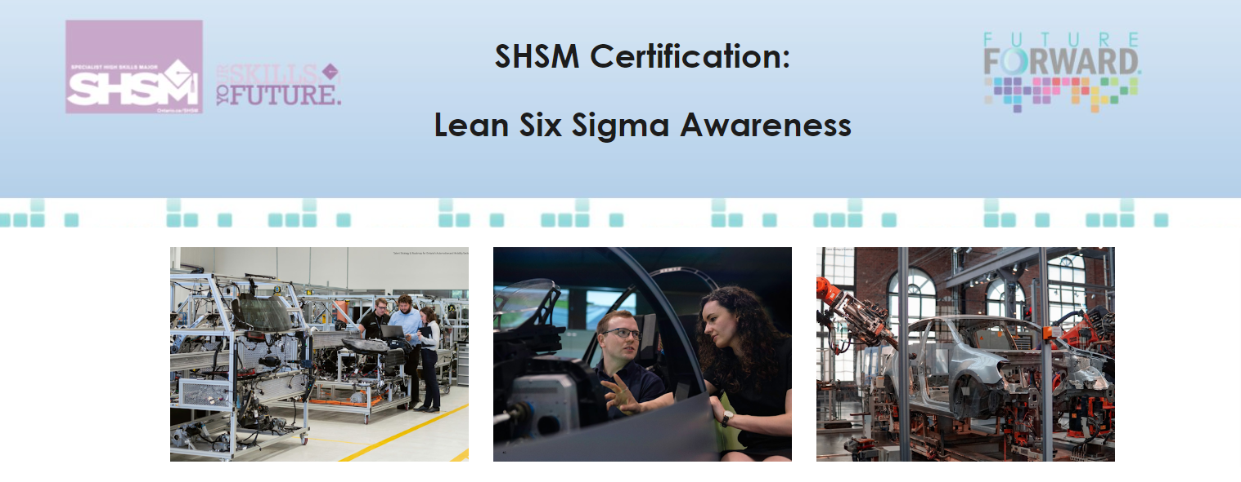
Certification Overview
This resource is designed to provide a broad-based Lean Six SIgma Awareness certification that can be completed by students in all SHSM sectors as 'advanced training in a technique' or 'leadership skills'.
'Lean manufacturing' is an elective SHSM certification for Manufacturing and Food Processing SHM sectors.

How is this a 'leadership skills' certification?
Many organizations use Lean Six Sigma management tools to improve how their organization works. This certification covers real-world terminology and concepts that all students can use in their future as leaders and managers to bring efficiency to an organization.
This certification is strongly recommended for students in the following sectors: Agriculture, Business, Construction, Energy, Environment, Food Processing, Health Care, Hospitality & Tourism, Information & Communication Technology, Manufacturing, Mining, Non-Profit, and Transportation.

As students progress through each module, there is a Student Workbook that they can add their thoughts and ideas to. It is clearly indicated in each module when students will need to add anything to the student workbook.
In total, this certification will take approximately 3 hours to complete.
This certification in Lean Six Sigma Awareness includes an introduction, six modules, and one extension module.
- Modules 1 introduces the Lean Approach, and explores the principles and methodologies used in the Lean Approach.
- Module 2 introduces Six Sigma, and introduces students to some basic terminology used by Six Sigma practitioners.
- Modules 3 puts Lean and Six Sigma together, and students learn how industry has combined these concepts to create improvements.
- Module 4 demonstrates how Lean Six Sigma is applied in a variety of workplaces.
- Module 5 takes a closer look at the concept of customer experience and how it connects to Lean Six Sigma.
- Module 6 allows students to look at Lean Six Sigma through the lens of their specific SHSM sector.
- Extension model connects students to OVIN (Ontario Vehicle Innovation Network). OVIN has connections to all SHSM sectors.

Certification Format Options
This certification can be educator-led or asynchronously completed by students. It is available as a website only. It can be completed as a ½ day certification or over the course of a few class periods.

Certification Assessment Options
For students to receive this certification, educators can choose to have students submit the student workbook and/or complete a multiple choice quiz. Content from the Student Workbook can be used to develop a self-marking quiz if you are assessing students using an auto-marking tool.

There are 2 separate Student Workbooks:
- Student Workbook for Modules 1-6
- Student Workbook for Extension Module: Connecting Lean Six SIgma to the Ontario Vehicle Innovation Network (OVIN)

Certificate sample

