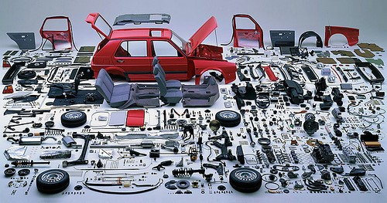
Aftermarket Parts Design for the Transportation Industries Aftermarket parts (also known as generic parts or non-OEM parts) are made by a manufacturer other than your vehicle's original manufacturer. These parts are designed to perform the same function as the original part and can be used as replacements for the car's original parts when doing repairs.

Product Life Cycle:
A product life cycle is the length of time from a product first being introduced to consumers until it is removed from the market. Product life cycles are used by management and marketing professionals to help determine advertising schedules, price points, expansion to new product markets, packaging redesigns, and more. These strategic methods of supporting a product are known as product life cycle management. They can also help determine when newer products are ready to push older ones from the market.
There are 10 stages of Product Life Cycle in Automobile Industry:
- Concept Sketching
- Styling Class-A
- Feasibility check
- Concept Validation
- New Product Design

- Development Stage
- Prototype Build
- Design Validation
- Pilot Production
10. Mass Production

Assignment:
You have been asked by your local Car Club to design and create a 3D model / mesh of an aftermarket car part. Using any 3D modelling software of your choice, design, prototype, create, and test one of the following car parts listed below. Items that will need to be considered and shown in your design work are:

- How will this attach/mount to the existing vehicle
- Materials and the environmental impact
- Cost
- Can this actually be manufactured

** They are interested in customization (with their own branding) on the part as well. Your design should include a basic logo embed on your feature.

Parts options:
- Hood scoop
- Antena fin
- Roof rack for equipment attachments
- Spoiler
- Deck lid
- Grill to incorporate ADAS

Submission Requirements:
- Your design process and all supporting documents, sketches, preliminary research, mind mapping.
- Your .OBJ file (3D model file) ready for print.
- One exploded view of your part and fastener parts.
- One fully orthographic viewed drawing.
- Findings from your design work and testing.

3D modelling - Rubric

 | Not Yet Met  (below Level 3) | Criteria Meets  (Level 3) | Exceeds Criteria  (Level 4 )
Knowledge and Understanding‐ Subject‐specific content acquired and the comprehension of its meaning and significance
Understanding of content (e.g. concepts, ideas, theories, principles, procedures,process. |  | Demonstrates no significant  misconceptions. Usually gives complete or nearly complete explanations.

Thinking and Investigation‐ The use of critica, creative thinking skills and inquiry, research and problem‐solving skills or processes
Use of processing skills and strategies (e.g. performing and recording, gathering evidence and data, observing). |  | Is able to design a model that is refined, accurate and reflects the hypothesis.  Explanation of the model is good with supporting details.
Use of critical/ creative thinking processes, skills and strategies (e.g. analysing, interpreting, problem solving, forming and justifying conclusions on the basis of evidence). |  | Is able to develop an imaginative model that displays good use of available resources, well thought out and above ordinary approach. Creative use of material and design.

Application‐ The use of knowledge and skills to make connections within and between various contexts
Transfer of knowledge and skills (e.g. concepts and processes) to unfamiliar contexts. |  | Is able to answer most or all of the questions with some explanation and detail,therefore considerable effectiveness.

Communication ‐The conveying of meaning through various forms
Expression and organization of ideas and information (e.g. clear expression, logical organization) in oral, visual and written forms (e.g. diagrams and models). |  | Is able to communicate and organize  ideas with considerable effectiveness  Is able to engage audience with  considerable effectiveness.
Use of supplemental materials in a PowerPoint  or similar presentation tool. The use of pictures, videos, etc...to enhance the understanding of the project. |  | Presentation includes pictures with some link to the 3D model  Uses charts and diagrams where appropriate and their purpose is clear.

Comments:

