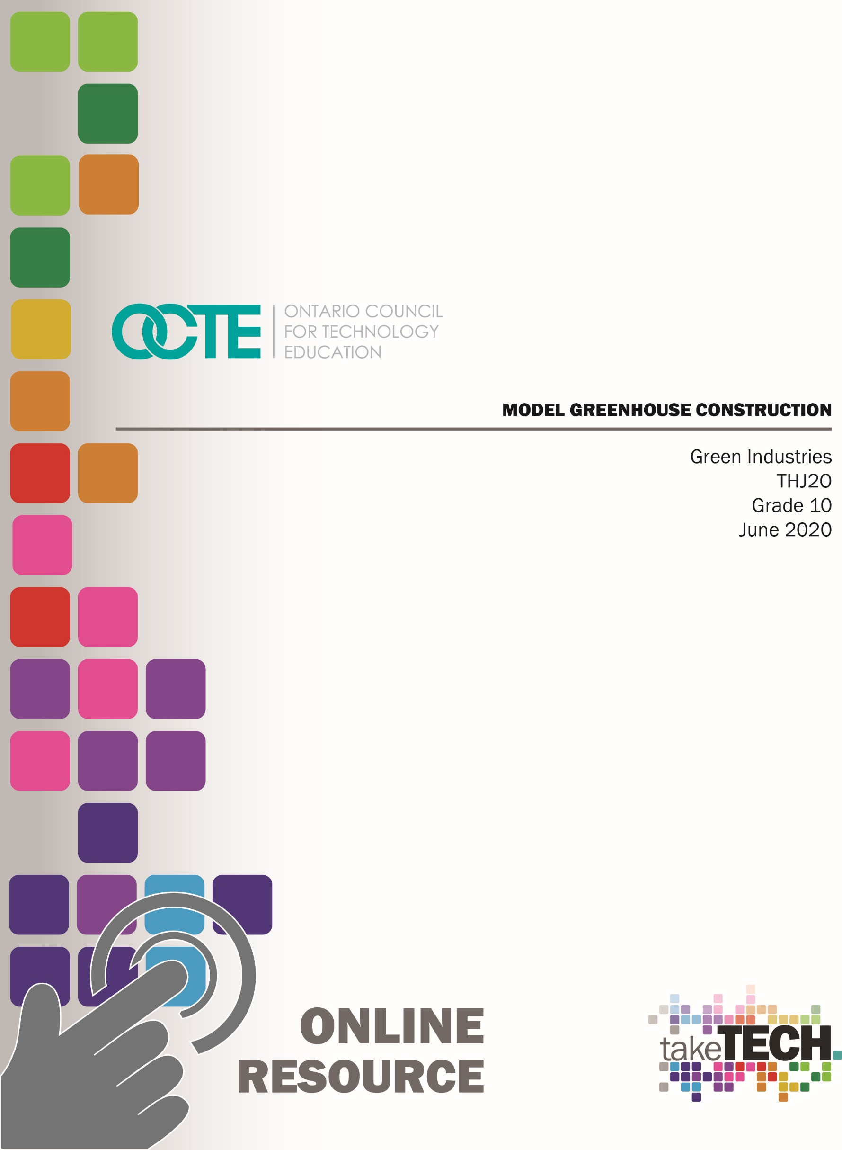

Table of Contents
Introduction 2
Project Outline 2
Prior Knowledge 3
Student Activities 3
Planning Notes 4
Resources and/or Handouts 4
Instructional Strategies 6
The Hook / Motivational Strategies 6
Learning Goals and Success Criteria 6
Learning Goals 6
Success Criteria 6
Overall and Specific Expectations 7
Overall Expectations 7
Specific Expectations 7
Safety Concerns 8
PPE Required: 8
Applicable SAFEDocs and ToolSAFE videos 8
Project Challenges 8
Differentiation of the Project / Activity 8
Assessment and Evaluation 9
Career and Industry Extensions 10
Ethical/Environmental Considerations 10
Reflection or Design Report 10
Appendix A – Building a Mini Greenhouse THJ2O 11
Appendix B - Brainstorming - Questions and Research 12
Appendix C – Design Process Checklist 13
Appendix D – Assessment Rubric 14
Appendix E – Reflection Notes 15
Appendix F – Teaching Notes 16
References 19

Introduction
Course Code: THJ2O
Broad base Technology: Green Industries
Destination: Open
Grade Level: 10
Prerequisite: none
Online Project Name: Model Greenhouse Construction

Project Outline
Based on concepts studied in class, students will design and construct a scale model of a greenhouse using teacher-approved materials. Using the design process, each student designs and builds a device that will act as a greenhouse in which to propagate plants from seed. Students will build a greenhouse that allows for easy access and could be used in an actual home setting. This can be significant for those interested in propagating organic plant material or establishing their own food sources during a pandemic for example. This activity will begin with formal lessons on the history, purpose, design, and factors associated with greenhouse operation.
Project Outline:
- Introduction – What is a greenhouse and what role do they play in society?
- Activity # 1: Early history of greenhouses
- Activity # 2: Factors contributing to successful plant growth
- Activity # 3: Study of greenhouse materials and styles
- Activity # 4: Greenhouse research and design
- Activity # 5: Greenhouse construction
By the end of this project, the student will:
- Gain knowledge of the contributing factors in good greenhouse design
- How to maintain suitable plant growth using proper greenhouse operation techniques
- Problem solve using the Design Process
- Create an item that can be used in everyday life.

Prior Knowledge
Students should have some basic skills equivalent to grade 10 level. Those skills include,
- Mathematical skills
- Measuring skills
- Safe and correct use of tools/equipment relevant to the construction of the project
- Decision-making skills
- Brainstorming and research techniques
- An understanding of the design process
- Drawing and sketching skills
- Communication skills (written and oral)
- A general awareness of safety, as it relates to shop practice
- Word Processing

Student Activities
Introduction (Teacher) - What is a greenhouse and what role do they play in society?
Activity 1 (Teacher) Early history of greenhouses
Activity 2 (Teacher) Factors contributing to successful plant growth
Activity 3 (Teacher) Study of greenhouse materials and styles
Activity 4 (Student) Greenhouse research and design
Activity 5 (Student) Greenhouse construction

Planning Notes
- Prepare for opportunities for students to sketch, brainstorm, plan and create final drawings.
- Review Board policy on computer/Internet use (safety/censorship).
- Review all resources in advance.
- Prepare all materials for the safety demonstrations.
- Prepare all tools and equipment required for the safety demonstration ensuring that the equipment is in good working order and the safety guards are in place.
- Prepare a lesson on greenhouse history, structures, functions, purposes, and requirements.
- Prepare a discussion reviewing the overall project. The discussion should include materials used, processes and construction techniques, collaboration, teamwork, technical skills, and how the project ministers to the wider community.
- Emphasizing safety, demonstrate how material is cut and fastened.
- Prepare any handouts for students.

Resources and/or Handouts
The resources for this project include the following:
- Building a Mini Greenhouse Outline - please see Appendix A
- Brainstorming - Questions & Research - please see Appendix B
- Design Process Checklist - please see Appendix C
- Assessment Rubric - please see Appendix D
- Reflection - please see Appendix E
- Teacher Planning Notes – please see Appendix F
Pictures/Blueprints
- Unsplash
- Pixabay
- Pexels
- Freeimages

Tools/Equipment
Some tools may be required depending on individual student designs. Students must create their project using the resources they have available to them. Teacher will assist on an as needed basis.
Software
Computer software is not necessary for the drawing portion of this activity. Software programs may vary from school to school and students are encouraged to use the one they are most comfortable with. Access to a word processing program should also be available.
Materials
Materials for this activity should be readily available at school. Resourceful students should be able to acquire materials from home or at the very least from their local dollar or discount store.
Textbooks/Books
Calkins, Carroll C. Reader's Digest Illustrated Guide to Gardening in Canada. Reader's Digest Association (Canada), 1979. ISBN 0-88850-081-5
Parker, Rick. Introduction to Plant Science. Delmar Publishers, 2000.
ISBN 0-8273-7307-4
Shry, Carroll L., and H.E Reiley. Introductory Horticulture. 6th ed., Delmar Publishers, 2002. ISBN 0-7668-1567-6
Videos/Links
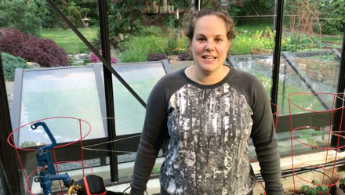 | Drip Irrigation in the Greenhouse  https://www.youtube.com/watch?v=wz_AA16-iQs
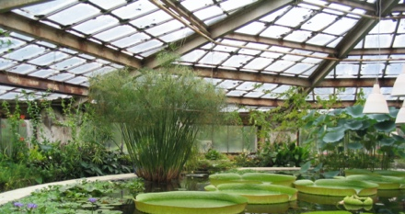 | Greenhouse Wikipedia Article  https://en.wikipedia.org/wiki/Greenhouse
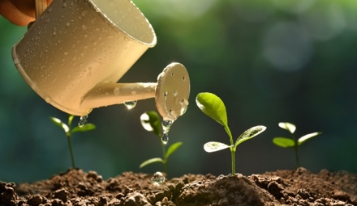 | 4 Plant Growth Factors That Affect All Plants  https://garden.lovetoknow.com/garden-basics/plant-growth-factors
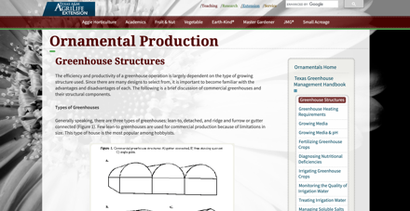 | Ornamental Production Greenhouse Structures  https://aggie-horticulture.tamu.edu/ornamental/greenhouse-management/greenhouse-structures/

Instructional Strategies
Teachers may use any of the following instructional strategies; 3-Part lesson, lecture, storyboard, word wall, think-pair-share, placemat activity, rapid write, K-W-L, anticipation chart, ABC taxonomy, think aloud, analyzing text, Cornell note taking, exit ticket/ticket out the door, plus/minus/delta, etc.

The Hook / Motivational Strategies
Being able to grow your own fruits and vegetables offers many benefits. This could become especially important in a time of a pandemic where shortages may occur. Organically grown fruits and vegetables also offer many benefits. Being resourceful and creative can also be an inexpensive alternative over the long run. It can also allow one to be self-sufficient.

Learning Goals and Success Criteria

Learning Goals
- Students will recognize the role of greenhouses in society
- Students will explore the concepts of greenhouse function and purpose
- Students will explore the benefits of self-sufficiency and advantages of growing their own produce including flowers and vegetables
- Students will apply the steps in the design process to construct a greenhouse
- Students will discover and use google sites for research purposes

Success Criteria
- Students will develop individual and teamwork skills in a workplace environment
- Students will demonstrate the steps in the design/construction process
- Students will demonstrate communicate skills through working and final drawings
- Students will describe the rationale of their design

Overall and Specific Expectations in Support of Ontario Curriculum Grades 9 - 10 Technological Education

Overall Expectations
A3. Demonstrate an understanding of design procedures and applications and production processes and systems as they relate to the green industries.
A4. Demonstrate competence in the use of mathematical, documentation, and communication skills as they apply to the green industries.
B2. Demonstrate competence in applying introductory technical skills used in the green industries.
D2. Identify careers in the green industries and describe the skills, education, and training required for entry into these positions.

Specific Expectations
A3.2 Identify a variety of design concepts and production processes and systems used in the green industries (e.g., simple garden designs, floral designs, greenhouse production layouts, barn layouts, lumber grading systems, sow operations, grape production).
A4.3 Use imperial and metric units of measurement correctly and make accurate calculations and measurements for various applications in the green industries (e.g., land area, volume, distance, scaling, pacing, weight, unit conversions, tree height).
B2.2 Demonstrate competence in the application of fundamental construction skills (e.g., selecting materials, measuring, cutting, joining) to a variety of construction projects (e.g., hard construction, laying pavers and flagstones, constructing a garden, building storage bins, creating a display booth).
D2.5 Demonstrate an understanding of the work habits that are important for success in the green industries, as identified in the Ontario Skills Passport (e.g., working safely, teamwork, reliability, organization, working independently, initiative, self-advocacy, customer service).

Safety Concerns
Safety concerns arise if a student requires wood or other materials to be cut. Cutting must be completed with the assistance of the teacher (at school) or using hand tools at home. Hot glue guns may be required in some instances. Please refer to the SAFEDocs for Green Industries located on the OCTE website.

PPE Required:
- Safety Glasses
- Gloves where applicable

Applicable SAFEDocs and ToolSAFE videos
Please refer to the SAFEDocs for Green Industries located on the OCTE website

Project Challenges
This project can be differentiated by:
- the use of more specialized software
- the research assignments could be assisted by an EA
- the activity could be observations of the teacher’s model greenhouse project
- the teacher could ask verbal questions to a student while an EA scribes during a synchronous interaction

Differentiation of the Project / Activity
Teachers can also refer to the Differentiation Scrapbook to take into account for learner ability, multiple intelligences, exceptional students, and ESL learners.

Assessment and Evaluation
Assessment should be ongoing and feedback to students should be immediate to promote student learning. This project is high in process content and substantial learning occurs during production. The final product does not necessarily reflect the learning. Assessment criteria should be posted in advance, for example see Appendix A, Building a Mini Greenhouse.

Assessment As Learning
- Make comments/suggestions as required.
- Provide timely/descriptive feedback.
- Keep students motivated and on track to be successful in the learning outcomes.
- Reflect on instructional next steps/modifications/accommodations.

Assessment For Learning
- Ask questions about student’s experience within green industries.
- Ask questions regarding experience working on other projects.
- Find out about students’ interests.
- Review recent report cards.
- Reflect on instructional next steps/modifications/accommodations.

Assessment Of Learning
- Review and evaluate each project.
- Triangulate assessment

Career and Industry Extensions
Students can explore career connections and opportunities in any Green Industry field:
- Landscape Design
- Landscape Construction/Installer
- Greenhouse Worker
- Landscape Technician
- Horticulturist
- Arborist

Ethical/Environmental Considerations
- Growing plants within a greenhouse allows gardeners to go green, which is a benefit to gardeners and the earth. Adding more plants helps to provide a fresher, cleaning atmosphere, making a greenhouse a great tool for fighting global warming.
- Many people are unhappy about the dangerous pesticides found on many commercially raised crops.
- Greenhouse gardening can even offer the advantage of saving energy, including using recycled materials. It can also reduce air and water pollution.

Reflection or Design Report
Teachers may wish to have the students complete a design report, reflection or create a portable greenhouse to consolidate their learning. This would be a nice way to capture the student’s understanding in a summative format and be used in preparation for further course tests or examinations.

Appendix A – Building a Mini Greenhouse THJ2O
Challenge: Your assignment is to design and construct a mini greenhouse, capable of housing one seed tray measuring 9 inches wide, 20 inches long and 3 inches high. Your model should allow for easy placement and replacement of the tray. The model should be for the propagation of plants from seed. Please allow a sufficient height so that your model can allow for small plants under one foot. You must have a way to access the inside of your greenhouse to maintain your plant material. You will have access to polyethylene, wood, and other building materials. You will also research this project to obtain some ideas. Remember to keep a list of all the resources you used for this project.

Please refer to the Design Process Checklist handout and include a 250-word essay of your rationale. Along with your model, your report should include:
- Title Page
- Rationale or concept of your model
- Materials list including the purpose of each of the materials used.
- Sketches

Appendix B - Brainstorming - Questions and Research
- What materials should I use?
- What materials do I have access to?
- What style of greenhouse should I construct? Have 2 or possibly 3 sketches.
- Should I build it with a waterproof bottom in case of water leakage?
- Should I make it portable?
- How big should I make it?
- How will I design my greenhouse so that I will be able to water plants in the future?
- What kind of plant propagation will I be doing?
- What tools do I have access to?
- Do I have a ‘Plan B’ in place?
- Do I have access to other alternative coverings such as plexiglass or clear acrylic?

Appendix C – Design Process Checklist
- Do you have the proper writing utensils and paper?
- Are you competent with a measuring tape or ruler?
- You will need to make 2 or possibly 3 rough sketches showing top, front, and side views.
- Did you make a list of possible materials?
- Gather your materials. See what is available to you and if you will have to acquire additional materials.
- Check to make sure the proper tools are available.
- Make sure you read over any safety material and always ask if you are unsure about something.
- Make a list of all your materials/fasteners and give the purpose of each one.
- Prepare in writing, a 250-word document outlining your ideas/rationale.

Appendix D – Assessment Rubric

Criteria | Level 1 | Level 2 | Level 3 | Level 4
Communication
Create design drawings | creates design drawings with limited awareness of accuracy | creates design drawings with some awareness of accuracy | creates design drawings with competent awareness of accuracy | creates design drawings with thorough awareness of accuracy
Thinking/Inquiry
Brainstorm design using the design report format | applies few of the skills involved in the design process | applies some of the skills involved in the design process | applies most of the skills involved in the design process | applies all the skills involved in the design process
Knowledge/Understanding
Describe materials that are appropriate for a given project | briefly describes materials that are appropriate for a given project | adequately describes materials that are appropriate for a given project | substantially describes materials that are appropriate for a given project | thoroughly describes materials that are appropriate for a given project
Explain concept providing details | explanation of concept provided limited details | explanation of concept provided some details | explanation of concept provided considerable details | explanation of concept provided thorough details
Application
Construction | finished project contained many construction flaws | finished project contained several construction flaws | finished project contained 1 or 2 construction flaws | finished project contained no construction flaws
Demonstrate safe use of tools, materials, and processes | demonstrates limited safe use of tools, materials, and processes | demonstrates adequate safe use of tools, materials, and processes | demonstrates considerable safe use of tools, materials, and processes | demonstrates excellent safe use of tools, materials, and processes
Demonstrate appropriate personal and health and safety practices | infrequently demonstrates appropriate personal and health and safety practices | often demonstrates appropriate personal and health and safety practices | usually demonstrates appropriate personal and health and safety practices | routinely demonstrates appropriate personal and health and safety practices
Demonstrate the process to test and evaluate project materials or components | demonstrates limited ability to follow procedures to test and evaluate project materials or components safely and effectively | demonstrates some ability to follow procedures to test and evaluate project materials or components safely and effectively | demonstrates considerable ability to follow procedures to test and evaluate project materials or components safely and effectively | demonstrates excellent ability to follow procedures to test and evaluate project materials or components safely and effectively
Note: A student whose achievement is below level 1 (50%) has not met the expectations for this assignment or activity.

Appendix E – Reflection Notes
- Explain what you liked and disliked about this project. Why?
- Did you learn something new? What stands out?
- If you had to revise one or two things on your final project, what would they be?
- Please provide any feedback you may have for improving this lesson.

Appendix F – Teaching Notes

Activity 1
(Teacher) - What is a greenhouse and what role do they play in society? Use a class discussion to open the students to test for prior knowledge.
Main role - Allows us to produce plants in a controlled environment. To produce plants out of season.

Activity 2
(Teacher) Early history of greenhouses
Existed in Roman times to have food year-round. The concept of the greenhouse involved in Europe in the 17th century in the Netherlands, Italy, and England. One of the problems was balancing the heat. Made mostly of glass back then. Structures have varied in design and materials over the years. Polyethylene is a popular choice today as well.

Activity 3
(Teacher) Factors contributing to successful plant growth
- Adequate light
- Favorable air control
- Protection from insects, animals, and diseases
- Suitable growing media including moisture and essential elements
Favorable enclosure temperatures – Remember, when radiant light enters the greenhouse it becomes trapped inside, therefore creating a heat source.
Computerized greenhouses allow us to control:
- Light Intensity
- Temperature
- Humidity
- Fans
- Shading
- Venting
- CO2
- Water Consumption

Activity 4
(Teacher) Study of greenhouse materials and styles
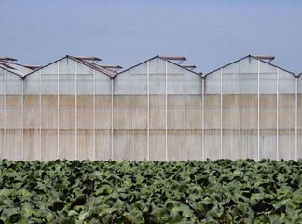 Gutter-connected
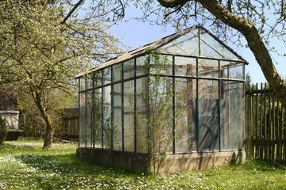 Stand-alone or detached
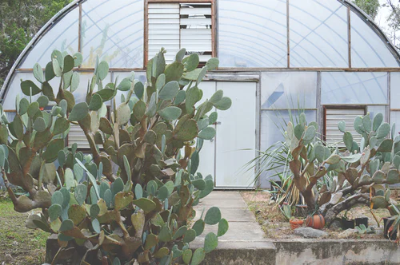 Quonset or Hoop-house

2 popular (actual) coverings are:
Glass
- Expensive
- Last longer
- Allows more light to pass through
- Retains less heat
- Requires constant cleaning
- More condensation
Polyethylene
- Usually two-ply with air in between to act as an insulator
- Allows less light to pass through
- Darkens with age (ultra-violet rays affect it)
- Lasts about 10 years if properly maintained
- Less expensive. Retains more heat
Other Materials
- Brick
- Wood
- Galvanized steel
- Aluminum

Activity 5
Research and Design
Students will be given time to research and design their model. Time may also be spent outside the classroom to finish the activity. Students are asked to seek the help of the teacher where needed.

Activity 6
Construction – Students begin the construction phase of the project.
Activity | Topics | Length
Activity 1 | Introduction - What is a greenhouse and what role do they play in society? | 15 minutes
Activity 2 | Early history of greenhouses | 15 minutes
Activity 3 | Factors contributing to successful plant growth | 30 minutes
Activity 4 | Study of greenhouse materials and styles | 30 minutes
Activity 5 | Greenhouse research and design | 60 minutes
Activity 6 | Greenhouse construction | 180 minutes

References
21st Century Competencies: Foundation Document for Discussion. Phase 1: Towards Defining 21st Century Competencies for Ontario, Winter 2016 Edition, 2016 http://www.edugains.ca/resources21CL/About21stCentury/21CL_21stCenturyCompetencies.pdf
Course Codes for Emphasis courses in the Revised Curriculum: Technological Education, Grades 11 and 12, 2009 http://www.edu.gov.on.ca/eng/curriculum/secondary/techedemphasiscourses.pdf
Drip Irrigation in the Greenhouse (Image), 2020 https://www.youtube.com/watch?v=wz_AA16-iQs
Freeimages (Images), 2020 https://www.freeimages.com/
Early History of Greenhouses (Website), 2020 https://en.wikipedia.org/wiki/Greenhouse
Greenhouse Structures (Website), 2020 https://aggie-horticulture.tamu.edu/ornamental/greenhouse-management/greenhouse-structures/
Growing Success: Assessment, Evaluation, and Reporting in Ontario Schools, First Edition, Covering Grades 1 to 12, 2010 www.edu.gov.on.ca/eng/policyfunding/growSuccess.pdf
Learning for All – A Guide to Effective Assessment and Instruction for All Students, Kindergarten to Grade 12, 2013 http://www.edu.gov.on.ca/eng/general/elemsec/speced/LearningforAll2013.pdf
Pexels (Images), 2020 https://www.pexels.com/
Pixabay (Images), 2020 https://pixabay.com/
Plant Growth Factors (Article), 2020 https://garden.lovetoknow.com/garden-basics/plant-growth-factors
The Differentiated Instruction Scrapbook http://www.edugains.ca/resourcesDI/EducatorsPackages/DIEducatorsPackage2010/2010DIScrapbook.pdf
The Ontario Curriculum, Grades 9 and 10: Technological Education, 2009 (revised) http://www.edu.gov.on.ca/eng/curriculum/secondary/teched910curr09.pdf
The Ontario Curriculum, Grades 11 and 12: Technological Education, 2009 (revised) http://www.edu.gov.on.ca/eng/curriculum/secondary/2009teched1112curr.pdf
Unsplash (Images), 2020 https://unsplash.com/

