Sketching Concepts

Sketching is a great way to come up with concepts quickly. It can be created on the train, at home, in a restaurant, in the park. All you need is a sketch pad and a writing tool.

Review the following videos on interior and exterior sketching.
  - Sketching video https://www.youtube.com/watch?v=EywSBcVcCVY
  - Sketching Interior view https://www.youtube.com/watch?v=Br95iIbkm20

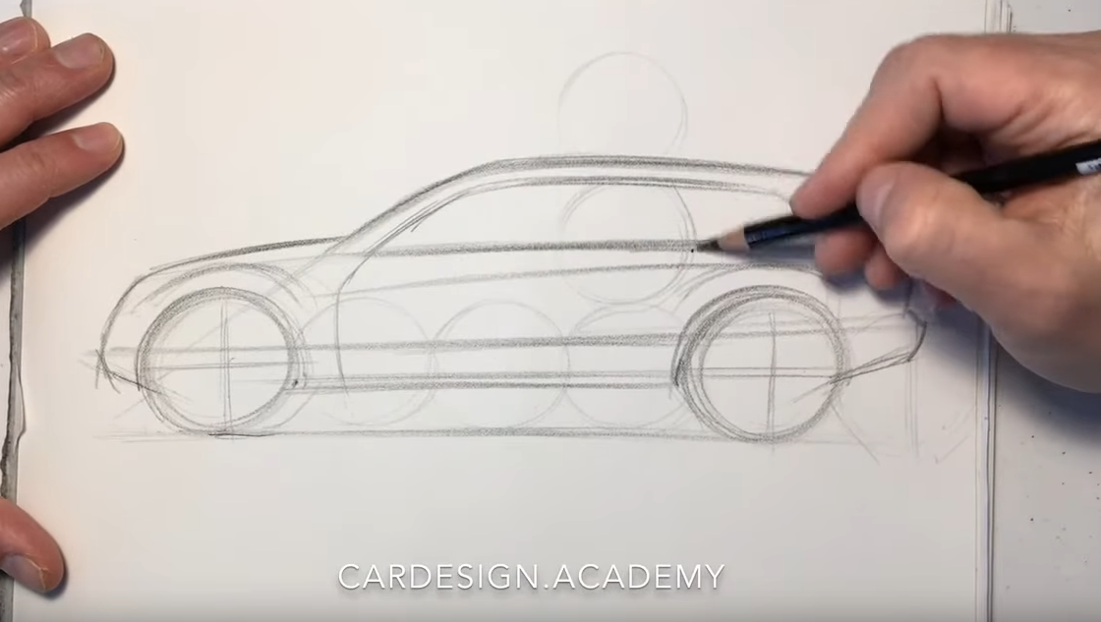

Task
- Develop 2-3 different concept sketches each for the taxi's exterior and interior design, using paper and pencils. Focus on the overall style and shape. Use the techniques reviewed in the videos. Textures and colours could be added at this stage but might be limited. The focus should be on overall style. Start with the wheel circles to get the scale and slowly move forward with the design. Don’t worry about making mistakes, focus on the concept and see where it takes you.

