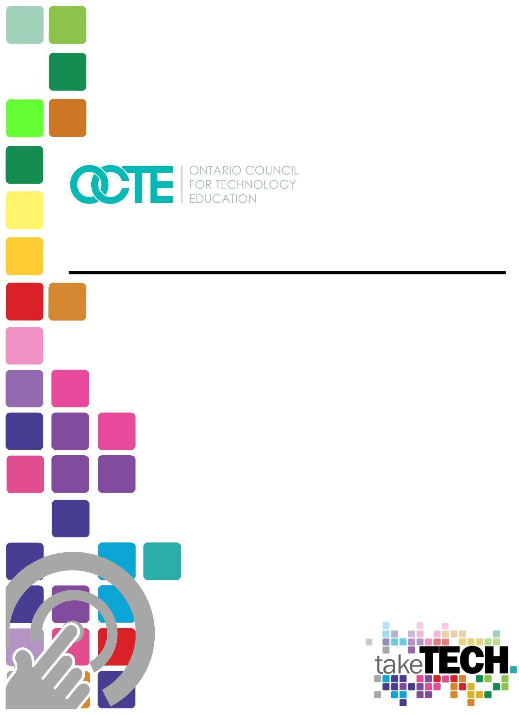

Future Forward - Grade 10 Career Studies Resource
What’s Driving the Future of Work in Ontario?

Table of Contents
Table of Contents 1
Introduction 1
Resource Outline 2
Prior Knowledge 2
Student Activities 2
Lesson 1 –Identifying Future Trends & Adapting to the Changing World of Work 2
Lesson 2 –Future-Proof Your Career with Transferable Skills 2
Lesson 3 – Finding Your Fit in Future Labour Markets 3
Planning Notes 3
Resources 4
Instructional Strategies 5
The Hook / Motivational Strategies 5
Learning Goals and Success Criteria 5
Overall and Specific Expectations in Support of Ontario Curriculum Grades 9 - 10 Technological Education 6
Overall Expectations 6
Specific Expectations 6
Safety Concerns 7
Differentiation of the Project / Activity 7
Assessment and Evaluation 7
Career and Industry Extensions 7
Ethical Considerations 8
Lesson 1 – Identifying Future Trends & Adapting to the Changing World of Work 9
Lesson 2 – Future-Proof Your Career With Transferable Skills 9
Lesson 3 – Understanding Labour Market Trends 10
Reflection or Design Report 10
References 11

Introduction
Course Code: GLC20, The Ontario Curriculum, Career Studies
Destination: Open
Grade Level: 10
Resource Name: Future Forward - What’s Driving the Future of Work in Ontario?

Resource Outline
The lessons provided in this resource will provide learners with an opportunity to understand the rapidly changing landscape of the future of work in Ontario. This resource uses the automotive and mobility sector as a ‘spotlight’ or exemplar. Students will view trends and data in the automotive and mobility sector as a lens through which to understand the ’Future of Work’.
The learner will analyze concepts and terms associated with the trends that are driving the future of work, transferable skills and labour markets. At the end of this assignment, the learner will have successfully used these concepts to improve their understanding of trends to make predictions about changes to the future of work in Ontario, have assessed their transferable skills, and will have reflected on their labour market ‘fit’ and opportunities.

Prior Knowledge
There are no prerequisites for the content contained in this resource. Teachers are encouraged to use the provided lesson plans, slides, handouts and links, throughout this resource. This resource has been written with the understanding that many of these concepts are new to Grade 10 students.
Teachers are encouraged to review this resource and consider how some of these items may replace lessons in their existing Careers Studies course offering. These lessons are designed to cover basic concepts covered in Careers Studies, using updated information and resources on labour market trends, transferable skills and the future of work.

Student Activities

Lesson 1 –Identifying Future Trends & Adapting to the Changing World of Work
- Understanding the ‘Future of Work’ and how to think like a futurist
- What are the current and future trends changing the nature of work in Ontario
- Industry spotlight: How will the automotive and mobility sector be impacted by these trends?

Lesson 2 –Future-Proof Your Career with Transferable Skills
- What are transferable skills?
- What transferable skills are essential in the ‘Future of Work’?
- Experiencing collaboration and its importance
- What is upskilling?
- What is reskilling?

Lesson 3 – Finding Your Fit in Future Labour Markets
- What is a labour market?
- How do I find, read and understand labour market data?
- Reflecting on how my skills match labour market trends

Planning Notes
It is estimated that the combination of lessons, activities, and assignments will take learners a minimum of 3, 75 minute periods to complete. Accommodation of extra time may be required for some learners. Extension activities are provided throughout for teachers who want to delve deeper into these topics with their students.
While these lessons are designed to keep a quick pace in a short (½ credit) course, teachers are encouraged to allocate up to 5 days to these lessons to allow for the adoption of the extension activities, which will deepen the learning experience for students. Ultimately, these lessons can ‘flex’ to fit a teacher’s ideal time horizon.
While these lessons have been placed in an intentional sequence, and are best delivered as a whole, they were also designed so they could be delivered as stand-alone lessons, dispersed throughout the course, or used in any order the teacher prefers.
Most activities can be saved or reflected upon in a student’s Individual Pathways Plan or a portfolio. Teachers are encouraged to remind students to continually reflect upon their findings using the questions: Who am I? What are my opportunities? Who do I want to become? What is my plan for achieving my goals?
Note: These lessons, and activities have been designed in such a way that a teacher can easily post slides and handouts to an online classroom, however, these have not been designed for asynchronous use. Teachers are encouraged to lead the whole class live, synchronously in these lessons. The included extension activities are designed to be assigned for asynchronous learning through an online classroom such as Google Classroom or Brightspace.
- Create a digital space for each learner to submit and receive the material (e.g., Microsoft One Drive, Google Drive, Dropbox, etc.)
- Post or provide the learners with the materials at timed intervals or all at once.
- Provide timely feedback to learners
- Review all links before the start of this project

Resources

Files
1a. Future Forward Careers - Lesson 1 – Identifying Future Trends & Adapting to the Changing World of Work
1b. Future Forward Careers - Lesson 1 – Slidedeck - Identifying Future Trends & Adapting to the Changing World of Work
1c. Handout - Future of Work
1d. Handout - Think Like a Futurist
1e. Handout - Reflecting on the 5 Trends2a. Future Forward Careers - Lesson 2 - Future-proof Your Career with Transferable Skills2b. Future Forward Careers - Lesson 2 - Slidedeck - Transferable Skills2c. Handout - Future-Proof Your Career With Transferable Skills 2d. Handout - OVIN Website Soft Skills3a. Future Forward Careers - Lesson 3 – Finding Your Fit in Future Labour Markets3b. Future Forward Careers - Lesson 3 - Slidedeck – Finding Your Fit in Future Labour Markets3c. Handout - The Future of Mobility3c. Handout - The Future of Mobility - Answer Key3d. Handout - OVIN Website Scavenger Hunt
3e. Handout - Where do my own skills fit into the Automotive and Mobility Labour Market

Tools/Equipment
- laptop/desktop computer, chromebook or tablet
- data projector or smartboard

Software
- learning management software such as Google Classroom or Brightspace

Materials
- paper to photocopy handouts (if not assigning via an LMS)

Videos
- What is the Future of Work? | World Economic Forum
- How Does a Futurist See the Future: 4 Questions You Need to Know | Jacob Morgan
- Discover the Skills for Success
- Skills for Success - Collaboration
- Skills for Success – Adaptability
- Skills for Success - Writing
- Skills for Success - Reading
- Skills for Success - Problem Solving
- Skills for Success - Numeracy
- Skills for Success - Digital Skills
- Skills for Success - Creativity and Innovation
- Skills for Success - Communication
- How to Play the Human Knot Game
- Collaboration - Auto Industry Example
- Skills Today vs. 5 Years From Now
- How Emerging Technologies Are Impacting Our Workplaces | Future Skills Council
- Essential Skills in the Automotive Industry
- Introduction to Labour Market Information

Websites
- Skills for Success - Assessment and Training Tool - Government of Canada
- Ontario Vehicle Innovation Network - Career Pathways
- Skills Canada Essential Skills App
- Take a Career Quiz - Ministry of Labour - Ontario
- Explore Ontario’s Labour Market Regions - Ministry of Labour - Ontario

Instructional Strategies
- The activities within the lessons have been scaffolded
- The lessons, activities, and assignment have been created using different forms of media and are multi-device supported
- Students are often prompted to reflect upon their learning and make predictions.
- Students can share ideas with a partner or the whole class.

The Hook / Motivational Strategies
Each lesson begins with a whole class brainstorming and discussion activity to engage learners and encourage them to reflect on their personal experiences with the topic.
The lessons, activities, and assignments have been created to allow learners of all abilities to develop and share their knowledge and understanding.

Learning Goals and Success Criteria
- Understand the ‘Future of Work’ and how to think like a futurist
- Can identify the current and future trends changing the nature of work in Ontario
- Define and reflect upon transferable skills?
- Demonstrate an understanding the importance of collaboration
- Define upskilling and reskilling
- Identify, find, read and understand labour market data
- Assess and reflected upon how their skills match the labour market

Overall and Specific Expectations in Support of Ontario Curriculum Grade 10 Career Studies

Overall Expectations
B1 demonstrate an understanding, based on research, of a variety of local and global trends related to work and employment, including the effect some of those trends have had on workers’ rights and responsibilities and on the role of transferable skills in career development today;
B2 develop a personal profile based on an exploration of their interests, values, skills, strengths, and needs, and examine the range of factors that can influence their future education and career/life opportunities

Specific Expectations
B1.1 identify some recent and evolving technological, economic, and social trends that have influenced the world of work, both locally and globally, noting their impact on the kind of work we do and how we do it as well as on workers’ rights and responsibilities, and analyse the possible impact of those trends on their own choices now and in the future;
B1.2 explain how transferable skills are developed through school, extracurricular, and/or community experiences, and analyse how they contribute to a person’s readiness for future educational, life, and work opportunities and to their career development
B1.3 reflect on how the transferable skills they have developed so far have aided them in their learning and in life, and identify the skills that they may need to develop further.
B2.1 investigate their own interests, values, skills (including transferable skills), strengths, and areas that require further development, documenting their insights in a personal profile

Safety Concerns
There are no physical safety concerns for the activities within this resource. Remind students to refrain from sharing any personally identifying information while using the online tools referenced in these activities.

Differentiation of the Project / Activity
Teachers can also refer to the Differentiation Scrapbook to take into account learner ability, multiple intelligences, exceptional students, and MLL learners. The lessons in this document include visual, written, and video-based instruction. Some YouTube videos support Closed Captioning.
Students may choose to complete activities using the Google Read & Write Extension.
Support for Google Read & Write
Quick Reference Guide

Assessment and Evaluation
Assessment and evaluation has not been addressed in this resource. Teachers may determine which observations, conversation and products are best suited for use as assessment as, of and for learning in their course.

Career and Industry Extensions
The ‘Future of Work’ refers to the changing landscape of work and employment, driven by technological advancements and shifting social and economic factors.
All industries, and especially the automotive industry, is impacted by the future of work through changes in the types of jobs available, the skills required, and the ways in which work is done.
The automotive and mobility sector provides employment for millions of people worldwide. It contributes significantly to the economy through manufacturing, sales, and servicing of vehicles. It impacts our lives by enabling the transportation of people and goods, supporting commerce and trade.
The industry drives innovation and technological advancements that have benefits beyond the industry itself. It serves as a salient lens through which to examine the topics contained in this resource. According to the Ontario Vehicle Innovation Network (OVIN), it is estimated that Ontario’s broader automotive industry will face a recruitment gap of 30, 090 individuals in total between 2021 and 2030.
This resource is one of many developed through the Future Forward Project. Future Forward is an OCTE (Ontario Council for Technological Education) resource development project, funded by the Ontario Vehicle Innovation Network (OVIN).
Learn more about OVIN via the linked video below:
Ontario Vehicle Innovation Network Talent Strategy Roadmap Video
Quick Facts about Ontaro’s Automotive and Mobility industry:
- 100,000+ direct jobs plus thousands of spin-off jobs in communities across the province
- Ontario is the only province in Canada that builds cars and trucks
- Ontario has an integrated supply chain, with 700 parts firms and 500+ tool, die and mold makers
- 24 Ontario colleges and 11 Ontario universities offer auto-related research initiatives and training programs
- 200+ companies are developing connected and autonomous vehicle technologies in Ontario
- Ontario’s skilled labour force is key to Ontario auto manufacturing success

Ethical Considerations
These resources have been written to allow students to connect to publicly available ‘job skill’ websites, which are federally and provincially funded and therefore accessible by all who can access the internet (no pay wall or subscriptions required).
Throughout this resource, students are encouraged to consider the concepts through an automotive and mobility sector spotlight, however teachers are advised to encourage students to apply their learning, thinking and reflections to all sectors of our economy.
The lessons in this resource include extension activities. Many of the included extension activities allow students to access additional resources to round out their learning experience to connect to all sectors of our economy.

Lesson 1 – Identifying Future Trends & Adapting to the Changing World of Work
Students will:

- Begin to understand the ‘Future of Work’ and how to think like a futurist
- Examine what are the current and future trends changing the nature of work in Ontario
- Using the automotive and mobility sector as an example, examine how the automotive and mobility sector will be impacted by these trends.

Lesson Plan Link:

1a. Future Forward Careers - Lesson 1 – Identifying Future Trends & Adapting to the Changing World of Work

Google Slides Link:

1b. Future Forward Careers - Lesson 1 – Slidedeck - Identifying Future Trends & Adapting to the Changing World of Work

Handouts:
1c. Future of Work - Handout
1d. Think Like a Futurist - Handout
1e. Reflecting on the 5 Trends - Handout

Lesson 2 – Future-Proof Your Career With Transferable Skills
Students will:

- Define and give examples of transferable skills
- Define upskilling and reskilling
- Understand the importance of collaboration, upskilling and reskilling in the ‘Future of Work’
Lesson Plan Link:
2a. Future Forward Careers - Lesson 2 - Future-proof Your Career with Transferable Skills
Google Slides Link:
2b. Future Forward Careers - Lesson 2 - Slidedeck - Transferable Skills
Handouts:
2c. Handout - Future-Proof Your Career With Transferable Skills 2d. Handout -Soft Skills in the Automotive Industry

Lesson 3 – Finding Your Fit in Future Labour Markets
Students will:
- Describe: what is a labour market?
- Find, read and understand labour market data
- Reflect on how their own personal skills match labour market trends

Lesson Plan Link:
3a. Future Forward Careers - Lesson 3 – Finding Your Fit in Future Labour Markets

Google Slides Link:

3b. Future Forward Careers - Lesson 3 - Slidedeck – Finding Your Fit in Future Labour Markets
Handouts:
3c. Handout - The Future of Mobility3c. Handout - The Future of Mobility - Answer Key3d. Handout - OVIN Website Scavenger Hunt3e. Handout - Where do my own skills fit into the Automotive and Mobility Labour Market

Reflection or Design Report
Upon the conclusion of these lessons, activities, and assignment, the teacher is encouraged to reflect with their learners about:
- What went well?
- What areas need to be improved?
- At what stage were you most engaged?
- How could these lessons, activities, and assignments be improved for next time?
- What advice would you give to someone before starting this work?
- Provide one example of something that you learned.
This reflection can be done through the use of a Google Form (or similar), small group reflection, or use of an LMS (Learning Management Software) discussion forum.

References
Career Pathways - OVIN’s Skills & Career Navigator
https://ovin-navigator.ca/skills-career-pathway/career-pathways/

Essential Skills in the Automotive Industry Video
https://www.youtube.com/watch?v=o5WwXGLc06I

Introduction to Labour Market Information
https://youtu.be/xe2SCDuOXcY?t=1

Labour Market Data - OVIN
https://ovin-navigator.ca/labour-market-insights/lmi-data/

Ovin Navigator
https://ovin-navigator.ca/

Skills for Success Canada
https://www.canada.ca/en/services/jobs/training/initiatives/skills-success.html

Supporting Ontario’s Automotive and Mobility Sector https://www.youtube.com/watch?v=qFURYlVhEcE

The Ontario Curriculum, Career Studies, Grade 10, Open (GLC20), 2019

The Ontario Vehicle Innovation Network
https://www.ovinhub.ca/

Transportation - OCTE
https://www.octe.ca/en/take-tech/our-curriculum-technological-education/exploring-tech-courses-in-high-school/bbt-transportation

Upskill and Reskill Definitions
https://learning.linkedin.com/resources/upskilling-and-reskilling/upskilling-reskilling#:~:text=Reskilling%20definition,toward%20a%20different%20path%20entirely.

World Economic Forum - The Future of Jobs Report 2023 and Skills Today vs. 5 Years From Now
https://www.weforum.org/reports/the-future-of-jobs-report-2023/infographics-2128e451e0

