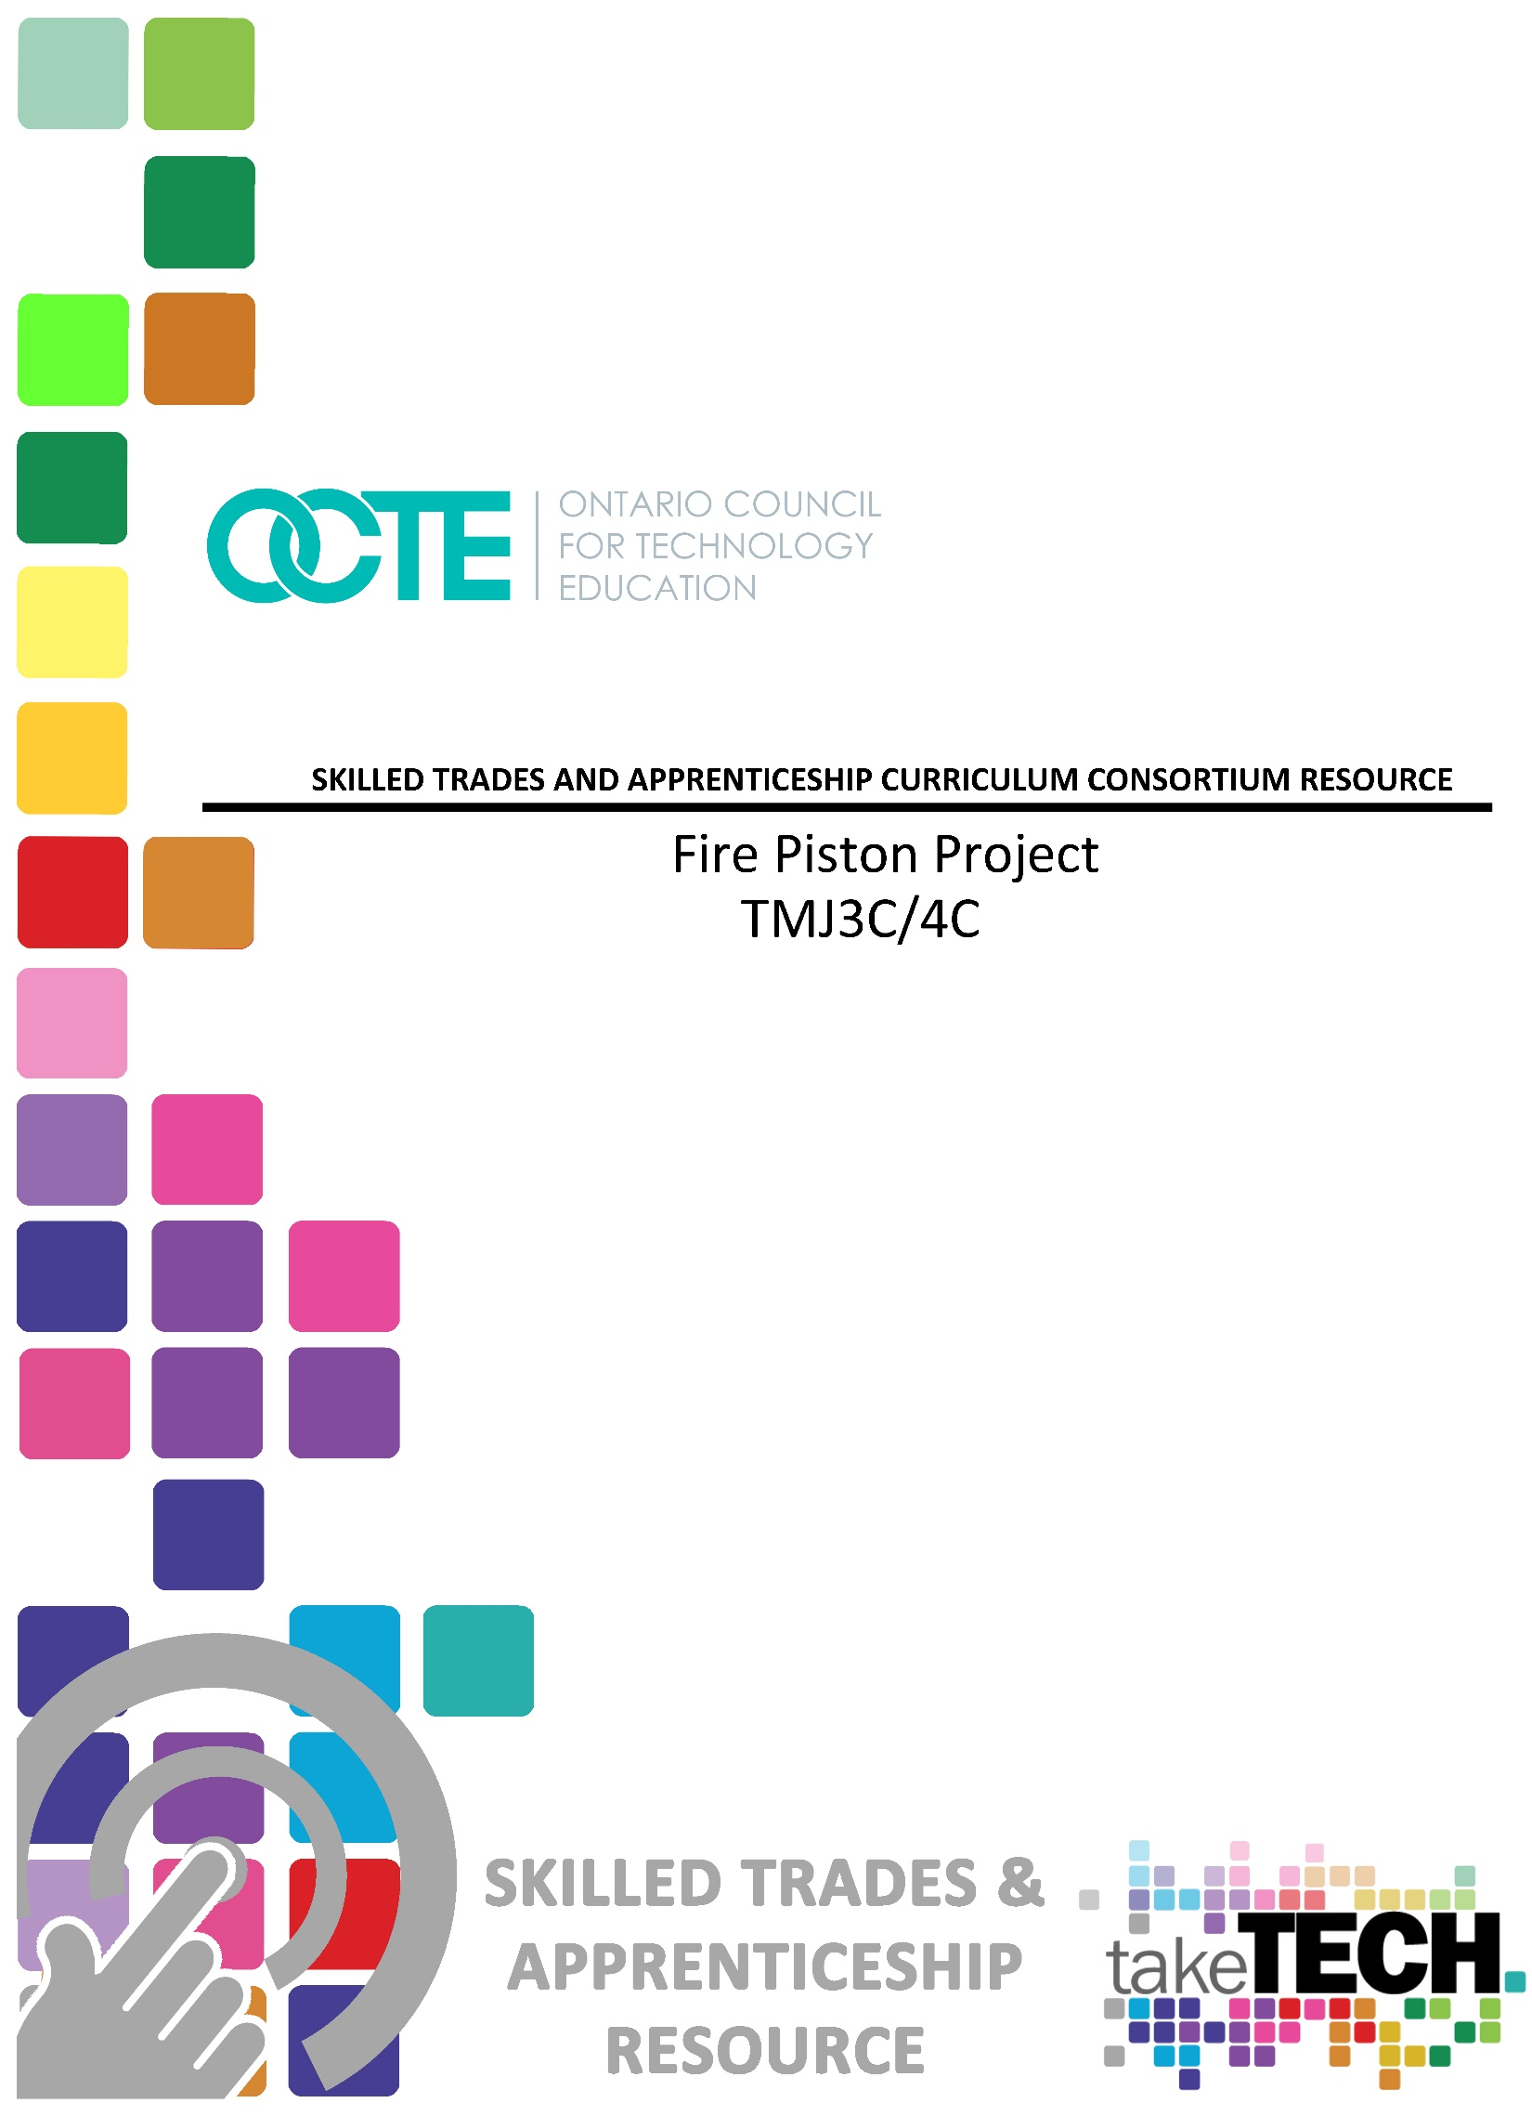

Table of Contents

Introduction 3
Project Outline 3
Prior Knowledge 3
Student Activities 4
Teacher Resources 4
Activity 1 – Machining the Fire Piston Cylinder 5
Activity 2 – Machining the Fire Piston 5
Activity 3 – Machining the .3125 End Cap 6
Activity 4 – Machining the .375 End Cap 6
Planning Notes 6
Skilled Trades and Apprenticeship Opportunities 7
Career and Industry Extensions 7
Continuum of Influence 8
Continuum of Skills 8
Resources 10
Blueprints 10
Pictures 10
Lesson Plan 10
Handouts 10
Materials 11
Exemplars 11
Websites for Teachers 11
Videos 11
Tools/Equipment 12
Instructional Strategies 12
The Hook / Motivational Strategies 12
Learning Goals and Success Criteria 12
Overall and Specific Expectations in Support of Ontario Curriculum Grades 9 - 12 Technological Education 14
Overall Expectations 14
Specific Expectations 14
Safety Concerns 16
Applicable SAFEDocs and ToolSAFE videos 16
Project Challenges 16
Differentiation of the Project / Activity 17
Assessment and Evaluation 17
Assessment For Learning 17
Assessment As Learning 18
Assessment Of Learning 18
Reflection or Design Report 18
Appendix A –Continuum of Influence 19
Appendix B - Fire Piston Picture 20
Appendix C - Fire Piston Blueprints 21
Appendix D - Metal Lathe SAFEDoc 25
Appendix E - Lathe Safety Test 26
Appendix F - Tap Drill Charts 27
Appendix G - Manufacturing Project Rubric 31
Appendix H - Fire Piston Unit Plan 32
References 35

Introduction
Course Code: TMJ3C
Broad base Technology: Manufacturing Technology
Destination: TMJ4C / TMJ4M
Grade Level: Grade 11
Prerequisite: None
Resource/Project Name: Fire Piston

Project Outline
This project is designed as a grade 11 beginner project. The purpose of this practical assignment is to teach metal lathe basics such as end facing, parallel turning, drilling, threading, turning grooves, and turning angles on a manual metal lathe. This project can be used as a refresher project for a student moving from TMJ20 to TMJ3C or as a way of introducing the above skills to a student new to Manufacturing Technology.

Prior Knowledge
Students should prior knowledge and training before attempting this assignment. Several concepts, techniques, shop practices, including shop safety, that students should be aware of are,
- Machine and Shop Safety
- Basic Blueprint reading
- Band saw operation
- Order of operations
- Lathe operation
- Bandsaw Passport (if required by school board)
- Lathe Passport (if required by school board)
- Knowledge of lathe components and tooling
- How to select proper RPM and feeds

Student Activities
To successfully complete this project, students will require access to the following resources:
- A computer, smart phone, or tablet
- Internet access
- OCTE Metal Lathe hand out
- OCTE ToolSAFE Engine Lathe
- Access to a metal lathe
- Access to lathe tooling
- Access to material
- Access to Fire Piston blueprints
- Access to a tap drill chart
In this project, students will:
- Set up RPM correctly for selected material.
- Use proper techniques for setting up tooling and materials for; end facing, parallel turning, drilling, reaming, cutting a taper and threading.
- Demonstrate knowledge of machine and shop safety.
- Machine mating components to and accurate tolerance for the correct fit.

Teacher Resources
To successfully complete this project, teachers will require access to the following resources:
- A computer, smart phone, or tablet
- Internet access
- OCTE Metal Lathe hand out
- OCTE ToolSAFE Engine Lathe
- Access to a metal lathe
- Access to lathe tooling
- Access to material
- Access to Fire Piston blueprints
- Form tool or grooving tool for O-Ring groove
- O-rings for the piston
- Access to a tap drill chart
- Manufacturing Project Rubric

Activity 1 – Machining the Fire Piston Cylinder

The goal for this activity is for students to learn / demonstrate the proper setup of tooling and the workpiece. Students will demonstrate how to select proper RPM for the material type and size as well as select the correct order of operations. Students will learn how to read a tap drill chart and learn the importance of selecting the correct drill size for the tapped hole. Students will also learn about different fits and how to properly ream a hole.
- Students will manufacture the Fire Piston Cylinder using the bandsaw, metal lathe, hand file, and various other hand tools and tooling.
- This component of the project will introduce/refresh students on manufacturing techniques used when operating a Bandsaw, Metal Lathe and other hand tools.
Time Required: 2+hrs
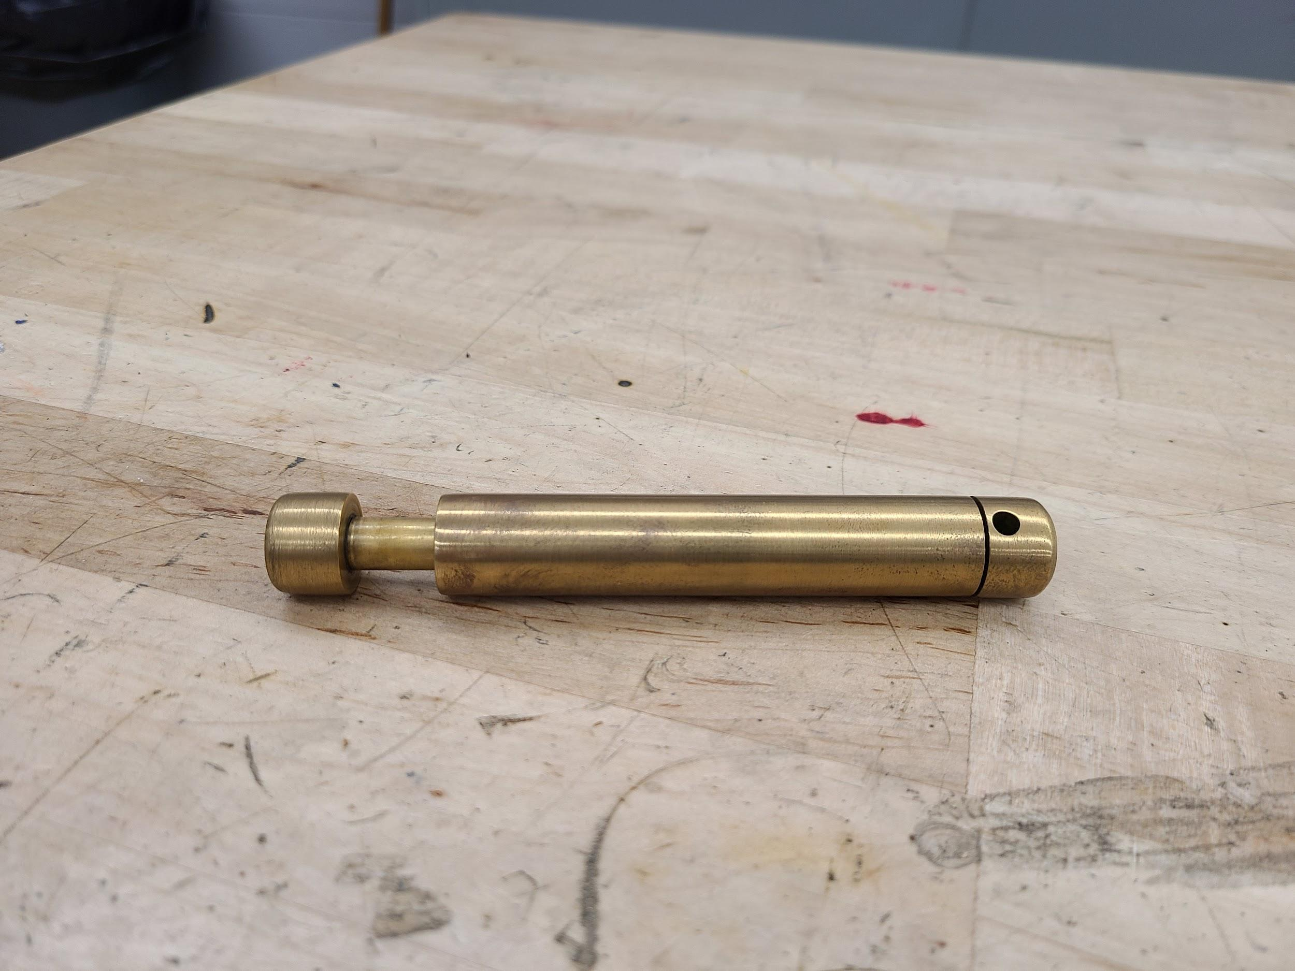

Activity 2 – Machining the Fire Piston

The goal for this activity is for students to practice and build on the skills learned during activity 1. Students will use the form tools for cutting the groove and select the proper drill for the tapped hole using the tap drill chart and knowledge learned from activity.
- Students continue to manufacture the Fire Piston Cylinder with use of a Bandsaw, Metal Lathe, Hand File and various other hand tools and tooling.
- This component of the project will introduce students to the manufacturing process of cutting an O-ring groove.
Time Required: 1.5+hrs

Activity 3 – Machining the .3125 End Cap

The goal for this activity is for students to practice and build on the skills learned during activities 1 and 2. Students will learn the correct way to thread using a die and die set. Students will use a grooving tool and knowledge from activity 2 to cut the groove at the base of the thread.
- Students continue to manufacture the Fire Piston Cylinder using a bandsaw, metal lathe, hand file, and various other hand tools and tooling.
- This component of the project will introduce/refresh students on the manufacturing process of cutting a thread with a die and diestock. Students will have the opportunity to practice cutting a groove using the lathe.
Time Required: 1.5+hrs

Activity 4 – Machining the .375 End Cap

The goal for this activity is for students to practice and build on the skills learned during activity 1, 2, and 3. The last component gives students the opportunity to practice the skills learned in the previous activities.
Time Required: 1.5+hrs

Planning Notes
The following are suggestions when planning to perform this project:
- It is critical that students have an understanding of machine and shop safety
- Students will need to know how to identify the different lathe tooling and how to select the correct tool for specific processes.
- Students must know how to set up tooling and the workpiece correctly in the metal lathe.
- Students will need an understanding of RPM selection.
- Ensure all materials are on hand.
- Ensure all tooling is available e.g. tap drills, clearance drill for reamed hole, reamer, tap and tap handles, die and die stock, O-rings.

Skilled Trades and Apprenticeship Opportunities
The skills and knowledge gained by completing this project will benefit students who are considering pursuing a career in the Industrial sector. The following is a list of trades within the Industrial sector where students can directly apply this knowledge:
- Tool and Die Maker 430A
- Machine and Tool Builder and Integrator 430M
- General Machinist 429A, 430A, 431A, 443A, 430M, 630T
- Industrial Mechanic / Millwright 433A, 426A
- Mould Maker 431A
- Pattern Maker 443A
- Tool / Tooling Maker 630T
It is recommended that the instructor utilize the Canadian Apprenticeship Forum for up to date resources on that include,
- Apprentice Attitudes Towards Learning and Examinations
- The Quality of Workplace Training
- Communication and Inclusion in Apprenticeship
- Apprentice Well Being
- Career Entry, Training and Completion in the Skilled Trades
- ﻿The Impact of COVID-19 on Apprenticeship

Career and Industry Extensions
The skills and knowledge gained by completing this project will be of great benefit to students when pursuing a career in multiple areas in the Industrial sector as well as other industries. Some additional examples of careers in other related industries are listed below:
- Metal Fabricator
- Mechanical Engineer
- Custom car / motorcycle / boat builder
- CNC lathe operator
- Heavy Equipment / Truck and Coach Service Technician
- Tool and Die Maker
- Machine Tool Builder and Integrator
- General Machinist
- CNC machine operator
- Mechanical engineering
- Manufacturing Engineering Technologist

Continuum of Influence
We all have different moments in our lives where we are affected by an experience. This can include learning a new concept or skill, experiencing something for the first time, taking a new course, developing a talent through practice and hard work, or even calling upon a skilled tradesperson to fix, repair, design, construct, maintain, build, bake, and create innovative solutions. The continuum of influence is a graphic representation of how those experiences can lead to developing a passion and talents in areas like Machine, Tool, Die, Mould & Automation (MTDMA) sectors.
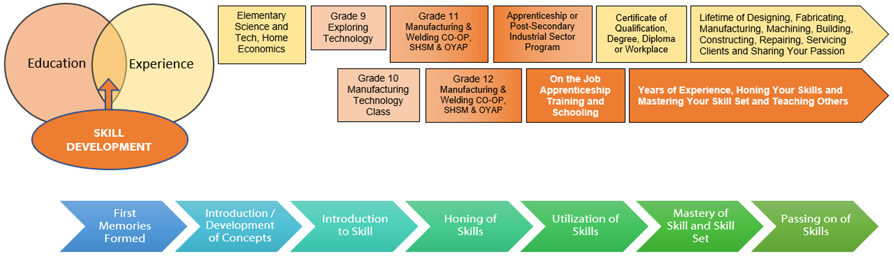
For a full size picture of the Continuum of Influence, see Appendix A

Continuum of Skills
As students pursue their careers in the manufacturing industry, and specifically the Machine, Tool, Die, Mould & Automation (MTDMA) sectors, they will have opportunities to build on the skills learned during this project. The Apprenticeship Training Standards have a common core curriculum for level 1 that covers many Industrial sector trades including, Tool and Die Maker 430A, Machine and Tool Builder and Integrator 430M, General Machinist 429A, 430A, 431A, 443A, 430M, 630T, Industrial Mechanic / Millwright 433A, 426A, Mould Maker 431A, Pattern Maker 443A, and Tool / Tooling Maker 630T.
The curriculum expectations met during this project are aligned with the Level 1 Common Core Apprenticeship Training Standard for all of the previously mentioned trades as follows:
A2.1 Describe and demonstrate the correct use of a variety of processes for joining materials (e.g., welding, bonding, fastening);

Alignment with Apprenticeship Training Standards:
- Aligned with: 6.1 Select bench or hand tools for bench working, operations. 6.3 Perform bench working metal removal procedures. 7.1 Demonstrate safe working procedures when setting up and operating metal cutting saws. 7.2 Describe functions and operating principles of vertical and horizontal bandsaws. 9.6 Perform turning. 9.5 Develop a plan for turning operations.

A2.4 Describe material conversions such as the separation process (e.g., converting a material’s size and shape by removing excess material); the addition process (e.g., combining materials to achieve enhanced qualities, as in alloys); the process of making changes to contours (e.g., assembling materials by such means as gluing, mixing, fastening, bonding, welding); and the process of changing the properties (e.g., thermal, chemical, mechanical, physical) of solid materials;

Alignment with Apprenticeship Training Standards:
- Aligned with: 9.1 Demonstrate safe working procedures when setting up and operating a lathe. , 9.2 Set up lathe machine components, controls, and coolant requirements., 9.2 Set up lathe machine components, controls, and coolant requirements., 9.5 Develop a plan for turning operations

A4.1 Demonstrate a working knowledge of various mathematical formulas (e.g., Pythagorean theorem, formulas for calculating volume and surface area) and applications (e.g., tap drill sizing, calculation of machine speeds and feeds, weight calculations) that are commonly used in manufacturing;

Alignment with Apprenticeship Training Standards:
- Aligned with: 2.7 Calculate part features and machining parameters using formulae to determine: • drill sizes • thread size • cutting speeds • feed rate • tapers • angles • depths of cut • cutter locations

B2.3 Use the proper procedures to prepare materials for production (e.g., measuring, marking, cutting to rough length, grinding, cleaning, deburring)

.Alignment with Apprenticeship Training Standards:
- Aligned with: 5.1 Describe fundamentals of dimensional metrology, 6.1 Select bench or hand tools for bench working operations, 6.3 Perform bench working metal removal procedures.

B3.1 Demonstrate the correct use of various measuring instruments (e.g., scales, vernier calipers, micrometers, gauges) to make measurements in both metric and US customary/British imperial units;

Alignment with Apprenticeship Training Standards:
- Aligned with: 5.2 Describe the operational principles of measuring, checking, and gauging equipment. 5.3 Demonstrate measuring techniques using direct/indirect reading linear measuring equipment.

B3.2 apply principles of dimensional metrology (e.g., precision measurement, tolerancing for interchangeable manufacturing) to manufacturing processes when producing a product.

Alignment with Apprenticeship Training Standards:
- Aligned with: 5.1 Describe fundamentals of dimensional metrology, 5.2 Describe the operational principles of measuring, checking, and gauging equipment.

Resources

Blueprints
Fire Piston Cylinder Blueprints (see Appendix C)
Fire Piston Blueprints (see Appendix C)
.3125 End Cap Blueprints (see Appendix C)
.375” End Cap Blueprints (see Appendix C)

Pictures
Completed Fire Piston Picture (see Appendix B)

Lesson Plan
Lesson Plan (see Appendix H)

Handouts
Fire Piston Cylinder Blueprint (see Appendix C)
Fire Piston Blueprint (see Appendix C)
.3125” End Cap Blueprint (see Appendix C)
.375” End Cap Blueprint (see Appendix C)
OCTE Metal Lathe Handout (see Appendix D
Metal Lathe Quiz (see Appendix E)
Tap Drill Chart (see Appendix F)
Fire Piston Rubric (see Appendix G)

Materials
1” diameter Brass or Aluminum
O-rings
Char Cloth

Exemplars
Completed Fire Piston Picture (see Appendix B)

Websites for Teachers
American Fastener Tap Drill Chart
Starrett Inch/Metric Tap Drill Sizes & Decimal Equivalents Chart

Tools/Equipment
The following tools and equipment will be required to complete this project:
- Metal lathe  - Turning tool  - Drill chuck  - Parting tool  - 5/16-18 tap and die  - 3/8-16 tap and die  - “F” drill, | - 5/16 drill  - HSS form tool ground to approximately 0.063” wide  - (for O-ring groove)  - 23/64” drill  - 3/8” reamer  - 1/2” x 90 deg. countersink  - Center drill

Videos
OCTE ToolSAFE TMJ Engine Lathe  https://www.octe.ca/en/resources/resource-folder/toolsafe/toolsafe-tmj-engine-lathe-turning  (4:44 minutes) | 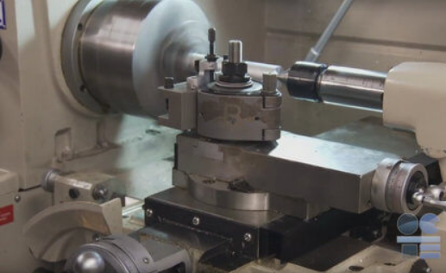
DIY Survival: Fire-Starting with a Fire Piston | Dual Survival

https://www.youtube.com/watch?v=1xbAVWBkGqI

(3:05 minutes)

Tools/Equipment
The following tools and equipment will be required to complete this project:
- Metal lathe  - Turning tool  - Drill chuck  - Parting tool  - 5/16-18 tap and die  - 3/8-16 tap and die  - “F” drill, | - 5/16 drill  - HSS form tool ground to approximately 0.063” wide  (for O-ring groove)  - 23/64” drill  - 3/8” reamer  - 1/2” x 90 deg. countersink  - Center drill

Instructional Strategies
Teachers may use any of the following instructional strategies; 3-Part lesson, lecture, storyboard, word wall, think-pair-share, placemat activity, rapid write, K-W-L, anticipation chart, ABC taxonomy, think aloud, analyzing text, Cornell note taking, exit ticket/ticket out the door, plus/minus/delta, etc.

The Hook / Motivational Strategies
Leading Question / Scenario: “You are on a hike with your friends when you get separated and lost in the wilderness. What are some essentials you would need to survive overnight in the wilderness?”
Have a class discussion on what would be needed and how they would obtain those “needs.” Write all student ideas on the board and expand on them. Students should identify the need to start a fire.
Show the DIY Survival: Fire-Starting with a Fire Piston | Dual Survival YouTube video.

Learning Goals and Success Criteria
Learning goals and success criteria are the foundation on which students base their ability to monitor their learning and determine next steps. Applicable learning goals will include the following:
- Students will learn basic lathe operation.
- Students will understand tap drill sizes and how to read the tap drill chart.
- Students will learn/review the process of cutting threads using taps and dies.
- Students will learn the process of reaming a hole.
- Students will learn the process of reaming cutting a groove.

Success criteria may include any of the following:
- Students will be able to identify the parts of the metal lathe.
- Students will be able to select the correct RPM for the material specified.
- Students will be able to select the correct tooling for the process required.
- Students will be able to complete basic metal processes e.g. end facing, drilling, parallel turning.
- Students will be able to accurately cut internal threads using a tap.
- Students will be able to cut external threads using a die.
- Students will understand how to select the correct drill size when tapping a hole.
- Students will have a basic understanding of dimensional tolerance.

Overall and Specific Expectations in Support of Ontario Curriculum Grades 9 - 12 Technological Education

Overall Expectations
- A2. Demonstrate an understanding of material conversion processes;
- A3. Demonstrate an understanding of various types of control systems used in manufacturing;
- A4. Apply relevant mathematical and scientific concepts and use appropriate forms of technical communication in the study of manufacturing technology;
- B1. Demonstrate the ability to interpret and prepare technical drawings and develop process plans;
- B2. Demonstrate a working knowledge of the characteristics of various materials and the proper selection of materials for the manufacture of a product;
- B3. Demonstrate a working knowledge of various metrology tools used to measure, lay out, and inspect products;
- B4. Use tools, equipment, and machine processes safely and correctly in the manufacture of a product.

Specific Expectations
- A2.1 Describe and demonstrate the correct use of a variety of processes for joining materials (e.g., welding, bonding, fastening);
- A2.4 Describe material conversions such as the separation process (e.g., converting a material’s size and shape by removing excess material); the addition process (e.g., combining materials to achieve enhanced qualities, as in alloys); the process of making changes to contours (e.g., assembling materials by such means as gluing, mixing, fastening, bonding, welding); and the process of changing the properties (e.g., thermal, chemical, mechanical, physical) of solid materials;
- A4.1 Demonstrate a working knowledge of various mathematical formulas (e.g., Pythagorean theorem, formulas for calculating volume and surface area) and applications (e.g., tap drill sizing, calculation of machine speeds and feeds, weight calculations) that are commonly used in manufacturing;
- A4.2 Apply mathematical concepts (e.g., linear systems; integers; decimals and fractions; order of operations) and skills in performing a variety of tasks required within the context of manufacturing design and production (e.g., angle calculations; calculation of perimeter, volume, and area; percent/decimal/fraction conversions; US customary/ British imperial and metric unit conversions);

- A4.6 Describe how the physical and mechanical properties of solid materials (e.g., physical: density, appearance, porosity, surface texture; mechanical: hardness, ductility, elasticity, brittleness, compression, fatigue, shear, tensility) create advantages or disadvantages that affect their suitability for use in manufacturing;
- A4.7 Use technical language correctly and appropriately (e.g., in reports and presentations) to communicate information related to manufacturing technology;
- A4.8 Use appropriate forms of communication (e.g., oral and written reports) and supporting documentation (e.g., statistical graphing; sketches; scale drawings; perspectives; orthographic, isometric, and oblique views; pattern and development projections; shop, assembly, and detail drawings) to convey ideas and processes and to show materials and specifications;
- B1.3 Convert drawing dimensions (e.g., US customary/British imperial units to metric units, fractions to decimals) using the appropriate chart, table, or formula;
- B2.2 Select appropriate materials for a project based on their properties and characteristics (e.g., physical, mechanical, thermal, chemical, electrical, magnetic, optical, acoustical) and the project’s design criteria (e.g., strength, finish, customer specifications, quality control processes, working environment);
- B2.3 Use the proper procedures to prepare materials for production (e.g., measuring, marking, cutting to rough length, grinding, cleaning, deburring);
- B3.1 Demonstrate the correct use of various measuring instruments (e.g., scales, vernier calipers, micrometers, gauges) to make measurements in both metric and US customary/British imperial units;
- B3.2 Apply principles of dimensional metrology (e.g., precision measurement, tolerancing for interchangeable manufacturing) to manufacturing processes when producing a product;
- B3.3 Demonstrate a working knowledge of the proper tools required to lay out a product precisely (e.g., height gauge, surface gauge, trammel points, protractor, scribe, straight edge);
- B3.4 Use metrology tools to inspect and evaluate products for quality control purposes (e.g., for inspection reports, destructive and non-destructive testing).
- B4.1 Demonstrate the use of appropriate bench work techniques to lay out, fit, and assemble workpieces;
- B4.2 Use appropriate procedures (e.g., correct machine set-up, operational safety procedures) when setting up, maintaining, using, and storing tools and equipment used in manufacturing and production processes;
- B4.3 Demonstrate the correct selection and use of appropriate tools and equipment (e.g., wrenches, electric drills, grinders, engine lathe, milling machine) for specific manufacturing tasks.

Safety Concerns
Students must follow instructions on machine safety while operating the band saw and metal lathe. Safety passports or equipment instruction, testing and demonstration sign offs may be used to track student training on pieces of equipment. Students must also wear all required PPE including:
- Safety Glasses
- Proper footwear
- Proper clothing ie. no lanyards or baggy clothing

Applicable SAFEDocs and ToolSAFE videos
Please refer to the OCTE SAFEDocs for Manufacturing Technology for safety documents in order to properly address and instruct this project.
- OCTE ToolSAFE TMJ Engine Lathe
- OCTE Metal Lathe Handout (see Appendix D)
- Metal Lathe Quiz (see Appendix E)
- Tap Drill Chart (see Appendix F)

Project Challenges
Some challenges that may occur during this project are:
First time students may not fully grasp lathe operation.
- Consider spending more time one on one to help support students' needs.
- Consider having students work with a partner.
- Use demonstration videos.

Students may have trouble reading the blueprints
- Consider working through the first blueprint step by step with students.
- Consider having students work with a partner.
- Consider providing extra worksheets for practice.

There may not be enough machines available for every student.
- Consider having students partner up on machines.
- Have students take turns on machines.

Students may break tooling.
- Use as a teachable moment to show class how to change tooling.
- Have extra tools ready.

Differentiation of the Project / Activity
This project can be differentiated by:
- Using different types of materials
- Using different sizes of material (make sure to scale all components)
- Working in groups, have students make specific components
- Lathe quiz could be made into a Google Form
- Students could complete the project online by doing a write up on the step-by-step procedures they would use to complete each component.
Teachers can also refer to the Differentiation Scrapbook to take into account for learner ability, multiple intelligences, exceptional students, and ESL learners.

Assessment and Evaluation

Assessment For Learning
- Ask students about wilderness survival as outlined in The Hook / Motivational Strategies.
- Provide students with a brief outline of the project and ask them how they would go about building it.
- Ask students what tools they think they might need to build the project.
- Identify particular learning needs of students.

Assessment As Learning
- Ask questions and make suggestions based on daily observation.
- Assess students’ cognition about their learning (asking them “why” and “how” they are completing a certain operation.
- Students monitor their own learning and ask questions as needed.

Assessment Of Learning
- Students will complete a quiz to assess their understanding of the lessons
- Evaluate each project according to the rubric

Reflection or Design Report
Teachers may wish to have the students complete a design report, reflection or create a foldable to consolidate their learning. This would be a nice way to capture the students’ understanding in a summative format and be used in preparation for their examination, entering post-secondary education, or the workforce.

Appendix A –Continuum of Influence
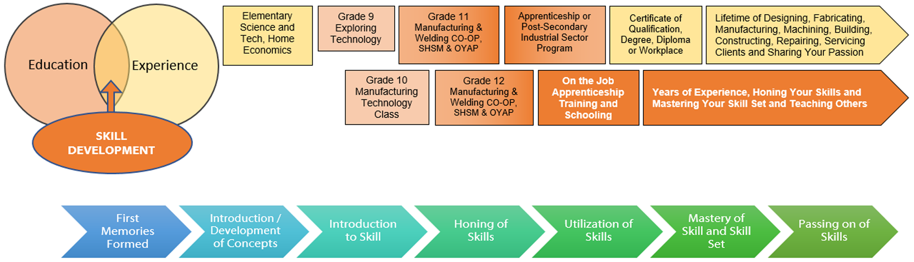

Appendix B - Fire Piston Picture

Appendix C - Fire Piston Blueprints
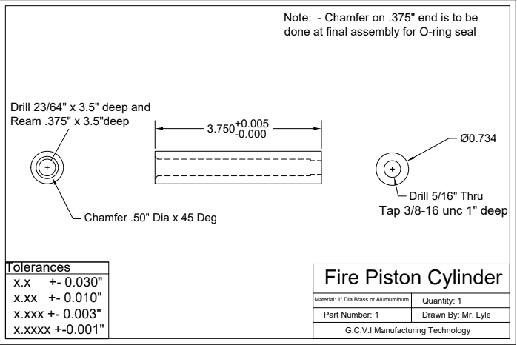
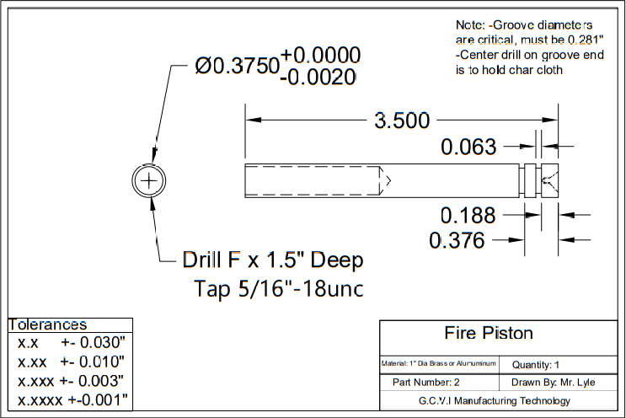
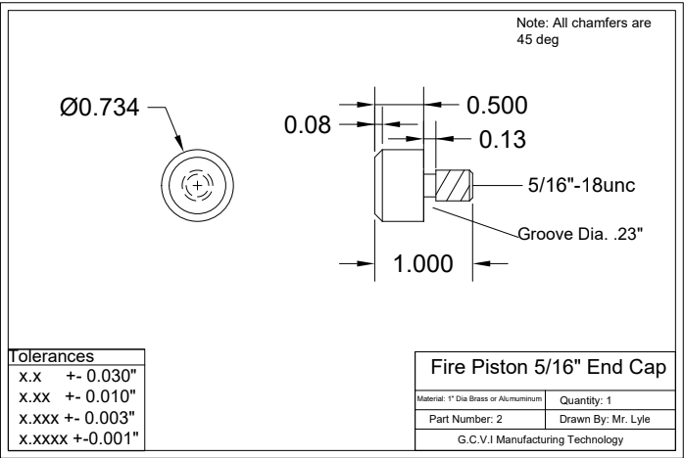
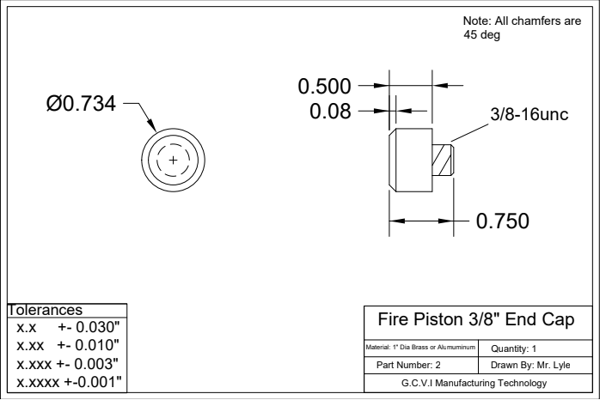

Appendix D - Metal Lathe SAFEDoc
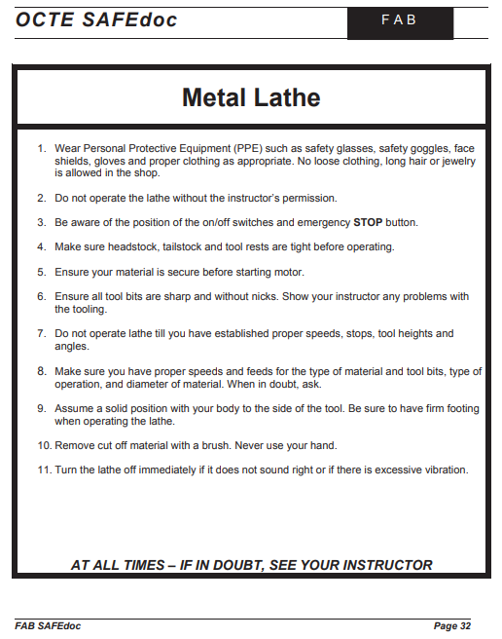

Appendix E - Lathe Safety Test
Lathe Safety Test
Student Name: __________________________________

- Always wear __________________ when operating the lathe.

- Be aware of the ________________ and emergency stop buttons.

- Always remove _______________ with a brush not your ____________.

- Turn the lathe off if it does not ______________right.

- Ensure your ______________ is secure before _____________ the machine.

- Make sure the chuck is ____________before starting the lathe.

- Always remove the ___________________before starting the machine.

- Ensure you have the correct ___________ speed before beginning to machine your workpiece.

- Always let the Lathe _________ by itself.

Word Bank:
Safety Glasses Cutting Sound On-Off Starting Chips
Hands Material Tight Stop Chuck Key

Appendix F - Tap Drill Charts

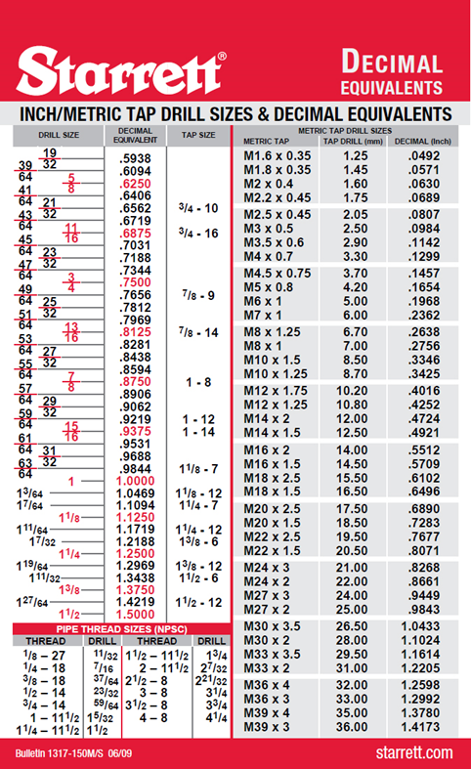
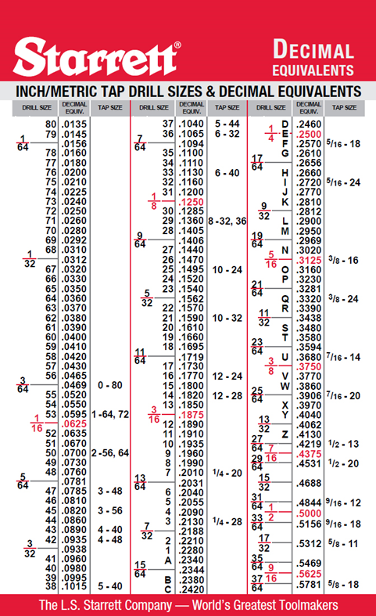

THREAD SIZE | DRILL DIAMETER  Coarse Thread | TAP DRILL SIZE
1-64 | .0595 | No. 53
2-56 | .0700 | No. 50
3-48 | .0785 | No. 47
4-40 | .0890 | No. 43
5-40 | .1015 | No. 38
6-32 | .1065 | No. 36
8-32 | .1360 | No. 29
10-24 | .1495 | No. 25
12-24 | .1770 | No. 16
1/4-20 | .2010 | No. 7
5/16-18 | .2570 | ‘F’
3/8-16 | .3125 | 5/16
7/16-14 | .3680 | ‘U’
1/2-13 | .4219 | 27/64
9/16-12 | .4844 | 31/64
5/8-11 | .5312 | 17/32
3/4-10 | .6562 | 21/32
7/8-9 | .7656 | 49/64
1″-8 | .8750 | 7/8

THREAD SIZE | DRILL DIAMETER  Fine Thread | TAP DRILL SIZE
0-80 | .0469 | 3/64
1-72 | .0595 | No. 53
2-64 | .0700 | No. 50
3-56 | .0820 | No. 45
4-48 | .0935 | No. 42
5-44 | .1040 | No. 37
6-40 | .1130 | No. 33
8-36 | .1360 | No. 29
10-32 | .1590 | No. 21
12-28 | .1820 | No. 14
1/4-28 | .2130 | No. 3
5/16-24 | .2720 | ‘I’
3/8-24 | .3320 | ‘Q’
7/16-20 | .3906 | 25/64
1/2-20 | .4531 | 29/64
9/16-18 | .5156 | 33/64
5/8-18 | .5781 | 37/64
3/4-16 | .6875 | 11/16
7/8-14 | .8125 | 13/16
1″-14 | .9375 | 59/64

Appendix G - Manufacturing Project Rubric
 | Level 1  50 - 65% | Level 2  66 – 75% | Level 3  76 – 85% | Level 4  86 – 100%
KNOWLEDGE\  UNDERSTANDING | Demonstrates a limited  understanding of important features on the blueprint | Demonstrates some  understanding of important features on the blueprint | Demonstrates a good  understanding of important features on the blueprint | Demonstrates a thorough  understanding of important features on the blueprint
THINKING | uses critical/ creative thinking skills to explain project requirements with limited effectiveness | uses critical/ creative thinking skills to explain project requirements with some effectiveness | uses critical/ creative thinking skills to explain project requirements with considerable effectiveness | uses critical/ creative thinking skills to explain project requirements with a high degree of effectiveness
COMMUNICATION | communicates about the machining process in a limited or unclear way | communicates about the machining process with some clarity | communicates about the machining process with considerable clarity | communicates about the machining process with a high degree of clarity
APPLICATION | creates finished product of limited quality with many flaws | creates finished product of moderate quality with some flaws | creates finished product of considerable quality with few flaws and a good level of detail | creates finished product of high degree of quality with no flaws and a high level of detail
Instructor Feedback:
______________________________________________________________________________________________________________________________________________________________________________
Final Grade: _____

Appendix H - Fire Piston Unit Plan
Apprenticeship Resource Lesson Plan
Topic: Fire Piston Project

Student Activity | Curr | Content | Teacher Activity
Students should already have these prerequisite skills prior to starting this project,  - Shop safety  - OCTE Metal Lathe Safety  - Measurement  - Lathe Components  Students are engaged with discussion and brainstorming ideas (10 - 15 minutes)  Students watch video (3 minutes)  Students engage in project introduction and demonstration (5 minutes)  Students select small groups to work in and gather around the lathe for instruction, safety, and engine lathe demonstration  (3-5 minutes)  Students demonstrate proper set up and operation of the lathe (15-20 min. /group)  Students engaged in the machining process and layout of their project. If they are not using the lathe, they are watching their partner or partners to make sure safe practices are being followed, correct set up and machine operation are adhered to.  (5 -7 days, depending on number of lathes, size of groups, length of classes, materials for projects, etc.)  Safety Concerns  - Students must follow all safety rules set by the school board, Technology department and the teacher  - Students must have safety passport or signed school board safety rules to enter shop  - Safety glasses must be worn  - No loose or baggy clothing  - Proper footwear is required  - Students must follow safe machine operating procedures  - Only one person uses a machine at any one time  - Do not distract others  - No running or horseplay in the shop | Activity#1  Activity#2 | Prior knowledge and skills  Lead in  Fire Piston Video  Project introduction and demonstration  Selection of groups  Lathe setup, safety and demonstration  Layout and machining process for the caps of the Fire Piston Project  Layout and machining process for the barrel of the Fire Piston Project  Safety | Teacher to assess prior knowledge and skill set of students  NOTE: Because this is a practical assignment, timing and demonstrations that need to be taught will vary based on the skill level of the students.  Ask students the leading question “You are on a hike with your friends when you get separated and lost in the wilderness. What are some essentials you would need to survive overnight in the wilderness?” Then discuss with the class and write ideas on the board.  Show video on the fire piston  Have completed piston ready and demonstrate how it works to the students  Split up students into small groups for the demo (if first time students, pair them with experienced students)  Demonstrate the setup of the machine for Specific Processes and record student demonstrations  Students set up and begin the machining process of their parts. Pause class periodically to demonstrate next steps and next process.  Repeat steps from Activity #1 for Activity #2 where required  Additional Teacher Notes  - Make sure material is prepped for the demo and shop power is on  - Ensure all machines have required tooling  - Ensure all tooling needed for threading is available  - Have demonstration material prepped  - Have a completed project ready to demonstrate to the students

Expected Outcomes | Assessment of Outcomes
The student will:  - Students will learn basic lathe operation  - Students will understand tap drill sizes and how to read the tap drill chart  - Students will learn/review the process of cutting threads using taps and dies  - Students will learn the process of reaming a hole  - Students will learn the process of reaming cutting a groove | - Students follow all shop safety rules  - Students come prepared to cut material (Safety Glasses, No loose clothing or jewelry)  - Students will be able to identify the parts of the metal lathe.  - Students will be able to select the correct RPM for the material specified  - Students will be able to select the correct tooling for the process required  - Students will be able to complete basic metal processes e.g. end facing, drilling, parallel turning  - Students will be able to accurately cut internal threads using a tap  - Students will be able to cut external threads using a die  - Students will understand how to select the correct drill size when tapping a hole  - Students will have a basic understanding dimensional tolerance

Motivation | Curriculum Expectations
Student can manufacture their own useful tool | A2.1, A2.4,  A4.1, A4.2, A4.7, A4.8,  B2.2, B2.3,  B3.1, B3.2 B3.3, B3.4,  B4.1, B4.2, B4.3

Reflections | Instructional Materials
Ask the students leading questions regarding their prior knowledge on processes or best guesses | Handouts  - Fire Piston Cylinder Blueprint  - Fire Piston Blueprint  - .3125 End Cap Blueprint  - .375” End Cap Blueprint  - OCTE Metal Lathe Handout  - Metal Lathe Quiz  - Fire Piston Rubric  Materials  - 1” diameter Brass or Aluminum  - O-rings  - Char Cloth  Exemplars  - Completed Fire Piston Picture  Websites for Teachers  - Tap Drill Chart Link:  https://www.americanfastener.com/tap-and-drill-size-chart/  Videos  - OCTE ToolSAFE video TMJ Engine Lathe  - DIY Survival: Fire-Starting with a Fire Piston | Dual Survival

References
21st Century Competencies: Foundation Document for Discussion. Phase 1: Towards Defining 21st Century Competencies for Ontario, Winter 2016 Edition, 2016 http://www.edugains.ca/resources21CL/About21stCentury/21CL_21stCenturyCompetencies.pdf
American Fastener Tap and Drill Size Chart, 2013 https://www.americanfastener.com/tap-and-drill-size-chart/
College of Trades Training Standards https://www.collegeoftrades.ca/training-standards
Course Codes for Emphasis courses in the Revised Curriculum: Technological Education, Grades 11 and 12, 2009 http://www.edu.gov.on.ca/eng/curriculum/secondary/techedemphasiscourses.pdf
DIY Survival: Fire-Starting with a Fire Piston | Dual Survival (YouTube video), 2014 https://www.youtube.com/watch?v=1xbAVWBkGqI
Growing Success: Assessment, Evaluation, and Reporting in Ontario Schools, First Edition, Covering Grades 1 to 12, 2010 www.edu.gov.on.ca/eng/policyfunding/growSuccess.pdf
Learning for All – A Guide to Effective Assessment and Instruction for All Students, Kindergarten to Grade 12, 2013 http://www.edu.gov.on.ca/eng/general/elemsec/speced/LearningforAll2013.pdf
Ministry News https://news.ontario.ca/en/release/1000078/ontario-to-modernize-and-streamline-apprenticeship-training
OCTE SAFEDocs for Manufacturing Technology, 2013 https://www.octe.ca/download_file/view/4842/1201
OCTE ToolSAFE TMJ Engine Lathe (video), 2017 https://www.octe.ca/en/resources/resource-folder/toolsafe/toolsafe-tmj-engine-lathe-turning
Resources, Ontario College of Trades, 2020 https://www.collegeoftrades.ca/resources
Red SEAL – Sceau Rouge, 2018 http://www.red-seal.ca/trades/tr.1d.2s_l.3st-eng.html
The Apprenticeship Advantage, Ontario College of Trades, 2020 https://www.collegeoftrades.ca/wp-content/uploads/ApprenticeshipAdvantage_English_web.pdf
Skilled Trades Identified in Ontario https://www.collegeoftrades.ca/wp-content/uploads/Sector_Brochure_One_Pager_web.pdf
Skilled Trades Ontario https://www.ontario.ca/page/skilled-trades
Starrett Inch/Metric Tap Drill Sizes & Decimal Equivalents (Chart), 2009
https://www.starrett.com/docs/educational/decimal-equivalent-card---bulletin-1317.pdf
Tap Drill Chart (YouTube video), 2018 https://www.youtube.com/watch?v=68U_ONuLVKk
The Differentiated Instruction Scrapbook http://www.edugains.ca/resourcesDI/EducatorsPackages/DIEducatorsPackage2010/2010DIScrapbook.pdf
The Ontario Curriculum, Grades 9 and 10: Technological Education, 2009 (revised) http://www.edu.gov.on.ca/eng/curriculum/secondary/teched910curr09.pdf
The Ontario Curriculum, Grades 11 and 12: Technological Education, 2009 (revised) http://www.edu.gov.on.ca/eng/curriculum/secondary/2009teched1112curr.pdf

