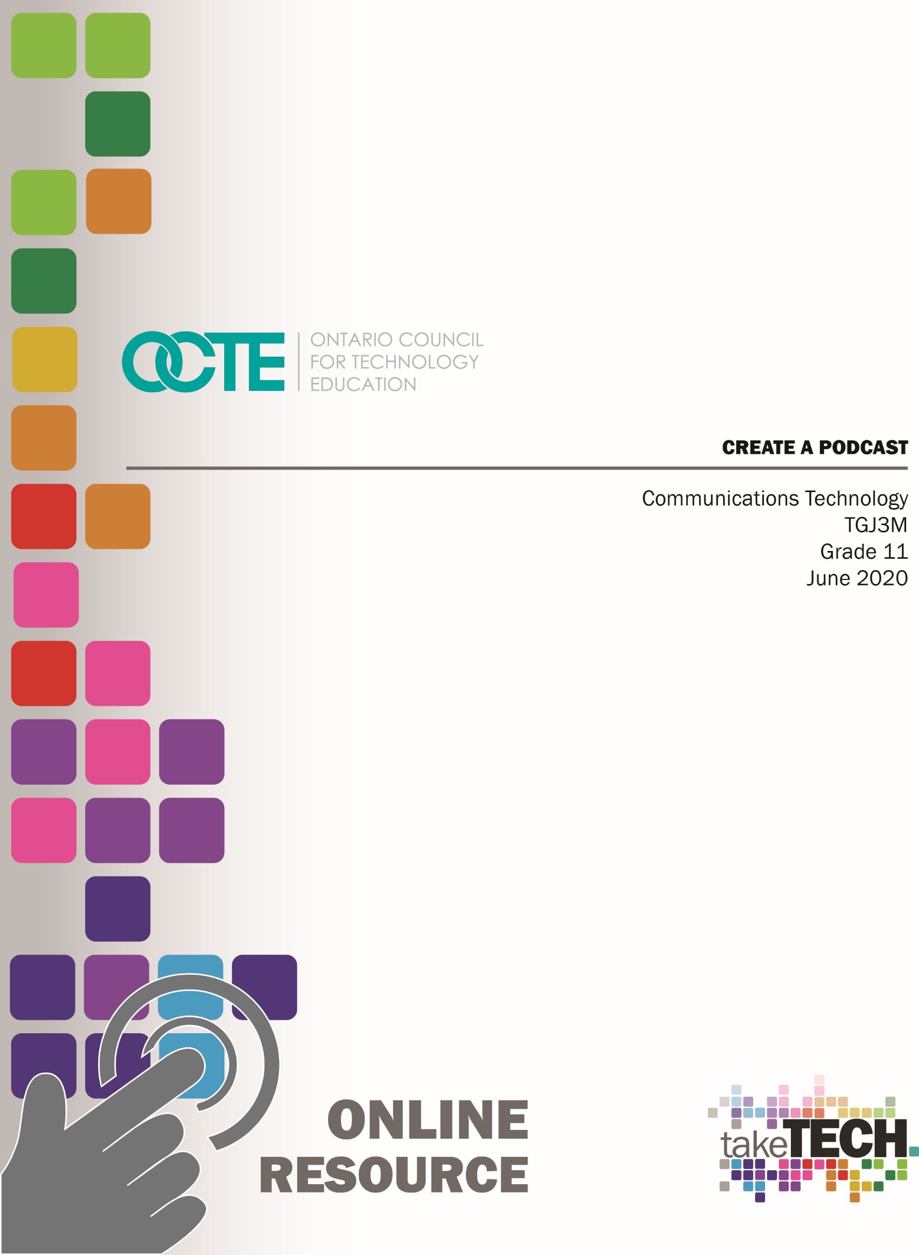

Table of Contents
Introduction 4
Project Outline 4
Prior Knowledge 4
Student Activities 5
Planning Notes 5
Resources 6
Instructional Strategies 8
The Hook / Motivational Strategies 8
Learning Goals and Success Criteria 8
Overall and Specific 8
Overall Expectations 8
Specific Expectations 9
Safety Concerns 9
Applicable SAFEDocs and ToolSAFE videos 10
Differentiation of the Project / Activity 10
Assessment and Evaluation 10
Career and Industry Extensions 10
Ethical Considerations 10
Environmental Considerations 10
Activity 1 – What is a Podcast 11
Activity 2 – Equipment and Software 11
Activity 3 – Planning to Podcast 12
Activity 4 – Producing Your Podcast 12
Assignment 1 – Create A Podcast 13
Reflection or Design Report 13
Appendix A – TGJ3M Podcast Worksheet 14
TGJ3M Activities and Assignment Worksheet 14
Overview: 14
Activity 1 – What is A Podcast 15
Activity 2 – Equipment and Software 19
Activity 3 – Planning to Podcast 21
Activity 4 – Producing Your Podcast 24
Assignment 1 – Create A Podcast 26
Appendix B – TGJ3M Podcasting Links from PowerPoints 29
Activity 1 – What Is A Podcast 29
Activity 2 – Software and Equipment 30
Activity 3 – Planning To Podcast 33
Activity 3 – Producing Your Podcast 35
Assignment 1 35
References 36

Introduction
Course Code: TGJ3M
Broad base Technology: Communication Technology
Destination: University/College
Grade Level: 11
Prerequisite: None
Online Project Name: Create A Podcast

Project Outline
This assignment will provide the learner with an opportunity to understand the exciting world of Podcasting. The learner will understand concepts, terms, and equipment associated with podcasts. The learner will demonstrate their knowledge by creating, choosing a topic, creating a script or outline, and producing a podcast.

Prior Knowledge
The learner will have demonstrated previous knowledge and safety considerations when working with audio equipment and audio levels. Teachers are encouraged to review copyright laws in Canada before starting these lessons, activities, and assignments.
Although this will be reviewed in the lessons and activities, the learner will benefit from having a basic understanding of Signal Path, analog to digital conversion, multitracking, file formats (.mp3, M4A, WAV, AIFF), mono vs. stereo, audio input, and editing and mixing. Examples of royalty-free and creative commons and audio sites that can be used in student work are:
- https://incompetech.com/music/royalty-free/
- http://ccmixter.org/
- https://www.jamendo.com/
- https://www.soundclick.com/default.cfm
- https://music.tutsplus.com/articles/freemusicarchive.org
- YouTube Audio Library
It may be helpful for students to understand how to download audio files from the internet, upload content, capture audio, and create screen captures:
- Windows: Snipping Tool or Snip and Sketch
- MacOS: Command+Shift+3 or Command+Shift+4
- Android: Power + Volume Down
- iPhone OS: Side Button + Volume Up Button

Students would benefit from:
- the ability to reflect on and identify their strengths as listeners and speakers (literacy skills)
- the ability to generate, gather and organize ideas and information to write for an intended purpose and audience (literacy skills)
- use speaking skills and strategies appropriately to communicate with different audiences (literacy skills)
- make connections among mathematical concepts and procedures, and relate mathematical ideas to situations or phenomena drawn from other contexts (numeracy)
- some experience accessing online resources, creating and downloading files, and submitting digital data to a destination according to their teacher’s direction (media skills)

Student Activities
Activity 1 – What is a Podcast
Activity 2 – Equipment and Software
Activity 3 – Planning to Podcast
Activity 4 – Producing Your Podcast
Assignment 1 – Create A Podcast

Planning Notes
The combination of lessons, activities, and assignments will take learners 1.5 weeks of 60-minute periods to complete. Accommodation of extra time may be required for some learners.
Note: These lessons, activities, and assignment has been structured in a way that permits a “deep dive” into audio and audio editing in Grade 11 in case the school has an emphasis program or SHSM
- Create a digital space for each learner to submit and receive the material (e.g., Microsoft One Drive, Google Drive, Dropbox, etc.)
- Provide each learner with the TGJ3M Podcast worksheet. The teacher may convert to a format most familiar to their learners (e.g., convert from .docx to Google Doc) Note: This is a living document, for the teacher to provide ongoing feedback, and opportunities for the learner to revise their work
- Post or provide the learners with the materials at timed intervals or all at once.
- Provide timely feedback to learners. The work has been scaffolded
- Review all links prior to the start of this project, in many cases; additional learning options were posted allowing for one link to be removed if needed
- Teachers may choose to limit the options available for audio editing; please review carefully beforehand.
Note: In a disrupted learning environment, it may be best to allow learners will have the opportunity to choose the tool that best suits their needs.

Resources

Files
Activity 1 – What is a Podcast
Activity 2 – Equipment and Software
Activity 3 – Planning to Podcast
Activity 4 – Producing Your Podcast
Assignment 1 – Create A Podcast

Tools/Equipment
- Mobile Device
- Dynamic microphone (recommended not required)
- PC or Mac (recommended not required

Software
Podcast Software for Mobile
- https://anchor.fm/
- https://auphonic.com/
- https://sone.app/
DAW Software for PC/Mac (recommended but not required)
- Protools First (Free Educational Application)
- Audacity (Open Source)
- Auphonic (free account)
Zoom (Recommended but not required)

Textbooks/Books
• | 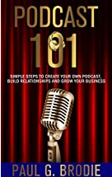 | Podcast 101 - by Paul Brodie and Billy J. Atwell  Free digital version is available from Amazon.ca  https://www.amazon.ca/Podcast-101-Simple-Relationships-Business/dp/1733521011/ref=sr_1_1?dchild=1&keywords=podcast+101&qid=1597162332&sr=8-1

Videos
- How to Start a Podcast // Step-by-Step Guide [2020]
https://www.youtube.com/watch?v=Gejf39h3_IY
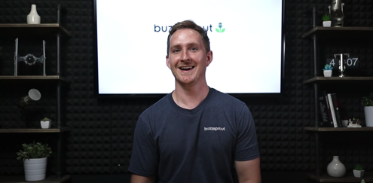
- Podcast Hosting: Get Your Podcast Online & Into Directories [2020]
https://www.youtube.com/watch?v=_Z-3j_M0_3M
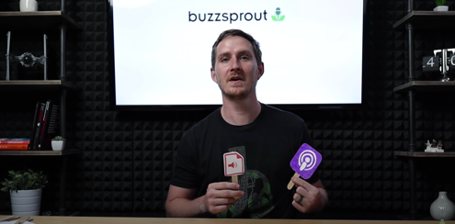

Websites for Teachers
- https://recordmixandmaster.com/

Royalty-Free and Creative Commons Sites
- https://incompetech.com/music/royalty-free/
- http://ccmixter.org/
- https://www.jamendo.com/
- https://www.soundclick.com/default.cfm
- https://music.tutsplus.com/articles/freemusicarchive.org

Instructional Strategies
- The lessons, activities, and assignment have been scaffolded
- The lessons, activities, and assignment have been created using different forms of media and are multi-device supported
- The learner is encouraged to revise their work using a living (collaborative) document shared with the teacher

The Hook / Motivational Strategies
- Podcasts entertain and inform they allow the creator to share their thoughts, emotions, and knowledge to the world.
- The ability to create a podcast is accessible to almost everyone, equipped with only a mobile device a podcaster can access the world through the world wide web.
- The lessons, activities, and assignments have been created to allow learners of all abilities to develop and share their voice.

Learning Goals and Success Criteria
- Identify how podcasts can be used to convey a message
- Understand the difference between Commercial and Entertainment Podcasts
- Recognize the impact that podcasts have on society
- Discover post-secondary audio field opportunities
- Compare different types of podcasts
- Design an original work that can be used to promote their Podcast

Overall and Specific Expectations in Support of Ontario Curriculum Grades 11 - 12 Technological Education

Overall Expectations
A1. Demonstrate an understanding of the core concepts, techniques, and skills required to produce a range of communications media products and services;
A2. Demonstrate an understanding of different types of equipment and software and how they are used to perform a range of communications technology operations and tasks;
B3. Create productions that demonstrate competence in the application of creative and technical skills and incorporate current standards, processes, formats, and technologies.
C1. Describe the impact of current communications media technologies and activities on the environment and identify ways of reducing harmful effects;
C2. Demonstrate an understanding of the social effects of current communications media technologies and the importance of respecting cultural and societal diversity in the production of media projects (optional)
D1. Demonstrate an understanding of and apply safe work practices when performing communications technology tasks;
D3. Identify careers in communications technology for which post-secondary education is required or advantageous, and describe college and university programs that prepare students for entry into these occupations

Specific Expectations
A1.2 Demonstrate an understanding of the concepts
A1.4 Identify different types of communications software
A2.2 Use application software and/or equipment competently to perform a variety of communications tasks
B3.1 Use appropriate procedures to set up and operate media production equipment
B3.2 Use appropriate software applications
B3.3 Demonstrate an understanding of industry guidelines, conventions, rules, and standards and apply them to the production of communications media products
C1.1 Describe the impact of current communications media technologies on the environment (optional)
C2.1 Demonstrate an understanding of social standards and cultural sensitivity and use appropriate and inclusive content, images, and language in communications media productions (optional)
D1.2 Demonstrate an understanding of and apply safe work practices when performing communications technology tasks

Safety Concerns
Learners may need to practice physical distancing, and the school board adopted cleaning processes for shared tools. (e.g., shared tablets, microphones, mobile devices, keyboard, mice, etc.)

Applicable SAFEDocs and ToolSAFE videos
Please refer to the OCTE SAFEDocs for BBT Technology for safety documents in order to properly address any safety concerns while instructing this project.

Differentiation of the Project / Activity
Teachers can also refer to the Differentiation Scrapbook to take into account learner ability, multiple intelligences, exceptional students, and ESL learners. The lessons in this document include visual, written, and video-based instruction. Some YouTube videos support Closed Captioning.
Students may choose to complete activities using the Google Read & Write Extension.
Support for Google Read & Write
Quick Reference Guide

Assessment and Evaluation
Rubric included in Appendix A TGJ3M Podcast Activities and Assignment worksheet

Career and Industry Extensions
In Activity 1 – What is a Podcast, learners research the industry and choose different career opportunities
In Activity 1 – What is a Podcast, learners explore post-secondary options in the broadcast industry

Ethical Considerations
In Assignment 1 – Create a Podcast, the teacher may choose to modify this project to encourage the understanding of the impact of media in society.

Environmental Considerations
In Assignment 1 – Create a Podcast, the teacher may choose to modify this project to encourage the understanding of the impact of communication technology systems of the environment.

Activity 1 – What is a Podcast
In a Learn@Home environment, students are to view the attached presentation. In a face to face environment, the teacher presents visual content, videos, and other examples to students, using the PowerPoint presentation:
PowerPoint Presentation Link:
Activity 1 – What is a Podcast
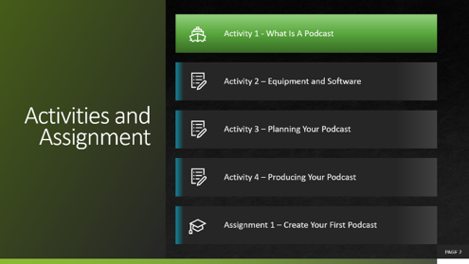
- Types of Podcasts
- Career Opportunities
- Post-Secondary Opportunities
Students may use Appendix A – TGJ3M Podcast Activities and Assignment worksheet with the PowerPoint

Activity 2 – Equipment and Software
PowerPoint Presentation Link:
Activity 2 – Equipment and Software
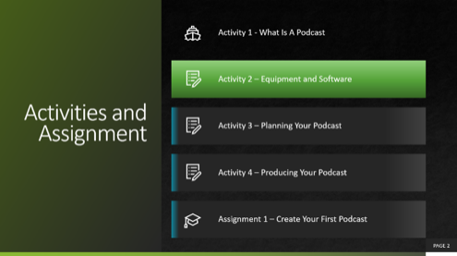
- Mobile Apps
- Critical Thinking
- Hardware
- Software
Students may use Appendix A – TGJ3M Podcast Activities and Assignment worksheet with the PowerPoint

Activity 3 – Planning to Podcast
PowerPoint Presentation Link:
Activity 3 – Planning to Podcast
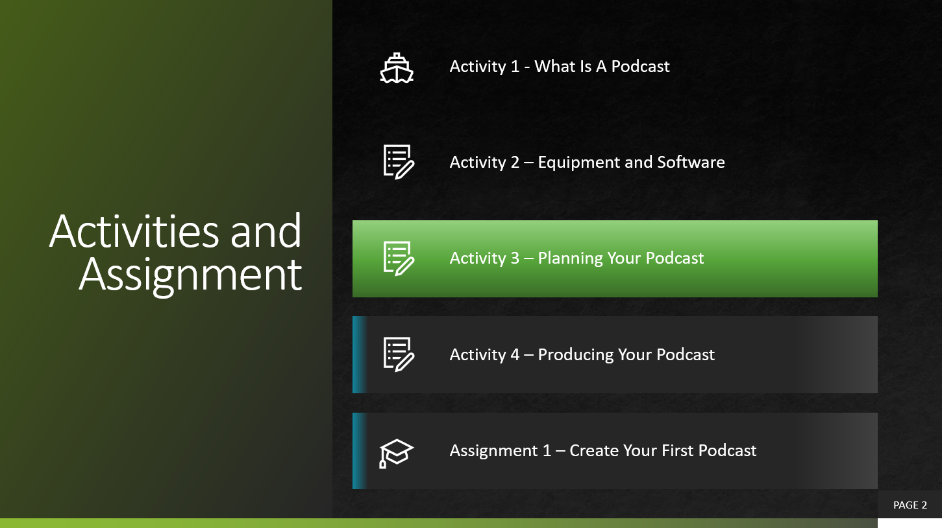
- Pre-planning
- Podcast Art
- Vector & Bitmaps
- Applications
- Activity
Students may use Appendix A – TGJ3M Podcast Activities and Assignment worksheet with the PowerPoint

Activity 4 – Producing Your Podcast
PowerPoint Presentation Link:
Activity 4– Producing Your Podcast
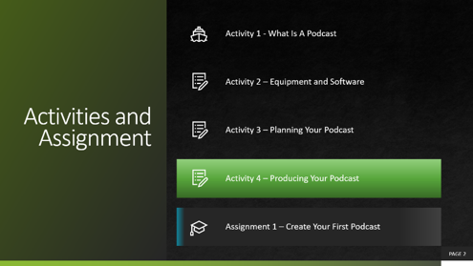
- Adding Sound
- Understanding Audio Concepts
- Pre-Recording, Mixing, Editing, and Mastering
- Room Considerations
- Interviewing
Students may use Appendix A – TGJ3M Podcast Activities and Assignment worksheet with the PowerPoint

Assignment 1 – Create A Podcast
- Decide on your topic
- Preplan (write your script outline)
- Check Equipment, Record, Edit, Master
- Create Podcast Cover
- Rubric

Reflection or Design Report
Upon the conclusion of these lessons, activities, and assignment, the teacher is encouraged to reflect with their learners about:
- What went well?
- What area’s need to be improved?
- At what stage were you most engaged?
- How could these lessons, activities, and assignments be improved for next time?
- What advice would you give to someone before starting this work?
- Provide one example of something that you learned.
This reflection can be through the use of a Google Form (or similar), small group reflection, or use of an LMS (Learning Management Software) discussion forum like Google Classroom, Desire2Learn, etc.

Appendix A – TGJ3M Podcast Worksheet

TGJ3M Activities and Assignment Worksheet

Overview:
This worksheet has been designed as a collaborative document to share with your teacher. As you work your way through these activities and assignments, your teacher will provide feedback that you may choose to use in revising your work. Pay careful attention to the rubric at the bottom of this sheet, and the teacher comments as you go along.
*Helpful tip, make a backup of your work

Overall Expectations:
A1. Demonstrate an understanding of the core concepts, techniques, and skills required to produce a range of communications media products and services;
A2. Demonstrate an understanding of different types of equipment and software and how they are used to perform a range of communications technology operations and tasks;
B3. Create productions that demonstrate competence in the application of creative and technical skills and incorporate current standards, processes, formats, and technologies.
C1. Describe the impact of current communications media technologies and activities on the environment and identify ways of reducing harmful effects;
C2. Demonstrate an understanding of the social effects of current communications media technologies and the importance of respecting cultural and societal diversity in the production of media projects (optional)
D1. Demonstrate an understanding of and apply safe work practices when performing communications technology tasks;
D3. Identify careers in communications technology for which post-secondary education is required or advantageous, and describe college and university programs that prepare students for entry into these occupations

Activities:
When starting each activity, complete all readings and watch all videos before beginning.

Questions:
Depending on your previous experiences, some of the material that is covered may be a review, and for others, it may be brand new. It is expected that you will have questions as you work your way through this; if you do, I am here to help you. Please let me know ASAP so that you get the help you need and do not get frustrated

Resources
These FREE and Creative Commons Audio Sites are a great place to find background audio and sound effects while respecting Copyright Laws in Canada
YouTube Music Library | No Copyright Sounds | VLOG No Copyright
Sound Cloud | Free Music Archive | Sound Bible Free Sound Effects
Incompetech | Ccmixter | Soundclick

Activity 1 – What is A Podcast

Question 1.1
What are you interested in? What types of things do you want to learn about, list 10 things below.
Interest | Why Is this important to you?
e.g., Cats | I have two cats that meow all the time; I want to know what they are trying to communicate

Question 1.2
Locate a podcast for each of the Interests that you indicated above. Once you have located each one, indicate the title of the Podcast and where it is hosted.
Podcast Title | Host
e.g. The Life of Cats | iHeartRadio

Question 1.3
Podcasts have a wide variety of production levels applied to them, choose five different Podcasts, and rate each one based on their production value. Excellent, Good, or Fair. Once you have rated them why do you think there is such a difference
Title | Production Value
e.g., The Life of Cats | Fair, lots of background noise, and the audio level keeps going up and down. I think this is because someone was producing their Podcast at home, with just a mobile device.

Question 1.4
It is vital to find elements of a career that we are passionate about. In the video that you just watched, Scott Dinsmore discussed the why’s and how’s of his choice. Now that you have a better understanding of the roles individuals play in the production and airing of a professional podcast, think about a position that might be suitable to you. Describe the type of skills and knowledge that you will need to be employed in this position (note: even if you have no interest in being in one of these roles, this is an essential step in learning about yourself a bit more).
Role | Responsibilities

Question 1.5
Once you have determined a role that is of interest, you can dig a bit deeper into the skills and knowledge that you will need to be successful in this role. Complete the following skill assessment.
Skill | Knowledge

Question 1.6
There are many ways that individuals acquire skills and knowledge. One way is by attending post-secondary institutions either locally, provincially, nationally, or internationally. Attending a post-secondary institution, not only provides valuable training, but it also can provide numerous networking opportunities. Typically, there are no diploma or degree courses explicitly offered for podcasting; they are usually found under the category of Broadcasting, Journalism, or Postproduction. Explore and document information on the following:
List 3 Provincial Post-Secondary, 2 National Post-Secondary, and 1 International Post-Secondary Option.
Post-Secondary | Course Name | Tuition Cost
e.g. Canadore College, Ontario | Postproduction | Year 1 – Tuition $4168.70 + Fees, Total $6902.79
If you had to choose one post-secondary institution to attend, which one would it be? Explain your answer.

Activity 2 – Equipment and Software

Question 2.1
What are some of the features of each of these podcast apps?
Service | Features/Operating Systems
Anchor
Auphonic
Sone

Question 2.2
Things in life are rarely free; it is crucial to understand that writers of apps are typically looking to monetize what they are providing. This can be by trying to sell you a service or upgrade or by selling your information. Now that you have explored these three apps, document how these services make money.
Service | How the App Makes Money

Question 2.3
What type of microphone is best for recording a podcast? Why do you recommend this microphone?

Choose three dynamic microphones and list the pros and cons of each, along with the price. Visit Long and McQuade and choose Shop to do your research https://www.long-mcquade.com/
Brand | Pro | Con | Price

Question 2.4
The Proximity effect can create a sense of warmth in your podcast, describe in your own words, how this happens.

Question 2.5
Using audio clips that you can create using a mobile device, Pro Tools First, or downloaded from the internet follow along with the step by step tutorials. Export and submit an audio clip for each of the tutorials. (Note: You can provide a link to your clip or send the clip directly in this document)
Audio Clip or Link | What I learned

Question 2.6
Create a 5-second intro and outro for a fake podcast, export, and submit the file in an AIFF, WAV or MP3 format. Submit A Link or File Here:

Activity 3 – Planning to Podcast

Question 3.1
In Question 1.1, you listed ten areas that you were interested in and why. Choose three of those interests (or feel free to choose three different ones and answer the following questions for each:

Who would be your ideal listener? (target audience)
Idea | Ideal Listener

What is the age range of your listener
Idea | Listener’s Age Range

When online, where do they hang out?
Idea | Hangout

Where do they shop, or what hobbies might they have?
Idea | Shop/Hobbies

Are they students? Or do they have a career?
Idea | Student/Career

Question 3.2
Thinking about the answers above and your reading about the seven different types of podcast formats, share your thoughts on which model you think would suit the podcast style you have been developing.
Style | Your Thoughts
One-on-one interview
Solo commentary
Panel (guest interview or discussion)
Nonfiction narrative story-telling
Fictional story-telling
Hybrid
Repurposed Content

Question 3.3
Research six different types of podcast artwork, and using your understanding of Colour, Typography, and Design explain why in your view, it is successful.
Artwork | Why it is Successful
example | The use of blue conveys a sense of calm; the muted colours suggest a laid back comfortable feeling. The font is easy to read and uses contrasting colours. Overall, I feel that this podcast is one I would want to listen to after a stressful day at school.

Question 3.3
Use your creativity to design two Podcast Album Covers; the first one will best represent who you are; the second one will represent a Podcast about a favorite animal/pet. The criteria for this cover is the following.
- 1400 x 1400 pixels in size
- Effectively uses colour and text
- One Podcast Cover combines Vectors and Bitmaps
Insert Your Podcast Covers Here:

Describe the most challenging thing or technical problem you encountered when designing your cover:

Activity 4 – Producing Your Podcast

Question 4.1
In the previous activity, you were provided with Royalty Free/Creative Commons websites for images. Research and list six websites that can be legally used for podcasts.
Name | Website | Type of Audio
e.g., Sound Click | https://www.soundclick.com/default.cfm | Music

Question 4.2
When preparing to record your podcast, the room is sometimes overlooked as a factor in achieving great audio. Research and document the best areas of a house that you can record in.
Room | Why It Is the Best Area | Noise Considerations
e.g., Basement | lots of bookcases, an ample amount of open space in the middle of the room | Air Conditioning, Furnace, Cat

Question 4.3
Audacity is an amazing open-source tool that offers the ability to analyze and eliminate background noise. Research and document the steps to remove background noise from the room. BONUS MARKS: Use Audacity or similar application and record the before and after, submit both clips.
Write the Steps Here:

Insert Before and After Clips as MP3, AIFF, or WAV files

Question 4.4
Zoom is a fantastic communication tool that can also be used to record surprisingly good quality podcast interviews, research, and document the process for doing this.
Answer Here:

Assignment 1 – Create A Podcast

Objective:
In this assignment, you will apply the skills and knowledge that you have acquired to create and produce your first Podcast.

Watch:
Video Link: How to Start a Podcast 2020: Podcasting for Beginners
https://www.youtube.com/watch?v=NUmdoFDtpQg
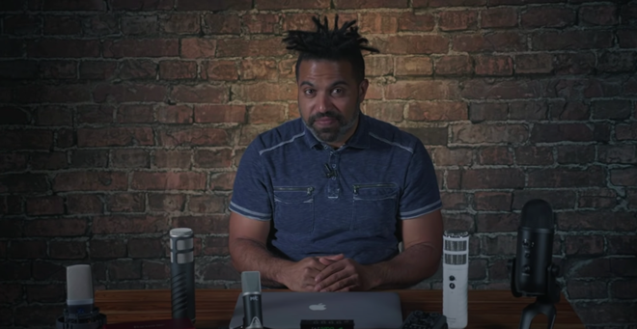 Video length: 12 minutes

Task:
You will create a 5 – 20-minute Podcast on one of the following topics, along with a 1400 x 1400 pixel podcast cover to promote your Podcast.
- Challenges youth have faced during the pandemic
- Successful learning habits for Learning@Home
- Mental well being
- Environmental impacts of a global pandemic
- Positive changes that have occurred since the global pandemic

Tools:
Mobile Device, Mobile App, Image Creation tool (e.g., https://vectr.com/)
Optional: Computer PC or Mac, Protools First (or similar), Audacity (or similar), microphone, Vector or Bitmap imaging software (for podcast cover)
Podcast Software for Mobile
- https://anchor.fm/
- https://auphonic.com/
- https://sone.app/
DAW Software for PC/Mac (recommended not required)
- Protools First (Free Educational Application)
- Audacity (Open Source)
- Auphonic (free account)

Steps:
Think about the learning that you have just done.
- Decide on your topic
- Preplan by writing your outline/script for your first Podcast (you will submit this)
- Ensure that the equipment, Apps or Software is ready to go
- Record in a quiet room, preferably in the center to avoid audio reflection
- Edit your audio
- Mix your audio
- Export your audio into one of the following formats .mp3, .mp4a, or AIFF and submit
- Produce a podcast cover 1400 x 1400x pixels using an image editor of your choice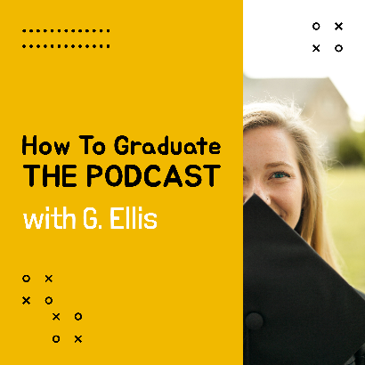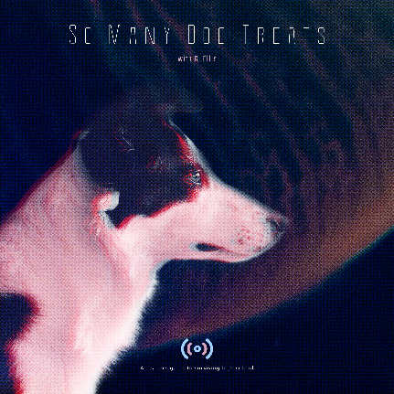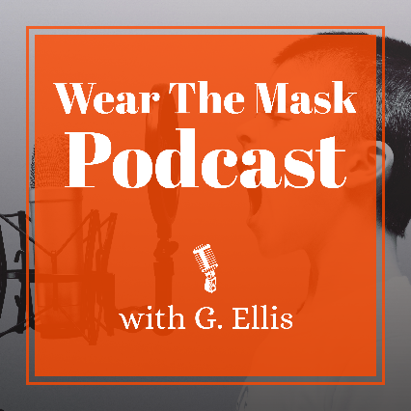
- Submit a 3 - 5 paragraph reflection about the learning that you did during this assignment, as well as any challenges you faced and how you overcame them.

Expectation | Level 4 | Level 3 | Level 2 | Level 1 | R
Communication: Define project objectives and performance criteria precisely.
Overall Expectation B3
Create an outline or script, Reflect on Learning | Defines and explains project objectives, process & reflection with profound detail. | Defines and explains the project objectives process & reflection with considerable detail. | Defines and explains project objectives, process & reflection with some detail. | Did not define or explain the project objectives, process & reflection. | Did not submit
Thinking: Use a variety of planning techniques and tools when creating plans for communications technology projects. Overall Expectation A2
Demonstrated a variety of techniques when the Podcast and Podcast art cover | Uses a variety of planning techniques and tools when creating plans for communications technology projects with a high degree of logic. | Uses a variety of planning techniques and tools when creating plans for communications technology projects with considerable logic. | Uses a variety of planning techniques and tools when creating plans for communications technology projects with some logic. | Uses a variety of planning techniques and tools when creating plans for communications technology projects with limited logic. | Did not submit apply previous learning
Application: Produce rich media products that conform to evolving industry standards and formats. Overall Expectation B2
Demonstrated a variety of tools and techniques when the Podcast and Podcast art cover | Produces rich media products that conform to evolving industry standards and formats with a high degree of fluency. | Produces rich media products that conform to evolving industry standards and formats with considerable fluency | Produces rich media products that conform to evolving industry standards and formats with some fluency. | Produces rich media products that conform to evolving industry standards and formats with limited fluency. | Does not meet the minimum requirements, please redo, and resubmit
Applied software skills to the completion of the podcast and podcast art cover | Applies software skills to integrate components for a media production with profound relevance. | Applies software skills to integrate components for a media production with considerable relevance. | Applies software skills to integrate components for a media production with some relevance. | Applies software skills to integrate components for a media production with limited relevance. | No indication editing or mixing application was used
Knowledge / Understanding: Demonstrate an understanding of advanced concepts used to produce communications products or services Overall Expectation A1
Applied learning to the completed Podcast | Demonstrates a thorough understanding of advanced concepts used to produce a communications product or service. | Demonstrates considerable understanding of advanced concepts used to produce a communications product or service. | Demonstrates some understanding of advanced concepts used to produce a communications product or service. | Demonstrates a limited understanding of advanced concepts used to produce a communications product or service. | No indication of completed learning

Appendix B – TGJ3M Podcasting Links from PowerPoints

Activity 1 – What Is A Podcast
Dig Deeper  How to Apply for a Broadcasting License  https://crtc.gc.ca/eng/info_sht/b313.htm | 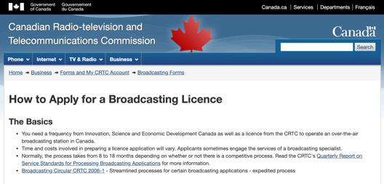
Listen and Learn  Ted Talks Daily  https://www.ted.com/about/programs-initiatives/ted-talks/ted-talks-daily | 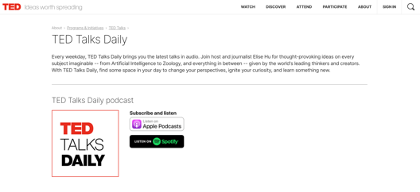
Read & Learn  Why do some podcasts sound bad  https://www.quora.com/Why-do-some-podcasters-presents-podcasts-with-so-bad-sound-quality-Is-it-that-hard-to-put-up-a-good-sound-quality-podcast | 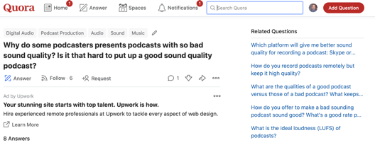
Read and Learn  Critical Thinking Skills  https://www.skillsyouneed.com/learn/critical-thinking.html | 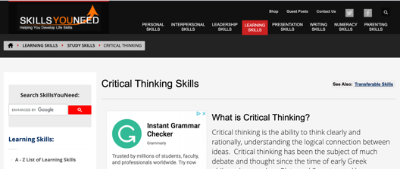
Read and Learn  Podcast The Joe Rogan Experience  https://www.thestar.com/entertainment/opinion/2020/05/20/joe-rogans-100-million-deal-with-spotify-has-valuable-lessons-for-all-podcasters.html | 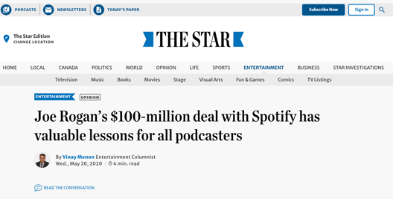
Read and Learn  Building a Podcast Team  https://sweetfishmedia.com/how-to-build-a-podcast-team/ | 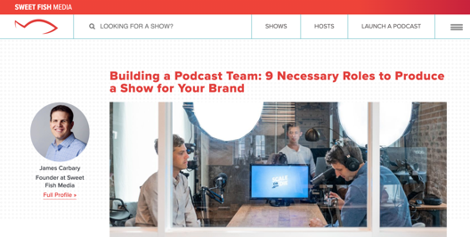

Watch & Learn  How to find work you love | Scott Dinsmore  https://www.youtube.com/watch?v=bvAEJ8G9l9U | 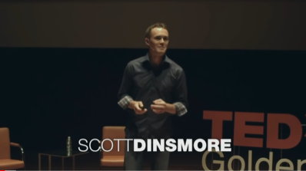
Read and Learn
Why Choose College
https://www.ontariocolleges.ca/en/colleges/why-college
Read and Learn  The Seven Most Common Podcast Formats  https://medium.com/@mark_leonard/the-seven-most-common-podcast-formats-87bbc3ecf40d/ | 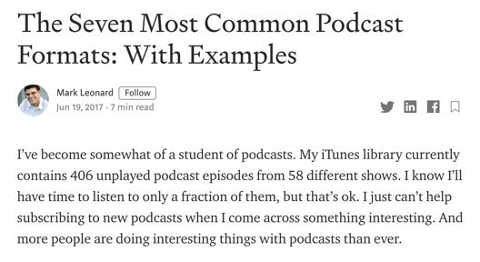

Activity 2 – Software and Equipment
Dig Deeper: Explore the following apps
- https://anchor.fm/
- https://auphonic.com/
- https://sone.app/
Dig Deeper  How Free Games Make Money  https://www.youtube.com/watch?v=fKK9nVLvhGM | 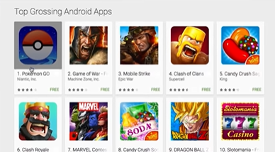

Read & Learn  Make Money From Your Free App  https://www.business.com/articles/why-free-apps/ | 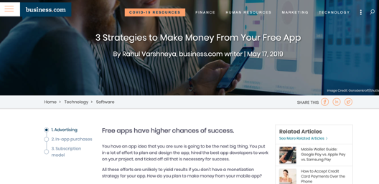
Watch and Learn  Recording 101: Microphones  https://www.youtube.com/watch?v=Z5Nza3Z6WTY | 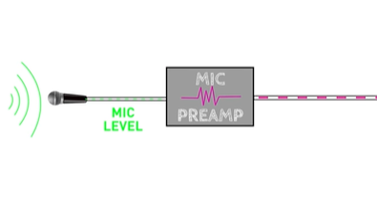
Read & Learn  The Proximity Effect  https://theproaudiofiles.com/proximity-effect/ | 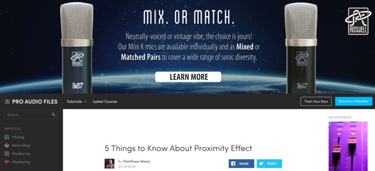
Application Download  Pro Tools First  https://www.avid.com/pro-tools/comparison | 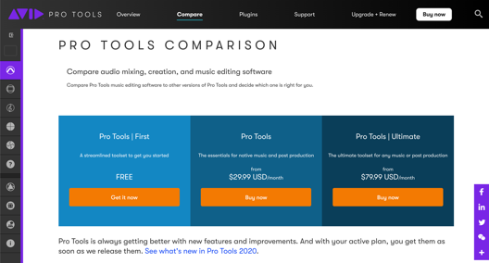
Application Download  Audactiy  https://www.audacityteam.org/ | 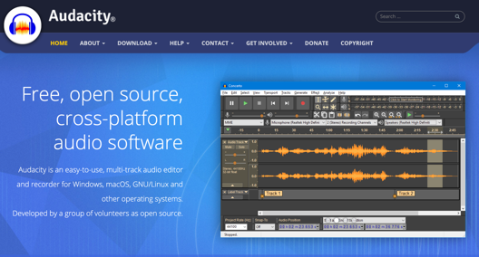
Watch and Learn  Tutorial for Beginners in 12 minutes  https://www.youtube.com/watch?v=g5zwi--TT2Y | 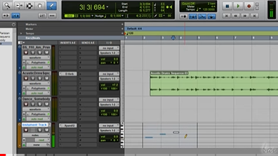

Watch and Learn  Pro Tools Workspace  https://www.youtube.com/watch?v=rdvt4JjgYno | 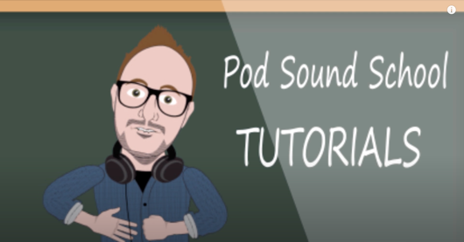
Watch and Learn
Modes and Tools
https://www.youtube.com/watch?v=m2acPBR4S1E
Watch and Learn  Recording Audio  https://www.youtube.com/watch?v=Xm-J6Xf4xow | 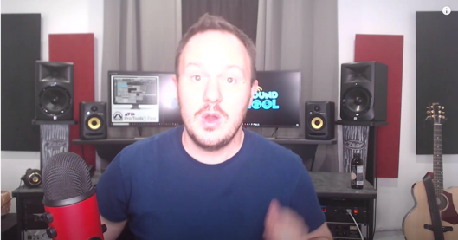
Watch and Learn  Intro Music  https://www.youtube.com/watch?v=GpjDz0yZ030 | 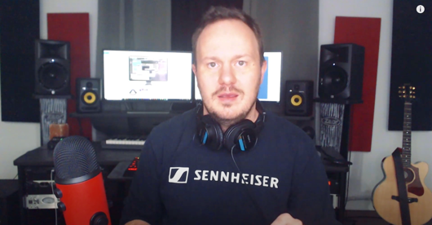
Watch and Learn  Edit Your Podcast  https://www.youtube.com/watch?v=8T4oC8Wu_7g | 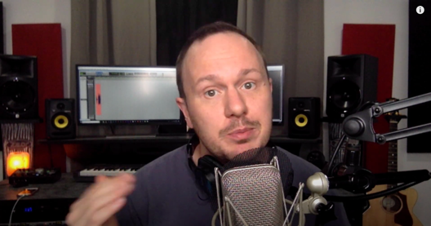
Watch and Learn  How to Edit a Podcast in Audacity  https://www.youtube.com/watch?v=Zw9nkEHQ5B8 | 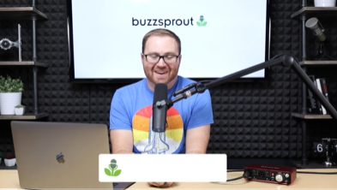

Watch and Learn
Voice and Voice Effects
https://www.youtube.com/watch?v=Ijidrx0K670
Watch and Learn  Make Your Voice Sound Better  https://www.youtube.com/watch?v=dQCB72S64L4 | 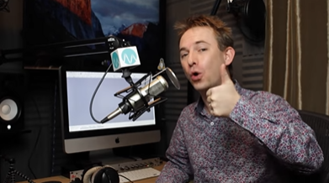
Watch and Learn
Create a Podcast Intro and Outro
https://www.youtube.com/watch?v=zdHENJNaydU

Activity 3 – Planning to Podcast
- Read and Learn
The Seven Most Common Podcast Formats
https://medium.com/@mark_leonard/the-seven-most-common-podcast-formats-87bbc3ecf40d
- Read and Learn
10 Tips for Podcast Creating Artwork
https://www.buzzsprout.com/blog/10-tips-create-awesome-podcast-artwork
- Read and Learn
What is the difference between Vector and Raster Graphics
https://support.pitneybowes.com/VFP05_KnowledgeWithSidebarHowTo?id=kA11E000000D0QFSA0&popup=false&lang=en_US
- Read and Learn
20 Beautiful Podcast Covers
https://inspirationfeed.com/podcast-covers/

- Read and Learn: Vectr Tutorials
Lesson 1 – Getting Started
https://vectr.com/tutorials/getting-started-tutorial/
Lesson 2 – Sharing/Exporting Your Work
https://vectr.com/tutorials/real-time-sharing-vectr-projects/
Lesson 3 – Create a simple Podcast Cover
https://vectr.com/tutorials/how-to-create-a-simple-flyer-or-poster/
Lesson 4 – Create a logo
https://vectr.com/tutorials/what-are-iconic-logos-and-how-to-create-one/
Lesson 5 – Create a Typographic Logo
https://vectr.com/tutorials/creating-typographic-logo/
- Image Websites
https://pixabay.com/
https://unsplash.com/
https://thenounproject.com/
https://burst.shopify.com/
https://www.pexels.com/
- Watch and Learn
Pixlr Beginners Tutorial
https://www.youtube.com/watch?v=7BWLhz1KKzo
- Online Image Editor
Pixlr
https://pixlr.com/

Activity 3 – Producing Your Podcast
Watch and Learn  Signal Flow  https://www.youtube.com/watch?v=pDzlLsYDIEE | 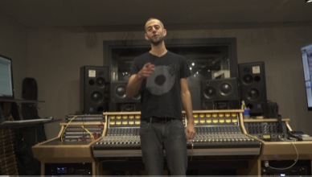
Read and Learn  Signal Flow  https://www.musicianonamission.com/signal-flow/ | 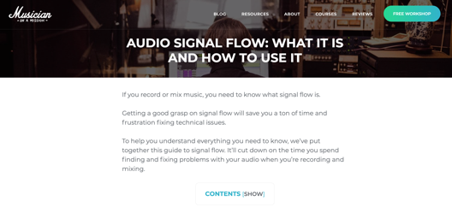
Read and Learn  XLR (External Line Return)  https://en.wikipedia.org/wiki/XLR_connector | 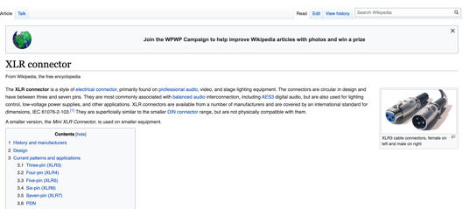
Read and Learn  Audio Terms and Formats  https://www.macworld.com/article/1136468/anyaudio.html | 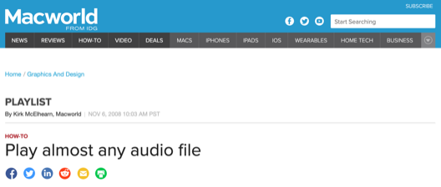

Assignment 1
Watch and Learn  How to Start a Podcast 2020: Podcasting for Beginners  https://www.youtube.com/watch?v=NUmdoFDtpQg | 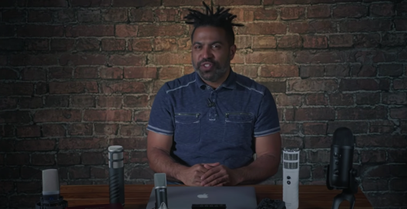

References
20 Beautiful Podcast Covers. Inspirationfeed, 2020 https://inspirationfeed.com/podcast-covers/
21st Century Competencies: Foundation Document for Discussion. Phase 1: Towards Defining 21st Century Competencies for Ontario, Winter 2016 Edition, 2016 http://www.edugains.ca/resources21CL/About21stCentury/21CL_21stCenturyCompetencies.pdf
3 Strategies to Make Money From Your Free App. Article by Rahul Varshneya, business.com, 2019 https://www.business.com/articles/why-free-apps/
5 Things to Know About Proximity Effect. Article by Matthew Weiss, Pro Audio Files, 2019 https://theproaudiofiles.com/proximity-effect/
Audacity: Improve your Voice TUTORIAL for Commentary & Podcasts. DJ Method, 2014 https://www.youtube.com/watch?v=Ijidrx0K670
AVID ProTools First Tutorial for Beginners in 12 minutes. Bai, 2019 https://www.youtube.com/watch?v=g5zwi--TT2Y
Course Codes for Emphasis courses in the Revised Curriculum: Technological Education, Grades 11 and 12, 2009 http://www.edu.gov.on.ca/eng/curriculum/secondary/techedemphasiscourses.pdf
Custom Podcast Intro Music. Pod Sound School, 2019 https://www.youtube.com/watch?v=GpjDz0yZ030
Girl working on Laptop in Bryant Park, photograph by Ed Yourdon, Creative Commons Attribution-NonCommercial-ShareAlike 2.0, 2009 https://www.flickr.com/photos/yourdon/
Growing Success: Assessment, Evaluation, and Reporting in Ontario Schools, First Edition, Covering Grades 1 to 12, 2010 www.edu.gov.on.ca/eng/policyfunding/growSuccess.pdf
How Free Games Make Money. Vox, 2016 https://www.youtube.com/watch?v=fKK9nVLvhGM
How to Create a Podcast Intro and Outro. Katie Steckly, 2019 https://www.youtube.com/watch?v=zdHENJNaydU
How to Design Stunning Podcast Cover Art That Stands Out in Apple Podcasts. Buzzsprout, 2020 https://www.buzzsprout.com/blog/10-tips-create-awesome-podcast-artwork
How to Edit a Podcast in Audacity. Buzzsprout, 2019 https://www.youtube.com/watch?v=Zw9nkEHQ5B8
How to find work you love | Scott Dinsmore. TED, 2015 https://www.youtube.com/watch?v=bvAEJ8G9l9U
How To Graduate The Podcast Cover. Image created By G. Ellis, 2020
How to Start a Podcast // Step-by-Step Guide. Buzzsprout, 2019 https://www.youtube.com/watch?v=Gejf39h3_IY
How to Start a Podcast 2020: Podcasting for Beginners. B&H Photo Video, 2020 https://www.youtube.com/watch?v=NUmdoFDtpQg
Learning for All – A Guide to Effective Assessment and Instruction for All Students, Kindergarten to Grade 12, 2013 http://www.edu.gov.on.ca/eng/general/elemsec/speced/LearningforAll2013.pdf
Pixlr Beginners Tutorial. DCP Web Designers, 2019 https://www.youtube.com/watch?v=7BWLhz1KKzo
Play almost any audio file. Article by Kirk McElhearn, Macworld, 2008 https://www.macworld.com/article/1136468/anyaudio.html
Podcast Hosting: Get Your Podcast Online & Into Directories. Buzzsprout, 2020 https://www.youtube.com/watch?v=_Z-3j_M0_3M
Podcast The Joe Rogan Experience. Article by Vinay Menon, Toronto Star, 2020 https://www.thestar.com/entertainment/opinion/2020/05/20/joe-rogans-100-million-deal-with-spotify-has-valuable-lessons-for-all-podcasters.html
Pro Tools First Modes and Tools. Pod Sound School, 2019 https://www.youtube.com/watch?v=m2acPBR4S1E
Pro Tools Workspace. Pod Sound School, 2019 https://www.youtube.com/watch?v=rdvt4JjgYno
Recording 101: Microphones. RocketJump Film School, 2016 https://www.youtube.com/watch?v=Z5Nza3Z6WTY
Signal Flow Explained. Love Science Music, 2019 https://www.youtube.com/watch?v=pDzlLsYDIEE
So Many Dog Treats Podcast Cover. Image created by G. Ellis, 2020
The Differentiated Instruction Scrapbook http://www.edugains.ca/resourcesDI/EducatorsPackages/DIEducatorsPackage2010/2010DIScrapbook.pdf
The Ontario Curriculum, Grades 11 and 12: Technological Education, 2009 (revised) http://www.edu.gov.on.ca/eng/curriculum/secondary/2009teched1112curr.pdf
The Ontario Curriculum, Grades 9 and 10: Technological Education, 2009 (revised) http://www.edu.gov.on.ca/eng/curriculum/secondary/teched910curr09.pdf
The Seven Most Common Podcast Formats: With Examples. Article by Mark Leonard, Medium, 2017 https://medium.com/@mark_leonard/the-seven-most-common-podcast-formats-87bbc3ecf40d
The Seven Most Common Podcast Formats: With Examples. Article by Mark Leonard, 2017 https://medium.com/@mark_leonard/the-seven-most-common-podcast-formats-87bbc3ecf40d
Understanding the difference between Vector Graphics and Raster Graphics. Pitney Bowes, 2019 https://support.pitneybowes.com/VFP05_KnowledgeWithSidebarHowTo?id=kA11E000000D0QFSA0&popup=false&lang=en_US
Wear The Mask Podcast Cover. Image created by G. Ellis, Aug 2020
Why do some podcasts sound bad. Quora, 2015 https://www.quora.com/Why-do-some-podcasters-presents-podcasts-with-so-bad-sound-quality-Is-it-that-hard-to-put-up-a-good-sound-quality-podcast
XLR (External Line Return). Wikipedia, 2020 https://en.wikipedia.org/wiki/XLR_connector

