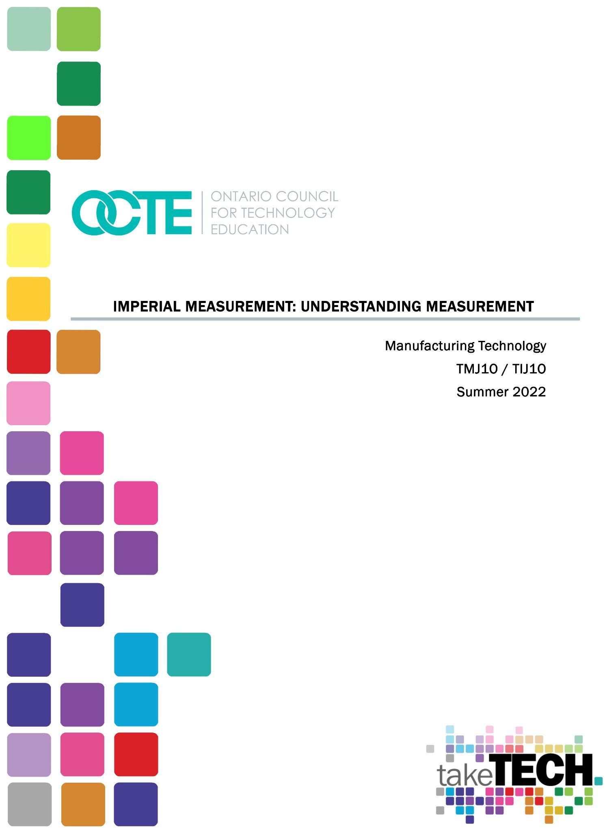

Table of Contents

Introduction 4
Project Outline 4
Prior Knowledge 4
Student Activities 4
Activity 1 – Introduction of the Imperial System 5
Activity 2 – Imperial Scale Practice 5
Activity 3 – Application of Measurement 5
Planning Notes 6
Skilled Trades and Apprenticeship Opportunities 6
Skills Continuum 6
Career and Industry Extensions 7
Resources 7
Files 7
Lesson Plan 8
Handouts 8
Tools/Equipment 8
Instructional Strategies 8
The Hook / Motivational Strategies 8
Learning Goals and Success Criteria 9
Overall and Specific Expectations in Support of Ontario Curriculum Grades 9 - 10 Technological Education 9
Overall Expectations 9
Specific Expectations 10
Applicable SAFEDocs and ToolSAFE videos 10
Project Challenges 10
Differentiation of the Project / Activity 10
Assessment and Evaluation 11
Assessment As Learning 11
Assessment For Learning 11
Assessment Of Learning 11
Religious Considerations 11
Career and Industry Extensions 11
Ethical Considerations 12
Environmental Considerations 12
Reflection or Design Report 12
Appendix A – Reading Imperial Measurements Using a Ruler with Precision 13
Appendix B – Inch Rule Reading “Whole Inches 30
Appendix C – Inch Rule Reading: “Half Inches 1” 33
Appendix D – Inch Rule Reading: “Quarter Inches 1” 36
Appendix E – Inch Rule Reading: “Eighth Inches 1” 39
Appendix F - Inch Rule Reading: “Sixteenth Inches” 42
Appendix G - Inch Ruler Reading Practical Measurement Assignment. 45
Appendix H – Measurement Lesson Plan 47
References 49

Introduction
Course Code: TIJ10
Broad base Technology: Manufacturing Technology
Destination:TMJ20/TMJ3C
Grade Level: 9
Project Name: Imperial Measurement Reading a Rule

Project Outline
This project is designed as a grade 9 beginner project. The purpose of this lesson is to refresh or teach imperial ruler reading. This project can be used as a refresher project for a student moving from TMJ20 to TMJ3C or as a way of introducing the skill of Imperial Measurement to a student new to Manufacturing Technology.

Prior Knowledge
- Elementary level numeracy skills

Student Activities
Reading Imperial Measurement Slide Show
Inch rule reading - Whole inches Google Quiz
Inch rule reading - Whole inches PDF
Inch rule reading - Half inches Google Quiz
Inch rule reading - Half inches PDF
Inch rule reading - Quarter inches Google Quiz
Inch rule reading - Quarter inches PDF
Inch rule reading - Eighth inches Google Quiz
Inch rule reading - Eighth inches PDF
Inch rule reading - Sixteenth inches Google Quiz
Inch rule reading - Sixteenth inches PDF
Practical Line Measurement Handout

Activity 1 – Introduction of the Imperial System
The goal for this activity is to introduce students to Imperial measurement and how to accurately read the Imperial measurement scale.
- Students will go over the slide show with the instructor and practice as a class in real time.
- This will introduce the students to basic imperial measurement.
Time Required: .5 hours

Activity 2 – Imperial Scale Practice
The goal for this activity is for students to practice and expand on their knowledge learned during Activity 1. Students will use the Google quizzes or PDF handouts to select the correct measurement from the labeled Imperial scale.
- Students will complete the Google quizzes as a formative learning activity to expand the knowledge earned in Activity 1.
- Students will have the option to redo the quizzes learning was not demonstrated.
Time Required: 1 hour

Activity 3 – Application of Measurement
The goal for this activity is for students to practice the skill of measuring using a Ruler or Tape Measure. This skill will be expanded upon during the semester while working in the shop/classroom on practical projects.
- Students will be given a Tape Measure or a Ruler and will measure each line and record their measurement on the handout.
- This activity will allow students to use measuring tools to practice the hands-on skill of measurement.

Planning Notes
The following are suggestions when planning to instruct on this lesson:
- What previous knowledge do the students have of fractions?
- What previous knowledge do the students have of Imperial Measurement?
- Ensure all materials and tools are on hand

Skilled Trades and Apprenticeship Opportunities
Some examples of Skilled Trades and Apprenticeship opportunities are:
- Tool and Die Maker
- Machine Tool Builder and Integrator
- General Machinist
- Millwright
- Mold Maker
- Etc.

Skills Continuum
As students pursue their careers in the Manufacturing technology industry, they will have opportunities to build on the skills learned during this assignment, as the curriculum expectations met during this project are aligned with the Level 1 Common Core apprenticeship standard.

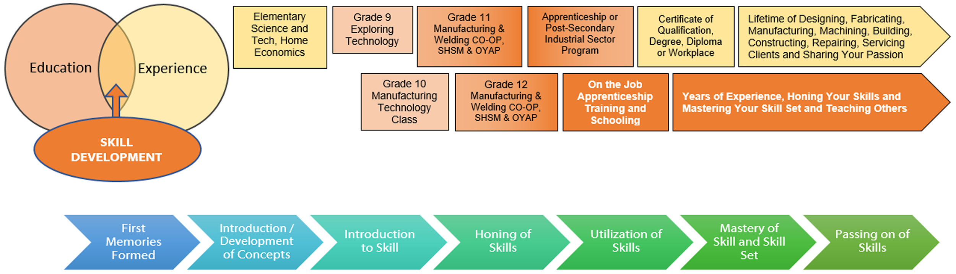

Career and Industry Extensions
Students can explore career connections and opportunities in the following fields:
- Tool and Die Maker
- Machine Tool Builder and Integrator
- General Machinist
- CNC machine operator
- Engineering
- Mold Maker

Resources

Files
Reading Imperial Measurement Slide Show Google Slides
Reading Imperial Measurement Slide Show PDF
Inch rule reading - Whole inches Google Quiz
Inch rule reading - Whole inches PDF
Inch rule reading - Half inches Google Quiz
Inch rule reading - Half inches PDF
Inch rule reading - Quarter inches Google Quiz
Inch rule reading - Quarter inches PDF
Inch rule reading - Eighth inches Google Quiz
Inch rule reading - Eighth inches PDF
Inch rule reading - Sixteenth inches Google Quiz
Inch rule reading - Sixteenth inches PDF

Lesson Plan

Lesson Plan (see Appendix H)

Handouts
Practical Line Measurement Handout
Inch rule reading - Whole inches PDF
Inch rule reading - Half inches PDF
Inch rule reading - Quarter inches PDF
Inch rule reading - Eighth inches PDF
Inch rule reading - Sixteenth inches PDF

Tools/Equipment
- Computer/ Tablet / Smartphone / Internet Access
- Tape Measure or Rule
- Pencil
- Eraser

Instructional Strategies
Teachers may use any of the following instructional strategies; 3-Part lesson, lecture, storyboard, word wall, think-pair-share, placemat activity, rapid write, K-W-L, anticipation chart, ABC taxonomy, think aloud, analyzing text, Cornell note taking, exit ticket/ticket out the door, plus/minus/delta, etc.

The Hook / Motivational Strategies
Leading Question: “Why do you all feel that measurement is an important skill to know?” “Why is it important to have an understanding of Imperial measurement?” “
Have a class discussion on the above questions and write all student ideas on the board and expand on them.

Learning Goals and Success Criteria
Learning goals and success criteria are the foundation on which students base their ability to monitor their learning and determine next steps. Applicable learning goals may include any of the following,
- Students will learn about the various methods in measuring.
- Students will gain knowledge of content (e.g., math facts, computational strategies, terminology, mathematical models)
- Students will demonstrate an understanding of content (e.g., concepts, theories, procedures, principles, mathematical processes)
Success criteria may include any of the following,
- I will be able to identify different measurements.
- I will be able to understand the benefits of measurement.
- I will be more comfortable measuring in front of my peers.
Teachers may use the Learning Goals and Success Criteria Viewing Guide as a resource should they require assistance

Overall and Specific Expectations in Support of Ontario Curriculum Grades 9 - 10 Technological Education

Overall Expectations
A1. Demonstrate an understanding of the fundamental concepts and skills required in the planning and development of a product or service, including the use of a design process and/or other problem-solving processes and techniques;
B1. Use problem-solving processes and project-management strategies in the planning and fabrication of a product or delivery of a service;
D1. Follow safe practices and procedures when using materials, tools, and equipment;

Specific Expectations
A2.3 Use metric and imperial units of measurement (e.g., metric: degrees Celsius, joules, micrometers [microns], millimeters, kilohms, L/100 km, tonnes; imperial: degrees Fahrenheit, BTUs, knots, mils, inches, feet, miles per gallon, pounds per square inch, tons) and the abbreviations or symbols associated with them correctly and as appropriate to the task;
B2.2 Make accurate measurements using a variety of tools (e.g., ruler, scale, tape measure, caliper, micrometer, thermometer, measuring cup), in metric or imperial units, as appropriate;
D2.4 Demonstrate an understanding of the Essential Skills that are important for success in the technology industries, as identified in the Ontario Skills Passport (e.g., reading text, writing, document use, computer use, oral communication, numeracy, thinking skills);

Applicable SAFEDocs and ToolSAFE videos
Please refer to the OCTE SAFEDocs for BBT Technology for safety documents in order to properly address and instruct this project.

Project Challenges
Practical Line Measurement Handout

Differentiation of the Project / Activity
This project can be differentiated by:
- Using different types of learning materials
- Working in groups, have students teach one another
- Measurement quiz could be made into a Google Form
Teachers can also refer to the Differentiation Scrapbook to take into account for learner ability, multiple intelligences, exceptional students, and ESL learners.

Assessment and Evaluation

Assessment As Learning
- Ask questions and make suggestions based on observation
- Assess students’ cognition about their learning (asking them “Why” and “How” they are completing a certain operation
- Students monitor their own learning and ask questions as needed

Assessment For Learning
- Provide feedback to students about their learning and how to improve
- Create differentiated teaching strategies and learning opportunities
- Identify particular learning needs of students

Assessment Of Learning
- Students will complete a quiz to assess their understanding of the lessons

Religious Considerations
The Ontario Catholic School Graduate Expectations (OCSGEs) were developed to provide a framework to represent the distinctiveness and purpose of Catholic education in Ontario. This project does not have any religious context, however, provides foundations and framework for success in manufacturing, design, construction, and transportation skilled trades, STEM - science, technology, engineering, and mathematics, etc.

Career and Industry Extensions
Students can explore career opportunities in the Manufacturing Industry including:
- General Machinist - Machine Tool Builder and Integrator
- Millwright - Mechanical Engineer
- Tool and Die Maker - Manufacturing Engineering Technologist

Ethical Considerations
The purposes of the ethical considerations and standards are to inspire members to care, provide respect, develop trust and integrity. Participants should be able to reflect on the learning and identify responsibilities and make ethical decisions.

Environmental Considerations
Mathematical calculations and concepts are evident in everyday life. There are ways to Reduce, Reuse, Recycle and measure various environmental impacts. Teachers are encouraged to bring environmental considerations that are local to their school, community and city or town.

Reflection or Design Report
Teachers may wish to have the students complete a design report, reflection or create a foldable document to consolidate their learning. This would be a nice way to capture the student’s understanding in a summative format and be used in preparation for their examination, entering post-secondary education or the workforce.

Appendix A – Reading Imperial Measurements Using a Ruler with Precision – PowerPoint Slide Deck

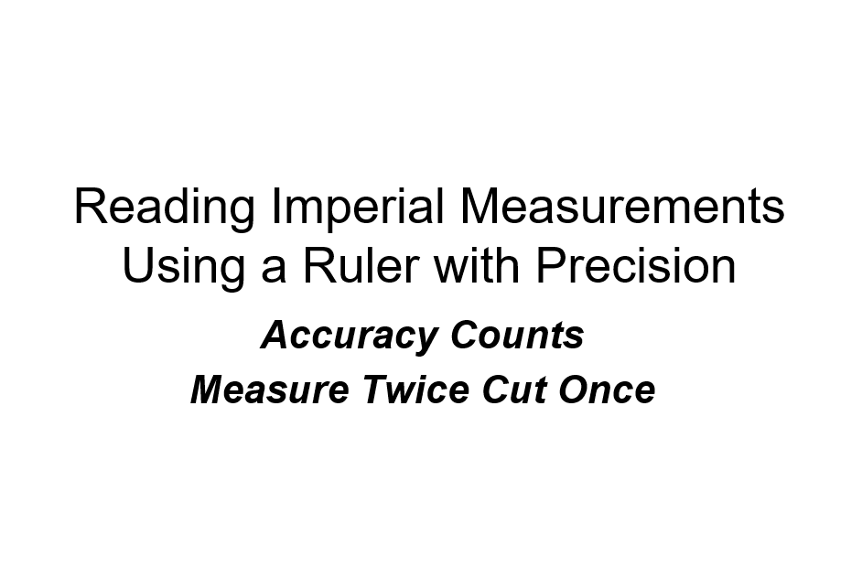

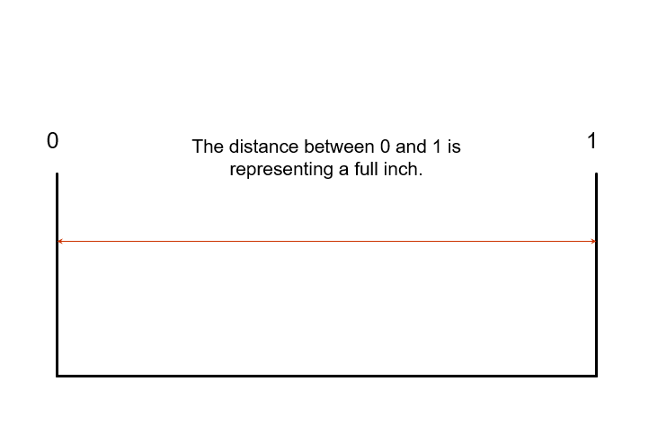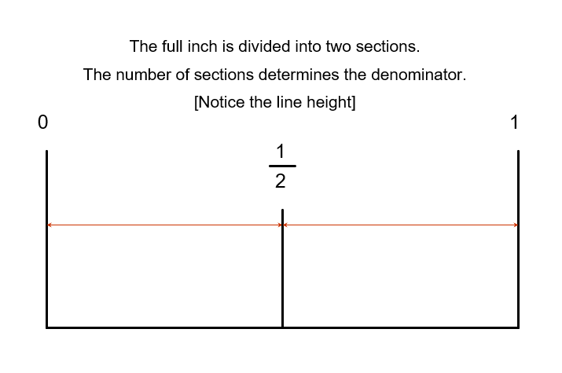

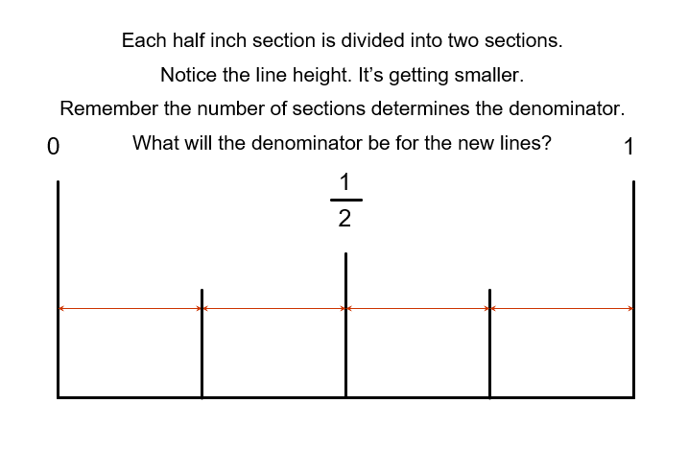
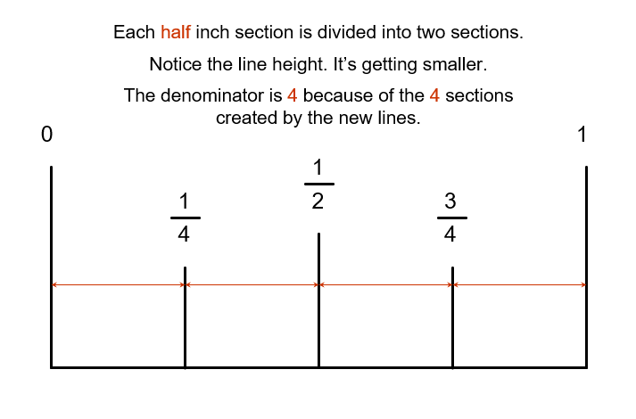
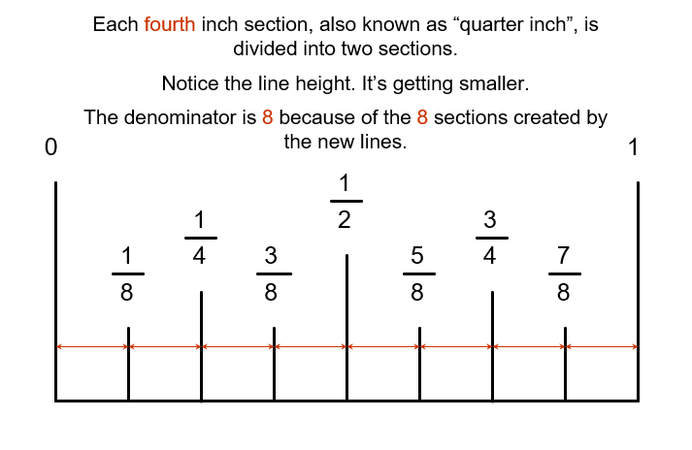
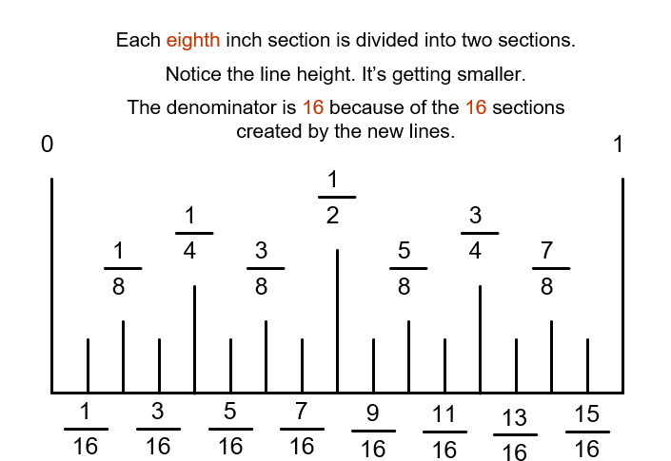
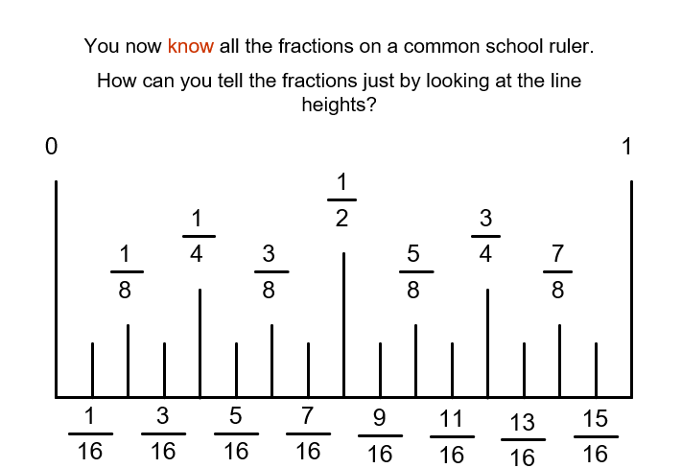
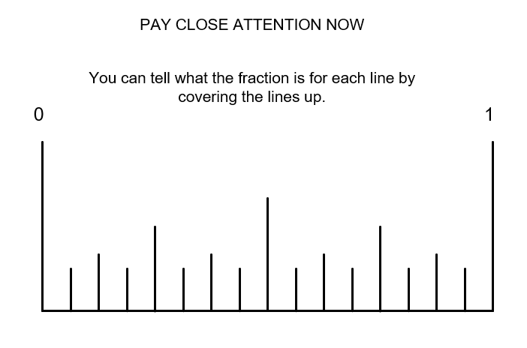
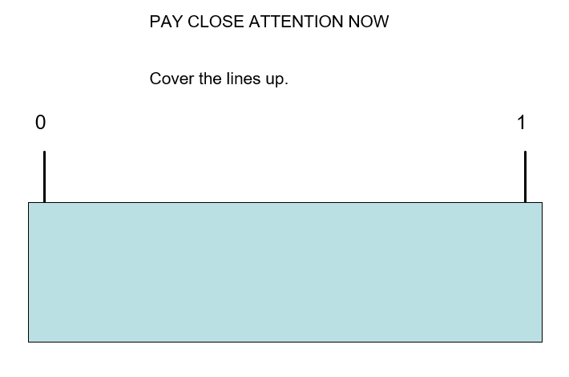
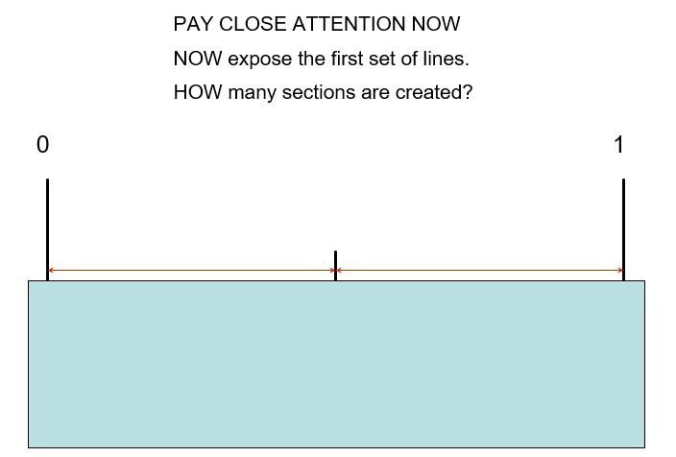
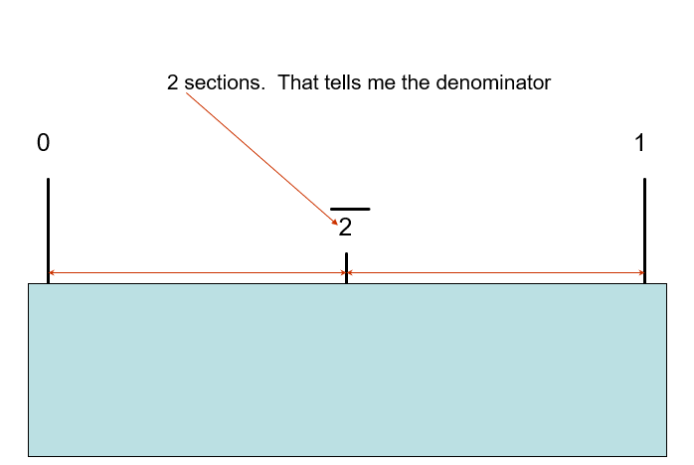
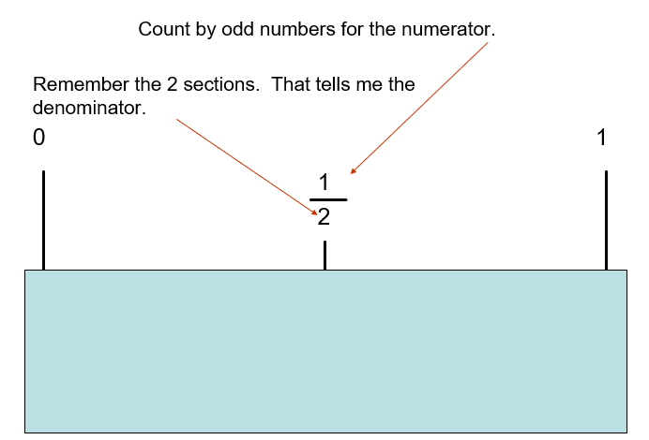
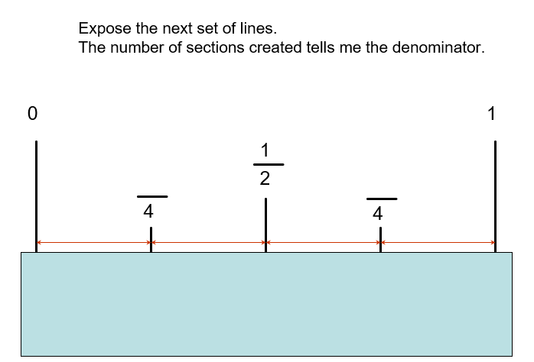
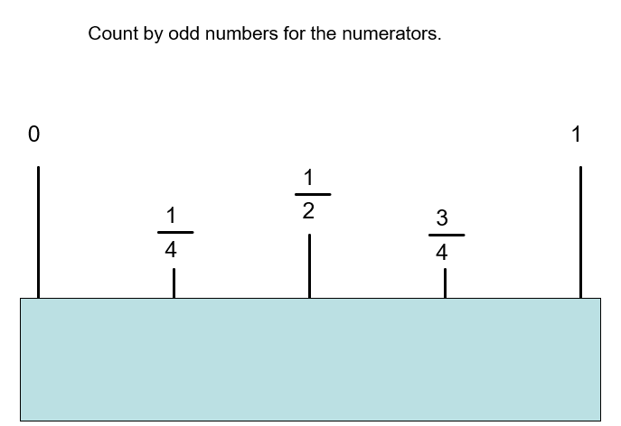
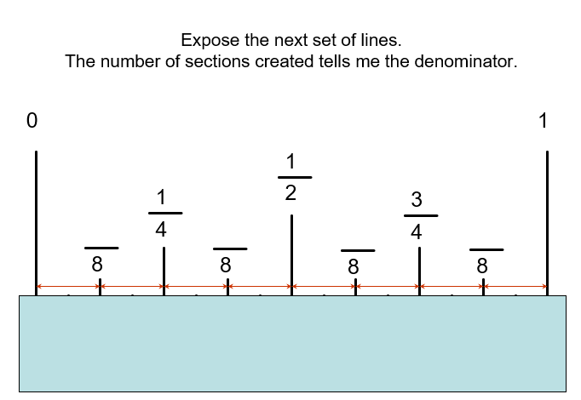
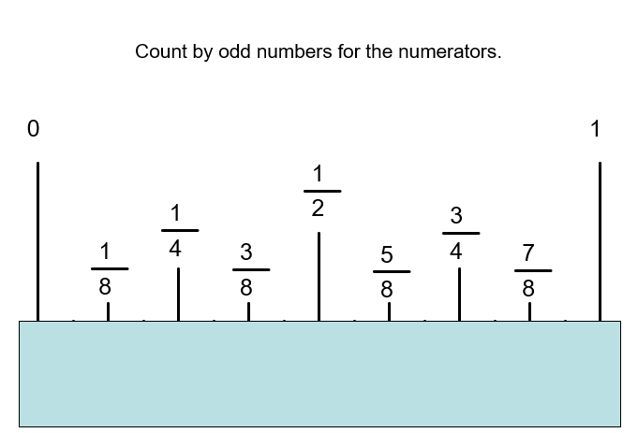
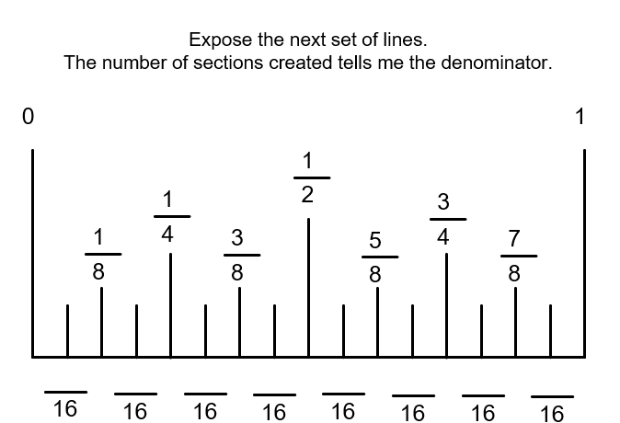
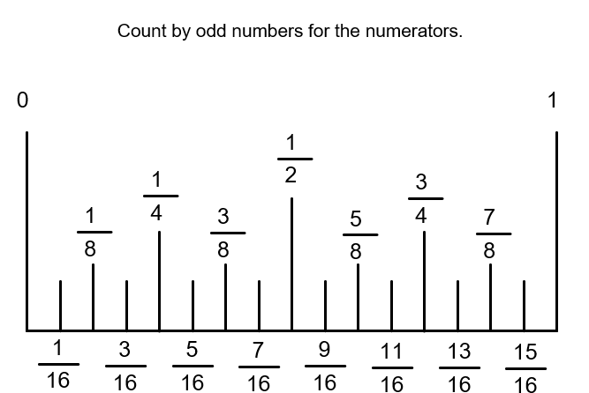
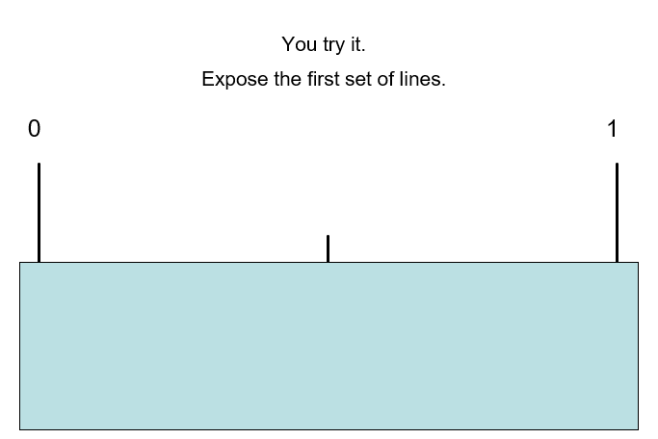
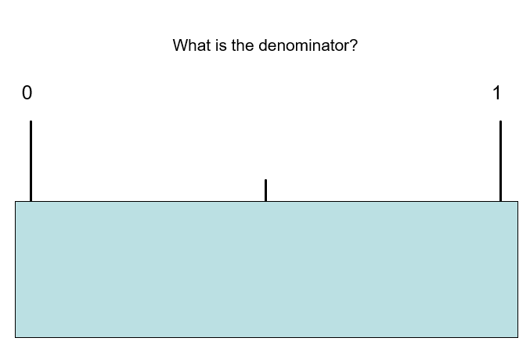
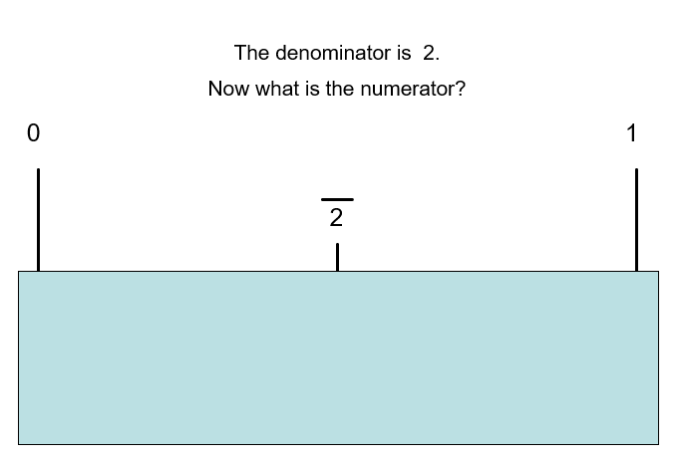
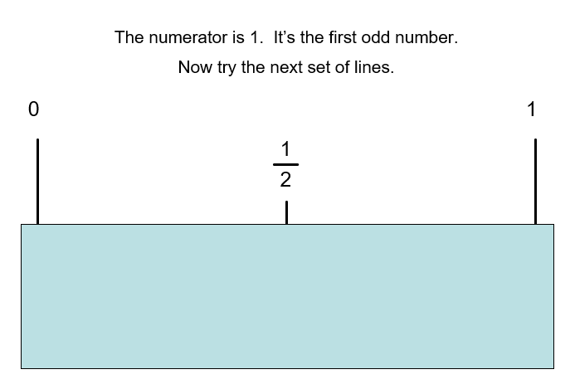

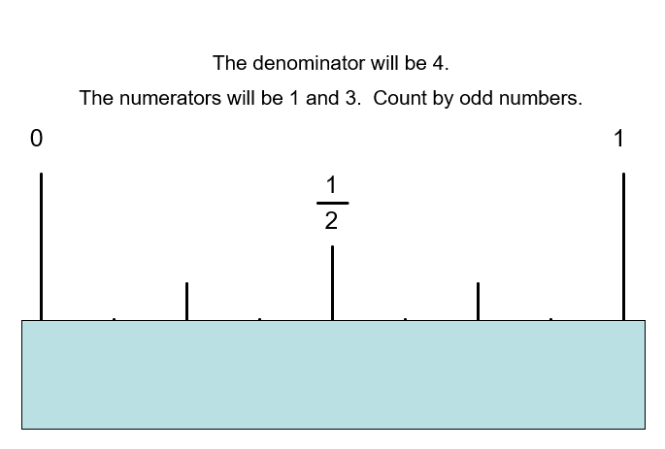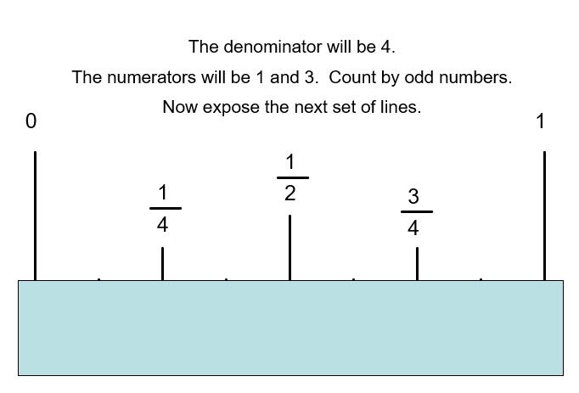
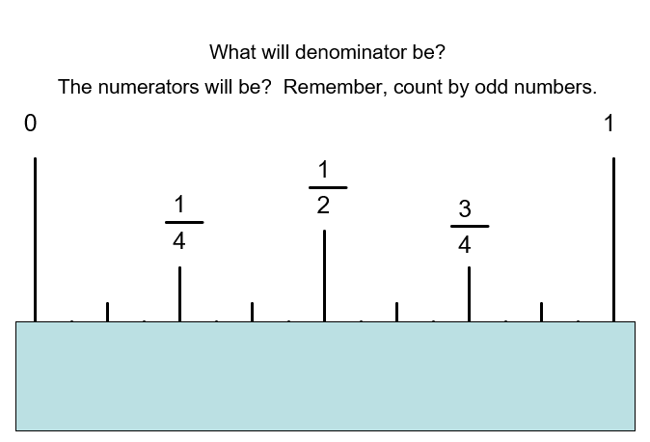
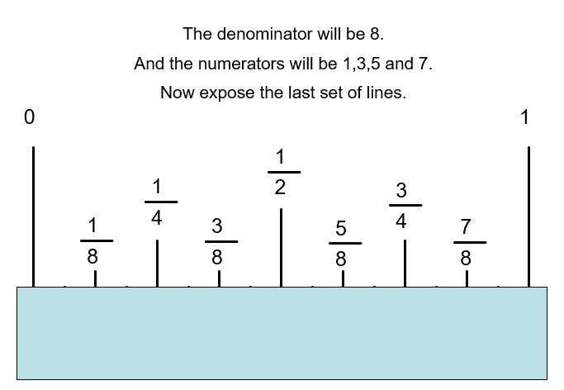
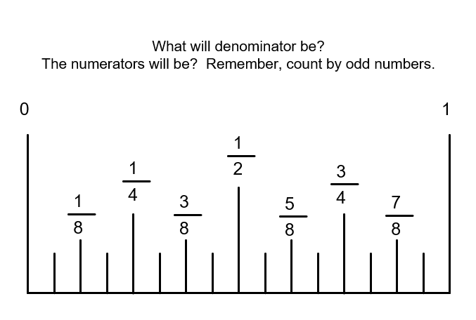
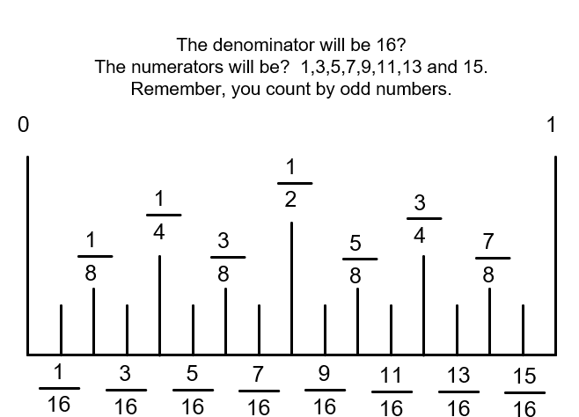
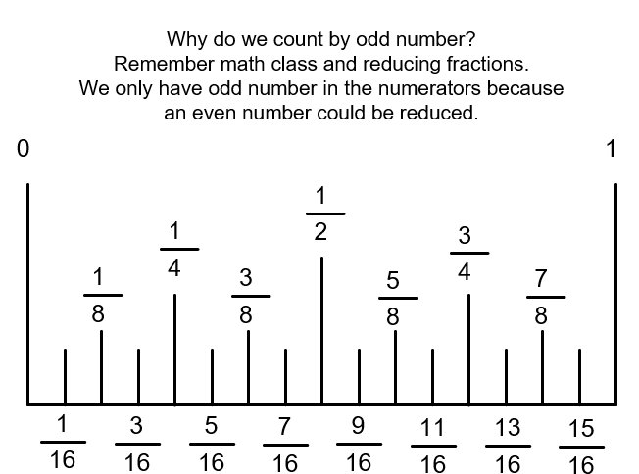
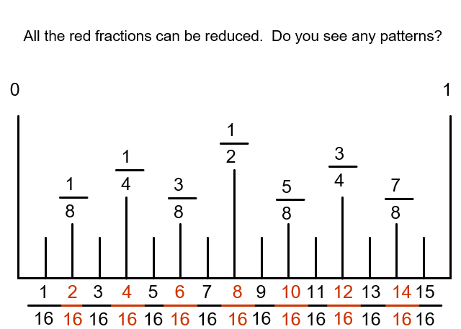
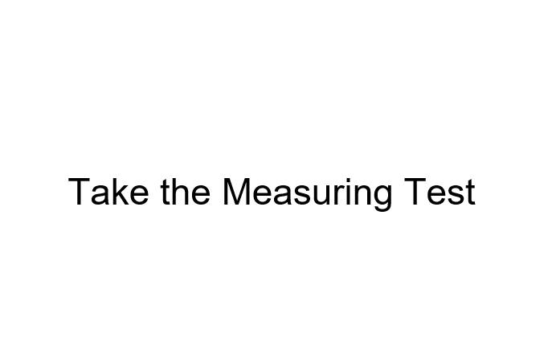

Appendix B – Inch Rule Reading “Whole Inches
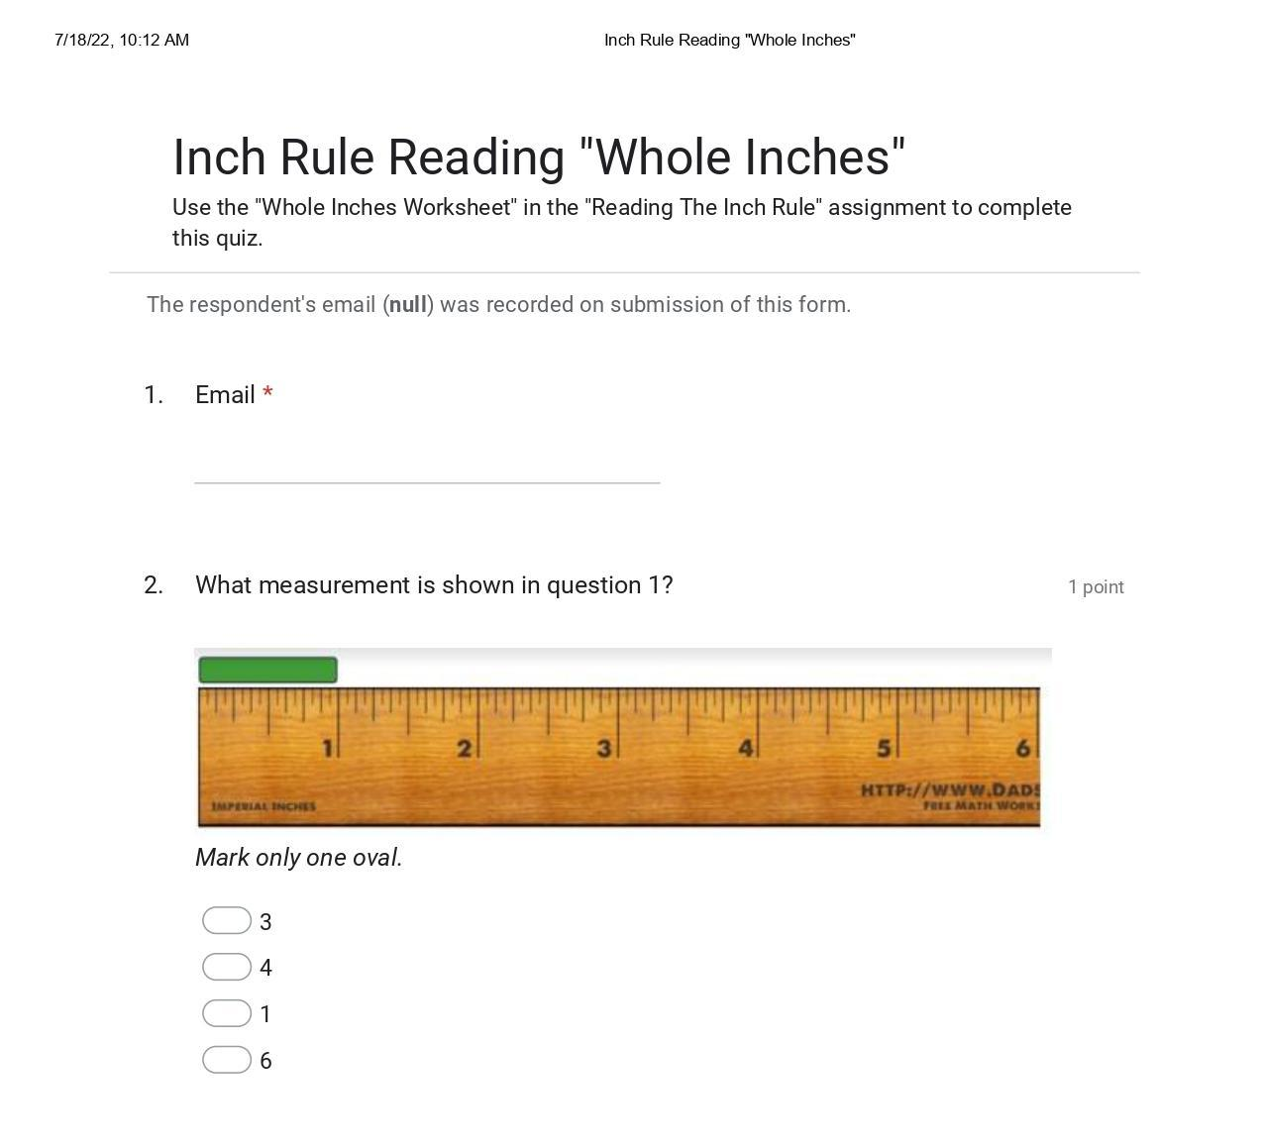
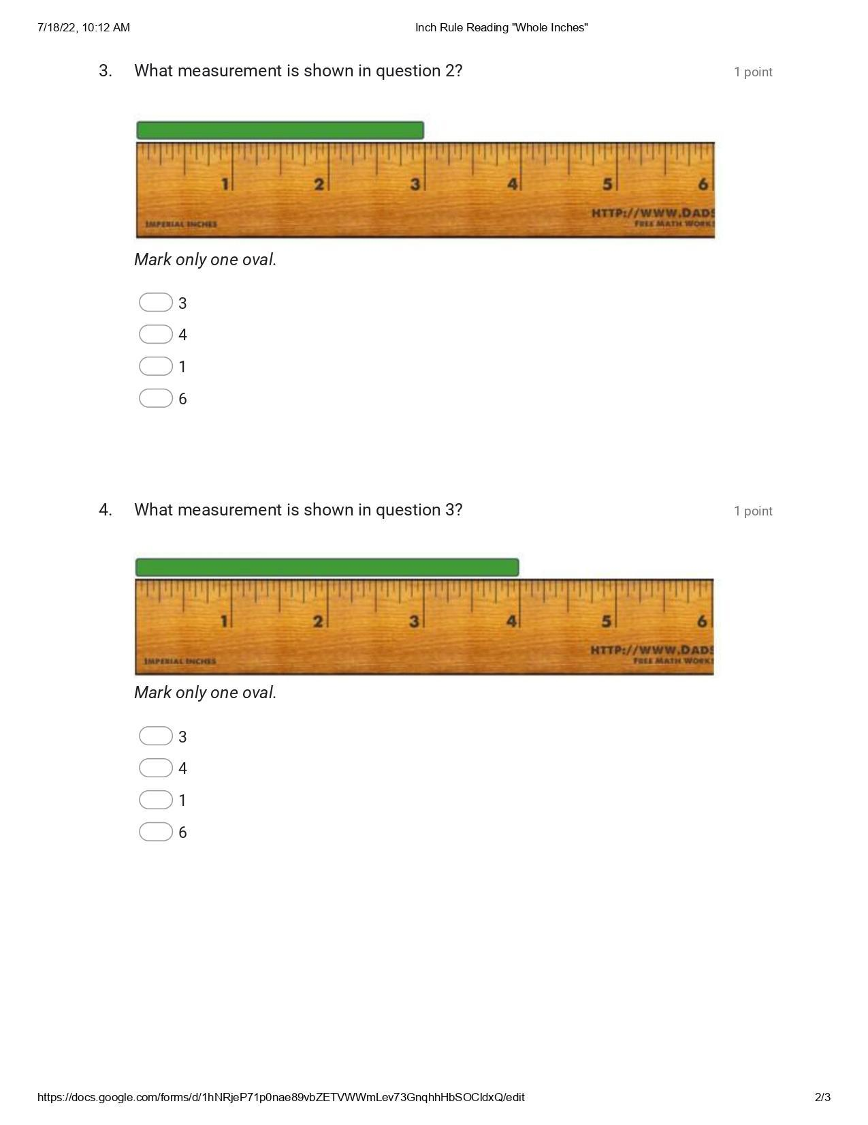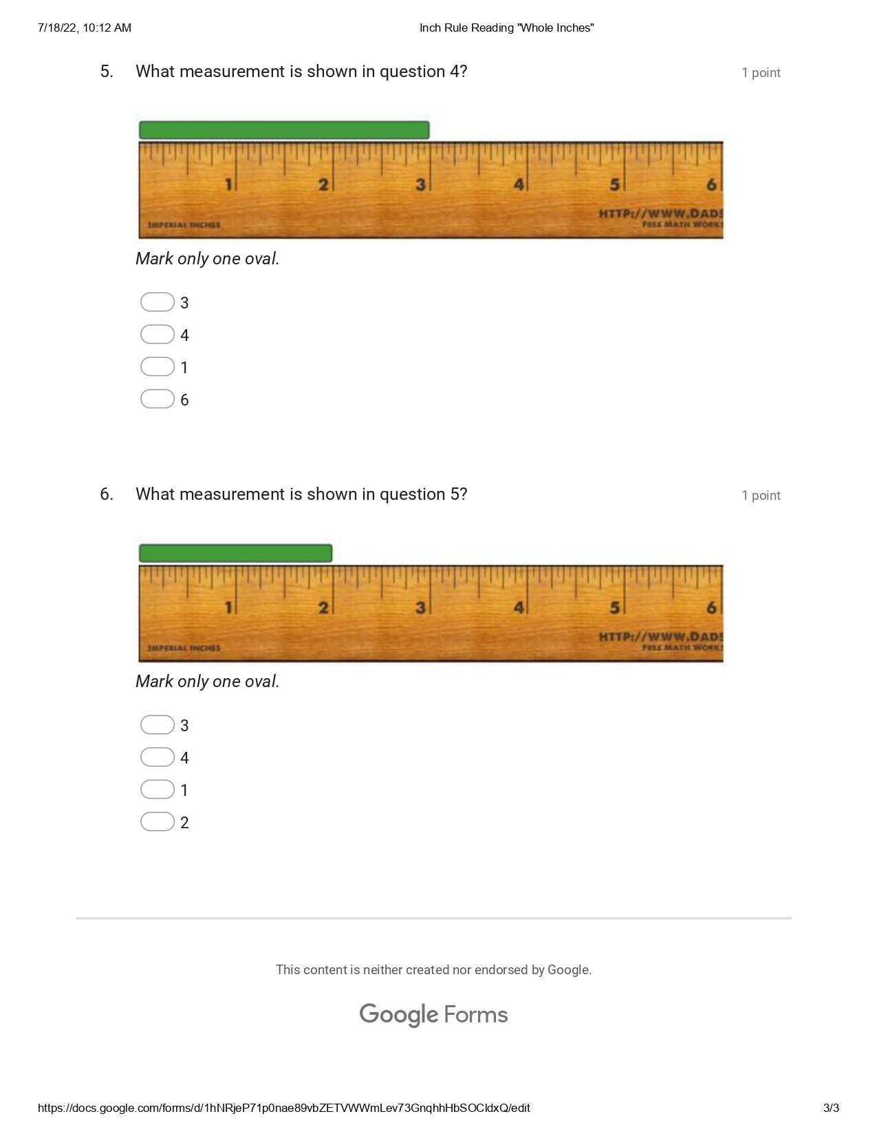

Appendix C – Inch Rule Reading: “Half Inches”
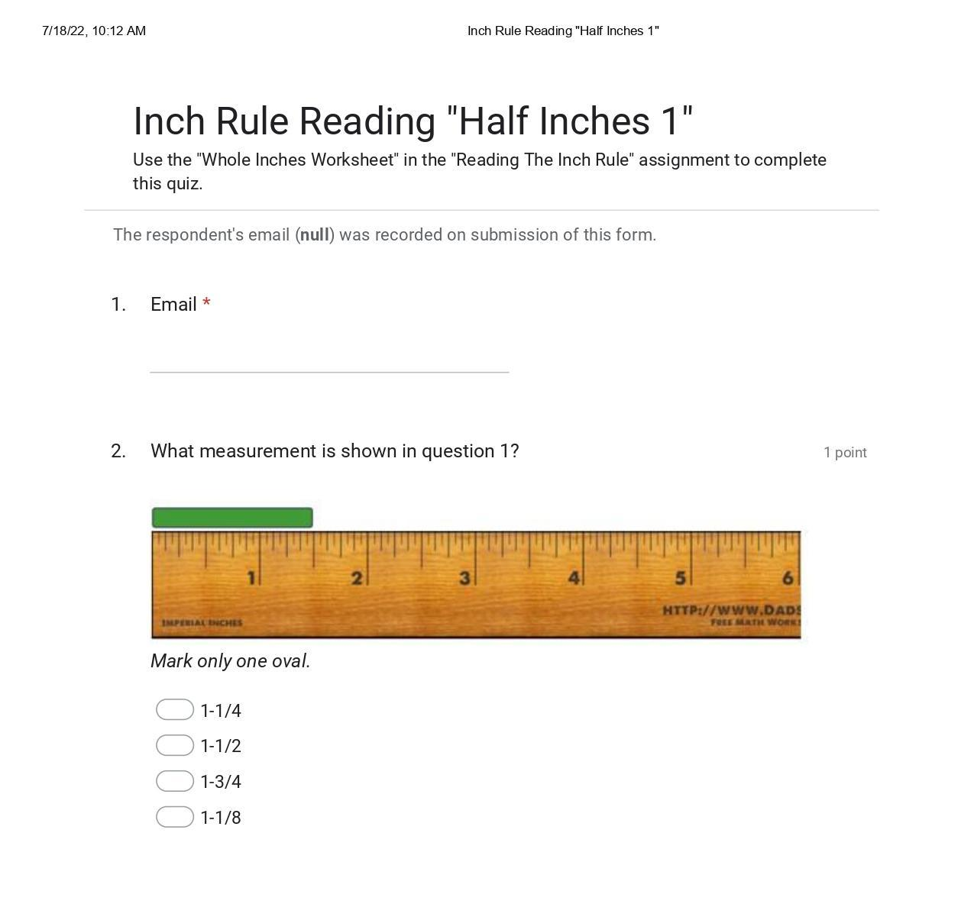
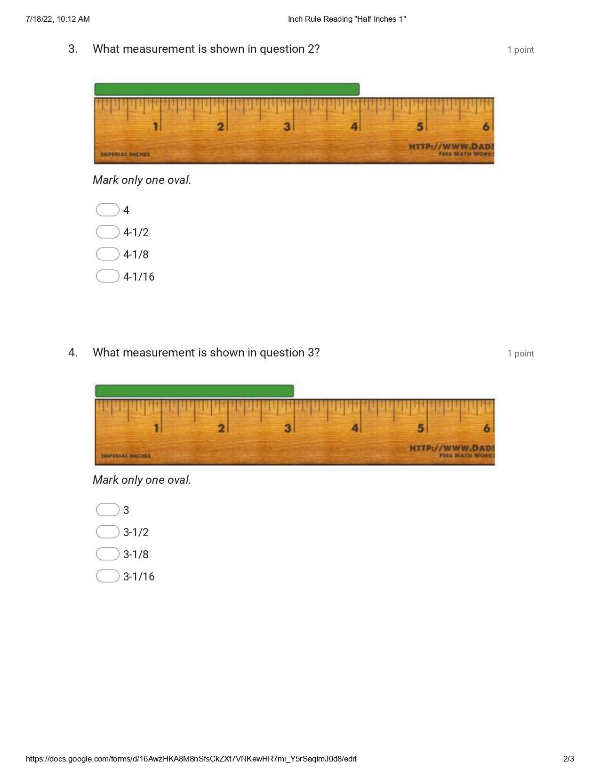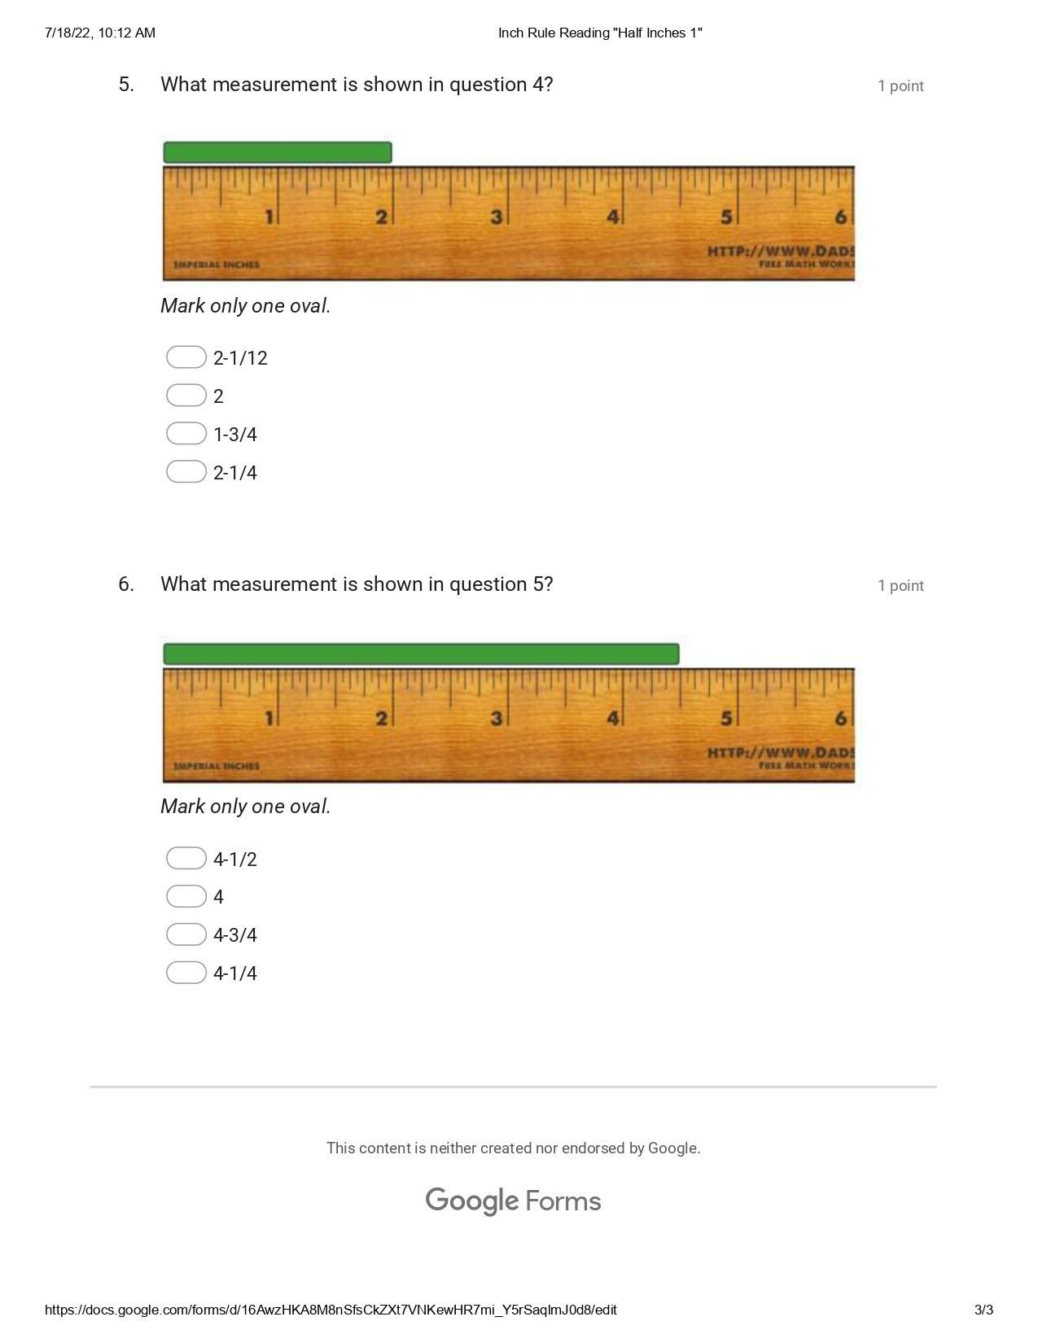

Appendix D – Inch Rule Reading: “Quarter Inches”

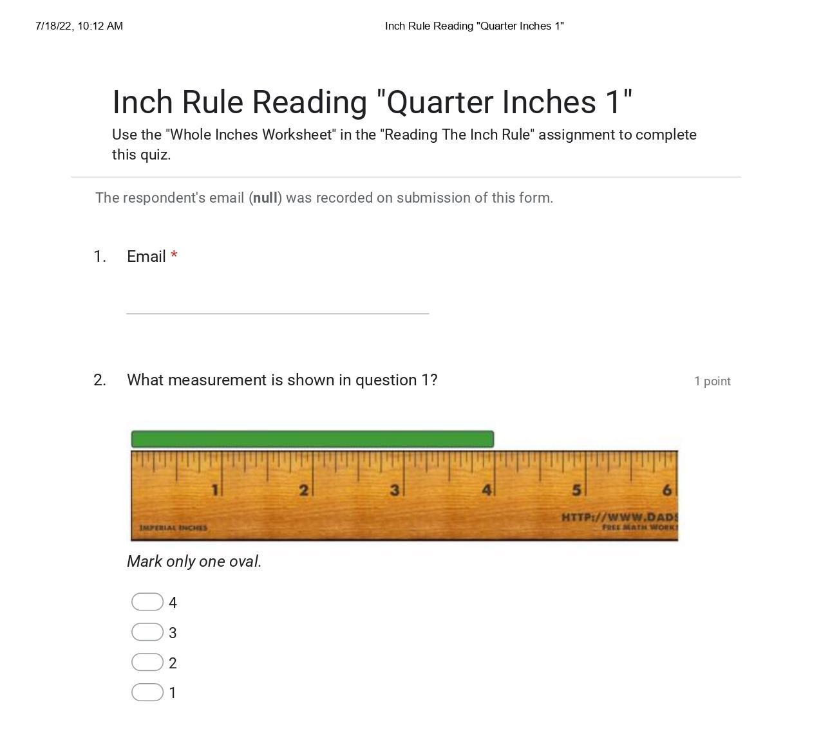
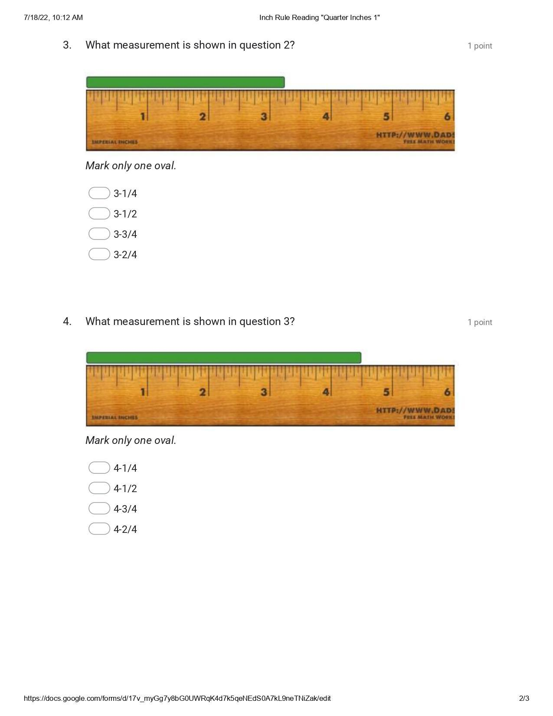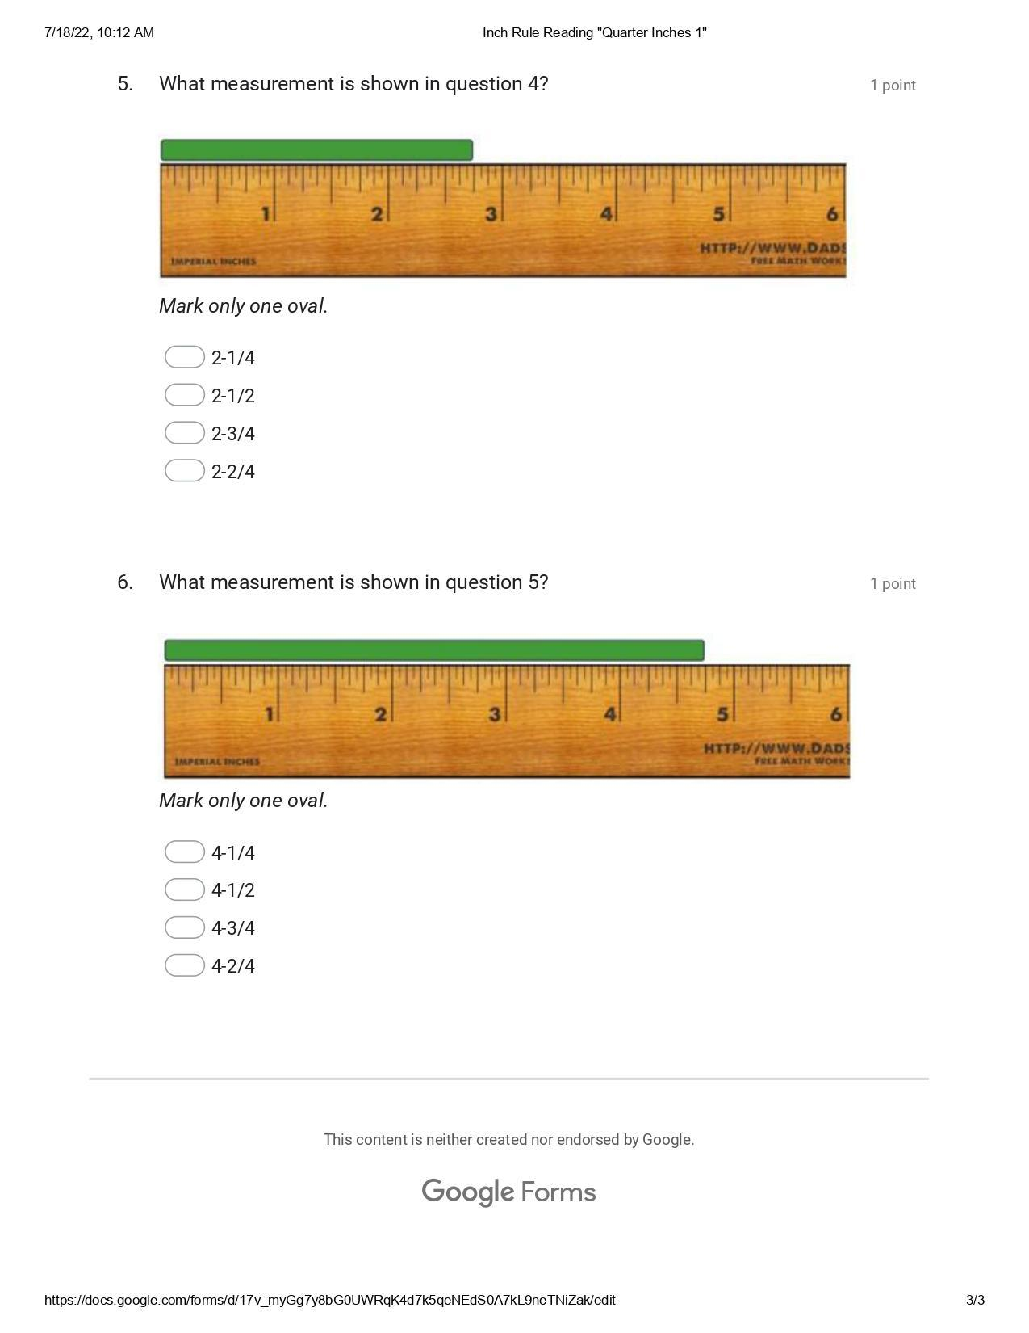

Appendix E – Inch Rule Reading: “Eighth Inches”

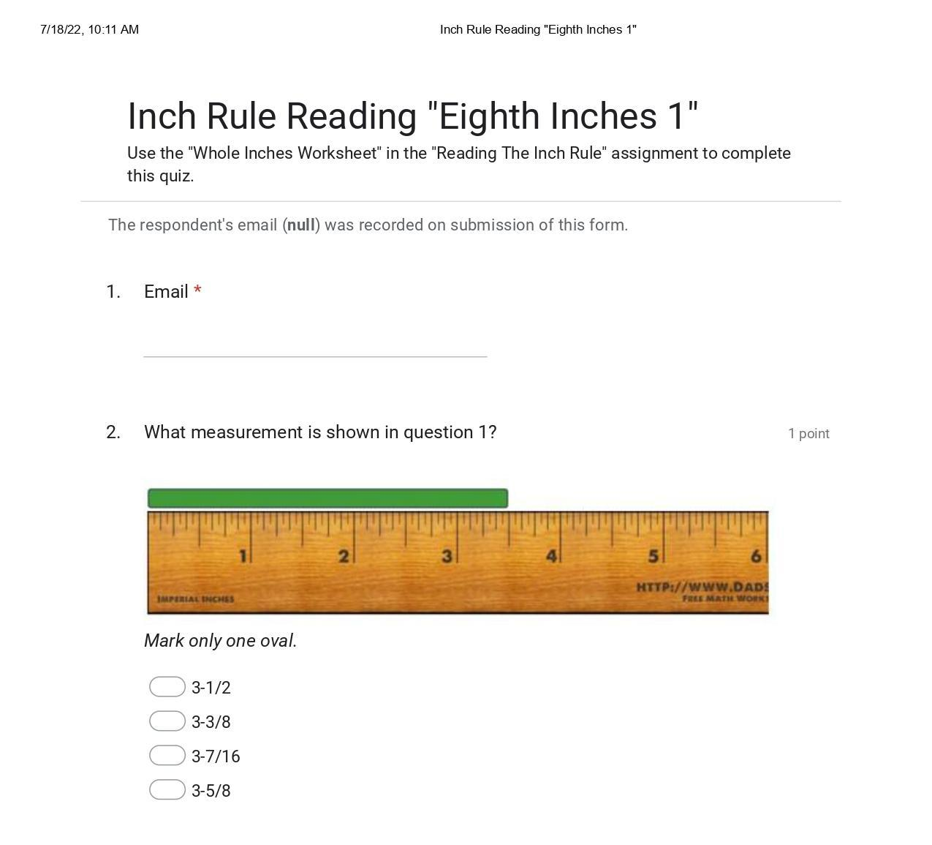
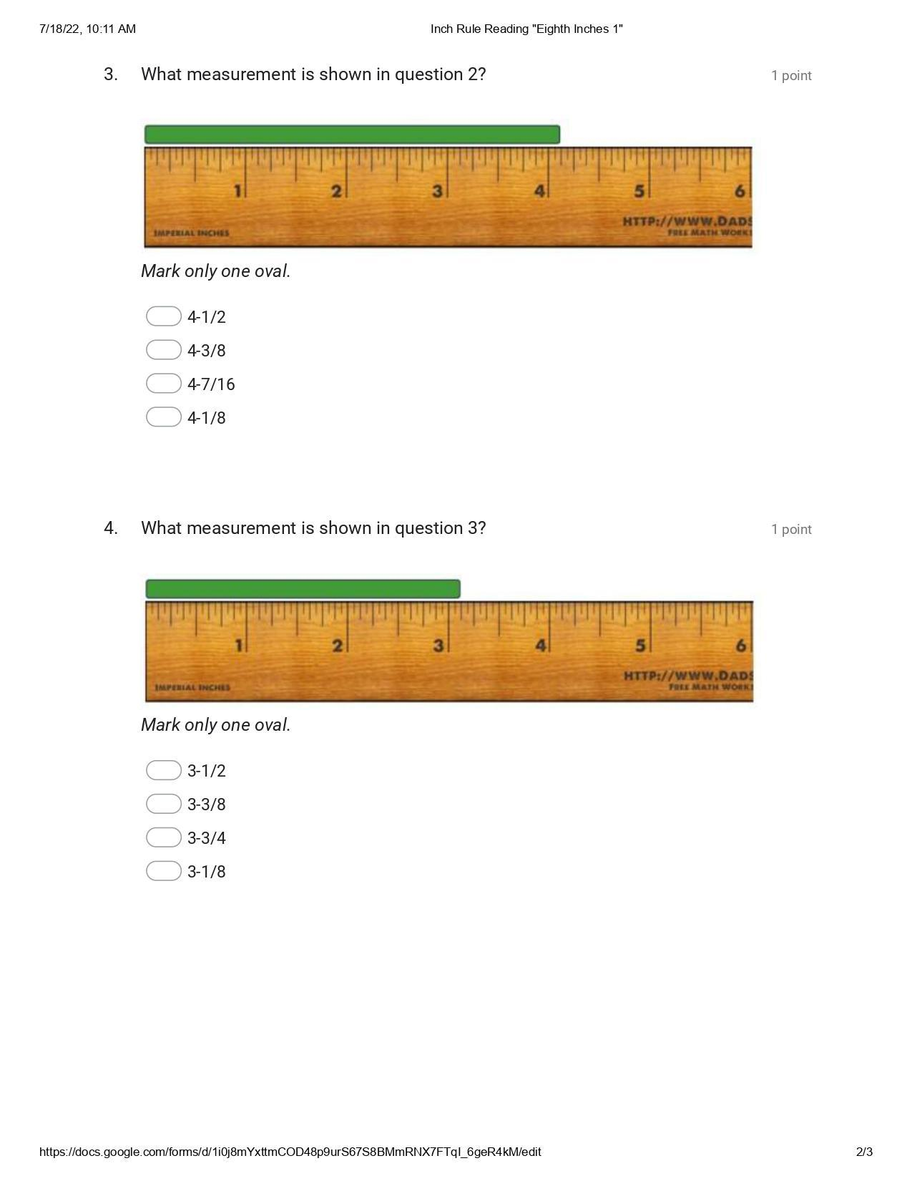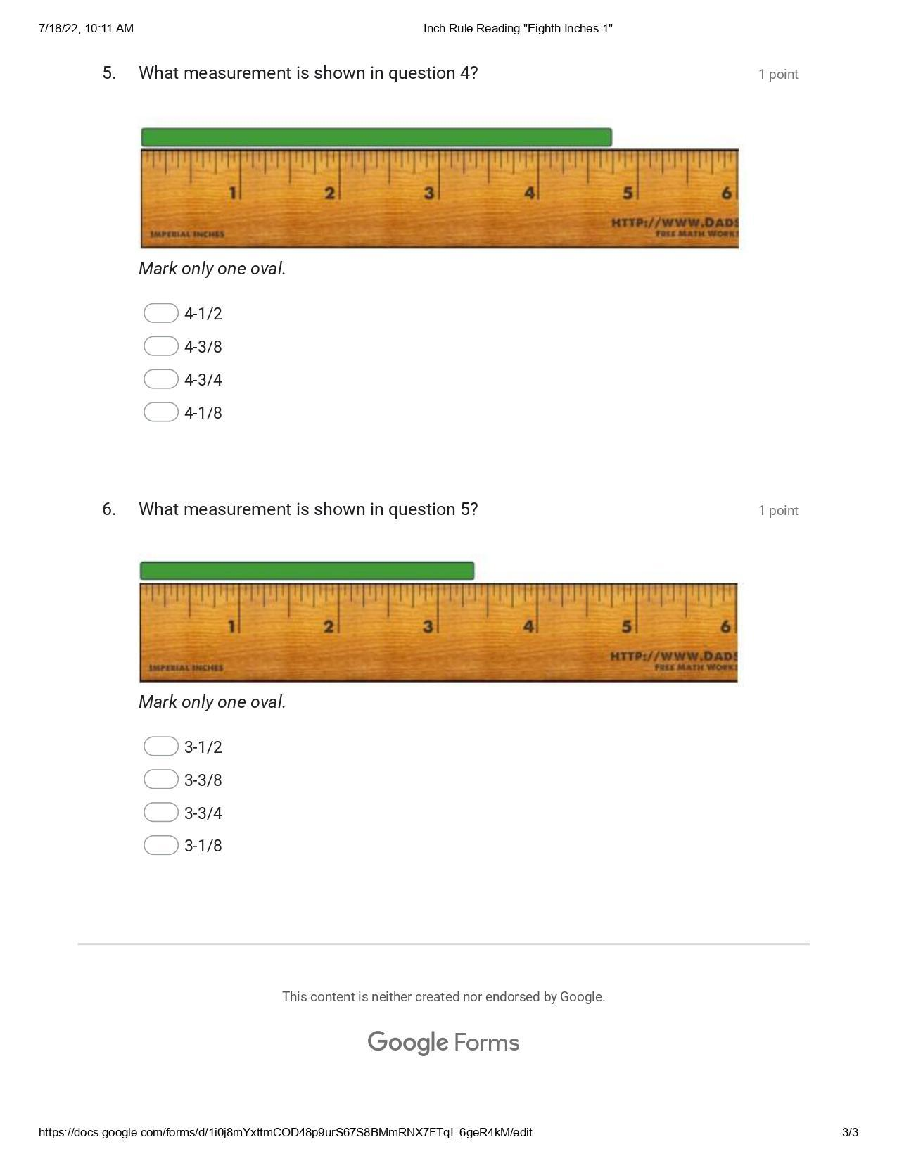

Appendix F - Inch Rule Reading: “Sixteenth Inches”

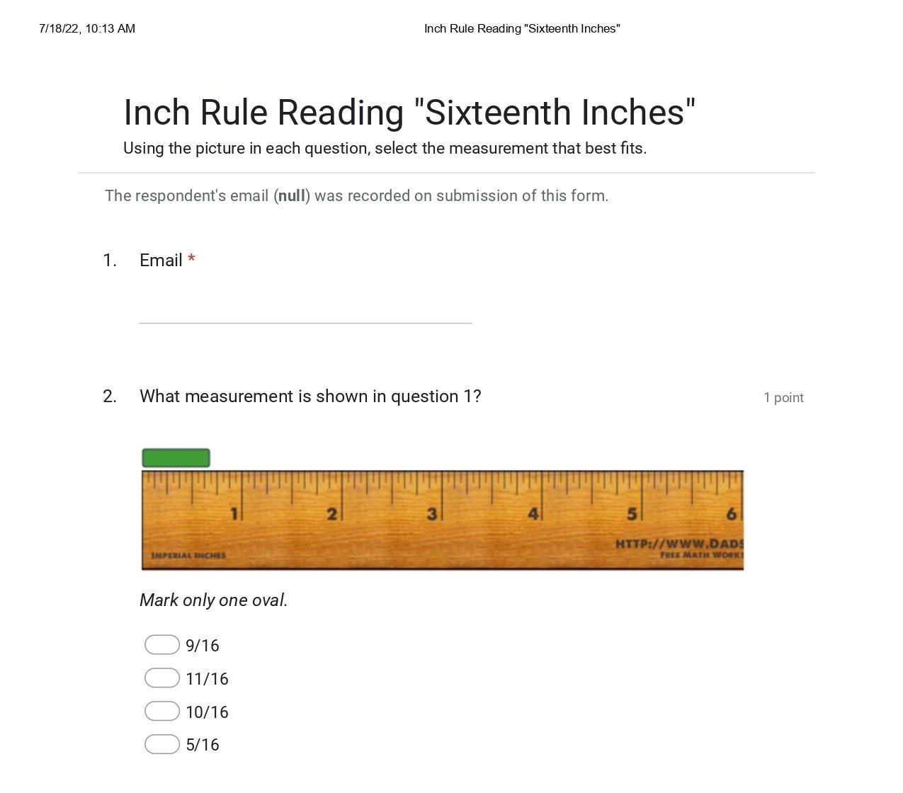

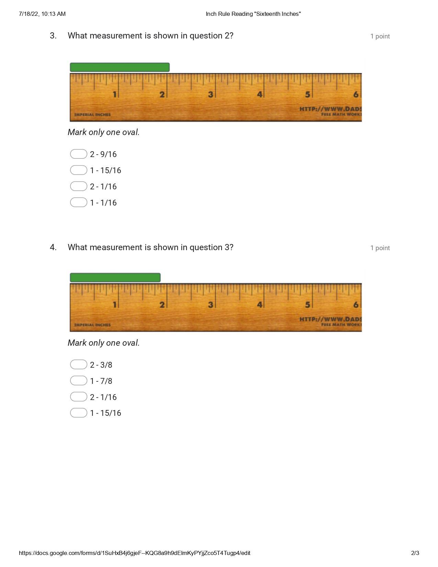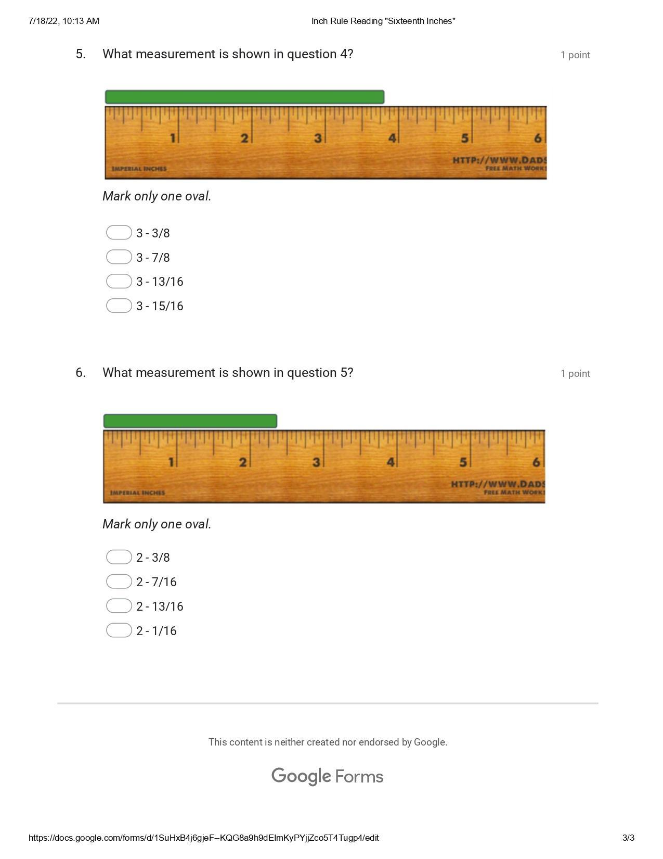

Appendix G - Inch Ruler Reading Practical Measurement Assignment.

Task: Using a ruler (rule), Measure the below lines 1-12 and record the measurement in the space provided. Make sure you bring the fraction to lowest terms. If you have any trouble please review the slide show “Reading Imperial Measurements Using a Ruler With Precision”. If you are still stuck, ask the instructor.

- __________________________________________________

Answer:_______

- _________________

Answer:_______

- __________________________________

Answer:_______

- ___________________________________________________________

Answer:_______

- __________

Answer:_______

- ________

Answer:_______

- ____________________________

Answer:_______

- _______________________________________________

Answer:_______

- ______________________________________

Answer:_______

- ___

Answer:_______

- __________________________________________________

Answer:_______

- ______________________________________________________________________

Answer:_______

Instructor Feedback:

________________________________________________________________________________________________________________________________________________________________________________________________________________________________________________________________________________________________________________________________________________________________________________________________________________________________________________________________________________________________________________________________________________________________________________________________________________________________________________________________________________________________________________________________________________________________________________________________________________________________________________________________________________________________________________________________________________________________________________________________________________________________________________________________________________________________________

Appendix H – Measurement Lesson Plan
Measurement Lesson Plan
TEACHER:  GRADE: 9 Integrated Technology | CURRICULUM SUBJECT: TIJ 10  UNIT:1
LESSON TOPIC:  Imperial Measurement | MATERIALS/ VISUAL AIDS:  - Tape measure  - Rulers
INTRODUCTION/ MOTIVATION:  Imperial measurement is an industry standard | PERFORMANCE CRITERIA (STUDENTS EXPECTATIONS):  Students will be required to understand the imperial measurement in order to manufacture projects in the construction lab.
EXPECTATIONS:  - SPV.01, SPV.04, SP1.07,SP1.08  - ICV.03, ICV.04, ICV.05, IC1.05, | MATERIALS/ VISUAL AIDS:  - tape measures  - rulers  - copies of google quizzes  - copy of Line Measurement handout
TEACHING/ LEARNING CONTENT:

- Use overhead for the Reading Imperial Measurements Using a Ruler With Precision, see if students understand the different increments
- Review fractions in lowest terms on board ( ex. 2/4 =1/2) if needed
- Explain lowest common denominator
- Demonstrate some examples
- Allow time for questions or concerns
- Distribute Google Quizzes
- Provide time for students to begin assignment

SUMMARY/ RECAPITULATION:

Imperial measurement will be the standard measurement used in the Manufacturing shop/ Class. Students are required to dialogue with proper terminology.
EVALUATION/ ASSIGNMENT:

Students are required to complete the Line Measurement worksheet and submit it for marking. This material will also be part of a future test.

LESSON NOTES/ REFLECTION:

References
21st Century Competencies: Foundation Document for Discussion. Phase 1: Towards Defining 21st Century Competencies for Ontario, Winter 2016 Edition, 2016 http://www.edugains.ca/resources21CL/About21stCentury/21CL_21stCenturyCompetencies.pdf
College of Trades Training Standards https://www.collegeoftrades.ca/training-standards
Course Codes for Emphasis courses in the Revised Curriculum: Technological Education, Grades 11 and 12, 2009 http://www.edu.gov.on.ca/eng/curriculum/secondary/techedemphasiscourses.pdf
Growing Success: Assessment, Evaluation, and Reporting in Ontario Schools, First Edition, Covering Grades 1 to 12, 2010 www.edu.gov.on.ca/eng/policyfunding/growSuccess.pdf
Imperial Measurement Slide Show (Google Slides), 2022 https://docs.google.com/presentation/d/1iB-qkbgzipCofWChsVQtwcNlHCgsPkLveBIwtxVuuLo/edit?usp=sharing
Imperial Measurement Slide Show, OCTE (PDF), 2022 https://drive.google.com/file/d/1FDcZlyEMUQ3Z5vZ-joFzW8eHKYuHhD57/view?usp=sharing
Inch rule reading - Eighth inches, OCTE (Google Quiz), 2022 https://docs.google.com/forms/d/1i0j8mYxttmCOD48p9urS67S8BMmRNX7FTqI_6geR4kM/edit?usp=sharing
Inch rule reading - Eighth inches, OCTE (PDF), 2022 https://drive.google.com/file/d/1ikOmHsd9-dK9C97vWaWqEdn67bg5zc-3/view?usp=sharing
Inch rule reading - Half inches, OCTE (Google Quiz), 2022 https://docs.google.com/forms/d/16AwzHKA8M8nSfsCkZXt7VNKewHR7mi_Y5rSaqlmJ0d8/edit?usp=sharing
Inch rule reading - Half inches, OCTE (PDF), 2022 https://drive.google.com/file/d/15n5kkB2868XUt9AKNE_S_cdtbK3SBUuu/view?usp=sharing
Inch rule reading - Quarter inches, OCTE (Google Quiz), 2022 https://docs.google.com/forms/d/17v_myGg7y8bG0UWRqK4d7k5qeNEdS0A7kL9neTNiZak/edit?usp=sharing
Inch rule reading - Quarter inches, OCTE (PDF), 2022 https://drive.google.com/file/d/1h6I8nZ8fXwLfyA2071FaS2O0VY3WA4wZ/view?usp=sharing
Inch rule reading - Sixteenth inches, OCTE (Google Quiz), 2022 https://docs.google.com/forms/d/1SuHxB4j6gjeF--KQG8a9h9dEImKyPYjjZco5T4Tugp4/edit?usp=sharing
Inch rule reading - Sixteenth inches, OCTE (PDF), 2022 https://drive.google.com/file/d/1h6I8nZ8fXwLfyA2071FaS2O0VY3WA4wZ/view?usp=sharing
Inch rule reading - Whole inches, OCTE (Google Quiz), 2022 https://docs.google.com/forms/d/1hNRjeP71p0nae89vbZETVWWmLev73GnqhhHbSOCldxQ/edit?usp=sharing
Inch rule reading - Whole inches, OCTE (PDF), 2022 https://drive.google.com/file/d/1kTZ5oXqD6QB5a0snvkbVuH1aFirkuZcj/view?usp=sharing
Learning for All – A Guide to Effective Assessment and Instruction for All Students, Kindergarten to Grade 12, 2013 http://www.edu.gov.on.ca/eng/general/elemsec/speced/LearningforAll2013.pdf
Learning Goals and Success Criteria Viewing Guide, Government of Ontario, 2011 http://www.edugains.ca/resourcesAER/VideoLibrary/LearningGoalsSuccessCriteria/LearningGoalsSuccessCriteriaViewingGuide2011.pdf

Measurement Lesson Plan, OCTE, 2022 https://docs.google.com/document/d/10ND-X_XhVzcUb9Qngc4z3mz2afDByVp0yuMYyoZi9-Q/edit?usp=sharing
OCTE SAFEdocs, OCTE, 2022
Ontario Catholic School Graduate Expectations, Institute for Catholic Education, 2022 https://iceont.ca/resources/ocsge/
Ontario Ethical Standards, Ontario College of Teachers, 2022 https://www.ctc.ca.gov/docs/default-source/educator-prep/cstp/ontario-ethical-standards.pdf
Practical Line Measurement Assignment, OCTE, 2022 https://drive.google.com/file/d/1K4nHWkrfbeZfp_9trsO8frmBl_bxs-Vr/view?usp=sharing
Reading Imperial Measurement Slide Show, OCTE (Google Slides), 2022 https://docs.google.com/presentation/d/1iB-qkbgzipCofWChsVQtwcNlHCgsPkLveBIwtxVuuLo/edit?usp=sharing
Reading Imperial Measurement Slide Show, OCTE (PDF), 2022 https://drive.google.com/file/d/1FDcZlyEMUQ3Z5vZ-joFzW8eHKYuHhD57/view?usp=sharing
Resources, Ontario College of Trades, 2020 https://www.collegeoftrades.ca/resources
Skilled Trades Identified in Ontario https://www.collegeoftrades.ca/wp-content/uploads/Sector_Brochure_One_Pager_web.pdf
Skilled Trades Ontario https://www.ontario.ca/page/skilled-trades
The Differentiated Instruction Scrapbook http://www.edugains.ca/resourcesDI/EducatorsPackages/DIEducatorsPackage2010/2010DIScrapbook.pdf
The Ontario Curriculum, Grades 9 and 10: Technological Education, 2009 (revised) http://www.edu.gov.on.ca/eng/curriculum/secondary/teched910curr09.pdf

