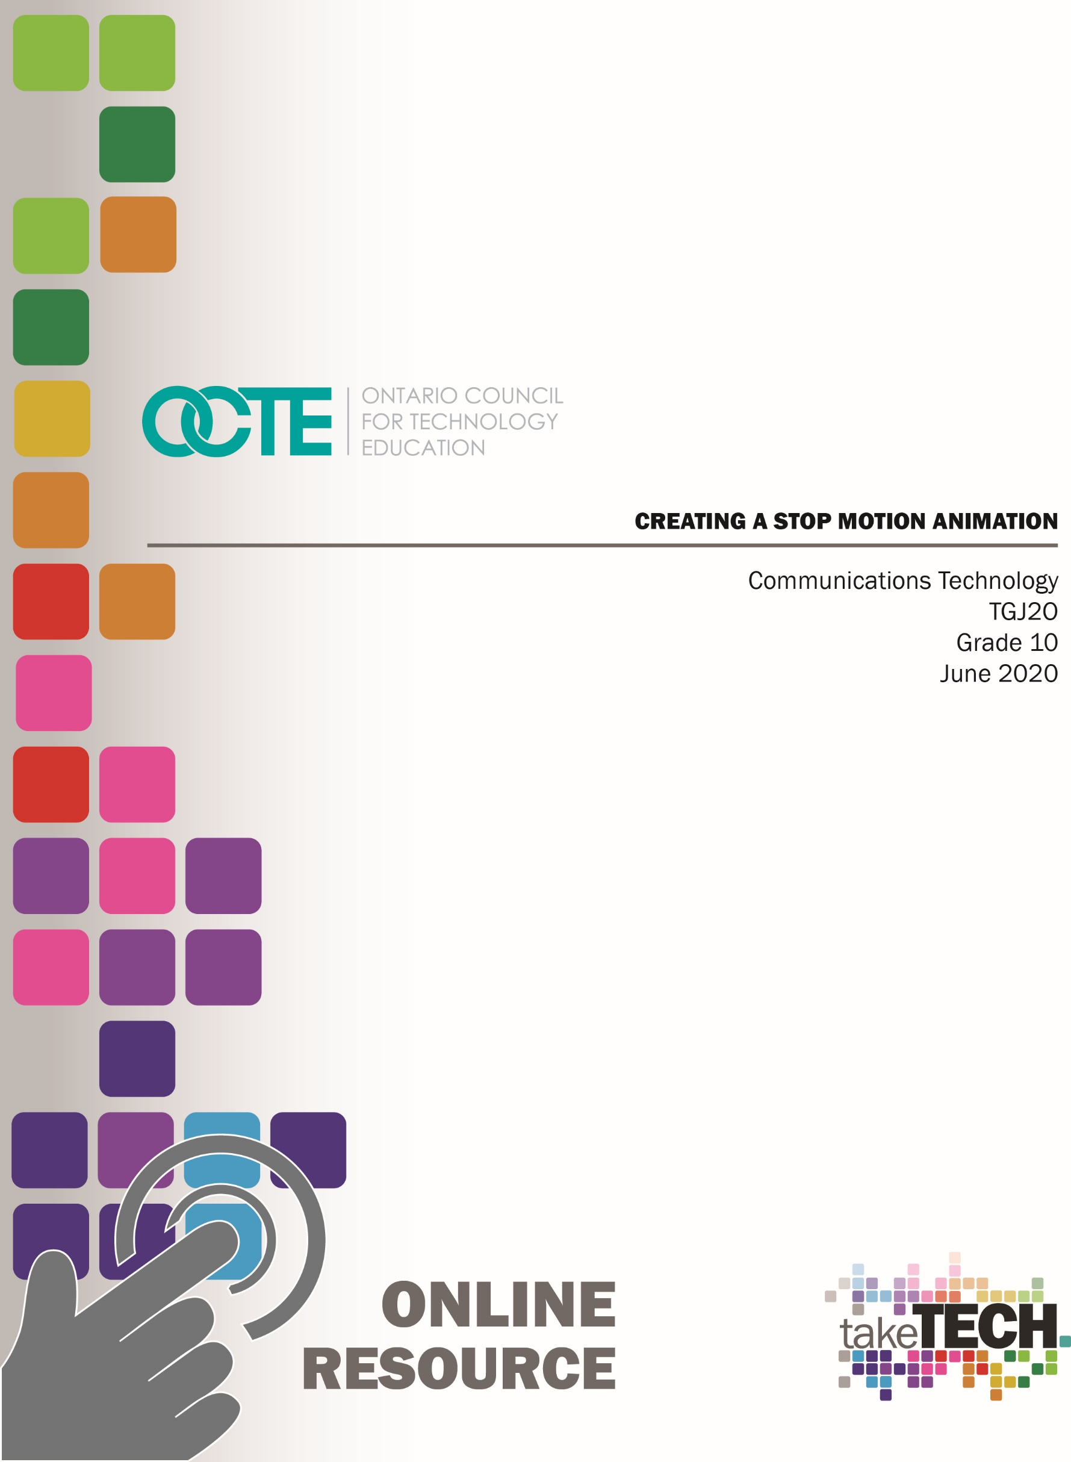

Table of Contents

Introduction 3
Project Outline 3
Prior Knowledge 3
Student Activities 4
Activity 1 – Explore the History of Animation and Career Opportunities 4
Activity 2 – Introduction to Animation Principles 4
Activity 3 – Stop Motion 4
Activity 4 – Creating Characters/Backgrounds 4
Activity 5 – Create a Stop Motion Animation 4
Planning Notes 5
Resources 6
Instructional Strategies 7
The Hook / Motivational Strategies 7
Learning Goals and Success Criteria 7
Overall and Specific Expectations 8
Overall Expectations 8
Specific Expectations 8
Safety Concerns 9
Applicable SAFEDocs and ToolSAFE videos 9
Differentiation of the Project / Activity 9
Assessment and Evaluation 9
Career and Industry Extensions 9
Ethical Considerations 10
Activity 1 – History of Animation, Post -Secondary and Career Exploration 10
Activity 2 – Animation Principles 11
Activity 3– Creating Characters and Backgrounds 11
Activity 4 – Stop Motion 12
Assignment 1 – Create A Stop Motion Video 12
Reflection or Design Report 13
Appendix A – TGJ20 Animation Worksheet 14
TGJ 2O Animation: Activities and Assignment Worksheet 14
Activity 1 – History of Animation and Career Opportunities 15
Activity 2 – Animation Principles 21
Activity 3 – Creating Characters and Backgrounds 23
Activity 4 – Stop Motion Animation 24
Assignment 1 – Create A Stop Motion Animation 26
Appendix B – TGJ20 Animation Watch & Learn Links and Read & Learn Links 28
Activity 1 – Animation History and Career Opportunities 28
Activity 2 – Animation Principles 29
Activity 3 – Creating Characters and Backgrounds 30
Activity 4 – Stop Motion 30
Stock Audio and Image Sites 31
FREE Stop Motion Apps and Storyboard Software 32
Assignment 1 – Create a Stop Motion Video 32
References 33

Introduction
Course Code: TGJ20
Broad base Technology: Exploring Technologies and Communications Technology
Destination: Open
Grade Level: 10
Online Project Name: Creating a Stop Motion Animation

Project Outline
This assignment will provide the learner with an opportunity to understand the role of animation in society and assume this role in the creation of an original product.
The learner will analyze concepts and terms associated with animation while engaging in hands-on activities that demonstrate skill and knowledge. At the end of this assignment, the learner will have successfully created a Stop Motion Animation.

Prior Knowledge
There are no pre-requisites for the content contained in these documents. Students are encouraged to use the provided resources, throughout this assignment, and contact the teacher when questions arise.
Teachers are encouraged to review copyright laws in Canada before starting this lesson and assignment. Examples of royalty-free and creative commons image and audio sites that can be used in student work are:
- YouTube Audio Library
- Free Music Archive
- Burst (by Shopify)
- Unsplash
- The Noun Project
- Pexels
- Pixabay
It may be helpful for students to understand how to download files from the internet, upload files to the school storage device, submit to a discussion group and create screen captures: (screen capture information below)
- Windows: Snipping Tool or Snip and Sketch
- MacOS: Command+Shift+3 or Command+Shift+4
- Android: Power + Volume Down
- iPhone OS: Side Button + Volume Up Button
Also, the student will benefit from:
- an understanding of linear measurement, and image scaling (numeracy skills)
- calculating the frame rate (numeracy skills)
- developing and organizing content (literacy skills)
- applying knowledge of conventions (literacy skills)
- accessing online resources, creating and downloading files, and submitting such files to a destination according to their teacher’s direction

Student Activities

Activity 1 – Explore the History of Animation and Career Opportunities
- History of Animation
- Post-Secondary opportunities
- Careers in Animation

Activity 2 – Introduction to Animation Principals
- What is Animation
- Animation Principals
- Understanding the Creation of Animations, You Like
- Optional Activity – Pixar in A Box

Activity 3 – Stop Motion
- History of Flipbooks
- Getting started with Flipbooks
- Creating Characters and backgrounds
- Creating Your Flipboard
- Optional Activity – Computer Created Flipboard

Activity 4 – Creating Characters/Backgrounds
- About Stop Motion
- Stop Motion Idea’s
- Stop Motion Tools
- Creating A Stop Motion
- Creating A Storyboard

Activity 5 – Create a Stop Motion Animation
- Stop Motion Overview
- Student Task
- Stop Motion Criteria
- Rubric

Planning Notes
It is estimated that the combination of lessons, activities, and assignments will take learners 1.5 weeks of 60-minute time blocks to complete. Accommodation of extra time may be required for some learners.
Note: These lessons, activities, and assignment have been structured in a way that permits a “deep dive” into animation in Grade 10.
- Create a digital space for each learner to submit and receive the material (e.g., Microsoft One Drive, Google Drive, Dropbox, etc.)
- Provide each learner with the TGJ20 Animation Activities and Assignment worksheet. The teacher may convert to a format most familiar to their learners (e.g., convert from .docx to Google Doc) Note: This is a living document, allowing the teacher to provide ongoing feedback for revision as the learner progresses
- Post or provide the learners with the materials at timed intervals or all at once.
- Provide timely feedback to learners; the work has been scaffolded
- Review all links before the start of this project, in many cases. Additional learning options were posted allowing for one link to be removed if needed
- Teachers may choose to limit the options available for Mobile Device Apps
Note: In a disrupted learning environment, it may be best to allow learners the opportunity to choose between hand-drawn or the use of vector creation tool.

Files
Activity 1 – Animation History and Career Opportunities
Activity 2 – Animation Principals
Activity 3 – Creating Characters and Backgrounds
Activity 4 – Stop Motion
TGJ20 Animation Activities and Assignment Worksheet
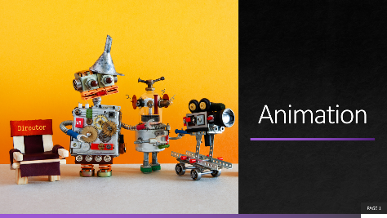

Resources

Tools/Equipment
- Laptop
- Tripod
- Scissors
- Mobile Device
- Desktop
- Chromebook
- Tablet

Software
- NFB Stop Motion App
- Stop Motion Studio
- Windows Movie Maker
- iMovie
- qStopMotion

Materials
- Paper
- Pencil

Videos
- YouTube Channel: PES
https://www.youtube.com/channel/UCXN7NMwjjQpBHxzMwOPYzjQ
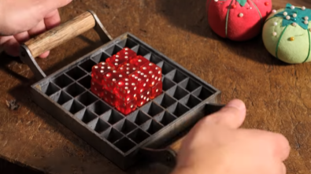
- Video Link: How to Make Stop Motion Videos
https://www.youtube.com/watch?v=_ppedXZHhE0&t=172s
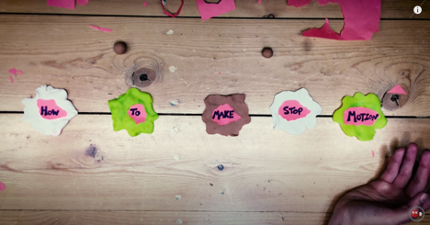

- YouTube Channel: Guldies
https://www.youtube.com/channel/UCHjVCR-fV_X789MsE7GRFqQ

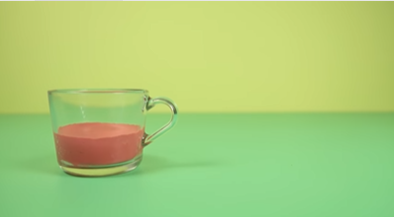

Websites for Teachers
- Smashing Magazine
- Instructables
- Nikon
- National Film Board Stop Motion Animation Workshop

Instructional Strategies
- The lessons, activities, and assignment have been scaffolded
- The lessons, activities, and assignment have been created using different forms of media and are multidevice supported
- The learner is encouraged to revise their work using a living (collaborative) document shared with the teacher

The Hook / Motivational Strategies
Animation has the power to transfer us to places where anything is possible. It allows the creator limitless opportunities to share their vision with the rest of the world forgoing traditional barriers. Animation is also a tool to teach or inform by making intangible things tangible.
The ability to create an animation is accessible to everyone; a learner can bring to life unique characters and scenes, with only a pencil and paper.
The lessons, activities, and assignments have been created to allow learners of all abilities to develop and share their vision.

Learning Goals and Success Criteria
- Identify how animation is used to convey a message
- Understand the difference between Commercial and Entertainment Stop Motion
- Recognize the impact of different types of animation
- Discover the role of an animator and possible career and education opportunities
- Discover post-secondary animation opportunities
- Compare different types of methods of animation and associated applications
- Design an original work that can be used as an exemplar for future Grade 10 students

Overall and Specific Expectations in Support of Ontario Curriculum Grades 9 - 10 Technological Education

Overall Expectations
A1. Demonstrate an understanding of the fundamental concepts and skills required in the planning and development of a product or service, including the use of a design process and/or other problem-solving processes and techniques.
B1 Apply project management techniques to the planning and development of communications media products;
B3 Create products or productions that demonstrate competence in the application of creative and technical skills.
D2. Identify careers in various technological fields, and describe the educational requirements for them

Specific Expectations
A1.2 Demonstrate an understanding of design elements (e.g., line, form, colour, texture, space) and principles (e.g., balance, rhythm, proportion, contrast, flow);
A1.3 Demonstrate an understanding of production processes and workflows (e.g., subject/location selection, lighting set-up, shooting, digital imaging, and digital editing in audio/video and photography; layout, pre-press, presswork, and binding in publishing; site design, page layout, content development, and testing in web design);
A1.5 Identify different types of communications software used to create communications technology products and services (e.g., software for photo, audio, and video editing, animation, page layout, web page creation, and computer graphics) and describe how they are used.
B1.2 Use appropriate organizational and time management tools and software applications
B3.1 Apply creative skills, equipment operating skills, and software skills to create components for a media production (e.g., text, video footage, voice-overs, graphics, animations for a video promoting a school event);
B3.2 Apply editing skills to integrate the components into a unified and effective production
D2.1 Identify career opportunities in communications technology and describe the qualifications needed for entry into these positions (e.g., apprenticeship training, college diploma, university degree, workplace experience);

Safety Concerns
There are no safety concerns for this assignment. Learners may need to practice physical distancing, and the school board adopted cleaning processes for shared tools. (e.g., shared tablets, cameras, mobile devices, keyboard, mice, etc.)

Applicable SAFEDocs and ToolSAFE videos
Please refer to the OCTE SAFEDocs for BBT Technology for safety documents to adequately address and instruct this project.

Differentiation of the Project / Activity
Teachers can also refer to the Differentiation Scrapbook to take into account learner ability, multiple intelligences, exceptional students, and ESL learners. The lessons in this document include visual, written, and video-based instruction. Some YouTube videos support Closed Captioning.
Students may choose to complete activities using the Google Read & Write Extension.
Support for Google Read & Write
Quick Reference Guide

Assessment and Evaluation
Rubric included in Appendix A TGJ20 Animation Activities and Assignment worksheet

Career and Industry Extensions
In Activity 1 – Explore the role of an animator, the teacher may add to this activity by encouraging or assigning research into additional post-secondary opportunities, either at a local, provincial, national, or international level (e.g., Pixar, Disney).
In Activity 1 – Students explore post-secondary options and admission requirements

Ethical Considerations
In Assignment 1 – Create a Stop Motion Video, the teacher may choose to modify this project to encourage the understanding of the impact of media in society or environmental considerations.

Activity 1 – History of Animation, Post -Secondary and Career Exploration
In a Learn@Home environment, students are to view the attached presentation. In a face to face environment, the teacher presents visual content, videos, and other examples to students, using the PowerPoint presentation.
PowerPoint Presentation Link:
1 Animation - History of Animation, Post-Secondary and Career Exploration
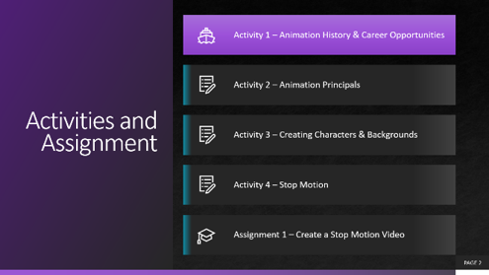
https://www.octe.ca/application/files/8115/9692/9065/Activity_1_-_Animation_History_and_Career_Opportunities.pptx
- History of Animation
- Post-Secondary opportunities
- Careers in Animation
Students may use Appendix A - TGJ20 Animation Activities and Assignment worksheet with the PowerPoint.

Activity 2 – Animation Principles
PowerPoint Presentation Link: 2 Animation – Animation Principles
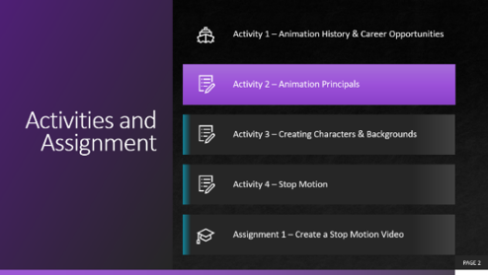
https://www.octe.ca/application/files/4515/9692/9162/Activity_2_-_Animation_Principals.pptx
- What is Animation
- Animation Principles
- Understanding the Creation of Animations, You Like
- Optional Activity – Pixar in A Box
Students may use Appendix A - TGJ20 Animation Activities and Assignment worksheet with the PowerPoint.

Activity 3– Creating Characters and Backgrounds
PowerPoint Presentation Link: 3 Animation – Creating Characters and Backgrounds
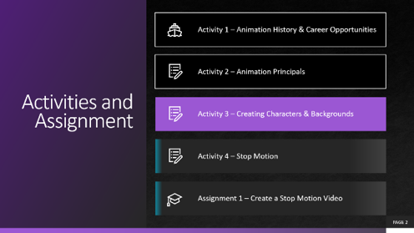
https://www.octe.ca/application/files/8215/9692/9302/Activity_3_-_Creating_Characters_and_Backgrounds.pptx
- History of Flipbooks
- Getting started with Flipbooks
- Creating Characters and backgrounds
- Creating Your Own Flipboard
- Optional Activity – Computer Created Flipboard
Students may use Appendix A - TGJ20 Animation Activities and Assignment worksheet with the PowerPoint.

Activity 4 – Stop Motion
PowerPoint Presentation Link: 4 Animation – Stop Motion
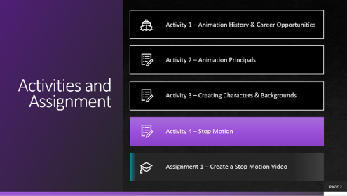
https://www.octe.ca/application/files/6015/9692/9475/Activity_4_-_Stop_Motion.pptx
- About Stop Motion
- Stop Motion Idea’s
- Stop Motion Tools
- Creating A Stop Motion
- Creating A Storyboard
Students may use Appendix A - TGJ20 Animation Activities and Assignment worksheet with the PowerPoint.

Assignment 1 – Create A Stop Motion Video
Assignment 1 – Create A Stop Motion Animation
- Stop Motion Overview
- Student Task/Steps
- Stop Motion Criteria
- Rubric
Students must use Appendix A - TGJ20 Animation Activities and Assignment worksheet with all the assignment instructions and assessment for this project.

Reflection or Design Report
Upon the conclusion of these lessons, activities, and assignment, the teacher is encouraged to reflect with their learners about:
- What went well?
- What area’s need to be improved?
- At what stage were you most engaged?
- How could these lessons, activities, and assignments be improved for next time?
- What advice would you give to someone before starting this work?
- Provide one example of something that you learned.
This reflection can be though the use of a Google Form (or similar), small group reflection, or use of an LMS (Learning Management Software) discussion forum.

Appendix A – TGJ20 Animation Worksheet

TGJ 2O Animation: Activities and Assignment Worksheet

Overview:
This worksheet has been designed as a collaborative document to be shared with your teacher. As you work your way through these activities and assignment, your teacher will provide feedback that you may choose to use in revising your work. Pay careful attention to the rubric at the bottom of this sheet, and the teacher comments as you go along.
*Helpful tip, make a backup of your work.

Overall Expectations:
A1. Demonstrate an understanding of the fundamental concepts and skills required in the planning and development of a product or service, including the use of a design process and/or other problem-solving processes and techniques.
B1. Apply project management techniques to the planning and development of communications media products;
B3. Create products or productions that demonstrate competence in the application of creative and technical skills.
D2. Identify careers in various technological fields, and describe the educational requirements for them

Activities:
When starting each activity, complete all readings and watch all videos before beginning.

Questions:
Depending on your previous experiences, some of the material that is covered maybe a review, and for others, it may be brand new. It is expected that you will have questions as you work your way through this; if you do, I am here to help you. Please let me know as soon as possible so that you get the help you need. I do not want you to get frustrated.

Resources
These FREE and Creative Commons Image Sites are a great place to find images and audio clips while respecting Copyright Laws in Canada
- YouTube Audio Library  - Free Music Archive  - StockSnap.io  - Burst (by Shopify) | - Unsplash  - The Noun Project  - Pexels  - Pixabay

Activity 1 – History of Animation and Career Opportunities

Question 1.1
Animation has been an essential part of society for a long time; these original artists paved the way for new generations of creators.
The internet has made access to these first animations easy, use your research skills to find, and watch three different animations that occurred between the years 1906 and 1915.
Answer Here:
Year | Animation Name | Your Thoughts

Question 1.2
The National Film Board has sponsored and stores some of the best contributions of Canadian animators. Some forms of animation you may immediately recognize other types may be entirely new for you.
Using the NFB site research, and watch ten different types of animations, use the table below to show your findings.
Note: If you are unsure what to look for, visit 20 Different Types of Animation Techniques and Styles
Animation Title | URL | Type of Animation
 |  | Traditional Animation
 |  | 2D animation
 |  | 3D animation
 |  | Typography Animation
 |  | Clay Animation
 |  | Flipbook Animation
 |  | Stop-Motion Animation
 |  | Sand Animation
What type of animation do you think is most useful for telling a story? Why do you feel this way?

Question 1.3
Canadians have made many contributions to the field of animation over the years. Thinking about your previous answer, “What type of animation do you think is most effective for telling a story” research three Canadians who you feel have contributed significantly and provide a few examples of their work.
Name | Example (URL) | Why You Chose This Canadian

Question 1.4
Visit Animation OntarioColleges.ca; what are some of the programs offered that are new to you?
College Name | Animation Program Offered | Location/City

Question 1.5
It is essential to understand that post-secondary institutions have requirements for entry into their programs. Even if you are not interested in a career in animation, this next activity will provide you with the transferable skills needed to help fast track your dream career.
Using the three different College programs that you listed above, research and record the requirements of entry into these programs.
College Name | Animation Program Offered | Entry Requirements
e.g. Herzing College | 2D Animator | Grade 12  Portfolio  Interview  Entrance Exam

Question 1.6
Ottawa and Toronto have seen investments from industry in the field of animation in recent years. Research four animation houses in the cities closest to you.
Name | City | URL
e.g., Mercury Filmworks | Ottawa | https://mercuryfilmworks.com

Question 1.7
Entry-level positions provide countless opportunities. Visit an animation career website like Screen Skills. What job do you think would fit your unique skill set? And explain why you think you would be useful in this role.

Question 1.8
As creators, we have the choice of tools that help us communicate our thoughts and ideas with others. Some of the skills and knowledge needed to communicate effectively will be acquired throughout your time in Communication Technology. The industry utilizes a variety of tools (e.g., software, hardware) to do this. Research two software applications that are of interest to you and at least one piece of equipment.
Software | Hardware
e.g., Adobe Animate | e.g., Wacom Tablet

Activity 2 – Animation Principals

Question 2.1
In the previous module, you listed some of the tools and hardware that Animators use to advance their craft. What are some ways that you can think of to bring inanimate objects to life?

Question 2.2
What are some animations that have inspired or entertained you? Why do you think these animations are meaningful to you?

Question 2.3
Visit The National Film Board, YouTube, or Vimeo and choose 1-3 school appropriate stop motion animation videos that demonstrate the 12 principles of animation. Fill in the table below with your findings.
Animation Principle | Stop Motion Video | URL | Time
e.g., Anticipation | Derek Loftis Stop Motion | vimeo.com/60088428 | 00:00:06
Squash and Stretch
Anticipation
Staging
Straight Ahead and Pose to Pose
Follow Through and Overlapping Action
Slow in and Slow Out
Arc
Secondary Action
Timing
Exaggeration
Solid Drawing
Appeal

Activity 3 – Creating Characters and Backgrounds

Question 3.1
One of the easiest ways that you can start to animate is by creating a flipbook. Visit Vimeo.com and search for Flipbook. Choose one Flipbook video that is easy to create and share it below.
Title | URL | Materials Needed
e.g., Flipbook Converse | https://vimeo.com/55964659 | Pencil, Blank Precut Paper, scissors, mobile device

Question 3.2
After reviewing the three videos and reading the Keys to Success, you are ready to create your flipbook animation.
Criteria:
- Minimum 6 seconds long
- School appropriate
- Meaningful to you
Using your mobile device, upload your Flipbook, and share it with your teacher and peers. Include below a brief description of the creation process, along with any challenges you faced for your Flipbook animation below.
Challenges:

Uploaded Flipbook Link (if applicable):

Activity 4 – Stop Motion Animation

Question 4.1
Today’s cameras can now be connected directly to a computer; this is called tethering and allows the creator to see the image in real-time. Research three computer software programs that enable the cameras to be tethered.
Software Program | Manufacturer | Camera Models Supported
e.g., Adobe Lightroom | Adobe | Sony, Nikon, Canon,  Olympus, Fuji

Question 4.2
What are some everyday objects that you can use to create a short stop motion video? List the first 20 that come to mind:
e.g., Fruit - Banana

Question 4.3
Thinking about the video that you just watched, what is one stop motion special effect that you could create at home?

Question 4.4
Think about one of the two Stop Motion idea’s, as well as the list of everyday objects that you have access too. With the app installed on your mobile device and the knowledge that you have learned, create your first simple Stop Motion Video. Share this video with your teacher. What were some of the challenges you faced when creating your stop motion video?

Share the link to your video (if applicable):

Assignment 1 – Create A Stop Motion Animation

Objective:
Apply the skills and knowledge that you have learned about animation into a Stop Motion video.

Watch:
How to Make a Stop Motion Video Cooking Vlog
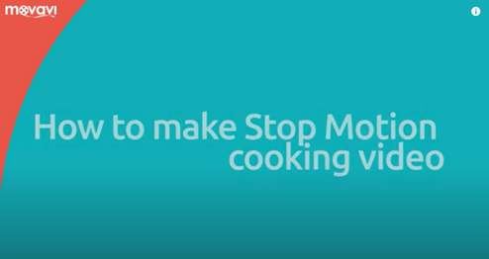
https://www.youtube.com/watch?v=qm56pvtA2JA
(Note: The first 5 min and 9 seconds is the most important)

Task:
You will create a 20-60 second stop motion video, between 12-24 FPS (frames per second)

Tools:
Mobile Device, Tripod (if available), Apps
FREE Stop Motion Apps and Storyboard Software
- NFB StopMo Studio
- Stop Motion Studio
- Storyboarder

Steps:
- Think about items that are readily available to you, and then consider how you can use these items to tell a story.
- Create an outline of your story or promotional video, using a storyboard, and submit this for approval. (You can tell a story or create a promotional video for a local business, or your community)
- Gather all the necessary items; refer back to Question 4.2 for ideas
- Ensure that your mobile device has been charged and the appropriate app is installed
- Edit your video
- Export your video in the .MP4 format
- Share your video with your teacher and peers
Expectation | Level 4 | Level 3 | Level 2 | Level 1 | R
Communication: define project objectives and performance criteria precisely.
Overall Expectation: B1
Create Storyboard, Communicate Stop Motion Concept. Reflect on Learning | Defines and explains project objectives, process & reflection with profound detail. | Defines and explains the project objectives process & reflection with considerable detail. | Defines and explains project objectives, process & reflection with some detail. | Did not define or explain the project objectives, process & reflection. | Did not submit before the completed video
Thinking: Use a variety of planning techniques and tools when creating plans for communications technology projects.
Overall Expectation: A1
Demonstrated a variety of techniques when creating the stop motion animation | Uses a variety of planning techniques and tools when creating plans for communications technology projects with a high degree of logic. | Uses a variety of planning techniques and tools when creating plans for communications technology projects with considerable logic. | Uses a variety of planning techniques and tools when creating plans for communications technology projects with some logic. | Uses a variety of planning techniques and tools when creating plans for communications technology projects with limited logic. | Did not submit apply previous learning
Application: Produce rich media products that conform to evolving industry standards and formats.
Overall Expectation: B3
Used a variety of tools and techniques when creating the Stop Motion Animation | Produces rich media products that conform to evolving industry standards and formats with a high degree of fluency. | Produces rich media products that conform to evolving industry standards and formats with considerable fluency | Produces rich media products that conform to evolving industry standards and formats with some fluency. | Produces rich media products that conform to evolving industry standards and formats with limited fluency. | Does not meet the minimum requirements, please redo, and resubmit

Appendix B – TGJ20 Animation Watch & Learn Links and Read & Learn Links

Activity 1 – Animation History and Career Opportunities
Watch @ Learn – Greatest Animators  Top 10 Greatest Animators of All Time  https://www.youtube.com/watch?v=xWbE9WnieJ0 | 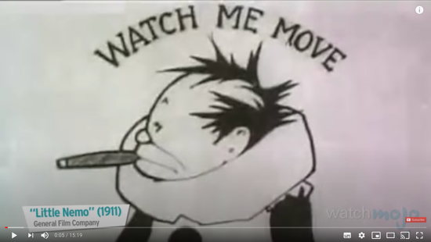
Watch @ Learn – NFB  National Film Board  https://www.nfb.ca/animation/ | 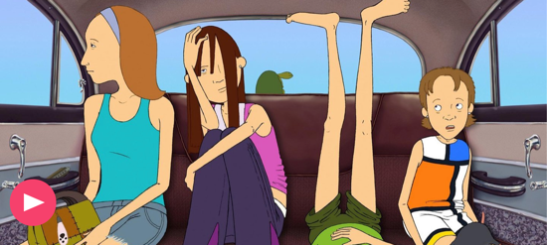
Read @ Learn – Ontario Colleges  Ontariocolleges.ca  https://www.ontariocolleges.ca/en/programs/arts-and-culture/animation | 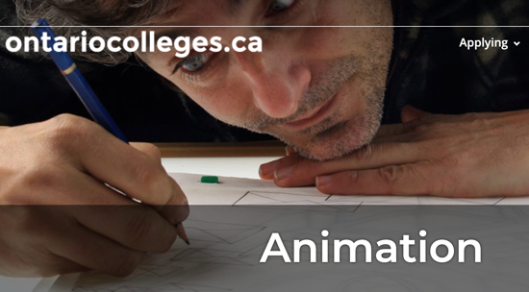
Watch @ Learn – Day at Work  Student Showcase Algonquin  https://www.youtube.com/watch?v=5EIfIF_9arw | 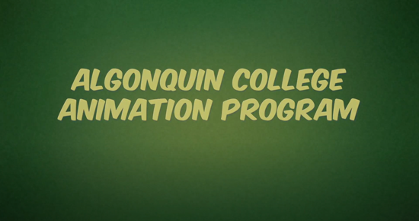
Watch @ Learn – Career  Building a Portfolio & Getting A Job  https://www.youtube.com/watch?v=PdeZsV6nIoY | 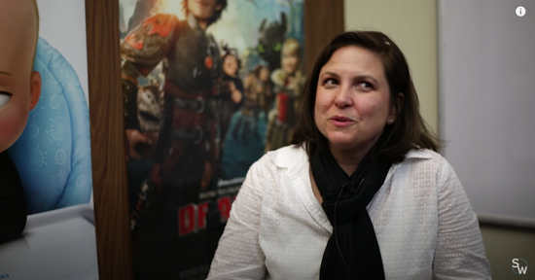
Watch @ Learn – Portfolio  Accepted Sheridan Animation Portfolio 2019  https://www.youtube.com/watch?v=JiBzfDlbg-M | 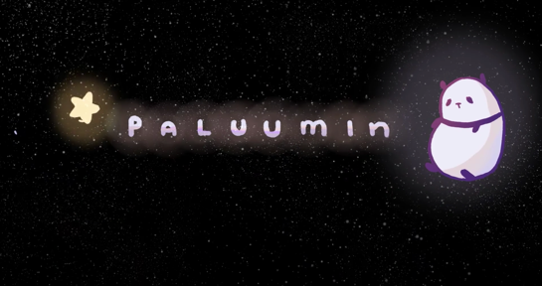
Watch @ Learn – 2D Animation Reel  Herzing College Toon Boom Harmony  https://www.youtube.com/watch?v=QRhTOB-u2kA | 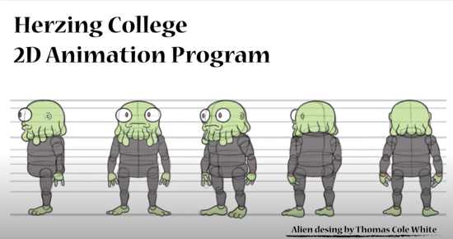

Activity 2 – Animation Principals
Watch @ Learn – The Illusion of Life
12 Basic Principals of Animation
https://vimeo.com/93206523
Watch @ Learn – 12 Principals  12 Principles of Animation (Official Full Series)  https://www.youtube.com/watch?v=uDqjIdI4bF4&list=PL-bOh8btec4CXd2ya1NmSKpi92U_l6ZJd&index=13 | 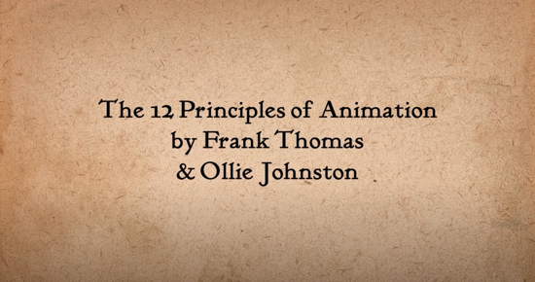
Watch @ Learn – Introduction  Pixar’s filmmaking pipeline  https://www.khanacademy.org/computing/pixar | 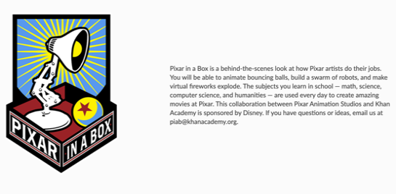

Activity 3 – Creating Characters and Backgrounds
Watch @ Learn – Flipbook Beginner  How to Make Easy Flipbooks  https://www.youtube.com/watch?v=fpQ4Eiq-0Bg | 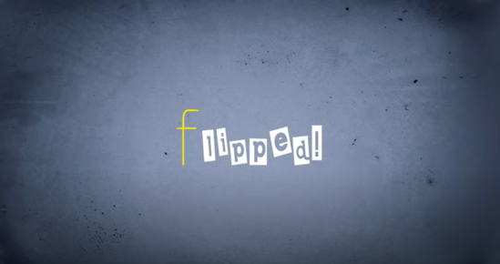
Watch @ Learn – Flipbook Intermediate  How to Make A Flipbook  https://www.youtube.com/watch?v=Un-BdBSOGKY | 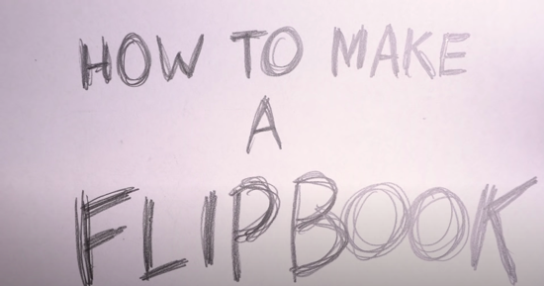
Read @ Learn – Flipbook Advanced  Make A 3D Flipbook Background  https://www.youtube.com/watch?v=qiYF9PDixTY | 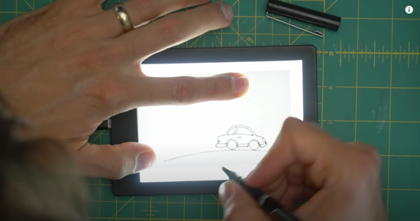

Activity 4 – Stop Motion
Watch @ Learn – Exemplar  Gone Fishing by Guldies  https://www.youtube.com/watch?v=4yG_k2Zlw7Y | 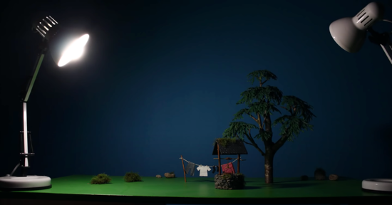
Watch @ Learn – Exemplar  Deadline by Bunliu  https://www.youtube.com/watch?v=BpWM0FNPZSs | 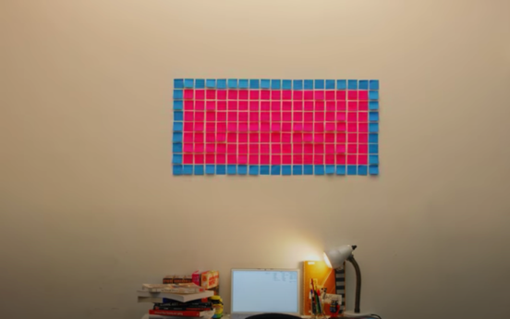
Read @ Learn – Science Film Making Tips  How to Make Stop Motion Videos  https://www.youtube.com/watch?v=_ppedXZHhE0&t=56s | 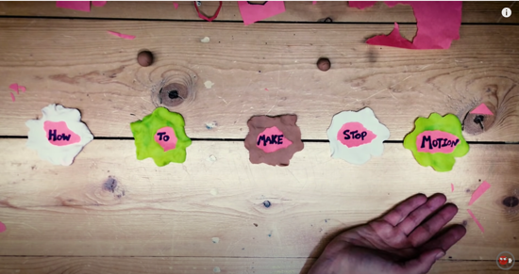
Read @ Learn – Richard Watterson  Stop Motion Claymation  https://www.youtube.com/watch?v=DVRxeCyltkE | 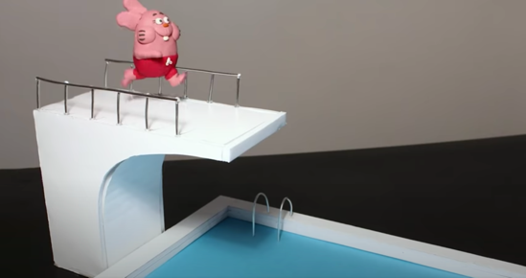
Read @ Learn – Gold Puffin  10 Things Stop Motion Pros Do  https://www.youtube.com/watch?v=fUX56F6BFKA | 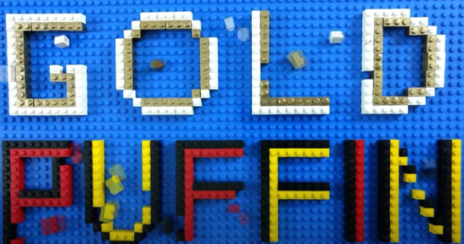

Stock Audio and Image Sites
YouTube Audio Library
https://studio.youtube.com/
Free Music Archive
https://www.freemusicarchive.org/
Burst (by Canadian Company Shopify)
https://burst.shopify.com/
Unsplash
https://unsplash.com/
The Noun Project
https://thenounproject.com/
Pexels
https://www.pexels.com/
Pixabay
https://pixabay.com/
Read @ Learn – Animation Basics  Home Made Special Effects  https://www.youtube.com/watch?time_continue=4&v=dq-3JfRrgRM&feature=emb_logo | 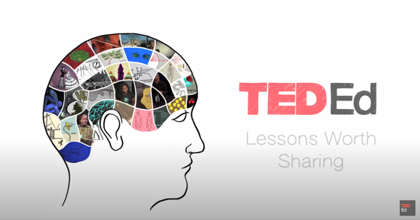
Read @ Learn – Oren Lavie  Her Morning Elegance  https://www.youtube.com/watch?v=2_HXUhShhmY | 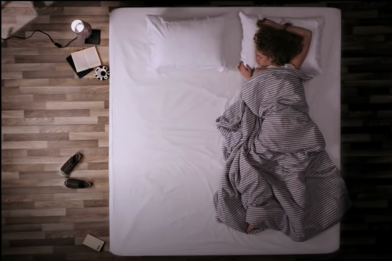

FREE Stop Motion Apps and Storyboard Software
NFB StopMo Studio
https://apps.apple.com/ca/app/nfb-stopmo-studio/id828606885?l=en
Stop Motion Studio
https://www.cateater.com/
Storyboarder
https://wonderunit.com/storyboarder/

Assignment 1 – Create a Stop Motion Video
Read @ Learn – Review  How to Make a Stop Motion Video  https://www.youtube.com/watch?v=qm56pvtA2JA | 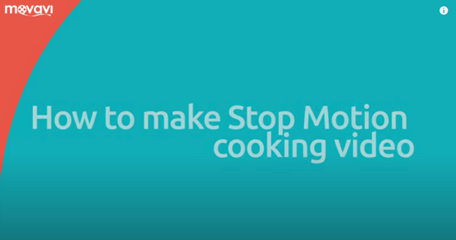

References
21st Century Competencies: Foundation Document for Discussion. Phase 1: Towards Defining 21st Century Competencies for Ontario, Winter 2016 Edition, 2016 http://www.edugains.ca/resources21CL/About21stCentury/21CL_21stCenturyCompetencies.pdf
Course Codes for Emphasis courses in the Revised Curriculum: Technological Education, Grades 11 and 12, 2009 http://www.edu.gov.on.ca/eng/curriculum/secondary/techedemphasiscourses.pdf
Growing Success: Assessment, Evaluation, and Reporting in Ontario Schools, First Edition, Covering Grades 1 to 12, 2010 www.edu.gov.on.ca/eng/policyfunding/growSuccess.pdf
Learning for All – A Guide to Effective Assessment and Instruction for All Students, Kindergarten to Grade 12, 2013 http://www.edu.gov.on.ca/eng/general/elemsec/speced/LearningforAll2013.pdf
The Differentiated Instruction Scrapbook http://www.edugains.ca/resourcesDI/EducatorsPackages/DIEducatorsPackage2010/2010DIScrapbook.pdf
The Ontario Curriculum, Grades 9 and 10: Technological Education, 2009 (revised) http://www.edu.gov.on.ca/eng/curriculum/secondary/teched910curr09.pdf
The Ontario Curriculum, Grades 11 and 12: Technological Education, 2009 (revised) http://www.edu.gov.on.ca/eng/curriculum/secondary/2009teched1112curr.pdf

