New interface STEP by STEP Inventor

- Click on the desktop logo for inventor
- In the top left corner click NEW icon
- Pick which measurement you are going to use… METRIC or IMPERIAL.
- Pick which type of 3D item you are designing:
  - Part
  - Drawing
  - Assembly
- Under the PART section pick the STANDARD(mm).IPT
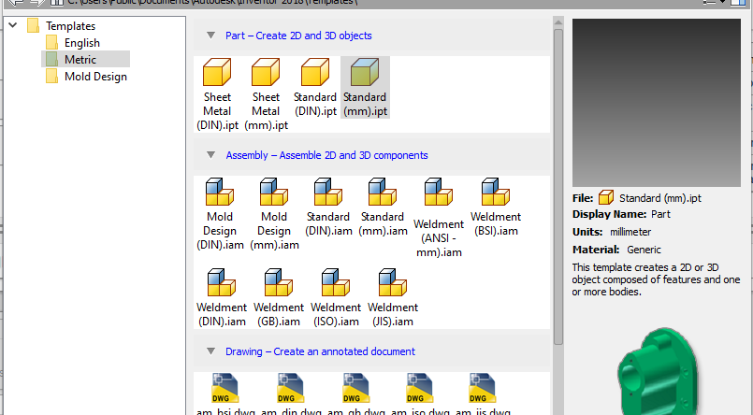
- Click create

Now we are in the drawing and unit of measurement as needed based on the Tutorials

- Create a 2D sketch by clicking on the top left side icon
- This brings us back to the ORANGE box
  - Pick the top view
- Now you will be brought back to 2D mode and you can start your drawing

