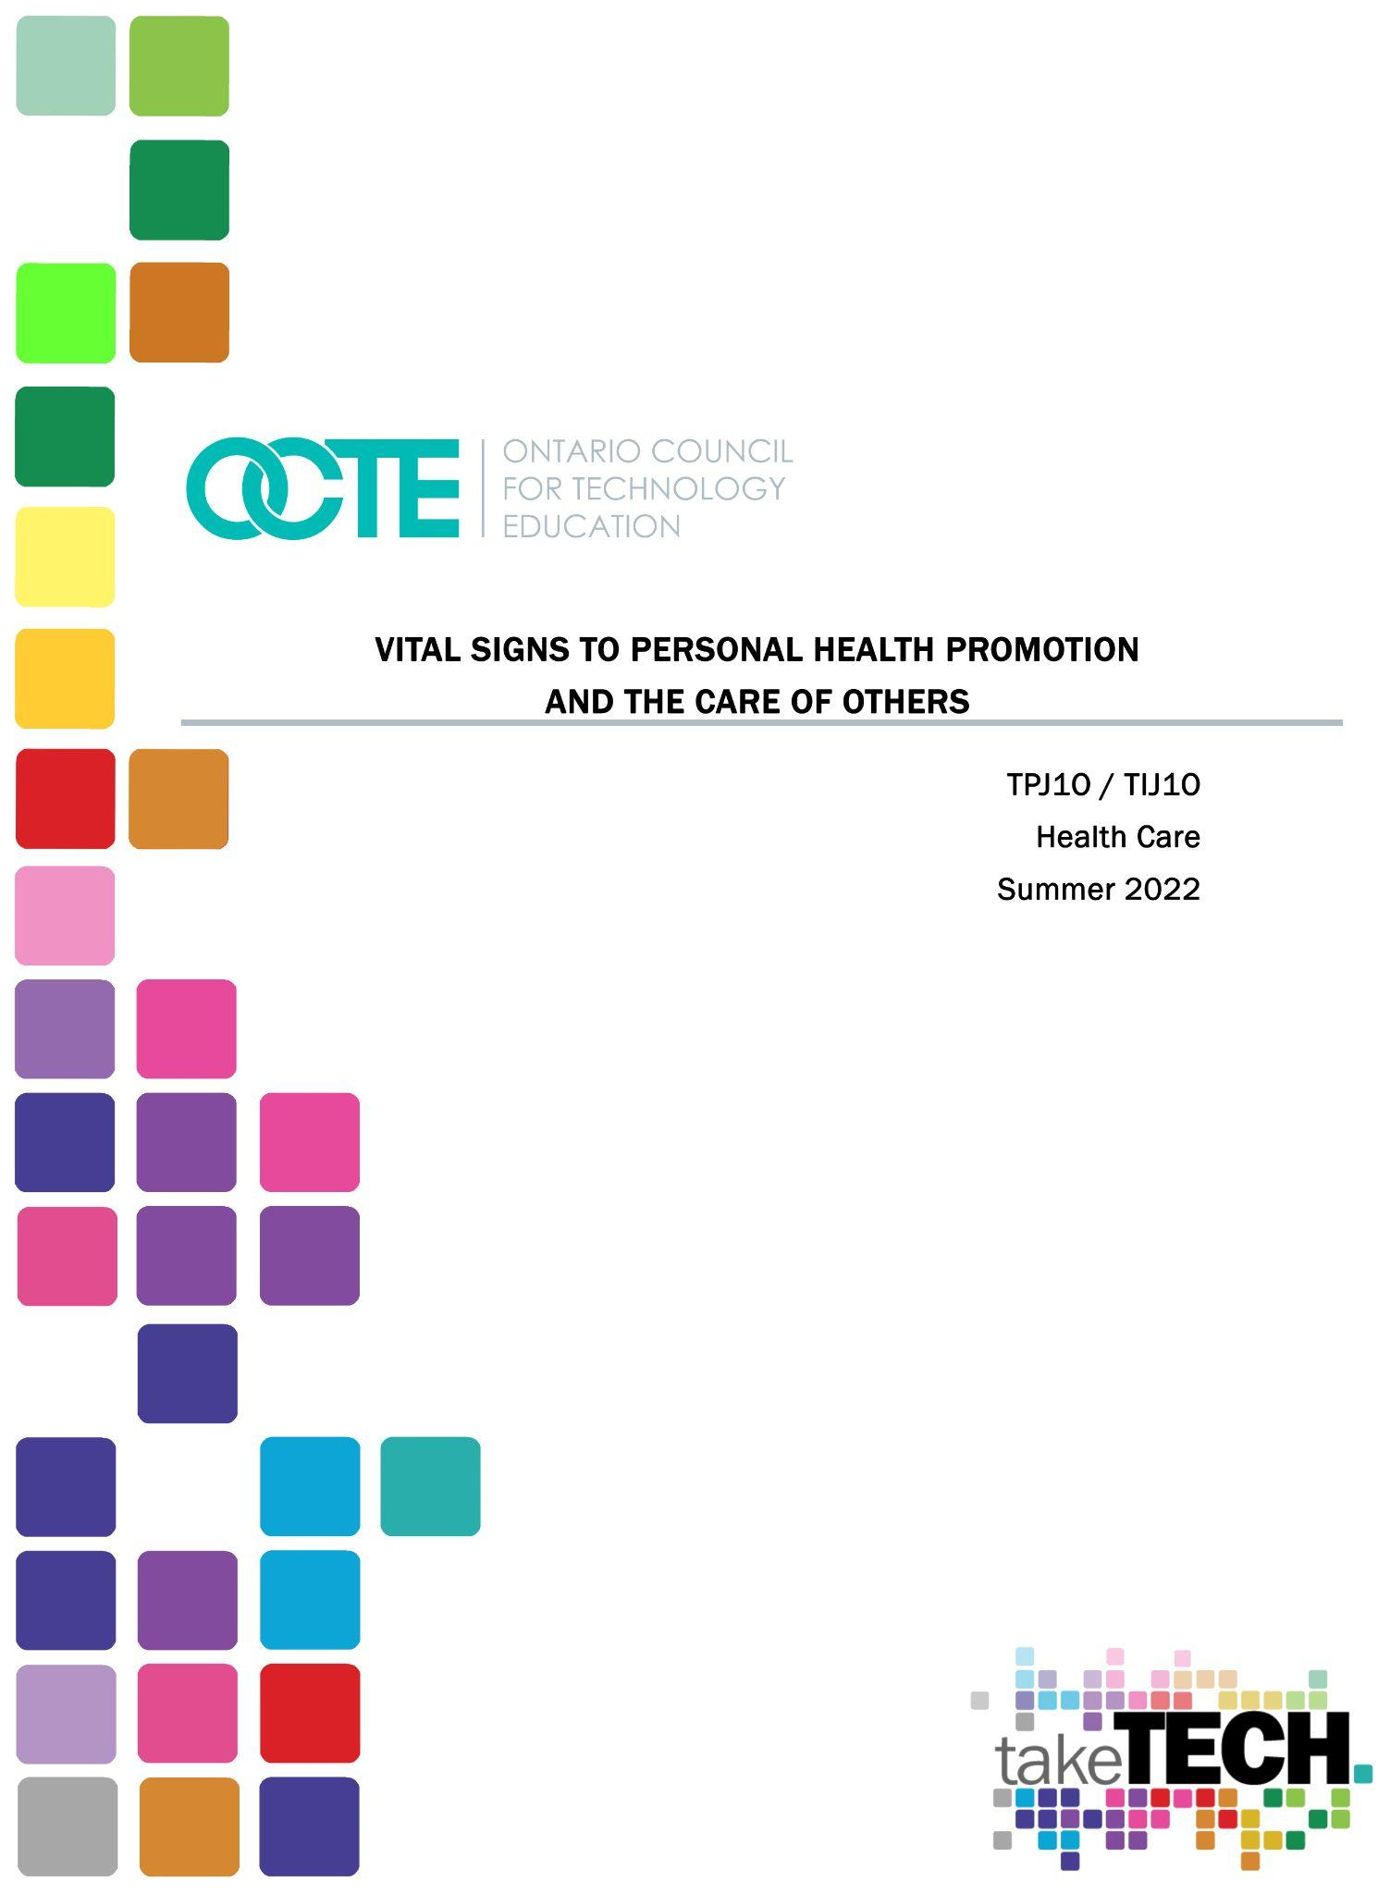

Table of Contents

Introduction 4
Project Outline 4
Planning Notes 4
Prior Knowledge 4
Student Activities 5
Activity 1 - The 24-Hour Clock (2-3 hours) 5
Instructions: 5
Activity 2 - How to Use a Stethoscope (75 minutes) 6
Activity 3 - Vital Signs Introduction (1-2 hours) 8
Activity 4 Vital Sign Clinic (2-3 hours) 10
Activity 5- Unit Test (45-75 minutes)(Optional) 10
Activity 6 - Vital Signs Pamphlet Assignment (2-3 hours)(Optional) 10
Skilled Trades and Apprenticeship Opportunities 11
Skills Continuum 11
Career and Industry Extensions 11
Resources 12
Lesson Plans Instructions 12
Handouts 12
Pictures/Blueprints 12
Tools/Equipment 12
Materials / Presentations 12
Websites for Teachers 12
Videos 13
Instructional Strategies 13
The Hook / Motivational Strategies 14
Learning Goals and Success Criteria 14
Overall and Specific Expectations in Support of Ontario Curriculum Grades 9 - 10 Technological Education 14
Overall Expectations 14
Specific Expectations 14
Safety Concerns (including PPE if required) 15
Challenges Implementing Project 15
Applicable SAFEDocs and ToolSAFE videos 15
Differentiation of the Project / Activity 15
Assessment and Evaluation 15
Assessment as Learning 15
Assessment As Learning 15
Assessment For Learning 16
Career and Industry Extensions 16
Ethical Considerations 16
Environmental Considerations 16
Reflection or Design Report 17
Appendix A – You Gotta Have A Heart Lab Sheet 18
Appendix B – Clinic Form Handout 19
Appendix C - Snellen Eye Chart 21
References 23

Introduction
Course Code: TIPJ10/TPJ10
Broad base Technology: Health Care Technologies
Destination: Open
Grade Level: 9
Prerequisite: None
Project Name: Vital Signs to Personal Health Promotion and the Care of Others

This is an introductory course that introduces students to personal health promotion and care of others. Using materials, processes, and techniques used in the industry, students learn the basic fundamental skills in health care regarding taking and maintaining healthy vital signs readings. Students will also consider related diseases, disorders and research environmental and societal issues that affect healthy vital sign readings.
There are some instructional videos that can help guide you through the logistics and main points of items in this Unit plan.

Project Outline
Students will demonstrate their learning skills regarding vital signs with an introduction to a variety of health care instruments and equipment then demonstrate their knowledge in their ability to document as well as use them correctly in a mock clinic setting.
Students will learn about the importance of documentation and the use of the 24 hour clock.
As an option, there is a reflection activity where students can apply their knowledge while researching preventative measures to avoid a selected abnormality, diseases and/or disorder.

Planning Notes
Each activity is organized as a step learning or scaffolding process in that some background knowledge is required in order to achieve full understanding of the concept of taking vital signs and the significance thereof.

Prior Knowledge
Vital Signs is an introductory lesson so no prior knowledge is required in order to complete this Unit Plan

Student Activities

Activity 1 - The 24-Hour Clock
Objective: Students require the knowledge of the 24-hour clock so that they will understand the importance of how to identify and eventually investigate various health abnormalities, diseases and/or disorders related to abnormal vital sign readings and when they occur.
Materials: 24 hour clock worksheet (internet link provided)
Time: 2-3 hours
Resources: PowerPoint Note, supportive YouTube video

Instructions:
KWL- Post the following questions on the whiteboard (Answers will vary)
What is a 24-hour clock? (Answer: it is the time keeping in which the day runs from midnight to midnight and indicated by the hours passed since midnight -hour 0 to 24 or 23:59)
Why is a 24-hour clock necessary in the Health Care field? (to give an exact time that treatments or ailments to a patient occur and are not confused or create medical errors)
Advise students to change their digital watches to the 24-hour clock mode to help in the understanding of 24 hour time
*24 hour clock PowerPoint
*24 hour clock Practice Worksheets
*24 hour clock Jigsaw Puzzle Activity

Activity 2 - How to Use a Stethoscope
Objective: Allows for auscultation (listening to internal normal/abnormal body sounds)

Materials: See Equipment list below
Time: 2-3 hours
Resources: PowerPoint Note, supportive YouTube video
Equipment needed:
-Class set or students can share a ½ class set of stethoscopes
-alcohol pad for each use and end of use
Stethoscope Basics video
How to Use a Stethoscope PPT
“You Gotta Have Heart” Lab sheet

You Gotta Have A Heart Lab Sheet
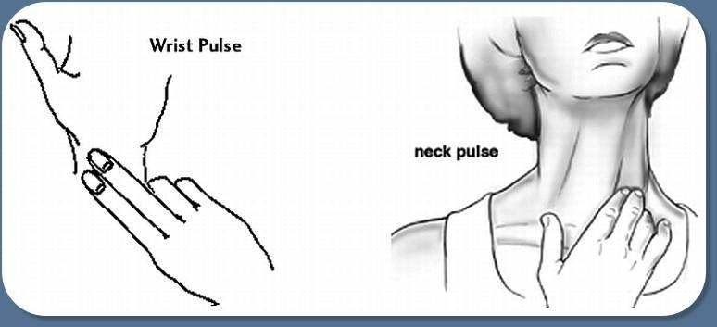

1. Find your pulse using your wrist artery or neck artery.
2. Clock 15 seconds. Count the number of times you feel your pulse.
_______Heartbeats in 15 seconds x 4 = _______ per minute
3. Do 20 jumping jacks. Now find your working pulse rate.
_______Heartbeats in 15 seconds x 4 = _______ per minute
4. Wait three minutes. Find your cool down heart rate.
_______Heartbeats in 15 seconds x 4 = _______ per minute

Heart Profile of:
Name:________________________
Age: _______
My heart beats __________times per minute,
(x60) __________ per hour,
(x24) __________ times per day,
(x365) __________ times per year.
In my lifetime, (x your age _________ ), my heart
has beat more than __________ times!!!!! WOW!!!!

Activity 3 - Vital Signs Introduction
Objective: Vital signs are the starting point for all health professionals to gauge their patient’s progression or digression of their symptoms, disease or disorder
Materials: See Equipment list below
Time: 2-3 hours
Equipment needed:
- 2- 3 SpO2 oximeters and/or video of it
-1-6 Electric Blood Pressure machine and or video of it
-Various thermometers (oral, tympanic, temporal) with disposable probe covers
-Snellen Eye Chart website with printable chart and full explanation. Printable chart
*Pulse Site diagram website- Pulse Diagram
What is Pulse? By Toronto Metropolitan University Pressbooks

Introduce SpO2 and/or use this Oxygen Saturation and the Pulse Oximeter video
Introduce Electric Blood Pressure Machine and/or view this Lumiscope video
Allow students to practice with equipment and record findings using proper 24-hour clock time and legal patient name

Label the following pulse sites from the Vital Signs PPT then try to palpate as many PULSE SITES AS POSSIBLE on both yourself and then a partner.

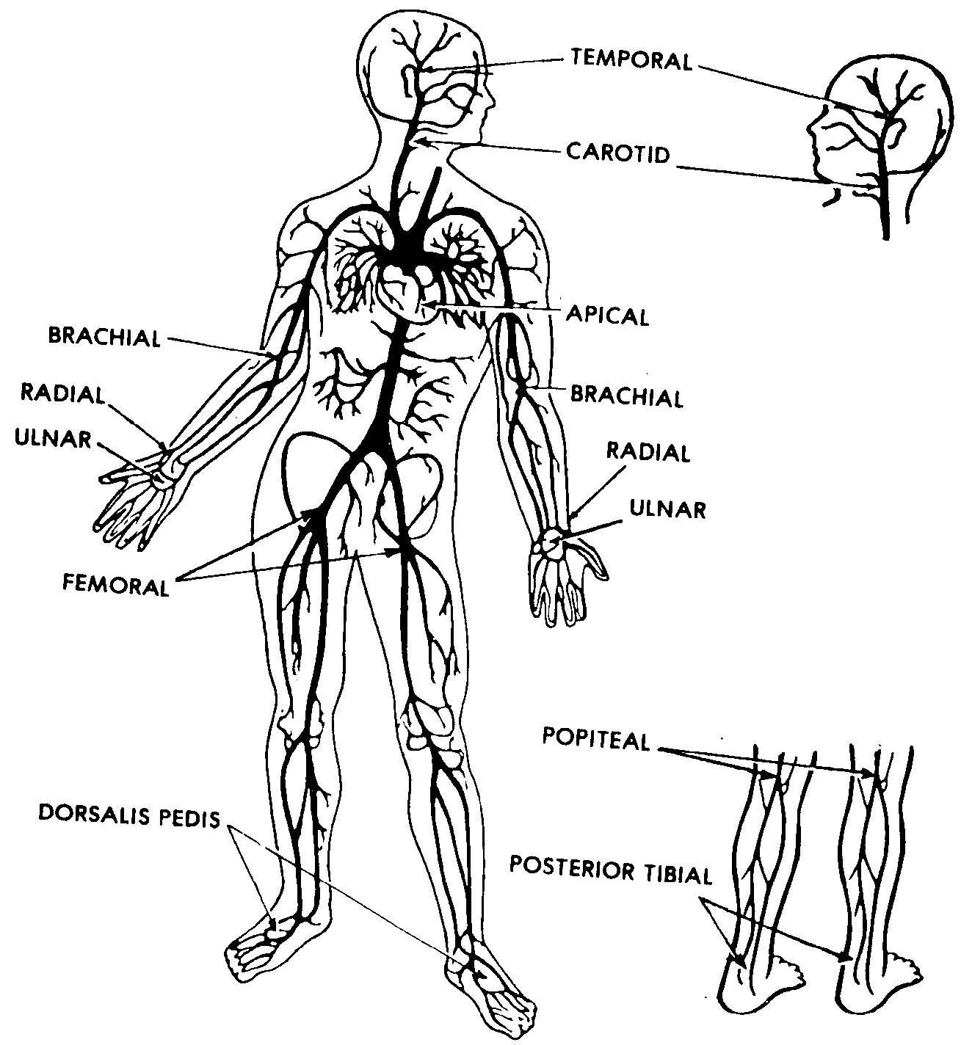

Activity 4 Vital Sign Clinic
Objective: Student can demonstrate their comprehension and understanding of the us of vital sign equipment
Materials: See Equipment list below
Time: 2-3 hours (NOTE: Set up clinic prior to class starting)
Resources: See Clinic Instructions
Equipment needed for each station is in the Vital Sign Clinic document below. Print a copy and place at each station with indicated Station number

Vital Signs PPT
Vital Sign Clinic Instructions
Clinic form handout
*Introduce students to each station of the clinic at the start of activity

Activity 5- Unit Test (Optional)
Note: I allow students to take as much time as needed to write test but also introduce the Pamphlet project below for student who finish their test to work quietly on as the other students finish their test
Vital Sign Unit Test Review, Test and Answers

Activity 6 - Vital Signs Pamphlet Assignment (Optional)
Objective: The Pamphlet Assignment is to allow the teacher/instructor to see if students can apply their vital sign acquired knowledge while researching preventative measures to avoid a selected abnormality, diseases and/or disorder.
Materials: Use the Internet Google search or create an exemplar
Time: 2-3 hours
Resources:
Disease or Disorder Prevention Pamphlet

Skilled Trades and Apprenticeship Opportunities
Learning vital signs is extremely important especially in the roles and responsibilities of numerous health care providers/professionals for example, family physicians, various levels of the nursing career (ie. registered practical nurses, personal support workers), and/or specialty areas of nursing, medical equipment dealers etc.

Skills Continuum
We all have different moments in our lives where we are affected by an experience. This can include learning a new concept or skill, experiencing something for the first time, taking a new course, developing a talent through practice and hard work, or even calling upon a medical professional or first aid responder to assist with a situation and relying on their knowledge, expertise and experience. Think of it as a skilled ‘tradesperson’ to fix, repair, design, construct, maintain, build, bake, and create innovative solutions. The continuum of influence is a graphic representation of how those experiences can lead to developing a passion and talents in areas of healthcare technology as a paramedic, nurse, nurse practitioner, medical assistant, doctor, lab technician, product sales, medical assistant, scientist, research and development, hospital administration, etc.
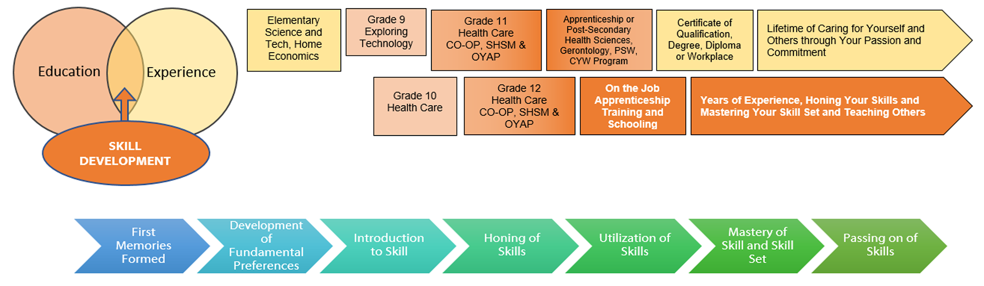

Career and Industry Extensions
Learning vital signs is extremely important for students to implement learned skills in the roles and responsibilities of numerous health care providers/professionals for example, family physicians, various levels of the nursing career (ie. registered practical nurses, personal support workers), and/or specialty areas of nursing, medical equipment dealers etc.

Resources

Lesson Plans Instructions
Attached to applicable activities

Handouts
“You Gotta Have Heart” Lab sheet
Vital Sign Clinic Instructions
Clinic form handout
Vital Sign Unit Test Review,
Vital Signs Test
Vital Signs Test Answers

Pictures/Blueprints
Snellen Eye Chart (see Appendix C)

Tools/Equipment
Medical equipment- Stethoscopes, Electric Blood pressure machines, various thermometer types, Flashlights, alcohol cleansing pads

Materials / Presentations
Handouts, PowerPoint Notes
How to Use a Stethoscope PPT
Vital Signs PPT

Websites for Teachers
24 hour clock Practice Worksheets
24 hour clock Jigsaw Puzzle Activity
What is Pulse? By Toronto Metropolitan University Pressbooks

Videos
Introduction to Vital Signs for Nursing Students
RN Kid
https://www.youtube.com/watch?v=WyI34ussq6U
(28:31)
Stethoscope Basics for the EMT
Chris Le Baudour
https://www.youtube.com/watch?v=5SBRX6jq3GI
(2:43)
Oxygen Saturation and the Pulse Oximeter: Nursing Skill Vital Signs
NurseMinder
https://www.youtube.com/watch?v=DNXlDcN1Or0
(7:25)
Lumiscope How to Use the Upper Arm Blood Pressure Monitor: How-to Instruction Video
Graham-Field
https://youtu.be/dcYlCrINPn8
(3:09)

Instructional Strategies
Teachers may use any of the following instructional strategies; lecture, storyboard, word wall of various pieces of equipment, disease related terminology etc., K-W-L, anticipation chart, think aloud, analyzing text, and/or Cornell note taking,

The Hook / Motivational Strategies
Teachers can determine the level of student understanding to increase or decrease the synchronous learning. For example as a hook, show the following video as an excellent introduction to vital signs.

Learning Goals and Success Criteria
Students will be able to understand personal health promotion and care of others. Using materials, processes, and techniques used in the industry, students learn the basic fundamental skills in health care regarding taking and maintaining healthy vital signs readings. Students will also consider related diseases, disorders and research environmental and societal issues that affect healthy vital sign readings.

Overall and Specific Expectations in Support of Ontario Curriculum Grades 9 - 10 Technological Education
This exploratory course introduces students to concepts and skills related to health care, which encompasses personal health promotion, and various medical instruments. In doing so, students will develop an awareness of related societal issues and will begin to explore secondary and postsecondary pathways leading to careers in the field.

Overall Expectations
A2. Describe factors that affect personal health and well-being
B1. Demonstrate an understanding of and apply correct procedures for ensuring asepsis and proper use of medical equipment

Specific Expectations
A2.5 Describe situations in which one should seek immediate medical
A2.8 Explain how lifestyle choices can have an impact on an individual’s health and well-being
B1.2 Describe a variety of health care instruments and equipment and demonstrate the ability to use them correctly (e.g., thermometer for body temperature, stethoscope for heart rate and respira­tion)
B4.4 Demonstrate an understanding of common health care terms (e.g., stethoscope)

Safety Concerns
Proper cleaning of medical equipment (ie. alcohol swabs for stethoscope ear pieces) and use of disposable probe covers and disposal thereof

Challenges Implementing Project
Students require access to indicated medical equipment

Applicable SAFEDocs and ToolSAFE videos
Refer to OCTE SAFEdoc for Hairstyling and Aesthetics , specifically:
page 13 Overall Expectations for TPJ20
page 18 Biohazards
page 21 Practice Labs
page 26 Health Care Equipment
page 34 Hand Washing

Differentiation of the Project / Activity
Using the Health Care Equipment may be difficult initially. For this situation teachers can review the PowerPoint and/or videos or work one-to-one (during class or privately)with students having difficulty before students continue on with the Vital Signs Clinic practical lab.
Visuals of all necessary information for students with reading difficulties is supported in the form of demonstration videos and teacher-initiated demonstrations.

Assessment and Evaluation

Assessment as Learning
Students complete work sheets and demonstrate learning in the Vital Sign Learning clinic.

Assessment As Learning
Teacher/Instructor circulate as students go through the various Vital Signs clinic stations

Assessment For Learning
Students can write Optional Vital Signs Unit test
Students can complete Vital Sign Pamphlet Assignment

Career and Industry Extensions
Industry extensions and career exploration include the following areas:
family physicians in different areas of expertise/focus , various levels of the nursing career (ie. registered practical nurses, personal support workers), and/or specialty areas of nursing, medical equipment dealers etc.

Ethical Considerations
Gender/dealing with patient (provide privacy if necessary) and thoroughly explain procedure prior to touching patient (if applicable)
Racist situations involving patient/health care providers can be avoided with changing of health care worker-to-patient assignment or workload.

Environmental Considerations
Proper cleaning protocols and dispensing of contaminated tools/supplies
B1.1 Demonstrate an understanding of and perform proper hand-washing techniques to prevent transmission of disease (e.g., preventing the spread of rhinovirus and/or conjunctivitis)
B1.2 Describe a variety of health care instruments and equipment and demonstrate the ability to use them correctly (e.g., thermometer for body temperature, stethoscope for heart rate and respiration
B1.3 Demonstrate an understanding of and apply safe procedures for preparing, handling, and storing food in order to reduce or eliminate contaminants (e.g., bacteria, viruses, fungi, parasites) and prevent disease (e.g., salmonella or E. coli infections).

Reflection or Design Report
Teachers may wish to have the students complete a design report, reflection or create a foldable to consolidate their learning. This would be a nice way to capture the student’s understanding in a summative format and be used in preparation for their examination, entering post-secondary education or the workforce.

Appendix A – You Gotta Have A Heart Lab Sheet

You Gotta Have A Heart Lab Sheet

1. Find your pulse using your wrist artery or neck artery.

2. Clock 15 seconds. Count the number of times you feel your pulse.
_______Heartbeats in 15 seconds x 4 = _______ per minute

3. Do 20 jumping jacks. Now find your working pulse rate.
_______Heartbeats in 15 seconds x 4 = _______ per minute

4. Wait three minutes. Find your cool down heart rate.
_______Heartbeats in 15 seconds x 4 = _______ per minute

Heart Profile of:

Name: ________________________
Age: _______
My heart beats __________times per minute,
(x60) __________ per hour,
(x24) __________ times per day,
(x365) __________ times per year.
In my lifetime, (x your age _________), my heart
has beat more than __________ times!!!!! WOW!!!!

Appendix B – Clinic Form Handout
Patient Name: Health Care Worker Name:
Site: | High School Clinic  Address  Town/City  Province (Ontario)  Postal Code | Visit Date: | ___ ___ / ___ ___ 2 0 ___ ___  d d m m y y y y

1. 24 clock time ____:____

2. Heart Rate _________bpm
Now have your patient do jumping jacks for 1 full minute or run up and down stairs x3 –then take heart rate

Accelerated Heart Rate _________bpm

3. Blood Pressure- Using an automated BP cuff.
Take and record your patient’s BP in the corresponding position

- ☐ Sitting ________/_________ (systolic/diastolic)
- ☐ Supine________/_________ (systolic/diastolic)

4. Oral Temperature ________ ☐ ○F ☐ ○C __________
Axillary Temperature ________ ☐ ○F ☐ ○C __________
Tympanic Temperature ________ ☐ ○C
Temporal Temperature ________ ☐ ○C

5. Respiratory Rate _________ /min

6. Height _______ ☐ inches __________☐ centimeters

7. O2 saturations ____________

8. Visual assessment1.
Have your patient lie on the bed and close their eyes. Then, using a flashlight, shine the line in and out of the eye. Watch the reaction of the pupils when you shine the light on/off them and guestimate the size using the pupil size chart below. Do both pupils react the same? If so, then you would record “equal and reactive” under findings and if not, you would record “unequal or non-reactive” if your patient’s pupils do not respond to light.

Findings:__________________________________________________________
__________________________________________________________________

What is the pupil’s response to bright light?__________________________

Visual assessment 2. Read the instructions at the Snellen station to record your patient’s findings

Right Eye_______________ Left Eye _______________

Appendix C - Snellen Eye Chart
Snellen Eye Chart
Home use of this Snellen eye chart will help you determine the clarity of your distance vision. This can be useful to screen children for nearsightedness, which causes blurry distance vision. The chart also can help you determine if you meet the legal visual acuity requirement for a valid driver’s license (20/40 in most states).
DIRECTIONS FOR USE
For the best accuracy (and to prevent memorization), have someone assist you when testing your vision with this eye chart. If you use eyeglasses or contact lenses for driving or other distance vision tasks, wear them during the test.
- Place the chart on a wall or easel 10 feet away.
- Cover one eye with your hand, a large spoon or some other item that completely blocks the vision of the covered eye. (Do not apply pressure to the covered eye, as it might affect that eye’s vision when you test it.)
- Identify a line on the chart you can comfortably read. Read the letters on that line aloud. Have your assistant stand near the chart and record your accuracy.
- Continue trying to read the letters on each successively smaller line. Do not squint.
- Have your assistant stop you when you fail to correctly identify at least 50 percent of the letters on a line.
- Switch to the other eye and repeat.
Record your visual acuity for each eye by noting the line for which you correctly identified either:
- a) More than half the letters on that line, but not all of them.
- b) All letters on that line, plus a few letters (less than half) on the next line.
Examples:
If you correctly identify five of the seven letters on the 20/32 line, your visual acuity for that eye is: 20/32–2/7 If you correctly identify all seven letters on the 20/32 line and three of the eight letters on the 20/25 line, your visual acuity in that eye is: 20/32+3/8
DISCLAIMER:
Eye charts measure only visual acuity, which is just one component of good vision. They cannot determine if your eyes are "working overtime" (needing to focus more than normal, which can lead to headaches and eye strain), or can they determine if your eyes work properly as a team for clear, comfortable binocular vision and accurate depth perception.
Eye charts also cannot detect serious eye problems such as glaucoma or early diabetic retinopathy that could lead to serious vision impairment and even blindness.
Only a comprehensive eye exam performed by a licensed optometrist or ophthalmologist can determine if your eyes are healthy and you are seeing as clearly and comfortably as possible.
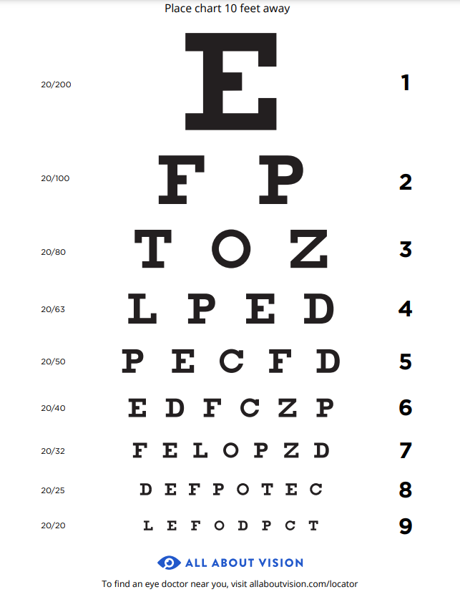

References
21st Century Competencies: Foundation Document for Discussion. Phase 1: Towards Defining 21st Century Competencies for Ontario, Winter 2016 Edition, 2016 http://www.edugains.ca/resources21CL/About21stCentury/21CL_21stCenturyCompetencies.pdf
24 hour clock Practice Worksheets, Math-Drills, 2022 https://www.math-drills.com/timeworksheets.php
24 hour clock Puzzle Activity (website), 2011 http://www.mathswithgraham.org.uk/?p=1950
A Teacher Checking His Student's Temperature, Yan Krukov (picture), 2021 https://www.pexels.com/photo/a-teacher-checking-his-student-s-temperature-8617612/
Eye test with Optician, Rollstein (photo), 2020 https://pixabay.com/photos/optician-eye-test-eyeglass-lenses-4753321/
Girl covering her left eye with snellen chart, (image), 2018 https://www.findhealthclinics.com/US/Hollywood/208509366221707/Selmo-Satanosky-OD
Growing Success: Assessment, Evaluation, and Reporting in Ontario Schools, First Edition, Covering Grades 1 to 12, 2010 www.edu.gov.on.ca/eng/policyfunding/growSuccess.pdf
How Do I Take an Axillary Temperature? Nemours Kids Health (image), 2022 https://kidshealth.org/en/parents/take-temperature.html
How Do I Take an Oral Temperature? Nemours Kids Health (image), 2022 https://kidshealth.org/en/parents/take-temperature.html
Introduction to Vital Signs for Nursing Students, RN Kid (video), 2021 https://www.youtube.com/watch?v=WyI34ussq6U
Learning for All – A Guide to Effective Assessment and Instruction for All Students, Kindergarten to Grade 12, https://www.dcp.edu.gov.on.ca/en/
Little Girl Measures Height, Happy broto (Vecteezy image), 2022 https://www.vecteezy.com/vector-art/1760141-little-girl-measures-height
Lumiscope How to Use the Upper Arm Blood Pressure Monitor: How-to Instruction Video, Graham-Field (video), 2020 https://youtu.be/dcYlCrINPn8

Measuring Body Temperature Using a Tympanic Thermometer, Nursing Times (image), 2020 https://www.nursingtimes.net/clinical-archive/assessment-skills/measuring-body-temperature-using-a-tympanic-thermometer-2-14-09-2020/
OCTE SAFEdoc for Hairstyling and Aesthetics, OCTE, 2013 https://www.octe.ca/application/files/3915/3796/3170/SAFEdoc_HC.pdf
Oxygen Saturation and the Pulse Oximeter: Nursing Skill Vital Signs, NurseMinder (video), 2020 https://youtu.be/DNXlDcN1Or0
OxyWatch C20 Pulse Oximeter, Thinkpaul (photo), 2011 https://upload.wikimedia.org/wikipedia/commons/b/b5/OxyWatch_C20_Pulse_Oximeter.png
Red SEAL – Sceau Rouge, 2018 http://www.red-seal.ca/trades/tr.1d.2s_l.3st-eng.html
Resources, Skilled Trades Ontario https://www.skilledtradesontario.ca/about-trades/trades-information/
Respiratory image with text - ill and well, Pinterest, 2022 https://i.pinimg.com/564x/fd/35/88/fd35887dbec65055509b9e5058e0de07.jpg
Respiratory Patterns, Best Stethoscope Guide (image), 2022 https://beststethoscopeguide.com/best-stethoscope-for-nurses/
Skilled Trades Identified in Ontario, Skilled Trades Ontario https://www.skilledtradesontario.ca/about-trades/trades-information/
Skilled Trades Ontario (website), 2022 https://www.skilledtradesontario.ca
Snellen Eye Chart, Hudson Valley Eye Surgeons, 2022 https://www.hves.com/wp-content/uploads/snellen-chart.pdf
Start an Apprenticeship in Ontario, Government of Ontario, 2022 https://www.ontario.ca/page/start-apprenticeship
Stethoscope Basics for the EMT, Chris Le Baudour (video), 2008 https://www.youtube.com/watch?v=5SBRX6jq3GI
Taking a pulse (image), https://www.hopkinsmedicine.org/health/conditions-and-diseases/vital-signs-body-temperature-pulse-rate-respiration-rate-blood-pressure
The Differentiated Instruction Scrapbook http://www.edugains.ca/resourcesDI/EducatorsPackages/DIEducatorsPackage2010/2010DIScrapbook.pdf
The Ontario Curriculum, Grades 9 and 10: Technological Education, 2009 (revised) http://www.edu.gov.on.ca/eng/curriculum/secondary/teched910curr09.pdf
What is Pulse, Toronto Metropolitan University (Pressbooks), 2017 https://pressbooks.library.torontomu.ca/vitalsign/chapter/what-is-pulse/
Wrist Pulse and Neck Pulse, Dr. Terry Simpson (image), 2022 https://drsimpson.net/fills/Lap-band-made-simple/Weight-loss-surgery-goals-1/Weight-loss-surgery-exercise/wrist-pulse-and-neck-pulse.jpg

