TIJ 1O Exploring Technology – Student Assignment
Exploring Manufacturing Technology – 3D Design and Printing
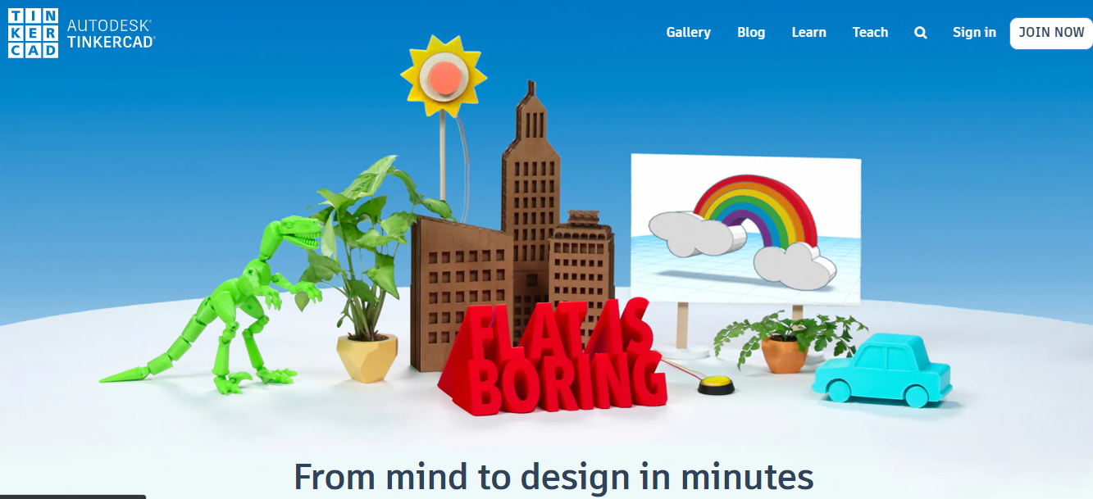
Contents
Minds On: (10 minutes) 2
Action: (6 hours total) 3
• Plan (1.5 hours) 3
• Learn (2 hours) 3
• Design (2.5 hours) 3
Plan 3
Plan 3
Learn: Overview 4
Learn: Environmental Considerations: 5
Learn: (Online training on Computer Aided Design (CAD) program Tinkercad) 6
Learn: (Online training on Computer Aided Design (CAD) program Tinkercad) 7
Learn: (Online training on Computer Aided Design (CAD) program Tinkercad) 8
Learn: (Online training on Computer Aided Design (CAD) program Tinkercad) 9
Design: (Computer Aided Design (CAD) using Tinkercad) 10
Consolidation: 12

TIJ 1O Exploring Technology – Student Assignment
Exploring Manufacturing Technology – 3D Design and Printing
In your high school, you may have a Manufacturing Technology facility or shop. It’s a challenge to recreate the experience of a Manufacturing Technology facility at your home, but there are things we can do and learn at home that can be applied in a manufacturing shop in the future. In this module, you will learn how to:
- Design 3D shapes in an Online CAD (Computer Aided Design) environment,
- Create 3D printer compatible files to create real 3D objects that you designed on the computer.

Minds On: (10 minutes)
If you’ve ever played a board game, you’ve moved pieces around on a board to track your progress.
What board games have you played in the past?

Any favourites?

What’s the best aspect of your favourite?
What would you do to improve a board game?

Action: (6 hours total)
- Plan (1.5 hours) - Think about an original board game that you could create
- Learn (2 hours) – Follow online module to learn how to design 3D objects
- Design (2.5 hours) – Apply your learning to design player pieces for your board game

Plan
What theme would you use to design your own game?
What would be the name of your new game?
How many people does your ideal board game allow to play at once? .
How many playing pieces does each player need? .
How many designs of pieces are needed for your game? .
In the chart below, you can see a series of board games along the top, and some criteria for each game down the left column. This chart organizes information from questions above for each game. Complete the right column of the chart with details for a game of your own design.
Game | Chess | Checkers | Monopoly | Your Game
# of players | 2 | 2 | 2-8
Pieces per player | 16 | 12 | 1
Design of pieces per player | 6 designs:  1 king  1 queen  2 rooks  2 bishops  2 knights  8 pawns  (1 colour per player) | 1 design:  All pieces are the same design  (1 colour per player) | 8 designs:  1 piece per player from this selection  - Scottie dog  - Top hat  - Thimble  - Boot  - Wheelbarrow  - Cat  - Racing car  - Battleship

Plan - Use paper and a pencil to sketch the designs you will need for each of the game pieces for your game.

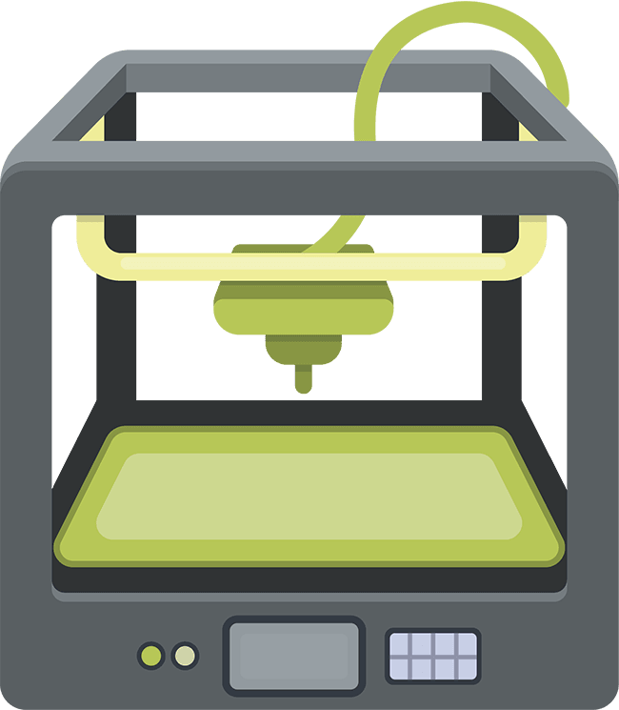
Manufacturing Parts for Your Game

Learn: Overview
- If your school has a Manufacturing Technology program, or a Maker Space, there might be a 3D printer for students to use. If not, your local library will likely be able to provide access to a 3D printer.

- 3D designing and printing is a highly technical process. It may take a few tries to get things right, and it won’t always go smoothly, so remember to be patient with yourself and take breaks when it gets frustrating.

- 3D printing creates 3 Dimensional objects from computer files. These printed objects are called 3 dimensional because they have height, width and depth. In order to create in 3D, the printer needs to have motion in 3 directions (axes) The x-axis is left and right motion, the Y-axis is motion between the front and back of the machine, and the Z-axis is motion up and down.

- A 3D printer converts a material called PLA (PolyLactic Acid) into whatever shape you design. The PLA comes in a long, thin strand called a filament, rolled onto a spool. Filament spools are available in a variety of colours. The filament is melted by the printing head of the machine, which moves from right to left (X-axis) and from the front of the printer to the back of the printer (Y-axis) applying a thin layer of melted filament according to the shape of the object you are making. Either the print head will move up or the bed of the printer will move down (Z-axis) so that another layer can be stacked up on the previous layer, and so on until all of the layers have built up to create your object. For more information on PLA, see the Environmental Considerations below.

- There are many different programs used to create the computer files for a 3D printer. We are going to use Tinkercad, which is software that is available online, free for you to use to create the files we need to make game pieces for your game.
A note about file types: The type of file that a computer creates is indicated in the name of the file, after the period. For example, the file for this handout was saved as: TIJ1O.docx
The part of the filename before the period ‘TIJ1O’ is the name of the file.
The part of the file after the period is the file extension, that indicates the type of file and what program the file will work with. ‘docx’ is an extension indicating that the file is a Microsoft Word file.
TinkerCad is a site that you can use to create the file that a 3D printer needs to make your project, an STL file. STL is the file extension. STL stands for STereoLithography. A 3D printer uses STL files to make objects.
Now that you know the theme of your game, and how many pieces and designs you need for 1 player, it’s time to start designing a game piece to be produced by a 3D printer.

Learn: Environmental Considerations:
We are aware of the concerns and the environmental impact of our continued use of plastics. Here is a bit more information about the plastic used in 3D printing, and the environmental impact of using this technology:
What is PLA, and what is it used for?
Polylactic Acid (PLA) is different than most thermoplastic polymers in that it is derived from renewable resources like corn starch or sugar cane. Most plastics, by contrast, are derived from the distillation and polymerization of nonrenewable petroleum reserves. Plastics that are derived from biomass (e.g. PLA) are known as “bioplastics.”
PLA production is a popular idea as it represents the fulfillment of the dream of cost-efficient, non-petroleum plastic production. The huge benefit of PLA as a bioplastic is its versatility and the fact that it naturally degrades when exposed to the environment. For example, a PLA bottle left in the ocean would typically degrade in six to 24 months. Compared to conventional plastics (which in the same environment can take several hundred to a thousand years to degrade) this is truly phenomenal.
Excerpt from: https://www.creativemechanisms.com/blog/learn-about-polylactic-acid-pla-prototypes

Learn: (Online training on Computer Aided Design (CAD) program Tinkercad)
Your Teacher will provide you with two items:
- Link to login screen on TinkerCad
- Your assigned Nickname for logging in
The link will bring you to this screen; this is where you can enter the nickname that your teacher provided. That’s all you’ll need to get into Tinkercad.
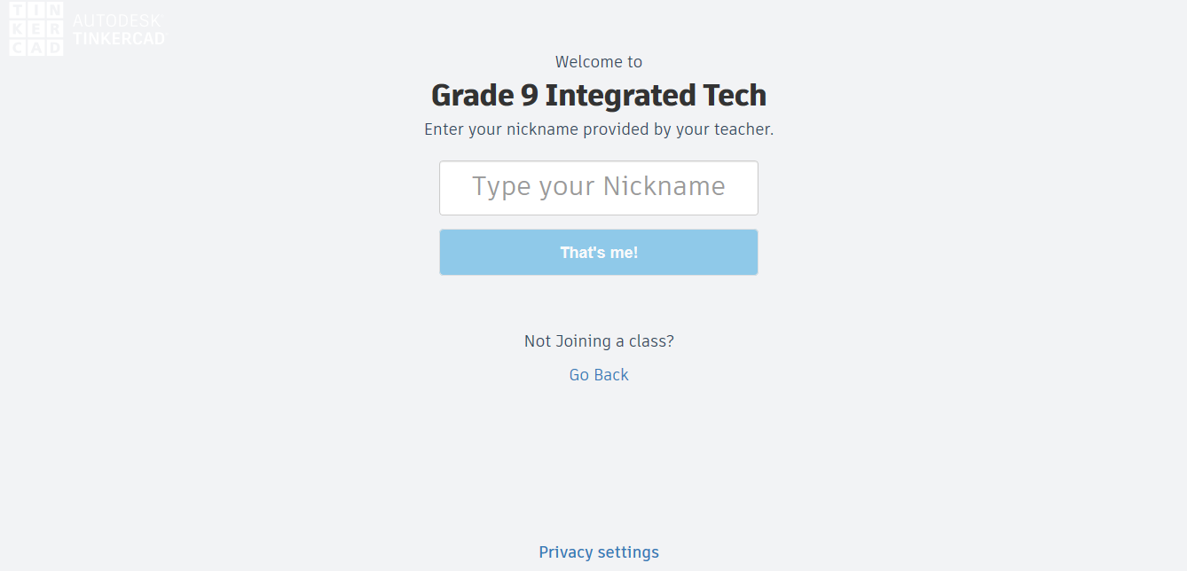
This is the home screen for your account, part of the class account that your teacher created.
You can click on this icon at any time to return to this screen.
Click here to begin learning about Tinkercad.
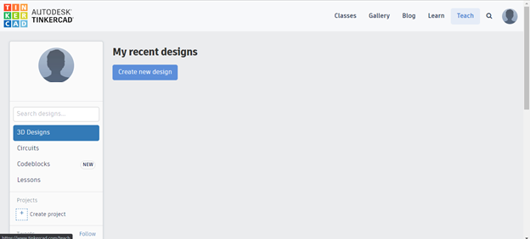

Learn: (Online training on Computer Aided Design (CAD) program Tinkercad)
Click on Starters, then scroll down and click on the See all Starters Button 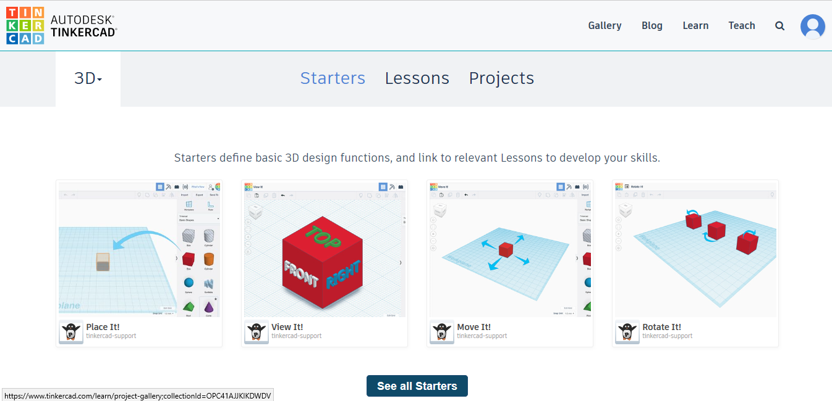

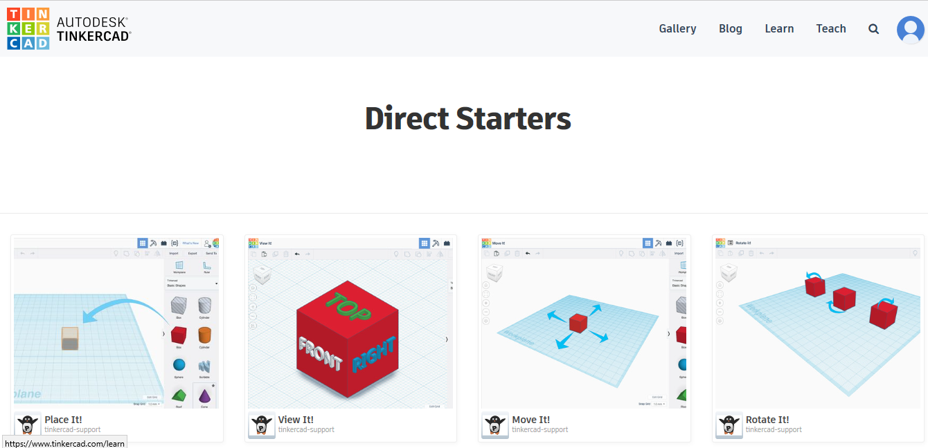
Go through each of the lessons, ideally in order.
1. Place It! 2. View It! 3. Move It! 4. Rotate It!
5. Size It Up! 6. Group It! 7. Align It!
These 7 short lessons will help you understand and work in the program.

Learn: (Online training on Computer Aided Design (CAD) program Tinkercad)
Once you’ve completed all 7 of the starter modules, you’ll be in good shape to progress through one more lesson, very similar to the task you will do to make a playing piece for a game of your design.
Come back to the home screen and click on Learn
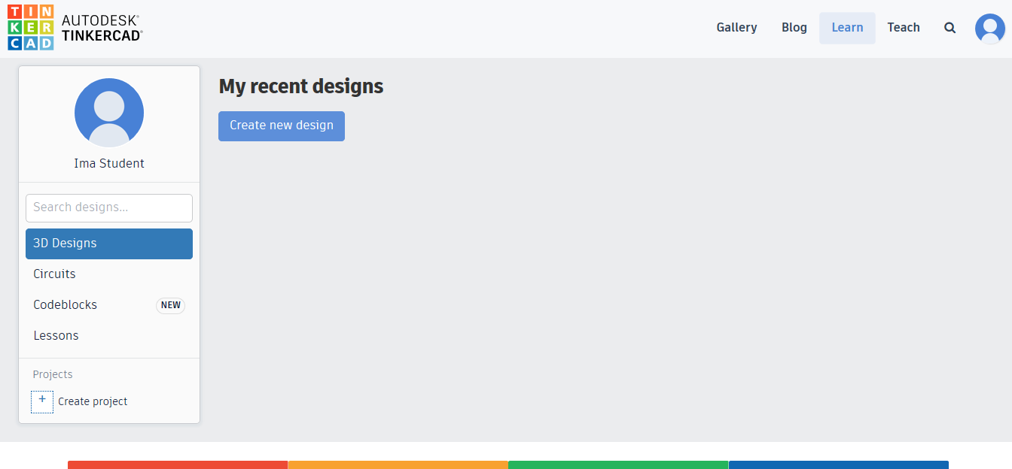

Click on Lessons, and then click on the Chess Pawn Lesson Plan
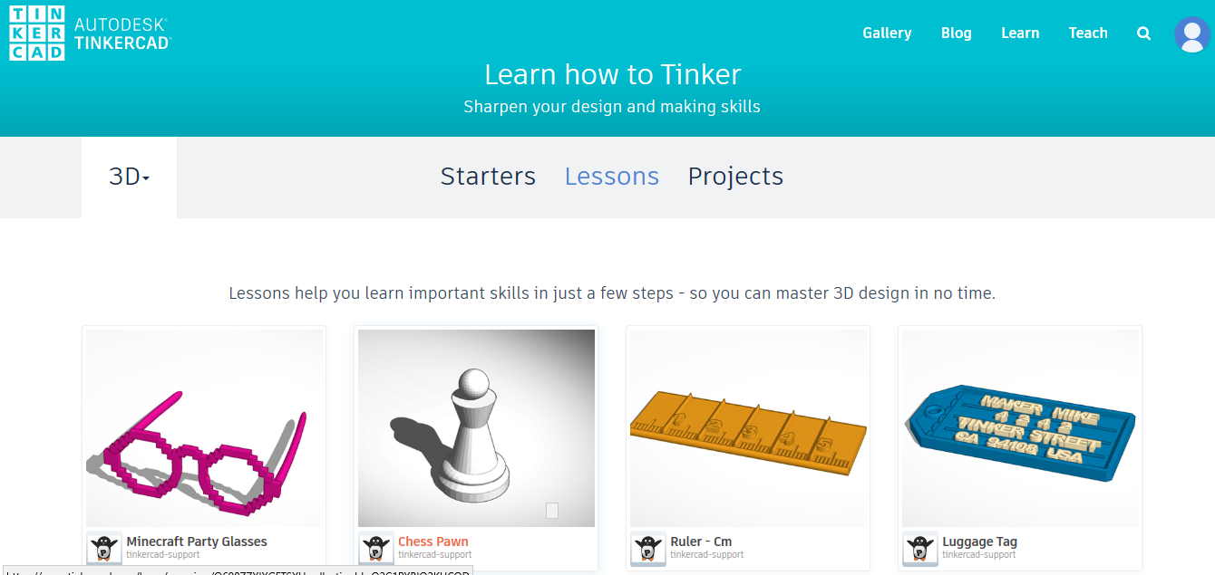

Learn: (Online training on Computer Aided Design (CAD) program Tinkercad)
Click on the word Start to start the lesson. Proceed through the steps of the learning module. It may take a few tries to get things right, and it won’t always go smoothly, so be patient with yourself and take breaks when it gets frustrating.
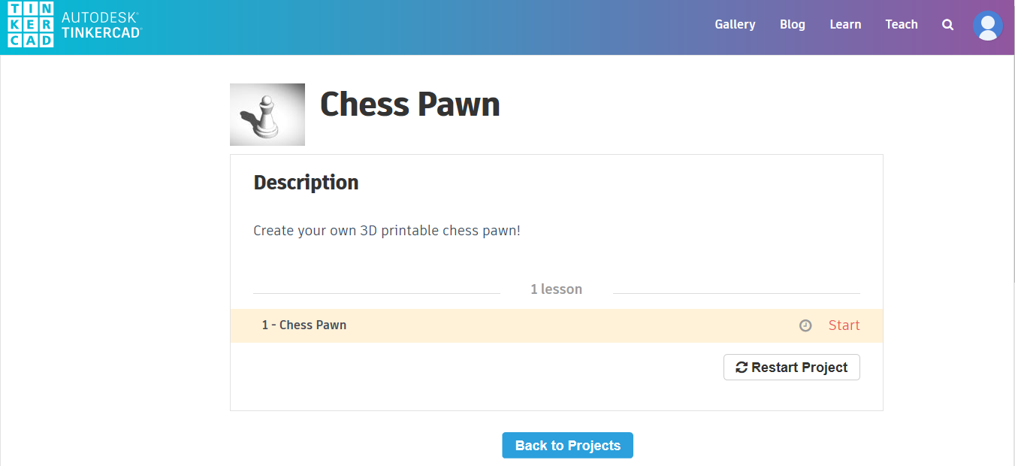
Once you’ve completed this lesson – Congratulations!! That took a lot of patience and attention to detail.
Take a break and move around a bit. Stretch and focus your eyes on something in the distance.

Design: (Computer Aided Design (CAD) using Tinkercad)
Final Step: Design your Game Piece
Look at the sketches that you made earlier. Identify which basic Tinkercad shapes you’ll need to use to make your object in Tinkercad.
Start designing your shape in Tinkercad. Remember to be patient and take breaks as needed.
When your design is complete, you need to save your file in the format that a 3D printer will understand, an STL file. Click on the Export Button.
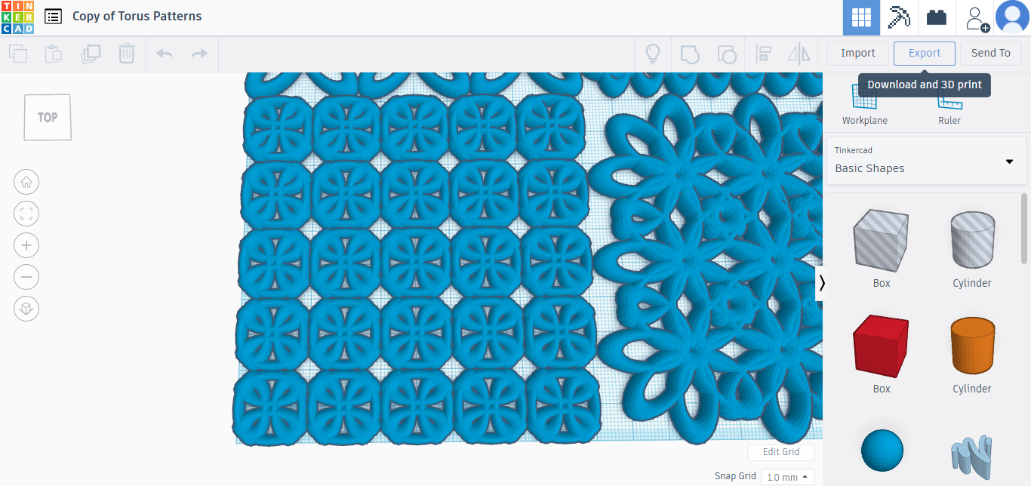
Click on .STL
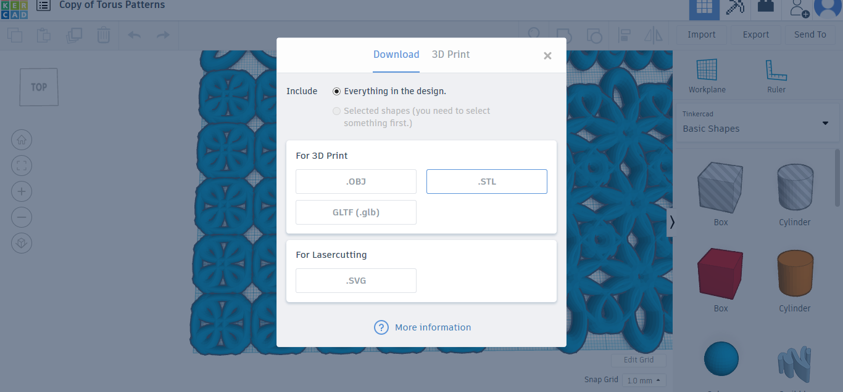

Final Step: Design your Game Piece
Select a location on your computer to save this file that you are downloading.
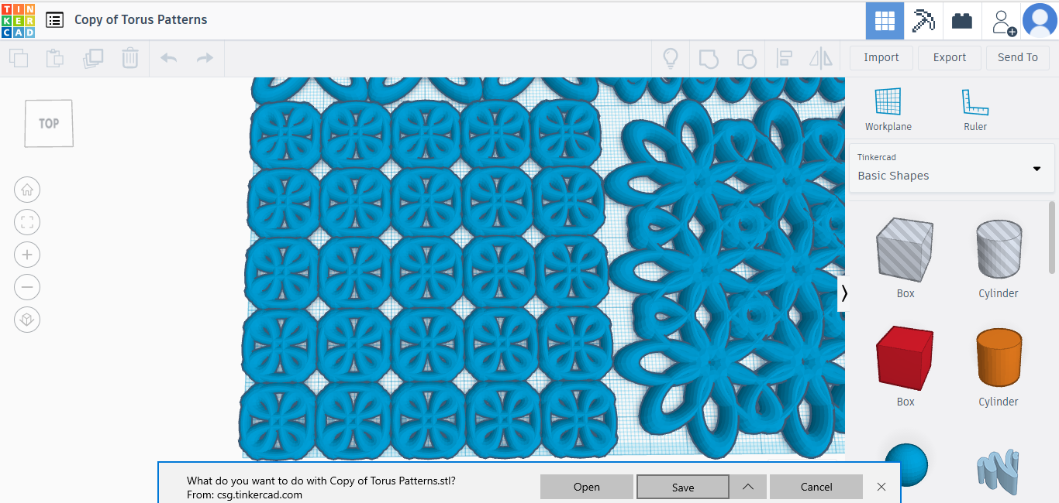

Send the file to your teacher as an email attachment, or upload it to a shared drive space, if your teacher has set one up.
You could also save your file onto a USB memory stick, which most 3D printers can accept.
Have your 3D project printed!
If time permits, try designing some or all of the other pieces that are required for the game you’ve planned.

Consolidation: (20 Minutes)
Once your project is printed, examine it.
- Are you happy with the overall product?

- Did it turn out at the right size?

- Are you happy with the smoothness and detail?

- What changes would you make to the design of this piece?

- What are the steps required to make the changes?

- Did you try designing any other parts?

- If so, did the process get quicker and/or easier?

- How could you make use of a 3D printer in the future?

