Intro Tutorial Project

- WHEEL part 1

Autodesk Inventor is specifically helpful for product design, tooling creation, mechanical design, and product simulation. This software enables users to construct accurate 3D models to aid in simulation and visualization before building products

Autodesk Inventor Wheel Tutorial

In this tutorial you will learn the basics of Autodesk Inventor through making a full car wheel. The tutorial will be broken down into 3 parts, these parts being “Car Wheel” “Car Tire” and lastly the assembly, where both parts will be attached to display a full 3D model of the car wheel.

Getting Started
To start off you are going to open up Autodesk Inventor,
- Locate the orange FILE option at the top left of the screen, click on it
- Select the NEW option
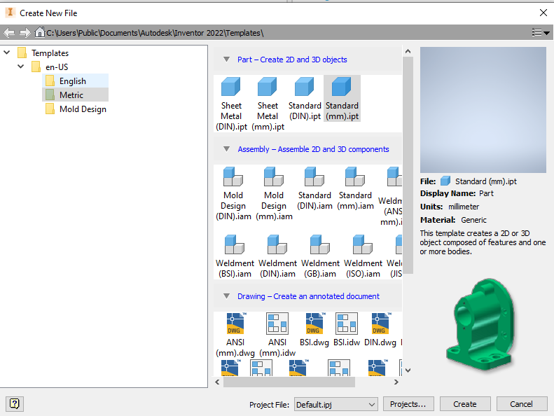
- You will have a pop up open looking like this:

- Select your unit of measure (Metric or English/Imperial)
- Select your drawing style PARTS - this is the area where you draw your objects
- Select STANDARD (mm or inch).IPT file format
- Then create to open the file

Now that you are in the file main screen you will notice that your RIBBON icons are in 3D. This is the 3D mode. (DO NOT DRAW IN 3D mode!) To start to create and draw you will need to:
- Click on the 2D SKETCH icon in the top left corner
- This will take your screen to an orange multi view object
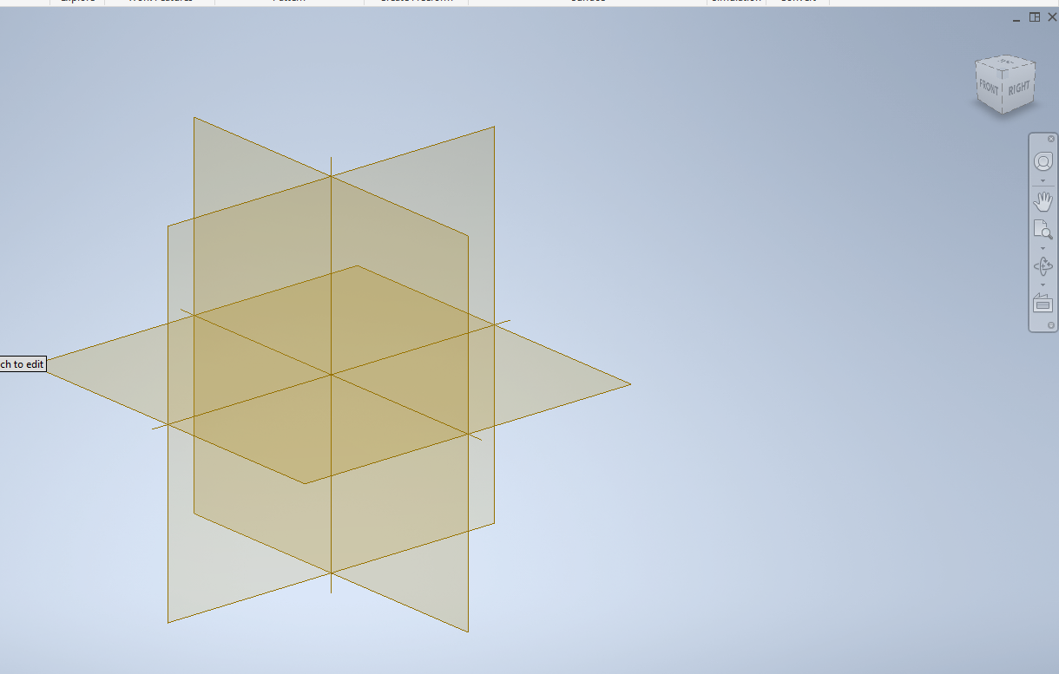
- Using your mouse click on the top side of the flat view (TOP as you will also see in the top right corner.

- You will now notice that the top ribbon has changed to 2D icons and you will see a black crosshair in the center of your screen. You are now ready to design/draw!

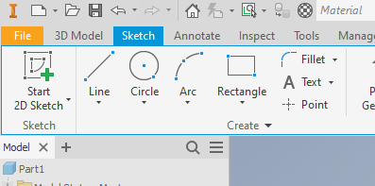
1. Let's start by drawing a circle. Find the CIRCLE icon in the draw menu

- Select the circle option
- Left mouse in the center of your drawing page
- Drag the mouse outwards to make a circle (left mouse click/ enter to set the size)
  - You can directly input your measurement here or you can go back and use the dimension tool in the same ribbon and edit the dimensioned circle from here.
- This circle needs to be 300 mm
- You can always edit the size of the geometry by clicking on the line work

2. The next step you will head to the modify section of the main drawing ribbon
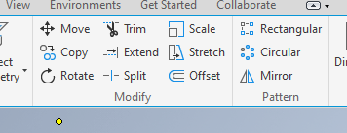
- Look for the OFFSET icon

- Select OFFSET and create a 2nd circle on the inside of the 1st @ 275mm Dia
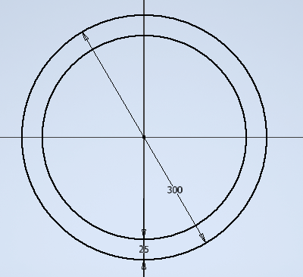

3. Start the next step by selecting the GREEN check mark on the far right of the ribbon. This FINISH SKETCH option is what will allow you to start to model and create the 3D shaping
- You will notice that the top RIBBON icons are now in 3D
- Select the EXTRUDE icon and then the inside of the two circles
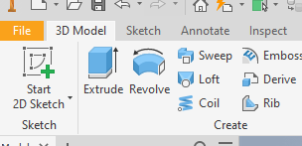

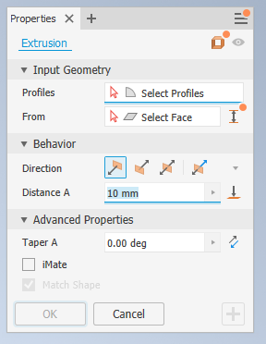
- A new pop up will appear

- You can select which way you want your 3D model to take shape in the direction options. Select UP
- Edit the measurement in “Distance A” to a height of 90mm
- Click OK

4. We are now going to add to your shaping so we need to head back to 2D sketch mode
- Top left click 2D SKETCH and select the FLAT TOP face of the ring
- We can now draw fresh geometry and move forward with our design
  - Notice on the left side of the screen you are NOW ON SKETCH 2
  - Everytime you move back and forth from 2D to 3D you will add a new sketch to the drawing. You can always edit these sketches at a later time.
- Using the CIRCLE icon draw fresh geometry at 300mm
- OFFSET a 2nd circle 15mm

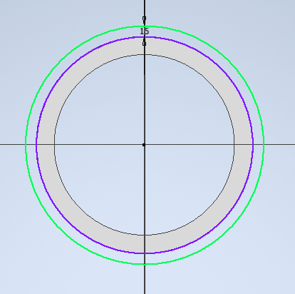
- FINISH SKETCH (green check mark) now in 3D mode
- Select the EXTRUDE icon and the new outer ring
- Direction UP
- Distance 8mm
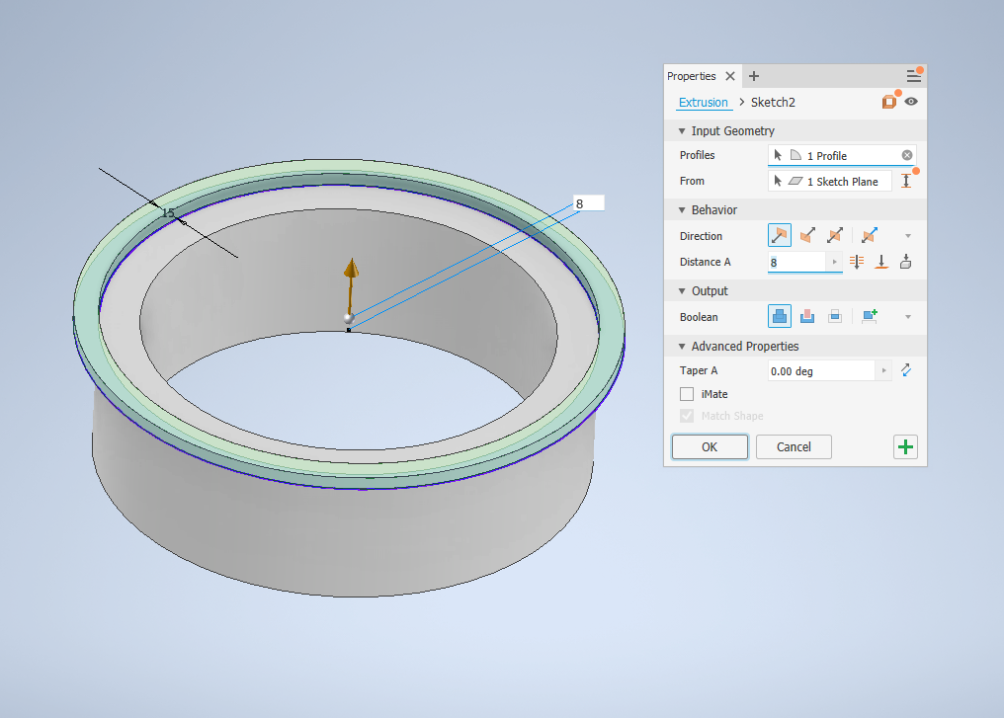
- OK

5. Rotate the ring by using the top right side pictorial box
- Find the bottom side
- Select 2D SKETCH and the bottom face
- Repeat step 4 but on the bottom side of the ring now
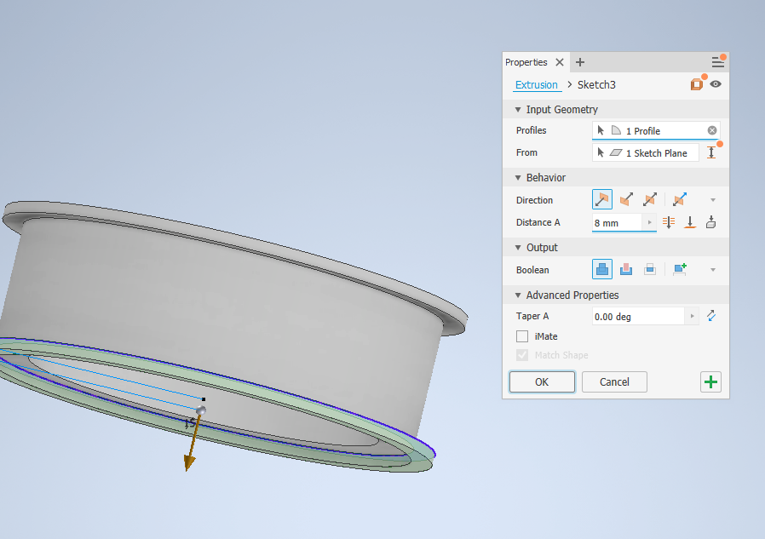

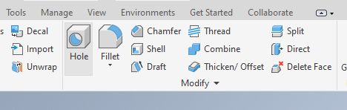
6. Continuing to work in 3D mode. We are now going to make some design edits to the shapes by using the CHAMFER tool in the 3D modify ribbon

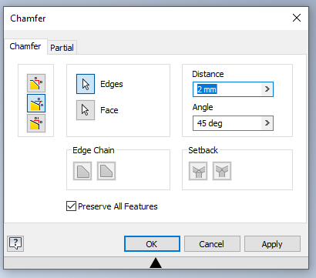

- Select the CHAMFER icon
- The pop up window will have a few options for this purpose will select the 2nd icon
- Edit the distance to 2.5mm
- Angle to 70 deg

Select the lower face of the ring and the outer edge of the ring
- OK
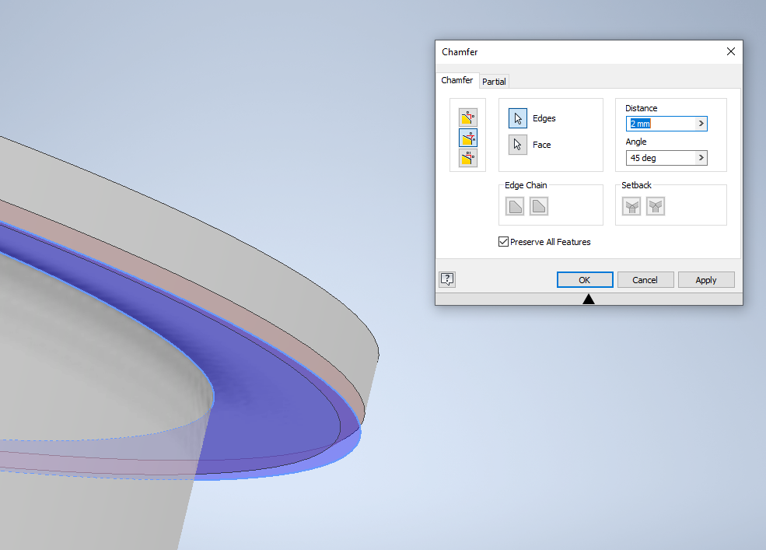

- Rotate the object and repeat on the other side of the main ring

7. Still working in 3D mode, we are now going to create a rounded edge to the interior in the rim using the FILLET tool, next to the chamfer tool location
- Modify the measure in the pop up window to say 5mm
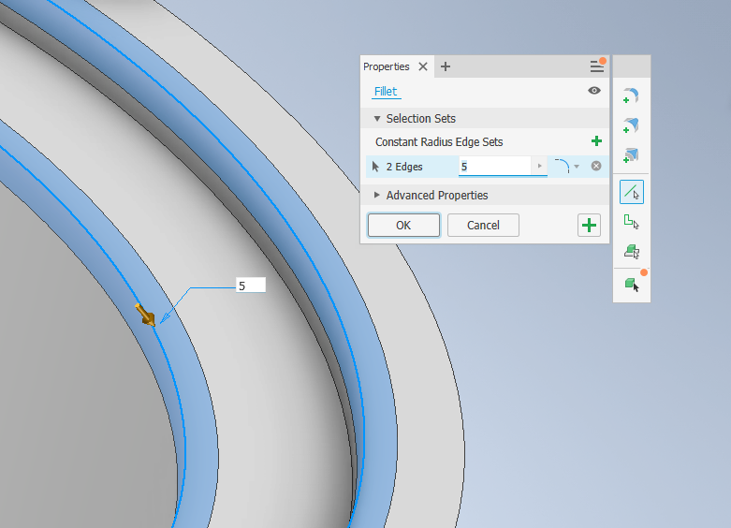
- Select the two inner edges (90 degs) of the rim and the top ring

8. Repeat step 7 but again on the opposite side of the Rim

9. This stage is called the button, it's a little finicky but we will get through this together… here we go!
- Select 2D SKETCH to create new geometry
- Select the most top/flat face of the rim
- Select the CIRCLE icon and start a sketch from the center point of your rim again
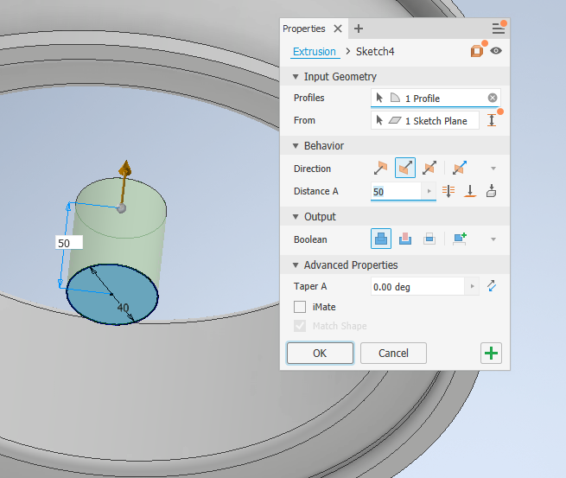
- Dia of this circle is 40mm
- FINISH SKETCH
- Select EXTRUDE and the center of the new circle
- EXTRUDE into the rim 50mm
- OK

10. Create a new 2D SKETCH on the face of the “button”
- Create fresh geometry using CIRCLE the same size of 40mm
- FINISH SKETCH

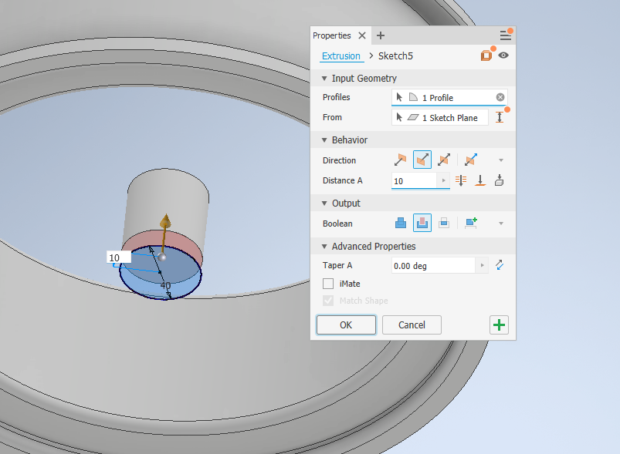
11. We are now going to counter-sink the button below the top face of the rim. This will allow the supports for the rim to be set back from the face of the rim.

- Select the EXTRUDE icon and the center button
- This time we are CUTTING the solid object
- Select the DOWN direction
- 15mm Distance
- And in the OUTPUT section select CUT
- OK
- This will counter sink the button

12. Select the create 2D SKETCH icon, pick the NEW top face of the button
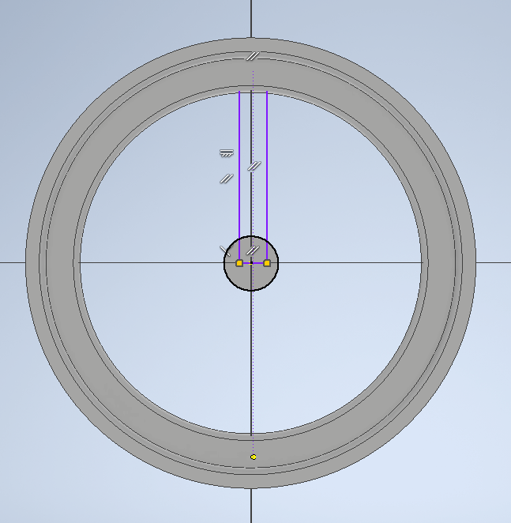
- We are going to create/draw the spokes of the RIM
- You are welcome to create/design your own shaping here. MAKE SURE your line work is ALL on the same sketch and is a CLOSED LOOP line item
- Or you are welcome to create a simple rectangle to follow along at this point.
- Using the RECTANGLE icon tool in the draw ribbon create a small rectangle that is both inside the buttons face and to the middle of the main ring

- FINISH SKETCH and head back to 3D mode

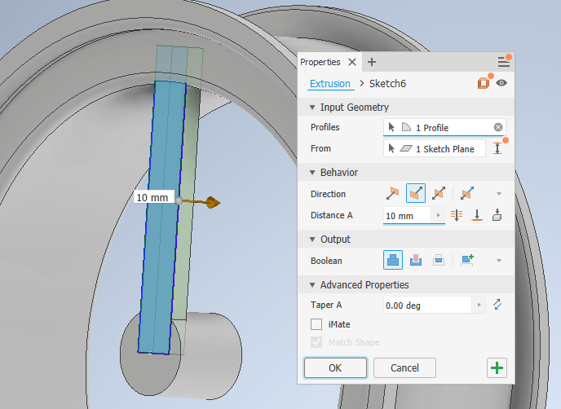
- EXTRUDE the spoke
  - DIRECTION down
  - OUTPUT join
  - DISTANCE 15mm

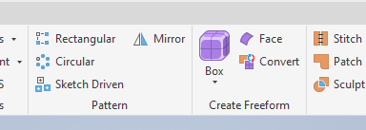
13. The next 3D modify tool is a neat one! The CIRCULAR PATTERN icon/tool allows you to take a 3D object and copy it in a circle pattern in equal distances and counts.

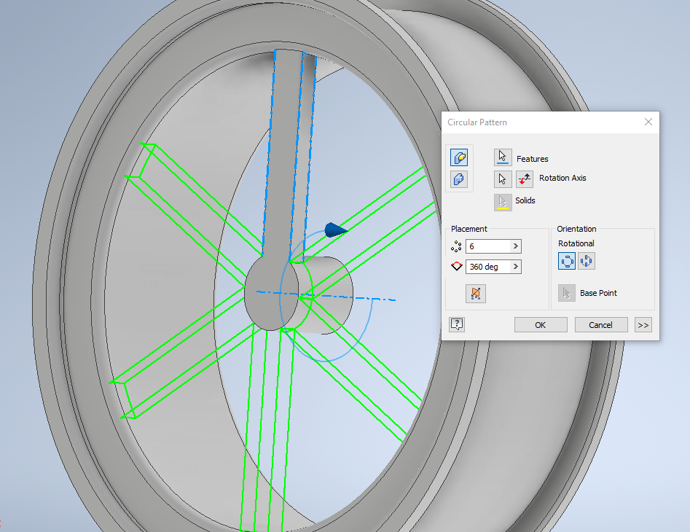

- Select the CIRCULAR icon
- Using the FEATURES option select the 3D spoke
- Then select the AXIS option and click on the HEIGHT of the button
- You can adjust how many spokes you want and the software will do the math to equally space out the 3D shape

- You can edit and design your spoke using CHAMFER and FILLET to create a more appealing design aesthetic should you choose to.

CONGRATS you just completed
PART 1 of 3 of this tutorial!!

Intro Tutorial Project

- TIRE part 2

Getting Started

To start off you are going to open up Autodesk Inventor,
- Locate the orange FILE option at the top left of the screen, click on it
- Select the NEW option
- You will have a pop up open looking like this
- Select your unit of measure (Metric or English/Imperial)
- Select your drawing style PARTS - this is the area where you draw your objects
- Select STANDARD (mm or inch).IPT file format
- Then create to open the file

Now that you are in the file main screen you will notice that your RIBBON icons are in 3D. This is the 3D mode. (DO NOT DRAW IN 3D mode!) To start to create and draw you will need to:
- Click on the 2D SKETCH icon in the top left corner
- This will take your screen to an orange multi view object
- Using your mouse click on the top side of the flat view (TOP as you will also see in the top right corner.

- You will now notice that the top ribbon has changed to 2D icons and you will see a black crosshair in the center of your screen. You are now ready to design/draw!

1. We are now going to create a tire that will be fitted to the rim in part 3 of this training.
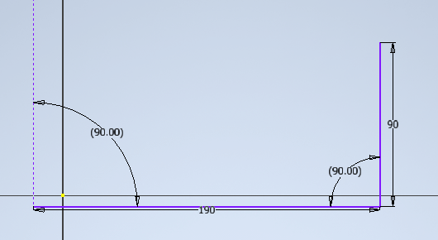
- In 2D mode select the LINE icon
- Create two lines 90 deg from each other
  - Length of 190mm
  - Height of 90mm
  - MAKE sure your line work is straight
- If you need to edit your line work you can always click on the line and direct input your measurements
- Make a full rectangle

2. While in the 2D SKETCH mode select the FILLET command
- Set the radius to 15mm
- Select the two perpendicular lines close to the corner and it should create a nice rounded edge at 15mm R
- Repeat this same step on the bottom of the rectangle
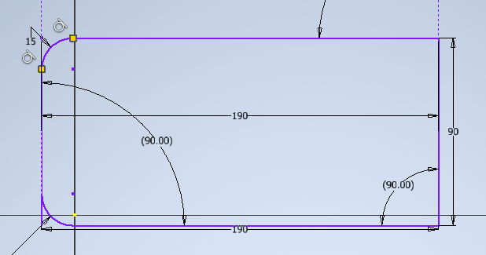

3. Still in 2D SKETCH mode
- Select the LINE icon
- Draw one line from yellow node 17.5mm to the right
- Draw a 2nd line from the bottom yellow node 17.5mm
also
- Delete the two longer horizontal
lines by right clicking on each
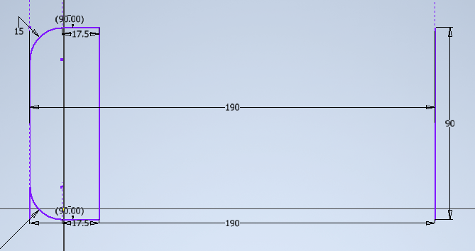
of them
PROFILE

AXIS

- Connect the 17.5mm lines together

4. Now that we have the cross section profile of the tire it's time to create the 3D model
- FINISH SKETCH
- In 3D mode select the REVOLVE icon in the create panel
- SImilar to the circle pattern icon, with REVOLVE you need to select the geometry profile
- Then select the axis arrow option and select the single line
- Your tire shape should appear
- OK
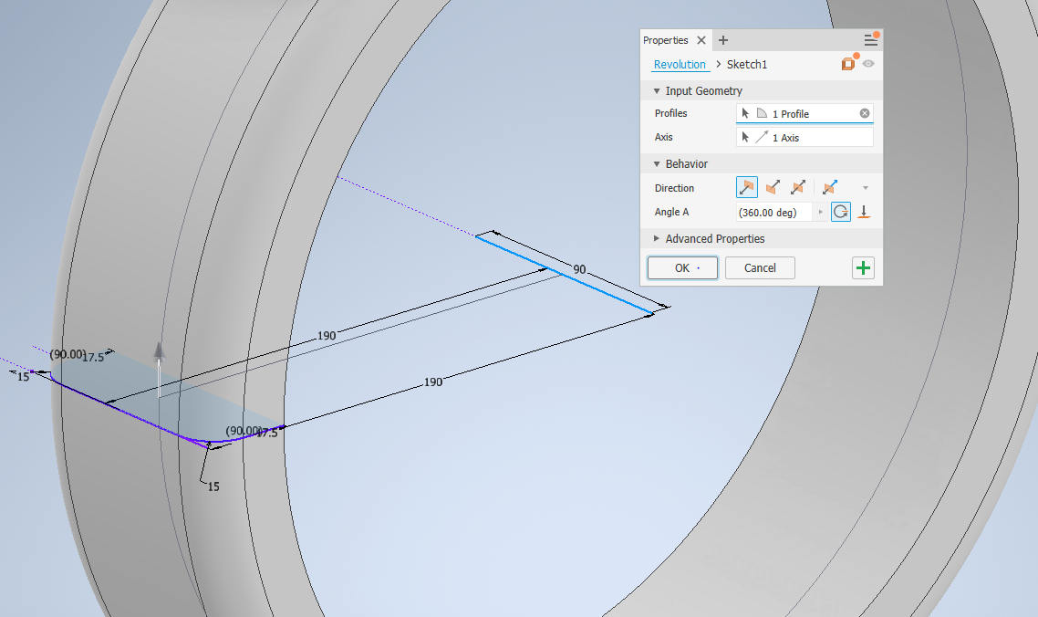

5. Did you know you can edit the texture and colours of your 3D solids?
- In the left sketch panel
- Right click on the REVOLVE sketch
- Find the PROPERTIES option at the bottom
- Look for feature appearance and select BLACK CAST
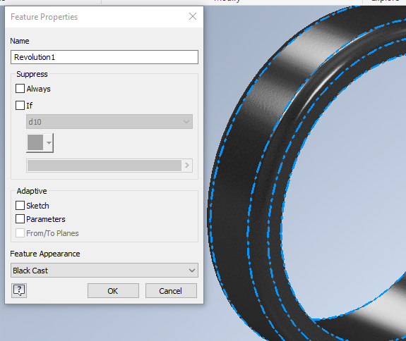

6. In 3D mode find the modify ribbon section
- Select the SHELL option. This will hollow out the solid object and create a small wall or “SHELL” of the tire
- Set the thickness to 15mm
- OK

CONGRATS you just completed
PART 2 of 3 of this tutorial!!

Intro Tutorial Project

- ASSEMBLY part 3

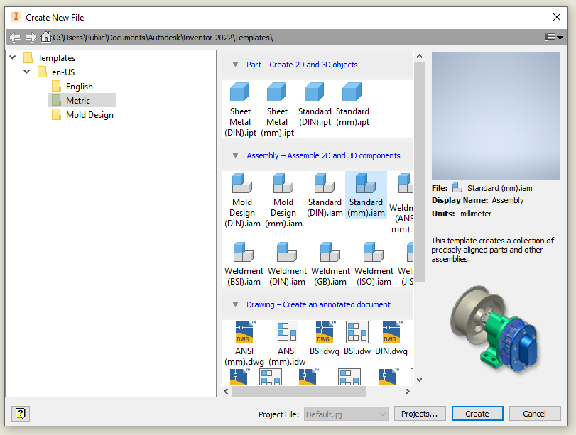

Getting Started
To start off you are going to open up Autodesk Inventor,
- Locate the orange FILE option at the top left of the screen, click on it
- Select the NEW option
- You will have a pop up open looking like this
- Select your unit of measure (Metric or English/Imperial)
- Select your drawing style ASSEMBLY - this is the area where you palace parts together to see if they will align and work together
- Select STANDARD (mm or inch).IAM file format
- Then create to open the file
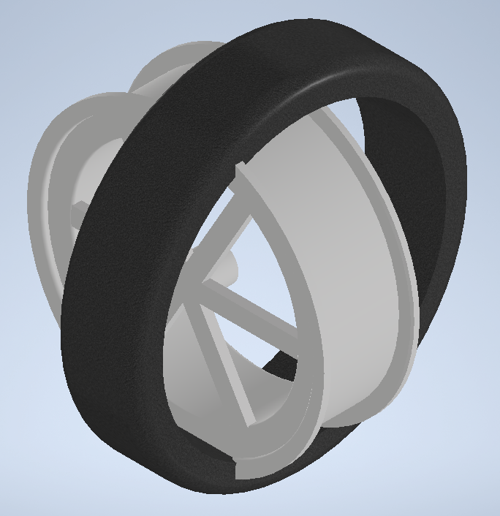
1. Look in the top left corner of the RIBBON. Look for the PLACE icon
- Find your saved Wheel file in your school G drive
- Select the Rim file
- Click into place on the screen
- Go back up to PLACE and find your TIRE file
- Select and place into the assembly file
  - They should appear perpendicular to each other

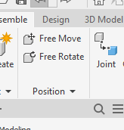
2. We are now going to slide and position the tire to be seated onto the rim
- In the top ribbon look for the POSITION option and open up the down arrow in the position option
- Find the GRIP SNAPS icon
- Select your tire
- A small menu bar will open with 6 options
- Select the 1st icon FREE DRAG
- Your tire will flat parallel with the rim and you can place your tire and rim flush with each other
- This may take a little playing to seat the two 3D solids properly with each other
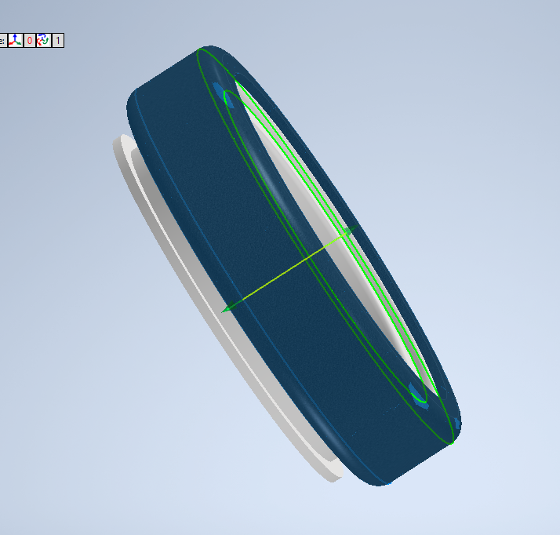

CONGRATS you are DONE !!!

