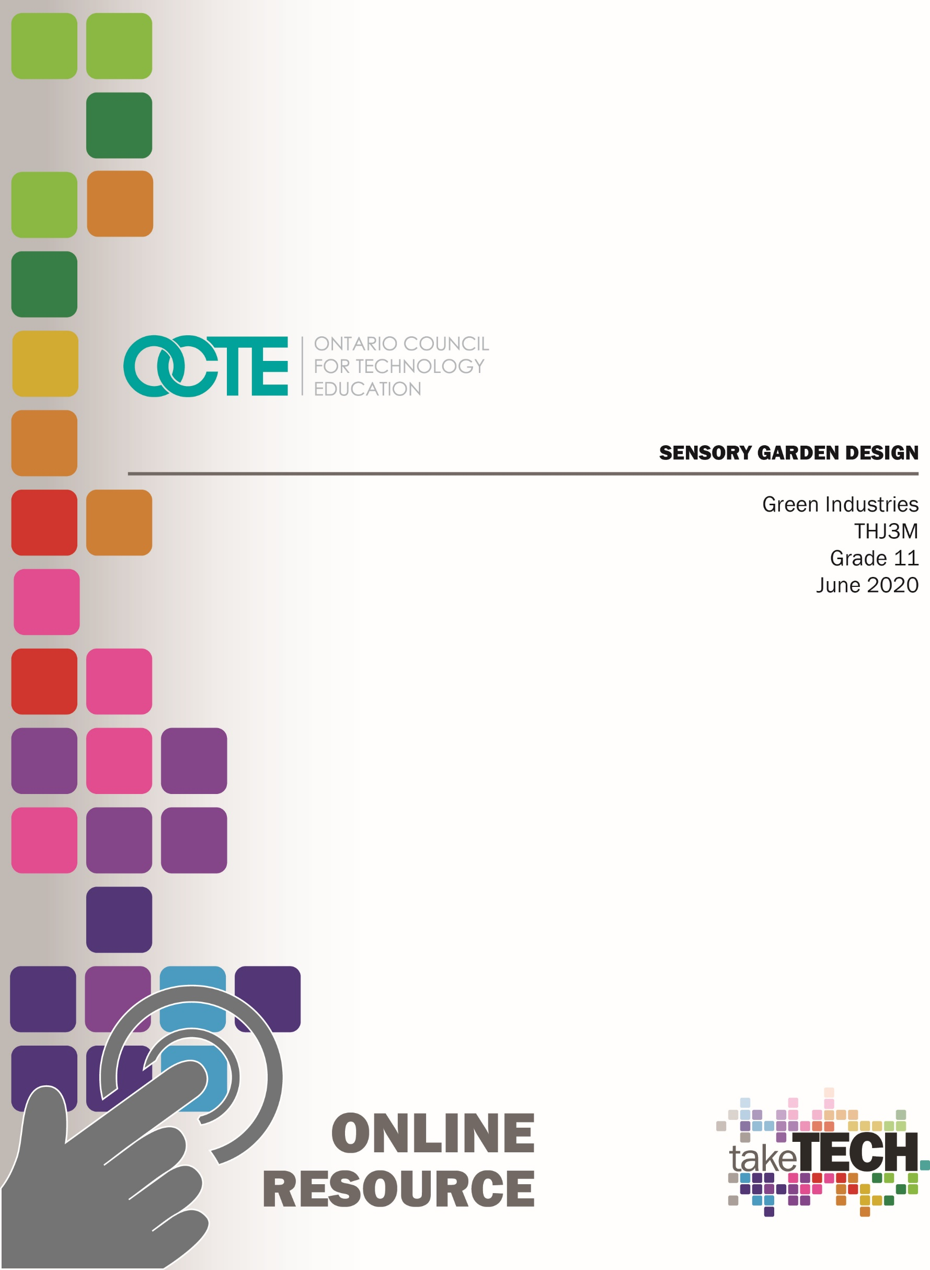

Table of Contents

Introduction 2
Project Outline 2
Prior Knowledge 3
Student Activities 3
Planning Notes 4
Resources and/or Handouts 4
Instructional Strategies 6
The Hook / Motivational Strategies 6
Learning Goals and Success Criteria 6
Learning Goals 6
Success Criteria 6
Overall and Specific Expectations 7
Overall Expectations 7
Specific Expectations 7
Safety Concerns 8
PPE Required 8
Applicable SAFEDocs and ToolSAFE videos 8
Project Challenges 8
Differentiation of the Project / Activity 8
Assessment and Evaluation 8
Career and Industry Extensions 9
Reflection or Design Report 9
Appendix A – Sensory Garden Design Project - Handout 10
Appendix B – Research Charts 11
Appendix C – Brainstorming – Questions & Research 16
Appendix D – Sensory Garden Assessment Rubric 17
Appendix E – Practical Drawing Assignment Checklist 18
Appendix F – Teaching Notes 19
References 21

Introduction
Course Code: THJ3M
Broad base Technology: Green Industries
Destination: University/College Preparation
Grade Level: 11
Prerequisite: None
Online Project Name: Sensory Garden Design

Project Outline
Based on theories and concepts studied in class, students will design a sensory garden of their choice. In this instance, the area to be designed in this instance is for a flower bed 3’ wide, 5’ long and 3’ high. The design must be wheelchair accessible from all sides. Students will research the different sensory plants and how they are accented in landscape design. This activity will begin with discussions on touch, smell, sound, taste, and sight and their role they play for those who have sensory processing issues.
The Project Outline will be as follows:
- Activity #1: The senses and their role for those who have processing issues.
- Activity #2: Commonly used plant material in sensory gardens.
- Activity #3: Landscape Design
- Activity #4: Review of drafting Principles
- Activity #5: Research and Design
- Activity #6: Rationale
By the end of this project, the student will:
- Learn how to be an effective contributor to society
- Problem solve using the Design Process
- Identify plant material and its use and limitations due to hardiness, exposure, etc.
- Create landscape designs to fit various functions
- Use various measurement techniques to calculate areas.

Prior Knowledge
- Mathematical skills
- Measuring skills
- Safe and correct use of tools/equipment relevant to the construction of the project
- Decision-making skills
- Brainstorming and research techniques
- An understanding of the design process
- Drawing and sketching skills
- Communication skills (written and oral)
- A general awareness of safety, as it relates to ethical computer practice
- Word Processing

Student Activities
Activity 1 – Introduction with assistance from Special Education teacher (if applicable) on the different types of senses.
Activity 2 – Discussion of plant materials that reflect the senses. (ie: what plants would be ideal for touch, smell, etc.?)
Activity 3 – Landscape Design. Landscape Design. Planning your Garden design. Students need to recognize the growing height and width of plant material in order to use the garden space efficiently. Mathematical skills such as area, addition, subtraction, multiplication, and division are necessary.
Activity 4 – Review of Drafting Principles
Activity 5 – Research and Design
Activity 6 – Write-up/Rationale

Planning Notes
- Prepare for student opportunities to sketch, brainstorm, plan and create final drawings.
- Review Board policy on computer/Internet use (safety/censorship).
- Review all resources in advance.
- Prepare all materials for the safety demonstrations where applicable.
- Prepare all tools and equipment required for the safety demonstration ensuring that the equipment is in good working order and the safety guards are in place.
- Prepare material or have associate teacher/guest speak about the five senses and how a sensory garden is therapeutic for those with sensory disorders and can be used as a calming place and a gentle way to help stimulate the senses
- Prepare a discussion reviewing the overall project. The discussion should include materials used, processes and research techniques, collaboration, teamwork, technical skills, and how the project ministers to the school and wider community.
- Prepare any handouts for students.

Resources and/or Handouts
The resources for this project include the following:
- Sensory Garden Design Project - please see Appendix A
- Research Charts - please see Appendix B
- Brainstorming – Questions & Research - please see Appendix C
- Sensory Garden Assessment Rubric - please see Appendix D
- Practical Drawing Assignment Checklist - please see Appendix E
- Teacher Planning Notes – please see Appendix F

Pictures/Blueprints
- Unsplash
- Pixabay
- Pexels
- Freeimages

Tools/Equipment/Materials
Word Processing Equipment
Graph paper
Pencils/Erasers/Rulers/Calculators or Calculating Devices
CAD Software

Software
AutoCAD software where applicable. Any computer-aided-design software may be used.

Textbooks/Books
Welland, Frances. Place That Plant. Parragon, 1998. ISBN 0-75252-429-1
The Big Book of Garden Design. Time Life Books, 1998. ISBN 0-7835-5280-7

Videos
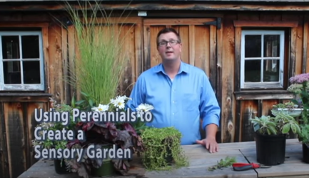 | Using Perennials to Create a Sensory Garden  https://www.youtube.com/watch?v=k9_GHx5wWxU
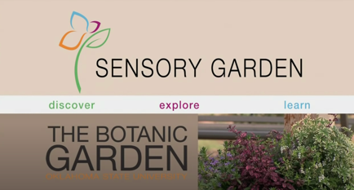 | The Sensory Garden  https://www.youtube.com/watch?v=2sbHZy73RS0

Websites for Teacher Learning
https://bloomcharity.org/magicalgardenscampaign/horticultural-therapy-useful-links/
https://geekclubbooks.com/2018/10/benefit-sensory-gardens/
https://www.gardeningknowhow.com/special/accessible/sensory-garden-ideas.htm
https://www.handmadeplaces.co.uk/2019/05/school-sensory-garden-design-children/
https://www.flowerpotman.com/sensory-gardens-at-home/sensory-garden-designs/
https://www.gardendesign.com/perennials/
https://www.landscapecalculator.com/calculators/flower
https://cozynsgardengallery.ca/perennials
http://planthardiness.gc.ca/
https://home.howstuffworks.com/perennials-12-24-inches.htm

Instructional Strategies
Teachers may use any of the following instructional strategies; 3-Part lesson, lecture, storyboard, word wall, think-pair-share, placemat activity, rapid write, K-W-L, anticipation chart, ABC taxonomy, think aloud, analyzing text, Cornell note taking, exit ticket/ticket out the door, plus/minus/delta, etc.

The Hook / Motivational Strategies
With this project, students should be able to appreciate the importance of contributing to their own school and greater community. Seeing one’s work displayed for all to see is a great accomplishment. Sensory gardens in schools have been shown to decrease negative behaviors and improve student engagement.

Learning Goals and Success Criteria

Learning Goals
- Students will recognize the role of sensory gardens in society
- Students will apply the steps in the design process to design a sensory garden
- Students will discover and use google sites for research purposes
- Students will discover an awareness of a plant’s value in our landscape.
- Students will implement various characteristics to identify plant material

Success Criteria
- Students will demonstrate the steps in the design process
- Students will demonstrate communicate skills through working and final drawings
- Students will describe the rationale of their design by writing a proposal
- Students will demonstrate the importance of plant selection relative to function.

Overall and Specific Expectations in Support of Ontario Curriculum Grades 11 - 12 Technological Education

Overall Expectations
A1. Demonstrate an understanding of species classification and identification and relationships between species and geographical regions.
A3. Develop and evaluate designs or processes for a variety of applications related to the green industries.
A4. Use mathematical, documentation, research, and communication skills as they apply to the green industries.
B3. Demonstrate competence in technical skills related to specific applications and tasks within the green industries.
D3. Identify careers in the green industries, and describe the skills, education, and training required for entry into these occupations.

Specific Expectations
A1.1 Distinguish between different plant and/or animal groups on the basis of key identification characteristics, and identify species using both common names and scientific classifications (e.g., annuals and perennials; native and non-native plants; major types, species, and varieties of trees, shrubs, flowering plants, and crops; animal breeds);
A3.1 Demonstrate an understanding of and apply the steps in a design process (see pp. 22–23) to a variety of requirements in the green industries (e.g., creation of forest management plans, environmental farm plans, urban landscape designs, hydroponic system designs);
A4.4 Perform metric and imperial unit conversions and other calculations as required for a variety of green industry applications (e.g., land areas, yields, green log weights, diet analyses, invoices).
B3.3 Demonstrate competence in related technical skills (e.g., using GPS equipment, welding, wiring and making electrical repairs, operating and maintaining small engines, making orthographic drawings, using computer applications) that are required to complete a variety of green industry projects.
D3.5 Demonstrate an understanding of and apply the Essential Skills that are important for success in the green industries, as identified in the Ontario Skills Passport (e.g., reading text, writing, document use, computer use, oral communication, numeracy, thinking skills);

Safety Concerns
Safety concerns arise if a student requires wood or other materials to be cut. Cutting must be completed with the assistance of the teacher (at school) or using hand tools at home. Hot glue guns may be required in some instances. Please refer to the SAFEDocs for Green Industries located on the OCTE website.

PPE Required:
Safety glasses are required when using any power tools.

Applicable SAFEDocs and ToolSAFE videos
Please refer to the OCTE SAFEDocs for Green Industries for safety documents in order to properly address and instruct this project.

Project Challenges
Teacher must accept that some students may not have experience with drafting or computer-aided-design fundamentals. This activity is also open to peer learning.

Differentiation of the Project / Activity
Teachers can also refer to the Differentiation Scrapbook to take into account for learner ability, multiple intelligences, exceptional students, and ESL learners.

Assessment and Evaluation

Assessment As Learning
- Make comments/suggestions as required.
- Provide timely/descriptive feedback.
- Keep students motivated and on track to be successful in the learning outcomes.
- Reflect on instructional next steps/modifications/accommodations.

Assessment For Learning
- Ask questions about student’s experience within green industries.
- Ask questions regarding experience working on other projects.
- Find out about students’ interests.
- Review recent report cards.
- Reflect on instructional next steps/modifications/accommodations.

Assessment Of Learning
- Review and evaluate each project.
- Triangulate assessment

Career and Industry Extensions
Students can explore career connections and opportunities in any Green Industry field:
- Landscape Architect
- Landscape Designer
- Landscape Technician
- Landscape Gardener
- Landscape Installer

Reflection or Design Report
Teachers may wish to have the students complete a design report, reflection or create a foldable to consolidate their learning. This would be a nice way to capture the student’s understanding in a summative format and be used in preparation for their examination, entering post-secondary education or the workforce.

Appendix A – Sensory Garden Design Project - Handout
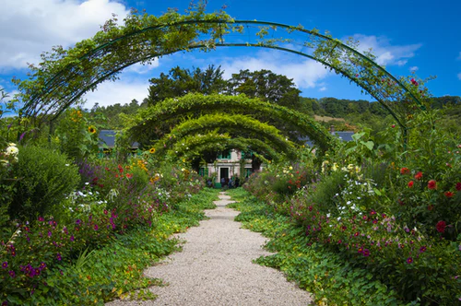
You have been asked to design a sensory garden for your high school. You may design one that reflects one of the senses. You will use perennial plants for this exercise. Depending on the location in the province, students are also encouraged to check with their local nurseries.

What is a sensory garden?
A sensory garden is designed to stimulate the senses including touch, smell, sound, taste, and sight.

Why have you been asked to do this?
Your school has students with sensory processing disorders. A sensory garden is therapeutic for those with sensory disorders and can be used as a calming place and a gentle way to help stimulate the senses.
Our existing flower/plant bed is 3’ by 5’ and is 3’ high (sizes can vary depending on existing beds) so that it will also be wheelchair accessible from all sides. Plant material should be within access for all students. More than one type of each plant may be used.

Your design must include:
- A 400-word proposal outlining the rationale for your plant and design selection.
- A drawing that reflects your ideas. Drawings may be computer generated or neatly hand sketched with a legend.

Appendix B – Research Charts

TOUCH
Make sure your plants are suitable for your region in Ontario (i.e. Region 6b for Sarnia)
SUITABLE PLANTS | PLANT FEATURES | GROWING SIZE
1.
2.
3.
4.
5.

PLANT SELECTION FROM ABOVE | PICTURE
1.
2.
3.
4.
5

SMELL
Make sure your plants are suitable for your region in Ontario (i.e. Region 6b for Sarnia)
SUITABLE PLANTS | PLANT FEATURES | GROWING SIZE
1.
2.
3.
4.
5.

PLANT SELECTION FROM ABOVE | PICTURE
1.
2.
3.
4.
5

TASTE
Make sure your plants are suitable for your region in Ontario (i.e. Region 6b for Sarnia)
SUITABLE PLANTS | PLANT FEATURES | GROWING SIZE
1.
2.
3.
4.
5.

PLANT SELECTION FROM ABOVE | PICTURE
1.
2.
3.
4.
5

SIGHT
Make sure your plants are suitable for your region in Ontario (i.e. Region 6b for Sarnia)
SUITABLE PLANTS | PLANT FEATURES | GROWING SIZE
1.
2.
3.
4.
5.

PLANT SELECTION FROM ABOVE | PICTURE
1.
2.
3.
4.
5

SOUND
Make sure your plants are suitable for your region in Ontario (i.e. Region 6b for Sarnia)
SUITABLE PLANTS | PLANT FEATURES | GROWING SIZE
1.
2.
3.
4.
5.

PLANT SELECTION FROM ABOVE | PICTURE
1.
2.
3.
4.
5

Appendix C – Brainstorming – Questions & Research
- What sensory have I chosen?
- What perennial plant material am I going to choose?
- How will I arrange my plants? Have 2 or possibly 3 sketches.
- Did I choose plants from the appropriate hardiness zone in my area?
- Are my plants low maintenance?
- Are the plants accessible in my area? Can they be purchased here?
- Have I allowed the proper spacing between plants?
- Is there a need to check of any of the downsides of my plant material? That is, possible allergies, insect infestation, etc.
- I will need to make sure all plant material is wheelchair accessible.

Appendix D – Sensory Garden Assessment Rubric
Criteria | Level 1 | Level 2 | Level 3 | Level 4
Communication
Create design drawings | creates design drawings with limited awareness of accuracy | creates design drawings with some awareness of accuracy | creates design drawings with competent awareness of accuracy | creates design drawings with thorough awareness of accuracy
Report follows assigned format | Report follows assigned format with limited consideration | Report follows assigned format with some consideration | Report follows assigned format with considerable consideration | Report follows assigned format with thorough consideration
Thinking/Inquiry
Brainstorm using the design report format | applies few of the skills involved in the design process | applies some of the skills involved in the design process | applies most of the skills involved in the design process | applies all the skills involved in the design process
Choice of plant material | choice of plant material reflects limited thinking | choice of plant material reflects some thinking | choice of plant material reflects considerable thinking | choice of plant material reflects thorough thinking
Knowledge/Understanding
Describe materials that are appropriate for a given project | briefly describes materials that are appropriate for a given project | adequately describes materials that are appropriate for a given project | substantially describes materials that are appropriate for a given project | thoroughly describes materials that are appropriate for a given project
Explain concept providing details | explanation of concept provided limited details | explanation of concept provided some details | explanation of concept provided considerable details | explanation of concept provided thorough details
Application
Demonstrates proper use of drafting techniques | Demonstrates limited use of drafting techniques | Demonstrates some use of drafting techniques | Demonstrates considerable use of drafting techniques | Demonstrates thorough use of drafting techniques
Demonstrate safe use of tools, materials, and processes | demonstrates limited safe use of tools, materials, and processes | demonstrates adequate safe use of tools, materials, and processes | demonstrates considerable safe use of tools, materials, and processes | demonstrates excellent safe use of tools, materials, and processes
Demonstrate appropriate personal and health and safety practices | infrequently demonstrates appropriate personal and health and safety practices | often demonstrates appropriate personal and health and safety practices | usually demonstrates appropriate personal and health and safety practices | routinely demonstrates appropriate personal and health and safety practices
Note: A student whose achievement is below level 1 (50%) has not met the expectations for this assignment or activity.

Appendix E – Practical Drawing Assignment Checklist
NAME: ____________________________________________
DRAWING TITLE: ___________________________________

(COMPUTER-GENERATED/HAND-SKETCH)

- ACCURACY – Have you drawn to scale
- OVERALL DIMENSIONS LABELLED
- DETAIL DIMENSIONS LABELLED
- CENTERING
- TITLE BLOCK IS COMPLETE
- ALL TEXT IN CAPITAL LETTERS
- PLANT MATERIAL LABELLED OR LEGEND
- NEATNESS COUNTS

Appendix F – Teaching Notes

Activity 1
Introduction on the different types of senses with assistance from the Special Education teacher if applicable.
https://geekclubbooks.com/2018/10/benefit-sensory-gardens/
https://bloomcharity.org/magicalgardenscampaign/horticultural-therapy-useful-links/

Activity 2
Discussion of plant materials that reflect the senses. For example, what plants would be ideal for touch, smell, etc.?
https://www.gardeningknowhow.com/special/accessible/sensory-garden-ideas.htm
https://www.handmadeplaces.co.uk/2019/05/school-sensory-garden-design-children/
https://www.flowerpotman.com/sensory-gardens-at-home/sensory-garden-designs/

Activity 3
Landscape Design. Planning your Garden design. Students need to recognize the growing height and width of plant material to use the garden space efficiently. Mathematical skills such as area, addition, subtraction, multiplication, and division are necessary.
https://www.gardendesign.com/perennials/
https://www.landscapecalculator.com/calculators/flower
https://home.howstuffworks.com/perennials-12-24-inches.htm
https://cozynsgardengallery.ca/perennials
http://planthardiness.gc.ca/

Activity 4
Review of drafting expectations

Activity 5
Research and Design.

Activity 6
Write-up/Rationale.

Activity | Topics | Length
Activity 1 | Introduction with assistance from Special Education teacher (if applicable) on the different types of senses | 30 minutes
Activity 2 | Discussion of plant materials that reflect the senses. (ie: what plants would be ideal for touch, smell, etc.?)  Perennials vs Annuals | 60 minutes
Activity 3 | Landscape Design. Planning your garden Design. | 30 minutes
Activity 4 | Review of Drafting expectations | 30 minutes
Activity 5 | Research and Design. | 120 minutes
Activity 6 | Write-up/Rationale. | 30 minutes

References
21st Century Competencies: Foundation Document for Discussion. Phase 1: Towards Defining 21st Century Competencies for Ontario, Winter 2016 Edition, 2016 http://www.edugains.ca/resources21CL/About21stCentury/21CL_21stCenturyCompetencies.pdf
Benefits of Sensory Gardens (Article), 2018 https://geekclubbooks.com/2018/10/benefit-sensory-gardens/
Benefits of Sensory Gardens (Article), 2018 https://bloomcharity.org/magicalgardenscampaign/horticultural-therapy-useful-links/
Course Codes for Emphasis courses in the Revised Curriculum: Technological Education, Grades 11 and 12, 2009 http://www.edu.gov.on.ca/eng/curriculum/secondary/techedemphasiscourses.pdf
Creating a Sensory Garden (Article), 2020 https://www.gardeningknowhow.com/special/accessible/sensory-garden-ideas.htm
Freeimages (Images), 2020 https://www.freeimages.com/
Growing Success: Assessment, Evaluation, and Reporting in Ontario Schools, First Edition, Covering Grades 1 to 12, 2010 www.edu.gov.on.ca/eng/policyfunding/growSuccess.pdf
How to Make a Children’s Sensory Garden & Play Area (Article), 2020 https://www.handmadeplaces.co.uk/2019/05/school-sensory-garden-design-children/
Ideas to design and build a sensory garden (Article), 2020 https://www.flowerpotman.com/sensory-gardens-at-home/sensory-garden-designs/
Landscape Calculator (Website), 2020 https://www.landscapecalculator.com/calculators/flower
Learning for All – A Guide to Effective Assessment and Instruction for All Students, Kindergarten to Grade 12, 2013 http://www.edu.gov.on.ca/eng/general/elemsec/speced/LearningforAll2013.pdf
Natural Resources Canada - Plant Hardiness of Canada (Website), 2020 http://planthardiness.gc.ca/
Perennials 12-24 inches in height (Article), 2020 https://home.howstuffworks.com/perennials-12-24-inches.htm
Perennials - How To Grow And Design With Perennial Plants And Flowers (Article), 2020 https://www.gardendesign.com/perennials/
Perennials (Website), 2020 https://cozynsgardengallery.ca/perennials
Pexels (Images), 2020 https://www.pexels.com/
Pixabay (Images), 2020 https://pixabay.com/
The Differentiated Instruction Scrapbook http://www.edugains.ca/resourcesDI/EducatorsPackages/DIEducatorsPackage2010/2010DIScrapbook.pdf
The Ontario Curriculum, Grades 9 and 10: Technological Education, 2009 (revised) http://www.edu.gov.on.ca/eng/curriculum/secondary/teched910curr09.pdf
The Ontario Curriculum, Grades 11 and 12: Technological Education, 2009 (revised) http://www.edu.gov.on.ca/eng/curriculum/secondary/2009teched1112curr.pdf
Unsplash (Images), 2020 https://unsplash.com/

