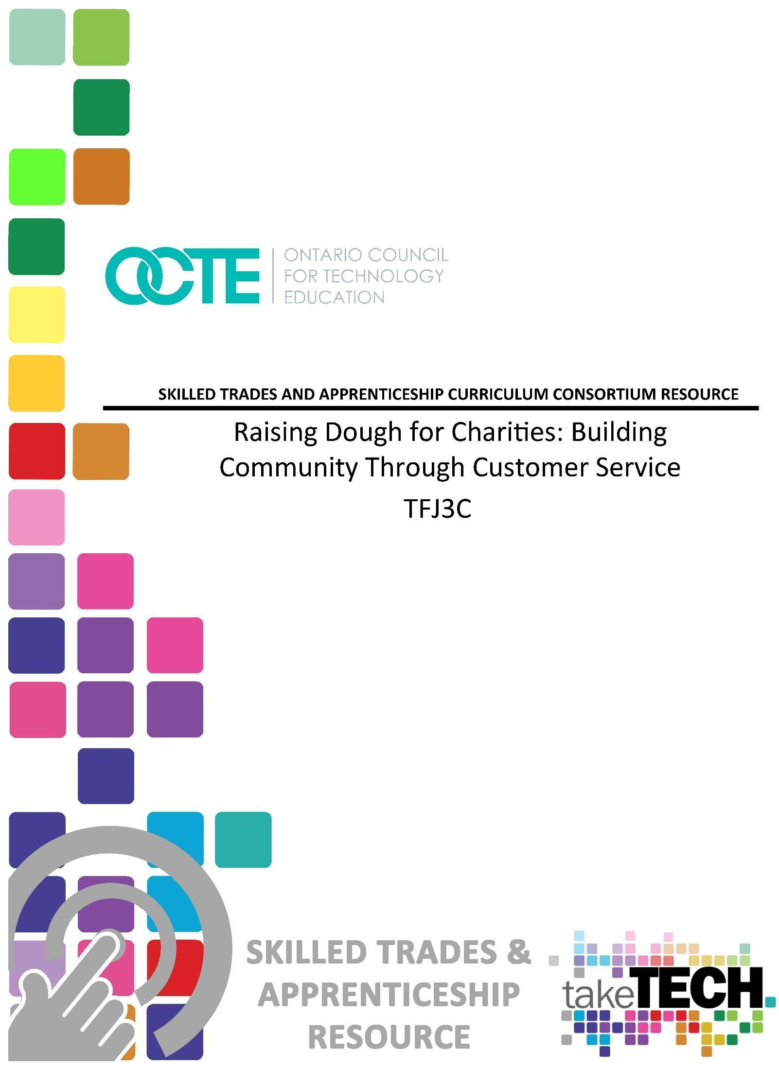

Table of Contents

Introduction 3
Project Outline 3
Prior Knowledge 3
Planning Notes 4
Skilled Trades and Apprenticeship Opportunities 5
Career and Industry Extensions 6
Continuum of Influence 6
Continuum of Skills 9
Introduction: Rai$ing Dough for Charities - Building Community through Great Customer Service 11
Student Activities Chart 11
Resources 12
Lesson Plans 12
Handouts 12
Pictures/Graphic Organizers 13
Tools/Equipment 13
PowerPoint Presentation Files 13
Exemplars 13
Websites for Teachers 13
Instructional Strategies 14
The Hook / Motivational Strategies 14
Learning Goals and Success Criteria 14
Overall and Specific Expectations in Support of Ontario Curriculum Grades 9 - 12 Technological Education 15
Overall Expectations 15
Specific Expectations 15
Safety Concerns 15
Applicable SAFEDocs and ToolSAFE videos 15
Project Challenges 16
Differentiation of the Project / Activity 16
Assessment and Evaluation 16
Religious Considerations 16
Reflection or Design Report 17
Appendix A - Project Introduction and Unit Plan 18
Appendix B – PowerPoint Presentation 20
Appendix C – Graphic Organizer – Brainstorming The Meaning Of Great Customer Service 21
Appendix D – Better Customer Service Starts With You 22
Appendix E – Customer Service Challenge Chart 24
Appendix F – Hospitality and Tourism Career Options 27
Appendix G - What Does Building Community Mean? 31
Appendix H - What Does Building Community Look Like In The Hospitality And Tourism Industry? 33
Appendix I - Poster Chart Assignment- Community Building In The Workplace 34
Appendix J – Rubric -Poster Chart Assignment- Community Building In The Workplace 36
Appendix K – Marketing Strategies For A Community Building Bake Sale 37
Appendix L – Digital Marketing Strategy Assignment 38
Part 1 - Rai$Ing Dough For A Charity Bake Sale 38
Appendix M - Digital Marketing Strategy Assignment, 40
Part 2 - Rubric - Rai$Ing Dough For A Charity Bake Sale 40
References 42

Introduction
Course Code: TFJ3C
Broad base Technology: Hospitality and Tourism
Destination: College
Grade Level: 11
Prerequisite (if applicable): None
Resource/Project Name: Raising Dough for Charities - Building Community Through Customer Service

Project Outline
By the completion of this project, the student will demonstrate an understanding of factors that affect the relationship between the tourism industry and society (C.2). Students will demonstrate an understanding of the importance of customer service (D.2).Students will design effective marketing initiatives to promote an event or activity (B.3).Students will demonstrate learning skills that include communication, teamwork, responsibility, organization and initiative. In the “Community of Character”, appreciation and empathy will be emphasized in support of the interconnection between social responsibility within the service sector, and how these skills apply to their career pathway.
This Project Outline includes the following components:
Part 1 An Introduction to Customer Service Excellence- PowerPoint Presentation
Part 2 Graphic Organizer – Brainstorming the meaning of great customer service
Part 3 Tips for Customer Service Excellence - Google Doc
Part 4 Better Customer Service Challenge Chart - Google Doc
Part 5 Hospitality and Tourism Career Options
Part 6 Definition of Building Community -Think Pair Share - Google Doc introduction
Part 7 Jamboard Activity - What does Building Community look like at a Bake Sale
Part 8 Poster Chart Assignment - Building Community in the Workforce
Part 9 Rubric - Poster Chart Assignment - Building Community in the Workforce
Part 10 Jamboard Activity - Marketing Strategy for a Community Bake Sale
Part 11 Digital Marketing Strategy Assignment, Part 1
Part 12 Google Slide Assignment, Digital Marketing Strategy, Part 2

Prior Knowledge
Prior to this project, students should have met the following specific expectations:
- A4.3 Demonstrate the ability to operate and maintain a variety of tools and equipment commonly used in different sectors of the tourism industry (e.g., stoves, computers, vacuum cleaners, audio-visual equipment), using proper processes and procedures;
- B1.1 Demonstrate the use of various cooking techniques (e.g., sauté, deep fry, roast, poach, steam, braise) to produce a variety of foods (e.g., meats, vegetables, rice and pasta dishes, desserts, bakery products);
- B3.1 Identify a customer target group (e.g., students, family members, senior citizens) for an event or activity and determine the needs and wants of this target group (e.g., with regard to timing, budget, menu, facilities, location);
- D1.1 Identify the laws, regulations, and regulatory/ oversight organizations that govern health, safety, and sanitary standards in the tourism industry (e.g., Occupational Health and Safety Act [OHSA], Health Protection and Promotion Act [HPPA];
- D1.4 Demonstrate the use of safe food handling and proper sanitary practices (e.g., prevent cross contamination of foods; keep their person and uniform clean; wear hair nets; observe good housekeeping practices, safe lifting practices).

Planning Notes
Moving forward in the post COVID landscape, the Government of Canada has identified the ability to work with others as one of 9 key essential skills. Embedded in this essential skill would be customer service, teamwork, empathy and a strong sense of community. The purpose of this project is to explore the importance of these skills in relation to a successful career in the Hospitality Industry. Ideally, this project would occur towards the end of a semester, as it encompasses scaffolding of safety skills, kitchen and sanitation skills, interpersonal and team building skills. In a continuum of this activity, students would be planning and preparing the products for the bake sale.

Skilled Trades and Apprenticeship Opportunities
By the end of this project, students will demonstrate an understanding of factors that affect the relationship between the tourism industry (including hospitality) and society. The activities focus on customer service skills, problem solving skills, and community building and marketing, which are essential skills that can be applied to apprenticeships in many skilled trades such as:
- Agricultural - Dairy Herdsperson (640D)
- Agricultural - Fruit Grower (640F)
- Agricultural - Swine Herdsperson (640S)
- Assistant Cook (415B)
- Baker (423A)
- Baker - Patissier (Baker) (423C)
- Chef (415C)
- Cook (415A)
- Horticultural Technician (Landscape Horticulturist) (441C)
- Institutional Cook (415D)
- Native Clothing and Crafts Artisan (296B)
- Retail Meat Cutter (245R)
It is recommended that the teacher follow the Canadian Apprenticeship Forum for up to date resources on:
- Apprentice Attitudes Towards Learning and Examinations
- The Quality of Workplace Training
- Communication and Inclusion in Apprenticeship
- Apprentice Well Being
- Career Entry, Training and Completion in the Skilled Trades
- The Impact of COVID-19 on Apprenticeship
The respective links on listed under the Teacher Resources Section
- Canadian Apprenticeship Forum website
- Canadian Apprenticeship Forum - Apprenticeship 101 website

Career and Industry Extensions
Not every classroom has four walls and this assignment has been designed to allow an opportunity to explore unconventional careers choices in the Hospitality and Tourism sector. Certainly, this project could be used as a starting point for Reach Ahead opportunities in an SHSM or a cross-curricular exercise with Coop programs, tech or academic classes. Additionally, it is recommended that teachers begin exploring micro-credentials and badges, as colleges begin to offer more opportunities for students to heighten and distill their skill sets.
Appendix 6, Career Option Exploration allows the student to independently study several career pathways - some traditional and some less orthodox. It is intended as a preliminary exercise in career exploration guided by the teacher's understanding of current trends in the hospitality and tourism sector.

Continuum of Influence
We all have different moments in our lives where we are affected by an experience. This can include learning a new concept or skill, experiencing something for the first time, taking a new course, developing a talent through practice and hard work, or even calling upon a skilled tradesperson to fix, repair, design, construct, maintain, build, bake, and create innovative solutions. The continuum of influence is a graphic representation of how those experiences can lead to developing a passion and talents in areas like Hospitality and Tourism. You can find the full mind map on the next page.

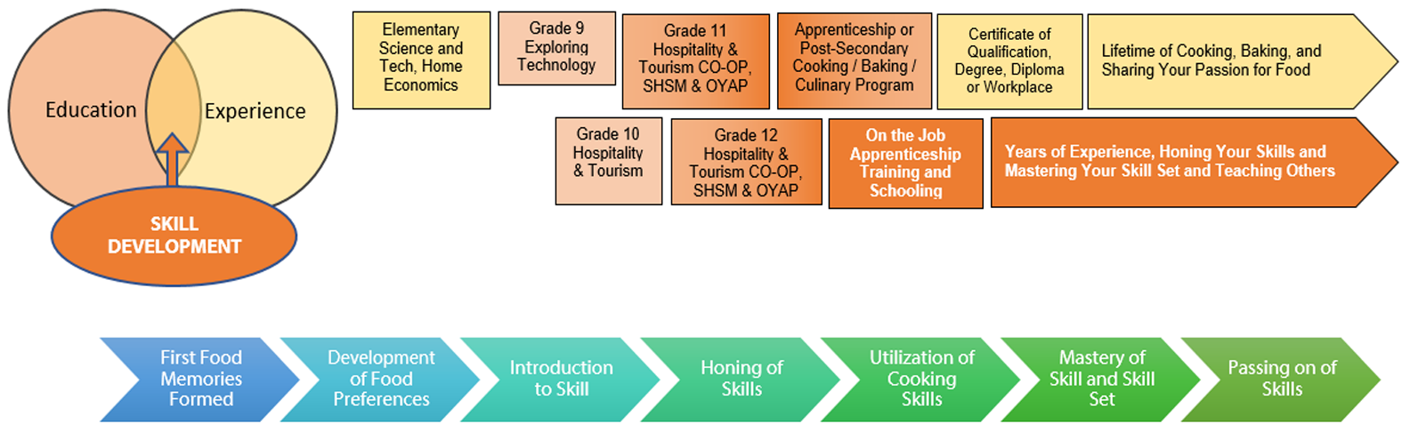

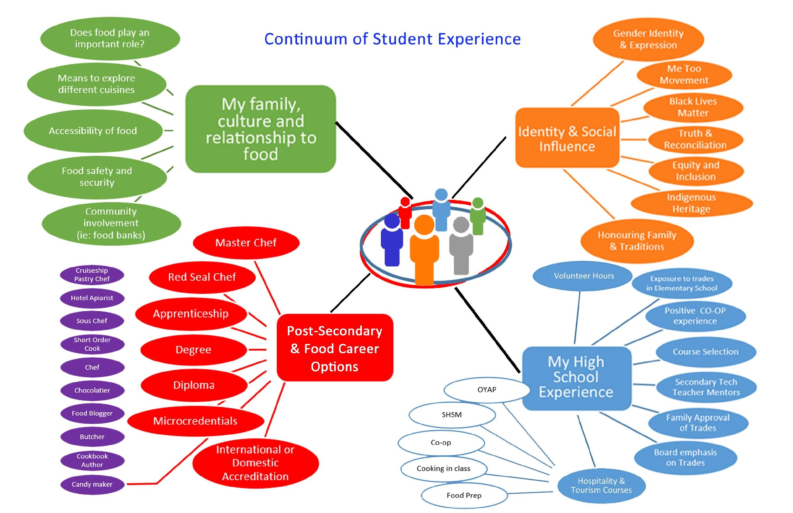

Continuum of Skills
As students pursue their careers in the Hospitality and Tourism industry, they will have opportunities to build on the skills learned during this project. The curriculum expectations met during this project act as the first building block towards skills that will be learned in the Level 1 apprenticeship of several different Hospitality and Tourism trades. This scaffolding of skills aligns as follows:
B3.2 Develop a marketing strategy that is appropriate to the target group and the event or activity;
Relation to Level 1 Apprenticeship Training Standards:
- Scaffolds to Level 1 Apprenticeship in School Curriculum 415C Chef section 68.14 Develop a menu and recipes for specific diets in relation to cultural, religious, allergenic and food, section 68.15 Explain the value of market research, section 68.16 Identify various means and types of market research and their uses, section 68.17 Explain the uses of market research in the compilation of menus.
- Scaffolds to Level 1 Apprenticeship in School Curriculum 415A Cook / 415B Assistant Cook section 3293 Culinary Business Practices.
- Scaffolds to Level 1 Apprenticeship in School Curriculum 423C Baker Patissier section 2.1.1 produce a formal (business) report using correct format and employing an acceptable standard of written English, 2.1.2 Prepare a written report correct report format and mechanics.
- Scaffolds to Level 1 Apprenticeship in School Curriculum 415D Institutional Cook section 1.1.5 Demonstrate a working knowledge of meal delivery systems and isolation procedures, describe different types of meal delivery systems for institutional settings; such as, hospitals (including isolation), long term care, schools, and large volume operations.
- Scaffolds to Level 1 Apprenticeship Curriculum 245R Retail Meat Cutter section 2.6 Set-up meat counter displays by following retailer`s merchandising procedures so that the meat products are displayed in accordance with industry standards.

C2.3 Describe the social responsibility of companies and workers in the tourism industry (e.g., with regard to equal employment opportunities, conservation and preservation of the environment, relations with local communities);
Relation to Level 1 Apprenticeship Training Standards:
- Scaffolds to Level 1 Apprenticeship in School Curriculum 415C Chef section 67.4 Design an effective staff selection process, apply employment standards and human rights legislation to the recruitment, candidate evaluation and hiring process, section 67.2 Identify and understand the requirements of relevant laws that impact on employment and the workplace, analyze the issues concerning workplace human rights and privacy legislation, identify key elements of legislation governing employment standards, analyze the issues concerning workplace harassment and sexual harassment
D2.2 Identify and describe fundamental principles of customer service (e.g., reliability, accountability, caring, responsiveness;
Relation to Level 1 Apprenticeship Training Standards:
- Scaffolds to Level 1 Apprenticeship in School Curriculum 415C Chef section 67.3 Design a comprehensive job description, identify the job analysis process, identify job responsibilities, tasks and specifications
D2.3 Explain how interpersonal, intrapersonal, and problem-solving skills are used to demonstrate professionalism and provide high-quality customer service.
Relation to Level 1 Apprenticeship Training Standards:
- Scaffolds to Level 1 Apprenticeship in School Curriculum 415C Chef section 67.8 Identify the components of an effective disciplinary policy.
- Scaffolds to Level 1 Apprenticeship in School Curriculum 415D Institutional Cook section 6.1.2 Interpersonal Communication speak clearly and concisely, listen attentively, seek validation to ensure understanding, convey information/opinion accurately, follow professional workplace etiquette, follow workplace policies and procedures.

Introduction: Rai$ing Dough for Charities - Building Community through Great Customer Service
Moving forward in the post COVID landscape, the Government of Canada has identified the ability to work with others as one of nine key essential skills. Embedded in this essential skill would be customer service, teamwork, empathy and a strong sense of community.
You will be building connections and partnerships through a school based community bake sale that supports relationships within your local community. You will need to brainstorm and identify what building community means and how to effectively reflect that at your bake sale. Through Jamboard and Google docs, you will demonstrate an understanding of the interconnection between your social responsibility within the service sector, and how these skills apply to your career pathway in the diverse Hospitality and Tourism sector.
Outstanding customer service defines a successful business, so you will need to identify and describe the key principles of excellent client care. Along the way, you will create a challenge chart that focuses on poor customer service. Using technology, you will be responsible for creating a fun hashtag that reaches out to your customer base. Through digital poster making, you will be designing a social media advertising campaign to support your community bake sale.

Student Activities Chart
Part 1 | Project Introduction/Rationale | Formative or Diagnostic | Summative
Part 2 | PowerPoint - An introduction to Customer Service Excellence
Part 3 | Graphic Organizer – Brainstorming the meaning of great customer service
Part 4 | Google Doc - Better Customer Service Starts with You
Part 5 | Challenge Chart - Google Doc, Better Customer Service |  | /50
Part 6 | Hospitality and Tourism Career Options Assignment |  | /30
Part 7 | Definition of Building Community - Think Pair Share - Google doc introduction ,classroom discussion
Part 8 | Jamboard Activity - What does Building Community Look Like
Part 9 | Poster Chart Assignment - Building Community in the Workforce |  | /50
Part 10 | Rubric - Poster Chart Assignment -Building Community in the Workforce
Part 11 | Jamboard Activity - Marketing Strategy for community Bake sale
Part 12 | Digital Marketing strategy assignment, Part 1
Part 13 | Google Slide Presentation- Digital Marketing Strategy, Part 2 |  | /50

Resources

Lesson Plans
Experiential Learning Curriculum Unit Plan Template (see Appendix A)

Handouts
Part 2 PowerPoint Presentation (see Appendix B)
Part 3 Graphic Organizer – Brainstorming (see Appendix C)
Part 4 Better Customer Service Starts With You (see Appendix D)
Part 5 Customer Service Challenge Chart-Google Doc (see Appendix E)
Part 6 Career Options Assignment (see Appendix F)
Part 7 Think/Pair/Share Building Community Google Doc (see Appendix G)
Part 8 Jamboard activity (see Appendix H)
Part 9 Poster Chart Assignment (see Appendix I)
Part 10 Rubric for Poster Chart Assignment (see Appendix J)
Part 11 Jamboard Activity, Marketing (see Appendix K)
Part 12 Digital Marketing Assignment, Part 1 (see Appendix L)
Part 13 Digital Marketing Assignment, Part 2 (see Appendix M)

Pictures/Graphic Organizers
Graphic Organizer – Brainstorming The Meaning of Great Customer Service (Appendix C)

Tools/Equipment
Digital device (computer, smart phone)

PowerPoint Presentation Files
An Introduction to Customer Service Excellence  https://www.octe.ca/application/files/5616/3016/1389/TFJ3C_PowerPoint_introduction_to_Customer_Service.pptx | 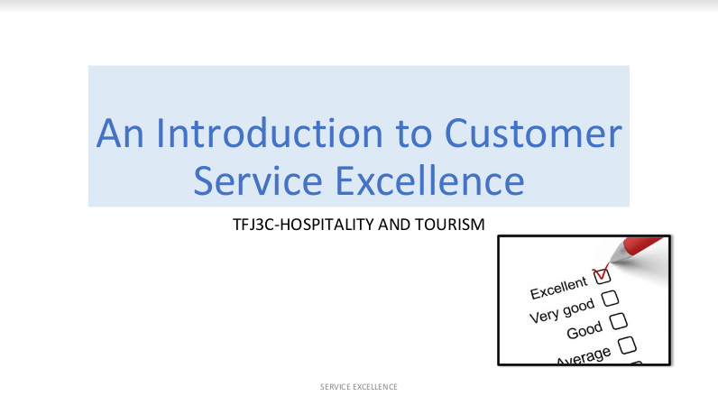

Exemplars
Exemplars are integrated within student handouts

Websites for Teachers
Tourism HT Canada - Take a Tourism Career Quiz website
Hospitality Workers Training Centre website
How To Build Community And Why It Matters So Much article
18 Bizarre Hotel Jobs That Cater to Travelers’ Weirdest Whims article
Tourism HT Canada - Canadian Academy of Travel & Tourism (CATT) program
Attractions Ontario website
Ontario Restaurant Hotel & Motel Association DineSafe website
The Canadian Tourism Industry: A Special Report (Fall, 2012)
Bakers Journal - Words That Sell article
Canadian Apprenticeship Forum website
Canadian Apprenticeship Forum - Apprenticeship 101 website

Instructional Strategies
Teachers may use any of the following instructional strategies; 3-Part lesson, lecture, storyboard, word wall, think-pair-share, placemat activity, rapid write, K-W-L, anticipation chart, ABC taxonomy, think aloud, analyzing text, Cornell note taking, exit ticket/ticket out the door, plus/minus/delta, etc.

The Hook / Motivational Strategies
It is time to explore the Hospitality and Tourism sector by creating a unique bake sale that will be filled with mouthwatering, custom baked flavourful treats. Students will need to create a marketing strategy that brings in clients from their school and the surrounding community. This special event will give students an opportunity to build relationships within their classroom, the school community, and beyond. By creating a dynamic, fun, and creative digital marketing strategy, students will decide what the customer experience will look like. Here is a chance for students to discover essential skill sets that will drive the success of their event and inform future career pathways. Students will put to use the outstanding customer service skills and principles that they have learned, so that their bake sale is a huge success. In turn, they will get to discover local charity organizations that will benefit from their new found success.

Learning Goals and Success Criteria
By the completion of this project, the student will demonstrate an understanding of factors that affect the relationship between the tourism industry and society (C.2). Students will demonstrate an understanding of the importance of customer service (D.2).Students will design effective marketing initiatives to promote an event or activity. (B.3).Students will demonstrate learning skills that include communication, teamwork, responsibility, organization and initiative. In the “Community of Character”, appreciation and empathy will be emphasized in support of the interconnection between social responsibility within the service sector, and how these skills apply to their career pathway.

Overall and Specific Expectations in Support of Ontario Curriculum Grades 9 - 12 Technological Education

Overall Expectations
B3. Design effective marketing initiatives to promote an event or activity;
C2. Demonstrate an understanding of factors that affect the relationship between the tourism industry and society;
D2. Demonstrate an understanding of the importance of customer service.

Specific Expectations
B3.2 Develop a marketing strategy that is appropriate to the target group and the event or activity;
C2.3 Describe the social responsibility of companies and workers in the tourism industry (e.g., with regard to equal employment opportunities, conservation and preservation of the environment, relations with local communities);
D2.2 Identify and describe fundamental principles of customer service (e.g., reliability, accountability, caring, responsiveness;
D2.3 Explain how interpersonal, intrapersonal, and problem-solving skills are used to demonstrate professionalism and provide high-quality customer service.

Safety Concerns
This project does not involve the use of tools until the written component is completed (see planning notes). Please use the OCTE SAFEDocs for Hospitality for future instruction.

Applicable SAFEDocs and ToolSAFE videos
Please refer to the OCTE SAFEDocs for BBT Technology for safety documents in order to properly address and instruct this project.

Project Challenges
This project requires each student to have access to a laptop, Chromebook or PC. Because it involves a concentrated amount of reading and writing, Google Read or similar assistive technology should be installed on all devices.

Differentiation of the Project / Activity
Differentiation will be achieved by teamwork, reflection and goal setting, voice and choice in project, formative assessment methods, VAK inventory, graphic organizers and use of multiple technologies.
Teachers can also refer to the Differentiation Scrapbook to take into account learner ability, multiple intelligences, exceptional students, and ESL learners.

Assessment and Evaluation
Evidence of student achievement for evaluation is collected through formative and summative tasks that allow the students to demonstrate their learning. The identification, clarification, and sharing of learning goals in a student-friendly language will facilitate a transparent, succinct success criteria. The project is based on a real world setting and will use rich performance tasks, effective communication, research, reflection, observation and anecdotal notes to evaluate the required skills and knowledge.

Religious Considerations
Raising Dough for Charities-building community through customer service has been designed to allow for cultural, religious, food sensitivity and environmental considerations. The spirit of the assignment is focused on empathy as an essential skill and desired character trait in all students. By using the Community of Character Wheel as a resource, it promotes consideration for all and supports a positive career pathway.

Reflection or Design Report
Teachers may wish to have the students complete a design report, reflection or create a foldable to consolidate their learning. This would be a good way to capture the student’s understanding in a summative format and be used in preparation for their examination, entering post-secondary education, or the workforce.

Appendix A - Project Introduction and Unit Plan

EXPERIENTIAL LEARNING CURRICULUM UNIT PLAN TEMPLATE
 |  | Date
Name of project | Raising Dough for Charities - Building community through customer service
Course, grade and level | TFJ3C, Hospitality and Tourism, Grade 11
Materials and technology requirements | Chrome book, laptop or PC
Purpose of project | Expose students to various skills and character attributes required to be a successful customer service representative.  Introduce students to various sectors of the hospitality and tourism service sector.
Estimated time to complete this component of the project | 5- 7 , 70 minute classes  This assignment has a part 2 extension that involves hands-on culinary work
Lessons/workshop/ assignment | See student activities page
Overall course expectations that are met by completing this project | B3. Design effective marketing initiatives to promote an event or activity  C2. Demonstrate an understanding of factors that affect the relationship between the tourism industry and society  D2. Demonstrate an understanding of the importance of customer service
Essential skills that are developed in this project | Comprehension of: empathy, teamwork, communication, active listening and a proactive approach to Problem solving, Reading text, Document use, Problem solving, Lifelong learner. Digital competency, Attitude

Type of assessment and evaluation used within this project | Pre Assessment, activate prior knowledge  Anecdotal  Rubric  Checklist  Observation  Conversation  Q and A
Instructional Strategies | Socratic  Carousel Brainstorming  Advanced organizer  Think Pair Share  Guided practice  Video
Photograph or image information | Included in document
Teacher’s notes

Appendix B – PowerPoint Presentation

An Introduction to Customer Service Excellence

https://www.octe.ca/application/files/5616/3016/1389/TFJ3C_PowerPoint_introduction_to_Customer_Service.pptx

Appendix C – Graphic Organizer – Brainstorming The Meaning Of Great Customer Service
/20
In the space provided below, provide examples of positive, effective approaches to great customer service. Think of how you would like to be treated at your favourite store, restaurant, event etc. Listening is a very important skill and has been provided as your first correct answer. You may use digital support to watch videos or work with a peer to come up with ideas. Two marks will be awarded for each correct answer.

THE CUSTOMER

LISTENING

______

________

______________

____________

___________

___________

__________

_________

_________
Student Name: ________________________ Date: ________________

Appendix D – Better Customer Service Starts With You
Tips that support customer service excellence.
TFJ3C Hospitality and Tourism
Here are skills that will support your journey to becoming a customer service star.

We have watched videos and PowerPoints and had classroom discussions about how all customers should be treated. Let us review this SKILL CHART together in class and think of scenarios that support great customer service. Whether you are at the movie theatre, restaurant, food truck, bake sale, school catering event, CNE, ice cream parlour, Formula one race track (you get the point) 🡪 Great customer service means repeat clients and repeat sales ($$$).

THE SKILL | HOW DO I DO IT?
Active Listener  ⭐⭐⭐⭐. | Understanding the customer’s problem correctly and anticipating possible questions is the key to effective communication and successful interactions.
Attentive  ⭐⭐⭐⭐. | Being attentive to all of the details the customer shares helps pinpoint the problem, avoid misunderstanding, and provide the best solution.
Communicator  ⭐⭐⭐⭐. | By working the front lines of the company, it is important to communicate knowledge and information to customers—clearly and concisely. Make it easy for customers to understand the interaction whether it is over the phone, on chat, or via email.
Confident  ⭐⭐⭐⭐. | Confident customer service reps create a foundation of trust and professionalism with customers.
Decision Maker  ⭐⭐⭐⭐. | The ability to make a decision is extremely important. By feeling confident in your role, you will also feel comfortable making hard decisions for various customer needs and questions.
Empathetic  ⭐⭐⭐⭐. | The ability to understand and share feelings of another person is crucial for customer service reps. Showing empathy and creating an emotional connection earns lifelong customers for the company.
Flexible  ⭐⭐⭐⭐. | Flexibility in thinking helps find the right way to communicate with every customer and deliver them a personalized experience.
Positive  ⭐⭐⭐⭐. | A positive and friendly attitude is the basis of a smooth interaction where the customer is more likely to be satisfied with the service.
Problem Solver  ⭐⭐⭐⭐. | Customers will not always diagnose their issues correctly. A great rep takes the initiative to solve the issue at hand and anticipate any future problems the customer may have and address it during the current interaction.
Team Player  ⭐⭐⭐⭐. | Being able to work for the good of the entire customer service team creates a positive and supportive environment. This will increase rep morale, drive productivity, and result in great interactions.

Appendix E –CUSTOMER SERVICE CHALLENGE CHART

WHAT NOT TO DO:
We have all experienced, seen, or heard about situations where these skills were not used or put into action. To make sure that you understand the importance of the ‘SKILL (s)’, please fill in the center (blue) column with examples of ‘POOR CUSTOMER SERVICE’. Make sure to use your previous learning from the PowerPoint presentation, videos, and classroom discussions to help you give examples of poor customer service. As well, you may research online resources if you are stuck for ideas.
Point form or bulleted text is fine. As an example, the first skill has been filled in for you so that you can see the required effort for each correct answer.
Five (5) marks will be awarded for each example that is thoroughly and thoughtfully completed.
Total /50

CUSTOMER SERVICE CHALLENGE CHART Student Name: __________________
THE SKILL | GIVE AN EXAMPLE OF POOR CUSTOMER SERVICE |  | T  E  A  C  H  E  R  USE
NOT an Active Listener | - customer finds burnt french fries at the bottom of his poutine  - after politely calling the server over to the table, the server looks away while being spoken to by the customer/client  - the server does not listen carefully and says to the customer: “So, the fries were cold?”  - The customer feels ignored... |  | 5 /5
NOT Attentive |  |  | /5
NOT a great Communicator |  |  | /5
NOT Confident |  |  | /5
NOT a good Decision Maker | . |  | /5
NOT Empathetic |  |  | /5
NOT Flexible |  |  | /5
NOT Positive |  |  | /5
NOT a good Problem Solver |  |  | /5
Not a Team Player |  |  | /5

Appendix F – Hospitality and Tourism Career Options

STEER YOUR CAREER... INTO HOSPITALITY AND TOURISM.
Looking at the chart below, let us take a look at some traditional and some unconventional choices for careers in the Hospitality and Tourism industry. Pick your top three (or even add a few to the list if you research a job that really interests you) and fill in the ‘TASK” section of the chart below. Use point form as this is meant to be an exercise in inquiry and will be revisited in other lessons. An example of a HOTEL BEEKEEPER (APIARIST) has been placed in the column in order to assist you with this assignment.
A maximum of 10 marks will be awarded for each thoughtfully, well researched career choice.

TOTAL /30

Mermaid Trainer...seriously!

Resourced from: https://www.farandwide.com/s/weird-hotel-jobs-fb2932e762c148e7
CRITERIA | 0-49% | LEVEL 1  50-59%  (MAX 3 MARKS) | LEVEL 2  60-69%  (MAX 5 MARKS) | LEVEL 3  70-79%  (MAX 7 MARKS) | LEVEL 4  80-100%  (MAX 10 MARKS)
Making connections within and between various contexts (e.g., between disciplines; between technology, the environment, and society; between school and future opportunities) |  | makes connections within and between various contexts with limited effectiveness | makes connections within and between various contexts with some effectiveness | makes connections within and between various contexts with a considerable effectiveness | makes connections within and between various contexts with a high degree of effectiveness

CAREER TITLE | THE TASK...WHAT DO I DO?
- Chose 3 careers that you want to explore
- Brief description of job duties
- Example of company/location
- What made you choose this career?
Wedding Coordinator
Food Designer/Stylist
Amusement Park Manager
Hotel Beekeeper  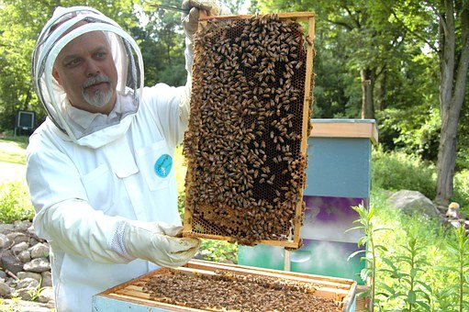 | -Rooftop Apiary are maintained daily by an experience Beekeeper  -High end(4 ⭐+) hotels may employ a beekeeper (e.g. Waldorf Astoria in NY city)  -Honey is used in foods, spa treatments, tea service etc.  -I love working outdoors; supporting the environment; being part of a team that creates a unique customer experience; creating natural food products...and I love to eat honey :)
Military/Naval Cook
Sleep Concierge
Spa and Wellness Manager
Baker
Cruise Line Events Coordinator
Line Cook
Pastry Chef
Chef

Guest Services Manager
Chocolatier
Butcher
Airline Catering Company
Casino Chef
Truffle Dog Trainer
Racetrack Food Vendor

Mermaid Trainer

Appendix G - What Does Building Community Mean?

How To Build Community And Why It Matters So Much
Define a community in the Hospitality and Tourism Industry
Community is critical to our overall wellbeing and the decline of our connectedness is coming at the same time mental health issues are on the rise. In a study by Queen’s University, 27% of people said they were suffering from loneliness, and research from Washington State University found all ages suffer from social anxiety and FOMO (fear of missing out) which are correlated with low self-esteem and low self-compassion. In addition, a newly published study by the University of Houston showed the mental health effects of the pandemic will be both long lasting and potentially devastating.
We are social animals and our instinct is to find strength in numbers. We appreciate a small circle of people, but need larger circles as well. Our health and happiness are inextricably linked with our connections.

Purpose
Strong communities have a significant sense of purpose. People’s roles have meaning in the bigger picture of the community and each member of the group understands how their work connects to others’ and adds value to the whole.
Build your community by keeping your purpose in mind and reminding yourself of how your contribution matters. You are a great parent, aunt or uncle, and you are having a meaningful impact on children’s learning. Alternatively, you are participating on a key project that will affect the user experience for your company’s customers. On the other hand, you are processing payments at a university where students will get their start toward their life goals. Even everyday contributions matter to the community as a whole.

Belonging
When we are part of a thriving community, we feel a sense of kinship, camaraderie and connectedness. There is a place and a role for each person, and group members feel they can bring all of themselves to their work and their team. There are high levels of trust and psychological safety in which people know others will have their backs and will give them not only the benefit of the doubt, but also the space to apply their talents and develop new ones. Within a strong community, people feel valued and all work has dignity. In addition, the needs of each member and the needs of the whole organization are fully met. As Plato said, “The part cannot be well unless the whole is well.” Communities take care of their members and vice versa—because they are invested in the collective success of the group.
Build your community by staying in touch with people—even if you have to accomplish it virtually. Invest time and energy in maintaining your bonds.
Also, demonstrate compassion and help others feel a sense of belonging. People appreciate being welcomed and valued. The sense of belonging you extend strengthens the whole.
Encourage team members to pull each other in, obtain feedback and work through tough challenges together. Encourage people to build their social capital—their relationship ties (think: webbing) across organizations. Social capital is positive for people because it provides the opportunity for growth, learning and advice. In addition, it is good for organizations because social capital helps people get work done more effectively and efficiently.
Build your community by seeking new learning and stretching your own skills. When people within communities are continually developing, the communities themselves progress as well. Help members of your group who are struggling by encouraging plenty of expression, especially from those with fresh or novel opinions. Innovation often comes from the edges— previously untested, untried or unpopular ideas.

Referenced from The Coronavirus Makes Having Work Friends More Important Than Ever: 6 Tips For Building The Best Relationships

Appendix H - What Does Building Community Look Like In The Hospitality And Tourism Industry?
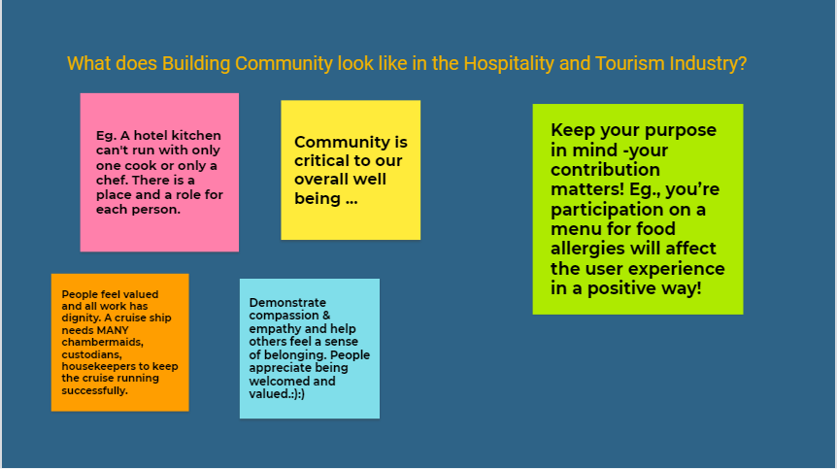

Appendix I - Poster Chart Assignment- Community Building In The Workplace
Using Google Doc, create a 1 or 2 page Poster Chart that reflects the importance of creating community in a workplace. The focus should be on the Hospitality and Tourism industry. A minimum of five skills should be reflected in your chart and it is recommended that additional research be conducted in support of a Level 4 outcome.
Make sure to use the rubric (below) for guidance and check that your spelling and grammar are accurate and professional. Use icons/images to reflect each of the community building skills you have chosen to represent. Imagine you would walk into your workplace and see this Poster chart on the wall next to safety posters and other documents of importance! Sites such as pixabay.com, vecteezy.com, and pexels.com have royalty free graphics and must be listed as a resource. BE CREATIVE-SHOW YOUR LEVEL 4 MINDSET!!

MARK Total /50

EG
COMMUNITY BUILDING IN THE WORKPLACE
Know your skills
 | SKILL | EXAMPLE |  |  | PICTURE/ICON
#1 | ENCOURAGE OTHERS | Encourage team members to pull each other in, obtain feedback, and work through a tough challenge .e.g. a team member miscounted the number of dessert platters ordered for a wedding reception…. Ask yourself, “How do we do better next time?”
RESOURCES :

CRITERIA | 0-49% | LEVEL 1  50-59%  (MAX 3 MARK) | LEVEL 2  60-69%  (MAX 5 MARKS ) | LEVEL 3  70-79%  (MAX 7 MARKS ) | LEVEL 4  80-100%  (MAX 10 MARKS )
Making connections within and between various contexts (e.g. between disciplines; between technology, the environment, and society; between school and future opportunities) |  | Makes connections within and between various contexts with limited effectiveness | Makes connections within and between various contexts with some effectiveness | Makes connections within and between various contexts with a considerable effectiveness | Makes connections within and between various contexts with a high degree of effectiveness
Expression and organization of ideas and information (e.g. clear expression, logical organization) in oral, visual, and written forms |  | Expresses and organizes ideas and information with limited effectiveness | Expresses and organizes ideas and information with some effectiveness | Expresses and organizes ideas and information with considerable effectiveness | Expresses and organizes ideas and information with a high degree of effectiveness
Use of critical/creative thinking processes (e.g. problem-solving, design, and decision-making processes) |  | Uses critical/ creative thinking processes with limited effectiveness | Uses critical/ creative thinking processes with some effectiveness | Uses critical/ creative thinking processes with considerable effectiveness | Uses critical/ creative thinking processes with a high degree of effectiveness
Understanding of content (e.g. procedures, technological concepts, processes, industry standards) |  | Demonstrates limited understanding of content | Demonstrates some understanding of content | Demonstrates considerable understanding of content | Demonstrates a high degree of understanding of content

Appendix J – Rubric -Poster Chart Assignment- Community Building In The Workplace

CRITERIA | 0-49% | LEVEL 1  50-59%  (MAX 3 MARK) | LEVEL 2  60-69%  (MAX 5 MARKS ) | LEVEL 3  70-79%  (MAX 7 MARKS ) | LEVEL 4  80-100%  (MAX 10 MARKS )
Research and representation of EACH H&T community building skills  /10 | Does not meet minimum requirements at this time | Gives poor examples of associated skill... No research beyond classroom resources. Does not meet the minimum number of skills | Gives one example of associated skill. Little research beyond classroom resources. Does meet the minimum number of skills | Gives several examples of associated skill. Some research beyond classroom resources. Does meet the minimum number of skills | Gives several examples of associated skill. Exceptionally well researched beyond classroom resources. Exceed the minimum number of skills
Skill example  /10 | Does not meet minimum requirements at this time | Little degree of association of skill to industry | Some degree of association of skill to industry. | Good degree of association of skill to industry. | High degree of association of skill to industry.  Exceptionally well thought out and thoughtful exemplars
Icon/photo  /10 | Does not meet minimum requirements at this time | Icon/Photo provided does not relate to  H &T skill | Icon/Photo somewhat relates to H&T skill. Clear image but not royalty free. | Good Icon/Photo that relates to H&T skill .Clear image but not royalty free. | Excellent Icon/Photo that relates to H&T skill Clear succinct image that is royalty free
Layout  professionalism, grammar, spelling  /10 | Does not meet minimum requirements at this time | Chart shows minimal thought for layout, originality, attention to detail, spelling and grammar | Chart shows some thought for layout, originality, attention to detail, spelling and grammar | Chart shows good amount of thought for layout, originality, attention to detail, spelling and grammar | Chart shows outstanding amount of thought for layout, originality, attention to detail, spelling and grammar
Resources link page  /10 | Does not meet minimum requirements at this time | Few external resources and web sites were referenced. Little effort made to research beyond classroom | Some external resources and web sites were referenced. Some effort made to research beyond classroom | Good amount of external resources and web sites were referenced.  Good effort made to research beyond classroom | Outstanding amount of external resources and web sites were referenced. Excellent initiative to research beyond classroom
 |  |  |  |  | /50

Appendix K – Marketing Strategies For A Community Building Bake Sale
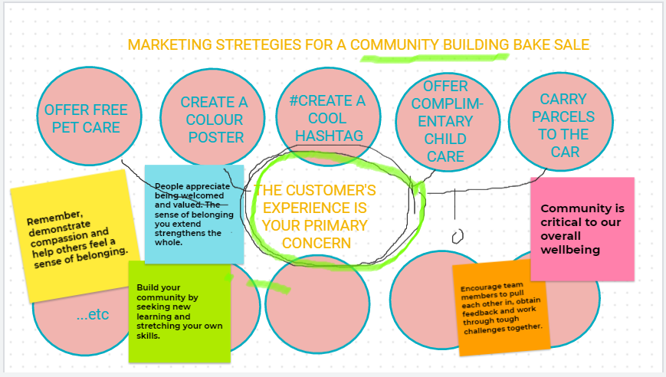

Appendix L – Digital Marketing Strategy Assignment

Part 1 - RAI$ING DOUGH for a CHARITY BAKE SALE
Now that you are knowledgeable about customer service skills and your responsibility in building community, it is time to identify and explain how you will promote your event to its intended target market. Your social media strategy could include a ‘Twitter hashtag’, digital poster (that can be printed as well), ‘Instagram’ posts, and an electronic invitation. Several short links and videos have been included in the chart below to support you in designing an effective marketing strategy that reaches your target group. Do not forget to think about a charity that you feel passionate about within your community. In Part 1, please review the links below and make notes that will support part 2 of this assignment.
Level 4 mindset: Pre-read part 2 before you begin. This helps to identify the desired outcome of your marketing strategy assignment!

Remember:
- Make sure you carry a common theme or idea throughout your campaign
- Identify the community(target market) that you want to reach and have support your bake sale
- Identify the charity you would like to support through the proceeds you make from the bake sale
- Make sure to ask for permission if you want to use a school board twitter feed
- If you add images to your tweets, you’ll get more shares and clicks that tweets without images

Digital Marketing Strategy Assignment
Site | Watch the link below | Icon /image
Charity options | https://capitalcurrent.ca/ottawa-charities-concerned-but-hopeful-as-funds-drop-during-covid-19/  https://www.runottawa.ca/torw/charities/2020-participating-charities
Centennial College Events Planning Video | https://youtu.be/Trt8Da6UUhI
"#Hashtag" with Jimmy Fallon & Justin Timberlake | https://youtu.be/57dzaMaouXA
 | https://neilpatel.com/blog/twitter-marketing-tips/
 | https://www.businessinsider.com/what-is-instagram-how-to-use-guide

Appendix M - Digital Marketing Strategy Assignment,

Part 2 Rubric - Rai$Ing Dough For A Charity Bake Sale
Assignment: Create a short Google Slide presentation that demonstrates your understanding of the importance of a marketing strategy in relation to the success of your event. Make sure to reference the rubric in the chart below, as it will assist you in creating the Google slideshow. Total marks /50

Task with included Rubric | 0-49% | LEVEL 1  50-59%  (MAX 3 MARK) | LEVEL 2  60-69%  (MAX 5 MARKS ) | LEVEL 3  70-79%  (MAX 7 MARKS) | LEVEL 4  80-100%  (MAX 10 MARKS) | ✅
Slide 1 - Make a list or checklist of your goals and objectives of your event...this creates tools to help you plan and organize your marketing strategy.  /10 |  | Limited effort, no elaboration or self-reflection  Checklist lacks detailed goals and objectives  Limited evidence is displayed of the importance of community | Displays some effort, no elaboration, no self-reflection  Checklist has some detail of goals and objectives  Some evidence is displayed of the importance of community | Displays considerable effort and elaboration  Checklist incorporates goals and objectives  Some evidence is displayed of the importance of community | Displays high degree of personal growth, self –reflection and critical, creative thinking  Outstanding and thoughtful detailed checklist  High level of evidence is displayed of the importance of community
Slide 2 - Determine the theme, location, date, time, and any additional features that will make your event stand out to the target market/client.  /10 |  | Limited effort to define details  Errors in spelling and grammar  Limited creativity or originality | Some effort to define details  Errors in spelling and grammar  Somewhat creative and original | Considerable effort to define details  Accurate spelling and grammar  Considerable originality with good degree of creativity | Excellent effort with thorough, thoughtful features  Accurate spelling and grammar  Outstanding attention to detail  Highly original concept

Task with included Rubric | 0-49% | LEVEL 1  50-59%  (MAX 3 MARK) | LEVEL 2  60-69%  (MAX 5 MARKS ) | LEVEL 3  70-79%  (MAX 7 MARKS) | LEVEL 4  80-100%  (MAX 10 MARKS) | ✅
Slide 3 - Using Piktochart, create a digital poster that will advertise your event.  www.piktochart.com  /10 |  | Limited effort, no relevant image(s),  Errors in grammar and spelling  No originality  Does not reflect the theme of T | Some effort, some relevant image(s),  Errors in grammar and spelling  Limited originality  Somewhat meets the theme of the event | Good effort, sufficient relevant image(s),  Good originality  Grammar and spelling are accurate  Meets the theme of the event | Outstanding effort excellent attention to detail  Images reflect the target audience and the products/services  Originality exceeds expectation with thoughtful links to theme  Grammar and spelling are accurate
Slide 4 - Promote your event by creating a hashtag (#) that represents your event in an original, thoughtful and impactful way.  /10 | . | Uses planning skills with a limited degree of effectiveness | Uses planning skills with some degree of effectiveness | Uses planning skills with a considerable degree of effectiveness | Uses planning skills with a high degree of effectiveness
Slide 5 - Create a Google Feedback form that asks your guests questions about the event. Focus on their likes, dislikes and suggestions for future events. /10 |  | Makes connections with event to essential job skills with limited effectiveness | Makes connections with event to essential job skills with some effectiveness | Makes connections with event to essential job skills with considerable effectiveness | Makes connections with event to essential job skills with high degree of effectiveness

References
"#Hashtag" with Jimmy Fallon & Justin Timberlake (Late Night with Jimmy Fallon) (YouTube video), 2013 https://youtu.be/57dzaMaouXA
12 Powerful Twitter Marketing Tips (That Actually Work), 2021 https://neilpatel.com/blog/twitter-marketing-tips/
18 Bizarre Hotel Jobs That Cater to Travelers’ Weirdest Whims (Far and Wide), 2018 https://www.farandwide.com/s/weird-hotel-jobs-fb2932e762c148e7
21st Century Competencies: Foundation Document for Discussion. Phase 1: Towards Defining 21st Century Competencies for Ontario, Winter 2016 Edition, 2016 http://www.edugains.ca/resources21CL/About21stCentury/21CL_21stCenturyCompetencies.pdf
2020 Participating Charities (Run Ottawa), 2021 https://www.runottawa.ca/torw/charities/2020-participating-charities
A beginner's guide to Instagram, the wildly popular photo-sharing app with over a billion users (Business Insider), 2020 https://www.businessinsider.com/what-is-instagram-how-to-use-guide
An Introduction to Customer Service Excellence (PowerPoint), 2021 https://www.octe.ca/application/files/5616/3016/1389/TFJ3C_PowerPoint_introduction_to_Customer_Service.pptx
Attractions Ontario (website) https://attractionsontario.ca/attraction-listings
Bakers Journal - Words That Sell (article) https://www.bakersjournal.com/words-that-sell-3723/
Broken Light bulb graphic (image), 2021 https://thenounproject.com/term/broken-light-bulb/207139/
Canadian Apprenticeship Forum (website) http://www.apprenticesincanada.com/
Canadian Apprenticeship Forum - Apprenticeship 101 (website) https://caf-fca.org/
Centennial College logo, 2021
Cheerful Young Ethnic Lady with Mother Cooking (Pexels photo), 2021 https://www.pexels.com/photo/cheerful-young-ethnic-lady-with-mother-cooking-meringue-together-in-kitchen-5908026/

Clip Art, (Google images) https://www.google.ca/search?q=clipart%20free%20light%20bulb&tbm=isch&hl=en&tbs=il:cl&sa=X&ved=0CAAQ1vwEahcKEwjQ2v_HuYHyAhUAAAAAHQAAAAAQBw&biw=1423&bih=789
Collaboration graphic (clipart), 2019 http://clipart-library.com/clipart/557957.htm
College of Trades Training Standards https://www.collegeoftrades.ca/training-standards
Colourful decisions making sign post graphic (clipart), 2021 https://s.clipartkey.com/mpngs/s/58-585216_colourful-decisions-decision-making-choices-clipart.png
Concept of Problem solving meter (photo), 2021 https://www.123rf.com/photo_80180004_concept-of-problem-solving-meter-3d-rendering.html
Empathy Cartoon (image), 2017 https://madebymany-v2-prod.s3.amazonaws.com/upload…ile/1200/xlarge_acc91de7bf8ffeed_Heart_Minds8.png
Course Codes for Emphasis courses in the Revised Curriculum: Technological Education, Grades 11 and 12, 2009 http://www.edu.gov.on.ca/eng/curriculum/secondary/techedemphasiscourses.pdf
Growing Success: Assessment, Evaluation, and Reporting in Ontario Schools, First Edition, Covering Grades 1 to 12, 2010 www.edu.gov.on.ca/eng/policyfunding/growSuccess.pdf
Hospitality Workers Training Centre (website) https://hospitalitytrainingcentre.com/
How to Build Community and Why It Matters So Much (Forbes), 2020 https://www.forbes.com/sites/tracybrower/2020/10/25/how-to-build-community-and-why-it-matters-so-much/?sh=7913212751bc
Images (Pixabay) https://pixabay.com/
Instagram logo, 2021 https://en.instagram-brand.com/#general
Learning for All – A Guide to Effective Assessment and Instruction for All Students, Kindergarten to Grade 12, 2013 http://www.edu.gov.on.ca/eng/general/elemsec/speced/LearningforAll2013.pdf
Light Bulb graphic (vector) https://publicdomainvectors.org/en/free-clipart/Light-bulb-sign/61745.html
Man listening vector graphic (clipart), 2019 http://clipart-library.com/clipart/2059391.htm
Mermaid Trainer Picture (Far and Wide), 2018 https://www.farandwide.com/s/weird-hotel-jobs-fb2932e762c148e7
Ministry News https://news.ontario.ca/en/release/1000078/ontario-to-modernize-and-streamline-apprenticeship-training
OCTE SAFEDocs for Broad Base Technology (website), 2021 https://www.octe.ca/en/resources/safety/safedocs
OCTE SAFEDocs for Hospitality and Tourism (document), 2013 https://www.octe.ca/application/files/6215/3796/3180/SAFEdoc_HOST.pdf
Ontario Restaurant Hotel & Motel Association DineSafe (website) https://dinesafe.ca/
Ottawa charities ‘concerned but hopeful’ as funds drop during COVID-19 (Capital Current), 2021, https://capitalcurrent.ca/ottawa-charities-concerned-but-hopeful-as-funds-drop-during-covid-19/
Positive thinking cartoon graphic (clipart), 2021 https://www.dreamstime.com/stock-illustration-imagine-yourself-successful-illustration-business-man-see-himself-being-mirror-image54136951
Red SEAL – Sceau Rouge, 2018 http://www.red-seal.ca/trades/tr.1d.2s_l.3st-eng.html
Resources, Ontario College of Trades, 2020 https://www.collegeoftrades.ca/resources
Skilled Trades Identified in Ontario (College of Trades), 2020 https://www.collegeoftrades.ca/wp-content/uploads/Sector_Brochure_One_Pager_web.pdf
Skilled Trades Ontario https://www.ontario.ca/page/skilled-trades
Special Event Planning students plan Living on the Edge event (YouTube video), 2019 https://youtu.be/Trt8Da6UUhI
Team player graphic (clipart), 2019 http://clipart-library.com/clipart/team-player-cliparts_5.htm
The Apprenticeship Advantage, Ontario College of Trades, (College of Trades) 2020 https://www.collegeoftrades.ca/wp-content/uploads/ApprenticeshipAdvantage_English_web.pdf
The Canadian Tourism Industry: A Special Report (Fall, 2012) https://tiac-aitc.ca/_Library/documents/The_Canadian_Tourism_Industry_-_A_Special_Report_Web_Optimized_.pdf
The Coronavirus Has Made Work Friends More Important Than Ever: 6 Tips For Building Relationships (Forbes), 2020 https://www.forbes.com/sites/tracybrower/2020/03/22/the-coronavirus-makes-having-work-friends-more-important-than-ever-6-tips-for-building-the-best-relationships
The Differentiated Instruction Scrapbook, 2010 http://www.edugains.ca/resourcesDI/EducatorsPackages/DIEducatorsPackage2010/2010DIScrapbook.pdf
The Ontario Curriculum, Grades 9 and 10: Technological Education, 2009 (revised) http://www.edu.gov.on.ca/eng/curriculum/secondary/teched910curr09.pdf
The Ontario Curriculum, Grades 11 and 12: Technological Education, 2009 (revised) http://www.edu.gov.on.ca/eng/curriculum/secondary/2009teched1112curr.pdf
Thumbs down image (clipart), 2019 http://clipart-library.com/clipart/8TGEnLgqc.htm
Time for Plan C (image), 2020 https://pixabay.com/illustrations/planning-plan-opportunity-option-4897792/
Tourism HT Canada - Canadian Academy of Travel & Tourism (CATT) program, 2021 https://tourismhr.ca/programs-and-services/canadian-academy-of-travel-and-tourism/
Tourism HT Canada - Take a Tourism Career Quiz (website), 2021 http://tourismhr.ca/discover-tourism/take-a-tourism-career-quiz/
Twitter logo social icon, 2021 https://about.twitter.com/en/who-we-are/brand-toolkit
Want To Find Your Purpose At Work? Change Your Perceptions (Forbes) 2019 https://www.forbes.com/sites/tracybrower/2019/08/12/want-to-find-your-purpose-at-work-change-your-perceptions
Working Remote: How To Build Trust From A Distance (Forbes), 2020 https://www.forbes.com/sites/tracybrower/2020/09/20/working-remote-how-to-build-trust-from-a-distance
You can do it (photo), 2021 https://pixabay.com/photos/motivation-frame-decoration-6184232/

