Cabin Layout
Car interiors are referred to as cabins. Similar to boats in the marine industry, this is the location of the vehicle where people sit.

Review the following video and consider the future designs and what might work well in your design… Is This What Car Interiors Will Look Like In 10 Years!?

Task #1
Research different types of cabin/interior layouts of autonomous vehicles. Remember if the vehicle is autonomous it means you don’t need to be sitting forward. Also consider accessibility to enter the cabin and seating arrangement.

Consider different setting arrangements as shown here
https://www.granstudio.com/grammer

Consider what works and what, might not work as seen below
https://www.topgear.com/car-news/list/nine-weird-car-seating-arrangements

Consider a traditional seating arrangement in rows. See below:
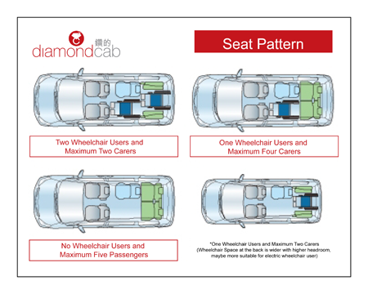
https://www.diamondcab.com.hk/en/taking-diamond-cab.php

Task #2
As a class using chairs and or benches if available setup the desired seating arrangement for your cabin. Test different seating arrangements for your application.

Consider the following:

- Number of seats
- Type of seats, bench chair, or?
- Accessibility for wheelchairs or not?
- Leg room
- Storage in the cabin
- How will people get in and out of the vehicle
- How many doors and where will they go.
- Direction of seating, forward, back, side
- Angle of seating, leaning back, at a 45 deg to other seats etc

Example:

U Style seating
Advantages, Lots of seating area, lots of options for seating position
Disadvantages, one one exit, limited space in the corners, limited leg room in the corners. Limited storage space
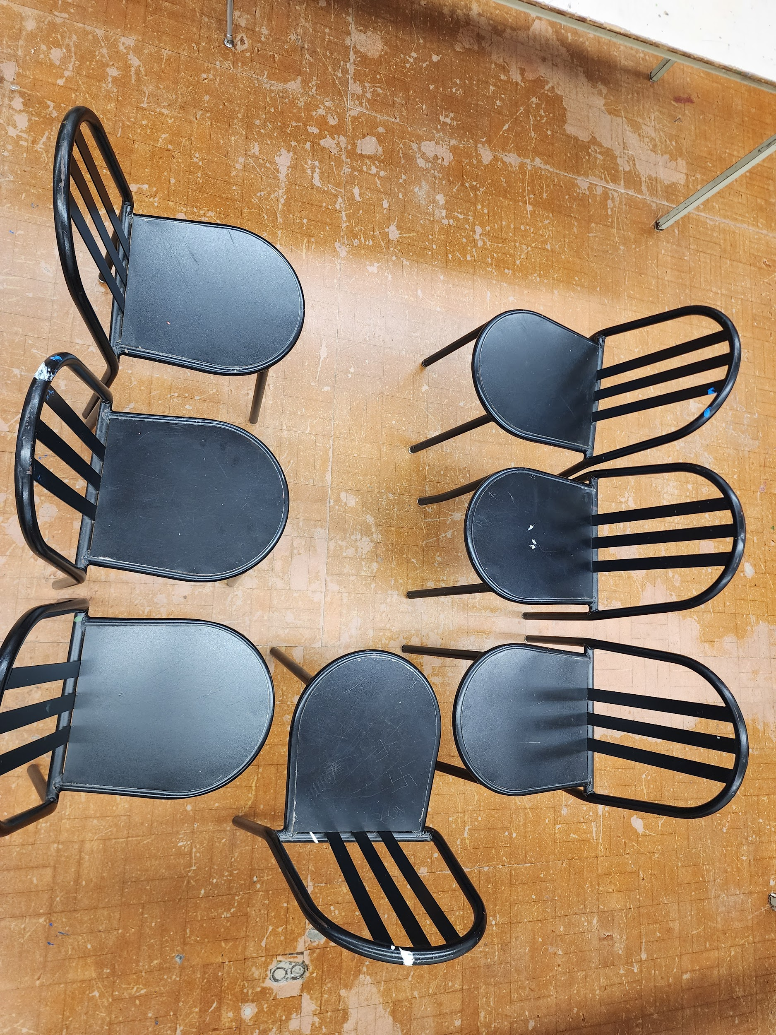

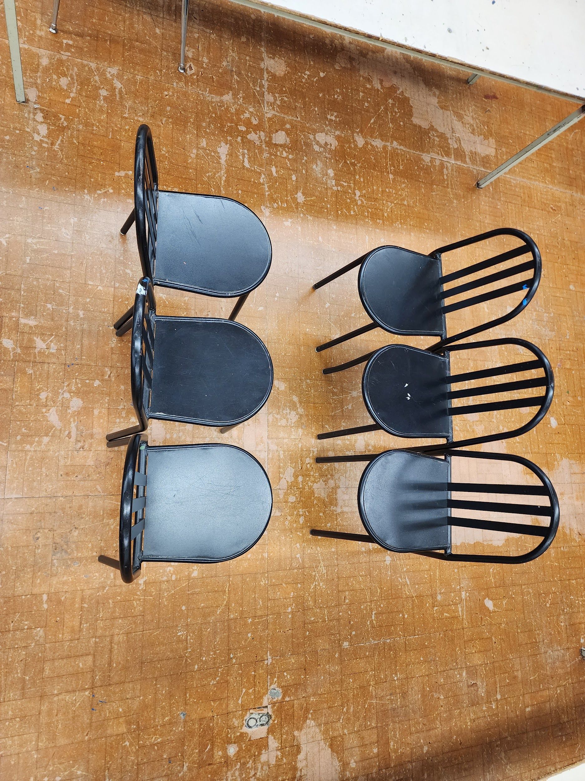
Bench Style seating
Advantages,Decent amount of seating, two exit points, lots of leg room for everyone, two different seating position, Disadvantages, two choices for seating position, limited seating, limited storage space

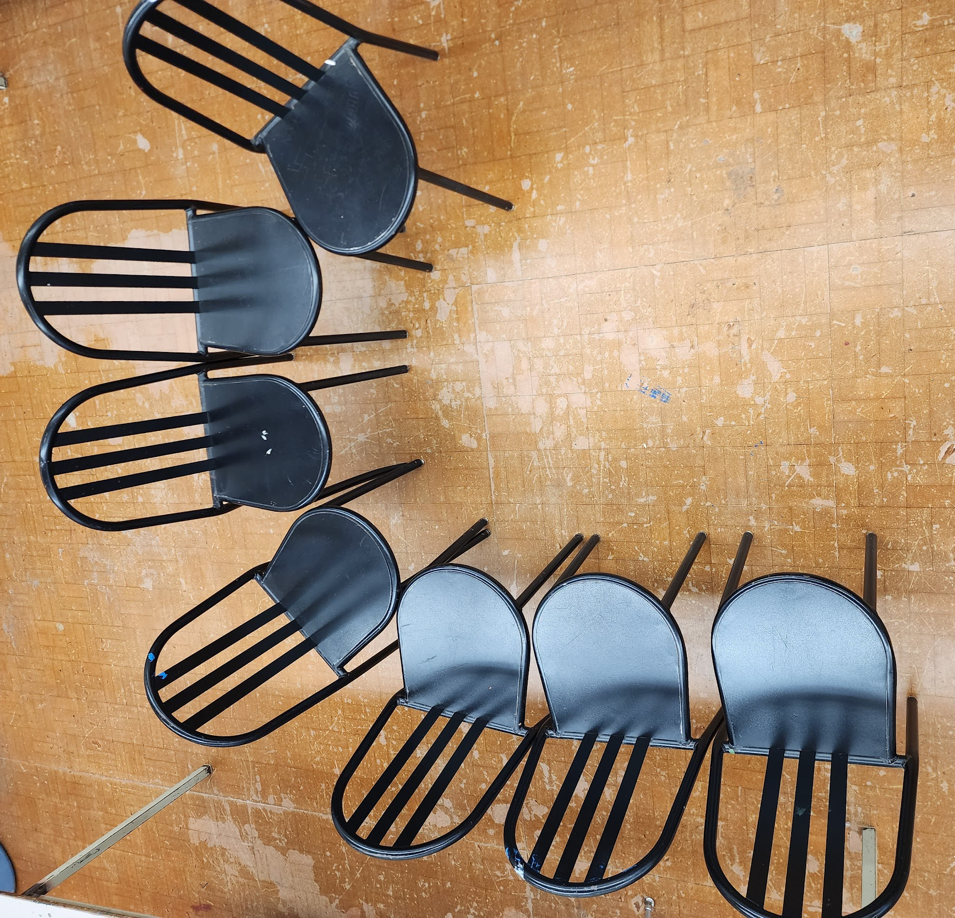
J Style seating
Advantages,Decent amount of seating, storage space, lots of leg room for everyone, two almost three different seating positions, Disadvantages, requires more space in total to create, wasted space, limited view of one side.

