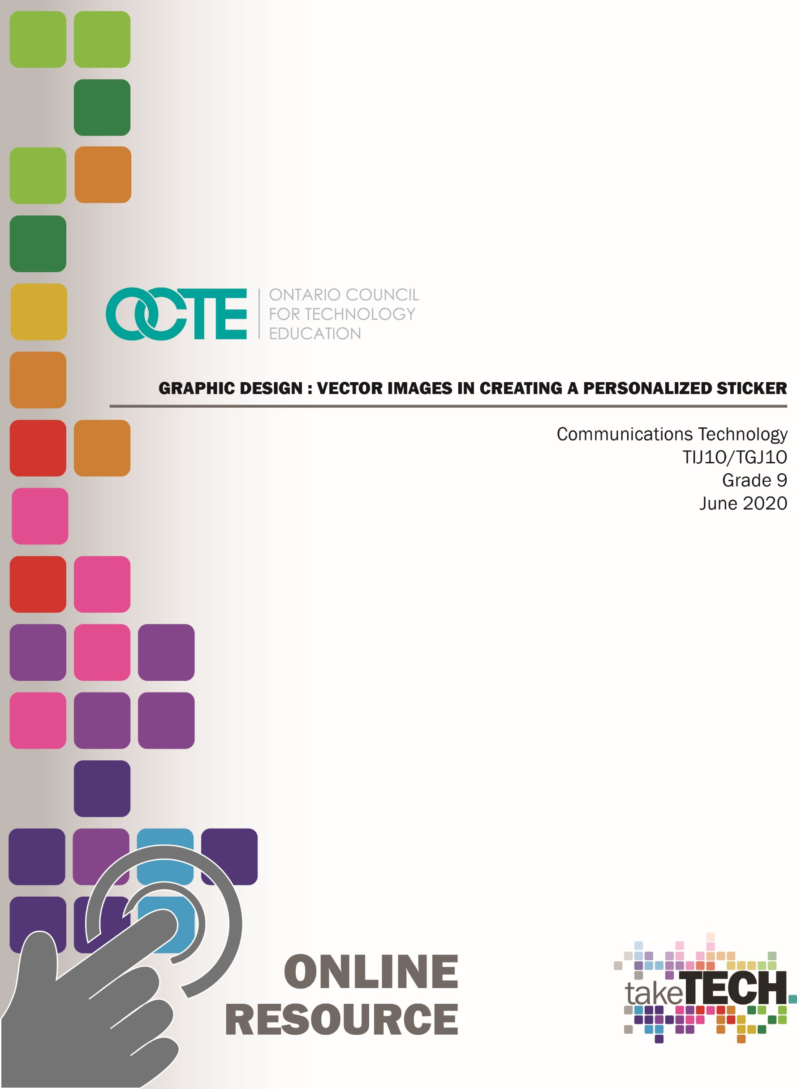

Table of Contents
Introduction 3
Project Outline 3
Prior Knowledge 3
Student Activities 4
Activity 1 – Explore the Role of a Graphic Designer 4
Activity 2 – Introduction to the Elements of Graphic Design 4
Activity 3 – The Power of Colour 4
Activity 4 – Create a Simple Vector Image 4
Activity 5 – Create a Sticker 4
Planning Notes 5
Instructional Strategies 6
Motivational Strategies 6
The Hook/Motivational Strategies 7
Learning Goals and Success Criteria 7
Overall and Specific Expectations 7
Overall Expectations 7
Specific Expectations 7
Safety Considerations 8
Applicable SAFEDocs and ToolSAFE videos 8
Differentiation of the Project / Activities 8
Assessment and Evaluation 8
Career and Industry Extensions 9
Ethical Considerations 9
Activity 1 – Explore the Role Of A Graphic Designer 10
Activity 2 – Elements of Graphic Design 10
Activity 3 – Exploring Colour 11
Activity 4 – Create a Simple Vector Image 11
Activity 5 – Create a Sticker Assignment 12
Reflection or Design Report 12
Appendix A – TIJ 1O Graphic Design Worksheet 13
TIJ1O Graphic Design: Activities and Assignment Worksheet 13
Activity 1 – Explore the Role of a Graphic Designer 14
Activity 2 – Elements of Graphic Design 15
Activity 3 – The Role of Colour 17
Activity 4 – Create Vector Images 20
Assignment 1 – Create A Sticker 20
Rubric Description 22
Assignment 1 – Create A Sticker Rubric 22
Appendix B – TIJ1O Graphic Design: Watch & Learn Links and Read & Learn Links 23
Activity 1 – Explore the Role of a Graphic Designer 23
Activity 2 – Elements of Graphic Design 24
Activity 3 – The Power of Colour 25
Activity 4 – Create Vector Images 27
Inkscape Tutorials and Download Link 29
Vector Tutorials and Web Link 29
References 30

Introduction
Course Code: TIJ1O / TGJ1O
Broad base Technology: Exploring Technologies and Communications Technology
Destination: Open
Grade Level: 9
Online Project Name: Graphic Design – Vector Images in Creating a Personalized Sticker

Project Outline
This assignment will provide the learner with an opportunity to understand the role of a graphic designer and assume this role in the creation of an original product.
The learner will analyze concepts and terms associated with colour theory, graphic design, and vector images.
The learner will demonstrate their knowledge by creating an original sticker design that can be printed out as a sticker—examples of various materials that could include Vinyl, Sticky Back Paper, or Window Film.

Prior Knowledge
There are no pre-requisites for the content contained in these documents. Students are encouraged to use the provided resources and contact the teacher when questions arise.
Teachers are encouraged to review copyright laws in Canada prior to starting this lesson and assignment. Examples of royalty-free and creative commons image sites that can be used in student work are:
- StockSnap.io
- Burst (by Shopify)
- Unsplash
- The Noun Project
- Pexels
- Pixabay
It may be helpful for students to understand how to download images from the internet or create screen captures:
- Windows: Snipping Tool or Snip and Sketch
- macOS: Command+Shift+3 or Command+Shift+4
- Android: Power + Volume Down
- iPhone OS: Side Button + Volume Up Button

Students would benefit from:
- an understanding of linear measurement,
- some experience accessing online resources, creating and downloading files, and submitting such files to a destination according to their teacher’s direction

Student Activities

TIJ 1O Graphic Design: Activities and Assignment Worksheet

Activity 1 – Explore the role of a Graphic Designer
- Role of a graphic designer
- Types of graphic design jobs
- Inspirational graphic designers

Activity 2 – Introduction to the Elements of Graphic Design
- Shapes and lines
- Company logos and meanings
- Use of texture in graphic design
- Understanding the role of balance in graphic design
- How elements can be used separately or together in graphic design

Activity 3 – The Power of Colour
- How colours emphasize messages
- Too many colours or conflicting colours, correction techniques
- The use of colour by Canadian companies to convey a message
- The psychology of colour

Activity 4 – Create a simple vector image
- Vector vs. Raster/Bitmap
- Application/program exploration
- Exporting vector images

Activity 5 – Create a sticker
- Research/pre-planning
- Student sticker assignment

Planning Notes
It is estimated that the combination of lessons, activities, and assignments will take learners 1.5 weeks of 60-minute periods to complete. Accommodation of extra time may be required for some learners.
Note: These lessons, activities, and assignment has been structured in a way that permits a “deep dive” into graphic design in Grade 9 should the school have a TGJ10 program or employ a tech rotation model.
- Create a digital space for each learner to submit and receive the material (e.g., Microsoft One Drive, Google Drive, Dropbox, etc.)
- Provide each learner with the TIJ Graphic Design worksheet. The teacher may convert to a format most familiar to their learners (e.g., convert from .docx to Google Doc) Note: This is a living document, allowing the teacher to provide ongoing feedback for revision as the learner progresses
- Post or provide the learners with the materials at timed intervals or all at once.
- Provide timely feedback to learners; the work has been scaffolded
- Review all links prior to the start of this project, in many cases. Additional learning options were posted allowing for one link to be removed if needed
- Teachers may choose to limit the options available for Vector image creation; please review carefully beforehand. Additional options can be located through this link Free Graphic Design Software or by a simple internet search
- Teacher may discuss appropriation and acceptable forms when discussing design elements with their students, and could be an entire class discussion extension to these activities
Note: In a disrupted learning environment, it may be best to allow learners the opportunity to choose the vector creation tool that best suits their needs.

Files
1 Graphic Design – Role of the Graphic Designer
2 Graphic Design – Elements of Graphic Design
3 Graphic Design – The Power of Colour
4 Graphic Design – Create a Vector
5 Graphic Design – Assignment – Create a Sticker
TIJ1O Graphic Design: Activities and Assignment Worksheet
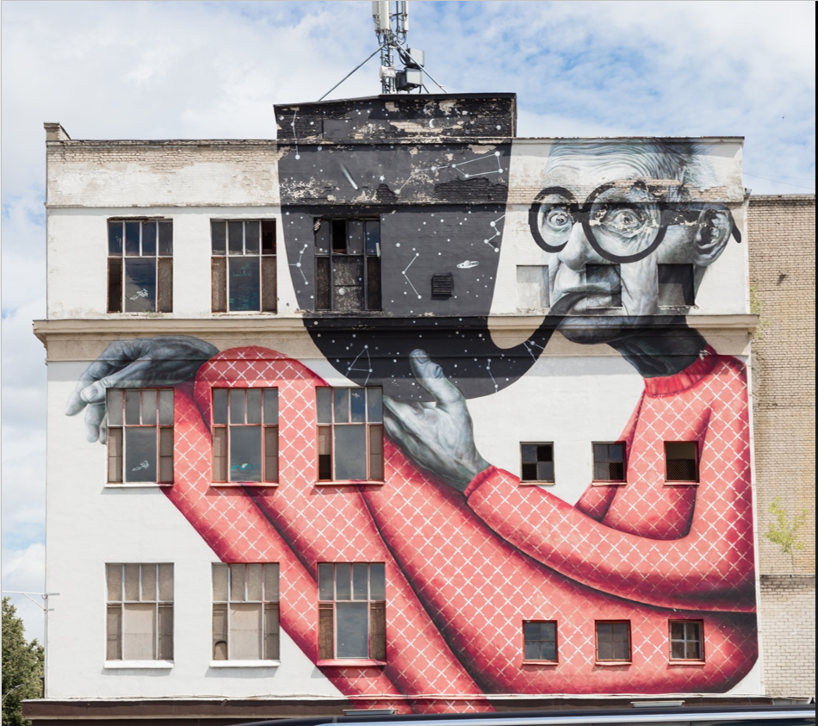

Tools/Equipment (optional)
- Mobile Device
- Laptop
- Desktop
- Chromebook
- Tablet

Software
- Adobe Illustrator
- Vectr
- Inkscape
- Alternative To

Journals/Magazines:
- Adobe Create Digital Magazine
- Photo News

Videos
- GCFLearnFree.org
- Adobe Creative Cloud
- Monkey’s Dream
- Adobe for Education

Websites for Teachers
- PetaPixel
- Adobe Education Exchange

Instructional Strategies
- The lessons, activities, and assignment have been scaffolded
- The lessons, activities, and assignment have been created using different forms of media and are multi-device supported
- The learner is encouraged to revise their work using a living (collaborative) document shared with the teacher

Motivational Strategies
We are all creators! The lessons, activities, and assignments have been created to allow learners of all abilities to build on their understanding of graphic design and create a meaningful product.
Understanding the conscious and subconscious impact of design and colour empowers the learner. How can they use this knowledge to influence how others perceive their work by applying these simple principals?

The Hook/Motivational Strategies
We are all creators! The lessons, activities, and assignments have been created to allow learners of all abilities to build on their understanding of graphic design and create a meaningful product.

Learning Goals and Success Criteria
- Identify how graphic design is used to convey a message
- Recognize the impact of colour on our everyday lives
- Discover the role of a graphic designer and possible career and education opportunities
- Compare different types of programs and applications choosing the best tool for their device
- Design an original work that can be used in their school or community

Overall and Specific Expectations in support of Ontario Curriculum Grades 9 -10 Technological Education

Overall Expectations
A1. Demonstrate an understanding of the fundamental concepts and skills required in the planning and development of a product or service, including the use of a design process and/or other problem-solving processes and techniques.
B2. Fabricate products or deliver services, using a variety of resources. (optional)
C2. Demonstrate an awareness of how various technologies affect society, as well as how society influences technological developments.
D2. Identify careers in various technological fields, and describe the educational requirements for them

Specific Expectations
A1.1 Describe a design process or other problem solving process for planning and developing products and/or services
A1.4 Incorporate appropriate technological concepts (e.g., aesthetics, control, environmental sustainability/ stewardship, ergonomics, fabrication/building/ creation, function, innovation, material, mechanism, power and energy, safety, structure, systems) in the design, fabrication or delivery, and evaluation of a product or service
B2.3 Meet all design criteria (e.g., technical requirements, type and quality of materials, appearance, ease of use, safety, timeline, client’s expectations) in creating a product or delivering a service;
C2.1 Describe some of the effects that technological innovations of the past have had on society (e.g., effects on health, on people’s ability to travel and communicate, on living standards, on education) and the economy (e.g., creation of new types of jobs, automation of factories);
D2.5 Demonstrate an understanding of the work habits that are important for success in the technology industries, as identified in the Ontario Skills Passport (e.g., working safely, teamwork, reliability, organization, working independently, initiative, self-advocacy, customer service);
D2.6 Develop and/or select pieces of work and other materials that provide evidence of their skills and achievements in technology, for inclusion in a portfolio (e.g., Passport to Safety certificate, project photographs, sketches, drawings, skills checklist, work logs).

Safety Considerations
Learners may need to practice physical distancing, and the school board adopted cleaning processes for shared tools. (e.g., shared tablets, keyboard, mice, etc.)

Applicable SAFEDocs and ToolSAFE videos
Please refer to the OCTE Safe Activity Foundations in Education Document for Communications Technology for any safety related materials.

Differentiation of the Project / Activities
Teachers may differentiate the project and its activities as they see fit based on their student learners. You may refer to the Differentiation Scrapbook to additionally take into account for learner ability, multiple intelligences, exceptional students, and ESL learners. The lessons in this document include visual, written, and video-based instruction. Some YouTube videos support Closed Captioning.
Students may choose to complete activities using the Google Read & Write Extension.
- Support for Google Read&Write
- Quick Reference Guide

Assessment and Evaluation
Examples:
- Kahoot – Colors, Colors, Colors
- Kahoot – Graphic Design
Rubric Included in Appendix A – TIJ10 Graphic Design Worksheet

Career and Industry Extensions
In Activity 1 – Explore the role of a graphic designer, the teacher may add to this activity by encouraging or assigning research into post-secondary opportunities, either at a local, provincial, or national level.

Ethical Considerations
In Activity 3 – The Power of Colour, the teacher may add to this activity by encouraging or assigning research into how colour is perceived by different cultures
In Assignment 1 – Create a Sticker, the teacher may choose to modify this project to encourage the creation of a sticker that promotes social awareness or environmental concerns

Activity 1 – Explore the Role of a Graphic Designer
Teacher presents visual content, videos and other examples to students, using the PowerPoint presentation:
1 Graphic Design – Role of the Graphic Designer
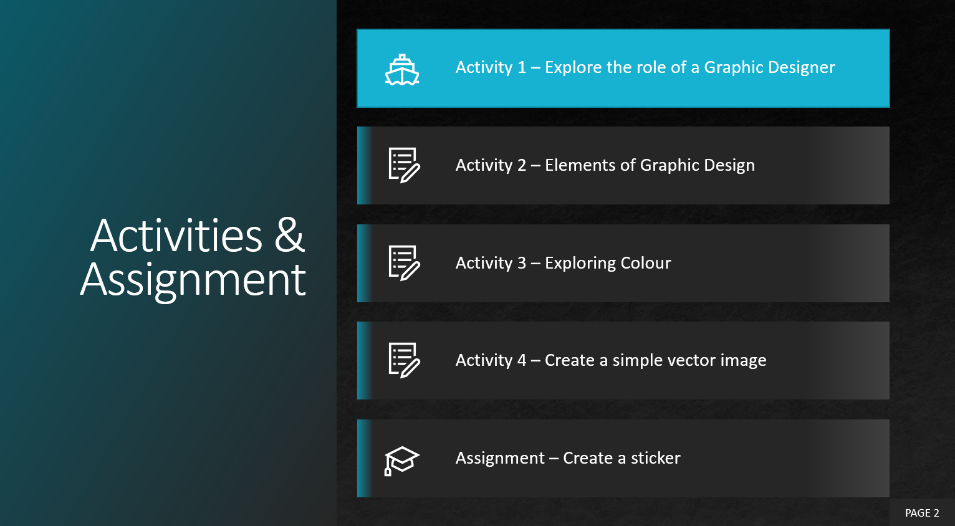
- What is the definition of Graphic Design?
- What is the role of a Graphic Designer?
- What can a Graphic Designer create?
Students may use Appendix A - TIJ 1O Graphic Design Worksheet with the PowerPoint

Activity 2 – Elements of Graphic Design
Teacher presents visual content, videos and other examples to students, using the PowerPoint presentation:
2 Graphic Design – Elements of Graphic Design
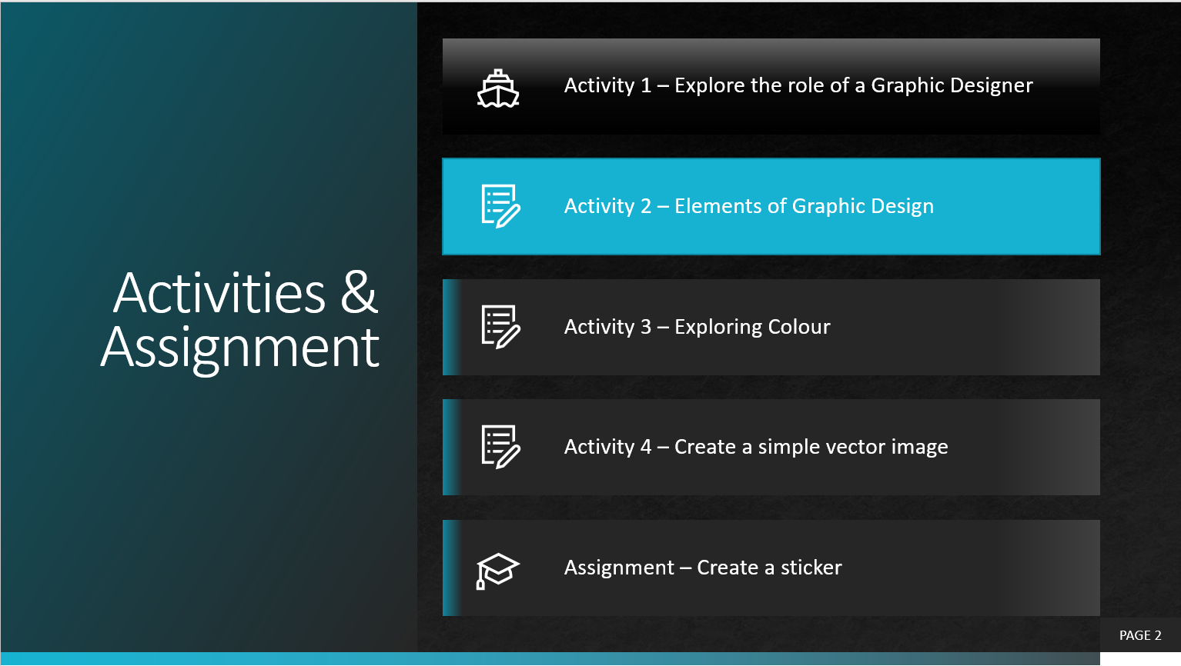
- Elements of Graphic Design
- Balance, Texture, Colour, Line, Form and Shapes
Students may use Appendix A - TIJ 1O Graphic Design Worksheet with the PowerPoint

Activity 3 – Exploring Colour
Teacher presents visual content, videos and other examples to students, using the PowerPoint presentation:
3 Graphic Design – The Power of Colour
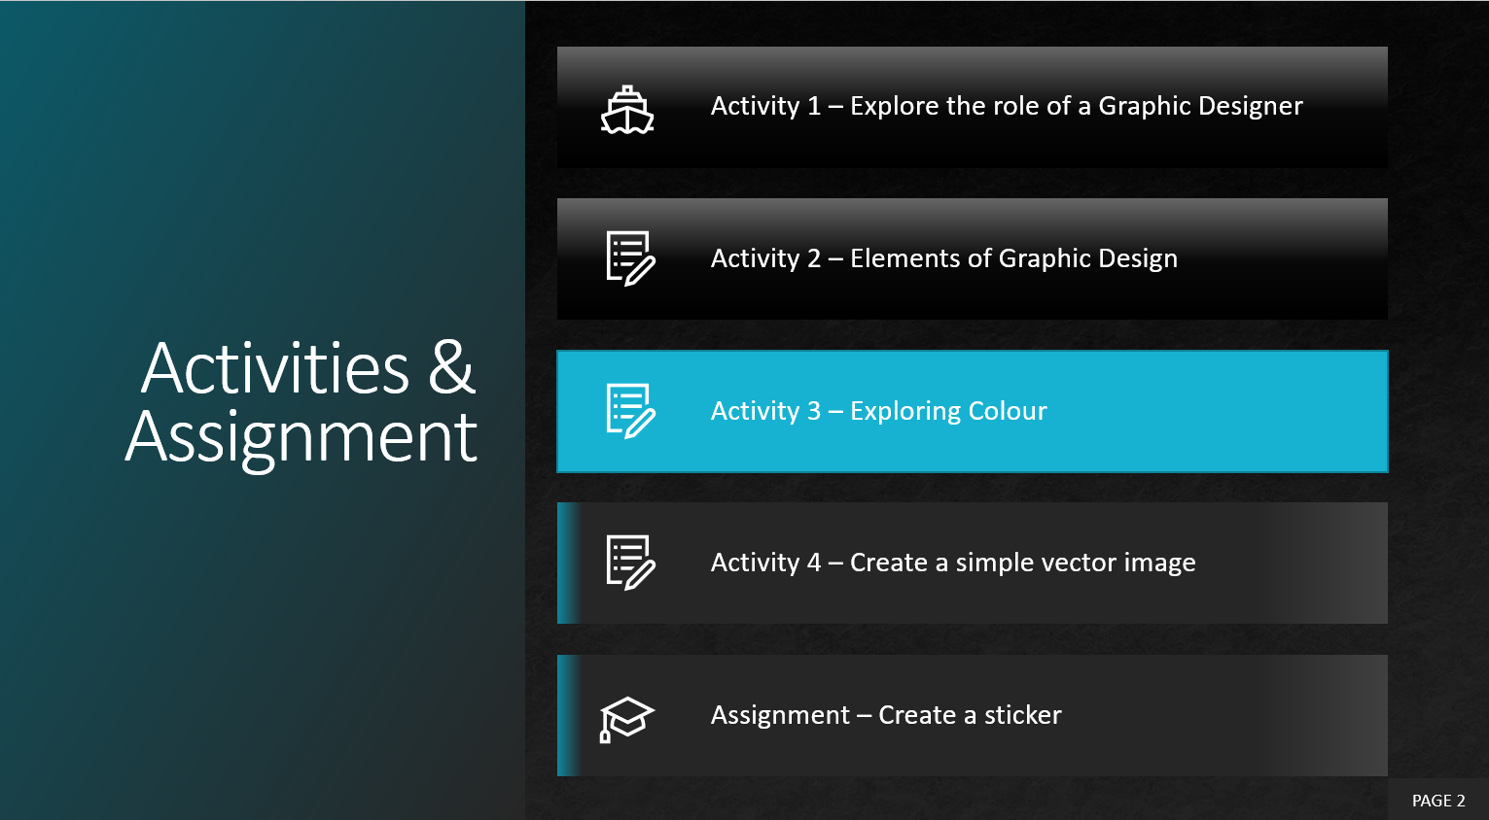
- Colour Theory
- Colour Models
- Colour Psychology
Students may use Appendix A - TIJ 1O Graphic Design Worksheet with the PowerPoint

Activity 4 – Create a Simple Vector Image
Teacher presents visual content, videos and other examples to students, using the PowerPoint presentation:
4 Graphic Design – Create a Vector
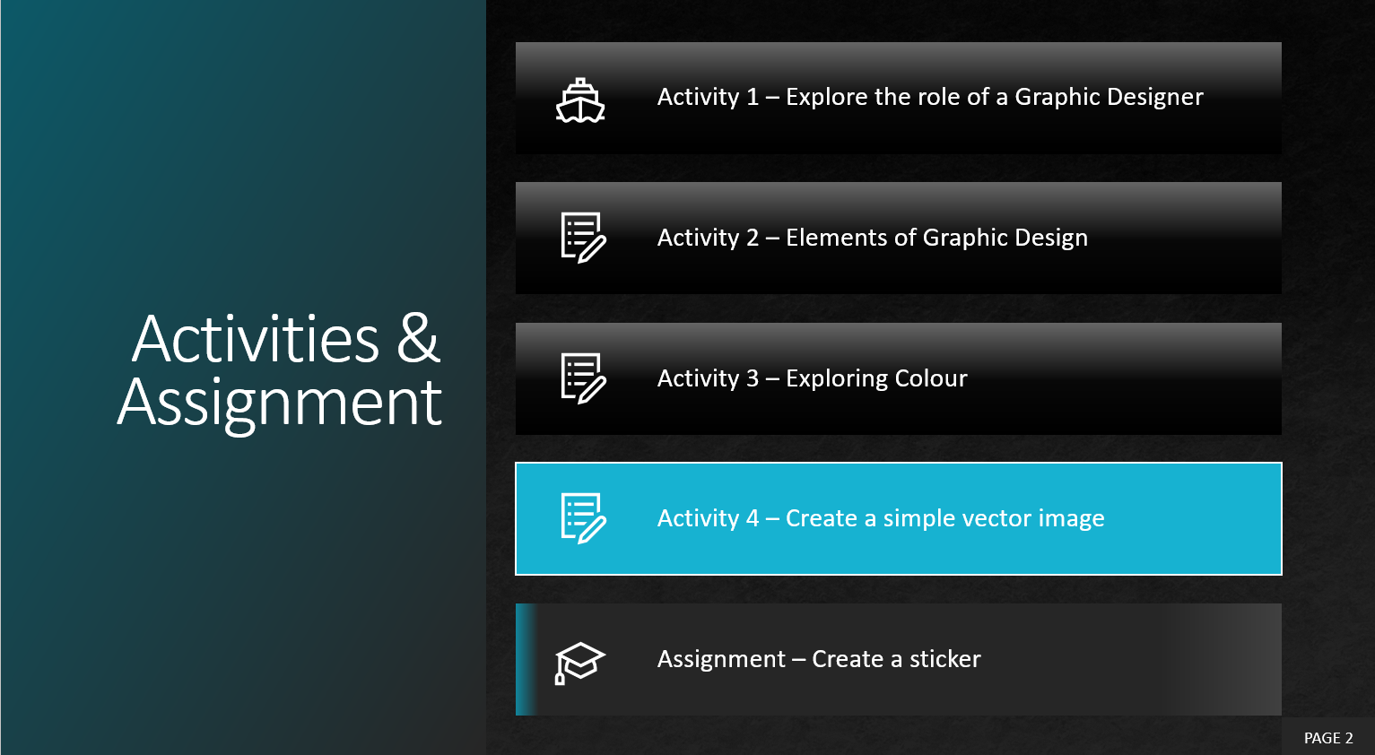
- What is a vector image?
- What software is used for vector images?
- Create a vector image
Students may use Appendix A - TIJ 1O Graphic Design Worksheet with the PowerPoint

Activity 5 – Create a Sticker Assignment
Teacher presents visual content, videos and other examples to students, using the PowerPoint presentation. Content links are also listed in Appendix B – TIJ1O Graphic Design Links
5 Graphic Design – Assignment – Create a Sticker
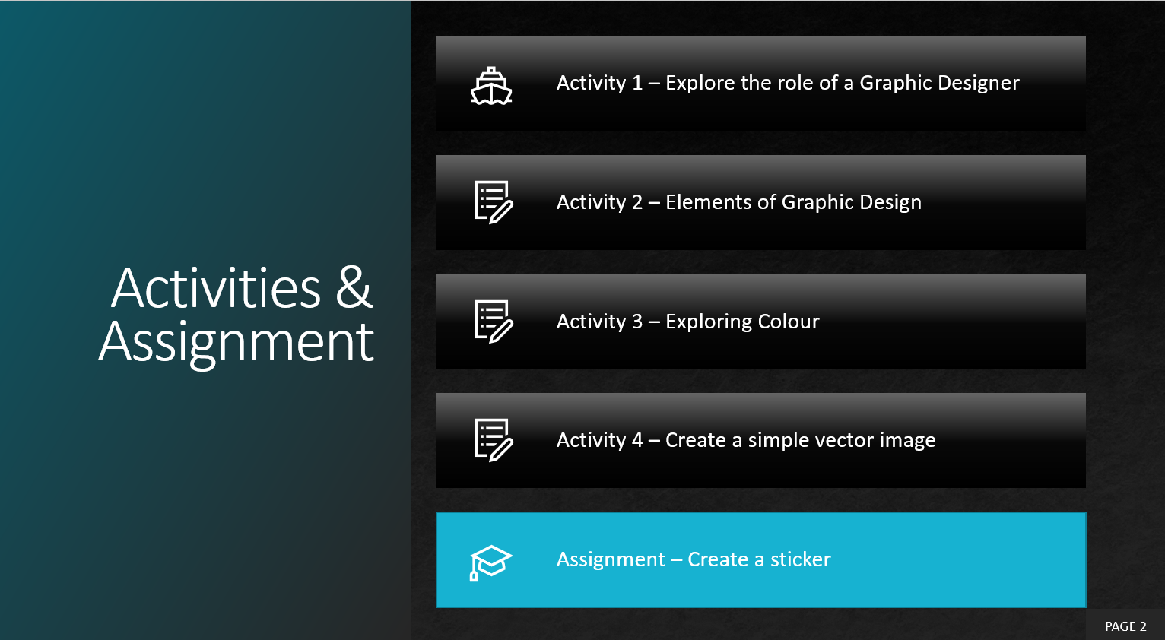
- Brainstorming
- Preproduction
- Production of a sticker
Students may use Appendix A - TIJ 1O Graphic Design Worksheet with the PowerPoint

Reflection or Design Report
Upon the conclusion of these lessons, activities, and assignment, the teacher is encouraged to reflect with their learners about:
- What went well?
- What area’s need to be improved?
- At what stage were you most engaged?
- How could these lessons, activities, and assignments better next time?
- What advice would you give to someone before starting this work?
- Provide one example of something that you learned.

Appendix A – TIJ 1O Graphic Design Worksheet

TIJ1O Graphic Design: Activities and Assignment Worksheet

Overview:
This worksheet has been designed as a collaborative document to be shared with your teacher. As you work your way through these activities and assignment, your teacher will provide feedback that you may choose to use in revising your work. Pay careful attention to the rubric at the bottom of this sheet, and the teacher comments as you go along.
*Helpful tip, make a backup of your work

Overall Expectations:
A1. Demonstrate an understanding of the fundamental concepts and skills required in the planning and development of a product or service, including the use of a design process and/or other problem-solving processes and techniques.
B2. Fabricate products or deliver services, using a variety of resources.
C2. Demonstrate an awareness of how various technologies affect society, as well as how society influences technological developments.
D2. Identify careers in various technological fields and describe the educational requirements for them.

Activities:
When starting each activity, complete all readings and watch all videos before beginning.

Questions:
Depending on your previous experiences, some of the material that is covered maybe a review, and for others, it may be brand new. It is expected that you will have questions as you work your way through this; if you do, I am here to help you. Please let me know ASAP so that you get the help you need and do not get frustrated

Resources
These FREE and Creative Commons Image Sites are a great place to find images, while respecting Copyright Laws in Canada
- StockSnap.io
- Burst (by Shopify)
- Unsplash
- The Noun Project
- Pexels
- Pixabay

Activity 1 – Explore the Role of a Graphic Designer

Question 1.1
Think about a logo for a company that you recognize Microsoft, Google, Snapchat, 7 UP…
- What is the name of the company that you thought about?
- Display their logo or provide a link to their logo.
- Name the people/roles that you think would have been involved in approving the logo.
Use the table below to answer the question
Company | Logo | People Involved
e.g.  Canada Goose | 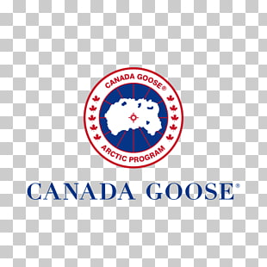 | company president, graphic designer, art manager, communications manager, focus groups, vice presidents

Question 1.2
Think about or research the types of jobs a graphic designer might work on, list six of these jobs
Graphic Designer Jobs

Question 1.3
What inspires you? When you watched the videos, you heard stories from Graphic Designers themselves. Think of Designs that have captured your attention or encouraged you to purchase something.
Research one graphic designer and answer the following questions.
- Who are they and why does the work that they have created mean something to you?
- What type of graphic design do they specialize in or are they a generalist?
- What type of education do they have?
- What or who inspires them?

Question (Optional)
Do you like to draw or sketch? Now is a great opportunity to showcase some of your favorite work. Take a photo with your mobile device and include it
Include your image or images here
Example 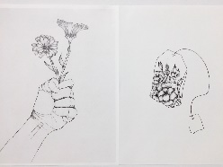

Activity 2 – Elements of Graphic Design

Question 2.1
Where was your eye drawn to on the image, why do you think that it was drawn to this area?

Question 2.2
Search and find on the internet three images where other types of lines are used (e.g. curved lines). What feeling do they convey to you? Do you think this was the intent of the creator? Place a copy of the image alongside your answer.

Question 2.3
How do the following companies use shapes to hide a hidden meaning? Look closely at the following companies’ logos. Describe what you see
Company | What Do You See
Pinterest
FedEx
Beats
Amazon
Baskin and Robbins
Hyundai
Wendy’s
Cisco

Question 2.4
Look around your house, or school try to find examples of books, cards, or posters that used different materials or created visual elements that demonstrate the use of texture. Use your mobile device to document and share at least two examples.
Include example 1 here
Include example 2 here

Question 2.5
Look at images on the internet, find two examples of Symmetrical and Asymmetrical photographs. Upload and share these images.
Include symmetrical image example 1 here
Include symmetrical image example 2 here
Include asymmetrical image example 1 here
Include asymmetrical image example 2 here

Question 2.6
What are three things that you learned from watching Fundamentals – Beginning Graphic Design that you did not know before.
1.
2.
3.

Activity 3 – The Role of Colour

Question 3.1
Choose and list three signs from your school, mall, or community center (e.g. EXIT) what colours are used to help communicate the message? What impact do you think they would have if they were different shades of grey?
1.
2.
3.

Question 3.2
Locate and analyze an image from the internet that you think uses too many colours. Explain one or two things that the creator could have done differently to have made this image more effective.
Include a copy of the image here
Include your answer here

Question 3.3
Display five logos, or signs from different Canadian companies. Think about what you have just learned watching the videos, how do the colours that they have chosen to support their brand/message?
Logo | Message

Question 3.4
Create a Positive Colour Association and a Negative Colour Association chart for three of the following colours – Black, Purple, Brown, Grey and Magenta. Include one image that represents one of the positive or negative Colour associations that you have chosen.
Black
Positive Colour Association | Negative Colour Association
Include Image Here
Purple
Positive Colour Association | Negative Colour Association
Include Image Here
Grey
Positive Colour Association | Negative Colour Association
Include Image Here
Brown
Positive Colour Association | Negative Colour Association
Include Image Here
Magenta
Positive Colour Association | Negative Colour Association
Include Image Here

Activity 4 – Create Vector Images
Now it is your turn, choose a Vector Image Program or Application that works for you! You can choose from one of the three applications that have detailed descriptions or select one from the list or your search.
Follow two or more step by step tutorials and submit your work here as a .png file (if you need help saving as a .png file just ask )
Include Image Here
Include Image Here
Include Image Here
Include Optional Image Here

Assignment 1 – Create a Sticker
Task: You will create an effective graphic design that demonstrates complex, multi-step creations using a variety of tools, to convey an impactful message, sentiment, or emotion based on your research. In this assignment you will apply all your learning in the creation of a sticker for either your school or community.
EVIDENCE OF LEARNING & SKILL DEVELOPMENT – Include any relevant links below
Vector or Graphic Design Project Components | Check | Link to evidence of completion
Inspiration(s) | ✔️ | Functional link(s)
Tutorial(s) | ✔️ | Functional link(s) to tutorials used for knowledge & Skill development.
Copy of Final Product exported for multi-screen viewing (.pdf or .png or .jpg) | ✔️ | Functional link to final product! THANK YOU!
Time: 2 hours
Step 1: Research what type of sticker is needed in your school or community? Where the sticker will go (example: floor, wall, window, ceiling, etc.). Document and share your research.
Step 2: Pre-plan sketch out the design for your sticker or use your computer and piece elements together from the internet
Step 3: Use a Vector program/application to create your sticker
- Use any tutorial to help you with your creations
Step 4: Share your sticker, or export your sticker and submit (sharing or exporting depends on the application or program that you are using)
Sticker Example:
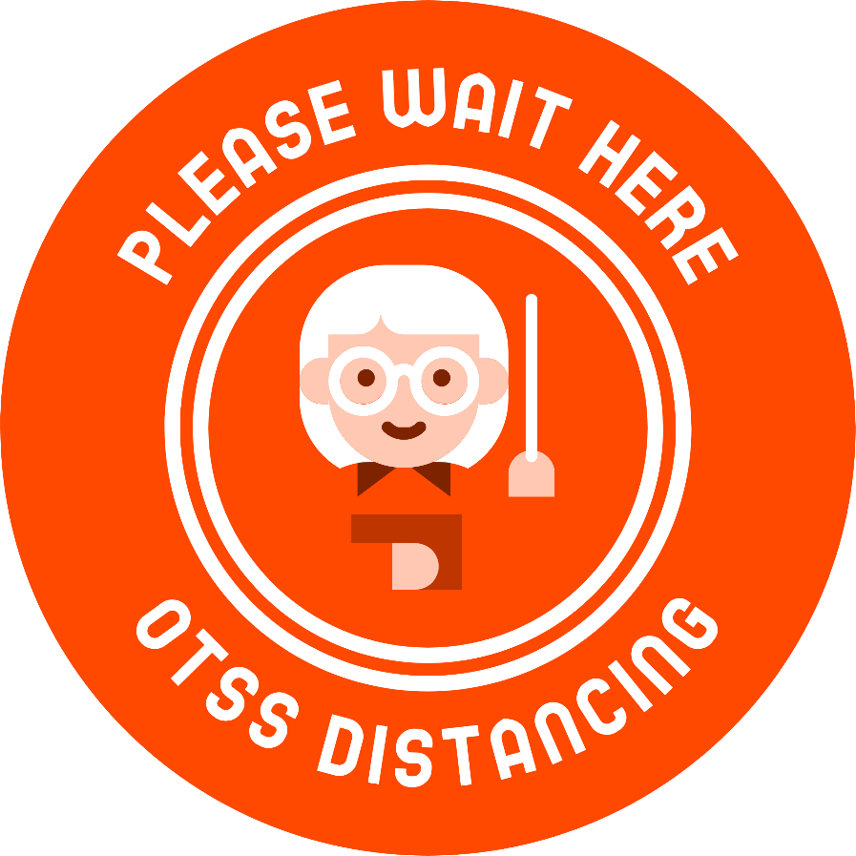
Submit: Submit your design below, also a reason why you created this project and the final product

Rubric Description
- The final product is an accumulation of your design choices and skills
- Demonstrating skills developed through your tutorial work and relating to your Inspiration Document.
- Exporting to specific file type (.ai, .svg .pdf or .png or .jpg)
- Creative appeal needs to elicit an emotional response from the audience

Assignment 1 – Create a Sticker Rubric
Expectation | Level 4 | Level 3 | Level 2 | Level 1 | R
Communication: define project objectives and performance criteria precisely.
Overall Expectation: C2
Research type of sticker needed | Defines and explains project objectives, process & reflection with profound detail. | Defines and explains project objectives process & reflection with considerable detail. | Defines and explains project objectives, process & reflection with some detail. | Did not define or explain project objectives, process & reflection. | Did not submit prior to execution of sticker
Thinking: Use a variety of planning techniques and tools when creating plans for communications technology projects.
Overall Expectation: A1
Preplanning Submitted Sketch or Design | Uses a variety of planning techniques and tools when creating plans for communications technology projects with a high degree of logic. | Uses a variety of planning techniques and tools when creating plans for communications technology projects with considerable logic. | Uses a variety of planning techniques and tools when creating plans for communications technology projects with some logic. | Uses a variety of planning techniques and tools when creating plans for communications technology projects with limited logic. | Did not submit prior to execution of sticker
Application: Produce rich media products that conform to evolving industry standards and formats. Overall Expectation: C2
Completed Sticker | Produces rich media products that conform to evolving industry standards and formats with a high degree of fluency. | Produces rich media products that conform to evolving industry standards and formats with considerable fluency | Produces rich media products that conform to evolving industry standards and formats with some fluency. | Produces rich media products that conform to evolving industry standards and formats with limited fluency. | Does not meet the minimum requirements, please redo, and resubmit

Appendix B – TIJ1O Graphic Design: Watch & Learn Links and Read & Learn Links

Activity 1 – Explore the Role of a Graphic Designer
Watch & Learn – Role of a Graphic Designer  The Secret World of Annie Atkins, Graphic Designer for Films I Adobe Creative Cloud  https://www.youtube.com/watch?v=flMespYYwTw | 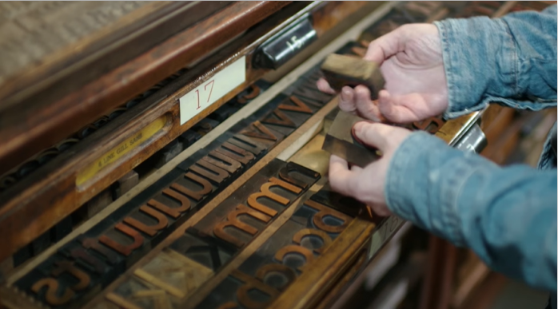
Watch & Learn – PBS Digital Studios  The Universal Arts of Graphic Design  https://www.youtube.com/watch?v=sTi5SNgxE3U&list=PLpQQipWcxwt9U7qgyYkvNH3Mp8XHXCMmQ&index=2 | 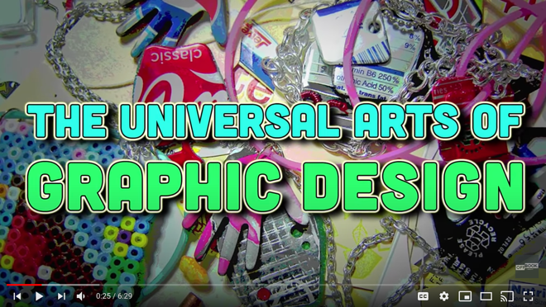
Watch & Learn – Design Careers  Lexi Fontein talks Graphic Design  https://www.youtube.com/watch?v=Ahy3EvFPJwM&list=PLpQQipWcxwt9U7qgyYkvNH3Mp8XHXCMmQ&index=19 | 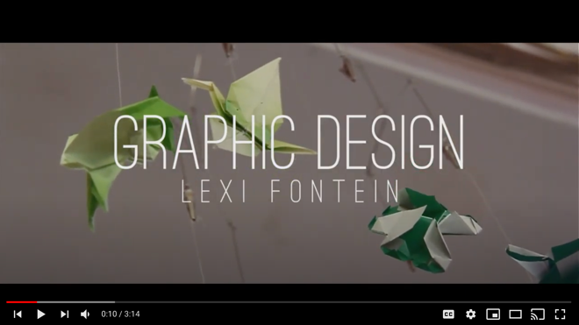
Watch & Learn – Day at Work  Maurice Woods talks Graphic Design  https://www.youtube.com/watch?v=BmBK0_vbYnY&list=PLpQQipWcxwt9U7qgyYkvNH3Mp8XHXCMmQ&index=15 | 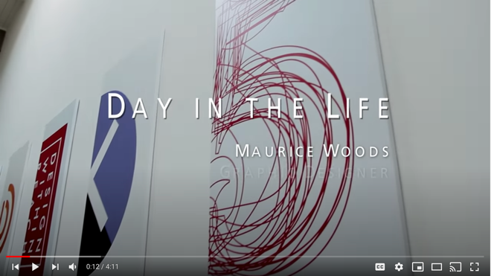
Watch & Learn – Nike Talent Presents  Day in the Life with Nike Design  https://www.youtube.com/watch?v=XfrK-n-ek-E | 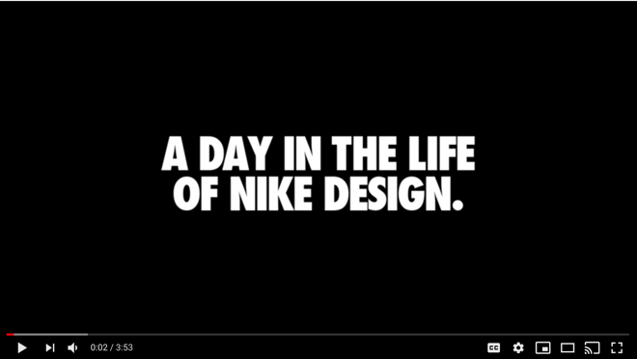

Activity 2 – Elements of Graphic Design
Watch & Learn – Fundamentals  Beginning Graphic Design  https://www.youtube.com/watch?v=YqQx75OPRa0&list=PLpQQipWcxwt9U7qgyYkvNH3Mp8XHXCMmQ&index=3 | 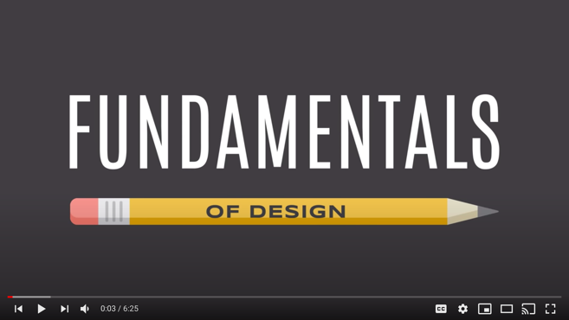
Watch & Learn – Beginning Graphic Design
Images
https://www.youtube.com/watch?v=MELKuexR3sQ&list=PLpQQipWcxwt9U7qgyYkvNH3Mp8XHXCMmQ&index=8
Watch & Learn –How Stamps Get Designed  Stamp Design - Antonio Alcalá  https://www.youtube.com/watch?v=eKh3lq6SV84&list=PLpQQipWcxwt9U7qgyYkvNH3Mp8XHXCMmQ&index=9 | 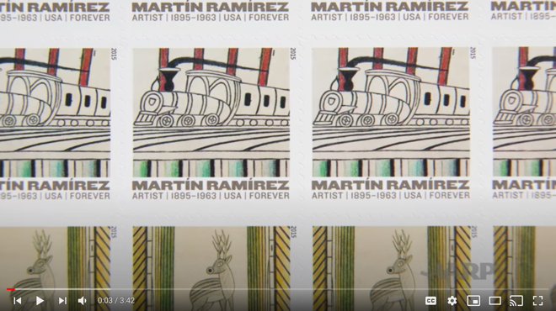
Watch & Learn –How Stamps Get Designed  2019 The Best Designs In The World  https://www.youtube.com/watch?v=HCHzExdKeRM | 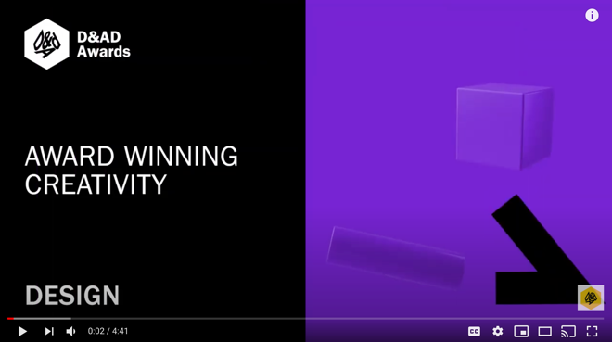

Activity 3 – The Power of Colour
Watch & Learn – Beginning Graphic Design  Color  https://www.youtube.com/watch?v=_2LLXnUdUIc&list=PLpQQipWcxwt9U7qgyYkvNH3Mp8XHXCMmQ&index=6 | 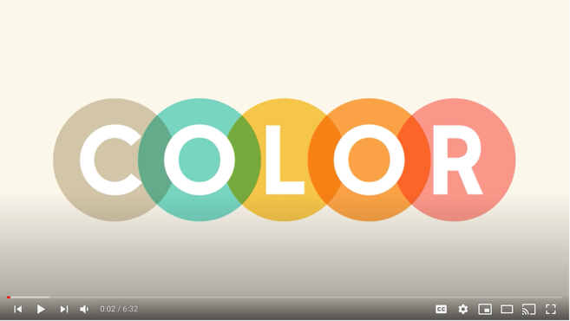
Watch & Learn – How to Use Colour  Colour Basics  https://www.youtube.com/watch?v=QkCVrNoqcBU | 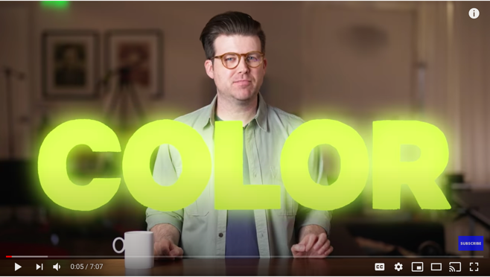
Read & Learn – Beginning Graphic Design  Colour A Closer Look  https://edu.gcfglobal.org/en/beginning-graphic-design/color/1/ | 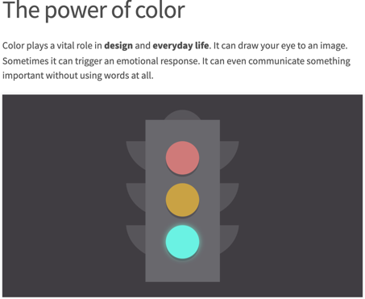
Watch & Learn – Photoshop  How to Change the Colour of Anything  https://www.youtube.com/watch?v=baW9jj0gs0w | 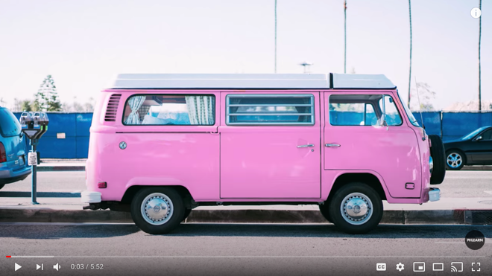
Watch & Learn – Understanding Colour Profiles  RGB vs CMYK  https://www.youtube.com/watch?v=nkYqX1diJlo | 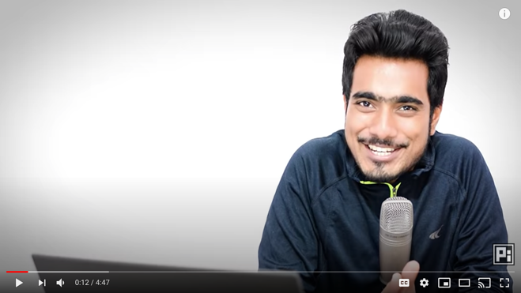
Watch & Learn – Colour Psychology  What Do Colors Mean and How Do They Affect Consumers?  https://www.youtube.com/watch?v=x0smq5ljlf4 | 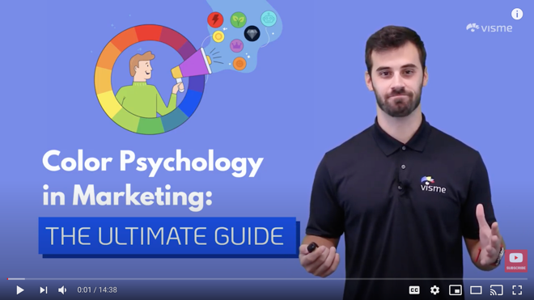
Watch & Learn – Colour Beginner Guide  Color Theory for Noobs  https://www.youtube.com/watch?v=AvgCkHrcj90 | 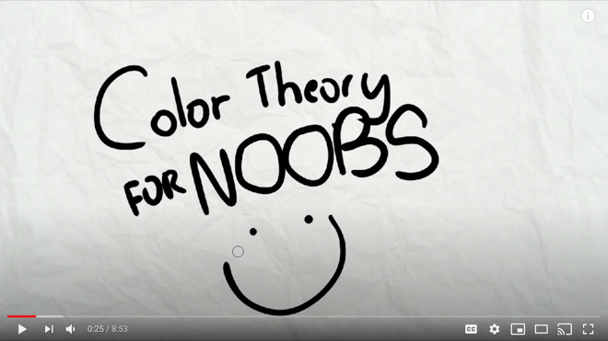
Read & Learn – Colour Psychology
How Colour Meaning Affect Your Brand
https://www.oberlo.com/blog/color-psychology-color-meanings

Activity 4 – Create Vector Images
Watch & Learn – Vector Graphics  What are Vector and Raster Graphics  https://www.youtube.com/watch?v=-Fs2t6P5AjY | 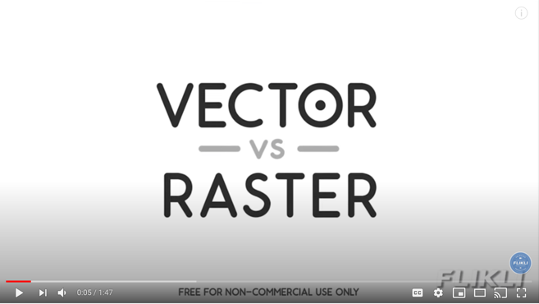
Watch & Learn – Buddy Media  Raster and Vector Graphics  https://www.youtube.com/watch?v=p2thSkOa_Xg | 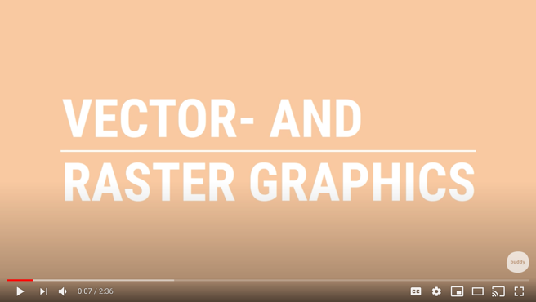
Adobe Illustrator Tutorials
Create an Icon
https://www.youtube.com/watch?v=e3xwlCCa2pk&list=PLB7pbNktGmfQPL3HocT2ZSXItntbFeCir
Adobe Illustrator Tutorials
Create a Digital Badge
https://www.youtube.com/watch?v=WWdQyK93-3s&list=PLB7pbNktGmfQPL3HocT2ZSXItntbFeCir&index=3
Adobe Illustrator Tutorials
Create a Graphic Portrait (Part 1)
https://www.youtube.com/watch?v=JAkbUWoig9Y&list=PLB7pbNktGmfQPL3HocT2ZSXItntbFeCir&index=4
Adobe Illustrator Tutorials
Create a Graphic Portrait (Part 2)
https://www.youtube.com/watch?v=ddaxv-2LMK4&list=PLB7pbNktGmfQPL3HocT2ZSXItntbFeCir&index=5

Inkscape Tutorials and Download Link
Lesson 1 – Interface and Basic Drawing
https://www.youtube.com/watch?v=8f011wdiW7g
Lesson 2 – Shape Tools and Options
https://www.youtube.com/watch?v=LEjlKhVnJgU
Lesson 3 – Fill and Stroke Settings
https://www.youtube.com/watch?v=o86MLSQHtMg
Lesson 4 – Groups, Levels, and Selection
https://www.youtube.com/watch?v=D_53Cb9aR0c
Lesson 5 – Exporting Images
https://www.youtube.com/watch?v=67-UDoYZG8U
Lesson 6 – Text and Fonts
https://www.youtube.com/watch?v=W9y_D90L8Jo
To Download Inkscape Click Here
https://inkscape.org/about/

Vector Tutorials and Web Link
Lesson 1 – Getting Started
https://vectr.com/tutorials/getting-started-tutorial/
Lesson 2 – Sharing/Exporting Your Work
https://vectr.com/tutorials/real-time-sharing-vectr-projects/
Lesson 3 – Create a simple poster
https://vectr.com/tutorials/how-to-create-a-simple-flyer-or-poster/
Lesson 4 – Create a logo
https://vectr.com/tutorials/what-are-iconic-logos-and-how-to-create-one/
Lesson 5 – Create a Typographic Logo
https://vectr.com/tutorials/creating-typographic-logo/
To Access Vectr Click Here
https://vectr.com/

References
21st Century Competencies: Foundation Document for Discussion. Phase 1: Towards Defining 21st Century Competencies for Ontario, Winter 2016 Edition, 2016 http://www.edugains.ca/resources21CL/About21stCentury/21CL_21stCenturyCompetencies.pdf
Copyright Information for Teachers, Council of Ministers of Education, Canada website https://www.cmec.ca/466/Copyright_Information_for_Teachers.html
Course Codes for Emphasis courses in the Revised Curriculum: Technological Education, Grades 11 and 12, 2009 http://www.edu.gov.on.ca/eng/curriculum/secondary/techedemphasiscourses.pdf
Google Read & Write (by texthelp), 2020 https://chrome.google.com/webstore/detail/readwrite-for-google-chro/inoeonmfapjbbkmdafoankkfajkcphgd
Graphic Design – Create a Vector (PowerPoint presentation), 2020 http://www.octe.ca/application/files/8415/9252/5721/4__Graphic_Design_-_Create_Vectors.pptx
Graphic Design – Assignment – Create a Sticker (PowerPoint presentation), 2020 http://www.octe.ca/application/files/7915/9252/5842/5__Graphic_Design_-_Assignment.pptx
Graphic Design – Elements of Graphic Design (PowerPoint presentation), 2020 http://www.octe.ca/application/files/4615/9252/5550/2__Graphic_Design_-_Elements_of_Graphic_Design.pptx
Graphic Design – Role of the Graphic Designer (PowerPoint presentation), 2020 https://www.octe.ca/application/files/9615/9745/6512/1_Role_of_Graphic_Designer.pptx
Graphic Design – The Power of Colour (PowerPoint presentation), 2020 http://www.octe.ca/application/files/4115/9252/5633/3__Graphic_Design_-_The_Power_of_Colour.pptx
Growing Success: Assessment, Evaluation, and Reporting in Ontario Schools, First Edition, Covering Grades 1 to 12, 2010 www.edu.gov.on.ca/eng/policyfunding/growSuccess.pdf
Learning for All – A Guide to Effective Assessment and Instruction for All Students, Kindergarten to Grade 12, 2013 http://www.edu.gov.on.ca/eng/general/elemsec/speced/LearningforAll2013.pdf
OCTE Safe Activity Foundations in Education Document for Communications Technology https://www.octe.ca/application/files/5515/3796/3096/SAFEdoc_COM.pdf
Quick Reference Guide (by texthelp), 2020 https://www.texthelp.com/Uploads/MediaLibrary/texthelp/US-Training-Documents/Read-Write-for-Google-Chrome-Quick-Reference-Card.pdf
The Differentiated Instruction Scrapbook http://www.edugains.ca/resourcesDI/EducatorsPackages/DIEducatorsPackage2010/2010DIScrapbook.pdf
The Ontario Curriculum, Grades 9 and 10: Technological Education, 2009 (revised) http://www.edu.gov.on.ca/eng/curriculum/secondary/teched910curr09.pdf
The Ontario Curriculum, Grades 11 and 12: Technological Education, 2009 (revised) http://www.edu.gov.on.ca/eng/curriculum/secondary/2009teched1112curr.pdf

