DMADV Project Examples

The DMADV (Define, Measure, Analyze, Design, and Verify) methodology, a key component of Six Sigma, has proven to be an effective approach for designing and improving processes across a wide range of industries. Its data-driven and customer-centric focus helps organizations identify the root causes of problems, develop innovative solutions, and create new processes that enhance efficiency and customer satisfaction.
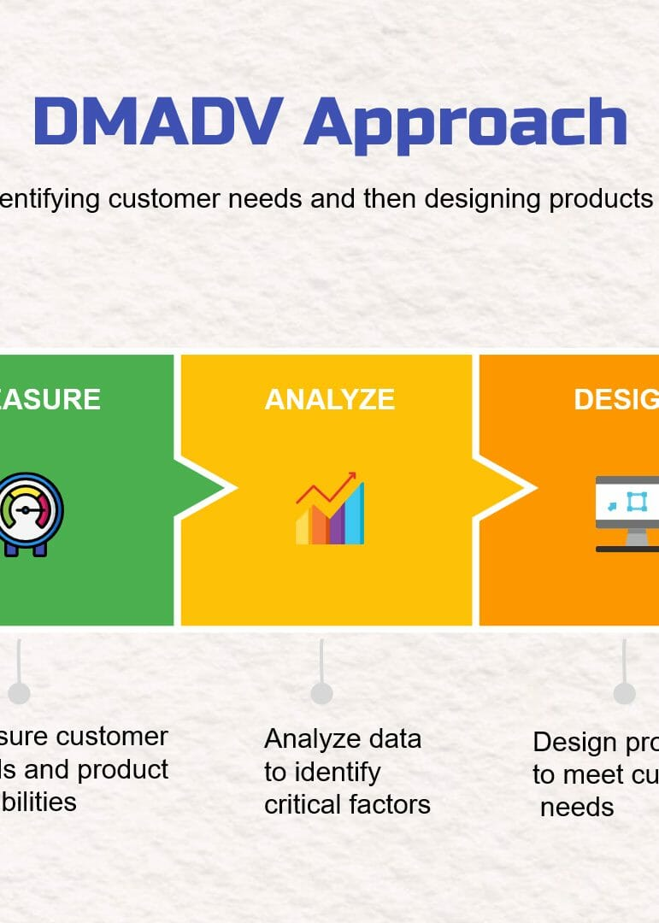
In this post, we will explore five industries—healthcare, manufacturing, financial services, retail, and education—and examine how the DMADV methodology can be applied to address various challenges and optimize processes within each industry.

Healthcare Industry:
a. Designing a new patient scheduling system to reduce wait times and optimize the use of resources.
b. Developing a telemedicine platform to improve patient access to medical professionals and services.
c. Creating a standardized process for handling electronic medical records to enhance data security and privacy.
d. Establishing an efficient and effective process for prescription refills, minimizing errors and delays.
e. Designing a new patient triage system to prioritize cases and optimize the use of emergency department resources.

Manufacturing Industry:
a. Developing a new production line layout to reduce bottlenecks and increase overall efficiency.
b. Designing a new quality control process to minimize defects and improve product reliability.
c. Creating a new supply chain management system to optimize inventory levels and reduce lead times.
d. Establishing a preventive maintenance program to minimize equipment downtime and improve overall equipment effectiveness.
e. Designing a new process for product development, reducing time-to-market and ensuring successful launches.

Financial Services Industry:
a. Developing a new loan approval process to reduce processing time and improve customer satisfaction.
b. Designing a fraud detection system to minimize financial losses and protect customer information.
c. Creating a streamlined onboarding process for new clients to enhance their experience and reduce administrative work.
d. Establishing a new investment management system to optimize portfolio performance and manage risks.
e. Designing a user-friendly mobile banking app to increase customer engagement and satisfaction.

Retail Industry:
a. Developing a new inventory management system to optimize stock levels and reduce carrying costs.
b. Designing a new store layout to improve customer flow and enhance the shopping experience.
c. Creating an efficient order fulfillment process for online orders to reduce delivery times and improve customer satisfaction.
d. Establishing a new returns and exchanges process to minimize costs and enhance customer trust.
e. Designing a new customer loyalty program to increase customer retention and drive revenue growth.

Education Industry:
a. Developing a new online learning platform to enhance student engagement and improve learning outcomes.
b. Designing a new curriculum development process to ensure alignment with industry trends and standards.
c. Creating a streamlined admissions process to reduce processing time and improve the overall applicant experience.
d. Establishing a new student support system to address academic, emotional, and social needs more effectively.
e. Designing a new teacher evaluation process to identify strengths, areas for improvement and drive professional development.

Conclusion:
The DMADV methodology has demonstrated versatility and effectiveness in tackling complex problems and driving process improvements across diverse industries. By embracing this data-driven approach, organizations can foster a culture of continuous improvement, streamline operations, enhance customer satisfaction, and ultimately achieve greater success in their respective fields. The examples provided here serve as a testament to the power of DMADV in transforming processes and driving innovation, positioning organizations for long-term growth and competitiveness.

