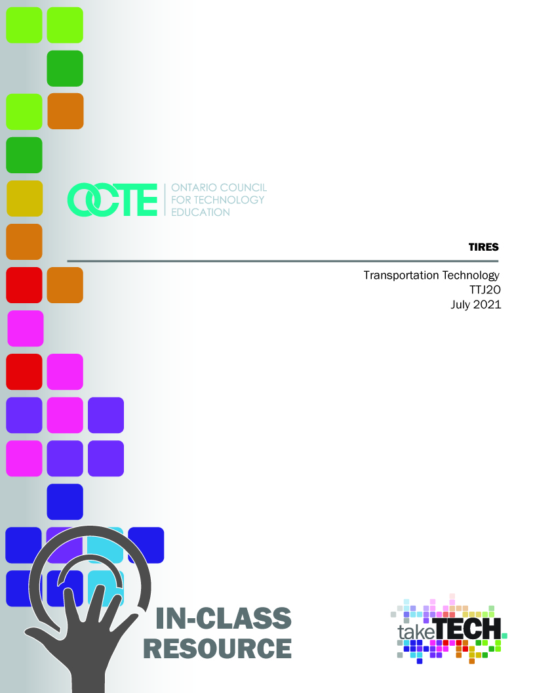

Table of Contents
Table of Contents 2
Introduction 2
Project Outline 2
Prior Knowledge 2
Student Activities 3
Activity 1 – The size of the tires and their date of manufacture. 3
Activity 2 – Tire inspection on a vehicle 8
When was the last time your tires were checked? 8
Activity 3 – Research: Potential employers and technological advances 11
Planning Notes 14
Skilled Trades and Apprenticeship Opportunities 14
Career and Industry Extensions 14
Continuum of Influence 14
Resources 16
Documents : 16
Lesson Plan 16
Answer sheets 22
Tools 22
Software 22
Web sites for teachers: 22
The Hook / Motivational Strategies 22
Learning Goals and Success Criteria 22
Overall and Specific Expectations in Support of Ontario Curriculum Grades 11 - 12 Technological Education 23
Overall Expectations 23
Specific Expectations 23
Safety Concerns 24
Applicable SAFEDocs and ToolSAFE Videos 24
Project Challenges 24
Differentiation of the Project / Activity 25
Assessment and Evaluation 25
Assessment for Learning 31
Assessment as Learning 31
Assessment of Learning 31
Environmental Considerations 31
Reflection or Design Report 31
Appendix A – Answer Sheet Activity 1 32
Appendix B – Answer Sheet Activity 2 36
Appendix C – Answer Sheet Activity 3 40
Appendix D – Continuum of Influence 43
References 44

Introduction
Code de cours: TTJ20
Broad base Technology: Transportation Technology
Destination: Open
Grade Level: 10
Prerequisite : None
Project Name: Tires

Project Outline
In this project, students will develop knowledge and skills related to basic tire knowledge. They will first discover the meaning of the numbers and letters that describe the tire size and where to find the manufacturer's recommendations. They will inspect a vehicle's tires for size, wear, and pressure. Finally, they will list the various places in their area where they could do an apprenticeship in the tire industry and discover the latest technological advances in tires.

Prior Knowledge
Students who have already repaired a flat tire on a vehicle (bicycle, motorcycle, automobile) and have seen severe winter conditions would be an asset in this project. Students who own a moped, motorcycle, go-kart, or a remote-control vehicle will have useful knowledge to stimulate interactions with the teacher.

Student Activities

Activity 1 – The size of the tires and their date of manufacture.
Activity Summary:
Students will discover the meaning of the numbers and letters written on the sidewall of tires. They will have to find this information on the tire, on the body of the vehicle, and in the owner's manual, in automotive repair software, or on the Internet. They will inspect the tire rubber and make a judgment about the safety of the tire. They will then produce an inspection report that will be given to the teacher

Steps to follow:
- With a synchronous learning time agreed upon by teachers and students, the teacher begins to lead students by asking key questions:

- Are tires important in your life?
- Will you ever have to buy tires?
- How many times a day do you put your life in the hands of tires?
- Have you ever been in a car accident where a car lost control?

- Have students go to a car or truck in the shop or at home and observe what is written on the sidewall of the tires. Have students take a few notes of what they observed on the tire.

- Ask students to share their observations and lead a discussion about the meaning of all these numbers and letters.

- Using the Powerpoint provided or the Transport Canada website, present the meaning of the information found on the sidewall of the tires. Emphasize the size of the tires and the date of manufacture. The teacher should also present what can affect the life of a tire and how to inspect the tire rubber and thread.

Meaning of the information written on the sidewall of the tires

- The teacher then presents the various places where the student can find the manufacturer's recommended dimensions.
  - Sticker inside the driver's door
  - Owner's manual
  - Auto repair software (ProDemand or other)

- The student should then perform the following work on a vehicle in the shop or at home. The student should take approximately thirty minutes to do the visual inspection and take pictures. The written report should also take about 30 minutes. Students should document their observations with photographs taken with a personal device.

Name: ___________________________
Tire sizes and their date of manufacture
- Find the manufacturer's recommended size on the sticker in the driver's door (sometimes the sticker can be located in the glove compartment or inside another door):

Attach the picture here

- Find the manufacturer's recommended size in the owner's manual, in a repair software or on the Internet.
Attach the picture here

- Using the information found in questions 1 and 2, write the manufacturer's recommended size for the vehicle:

  - Front tire: _____________________________________________
  - Rear tire: ____________________________________________
  - Spare tire (if available): ______________________________

- Take a picture of the sidewall of the inspected vehicle's tire and find the following information about the tire:
Attach the picture here:

Information to be found on the sidewall of the tire | Student’s answers
Tire make and model
Width of tire (in mm)
Tire height (in %)
Wheel rim diameter (in inches)
Tire load rating
Tire speed rating
Date manufactured

- A) Are the vehicle's tires within the manufacturer's recommended size? Use the information found in the PowerPoint and from the class discussion ____________________________________________________________________________________________________________________________________________________________________________________________________________________________________________________________________________________
- B) Are the vehicle's tires safe for their age and rubber condition. Use the information found in the PowerPoint, the class discussions with the teacher and by observing the condition of the rubber of the four tires and their date of manufacture.
____________________________________________________________________________________________________________________________________________________________________________________________________________________________________________________________________________________
Attach a photo of the date of manufacture of the tire:

Activity 2 – Tire inspection on a vehicle
Activity Summary:
Students will be required to inspect a vehicle's tires at home or in the school shop. They will have to determine if the tires are inflated to the correct pressure, have even wear and are safe for the road. They will then produce an inspection report that will be given to the teacher.
Steps to follow:
- With a synchronous learning time agreed upon by teachers and students, the teacher begins to lead students in asking key questions:

- - What is the life span of a car, motorcycle, bicycle, farm vehicle tire, etc.?
- - What is the consequence of having an under-inflated tire on your bike?
- - What is the consequence of having an overinflated tire on your bike?
- - What is a tire rotation and why is it important to do it at regular intervals?
- - What are the risks of using a tire with excessive tread wear

- The teacher asks the students to go to a bicycle, car or truck in the shop or at home and visually observe the tire pressure and wear. Students should make a few notes about what they observed in terms of tire pressure and wear on each tire on the vehicle, making sure to record the position of the tire.
- Have students share their observations and lead a discussion about manufacturer's recommended pressure and a tread with safe wear.
- Using the Powerpoint provided or the Transport Canada website, present a lesson on recommended tire pressure, checking tire pressure, checking for tire wear and uneven tire wear.

When was the last time your tires were checked?
- The teacher then presents the different places where the student can find the pressure recommended by the manufacturer.
  - Sticker inside the driver's door
  - Owner's manual
  - Auto repair software (ProDemand or other)
- The student should then perform the following work on a vehicle in the shop or at home. The student should take approximately 30 minutes to do the visual inspection and take pictures. The written report should also take about 1 hour to complete. Students should document their observations with photographs taken with a personal device.
The student may choose to present the following information using Google Slide or PowerPoint

Slide 1:
Title : Vehicle presentation
- Your name
- A picture of your parents' car.
- Identify the make, model and year of the vehicle.
Slide 2:
Title : Recommended tire pressure
- Insert a photo of the sticker (located in the driver's seat) that indicates the recommended tire pressure
- Identify the recommended tire pressure for the front tires, rear tires and spare tire with a pressure measurement unit.

Slide 3:
Title : Driver's side front tire inspection
- Insert a photo of the driver’s front tire that shows its overall condition.
- Inspection of the tire: did you observe any cracks in the rubber, rocks, a nail or screw in the tire, or uneven wear?
- Inspection of the tire tread. Is the tire wear safe? Show result with a picture of a depth gauge (if available) or with a Canadian quarter.

Slide 4:
Title : Passenger's side front tire inspection
- Insert a photo of the driver’s front tire that shows its overall condition.
- Inspection of the tire: did you observe any cracks in the rubber, rocks, a nail or screw in the tire, or uneven wear?
- Inspection of the tire tread. Is the tire wear safe? Show result with a picture of a depth gauge (if available) or with a Canadian quarter.

Slide 5:
Title : Driver's side rear tire inspection

- Insert a photo of the driver’s front tire that shows its overall condition.
- Inspection of the tire: did you observe any cracks in the rubber, rocks, a nail or screw in the tire, or uneven wear?
- Inspection of the tire tread. Is the tire wear safe? Show result with a picture of a depth gauge (if available) or with a Canadian quarter.

Slide 6:
Title : Passenger's side rear tire inspection
Insert a photo of the driver’s front tire that shows its overall condition.
- Inspection of the tire: did you observe any cracks in the rubber, rocks, a nail or screw in the tire, or uneven wear?
- Inspection of the tire tread. Is the tire wear safe? Show result with a picture of a depth gauge (if available) or with a Canadian quarter.

Slide 7:
Title : Objectivity
Answer the following questions:
- Are my parents' tires safe for the upcoming season? Justify your answer with two arguments.
- Why is it important to inspect tires regularly on a vehicle? Justify your answer with three arguments.

Activity 3 – Research: Potential employers and technological advances
Activity Summary
Students will have to locate on a map various potential employers related to the tire industry (tire creation/design, manufacturing, sales, installation, repair, retreading) for different types of vehicles (bicycle, motorcycle, automobile, heavy equipment, off-road vehicle, agricultural vehicles, etc.). They will also explore the various technological advances in tires in recent years by presenting a summary of three technological innovations in recent years.
Steps to follow:
Name: ________________________________

Research: Potential employers and technological advances.
- Using a tool like Google Map, explore your home with a radius of about 20 kilometers to find potential employers that would allow you to use the knowledge you have learned about tires.

- Find and copy a map similar to this one. Insert or paste the image into a word processor and identify the different businesses found with an arrow and the name of the business.
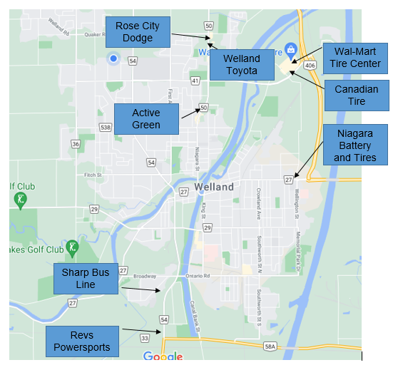
Ex.: Welland:

- Classify the employers found in a table that specifies the type of business they operate and their address. There may be more than one employer per type of business. Then estimate the number of employees in that business.

Ex. :
Company's name | Type of business | Address | Estimated number of employees
 | Bicycle repair shop
 | Motorcycle repair shop
 | Off-road vehicle repair shop
 | Auto repair shop
 | Heavy equipment repair shop
 | Farm vehicle repair shop
 | Industrial vehicle repair shop
 | Company of design and manufacture of tire
 | Others:

- If you worked in one of the businesses found above, how would you respond to a customer who asked you the following questions:

- I drive a pickup truck with P235/75R17 105T tires and I would like to have a tire that is more resistant to loads when I pull a loaded trailer. What tires do you recommend?

- I have the option of purchasing used tires mounted on a wheel, but with a slightly larger diameter. What would be the effect on my vehicle if I installed these larger tires? (Considerations: gas mileage, mileage/odometer on vehicle, speedometer, safety aspect)

- The tire industry is constantly evolving. There have been many technological innovations in recent years that allow vehicles to be safer and more efficient. Choose three technological innovations from recent years and present how these improvements make vehicles safer in a Google Slide or PowerPoint.

Here is a non-exclusive list of innovations you could choose from.

  - TPMS,
  - Nitrogen to inflate tires,
  - Tweel
  - Remote tire inflation
  - Tire recycling,
  - Tire wear and adhesion sensor
  - Uptis tire
  - Use of Sonja oil as an ingredient in tire rubber
  - Run-flat tire
  - Airless tires

Planning Notes
Teachers should provide some form of video conferencing to interview students during activities if the learning is online or have a vehicle for classroom/group learning. This way, teachers can assess a vehicle with their students.
Here are other suggestions,
- Some lessons could be supplemented by educational resources available on the Internet.

Skilled Trades and Apprenticeship Opportunities
The student may discover several businesses that would allow him/her to find an apprenticeship opportunity near his/her home. The knowledge gained may allow the student to begin an apprenticeship in a repair center, starting as a tire installation technician.
Careers where these skills can be used include:
- Alignment and Brakes Technician 310E
- Automotive Service Technician 310S

Career and Industry Extensions
By completing the three steps of the project, the student could develop an interest in tires. He or she might consider an apprenticeship in a tire repair shop. They could also consider working in a tire sales business or a company that manufactures or retreads tires for the different types of vehicles used in society.

Continuum of Influence
The teacher can talk about the importance of tires in our daily lives. The teacher can also make students realize that most adult will have to purchase new or used tires for a vehicle at some point in their lives. Therefore, it is important to have some knowledge about tires.

The full continuum of influence can be found in Appendix D.
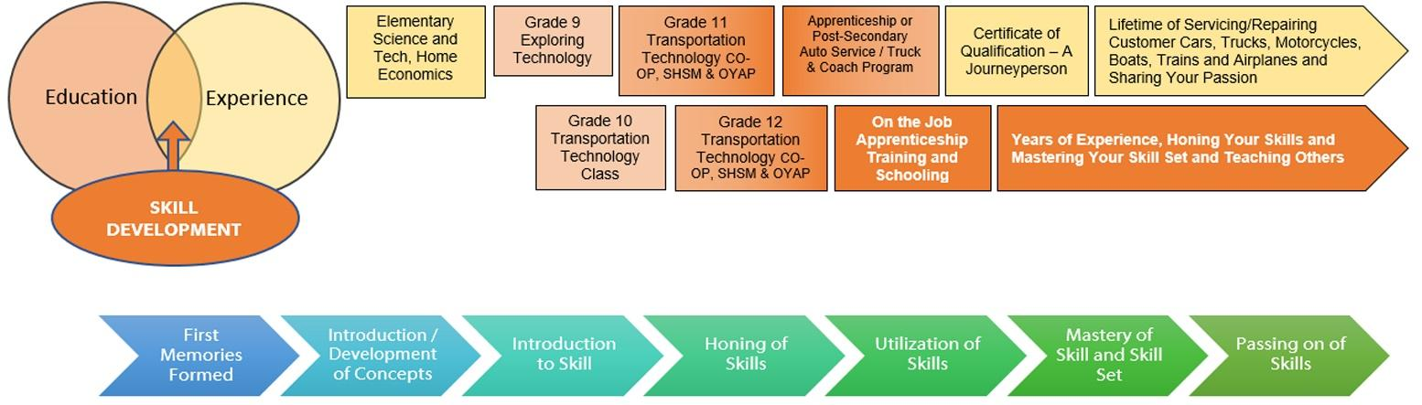

Resources

Documents:
PowerPoint on Tire inspection example for student.
PowerPoint on Tire pressure and wear.
PowerPoint on Tire size and age.

Lesson Plan
Tire sizes and their date of manufacture - Activity 1 - 110 minutes Level: 10 – TTJ2O
Learning Goals | At the end of the activity, students will be able to:  - Understand the meaning of the numbers and letters on the sidewall of a vehicle's tires.  - Find manufacturer's recommended dimensions on the vehicle, in a repair software, or on the Internet.  - Inspect a vehicle and determine if the tires meet the recommended dimensions.  - Find the tires manufacturing date and inspect whether the rubber is in good working condition. | Material:  A vehicle at home or at school
Success Criteria | The success criterion is:  - Inspect a vehicle and make judgments about tire size and age.
Activate student thinking (20 min) | Teacher asks students questions to stimulate interest:  - Are tires important in your life?  - Will you ever have to buy tires?  - How many times a day do you put your life in the hands of tires?  - Have you ever been in a car accident where the car lost control? | A video in which we see:  An accident where a vehicle loses control on the road due to lack of grip.  - vehicles with oversized tires.
Development of students' thinking (30 min)  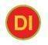 | Students will inspect a vehicle in the shop for tire dimensions and other useful information to stimulate discussion and sharing.  The teacher gives a lesson on the meaning of the numbers/letters on the sidewall of the tires. | Have a vehicle in the shop for demonstration  Accommodating Students with IEPs  Pairing the student with a high-performing student.
Consolidate student thinking (60 min) | Distribute Activity 1 in which the student must:  - find and take a picture of the manufacturer's recommended dimensions sticker.  - Find and capture the manufacturer's recommended tire size in a repair software program or on the Internet.  - Inspect the four tires and take a picture of the tire size and date of manufacture.  - Make a judgement on the size of the tires and their date of manufacture. | Have different vehicles available in the shop.  Have a camera available for students without cell phones.
Tire inspection on a vehicle – Activity 2 - 120 minutes Level : 10 – TTJ2O
Learning Goals | At the end of the activity, students will be able to:  Inspect a vehicle's tires and produce a professional report. | Material:  A vehicle at home or at school
Success Criteria | The success criterions are:  - Visually inspect tire tread for uneven wear.  - Measure tire pressure.  - Measure the tread with a wear gauge or 25c.  - Provide professional opinion in relation to tire safety.
Activate student thinking (15 min) | Teacher asks students questions to stimulate interest:  - What is the life span of a car, motorcycle, bicycle, farm vehicle tire, etc.?  - What is the consequence of having an under-inflated tire on your bike?  - What is the consequence of having an overinflated tire on your bicycle?  - What is a tire rotation and why is it important to do it at regular intervals?  - What are the risks of using a tire with excessive tread wear? | Support:  The teacher could have a bike with underinflated tires and a bike with overinflated tires to demonstrate.
Development of students' thinking (45 min) | - The teacher, using the Powerpoint provided or the Transport Canada website, presents a lesson on recommended tire pressure, checking tire pressure, tire wear and uneven tire wear  - Students inspect a vehicle in the shop and share their observations of tire wear and pressure. | Have a vehicle in the shop for demonstration  Accommodating Students with IEPs  Pairing the student with a high-performing student.
Consolidate student thinking (60 min) | Distribute Activity 2 in which the student must:  - inspect another vehicle in the shop or at home  - produce an inspection report using presentation software and several photographs.  - If available, the student will use a pressure gauge and wear gauge to produce a professional report. | Have different vehicles available in the shop.  Have a camera available for students without cell phones.  Have pressure gauges and wear gauges available.
Research : Potential employers and technological advances –
Activity 3 - 120 minutes Level : 10 – TTJ2O
Learning Goals | At the end of the activity, students will be able to:  - Find potential employers for a possible apprenticeship.  - Develop expertise in tire evolution. | Material:  Have computers available with Internet access.
Success Criteria | The success criterions are:  - Locate potential employers in the region on a map.  - Categorize the employers by industry and estimate the number of employees.  - Present three technological advances in tires.
Activate student thinking (20 min) | Teacher asks students questions to stimulate interest:  1. The teacher, with the help of the students, names different potential employers in their town or village.  2. Students then identify the different types of businesses that work with tires in their town or village. | Support:  A map of the region

Development of students' thinking (40 min) | - Students are to locate on a map of their area the various employers involved in the tire business.  - Students should select three technological advances in tires and identify how these advances make vehicles safer. | Accommodating Students with IEPs  Pairing the student with a high-performing student.
Consolidate student thinking (60 min) | Distribute Activity 3 in which the student must:  - Classify in a table, the different employers in the area according to the type of business they do.  - Estimate the number of employees at the businesses found.  - Produce a presentation that explains how the three technological advances are making vehicles safer. | Have computers available with Internet access.

Icon | Opportunity identified within the lesson
 | Assessment FOR Learning
 | Assessment AS Learning
 | Assessment OF Learning
 | Opportunity for educational differentiation according to the school environment
 | Audio/video (Video, Sound, PowerPoint, etc.)
 | Collection of information for assessment or evidence of learning purposes.
 | Search on the Internet or in a book
 | Professional dialogue

Answer sheets
Answer sheet Activity 1 (Appendix A)
Answer sheet Activity 3 (Appendix C)

Tools
If the student has access to a pressure gauge and a wear gauge, the project will have a more professional dimension when reporting the results of the inspection.

Software
Repair software would be an asset in this project.

Web sites for teachers:

Transport Canada : Riding On Air (Government of Canada)

The Hook / Motivational Strategies
Teachers may use any of the following instructional strategies; 3-Part lesson, lecture, storyboard, word wall, think-pair-share, placemat activity, rapid write, K-W-L, anticipation chart, ABC taxonomy, think aloud, analyzing text, Cornell note taking, exit ticket/ticket out the door, plus/minus/delta, etc.

Learning Goals and Success Criteria
By the end of this project students will be able to:
- Understand the identifications on the sidewalls of tires.
- Inspect tire sizes, pressure, and wear on a vehicle.
- Locate job and learning opportunities on a map of their city or town.
- Describe some technological innovations in tires in recent years.

Overall and Specific Expectations in Support of Ontario Curriculum Grades 11 - 12 Technological Education

Overall Expectations
A4. demonstrate an understanding of the technical and mathematical knowledge and skills required to properly maintain and repair vehicles, aircraft, and/or watercraft.
B3. perform basic service on various vehicle, aircraft, and/or watercraft systems and components.
C1. demonstrate an understanding of ways in which various aspects of the transportation industry affect the environment and ways in which harmful effects can be remedied or reduced.
C2. demonstrate an understanding of the relationship between various aspects of the transportation industry and society.
D1. demonstrate an understanding of and compliance with occupational health and safety regulations and standards in transportation technology.
D2. identify career opportunities in the transportation industry and the education and training required for them

Specific Expectations
A4.1 use appropriate resources (e.g., shop manuals, online information) to find information as required for basic maintenance and repair of vehicles and/or craft;
A4.2 report on work in progress (e.g., complete a work order, parts list, and/or journal) using appropriate documentation;
A4.3 apply appropriate mathematical and/or scientific principles, procedures, and terms and symbols when conducting and/or reporting on work on vehicles and/or craft (e.g., convert measures from US customary/British imperial units to metric units – pounds per square inch [PSI] to kilopascals [kPa], gallons to litres; calculate antifreeze-to-water ratio);
B3.2 perform appropriate measurements related to system components (e.g., tire pressure; chain, cable, and/or belt tension and wear; specific gravity of engine coolant; battery voltage), making any necessary adjustments to meet manufacturers’ specifications;

C1.1 research and report on ways in which the transportation industry affects the environment and on efforts being made to remedy or reduce harmful effects (e.g., improved production methods, automotive parts recycling), including ways of disposing of waste products (e.g., used oil, used batteries, used paint/thinners);
C2.1 research and report on the development of improved safety features in transportation technology (e.g., airbags, anti-lock brakes);
C2.2 describe recent technological innovations (e.g., related to performance, comfort, driveability, fuel economy, recycling of parts) in vehicles and/or craft;
D1.1 identify and explain the importance of legislation and regulations related to procedures and operations used in transportation technology facilities (e.g., Occupational Health and Safety Act [OHSA], Workplace Hazardous Materials Information System [WHMIS], Apprenticeship and Certification Act);
D2.2 identify a variety of career opportunities in the transportation industry (e.g., apprenticeship/ trade, parts retail, business ownership) and describe the secondary school pathways (i.e., selection of courses, programs, and experiential learning opportunities) that would provide the best preparation for these careers;

Safety Concerns
Activities at this resource are considered low risk. The vehicle being inspected must be immobilized by the owner, not the student. At no time should the student put any part of their body under the inspected vehicle. This is a visual inspection only. Proper ergonomics should be emphasized when sitting and working at the computer.

Applicable SAFEDocs and ToolSAFE Videos
This project has been established as an online or blended format. Should ask students to look under the hood or perform other inspections on vehicles, please refer to the OCTE SAFEDocs for Transportation Technology for safety documents.

Project Challenges
Some students may not have access to a vehicle at home to do an inspection. Some tires may not have all the correct identifications on the sidewall or the identifications may be illegible due to premature wear or dirt. Some students may live in a large city or small town and this could make it difficult to research the types of businesses.

Differentiation of the Project / Activity
Teachers can differentiate this project by having students research and inspect vehicles that are readily available or owned by themselves or family members. This could be a motorcycle, ATV, or any other form of transportation. They may also work on types of vehicles used primarily in their community such as farm vehicles, mining vehicles or cargo/passenger aircraft. Teachers can also refer to the Differentiation Scrapbook to take into account for learner ability, multiple intelligences, exceptional students, and ESL learners.
.

Assessment and Evaluation
Categories | 50-59% (Level 1) | 60-69% (Level 2) | 70-79% (Level 3) | 80-100% (Level 4)
Knowledge and Understanding – Subject-specific content acquired in each course (knowledge), and the comprehension of its meaning and significance (understanding)
 | The student:
Understanding of Content:  Demonstrate an understanding of tire dimensions (width, height, diameter, radial, speed rating, load rating, tire make and model) and sidewall identifications. | demonstrates limited knowledge of content | demonstrates some knowledge of content | demonstrates considerable knowledge of content | demonstrates considerable thorough of content
Understanding content:  Demonstrate an understanding of tire wear (wear indicator, premature wear, even wear) and the manufacturer's recommended tire pressure.  . | demonstrates limited knowledge of content | demonstrates some knowledge of content | demonstrates considerable knowledge of content | demonstrates considerable thorough of content

Thinking – The use of critical and creative thinking skills and/or processes.
 | The student:
Use of planning skills: The student plans an inspection time for a vehicle in the shop or at home. Document their observations with photographs for each tire inspected. | uses planning skills with limited effectiveness | uses planning skills with some effectiveness | uses planning skills with considerable effectiveness | uses planning skills with a high degree of effectiveness
Use of processing skills:  Find tire dimensions, date of manufacture and manufacturer's recommended sizes and pressures. He also finds three technological innovations related to tires. | uses processing skills with limited effectiveness | uses processing skills with some effectiveness | uses processing skills with considerable effectiveness | uses processing skills with a high degree of effectiveness
Use of critical/creative thinking processes: The student responds to a potential customer with an appropriate opinion and rationale about tire dimensions. | uses critical/creative thinking process skills with limited effectiveness | uses critical/creative thinking process skills with some effectiveness | uses critical/creative thinking process skills with considerable effectiveness | uses critical/creative thinking process skills with a high degree of effectiveness
Communication – The conveying of meaning through various forms.
 | The student:
Expression and organization of ideas and information:  The student gives his/her opinion on the size, wear and age of the tires on the vehicle he/she has inspected. The student identifies and classifies the different types of businesses in his/her city or town that relate to the different types of tires. | expresses and organizes ideas and information with limited effectiveness | expresses and organizes ideas and information with some effectiveness | expresses and organizes ideas and information with considerable effectiveness | expresses and organizes ideas and information with a high degree of effectiveness
Use of communication for different audiences in oral, visual, and written forms:  The student creates a presentation that shows the results of their visual inspection of a vehicle's tires. The student creates a presentation that explains three technological innovations in tires in recent years. | communicates for different audiences and purposes with limited effectiveness | communicates for different audiences and purposes with some effectiveness | communicates for different audiences and purposes with considerable effectiveness | communicates for different audiences and purposes with a high degree of effectiveness
Use of conventions vocabulary, and terminology of the discipline in oral, visual, and written forms:  The student uses the correct terminology in the correct context. (tire width and height, tire diameter, load and speed rating, wheel, tread, sidewall, wear indicator, uniform and premature wear, radial, passenger tire, light truck tire, wear gauge) ; | uses conventions, vocabulary, and terminology of the discipline with limited effectiveness | uses conventions, vocabulary, and terminology of the discipline with some effectiveness | uses conventions, vocabulary, and terminology of the discipline with considerable effectiveness | uses conventions, vocabulary, and terminology of the discipline with a high degree of effectiveness

Application – The use of knowledge and skills to make connections within and between various contexts
 | The student:
Application of knowledge and in familiar contexts: The student inspects a vehicle's tires for size, age and wear. | applies knowledge and skills in familiar contexts with limited effectiveness | applies knowledge and skills in familiar contexts with some effectiveness | applies knowledge and skills in familiar contexts with considerable effectiveness | applies knowledge and skills in familiar contexts with a high degree of effectiveness
Transfer of knowledge and skills to new contexts: The student answers questions about the size of the tires, their load and speed codes. | transfers knowledge and skills to new contexts with limited effectiveness | transfers knowledge and skills to new contexts with some effectiveness | transfers knowledge and skills to new contexts with considerable effectiveness | transfers knowledge and skills to new contexts with a high degree of effectiveness
Making connections within and between various contexts: Students will identify potential employers for an apprenticeship or professional career in their city or town. | makes connections within and between various contexts with limited effectiveness | makes connections within and between various contexts with some effectiveness | makes connections within and between various contexts with considerable effectiveness | makes connections within and between various contexts with a high degree of effectiveness

Assessment for Learning
Assessment for learning is reflected in each lesson plan

Assessment as Learning
Assessment as learning is reflected in each lesson plan

Assessment of Learning
Assessment of learning is reflected in each lesson plan

Environmental Considerations
The teacher should address tire recycling and retreading in order to make students aware of environmental considerations. Students will have a good understanding of the importance of having proper tire pressure to minimize their environmental footprint.

Reflection or Design Report
Teachers may wish to have the students complete a design report, reflection or create a foldable to consolidate their learning. This would be a nice way to capture the student’s understanding in a summative format and be used in preparation for their examination, entering post-secondary education or the workforce.

Appendix A – Answer Sheet Activity 1
Name: _______________________________

Tire sizes and their date of manufacture.
- Find the manufacturer's recommended size on the sticker in the driver's door (sometimes the sticker can be located in the glove compartment or inside another door) :

- Find the manufacturer's recommended size in the owner's manual, in a repair software or on the Internet.
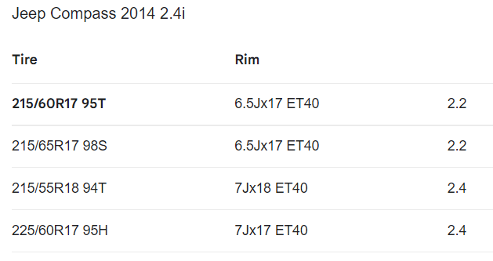

There are several possible sizes depending on the level of equipment chosen. With my Compass vehicle, I can see that the size 215/65R17 98S is listed.

- Using the information found in questions 1 and 2, write the manufacturer's recommended size for the vehicle:

  - Front tire : ___P215/65R17 98S_____________________________

  - Rear tire: ___ P215/65R17 98S ___________________________

  - Spare tire (if available): __ P215/65R17 98S _____________

- Take a picture of the sidewall of the inspected vehicle's tire and find the following information about the tire:
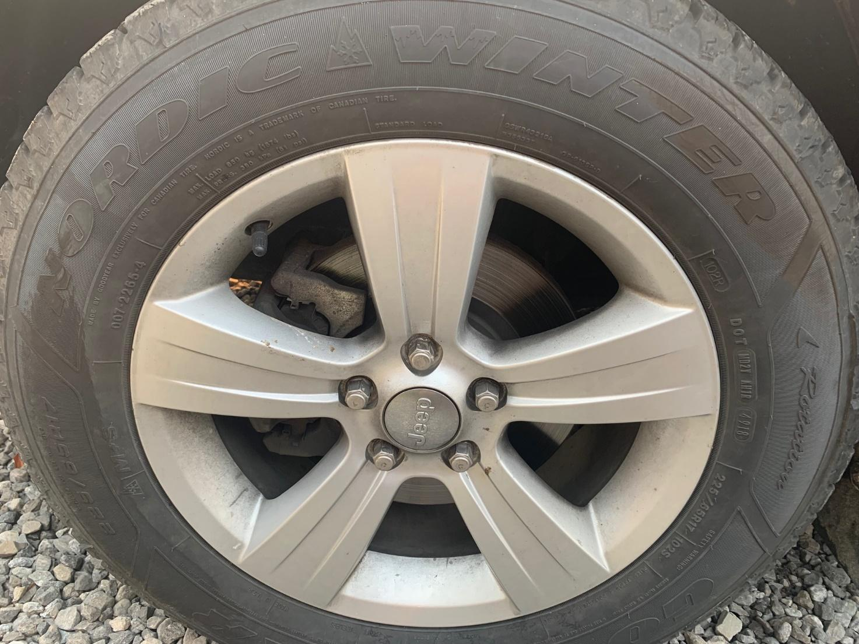

Information to be found on the sidewall of the tire |  | Student’s answers
Tire make and model |  | Goodyear Nordic Winter
Width of tire (in mm) |  | 225
Tire height (in %) |  | 65
Wheel rim diameter (in inches) |  | 17
Tire load rating |  | 102
Tire speed rating |  | S
Manufactured date | 49th week of 2018
- A) Are the vehicle's tires within the manufacturer's recommended size? Use the information found in the PowerPoint and from the class discussion.
The tires on the inspected vehicle do not meet the manufacturer's recommended dimensions. The width of the installed tires is 225 mm and the manufacturer recommends 215. The tires are therefore 10 mm too wide. Moreover, the tires are a little too high, because 65% of 225 (146.25 mm) does not give the same ratio for the height as 65% of 215 (139.75 mm). The tires are therefore 6.5 mm too high compared to the recommended height. The tire has a slightly higher load rating than originally (102 instead of 98) and an identical speed rating S.

- B) Are the vehicle's tires safe for their age and rubber condition. Use the information found in the PowerPoint, the class discussions with the teacher and by observing the condition of the rubber of the four tires and their date of manufacture.
Yes, the tires are safe, as they were all made in late 2018. So, they are three years old and the rubber is still in good condition. The rubber on a tire typically has a life span of about 6 years. I did not notice any cracking or premature aging on any of the four tires.
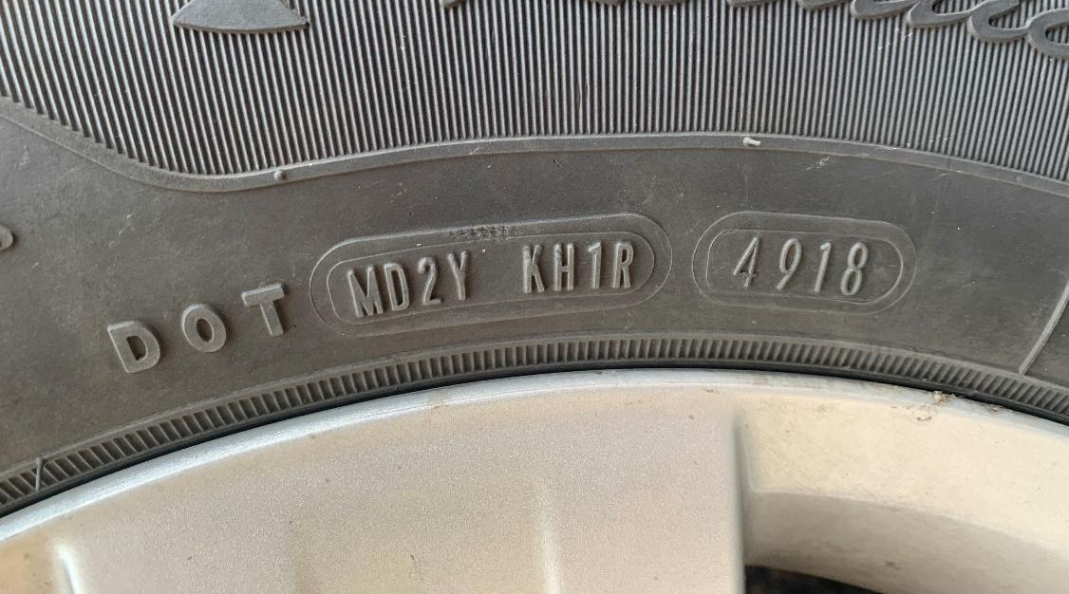

Appendix B – Answer Sheet Activity 2
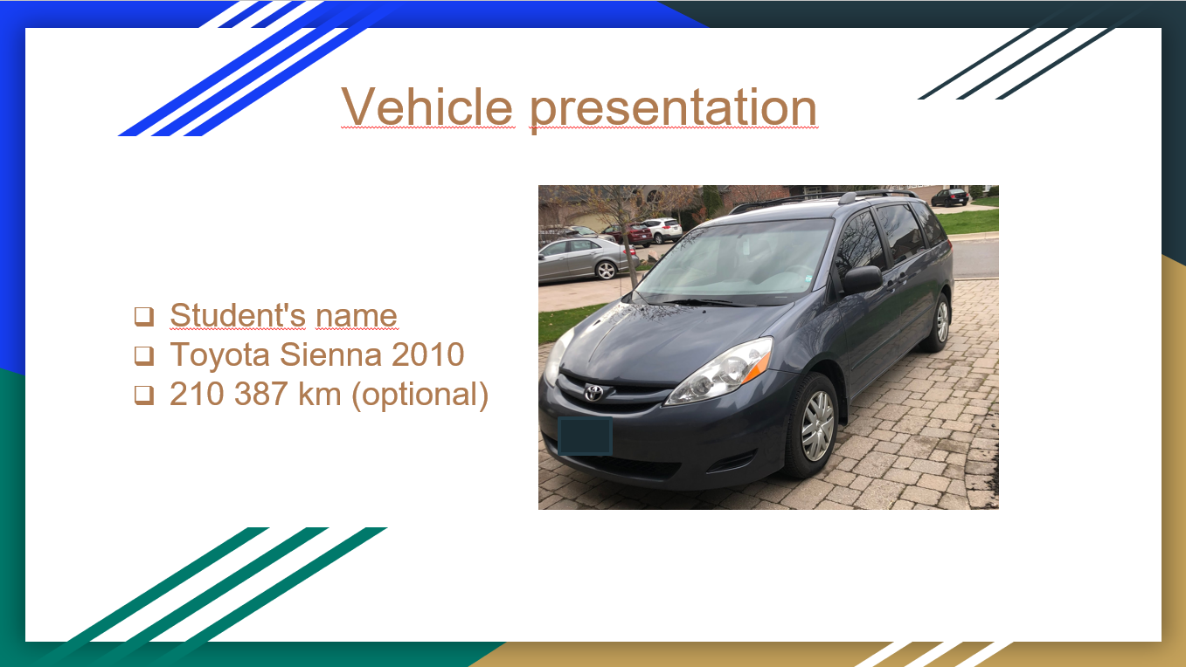
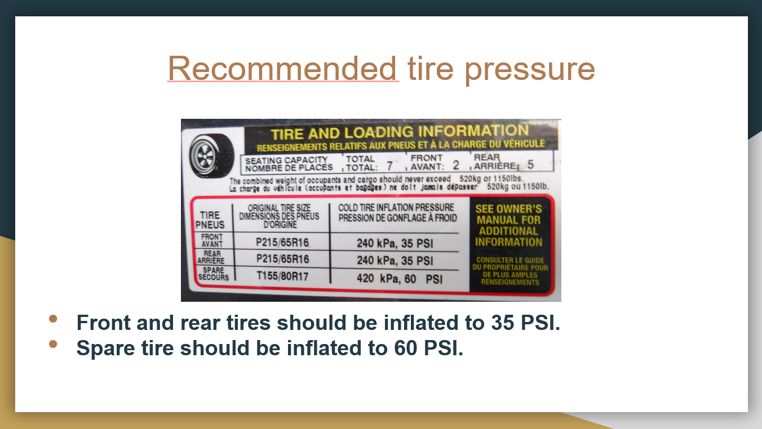
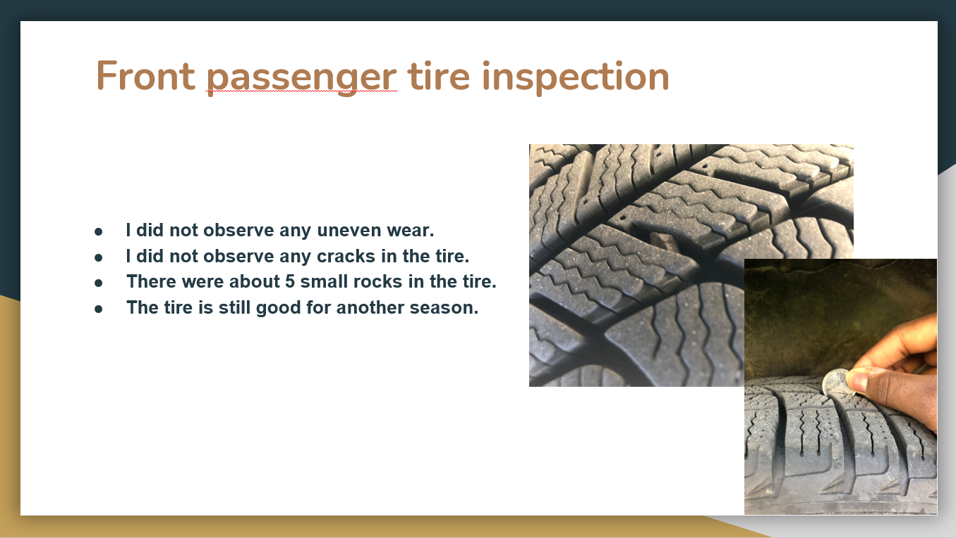
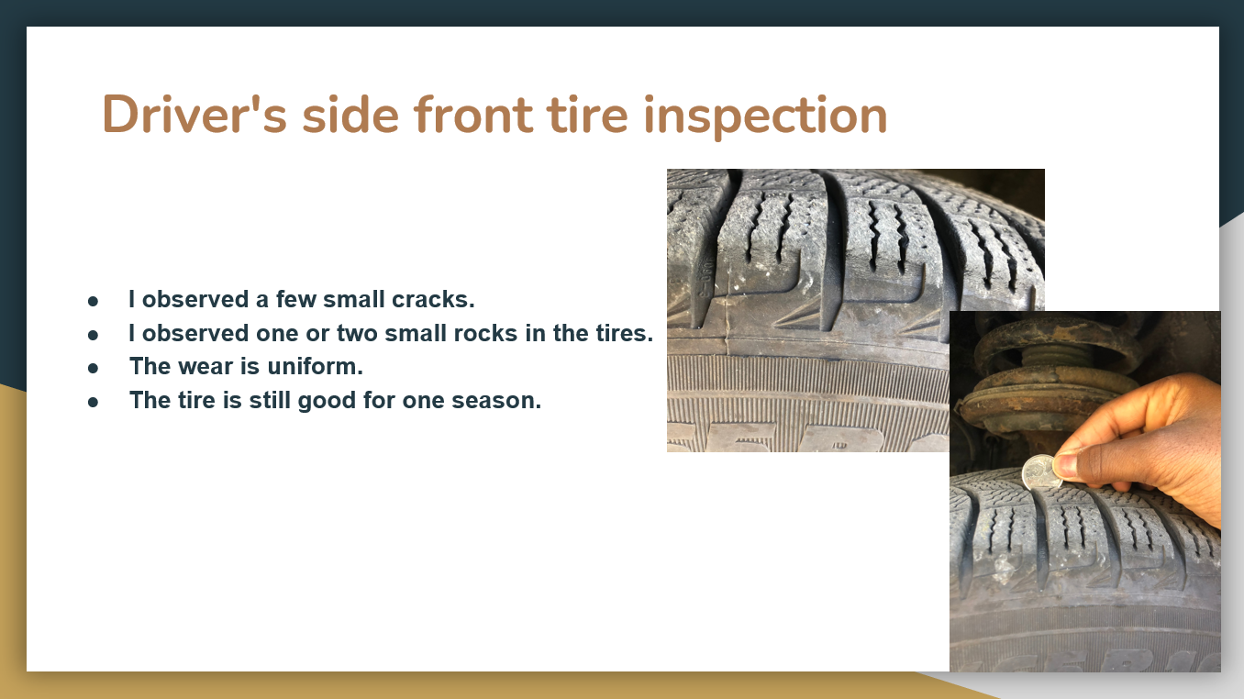

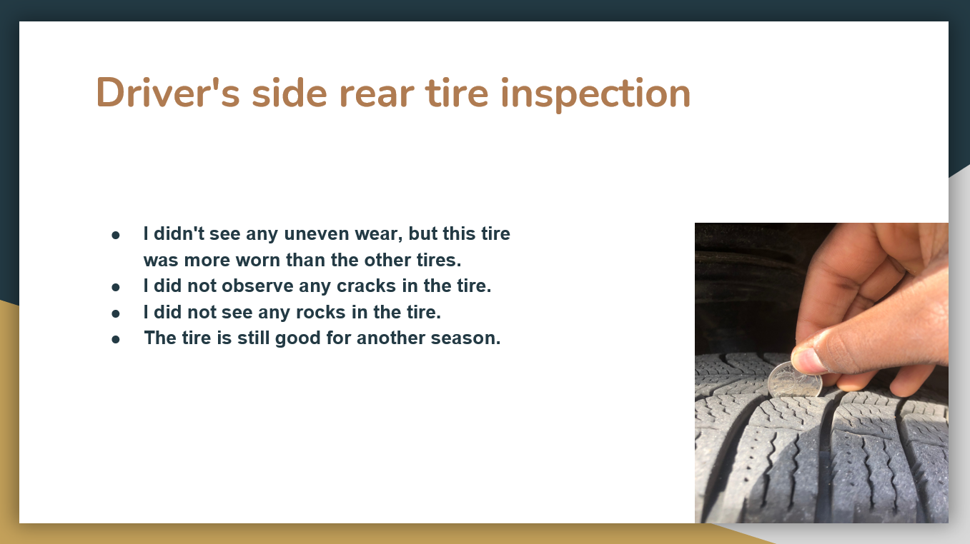
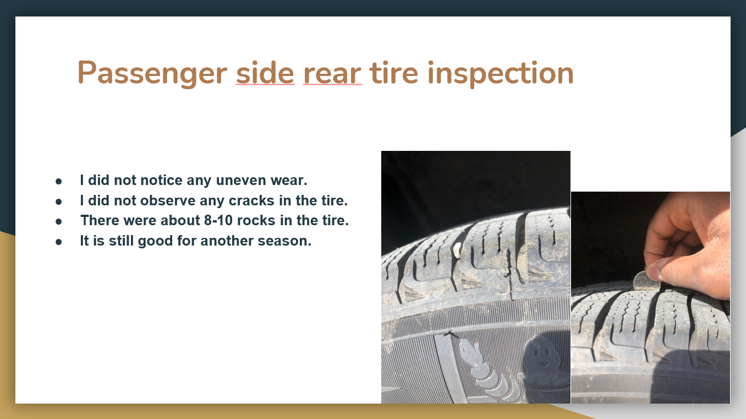
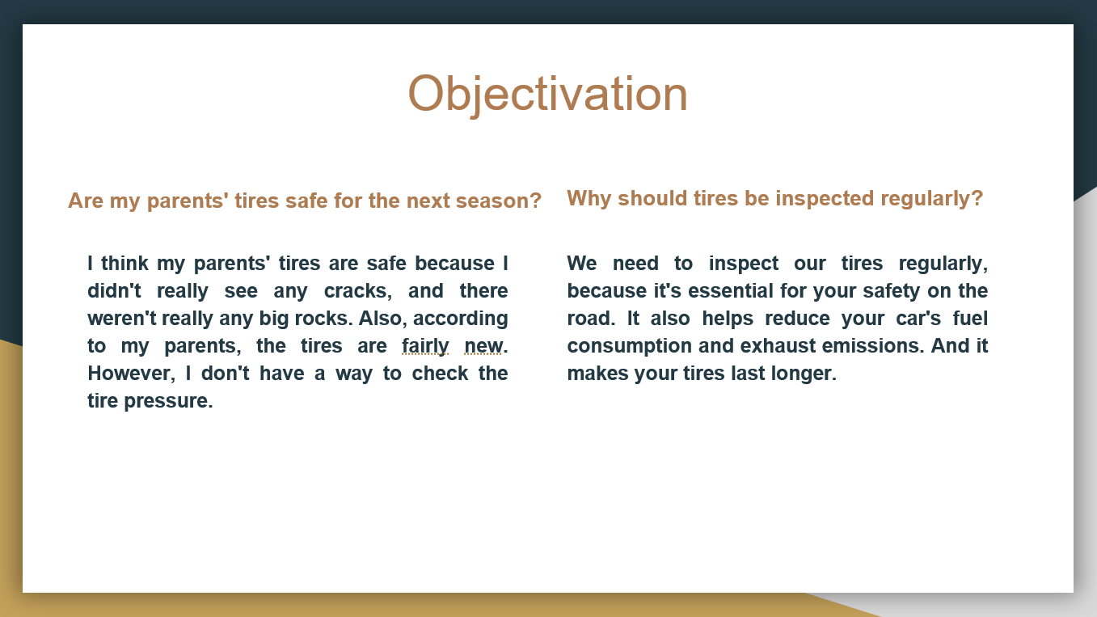

Appendix C – Answer Sheet Activity 3
. Name: __________________________________

Potential employers and technological advances
- Using a tool like Google Map, explore your home with a radius of about 20 kilometres to find potential employers that would allow you to use the knowledge you have learned about tires.

- Find and copy a map similar to this one. Insert or paste the image into a word processor and identify the different businesses found with an arrow and the name of the business.
Ex. :

- Classify the employers found in a table that specifies the type of business they operate and their address. There may be more than one employer per type of business. Then estimate the number of employees in that business.

Ex.: Answers will vary depending on where the student lives.
Company's name | Type of business | Address | Estimated number of employees
 | Bicycle repair shop
 | Motorcycle repair shop
 | Off-road vehicle repair shop
 | Auto repair shop
 | Heavy equipment repair shop
 | Farm vehicle repair shop
 | Industrial vehicle repair shop
 | Company of design and manufacture of tire
 | Others:

- If you worked in one of the businesses found above, how would you respond to a customer who asked you the following questions:

- I drive a pickup truck with P235/75R17 105T tires and I would like to have a tire that is more resistant to loads when I pull a loaded trailer. What tires do you recommend?
I would recommend a LT235/75R17 light truck tire, as they are stronger with their reinforced sidewall. Generally, an LT tire is made with 10 plies on the sidewalls so they can handle a greater load. However, driving will be affected, as the stiffness and higher pressure of the tire will cause some discomfort on the road.
- I have the option of purchasing used tires mounted on a wheel, but with a slightly larger diameter. What would be the effect on my vehicle if I installed these larger tires? (Considerations: gas mileage, mileage/odometer on vehicles, speedometer, safety aspect)
If the new sizes are listed in the manufacturer's possible sizes, a tire with a larger diameter will result in a smoother ride, as the tire overcomes road imperfections. However, the vehicle's odometer will increase more quickly because the vehicle's speed will be higher than with the original tires. Finally, a tire with a larger diameter will be safer because the contact area between the tire and the road will be larger than tires with a smaller diameter.
- The tire industry is constantly evolving. There have been many technological innovations in recent years that allow vehicles to be safer and more efficient. Choose three technological innovations from recent years and present how these improvements make vehicles safer in a Google Slide or PowerPoint.

Here is a non-exclusive list of innovations you could choose from.

  - TPMS,
  - Nitrogen to inflate tires,
  - Tweel
  - Remote tire inflation
  - Tire recycling,
  - Tire wear and adhesion sensor
  - Uptis tire
  - Use of Sonja oil as an ingredient in tire rubber
  - Run-flat tire
  - Airless tires
Answers can vary

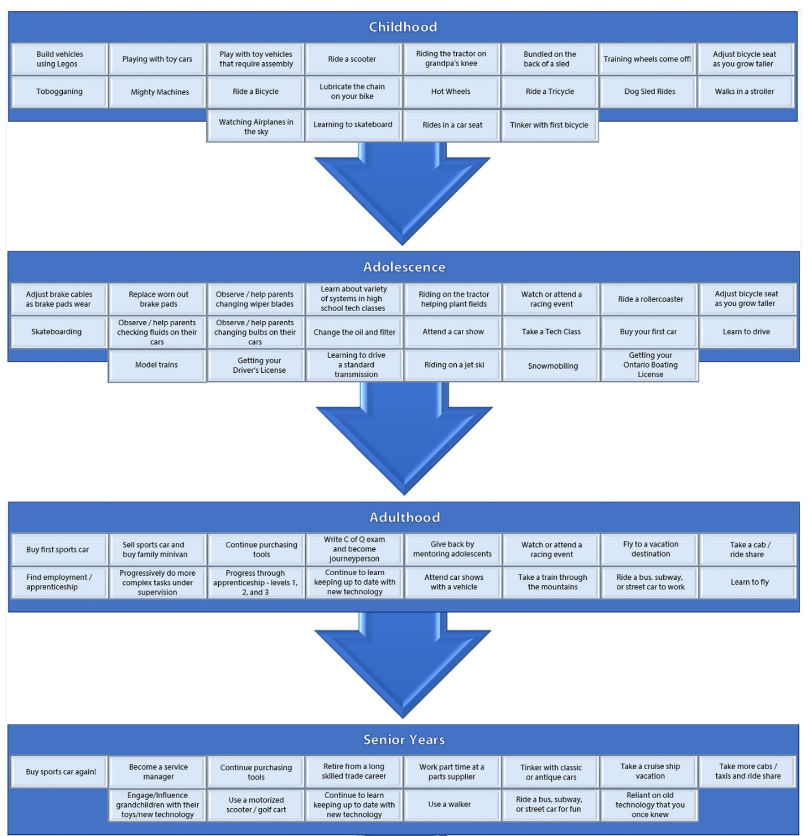
Appendix D – Continuum of Influence

References
Course Codes for Emphasis courses in the Revised Curriculum: Technological Education, Grades 11 and 12, 2009 http://www.edu.gov.on.ca/eng/curriculum/secondary/techedemphasiscourses.pdf
21st Century Competencies: Foundation Document for Discussion. Phase 1: Towards Defining 21st Century Competencies for Ontario, Winter 2016 Edition, 2016 http://www.edugains.ca/resources21CL/About21stCentury/21CL_21stCenturyCompetencies.pdf
Growing Success: Assessment, Evaluation, and Reporting in Ontario Schools, First Edition, Covering Grades 1 to 12, 2010 www.edu.gov.on.ca/eng/policyfunding/growSuccess.pdf
Learning for All – A Guide to Effective Assessment and Instruction for All Students, Kindergarten to Grade 12, 2013 http://www.edu.gov.on.ca/eng/general/elemsec/speced/LearningforAll2013.pdf
Tire inspection example for student (PowerPoint), 2021
Tire pressure and wear (PowerPoint), 2021
Tire size and age (PowerPoint), 2021
The Ontario Curriculum, Grades 9 and 10: Technological Education, 2009 (revised) http://www.edu.gov.on.ca/eng/curriculum/secondary/teched910curr09.pdf
The Ontario Curriculum, Grades 11 and 12: Technological Education, 2009 (revised) http://www.edu.gov.on.ca/eng/curriculum/secondary/2009teched1112curr.pdf
Ministry News https://news.ontario.ca/en/release/1000078/ontario-to-modernize-and-streamline-apprenticeship-training
OCTE SAFEDocs for Transportation Technology, 2013 https://www.octe.ca/application/files/1015/3796/3192/SAFEdoc_TRANS.pdf
The Differentiated Instruction Scrapbook http://www.edugains.ca/resourcesDI/EducatorsPackages/DIEducatorsPackage2010/2010DIScrapbook.pdf
Transport Canada: Riding On Air (Government of Canada), 2013 https://tc.canada.ca/en/road-transportation/stay-safe-when-driving/riding-air
Ontario College of Trades: https://www.collegeoftrades.ca/training-standards-motive-power-sector

