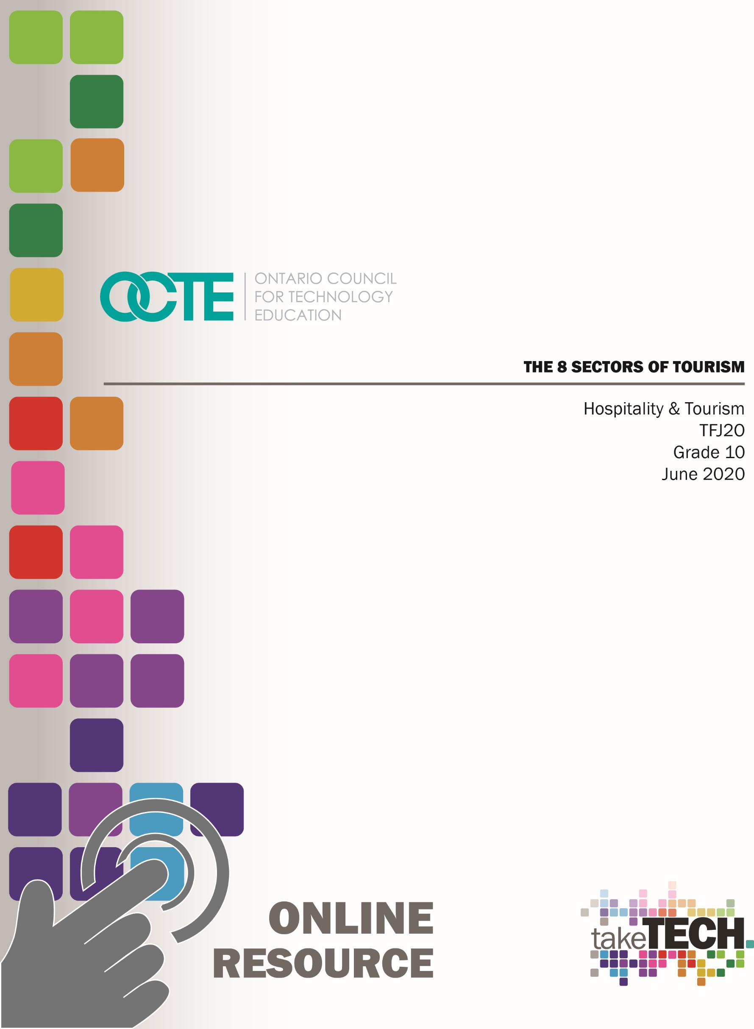

# Table of Contents

Introduction 3

Project Outline 3

Prior Knowledge 4

Planning Notes 4

Resources 5

Handouts 5

Presentations 5

Tools/Equipment 5

Software 5

Assignments 5

Charts and Tables 5

Rubrics 5

Instructional Strategies 6

The Hook / Motivational Strategies 6

Learning Goals and Success Criteria 6

Overall and Specific Expectations 6

Overall Expectations 6

Specific Expectations 7

Safety Concerns 7

Applicable SAFEDocs and ToolSAFE videos 7

Project Challenges 8

Differentiation of the Project / Activity 8

Assessment and Evaluation 8

Religious Considerations 8

Career and Industry Extensions 8

Reflection or Design Report 8

Activity 1 – Introduction - The 8 Sectors of Tourism 9

Activity 2 – The 8 Sectors of Tourism (PowerPoint) 10

Activity 3 – The 8 Sectors of Tourism (Handouts) 11

Accommodation Sector 11

Adventure Tourism and Recreation Sector 12

Attractions Sector 13

Events and Conferences Sector 14

Food and Beverage Sector 15

Tourism Services Sector 16

Transportation Sector 17

Travel Trade Sector 18

Activity 4 – Travel Trade (Sector 8) Sector Assignments 19

Discover Ontario Assignment 19

Discover Canada Assignment 21

Discover Ontario and Canada Travel Trade Sector Assignment Rubric 22

Activity 5 – Accommodation (Sector 1) Sector Assignments 23

Presidential Suite Assignment 26

Activity 6 – Adventure Tourism and Recreation (Sector 2) Sector Assignments 30

Design an Adventure Tourism and Recreation Event or Activity 30

Customer Profile Charts 32

Travel Itinerary 34

Activity 7 – Attractions (Sector 3) Sector Assignment 36

Design a Brochure for an Attraction in Ontario 36

Design a Brochure for an Attraction in Ontario Rubric 37

Activity 8 – Events and Conferences (Sector 4) Sector Assignment 38

Website Article Review 38

Activity 9 – Food and Beverage (Sector 5) Sector Assignments 40

Food Trends Assignment 41

Radio Announcement Assignment 42

Common Symbols Used for Classification in the Tourism Industry Presentation 43

Common Symbols Used for Classification in the Tourism Industry Handout 44

Activity 10 – Adventure Tourism and Recreation (Sector 6) Sector Assignment 45

Travel Agent Assignment 45

Activity 11 – Transportation (Sector 7) Sector Assignment 47

Using the Transportation Sector to Travel Around Ontario 47

References 49

# Introduction

Course Code: TFJ2O

Broad base Technology: Hospitality and Tourism

Destination: Open

Grade Level: 10

Prerequisite: None

Online Project Name: The 8 Sectors of Tourism

# Project Outline

By the end of this unit the student will demonstrate an understanding of the field of hospitality and tourism, in terms of services and products offered in the various sectors of the tourism industry. (A1) Students will be able to identify the various sectors of the tourism industry, describe services and products offered in each sector as well as describe various types of accommodations. Students will be able to identify common symbols used for classification purposes in the tourism industry and explain factors that determine the rating of tourist accommodation facilities. Students will be able to identify province-wide tourist activities and attractions in communities in Ontario.

The Project Outline includes the following components,

Activity 1 Introduction to Project

Activity 2 The 8 Sectors of Tourism (PowerPoint)

Activity 3 The 8 Sectors of Tourism (Handout)

Activity 4 Travel Trade (Sector 8) Sector Assignments

Discover Ontario Assignment

Discover Canada Assignment

Discover Ontario and Canada Travel Trade Sector Assignment Rubric

Activity 5 Accommodation (Sector 1) Sector Assignments

Presidential Suite Assignment

Presidential Suite Brainstorming Chart

Presidential Suite Floor Plan

Presidential Suite Description

Activity 6 Adventure Tourism and Recreation (Sector 2) Sector Assignments

Design an Adventure Tourism and Recreation Event or Activity

Customer Profile Chart

Customer Travel Itinerary

Activity 7 Attractions (Sector 3) Sector Assignments

Design a Brochure for an Attraction in Ontario

Design a Brochure for an Attraction in Ontario Rubric

Activity 8 Events and Conferences (Sector 4) Sector Assignment

Website Article Review

Activity 9 Food and Beverage (Sector 5) Sector Assignments

Food Trends Assignment

Radio Announcement Assignment

Activity 10 Common Symbols Used for Classification in the Tourism Industry PowerPoint

Common Symbols Used for Classification in the Tourism Industry

(Sector 6) Handout

Travel Agent Assignment

Activity 11 Transportation (Sector 7) Sector Assignment

Using the Transportation Sector to Travel around Ontario Assignment

# Prior Knowledge

This resource is for the TFJ2O course which is open and has no prerequisite. No prior knowledge is required, however good literacy and communication skills are an asset.

# Planning Notes

All student activities have been divided into 11 activities to help organize student projects and to provide multiple sources to provide evidence of student learning. Each activity builds on the project to help cover the 8 Sectors of Tourism and increase overall student success.

# Resources

As stated in the Project Outline, the activities for this project includes PowerPoint presentations, handouts, research tasks, assignments, tables, charts, and student reviews. Below is a comprehensive list of resources integrated in this entire project.

### Handouts

The 8 Sectors of Tourism (Handouts)

Common Symbols Used for Classification in the Tourism Industry (Sector 6) Handout

### Presentations

The 8 Sectors of Tourism (PowerPoint)

Common Symbols Used for Classification in the Tourism Industry (PowerPoint)

### Tools/Equipment

Computer / Tablet

Internet

### Software

Students will need training on acceptable computer use set by your school board.

### Assignments

Discover Ontario Assignment

Discover Canada Assignment

Presidential Suite Assignment

Presidential Suite Floor Plan

Presidential Suite Description

Design an Adventure Tourism and Recreation Event or Activity

Customer Travel Itinerary

Design a Brochure for an Attraction in Ontario

Website Article Review

Food Trends Assignment

Radio Announcement Assignment

Travel Agent Assignment

### Charts and Tables

Presidential Suite Brainstorming Chart

Customer Profile Chart

Using the Transportation Sector to Travel around Ontario Assignment

### Rubrics

Design a Brochure for an Attraction in Ontario Rubric

Discover Ontario and Canada Travel Trade Sector Assignment Rubric

# Instructional Strategies

Instructional strategies include project-based, problem-based approach, student profiles, exit card, and graphic organizers.

# The Hook / Motivational Strategies

It is time to travel around Ontario and all over Canada to learn about the 8 Sectors of Tourism. You will explore the Accommodation Sector by creating your very own lavish Presidential Suite, plan an Adventure and Recreation Activity and discover the great Attractions that we have to offer. The Food and Beverage Sector assignment will have you looking into current food trends that look to bring new and creative ideas to customers all over the world. The Transportation Sector will having you in a car, a plane, a train or a boat looking at all avenues to travel in Ontario. All this waits for you as you start learning about the 8 Sectors of Tourism. All aboard!

# Learning Goals and Success Criteria

By the end of this unit the student will demonstrate an understanding of the field of hospitality and tourism, in terms of services and products offered in the various sectors of the tourism industry. Students will be able to identify the various sectors of the tourism industry, describe services and products offered in each sector as well as describe various types of accommodations. Students will be able to identify common symbols used for classification purposes in the tourism industry and explain factors that determine the rating of tourist accommodation facilities. Students will be able to identify province-wide tourist activities and attractions in communities in Ontario.

# Overall and Specific Expectations in Support of Ontario Curriculum Grades 9 - 10 Technological Education

## Overall Expectations

A1. Demonstrate an understanding of the field of hospitality and tourism, in terms of services and products offered in the various sectors of the tourism industry;

B4. Demonstrate an understanding of the elements of planning an event or activity.

## Specific Expectations

A1.1 Identify the various sectors of the tourism industry (e.g., accommodations, recreation and entertainment, food and beverage services, transportation, travel services);

A1.2 Describe the services and products offered in each sector of the tourism industry (e.g., accommodations: single room, suite, residence; recreation and entertainment: event planning, sporting event; food and beverage services: restaurant dining; transportation: air travel, car rental; travel services: trip planning, guided tours) and explain how these sectors are interrelated;

A1.3 Describe various types of accommodations (e.g., hotel, motel, bed and breakfast);

A1.4 Identify common symbols used for classification purposes in the tourism industry (e.g., five-diamond award system, used by the Canadian and American Automobile Associations; three-star award system, used by the Michelin Guide) and explain the factors that determine the rating of a tourist accommodation facility (e.g., location, cleanliness, quality of service, value);

A1.5 Identify the types of tourist attractions associated with the various geographic regions of Ontario (e.g., wineries in the Niagara region, ecotourism in northern Ontario, museums and art galleries in Ottawa, sporting events and conventions in major urban areas);

A1.6 Identify province-wide tourist activities and attractions in Ontario (e.g., seasonal festivals, cultural events, areas of natural beauty, historical sites, fishing and hunting, Aboriginal powwows);

A1.7 Identify tourist activities and attractions in local communities in Ontario (e.g., fall fairs, homecoming events, minor sports tournaments, restaurants, hotels);

B4.2 Design a tourism event or activity (e.g., reception, ski vacation, fishing trip, catered event) that meets a customer’s specific needs;

B4.3 Develop an itinerary or schedule for a tourism event or activity (e.g., corporate outing, cruise vacation, sporting event, cultural festival);

# Safety Concerns

Computer use and internet safety would be the only safety concerns related to this project.

# Applicable SAFEDocs and ToolSAFE videos

Please refer to the [OCTE SAFEDocs for Hospitality](https://www.octe.ca/application/files/6215/3796/3180/SAFEdoc_HOST.pdf) for safety documents in order to properly address and instruct any safety concerns.

# Project Challenges

All student activities have been divided into eleven different activities to help organize student projects and assignments. Each activity builds on the project to cover the 8 Sectors of Tourism. Each activity can also be used independent of the other activities. Students would need electronic devices as well as internet to complete most if not all of these online activities.

# Differentiation of the Project / Activity

Teachers can also refer to the [Differentiation Scrapbook](http://www.edugains.ca/resourcesDI/EducatorsPackages/DIEducatorsPackage2010/2010DIScrapbook.pdf) to take into account for learner ability, multiple intelligences, exceptional students, and ESL learners. Differentiation can be achieved by providing choice with project, graphic organizer, learning preference, VAK inventory, and exit card strategies.

# Assessment and Evaluation

Evidence of student achievement for evaluation is collected throughout this project from different sources using multiple sources to evaluate student learning. Student products will be in the form of assignments for evaluation. Assignments for evaluation include rich performance tasks, demonstration, research, project based on real world setting. Assessment will include the categories of knowledge/understanding, thinking, communication and application.

# Religious Considerations

With the 8 Sectors of Tourism activities it is structured to consider any religious and/or cultural considerations. Student’s preferences or student’s interests in structuring the project to coincide with the tourism industry that represents a particular religion and/or culture will support and enhance the overall finished project.

# Career and Industry Extensions

This project does not include any industry extensions/career exploration; however, the project could lead to further reach ahead activities to support a SHSM hospitality program.

# Reflection or Design Report

Teachers may wish to have the students complete a design report, reflection or create a foldable to consolidate their learning. This would be a nice way to capture the student’s understanding in a summative format and be used in preparation for their examination, entering post-secondary education or the workforce.

# Activity 1 – Introduction - The 8 Sectors of Tourism

It is time to travel around Ontario and all over Canada to learn about the 8 Sectors of Tourism. At each stop sign, you will find an assignment that will help build your knowledge of the 8 Sectors of Tourism. You will explore the Accommodation Sector by creating your very own lavish Presidential Suite, plan an Adventure and Recreation Activity and discover the great Attractions that we have to offer. The Food and Beverage Sector assignment will have you looking into current food trends that look to bring new and creative ideas to customers all over the world. The Transportation Sector will having you in a car, a plane, a train or a boat looking at all avenues to travel in Ontario. All this waits for you as you start learning about the 8 Sectors of Tourism. All aboard! Full steam ahead!

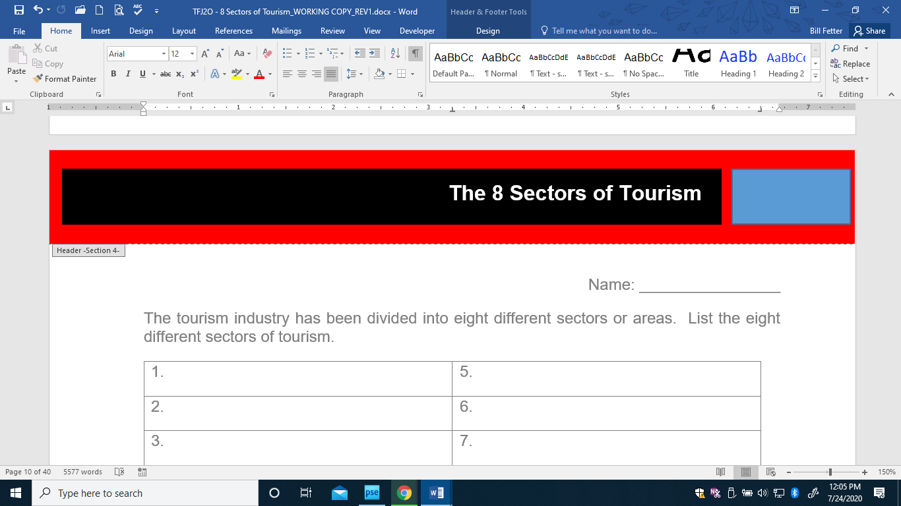

Name: ___________________

The tourism industry has been divided into eight different sectors or areas. Using your research skills and/or viewing the PowerPoint presentation titled “The 8 Sectors of Tourism”, list the eight different sectors of tourism.

| 1. | 5. |
| --- | --- |
| 2. | 6. |
| 3. | 7. |
| 4. | 8. |

# Activity 2 – The 8 Sectors of Tourism (PowerPoint)

[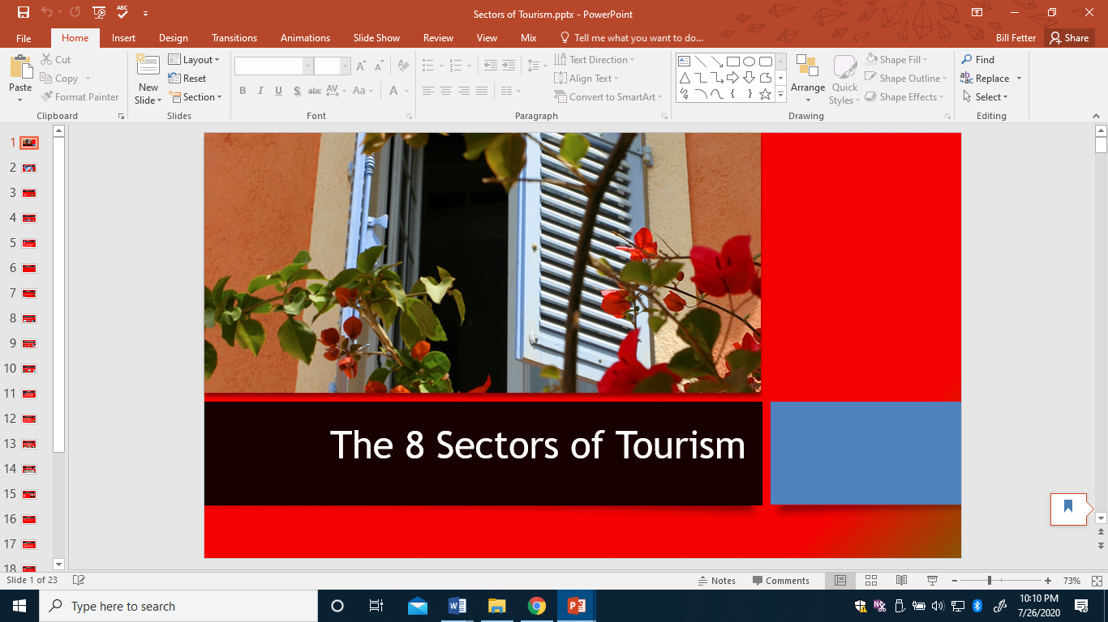](https://www.octe.ca/application/files/4115/9572/4388/Sectors_of_Tourism.pptx)

<https://www.octe.ca/application/files/4115/9572/4388/Sectors_of_Tourism.pptx>

# Activity 3 – The 8 Sectors of Tourism (Handouts for PowerPoint)

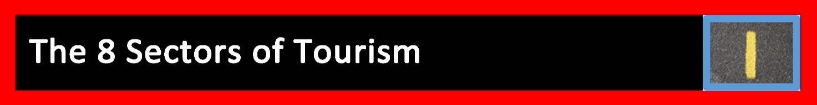

# Accommodation Sector

What is the function of the Accommodation Sector?

**Accommodation Sector Definitions**

Include a definition for the various services and products offered.

Single room:

Double room:

Triple room:

Queen:

King:

Suite:

Presidential Suite:

Connecting rooms:

Accessible rooms:

**Various Types of Accommodation**

Include a definition for the various types of accommodation.

Hotel:

Motel:

Bed and Breakfast:

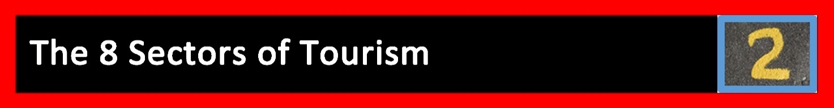

# Adventure Tourism and Recreation Sector

What is the function of the Adventure Tourism and Recreation Sector?

Provide six examples of different opportunities for adventure from this sector.

| 1. |
| --- |
| 2. |
| 3.  4.  5.  6. |

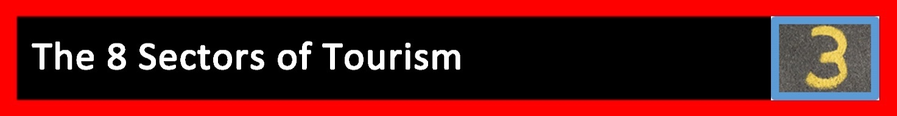

# Attractions Sector

What is the function of the Attraction Sector?

Every province and territory in Canada has major and minor attractions that attract visitors and generate tourism revenue. List four attractions that Canada has to offer.



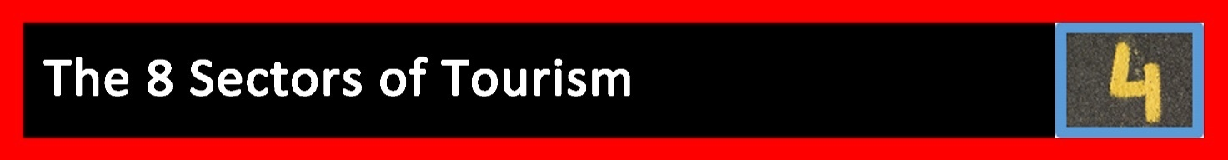

# Events and Conferences Sector

What is the function of the Events and Conferences Sector?

Explain the concept of “spinoff dollars”. Provide two examples of “spinoff dollars” from this sector.



# Food and Beverage Sector

What is the function of the Food and Beverage Sector?

The Food and Beverage Sector contributes the highest number of jobs available for today’s youth. List four skills that you currently have that would help to get a job in the Food and Beverage Sector.



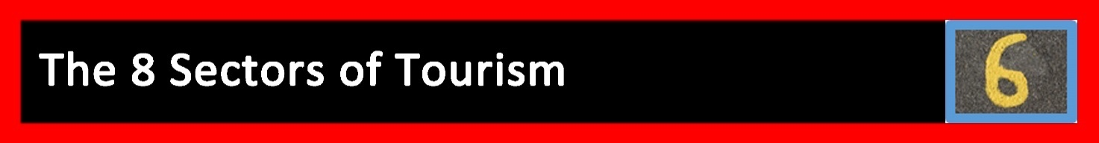

# Tourism Services Sector

What is the function of the Tourism Services Sector?

What are the five areas that make up this sector?

| 1. |
| --- |
| 2. |
| 3. |
| 4. |
| 5. |

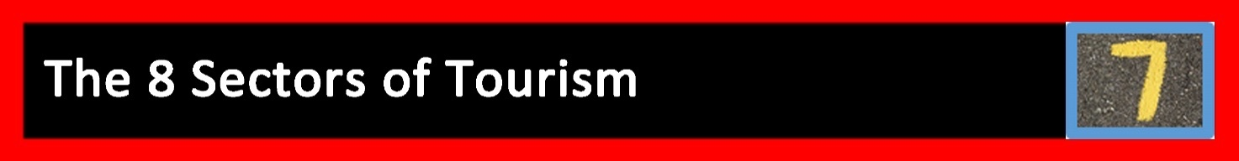

# Transportation Sector

What is the function of the Transportation Sector?

What are the four categories that this sector is divided into?

| 1. |
| --- |
| 2. |
| 3. |
| 4. |

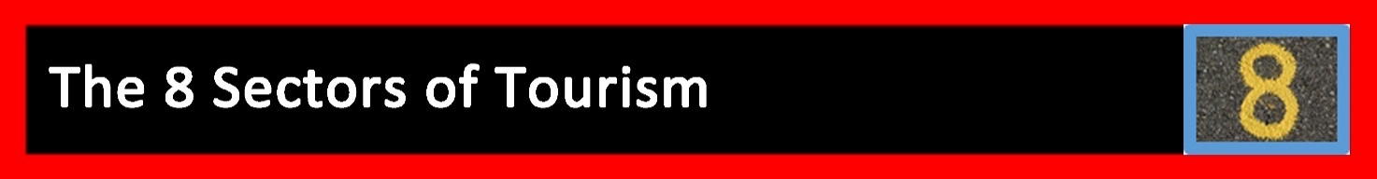

# Travel Trade Sector

What is the function of the Travel Trade Sector?

# Activity 4 – Travel Trade (Sector 8) Sector Assignments

Name: _____________________

 Travel Trade Sector Assignments

 Discover Ontario Assignment

For this assignment you will map out all areas that you read, research and learn about while completing The 8 Sectors of Tourism Unit. For each new location that you discover during your studies will need to mark the location on your map. This assignment will be added to as you work your way through all the different sectors. When you have finished all of the sector assignments this final project will be submitted. Use the “stop sign”  by copying and pasting it to the locations that you learn about along the way. As you add your stop signs make sure to change the number so that you can add it to your list of stops along the way. Please see map below and increase the size of the map as required for the assignment. Have fun as you discover all of the wonderful things Ontario has to offer.

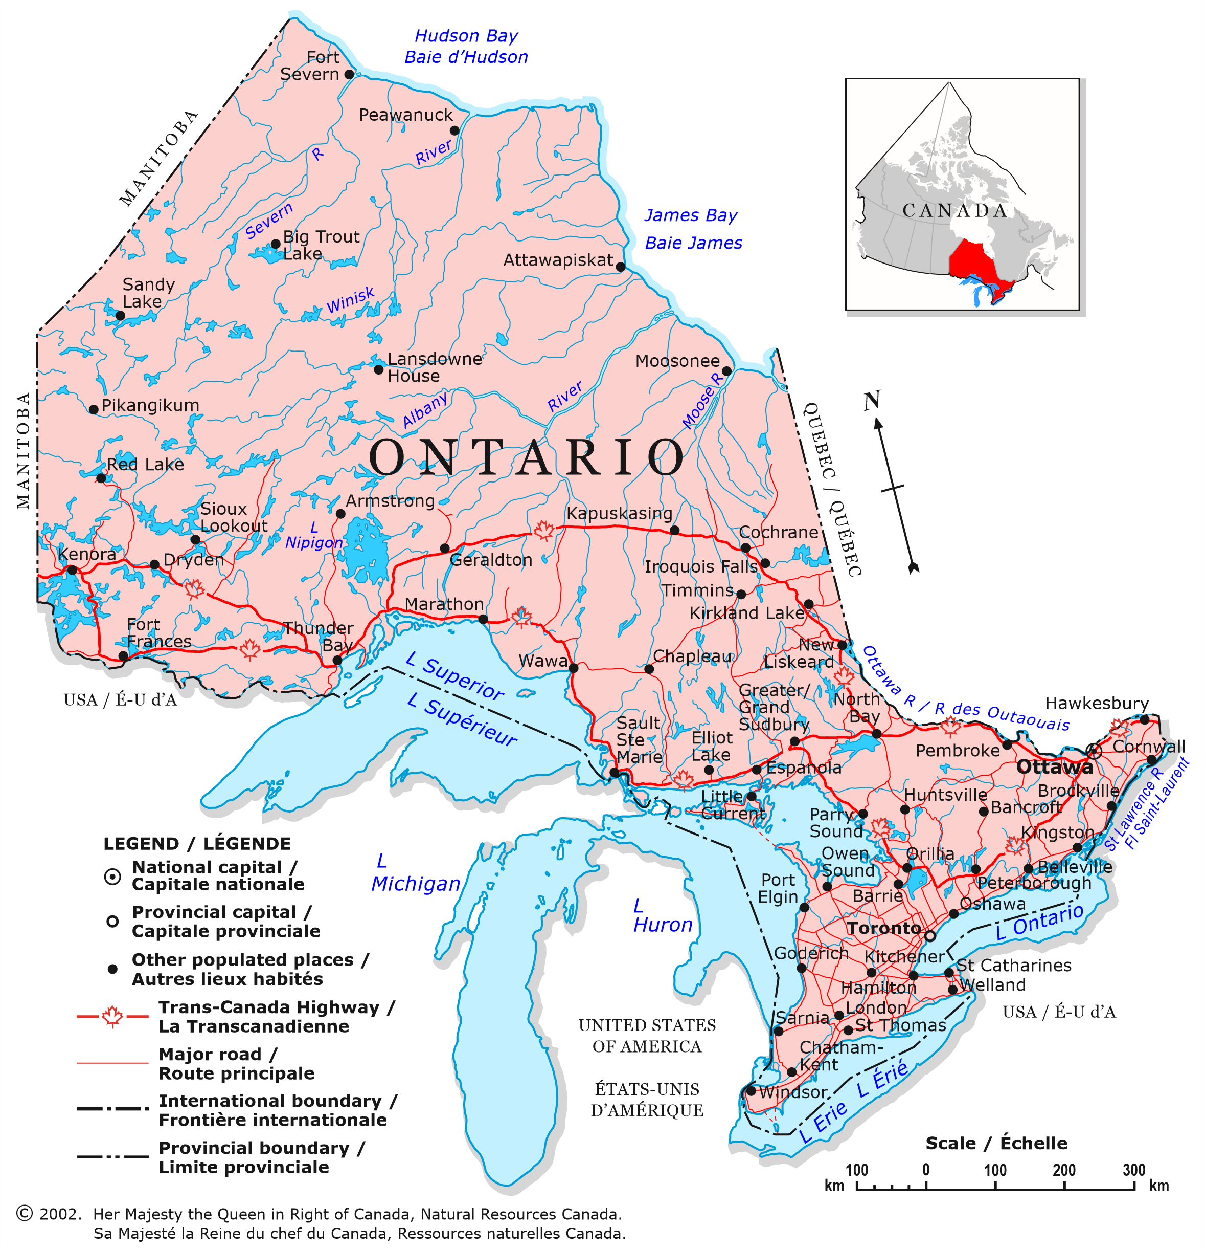

Please see map for all the wonderful things I have learned about in Ontario.

(Add numbers as needed)

1.

2.

3.

4.

5.

6.

7.

8.

 Discover Canada Assignment

Just like you were mapping out all of the things you discovered in Ontario this map will be used to demonstrate the areas that you discovered in Canada that were outside of Ontario. Remember you do not need to map places from Ontario as they will be included on the Ontario Map.

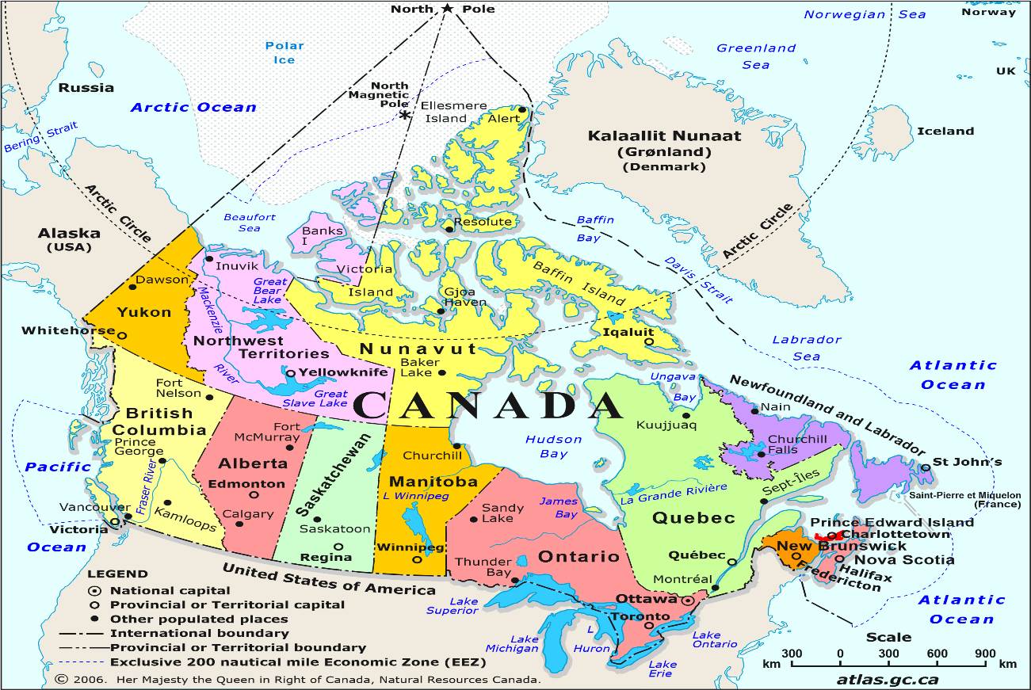

Please see map for all the wonderful things I have learned about in Canada.

(Add numbers as needed)

1.

2.

3.

4.

5.

6.

7.

8.

| Discover Ontario and Canada Travel Trade Sector Assignment Rubric | | | | | |
| --- | --- | --- | --- | --- | --- |
| **Objectives**  Demonstrates an understanding of the field of hospitality and tourism, in terms of services and products offered in the various sectors of the tourism industry. | | | | | |
| **Categories** | **0-49%**  **(Level 0)** | **50-59%**  **(Level 1)** | **60-69%**  **(Level 2)** | **70-79%**  **(Level 3)** | **80-100%**  **(Level 4)** |
|  | The student: | | | | |
| **Knowledge and understanding of content**  Identifies the types of tourist attractions associated with the various geographic regions in Ontario | demonstrates no understanding or knowledge of content | demonstrates limited knowledge and understanding of content | demonstrates some knowledge and understanding of content | demonstrates considerable knowledge and understanding of content | demonstrates thorough knowledge and understanding of content |
| **Thinking**  Uses planning skills to identifies province-wide tourist activities and attractions in Ontario | demonstrates no use of planning skills | uses planning skills with limited effectiveness | uses planning skills with some effectiveness | uses planning skills with considerable effectiveness | uses planning skills with a high degree of effectiveness |
| **Communication**  Expression and organization of ideas and information while identifying tourist activities and attractions in local communities | does not demonstrate or express organized ideas and information | expresses and organizes ideas and information with limited effectiveness | expresses and organizes ideas and information with some effectiveness | expresses and organizes ideas and information with considerable effectiveness | expresses and organizes ideas and information with a high degree of effectiveness |
| **Application**  Makes connections between various contexts (e.g., between the content and the world outside of the school) | does not make connections between various contexts | makes connections within and between various contexts with limited effectiveness | makes connections within and between various contexts with some effectiveness | makes connections within and between various contexts with considerable effectiveness | makes connections within and between various contexts with a high degree of effectiveness |

Student Name: _____________________

# Activity 5 – Accommodation (Sector 1) Sector Assignments

## Decorative yellow number 1, on asphalt roadway signifying Sector number 1 of 8 - Accommodation Sector Assignment Accommodation Sector Assignment

Tourism spending in Canada for the 2nd quarter in 2019 was $24.3 billion according to [Stats Canada](https://www150.statcan.gc.ca/). Accommodation is one of the largest and fastest growing sectors in the tourism industry. Catering to your customers to provide the ultimate accommodations is important in order to build your business. Read the following hotel trends that are important to customers now and in the future.

### Hotel Trends

1. **Smart Rooms**

* Wireless device charging,
* Smart controls for temperature, light and power
* Tablet based information binder about restaurant hours, room service menu, spa services, etc.
* Sound proofing tech
* Voice-activated controls
* Smart mirrors
* Keyless entry
* Concierge video chat
* Smart TV

1. **Going** **Green**

* More than suggesting guests reuse towels for an extra day
* LEED (Leadership in Energy and Environmental Design) Certification
* Solar power, water conservation
* No plastic
* Motion sensors

1. **Changing** **Workforce**

* Employee shortage
* Generation Z in the workplace with never living in an age without the internet, which will be different than those of older generations
* Union
* Safety regulation

1. **Alternate** **Accommodations**

* Vacation rentals
* AirBnB
* Mobile hotels
* Underwater hotels
* Working remotely

1. **Technology**

* Selling experiences
* A.I. (Artificial Intelligence) pricing
* Bring your own devices
* Mobile check-in
* Choose your own room (guest can chose their specific room before arrival, just like selecting on an airplane)
* Fitness on the road
* Emerging social media platforms
* Booking on mobile devices
* High speed internet capable of streaming movies or downloading large files
* Robot room service
* Translation Apps (for language translation for international guests)
* Contactless payment

1. **Traveler** **Preferences**

* Experiences not things
* Coffee culture (guest expecting a higher standard of coffee in guestrooms)
* Experiential travel (yoga retreats, surf camps, animal encounters, health and wellness, culinary experiences, etc.)
* Music driven travel
* Glamping
* Rise of influencers (popular social media influencers helping to promote your business)
* Staycations
* Last minute bookings
* Sports themed hotels
* Theme park experiences

1. **Hotel** **Business**

* Cool luxury hotels
* Cocktail mixology in your room
* Micro rooms (small rooms that are functional and luxurious)
* Mixed use spaces (when space is at a premium, new construction or renovation often involves combining different types of spaces, like ground-level retail, a few floors of hotel rooms, and apartments on top)

1. **Hotel** **Design**

* Interior meets outdoor (outdoor designs created inside hotel lobbies and rooms)
* Experiential social space ( to build community hotels are offering public spaces to share from workspaces to kitchens to game rooms)
* Green hotel brands
* High-end art gallery experience
* View the article [100 hotel trends from HotelTechReport](https://hoteltechreport.com/news/100-hotel-trends)



Name: ___________________

## Presidential Suite Assignment

The Presidential Suite is the most expensive room provided by a hotel. This accommodation always has one or more bedrooms and a living space with strong emphasis on grand in-room decorations, high-quality amenities and supplies, and tailor-made services (e.g., a personal butler or chef during the stay). Research five different Presidential Suites available in Canada (two from Ontario) and fill in information below from your research.

**Presidential Suite Brainstorming Chart** /100

|  | **Hotel name, location and cost per night**  **/15** | **Room**  **Description**  **/25** | **Room**  **decoration**  **details**  **/25** | **Special amenities**  **/25** | **Additional information**  **/10** |
| --- | --- | --- | --- | --- | --- |
| **Presidential Suite # 1** | /3 | /5 | /5 | /5 | /2 |
| **Presidential Suite # 2** | /3 | /5 | /5 | /5 | /2 |
| **Presidential Suite # 3** | /3 | /5 | /5 | /5 | /2 |
| **Presidential Suite # 4** | /3 | /5 | /5 | /5 | /2 |
| **Presidential Suite # 5** | /3 | /5 | /5 | /5 | /2 |

Now that you have had a chance to explore some of the available Presidential Suites it is time to design your ultimate Presidential Suite. Remember your Presidential Suite should be a room that customers would be excited to book for their upcoming vacation or special occasion. Remember to think of the things that you would like to see in an exclusive room as well as reviewing the hotel trends that customers would be expecting and excited to see in your room. Presidential Suites are very exclusive and generally not the room most of us would be booking on a regular basis as the cost of them would exceed what most people would be able to afford to pay for a night. Remember you’re the designer so the cost per the room is to attract customers that would regularly book this type of room.

**Presidential Suite Brainstorming Chart** /40

Complete this chart by including your ideas in bulleted point form to start putting together your ideas for your Presidential Suite.

| **Design Your Own Presidential Suite** | **Room Description**  /10 | **Room**  **decoration details**  /10 | **Special**  **Amenities**  /10 | **Additional information**  /10 |
| --- | --- | --- | --- | --- |
|  |  |  |  |

**Presidential Suite Floor Plan** /50

After completing your brainstorming now it is time to design your floor plan. Use the space below to create a bird’s eye view (a view from a high angle as if seen by a bird in flight) of your Presidential Suite Floor Plan. Remember to use detail to label your floor plan. This floor plan would be used on the hotel website to market your room. Don’t forget to include a legend or label your floor plan.

|  |
| --- |

**Presidential Suite Description** /10

Include a paragraph that describes your Presidential Suite to future customers. This paragraph would be used on a hotel website to advertise the room. Include a description of the room, the special amenities and features of the room and the cost per night. Don’t forget to check for spelling and grammatical errors.

# Activity 6 – Adventure Tourism and Recreation (Sector 2) Sector Assignments

Name: ___________________

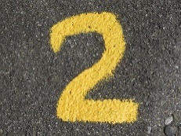 Adventure Tourism and Recreation Assignment

 Design an Adventure Tourism and Recreation Event/Activity

You will be responsible for planning an Adventure Tourism and Recreation event or activity. You will be responsible for planning an adventure for two of the five customers below. Remember this sector includes everything from bird watching to salmon fishing, horseback riding to white water rafting, and golf to wilderness trekking. Adventure tourism and recreation draws those who want to experience Canada as a place that is natural and unspoiled, and those who want active, unusual vacations. This sector includes businesses that provide experiences where customers request active, recreational experiences or travel adventures where they can learn about nature and/or culture.

**Choose Your Customers**

You will only pick two of these customer profiles to work on, highlight the customer profiles that you intend to work on.

**Customer Profile # 1**

Steve is a retired gentleman looking for some adventure. He is somewhat active for a man his age but he is cautious not to overdo his activity. He likes being outdoors, bike riding and golf. He is looking to get away for this weekend with his wife and would like to book an adventure for them both to enjoy.

**Customer Profile # 2**

Becky is a mother of three young children. Her youngest just turned one and she is looking for a weekend away. She would like to have a peaceful and relaxing weekend with some of her friends. She is not sure where to start but would really like the time to relax and recharge before returning home to her busy life with her family.

**Customer Profile # 3**

Jackie and Rebecca have been saving for a really long time to be able to afford their next adventure. They both love to read, write and explore poetry. In an effort to save money they have been experimenting more with different cuisines while preparing meals at home. Jackie is more comfortable in the kitchen than Rebecca but they are both working on building their cooking skills. They are looking for an adventure that will help them expand and build some more cooking skills that will help them in the future.

**Customer Profile # 4**

Ralph is in his 30’s and after having a really successful year at his workplace he is looking for some adventure. He often completes most of his work at a desk behind a computer. Before he became so busy with work he was up for any adventure. Given that he loves the outdoors and is physically able to do more strenuous activity he is looking for an adventure that he will remember for a long time.

**Customer Profile # 5**

Matt and Jeff have been together for five years and would like to celebrate their anniversary. They would like to unplug and get away from all the chaos of living in the big city. They would like to get back to basics and have an adventure at a place that is natural and unspoiled. They have a love for learning about new things and are looking forward to their next adventure together.

Customer Profile Charts /20

After reading the customer profiles complete and fill in two customer profile charts for the next step with your assignment.

Travel Itinerary /30

Chose only one of the above Customer Profiles and complete the Travel Itinerary Form.

Travel Itinerary

| **Customer Name(s)**:  /1 | |
| --- | --- |
| **Destination Location**:  (City, Province)  /1 | **Duration of Stay**:  /1 |
| **Travel Arrangements**:  (Transportation)    /1 | **Hotel Name**:  **Hotel Website**:  **Social Media Platforms**:    /3 |
| **Food and Beverage Options**:  /3 | **Room Amenities**:  /2 |

| **Description of Adventure**:  /5 | |
| --- | --- |
| **Reason this Adventure was Chosen for Customer**:  /3 | |
| **Day 1** | **What To Do**: |
| **Day 2** | **What To Do**: |
| **Day 3 \*** | **What to Do**:  /10 |
| **Additional Information**: | |

*Add additional days if needed

# Activity 7 – Attractions (Sector 3) Sector Assignment

Name: _______________________

 Attractions Sector Assignment

 Design a Brochure for an Attraction in Ontario

The Attraction Sector includes historic sites, heritage homes, museums, halls of fame, art galleries, botanical gardens, aquariums, zoos, water parks, amusement parks, casinos and cultural attractions. Many attractions are educational in nature, others are solely for entertainment. For this assignment you will research an Attraction in Ontario. You will be required to design a three panel brochure that includes both written and visual information on your chosen attraction. Your brochure should be a piece of paper 8 ½ x 11, folded into a three panel brochure. Be sure to complete both the front and the back of each panel. There are several computer programs that will set up a three panel brochure for you to use. Be sure to make the brochure colourful, neat, free of spelling/grammar errors and professional. The brochure should be visually attractive, easy to understand, have valuable information for guests and complete. Don’t forget to add any locations that you find while researching to your Ontario map from the “Discover Ontario Travel Trade Sector Assignment”.

| Design a Brochure for an Attraction in Ontario Rubric | | | | | |
| --- | --- | --- | --- | --- | --- |
| **Objectives**  Demonstrates an understanding of the field of hospitality and tourism, in terms of services and products offered in the various sectors of the tourism industry. | | | | | |
| **Categories** | **0-49%**  **(Level 0)** | **50-59%**  **(Level 1)** | **60-69%**  **(Level 2)** | **70-79%**  **(Level 3)** | **80-100%**  **(Level 4)** |
|  | The brochure: | | | | |
| **Communication of Information and Ideas** | does not communicate information and ideas | communicates information and ideas with limited clarity | communicates information and ideas with some clarity | communicates information and ideas with considerable clarity | communicates information and ideas with high degree of clarity |
| **Relevant Information for Attraction** | does not have relevant information for Attraction | has relevant information with limited accuracy and effectiveness | has relevant information with some accuracy and effectiveness | has relevant information with considerable accuracy and effectiveness | has relevant information with high degree of accuracy and effectiveness |
| **Creativity** | has not met minimum curriculum expectations for this assignment | has little to no creative thought put into assignment, very plain and no effort to be creative is present | Is moderately creative, has some thought put into layout of presentation. No extras are added. | presentation has elements of creativity that enhances the information on the finished product. | presentation has excellent attention to detail. Is above and beyond average presentation. Very creative brochure. |
| **Requirements and “Must Haves”** | has not met the minimum curriculum expectations for this assignment | is incomplete or missing components and missing detailed Attraction information | has most of the necessary components but some Attraction requirements are missing | has all requirements met and thoughtfully laid out. All Attraction information is complete | has additional material provided to enhance the overall brochure |

# Activity 8 – Events and Conferences (Sector 4) Sector Assignment

Name: __________________

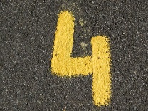 Events and Conferences Sector Assignment

 Website Article Review

Find a credible article about an Event or Conference in Canada to research. Once you have read the article complete the website summary. Don’t forget to add any locations that you find while researching to your Ontario or Canadian map from the “Discover Ontario Travel Trade Sector Assignment”.

| **Website Summary** The Website Summary Banner with a picture of four cartoon-like people sitting at a table discussing a paper on the right hand side of the banner.  x/16 | | | | | |
| --- | --- | --- | --- | --- | --- |
|  | **Topic:**  Events and Conference in Canada |  | **Website Research:**  Find a creditable article on an Event or Conference in Canada. No Wikipedia articles please. |  | **Reasoning:**  To further your learning of the 8 Sectors of Tourism to support the TFJ2O curriculum |
| Title of Article /1  Website Address or Link /1  Summarize /10  Summarize what the article is about. Each bullet point should be at least one sentence or point from the article.         Interesting Ideas from the Article /4  Provide two interesting facts/ideas from the article you read. | | | | | |

# Activity 9 – Food and Beverage (Sector 5) Sector Assignments

Name: __________________

 Food and Beverage Sector Assignment

To be competitive all of the 8 Sectors of Tourism must be up to date and relevant with current trends to keep customers excited. This is no different for the Food and Beverage Sector as these business work to be successful in the hospitality market. One of the most challenging expenses for the Food and Beverage Sector is the ever increasing price for retail space. In Toronto, Ontario commercial/retail property rents for $10,000, $20,000 plus much more per month. The price of rent can make it very difficult to own or operate your own Food and Beverage establishment. A growing trend in this sector is to have a mobile Food and Beverage business. We see these types of establishments through pop-up restaurants, specialty food trucks and special events and festivals organized across Canada each year.



## Food Trends Assignment

For this assignment you will identify and chart 5 province-wide seasonal festivals or cultural events that have the main focus of food and/or beverages.

|  | **Name**  **Location**  **Entrance Fee**  **for Festival**  **/15** | **Description of Marketing Strategies for Festival**  **/25** | **Description of Festival**  **/25** | **History of Festival**  **/10** |
| --- | --- | --- | --- | --- |
| **Festival # 1** | /3 | /5 | /5 | /2 |
| **Festival # 2** | /3 | /5 | /5 | /2 |
| **Festival # 3** | /3 | /5 | /5 | /2 |
| **Festival # 4** | /3 | /5 | /5 | /2 |
| **Festival # 5** | /3 | /5 | /5 | /2 |

Radio Announcement Assignment /10

After you have identified and charted 5 province-wide seasonal festivals or cultural events that have the main focus of food and/or beverages it is now time to share the information with the class. In a radio announcement type of advertisement you will record a minimum 2 minute recording to be shared with the class. This radio advertisement should provide information and details about the festival you have chosen. Remember to keep the announcement fun, exciting, informative and professional.

______________________________________________________________________

______________________________________________________________________

______________________________________________________________________

______________________________________________________________________

______________________________________________________________________

______________________________________________________________________

______________________________________________________________________

______________________________________________________________________

______________________________________________________________________

______________________________________________________________________

______________________________________________________________________

______________________________________________________________________

______________________________________________________________________

## Common Symbols Used for Classification in the Tourism Industry PowerPoint Presentation

[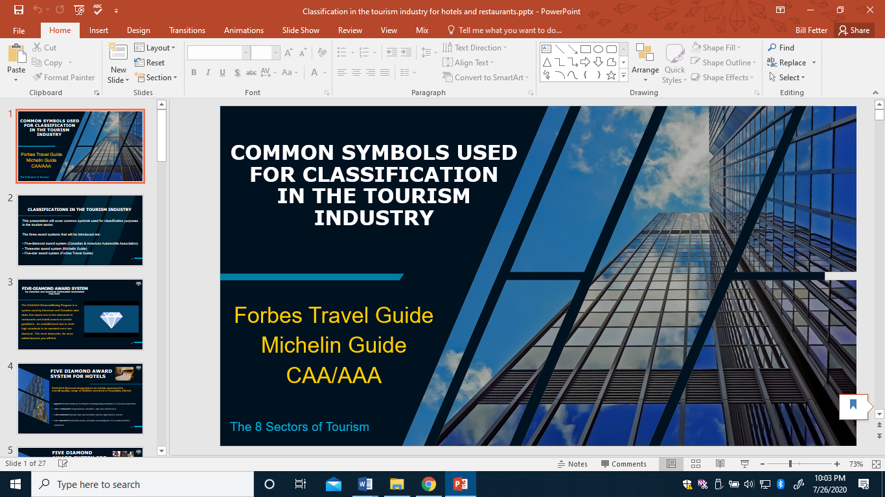](https://www.octe.ca/application/files/5115/9621/5979/Classification_in_the_tourism_industry_for_hotels_and_restaurants_1.pptx)

<https://www.octe.ca/application/files/5115/9621/5979/Classification_in_the_tourism_industry_for_hotels_and_restaurants_1.pptx>

Name: ____________________

## Common Symbols Used for Classification in the Tourism Industry PowerPoint Handout

The three award systems introduced in the PowerPoint are?

| **FIVE-DIAMOND AWARD SYSTEM**  By Canadian and American Automobile Association  CAA/AAA | **Important Notes from the PowerPoint**  (in point form, add more bullets as required) |
| --- | --- |
| 5 Diamond Symbol/Logo used by AAA/CAA |
| **THREE-STAR AWARD SYSTEM**  By the Michelin Guide | **Important Notes from the PowerPoint**  (in point form, add more bullets as required) |
| Michelin Star symbol/logo used by the Michelin Guide |
| **FIVE STAR AWARD SYSTEM**  By Forbes Travel Guide | **Important Notes from the PowerPoint**  (in point form, add more bullets as required) |
| Five-Star Forbes Travel Guide Logo by Forbes Travel Guide |

# Activity 10 – Adventure Tourism and Recreation (Sector 6) Sector Assignment

Name: ___________________

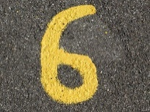 Tourism Services Sector Assignment

 Travel Agent Assignment

/60

For this assignment you have the chance to put your learning into action. After going through the PowerPoint and learning about the Forbes Travel Guide, the Michelin Guide and CAA/AAA Five-diamond award system you will have the opportunity to identify these common symbols used for classification purposes in the tourism industry. As a travel agent, in the Tourism Services Sector you would be responsible for searching out travel locations for customers looking for their next vacation in Ontario or Canada. Using the Forbes Travel Guide, the Michelin Guide and the CAA/AAA award systems find four different properties with high rating for each respective award systems. Once you have found four different properties make sure to include them in the graphic organizer below as well as on your Ontario and Canadian map. In the graphic organizer include the name of the place, the location, how it is rated and any additional features that would be enjoyable for the customer.

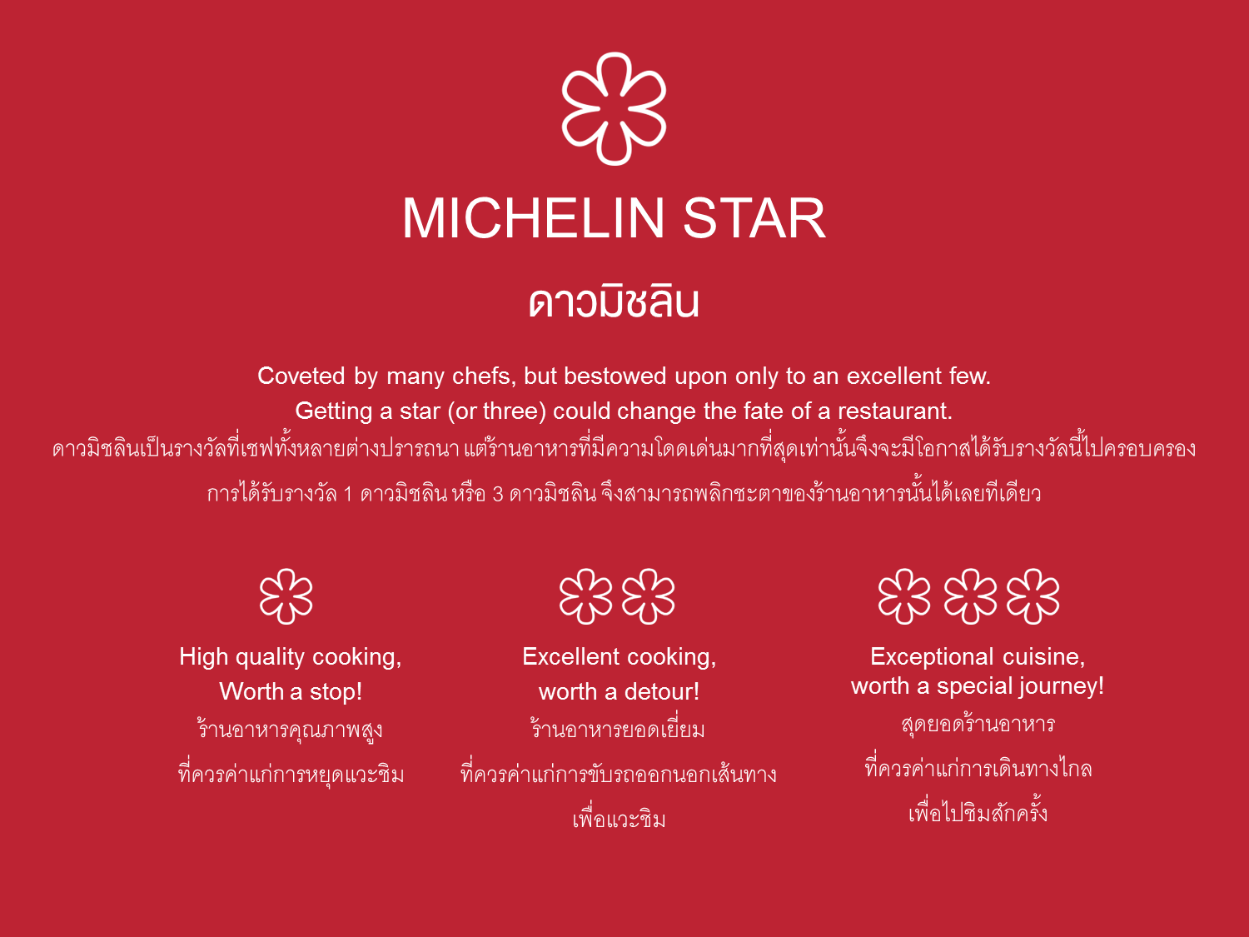

# Activity 11 – Transportation (Sector 7) Sector Assignment

Name: ___________________

 Transportation Sector Assignment

This sector provides the movement while people are travelling.

The sector is divided into four categories:

1. Air
2. Railway
3. Water
4. Ground transport

 Using the Transportation Sector to Travel around Ontario

All aboard for the next assignment to look at different ways to travel around Ontario. Look at all the great opportunities to travel from place to place exploring our great country. Fill in the information below to complete your last stop with the Transportation Sector exploring all The 8 Sectors of the Tourism Industry.

Research these transportation arrangements and complete the chart below.

|  |  | Determine and Outline Options with Cost |
| --- | --- | --- |
| **Vancouver to Toronto** | Plane |  |
| Train |  |

|  |  | Determine and Outline Options with Cost |
| --- | --- | --- |
| **London to Montreal** | Plane |  |
| Train |  |

|  |  | Determine and Outline Options with Cost |
| --- | --- | --- |
| **Kingston to Quebec City** | Boat | |

|  |  | Determine the time required to travel and Outline Options for each method of Transportation |
| --- | --- | --- |
| **Vancouver to Toronto** | Plane |  |
| Train |  |
|  | Car |  |

# References

21st Century Competencies: Foundation Document for Discussion. Phase 1: Towards Defining 21st Century Competencies for Ontario, Winter 2016 Edition, 2016 <http://www.edugains.ca/resources21CL/About21stCentury/21CL_21stCenturyCompetencies.pdf>

AAA Diamonds: Diamond Designations (website), 2020 <https://www.aaa.com/diamonds/diamond-awards>

Auguste Escoffier School of Culinary Arts. *A Brief History of the Michelin Star Rating* (article), 2019 <https://www.escoffier.edu/blog/world-food-drink/a-brief-history-of-the-michelin-guide/>

Canadian Industry Statistics – Innovation, Science, Economic Development Canada, 2020 <https://www.ic.gc.ca/app/scr/app/cis/search-recherche>

Canadian Tourism Human Resource Council (website), 2019 www.cthrc.ca

Classification in the tourism industry for hotels and restaurants (PowerPoint), 2020 <https://www.octe.ca/application/files/5115/9621/5979/Classification_in_the_tourism_industry_for_hotels_and_restaurants_1.pptx>

Course Codes for Emphasis courses in the Revised Curriculum: Technological Education, Grades 11 and 12, 2009 <http://www.edu.gov.on.ca/eng/curriculum/secondary/techedemphasiscourses.pdf>

Federation of Ontario Public Libraries (website), 2020 <http://fopl.ca/>

Forbes (website), 2020 <https://www.forbes.com/>

Forbes Travel Guide: 2020 Star Award Winners (website), 2020 <https://www.forbestravelguide.com/award-winners>

Forbes Travel Guide (The Five Star Travel Corporation) Logo (image), 2020 <https://www.forbestravelguide.com/termsofuse>

Growing Success: Assessment, Evaluation, and Reporting in Ontario Schools, First Edition, Covering Grades 1 to 12, 2010 [www.edu.gov.on.ca/eng/policyfunding/growSuccess.pdf](http://www.edu.gov.on.ca/eng/policyfunding/growSuccess.pdf)

HotelTechReport, 100+ Hotel Trends to Watch in 2020 (article by Jordan Hollander), 2020 <https://hoteltechreport.com/news/100-hotel-trends>

Invest Ontario (website), 2020 <https://www.investinontario.com/tourism>

Learning for All – A Guide to Effective Assessment and Instruction for All Students, Kindergarten to Grade 12, 2013 <http://www.edu.gov.on.ca/eng/general/elemsec/speced/LearningforAll2013.pdf>

Map of Canada (image), 2019 <http://ftp.geogratis.gc.ca/pub/nrcan_rncan/raster/atlas_6_ed/reference/eng/can_eng.pdf>

Map of Ontario (image), 2019 <http://ftp.geogratis.gc.ca/pub/nrcan_rncan/raster/atlas_6_ed/reference/bilingual/ont_new.jpg>

Michelin Guide (website), 2020 https[://guide.michelin.com/](https://guide.michelin.com/)

Michelin Guide Terms of Use (website), 2020 <https://guide.michelin.com/en/terms-of-use>

Michelin Star (image), 2020 <https://d3h1lg3ksw6i6b.cloudfront.net/media/image/2018/05/23/bd01026a1778478cba866b2035e8baed_1-MICHELIN+STAR.png>

Pixabay (clipart), 2020 www.pixabay.com

Sectors of Tourism (PowerPoint), 2020 <https://www.octe.ca/application/files/4115/9572/4388/Sectors_of_Tourism.pptx>

Setupmyhotel (website), 2020 <https://setupmyhotel.com>

Stats Canada <https://www150.statcan.gc.ca>

The Differentiated Instruction Scrapbook <http://www.edugains.ca/resourcesDI/EducatorsPackages/DIEducatorsPackage2010/2010DIScrapbook.pdf>

The Ontario Curriculum, Grades 9 and 10: Technological Education, 2009 (revised) <http://www.edu.gov.on.ca/eng/curriculum/secondary/teched910curr09.pdf>

The Ontario Curriculum, Grades 11 and 12: Technological Education, 2009 (revised) <http://www.edu.gov.on.ca/eng/curriculum/secondary/2009teched1112curr.pdf>

Tourism HR Canada (website), 2020 <http://tourismhr.ca/>