Future-Proof Your Career with Transferable Skills - Handout
Answer the following during the lesson.

- Define transferable (essential) skills in your own words.

Skills for Success website: (https://www.canada.ca/en/services/jobs/training/initiatives/skills-success.html)
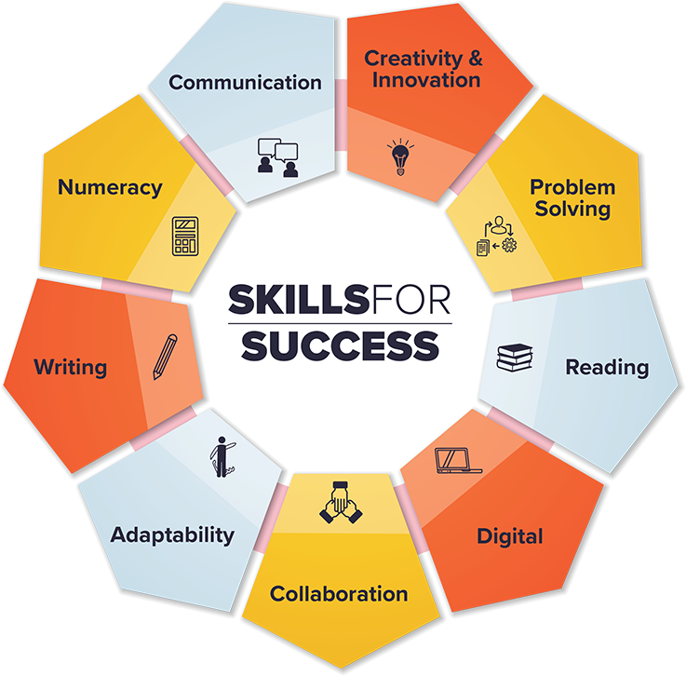

- ___________________________ is working with and supporting others to reach a common goal.

- ___________________________ is being able to adjust and continually learn when something unexpected occurs or the workplace changes.

- ___________________________ is being able to share information with words, symbols, and images.

- ___________________________ is being able to find, understand, and use information.

- ___________________________ is being able to identify, analyze, propose solutions, and make decisions.

- ___________________________ is being able to understand and work with mathematical information.

- ___________________________ is being able to effectively use computers and other digital technology to find, manage, apply, create and share information and content.

- ___________________________ is being able to imagine, develop, express, encourage, and apply ideas in new ways.

- ___________________________ is being able to receive, understand, consider, and share information and ideas through speaking, listening, and interacting with others.

- ___________________________ is learning something outside of your existing skill set. E.g. A car assembler is replaced by a robot so they learn how to maintain the robot.

- ___________________________ is learning something to expand your existing skill set. E.g. A car painter learning a new technique to paint more efficiently.
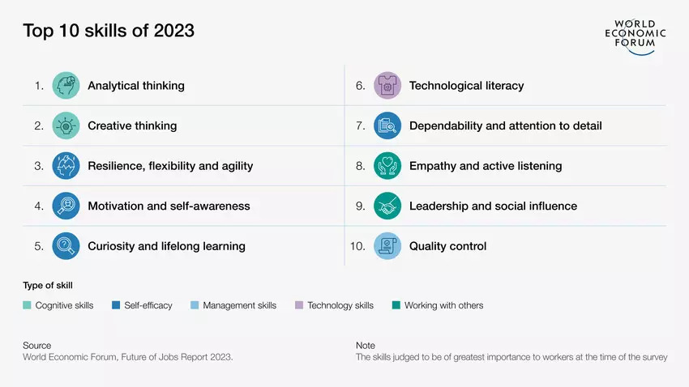
- Based on the infographic above, identify 3 skills that you think reflect you the best.

- ___________________________________________________________

- ___________________________________________________________

- ___________________________________________________________

14. Based on the video Transferable (Essential) Skills in the Automotive Industry video, give one example of how essential skills are used in the automotive industry.

____________________________________________________________________________

____________________________________________________________________________

