Base Structure

The base structure for the taxi can be design and printed with a 3D printer, it could be created using wood and tools like a bandsaw or scroll saw. This also could be assembled using lego. Consider what type of wheels and axles will work, custom ones could be designed and 3D printed. Wheels could be attached and made to roll or fixed.

The structure will need to be smaller by 3 to 5 mm so that clay can be added and shaped on top.

If tools are being used make sure to review OCTE Safedocs prior to using.
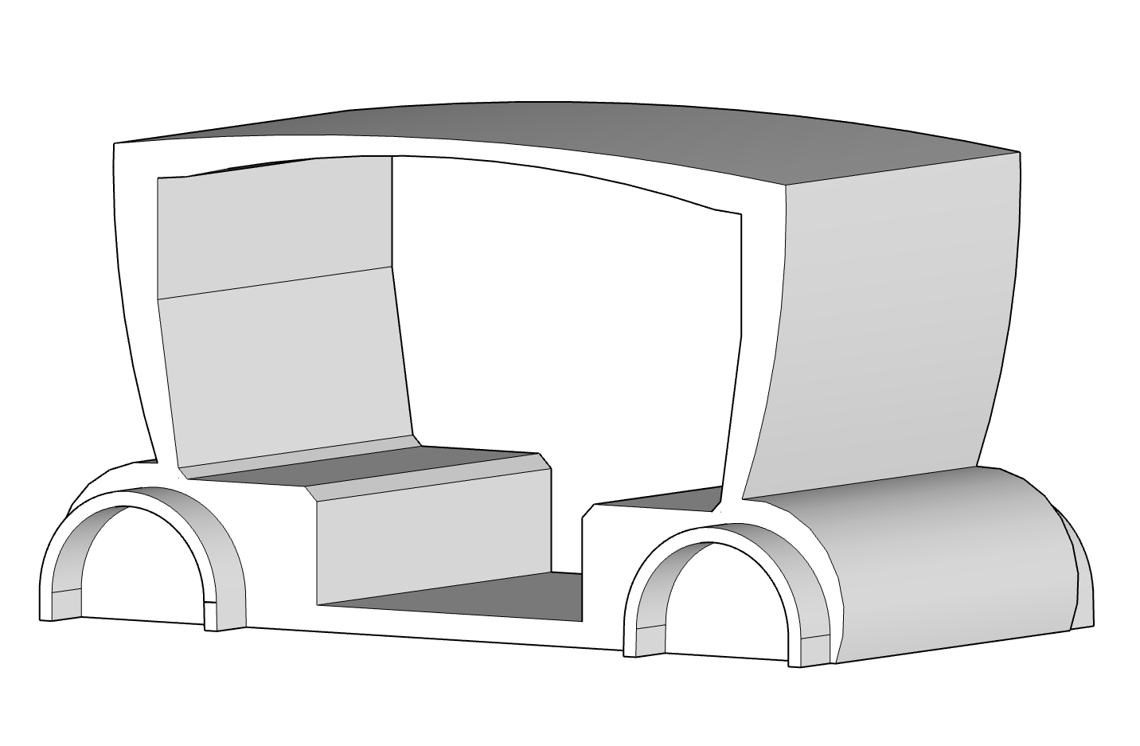
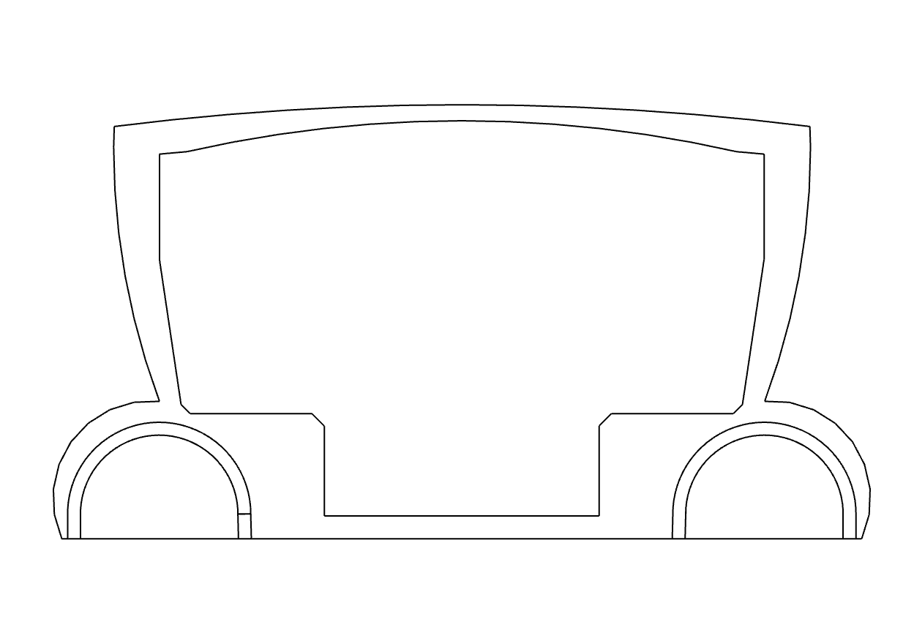
Examples:

