Soft Skills in the Automotive Industry

Use the following website to answer the question below: https://ovin-navigator.ca/labour-market-insights/lmi-data/

⬇️SCROLL DOWN ⬇️ UNTIL YOU SEE THE GRAPHIC BELOW…
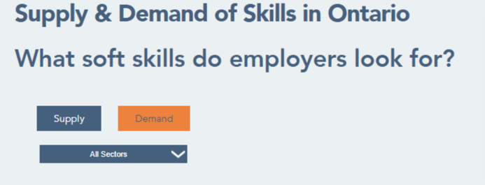

Click on the <Supply> button and <Demand> button. Use the drop down menu to switch between sectors, and choose <All Sectors> to investigate what soft (transferable) skills employers are looking for.

Compare the supply and demand for soft skills in the sectors. What trends do you see?

